Topic 5

Straight Line Graphs

Bronze, Silver, Gold

Worksheets for

AS Level Mathematics

Teacher Notes
These Bronze, Silver and Gold worksheets are designed to be used either straight after the content has been taught or as part of a skills gap analysis, especially as students move into year 13.
They are drawn from the latest specification questions and legacy questions. The papers are between 25 and 35 marks.
The topic number on this worksheet relates to the corresponding chapter number in the ‘Pearson Edexcel AS and A Level Mathematics: Pure Mathematics Year 1/AS’ textbook.

Non-Calculator Questions
The new specification allows calculators to be used in all papers. We have, however, put these questions together with the intention that students can complete them without a calculator. It’s important for pupils to be able to maintain their non-calculator skills, especially on topics such as surds or indices, to support question that use the keywords “show that” or “prove”. If you wish to ease the difficulty slightly then you can, of course, allow students to attempt them with the support of a calculator.

Quick Links
(Press Ctrl, as you click with your mouse to follow these links)
- Bronze Questions
- Bronze Mark Scheme
- Silver Questions
- Silver Mark Scheme
- Gold Questions
- Gold Mark Scheme

Extension and Enrichment
If you have students that have enjoyed the challenge of the Gold questions, then they should have a go at the more challenging question from our Advanced Extension Award (AEA) papers. The Mathematics AEA is a single, 3 hour non-calculator paper, taken at the end of year 13. It helps students to develop high level problem solving and proof skills. It is entirely based on the content of the A Level Mathematics Course. No extra material needs to be covered to take the AEA in Mathematics. A second important difference is that marks are awarded for the clarity and quality of their solution. Developing this key skill, alongside the extra problem-solving experience, can pay dividends in the way they approach A Level Mathematics and Further Mathematics problems.
More information about the Advanced Extension Award can be found here on the Pearson Edexcel Website, or here on the Maths Emporium


Bronze Questions
Calculators may not be used
The total mark for this section is 34

Q1
The line l passes through the points A (3, 1) and B (4, – 2).
Find an equation for l
(Total for Question 1 is 6 marks)
__________________________________________________________________________

Q2
The line L₁ has equation 4x + 2y − 3 = 0
(a) Find the gradient of L₁
(2)
The line L₂ is perpendicular to L₁ and passes through the point (2, 5)
(b) Find the equation of L₂ in the form y = mx + c, where m and c are constants.
(3)

(Total for Question 2 is 5 marks)
__________________________________________________________________________

Q3
The line l₁ has equation 4y – 3x = 10
The line l₂ passes through the points (5, –1) and (–1, 8)
Determine, giving full reasons for your answer, whether lines l₁ and l₂ are parallel, perpendicular or neither.

(Total for Question 3 is 4 marks)
__________________________________________________________________________

Q4
The line l₁ has equation y = − 2x + 3
The line l₂ is perpendicular to l₁ and passes through the point (5, 6).
(a) Find an equation for l₂ in the form ax + by + c = 0, where a , b and c are integers.
(3)
The line l₂ crosses the x-axis at the point A and the y-axis at the point B.
(b) Find the x-coordinate of A and the y-coordinate of B.
(2)
Given that O is the origin,
(c) find the area of the triangle OAB.
(2)

(Total for Question 4 is 7 marks)
__________________________________________________________________________

Q5
The point A (–6, 4) and the point B (8, –3) lie on the line L.
(a) Find an equation for L in the form ax + by + c = 0, where a, b and c are integers.
(4)
(b) Find the distance AB, giving your answer in the form k√5, where k is an integer.
(3)

(Total for Question 5 is 7 marks)
__________________________________________________________________________

Q6
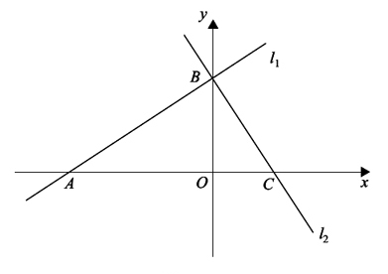
Figure 1

The line l₁ has equation 2x − 3y + 12 = 0
(a) find the gradient of l₁.
(1)
The line l₁ crosses the x-axis at the point A and the y-axis at the point B, as shown in Figure 1.
The line l₂ is perpendicular to l₁ and passes through B.
(b) Find an equation of l₂.
(3)
The line l₂ crosses the x-axis at the point C.
(c) Find the area of triangle ABC.
(4)

(Total for Question 6 is 8 marks)
__________________________________________________________________________

End of Questions

Bronze Mark Scheme
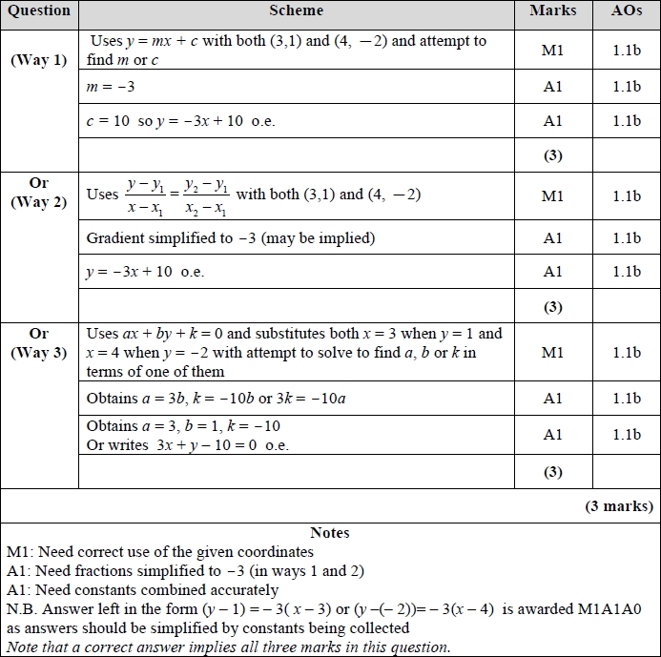
Q1

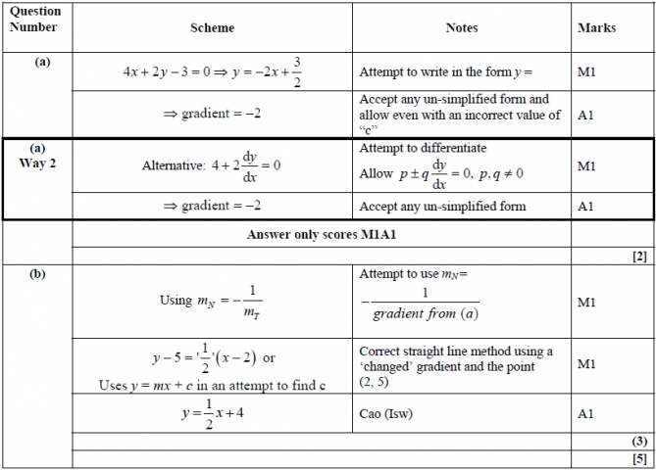
Q2

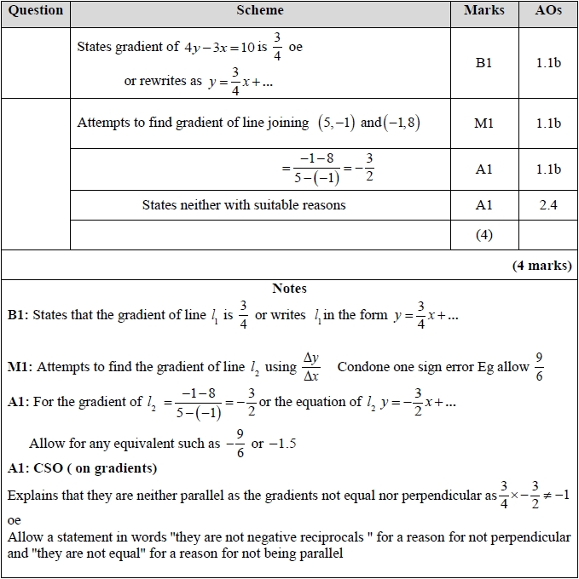
Q3

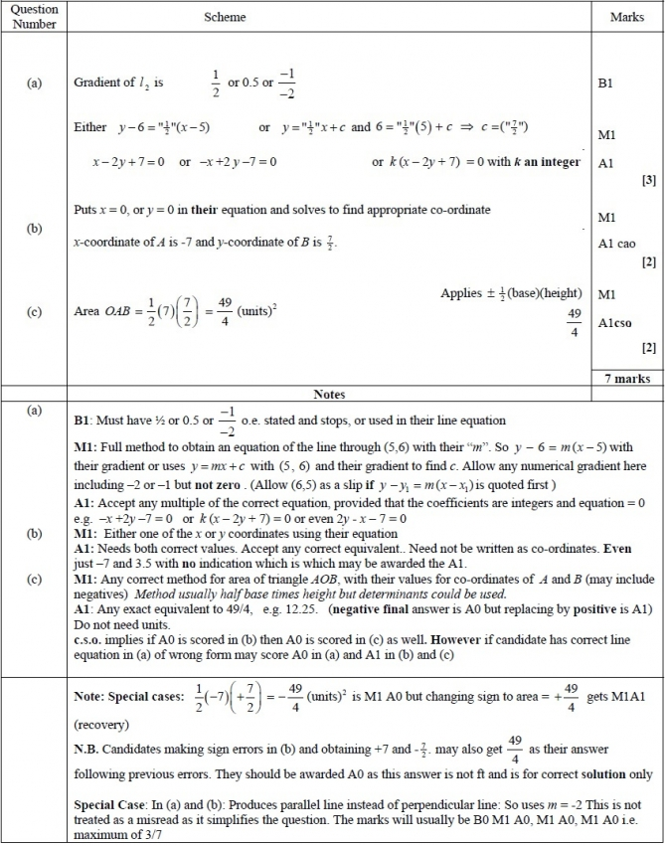
Q4
Q5
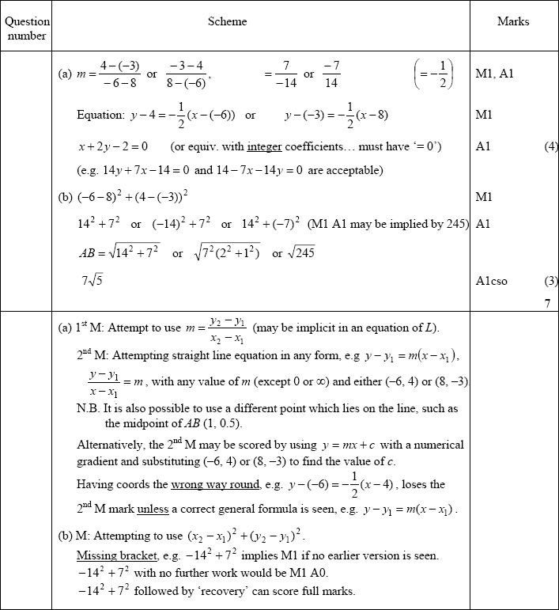

Q6
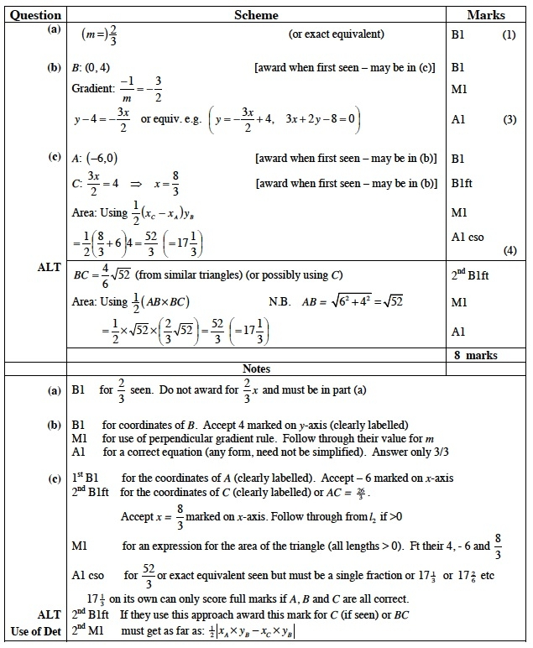


Silver Questions
Calculators may not be used
The total mark for this section is 31

Q1
The points P and Q have coordinates (−1, 6) and (9, 0) respectively.
The line l is perpendicular to PQ and passes through the mid-point of PQ.
Find an equation for l, giving your answer in the form ax + by + c = 0, where a, b and c are integers.
(5)

(Total for Question 1 is 5 marks)
__________________________________________________________________________

Q2
The straight line L₁ passes through the points (−1, 3) and (11, 12).
(a) Find an equation for L₁ in the form ax + by + c = 0,
where a, b and c are integers.
(4)
The line L₂ has equation 3y + 4x − 30 = 0.
(b) Find the coordinates of the point of intersection of L₁ and L₂.
(3)

(Total for Question 2 is 7 marks)
__________________________________________________________________________

Q3
The line L₁ has equation 2y − 3x − k = 0, where k is a constant.
Given that the point A (1, 4) lies on L₁, find
(a) the value of k,
(1)
(b) the gradient of L₁.
(2)
The line L₂ passes through A and is perpendicular to L₁
(c) Find an equation of L₂ giving your answer in the form ax + by + c = 0, where a, b and c are integers.
(4)
The line L₂ crosses the x-axis at the point B.
(d) Find the coordinates of B.
(2)
(e) Find the exact length of AB.
(2)

(Total for Question 3 is 11 marks)
__________________________________________________________________________

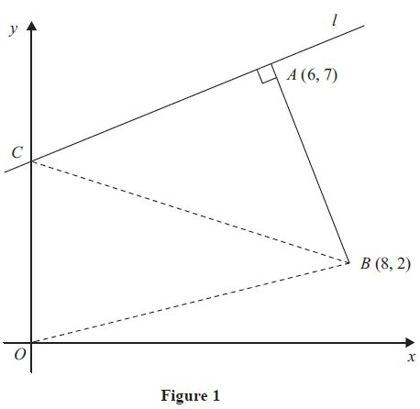
Q4
The points A and B have coordinates (6, 7) and (8, 2) respectively.
The line l passes through the point A and is perpendicular to the line AB, as shown in
Figure 1.
(a) Find an equation for l in the form ax + by + c = 0, where a, b and c are integers.
(4)
Given that l intersects the y-axis at the point C, find
(b) the coordinates of C,
(2)
(c) the area of ΔOCB, where O is the origin.
(2)
(Total for Question 4 is 8 marks)
__________________________________________________________________________

End of Questions

Silver Mark Scheme

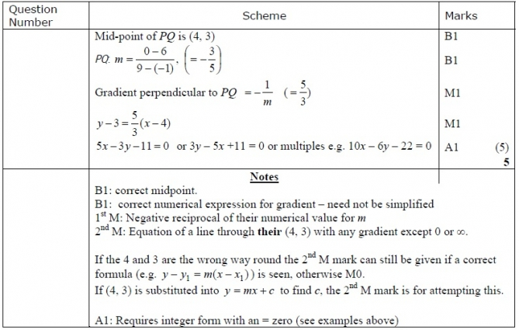
Q1

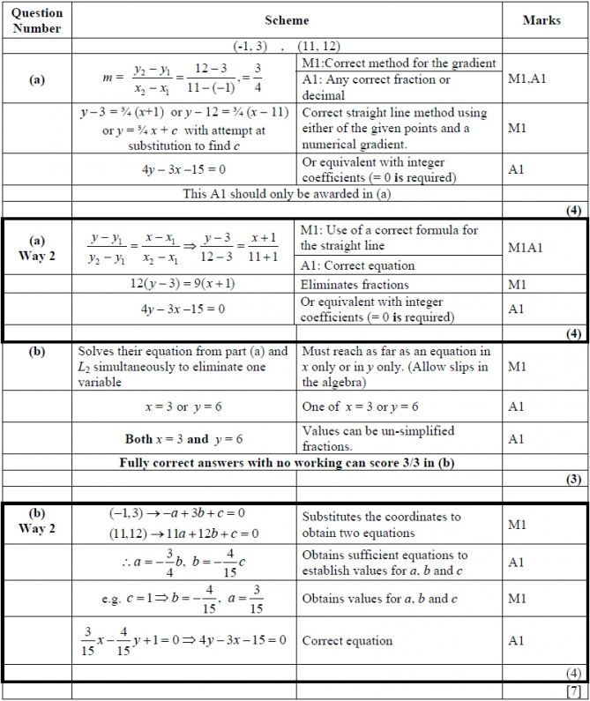
Q2

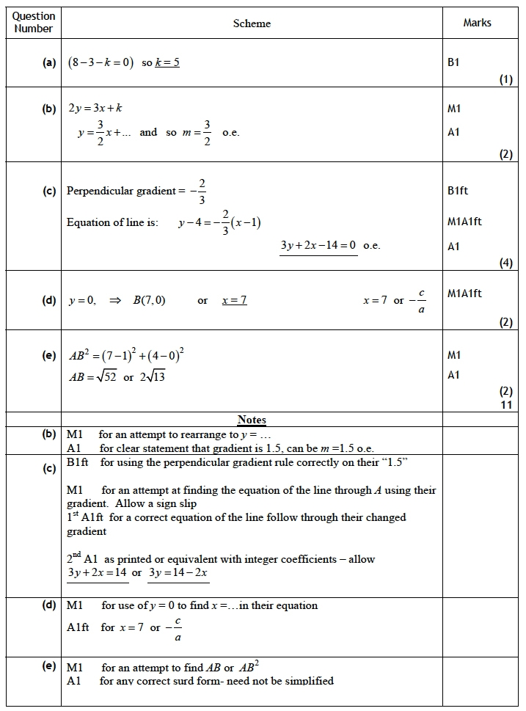
Q3

Q4
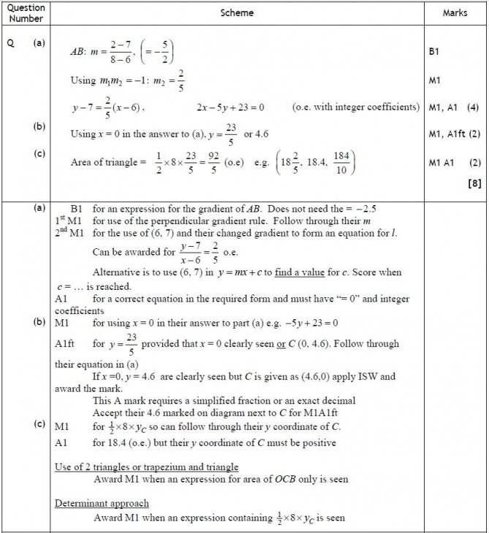

Gold Questions
Calculators may not be used
The total mark for this section is 27

Q1
(a) Find an equation of the line joining A(7, 4) and B(2, 0), giving your answer in the
form ax+by+c = 0, where a, b and c are integers.
(3)

(b) Find the length of AB, leaving your answer in surd form.
(2)
The point C has coordinates (2, t), where t > 0, and AC = AB.
(c) Find the value of t.
(1)
(d) Find the area of triangle ABC.
(2)
(Total for Question 1 is 8 marks)
__________________________________________________________________________

Q2
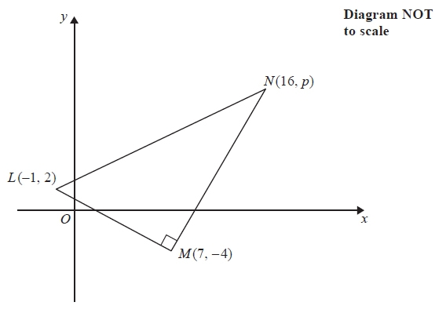
Figure 2

Figure 2 shows a right angled triangle LMN.
The points L and M have coordinates (−1, 2) and (7, −4) respectively.
(a) Find an equation for the straight line passing through the points L and M.
Give your answer in the form ax + by + c = 0, where a, b and c are integers.
(4)
Given that the coordinates of point N are (16, p), where p is a constant, and angle
LMN = 90°,
(b) find the value of p.
(3)
Given that there is a point K such that the points L, M, N, and K form a rectangle,
(c) find the y coordinate of K.
(2)
(Total for Question 2 is 9 marks)
__________________________________________________________________________

Q3
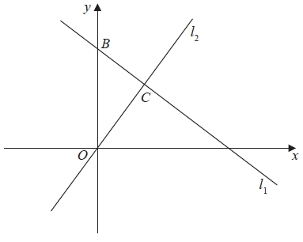
Figure 2

The line l₁, shown in Figure 2 has equation 2x + 3y = 26
The line l₂ passes through the origin O and is perpendicular to l₁
(a) Find an equation for the line l₂
(4)
The line l₂ intersects the line l₁ at the point C
Line l₁ crosses the y-axis at the point B as shown in Figure 2.
(b) Find the area of triangle OBC
Give your answer in the form , where a and b are integers to be determined.
(6)
(Total for Question 3 is 10 marks)
__________________________________________________________________________

End of Questions

Gold Mark Scheme

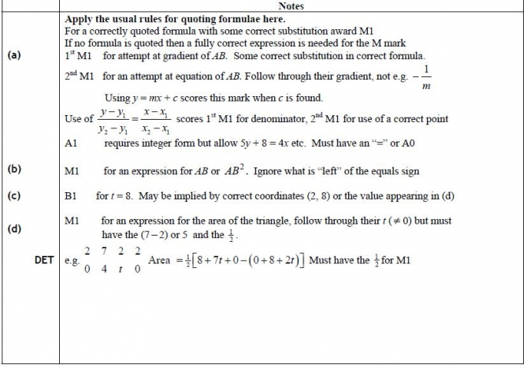
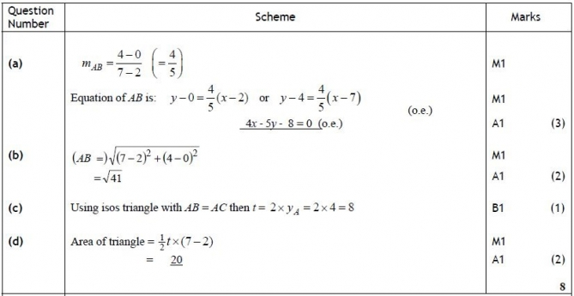
Q1
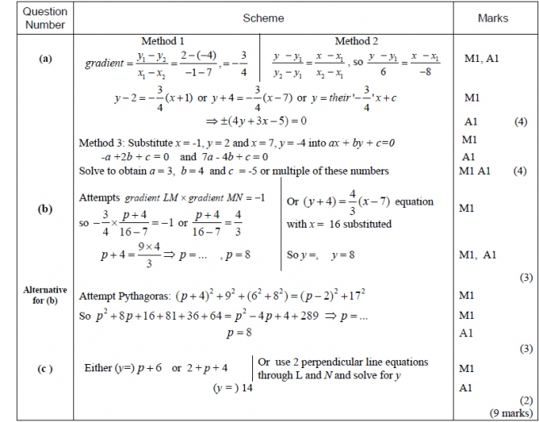
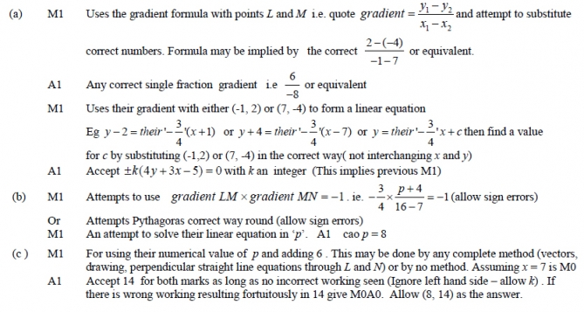
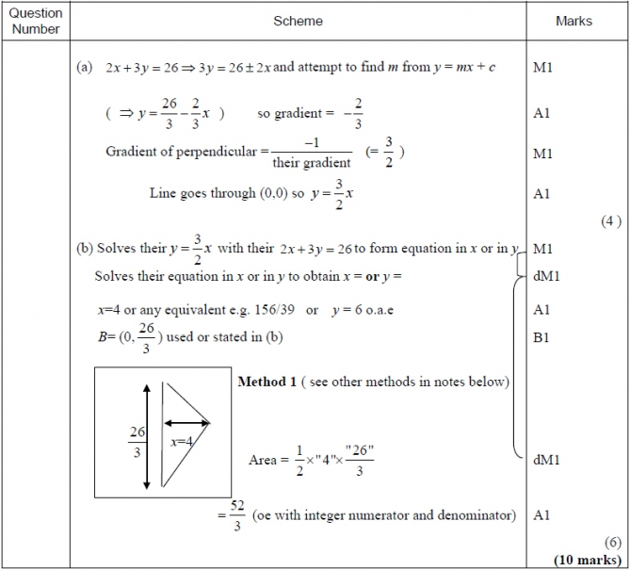
Q2
Q3

Notes
(a) M1 Complete method for finding gradient. (This may be implied by later correct answers.) e.g. Rearranges 2x + 3y = 26 ⇒ y = mx + c so m =
Or finds coordinates of two points on line and finds gradient e.g. (13, 0) and (1, 8) so m = 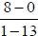
A1 States or implies that gradient = − ²⁄₃ condone − ²⁄₃x if they continue correctly. Ignore errors in constant term in straight line equation
M1 Uses m₁×m₂= − 1 to find the gradient of l₂. This can be implied by the use of 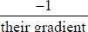
A1 y = ³⁄₂x or 2y − 3x = 0 Allow y = ³⁄₂x + 0 Also accept 2y = 3x, y = 39/26x or even y − 0 = ³⁄₂ (x − 0) and isw
(b) M1 Eliminates variable between their y = ³⁄₂x and their (possibly rearranged) 2x + 3y = 26 to form an equation in x or y. (They may have made errors in their rearrangement)
dM1 (Depends on previous M mark) Attempts to solve their equation to find the value of x or y
A1 x = 4 or equivalent or y = 6 or equivalent
B1 y coordinate of B is (stated or implied) – isw if written as (, 0). Must be used or stated in (b)
dM1 (Depends on previous M mark) Complete method to find area of triangle OBC (using their values of x and/or y at point C and their 26/3)
A1 Cao 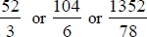 o.e.
Method 1:
Uses the area of a triangle formula ½×OB ×(x coordinate of C)
Alternative methods:
Several Methods are shown below. The only mark which differs from Method 1 is the last M mark and its use in each case is described below:
Method 2 in (b) using ¹⁄₂× BC × OC
dM1 Uses the area of a triangle formula ½× BC × OC Also finds OC (=√52 ) and BC = 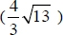
Method 3 in (b) using 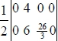
dM1 States the area of a triangle formula or equivalent with their values
Method 4 in (b) using area of triangle OBX – area of triangle OCX where X is point (13, 0)
dM1 Uses the correct subtraction 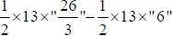
Method 5 in (b) using area = ½ (6 × 4) + ½ (4 × 8/3) drawing a line from C parallel to the x axis and dividing triangle into two right angled triangles
dM1 for correct method area = ½ ("6" × "4") + ½ ("4" × ["26/3" − "6"])
Method 6 Uses calculus
dM1 