Topic 5: Radians

Bronze, Silver and Gold Worksheets for

A Level Mathematics

Teacher Notes
These Bronze, Silver and Gold worksheets are designed to be used either straight after the content has been taught or as part of a skills gap analysis, especially as students move into year 13.
They are drawn from the latest specification questions and legacy questions. The papers are between 20 and 35 marks.
The topic number on this worksheet relates to the corresponding chapter number in the ‘Pearson Edexcel A Level Mathematics: Pure Mathematics Year 2’ textbook.
Please note the questions in this topic are calculator questions.

Quick Links
(Press Ctrl, as you click with your mouse to follow these links)
- Bronze Questions
- Bronze Mark Scheme
- Silver Questions
- Silver Mark Scheme
- Gold Questions
- Gold Mark Scheme

Extension and Enrichment
If you have students that have enjoyed the challenge of the Gold questions, then they should have a go at the more challenging question from our Advanced Extension Award (AEA) papers. The Mathematics AEA is a single, 3 hour non-calculator paper, taken at the end of year 13. It helps students to develop high level problem solving and proof skills. It is entirely based on the content of the A Level Mathematics Course. No extra material needs to be covered to take the AEA in Mathematics. A second important difference is that marks are awarded for the clarity and quality of their solution. Developing this key skill, alongside the extra problem-solving experience, can pay dividends in the way they approach A Level Mathematics and Further Mathematics problems.
More information about the Advanced Extension Award can be found here on the Pearson Edexcel Website, or here on the Maths Emporium

Bronze Questions
Calculator
The total mark for this section is 25
Q1
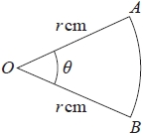
Figure 1
Figure 1 shows a sector AOB of a circle with centre O and radius r cm.
The angle AOB is θ radians.
The area of the sector AOB is 11 cm².
Given that the perimeter of the sector is 4 times the length of the arc AB, find the exact value of r.
(4)

(Total for Question 1 is 4 marks)
__________________________________________________________________________

Q2
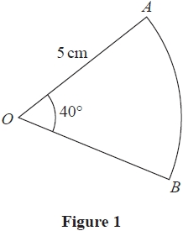
Figure 1 shows a sector AOB of a circle with centre O, radius 5 cm and angle AOB = 40°
The attempt of a student to find the area of the sector is shown below.
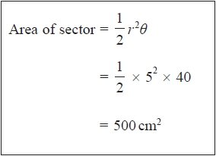
(a) Explain the error made by this student.
(1)
(b) Write out a correct solution.
(2)

(Total for Question 2 is 3 marks)
__________________________________________________________________________

Q3
(a) Sketch, for 0 ≤ x ≤ 2π, the graph of
(2)
(b) Write down the exact coordinates of the points where the graph meets the coordinate axes.
(3)
(c) Solve, for 0 ≤ x ≤ 2π, the equation
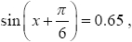
giving your answers in radians to 2 decimal places.
(5)

(Total for Question 3 is 10 marks)
__________________________________________________________________________

Q4
(i) Solve, for 0 ≤ θ < 180°, the equation
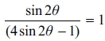
giving your answers to 1 decimal place.
(3)
(ii) Solve, for 0 ≤ x < 2π, the equation
5sin²x − 2cos x − 5 = 0
giving your answers to 2 decimal places.
(Solutions based entirely on graphical or numerical methods are not acceptable.)
(5)

(Total for Question 4 is 8 marks)
__________________________________________________________________________
End of Questions

Bronze Mark Scheme
Q1
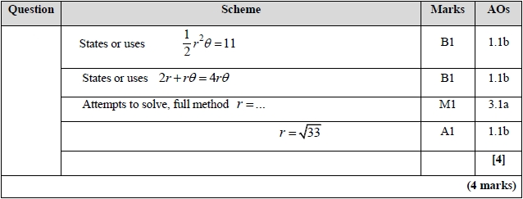
Q2
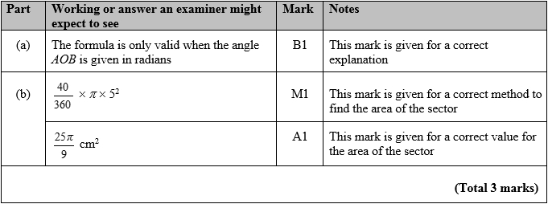

Q3

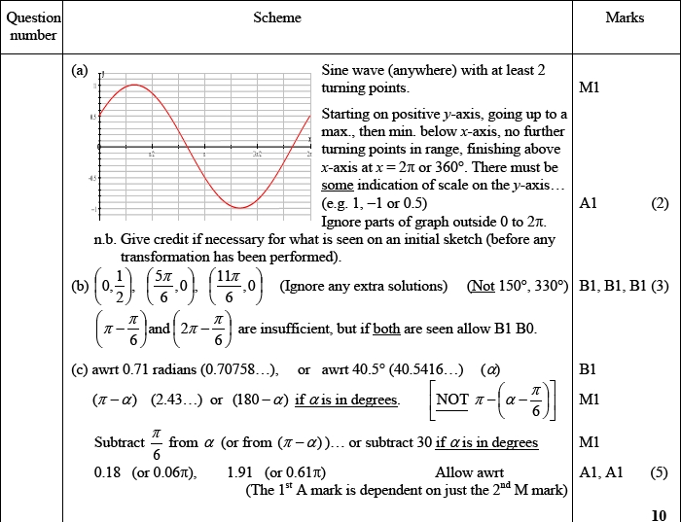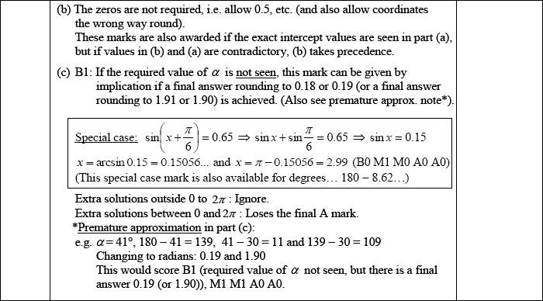

Q4
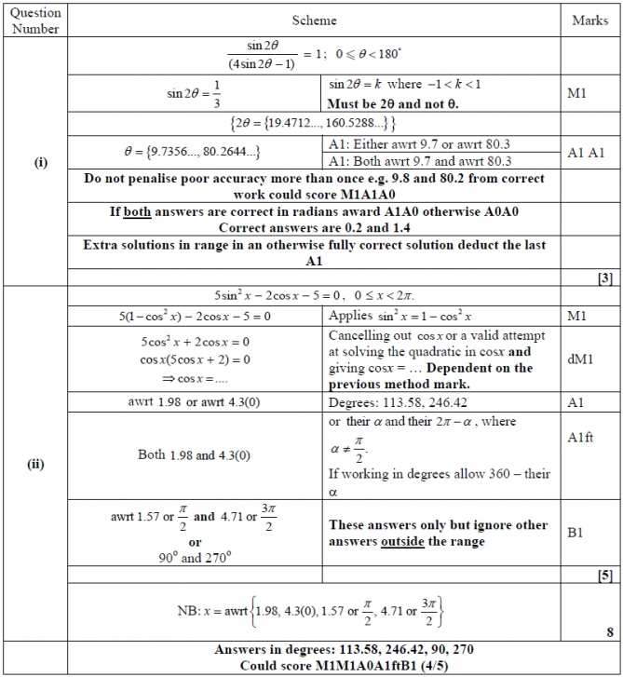


Silver Questions 20 Marks
Calculator
The total mark for this section is 20
Q1
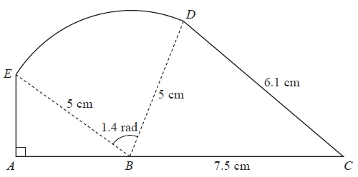
Figure 2
The shape ABCDEA, as shown in Figure 2, consists of a right-angled triangle EAB and a triangle DBC joined to a sector BDE of a circle with radius 5 cm and centre B.
The points A, B and C lie on a straight line with BC = 7.5 cm.
Angle EAB = radians, angle EBD = 1.4 radians and CD = 6.1 cm.
(a) Find, in cm², the area of the sector BDE.
(2)
(b) Find the size of the angle DBC, giving your answer in radians to 3 decimal places.
(2)
(c) Find, in cm², the area of the shape ABCDEA, giving your answer to 3 significant figures.
(5)

(Total for Question 1 is 9 marks)
__________________________________________________________________________

Q2
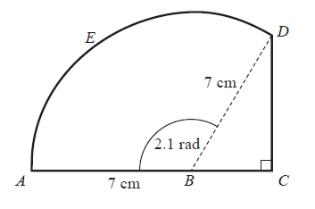
Figure 2
Figure 2 shows the shape ABCDEA which consists of a right-angled triangle BCD joined to a sector ABDEA of a circle with radius 7 cm and centre B.
A, B and C lie on a straight line with AB = 7 cm.
Given that the size of angle ABD is exactly 2.1 radians,
(a) find, in cm, the length of the arc DEA,
(2)
(b) find, in cm, the perimeter of the shape ABCDEA, giving your answer to 1 decimal place.
(4)

(Total for Question 2 is 6 marks)
__________________________________________________________________________
Q3
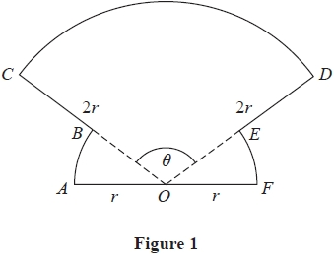
The shape OABCDEFO shown in Figure 1 is a design for a logo.
In the design
- OAB is a sector of a circle centre O and radius r
- sector OFE is congruent to sector OAB
- ODC is a sector of a circle centre O and radius 2r
- AOF is a straight line
Given that the size of angle COD is θ radians,
(a) write down, in terms of θ, the size of angle AOB
(1)
(b) Show that the area of the logo is
(2)
(c) Find the perimeter of the logo, giving your answer in simplest form in terms of r, θ and π.
(2)

(Total for Question 3 is 5 marks)
__________________________________________________________________________
End of Questions

Silver Mark Scheme
Q1
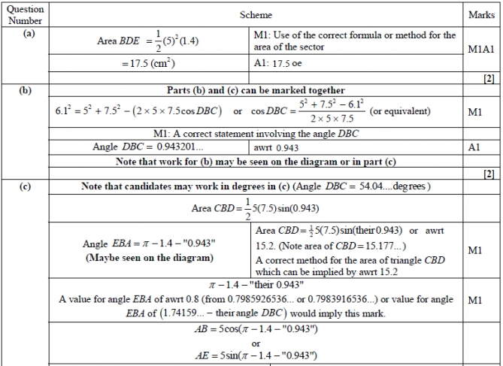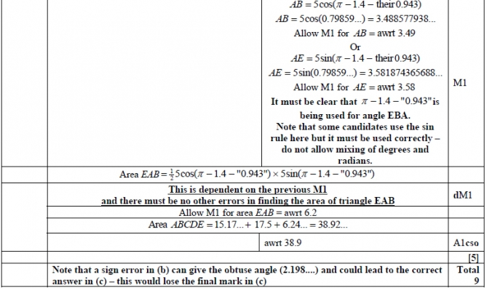

Q2
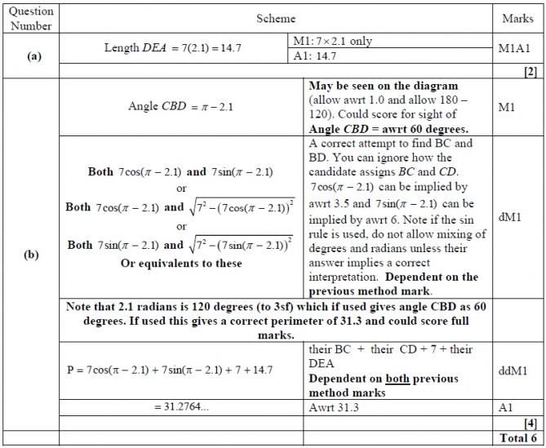
Q3
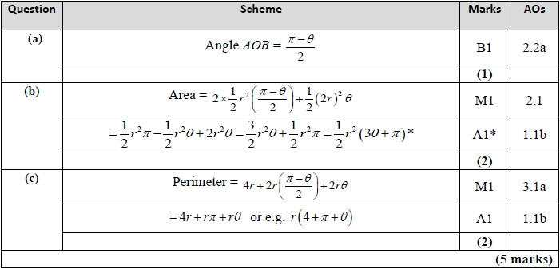

Gold Questions
Calculator
The total mark for this section is 30
Q1
A circle C has centre M (6, 4) and radius 3.
(a) Write down the equation of the circle in the form
(2)
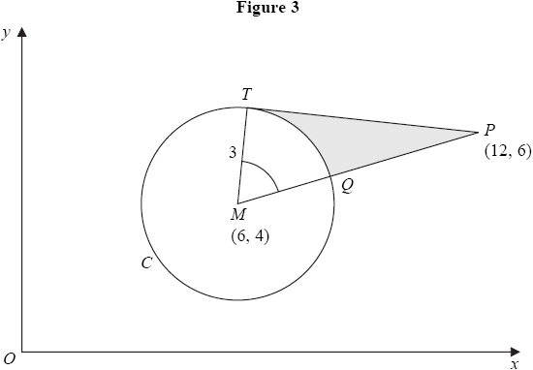
Figure 3 shows the circle C. The point T lies on the circle and the tangent at T passes through the point P (12, 6). The line MP cuts the circle at Q.
(b) Show that the angle TMQ is 1.0766 radians to 4 decimal places.
(4)
The shaded region TPQ is bounded by the straight lines TP, QP and the arc TQ, as shown in Figure 3.
(c) Find the area of the shaded region TPQ. Give your answer to 3 decimal places.
(5)

(Total for Question 1 is 11 marks)
__________________________________________________________________________

Q2

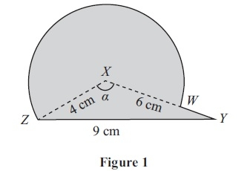
The triangle XYZ in Figure 1 has XY = 6 cm, YZ = 9 cm, ZX = 4 cm and angle ZXY = a. The point W lies on the line XY.
The circular arc ZW, in Figure 1 is a major arc of the circle with centre X and radius 4 cm.
(a) Show that, to 3 significant figures, a = 2.22 radians.
(2)
(b) Find the area, in cm², of the major sector XZWX.
(3)
The region enclosed by the major arc ZW of the circle and the lines WY and YZ is shown shaded in Figure 1.
Calculate
(c) the area of this shaded region,
(3)
(d) the perimeter ZWYX of this shaded region.
(4)

(Total for Question 2 is 12 marks)
__________________________________________________________________________

Q3
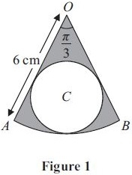
The shape shown in Figure 1 is a pattern for a pendant. It consists of a sector OAB of
a circle centre O, of radius 6 cm, and angle . The circle C, inside the sector, touches the two straight edges, OA and OB, and the arc AB as shown.
Find
(a) the area of the sector OAB,
(2)
(b) the radius of the circle C.
(3)
The region outside the circle C and inside the sector OAB is shown shaded in Figure 1.
(c) Find the area of the shaded region.
(2)

(Total for Question 3 is 7 marks)
__________________________________________________________________________
End of Questions

Gold Mark Scheme

Q1

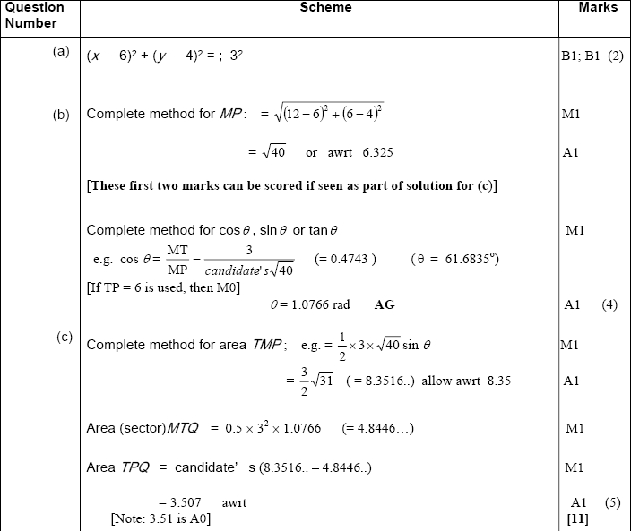

Q2

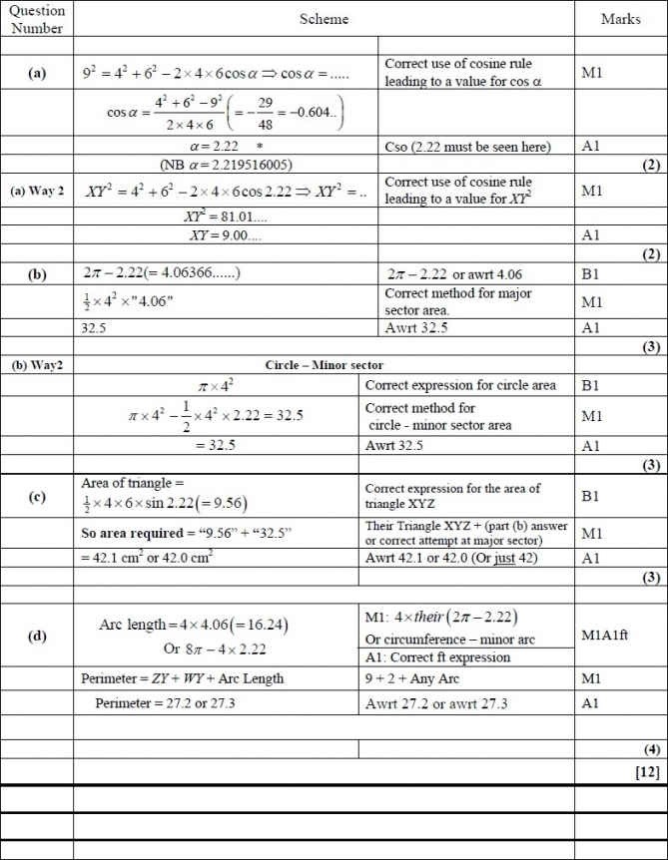

Q3
