Topic 1 - Regression, Correlation and Hypothesis Testing

Bronze, Silver and Gold Worksheets for

A Level Mathematics

Teacher Notes
These Bronze, Silver and Gold worksheets are designed to be used either straight after the content has been taught or as part of a skills gap analysis.
They are drawn from the latest specification questions and legacy questions. The papers are between approximately 25 and 45 marks.
The topic number on this worksheet relates to the corresponding chapter number in the ‘Pearson Edexcel A Level Mathematics: Statistics and Mechanics Year 2’ textbook.

Quick Links
(Press Ctrl, as you click with your mouse to follow these links)
- Bronze Questions
- Bronze Mark Scheme
- Silver Questions
- Silver Mark Scheme
- Gold Questions
- Gold Mark Scheme

Extension and Enrichment
If you have students that have enjoyed the challenge of the Gold questions, then they should have a go at the more challenging question from our Advanced Extension Award (AEA) papers. The Mathematics AEA is a single, 3 hour non-calculator paper, taken at the end of year 13. It helps students to develop high level problem solving and proof skills. It is entirely based on the content of the A Level Mathematics Course. No extra material needs to be covered to take the AEA in Mathematics. A second important difference is that marks are awarded for the clarity and quality of their solution. Developing this key skill, alongside the extra problem-solving experience, can pay dividends in the way they approach A Level Mathematics and Further Mathematics problems.
More information about the Advanced Extension Award can be found here on the Pearson Edexcel Website, or here on the Maths Emporium

Bronze Questions
Calculator
The total mark for this section is 27
Q1

A scientist is researching whether or not birds of prey exposed to pollutants lay eggs with thinner shells. He collects a random sample of egg shells from each of 6 different nests and tests for pollutant level, p, and measures the thinning of the shell, t. The results are shown in the table below.

p | 3 | 8 | 30 | 25 | 15 | 12
t | 1 | 3 | 9 | 10 | 5 | 6

[You may use ∑p² = 1967 and ∑pt = 694]

(a) On graph paper, draw a scatter diagram to represent these data.
(2)

(b) Explain why a linear regression model may be appropriate to describe the relationship between p and t.
(1)
(c) The scientist reviews similar studies and finds that pollutant levels above 16 are likely to result in an increased risk of infection soon after hatching.

Given that t = a + bp.

Estimate the minimum thinning of the shell that is likely to result in an increased risk of infection.
(2)

(Total for Question 1 is 5 marks)
__________________________________________________________________________

Q2
A random sample of 15 days is taken from the large data set for Perth in June and July 1987.
The scatter diagram in Figure 1 displays the values of two of the variables for these 15 days.
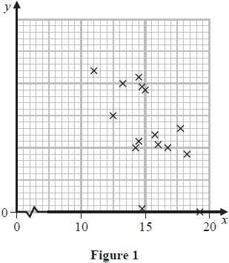
(a) Describe the correlation.
(1)
The variable on the x-axis is Daily Mean Temperature measured in °C.
(b) Using your knowledge of the large data set,
(i) suggest which variable is on the y-axis,
(ii) state the units that are used in the large data set for this variable.
(2)
Stav believes that there is a correlation between Daily Total Sunshine and Daily Maximum Relative Humidity at Heathrow.
He calculates the product moment correlation coefficient between these two variables for a random sample of 30 days and obtains r = −0.377.
(c) Carry out a suitable test to investigate Stav's belief at a 5% level of significance.
State clearly
- your hypotheses
- your critical value
(3)
On a random day at Heathrow the Daily Maximum Relative Humidity was 97%
(d) Comment on the number of hours of sunshine you would expect on that day,
giving a reason for your answer.
(1)

(Total for Question 2 is 7 marks)
__________________________________________________________________________
Q3
A meteorologist believes that there is a relationship between the daily mean windspeed, w kn, and the daily mean temperature, t °C. A random sample of 9 consecutive days is taken from past records from a town in the UK in July and the relevant data is given in the table below.
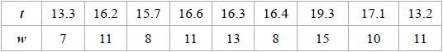
The meteorologist calculated the product moment correlation coefficient for the 9 days and obtained r = 0.609
(a) Explain why a linear regression model based on these data is unreliable on a day when the mean temperature is 24 °C
(1)
(b) State what is measured by the product moment correlation coefficient.
(1)
(c) Stating your hypotheses clearly test, at the 5% significance level, whether or not the product moment correlation coefficient for the population is greater than zero.
(3)
Using the same 9 days a location from the large data set gave = 27.2 and = 3.5.
(d) Using your knowledge of the large data set, suggest, giving your reason, the location that gave rise to these statistics.
(1)

(Total for Question 3 is 6 marks)
__________________________________________________________________________

Q4
Barbara is investigating the relationship between average income (GDP per capita), x US dollars, and average annual carbon dioxide (CO₂) emissions, y tonnes, for different countries.
She takes a random sample of 24 countries and finds the product moment correlation coefficient between average annual CO₂ emissions and average income to be 0.446.
(a) Stating your hypotheses clearly, test, at the 5% level of significance, whether or not the
product moment correlation coefficient for all countries is greater than zero.
(3)
Barbara believes that a non-linear model would be a better fit to the data.
She codes the data using the coding m = log₁₀ x and c = log₁₀ y and obtains the model
c = −1.82 + 0.89m.
The product moment correlation coefficient between c and m is found to be 0.882.
(b) Explain how this value supports Barbara's belief.
(1)
(c) Show that the relationship between y and x can be written in the form y = ax^{n} where a and
n are constants to be found.
(5)

(Total for Question 4 is 9 marks)
__________________________________________________________________________
End of Questions

Bronze Mark Scheme
Q1

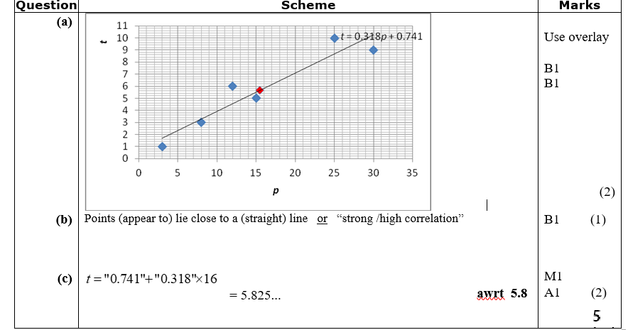

Q2
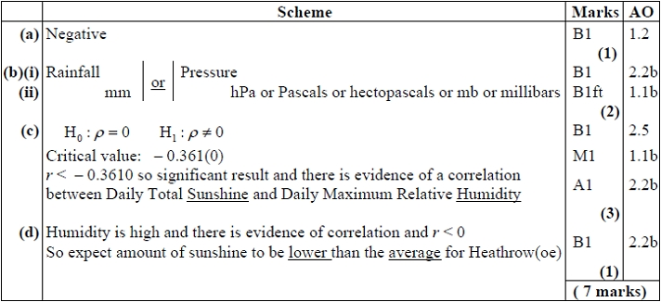
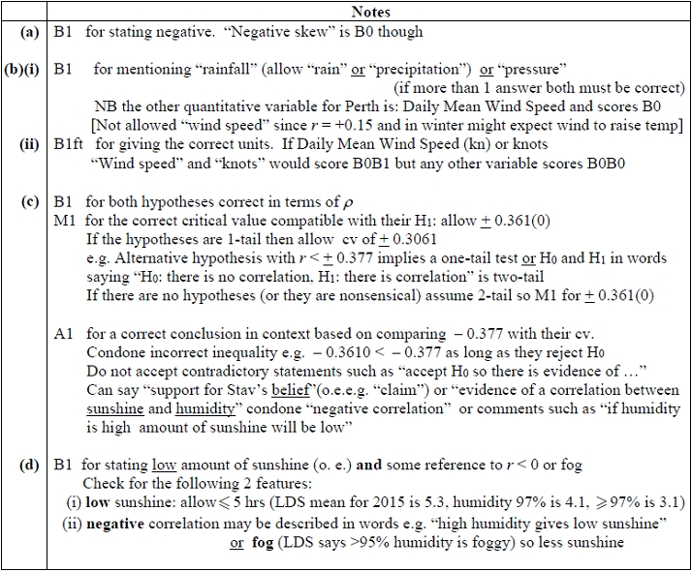

Q3
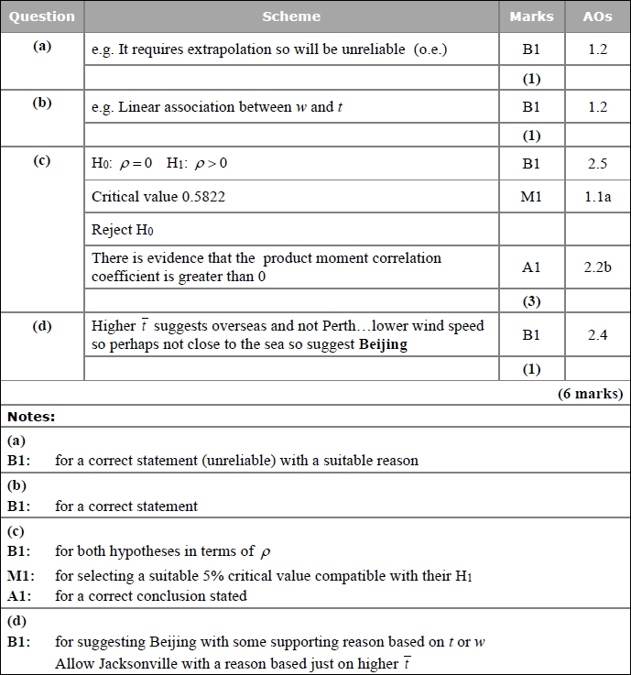

Q4
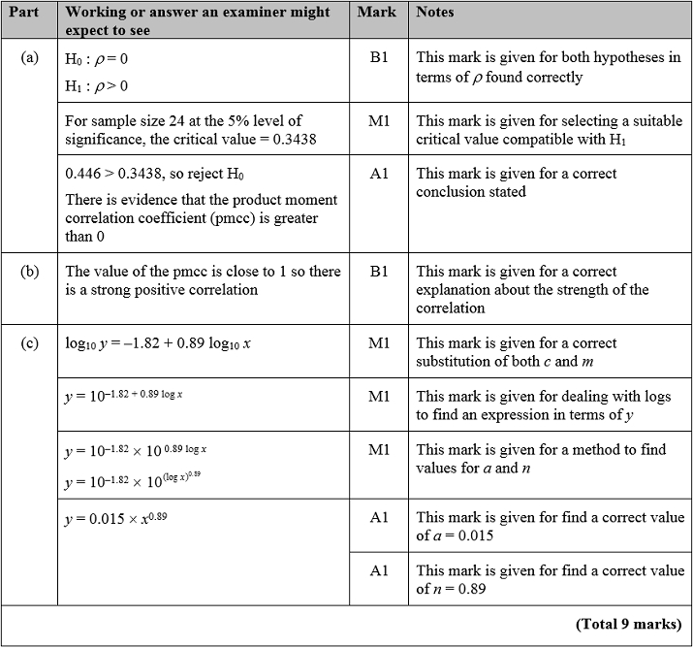


Silver Questions
Calculator
The total mark for this section is 27
Q1
In a controlled experiment, the number of microbes, N, present in a culture T days after the start of the experiment were counted.
N and T are expected to satisfy a relationship of the form
N = aT^{b}, where a and b are constants.
(a) Show that this relationship can be expressed in the form
log₁₀N = mlog₁₀T + c
giving m and c in terms of the constants a and/or b.
(2)

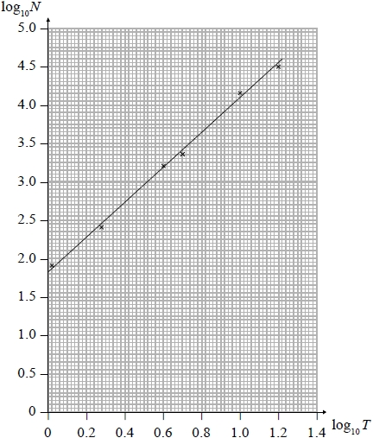
Figure 3
Figure 3 shows the line of best fit for values of log₁₀N plotted against values of log₁₀T.
(b) Use the information provided to estimate the number of microbes present in the culture 3 days after the start of the experiment.
(4)

(c) Explain why the information provided could not reliably be used to estimate the day when the number of microbes in the culture first exceeds 1 000 000.
(2)
(d) With reference to the model, interpret the value of the constant a.
(1)

(Total for Question 1 is 9 marks)
__________________________________________________________________________
Q2
The value, £V, of a vintage car t years after it was first valued on 1st January 2001, is modelled by the equation
V = Ap^{t} where A and p are constants.
Given that the value of the car was £32 000 on 1st January 2005 and £50 000 on 1st January 2012
(a) (i) find p to 4 decimal places,
(ii) show that A is approximately 24 800.
(4)
(b) With reference to the model, interpret
(i) the value of the constant A,
(ii) the value of the constant p.
(2)
Using the model,
(c) find the year during which the value of the car first exceeds £100 000.
(4)

(Total for Question 2 is 10 marks)
__________________________________________________________________________

Q3
A researcher believes that there is a linear relationship between daily mean temperature and daily total rainfall. The 7 places in the northern hemisphere from the large data set are used. The mean of the daily mean temperatures, t °C, and the mean of the daily total rainfall, s mm, for the month of July in 2015 are shown on the scatter diagram below.
2
4
6
5
10
15
20
25
30
O
t
s
G
H

- With reference to the scatter diagram, explain why a linear regression model may not be suitable for the relationship between t and s.
(1)

The researcher calculated the product moment correlation coefficient for the 7 places and obtained r = 0.658.

- Stating your hypotheses clearly, test at the 10% level of significance, whether or not the product moment correlation coefficient for the population is greater than zero.
(3)
- Using your knowledge of the large data set, suggest the names of the 2 places labelled G and H.
(1)
- Using your knowledge from the large data set, and with reference to the locations of the two places labelled G and H, give a reason why these places have the highest temperatures in July.
(2)
(e) Suggest how you could make better use of the large data set to investigate the relationship between daily mean temperature and daily total rainfall.
(1)
(Total for Question 3 is 7 marks)
__________________________________________________________________________
End of questions
Silver Mark Scheme
Q1
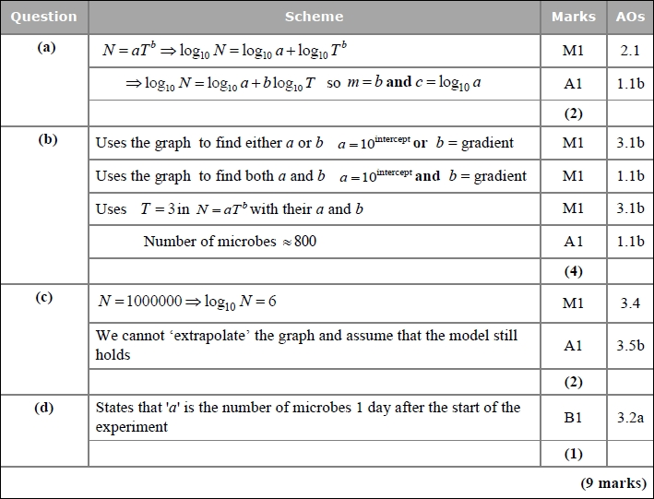
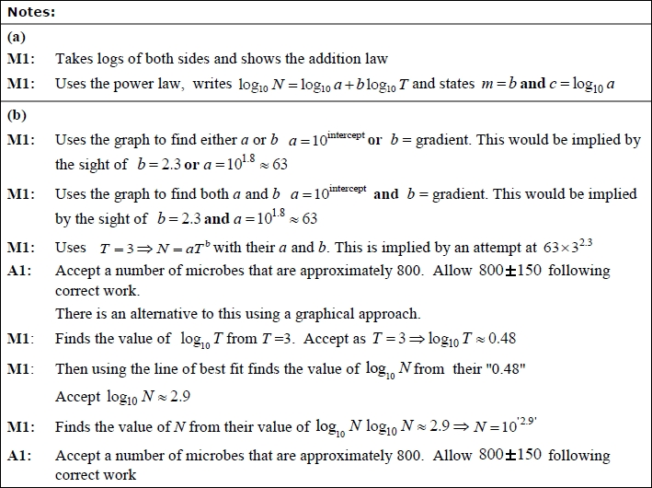
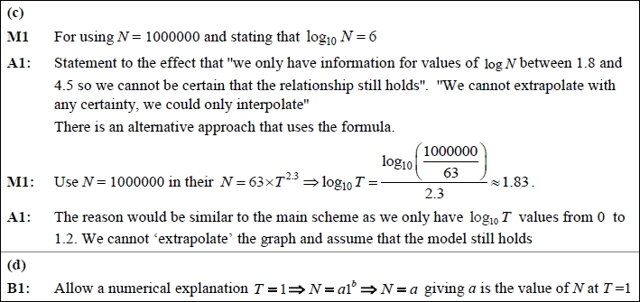

Q2
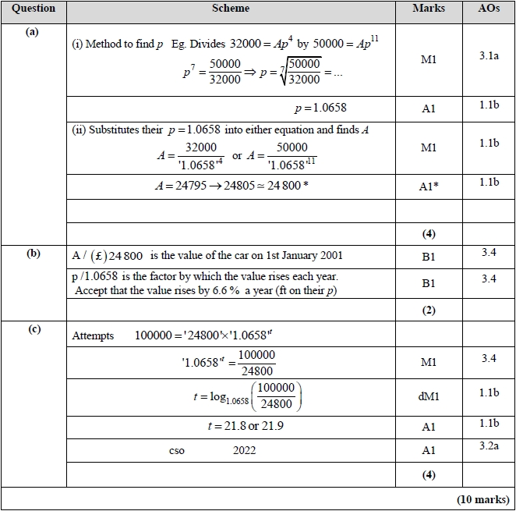
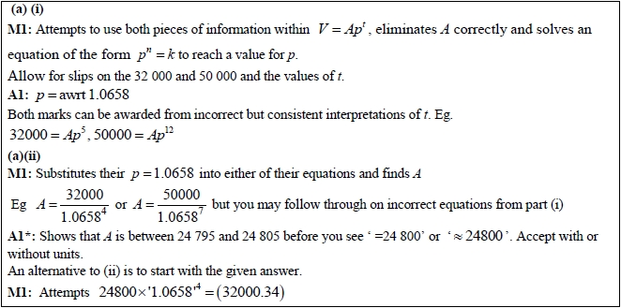
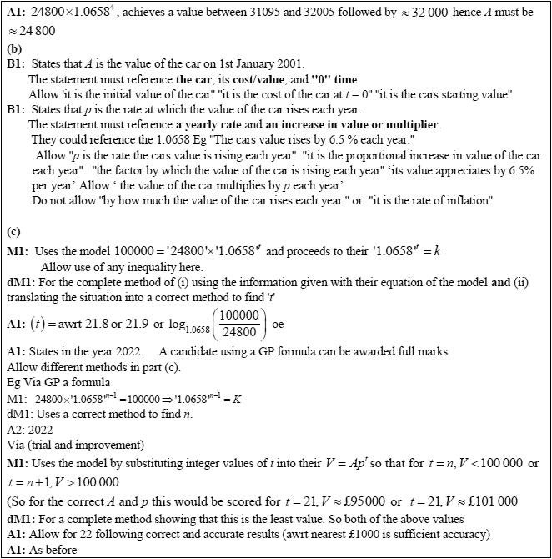

Q3
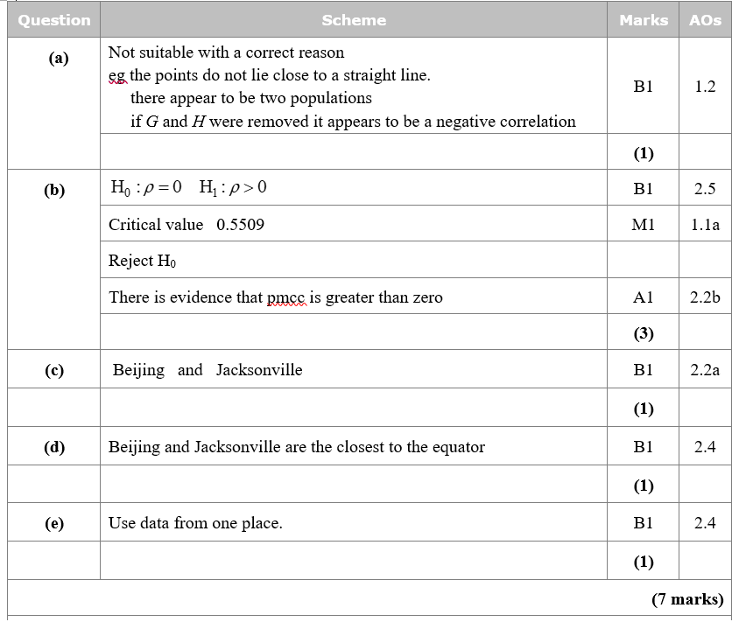
Gold Questions
Calculator
The total mark for this section is 24 marks
Q1
An ornithologist believes that there is a relationship between the tail length, t mm, and the wing length, w mm, of female hook-billed kites. A random sample of size 10 is taken from a database of these kites and the relevant data is given in the table below.
t (mm) | 191 | 197 | 208 | 180 | 188 | 210 | 196 | 191 | 179 | 208
w (mm) | 284 | 285 | 288 | 273 | 280 | 283 | 288 | 271 | 257 | 289

The ornithologist plans to use a linear regression model based on these data and interpolate or extrapolate as necessary to estimate the wing length of other female hook-billed kites from their tail length.
(a) (i) Explain what is meant by extrapolation. (1)
(ii) Explain the dangers of extrapolation. (1)
The ornithologist attempts to calculate the product moment correlation coefficient, r, and obtains a value of 1.3.
(b) Explain how she should be able to identify that this is incorrect without carrying out any further calculations.
(1)
(c) Use your calculator to find the correct value of the product moment correlation coefficient, r.
(1)
(d) Stating your hypotheses clearly test, at the 1% significance level, whether or not there is evidence that the product moment correlation coefficient for the population is positive.
(3)
(e) Explain what your test in part (d) suggests about female hook-billed kites.
(1)

(Total for Question 1 is 8 marks)
__________________________________________________________________________

Q2
Tessa owns a small clothes shop in a seaside town. She records the weekly sales figures, £ w, and the average weekly temperature, t °C, for 8 weeks during the summer.
The product moment correlation coefficient for these data is −0.915.
(a) Stating your hypotheses clearly and using a 5% level of significance, test whether or not the correlation between sales figures and average weekly temperature is negative.
(3)
(b) Suggest a possible reason for this correlation.
(1)
Tessa suggests that a linear regression model could be used to model these data.
(c) State, giving a reason, whether or not the correlation coefficient is consistent with Tessa's suggestion.
(1)
(d) State, giving a reason, which variable would be the explanatory variable.
(1)
Tessa calculated the linear regression equation as w = 10 755 – 171t
(e) Give an interpretation of the gradient of this regression equation.
(1)

(Total for Question 2 is 7 marks)
__________________________________________________________________________

Q3
A research engineer is testing the effectiveness of the braking system of a car when it is driven in wet conditions.
The engineer measures and records the braking distance, d metres, when the brakes are applied from a speed of V km h⁻¹.
Graphs of d against V and log₁₀ d against log₁₀ V were plotted.
The results are shown below together with a data point from each graph.
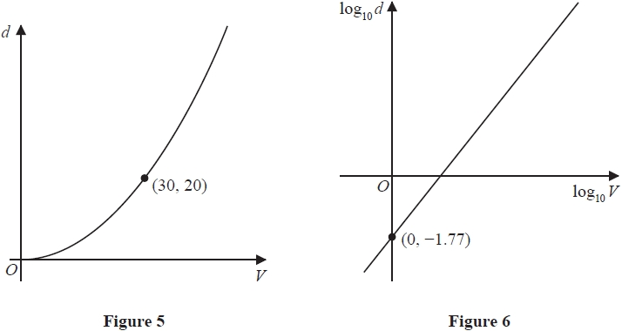
(a) Explain how Figure 6 would lead the engineer to believe that the braking distance should be modelled by the formula
d = kV^{n} where k and n are constants
with k ≈ 0.017.
(3)
Using the information given in Figure 5, with k = 0.017,
(b) find a complete equation for the model giving the value of n to 3 significant figures.
(3)
Sean is driving this car at 60 km h⁻¹ in wet conditions when he notices a large puddle in
the road 100 m ahead. It takes him 0.8 seconds to react before applying the brakes.
(c) Use your formula to find out if Sean will be able to stop before reaching the puddle.
(3)

(Total for Question 3 is 9 marks)
__________________________________________________________________________
End of questions

Gold Mark Scheme

Q1

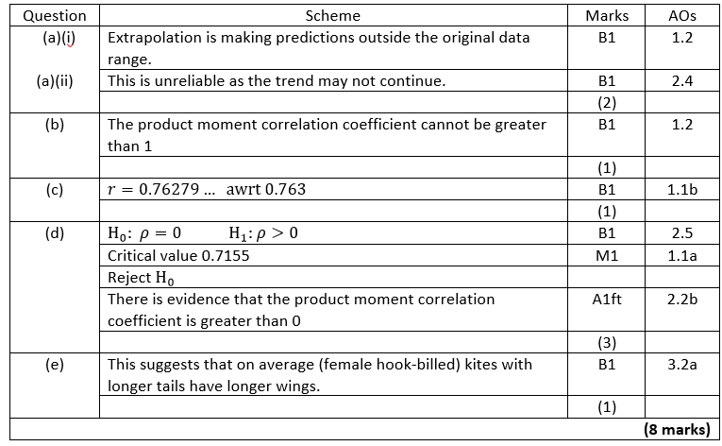

Q2
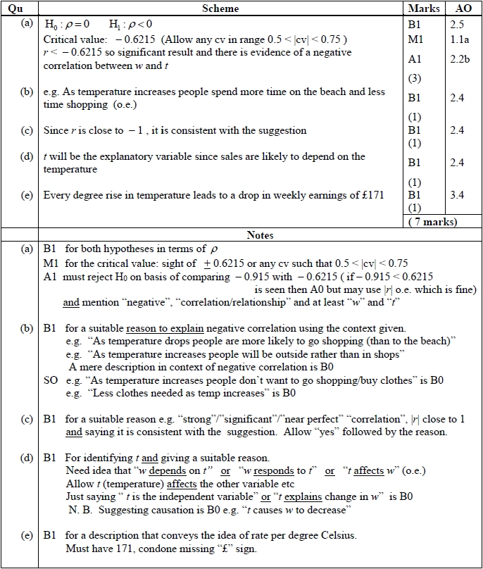

Q3
