Topics 2 and 3

Measures of Location
and Spread and
Representation of Data

Bronze, Silver, Gold

Worksheets for

AS Level Mathematics

Teacher Notes
These Bronze, Silver and Gold worksheets are designed to be used either straight after the content has been taught or as part of a skills gap analysis, especially as students move into year 13.
They are drawn from the latest specification questions and legacy questions. The papers are between 25 and 35 marks.
The topic number on this worksheet relates to the corresponding chapter number in the ‘Pearson Edexcel AS and A Level Mathematics: Statistics and Mechanics Year 1/AS’ textbook.

Quick Links
(Press Ctrl, as you click with your mouse to follow these links)
- Bronze Questions
- Bronze Mark Scheme
- Silver Questions
- Silver Mark Scheme
- Gold Questions
- Gold Mark Scheme

Extension and Enrichment
If you have students that have enjoyed the challenge of the Gold questions, then they should have a go at the more challenging question from our Advanced Extension Award (AEA) papers. The Mathematics AEA is a single, 3 hour non-calculator paper, taken at the end of year 13. It helps students to develop high level problem solving and proof skills. It is entirely based on the content of the A Level Mathematics Course. No extra material needs to be covered to take the AEA in Mathematics. A second important difference is that marks are awarded for the clarity and quality of their solution. Developing this key skill, alongside the extra problem-solving experience, can pay dividends in the way they approach A Level Mathematics and Further Mathematics problems.
More information about the Advanced Extension Award can be found here on the Pearson Edexcel Website, or here on the Maths Emporium

Bronze Questions
Calculator
The total mark for this section is 35

Q1
Keith records the amount of rainfall, in mm, at his school, each day for a week. The results are given below.
Jenny then records the amount of rainfall, x mm, at the school each day for the following 21 days. The results for the 21 days are summarised below.
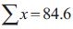
(a) Calculate the mean amount of rainfall during the whole 28 days.
(2)

Keith realises that he has transposed two of his figures. The number 9.4 should have been 4.9 and the number 0.5 should have been 5.0
Keith corrects these figures.
(b) State, giving your reason, the effect this will have on the mean.
(2)

(Total for Question 1 is 4 marks)
__________________________________________________________________________

Q2
Sara is investigating the variation in daily maximum gust, t kn, for Camborne in June and July 1987.
She used the large data set to select a sample of size 20 from the June and July data for 1987. Sara selected the first value using a random number from 1 to 4 and then selected every third value after that.
(a) State the sampling technique Sara used.
(1)
(b) From your knowledge of the large data set, explain why this process may not generate a sample of size 20.
(1)
The data Sara collected are summarised as follows
(c) Calculate the standard deviation.
(2)

(Total for Question 2 is 4 marks)
__________________________________________________________________________

Q3
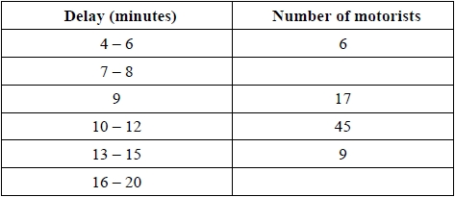
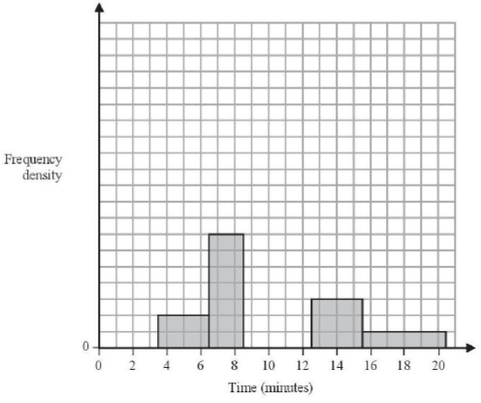
The partially completed histogram and the partially completed table show the time, to the nearest minute, that a random sample of motorists were delayed by roadworks on a stretch of motorway.

Estimate the percentage of these motorists who were delayed by the roadworks for between 8.5 and 13.5 minutes.

(Total for Question 3 is 5 marks)
__________________________________________________________________________

Q4
Helen is studying the daily mean wind speed for Camborne using the large data set from 1987.
The data for one month are summarised in Table 1 below.
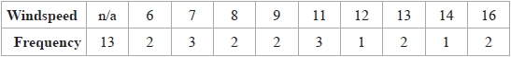
Table 1
(a) Calculate the mean for these data.
(1)

(b) Calculate the standard deviation for these data and state the units.
(2)
The means and standard deviations of the daily mean wind speed for the other months from the large data set for Camborne in 1987 are given in Table 2 below. The data are not in month order.
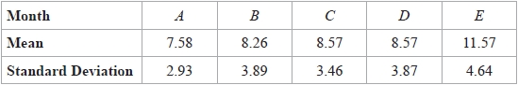
Table 2

(c) Using your knowledge of the large data set, suggest, giving a reason, which month had a mean of 11.57
(2)

The data for these months are summarised in the box plots on the next page.
They are not in month order or the same order as in Table 2.
(d) (i) State the meaning of the * symbol on some of the box plots.
(ii) Suggest, giving your reasons, which of the months in Table 2 is most likely to be summarised in the box plot marked Y.
(3)

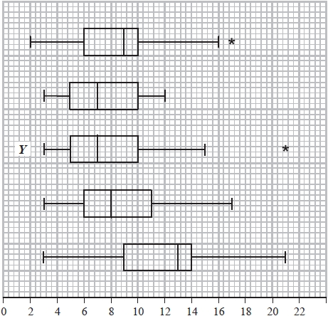

(Total for Question 4 is 8 marks)
__________________________________________________________________________

Q5
Each of 60 students was asked to draw a 20° angle without using a protractor. The size of
each angle drawn was measured. The results are summarised in the box plot below.
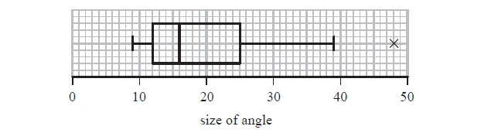
(a) Find the range for these data.
(1)
(b) Find the interquartile range for these data.
(1)
The students were then asked to draw a 70° angle.
The results are summarised in the table below.
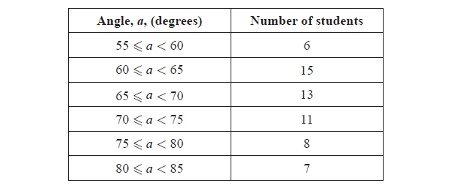

(c) Use linear interpolation to estimate the size of the median angle drawn. Give your
answer to 1 decimal place.
(2)
(d) Show that the lower quartile is 63°
(2)

For these data, the upper quartile is 75°, the minimum is 55° and the maximum is 84°
An outlier is an observation that falls either
more than 1.5 × (interquartile range) above the upper quartile or
more than 1.5 × (interquartile range) below the lower quartile.
(e) (i) Show that there are no outliers for these data.
(ii) Draw a box plot for these data on the grid on the following page.
(5)
(f) State which angle the students were more accurate at drawing. Give reasons for
your answer.
(3)
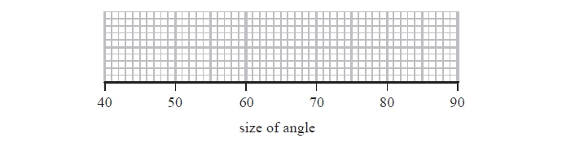

(Total for Question 5 is 14 marks)
__________________________________________________________________________

Bronze Mark Scheme
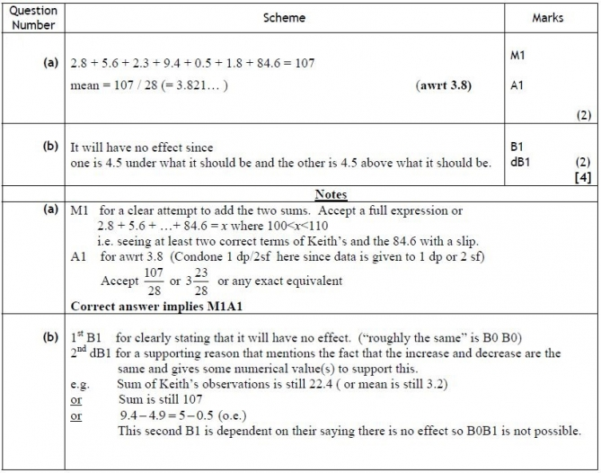
Q1.

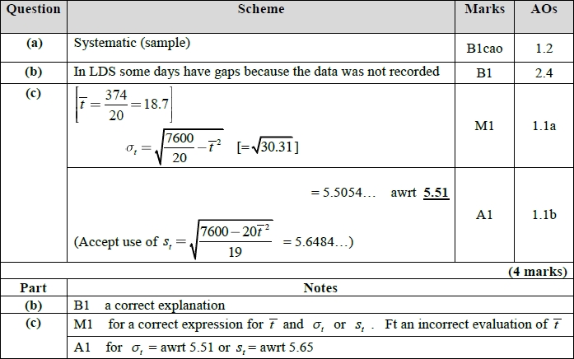
Q2.

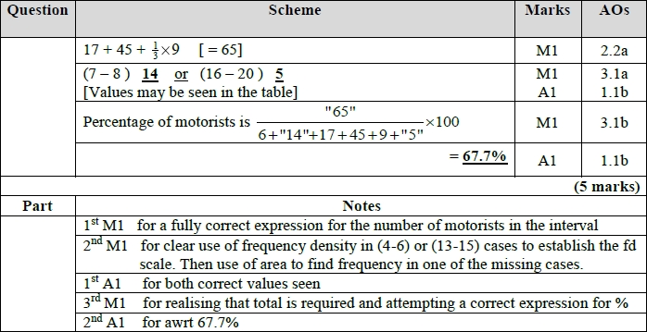
Q3.
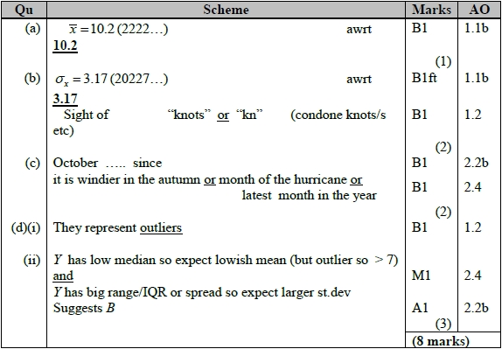
Q4.

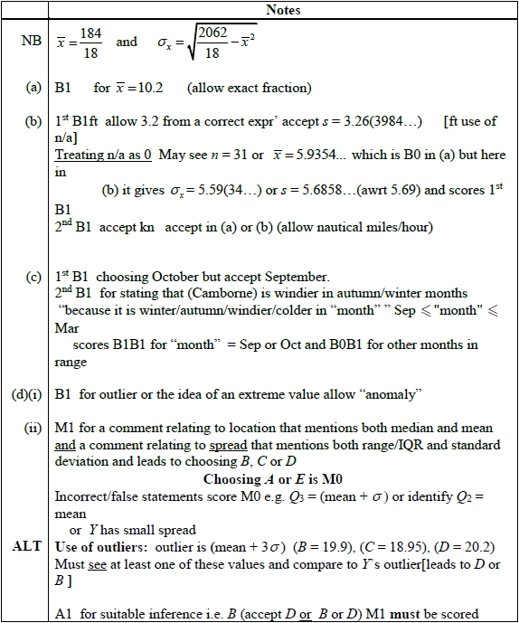

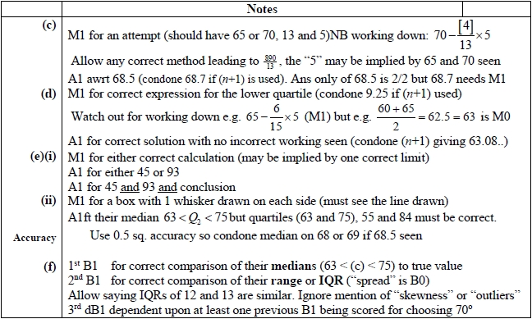
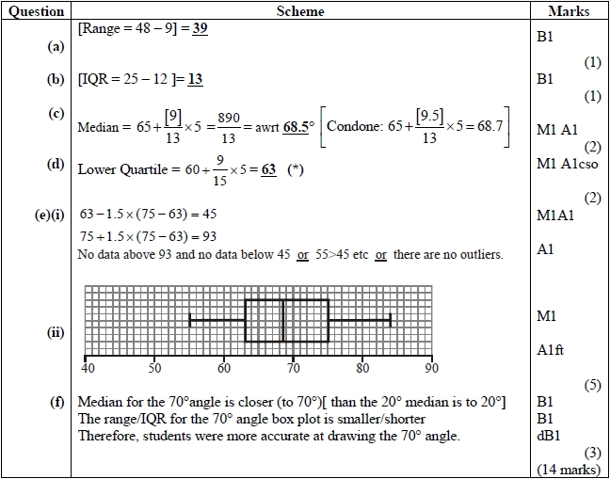
Q5.

Silver Questions
Calculator
The total mark for this section is 30

Q1
Sara was studying the relationship between rainfall, r mm, and humidity, h %, in the UK. She takes a random sample of 11 days from May 1987 for Leuchars from the large data set.
She obtained the following results.
Sara examined the rainfall figures and found
A value that is more than 1.5 times the interquartile range (IQR) above Q₃ is called an outlier.
(a) Show that r = 20.6 is an outlier.
(1)
(b) Give a reason why Sara might
(i) include
(ii) exclude
this day's reading.
(2)

(Total for Question 1 is 3 marks)
__________________________________________________________________________

Q2
The histogram in Figure 1 shows the time taken, to the nearest minute, for 140 runners to complete a fun run.
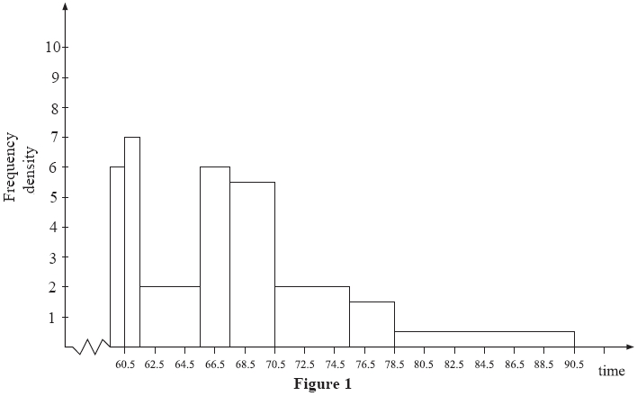
Use the histogram to calculate the number of runners who took between 78.5 and 90.5 minutes to complete the fun run.

(Total for Question 2 is 5 marks)
__________________________________________________________________________

Q3
Joshua is investigating the daily total rainfall in Hurn for May to October 2015
Using the information from the large data set, Joshua wishes to calculate the mean of the
daily total rainfall in Hurn for May to October 2015
(a) Using your knowledge of the large data set, explain why Joshua needs to clean the data before calculating the mean.
(1)

Using the information from the large data set, he produces the grouped frequency table below.
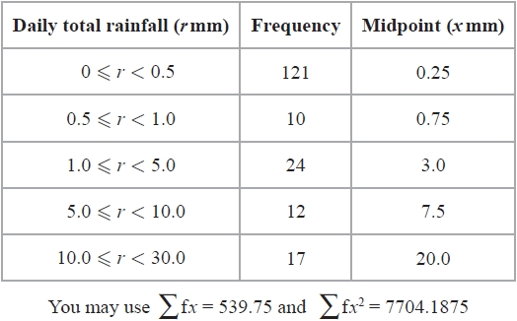
(b) Use linear interpolation to calculate an estimate for the upper quartile of the daily total rainfall.
(2)
(c) Calculate an estimate for the standard deviation of the daily total rainfall in Hurn for May to October 2015
(2)
(d) (i) State the assumption involved with using class midpoints to calculate an estimate of a mean from a grouped frequency table.
(ii) Using your knowledge of the large data set, explain why this assumption does not hold in this case.
(iii) State, giving a reason, whether you would expect the actual mean daily total
rainfall in Hurn for May to October 2015 to be larger than, smaller than or the
same as an estimate based on the grouped frequency table.
(3)

(Total for Question 3 is 8 marks)
__________________________________________________________________________

Q4
The marks of a group of female students in a statistics test are summarised in Figure 1
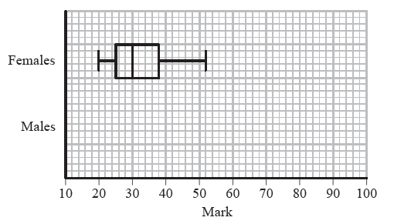
Figure 1
(a) Write down the mark which is exceeded by 75% of the female students.
(1)
The marks of a group of male students in the same statistics test are summarised by the stem and leaf diagram below.
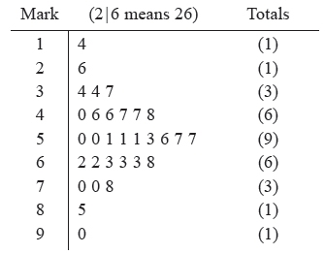
(b) Find the median and interquartile range of the marks of the male students.
(3)
An outlier is a mark that is either more than 1.5 × interquartile range above the upper quartile
or more than 1.5 × interquartile range below the lower quartile.
(c) In the space provided on Figure 1 draw a box plot to represent the marks of the male students, indicating clearly any outliers.
(5)
(d) Compare and contrast the marks of the male and the female students.
(2)

(Total for Question 4 is 11 marks)
__________________________________________________________________________
Q5
The variable x was measured to the nearest whole number. Forty observations are given in the table below.
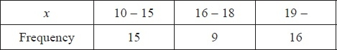

A histogram was drawn and the bar representing the 10 - 15 class has a width of 2 cm and a height of 5 cm. For the 16 - 18 class find
(a) the width,
(1)
(b) the height of the bar representing this class.
(2)

(Total for Question 5 is 3 marks)
__________________________________________________________________________

Silver Mark Scheme

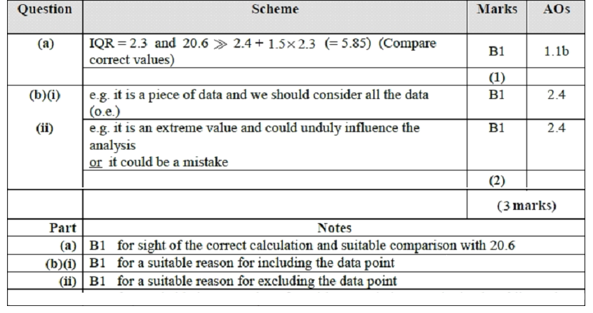
Q1

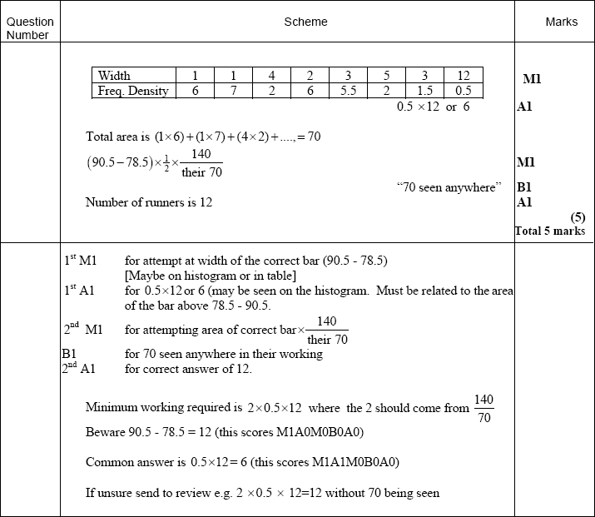
Q2

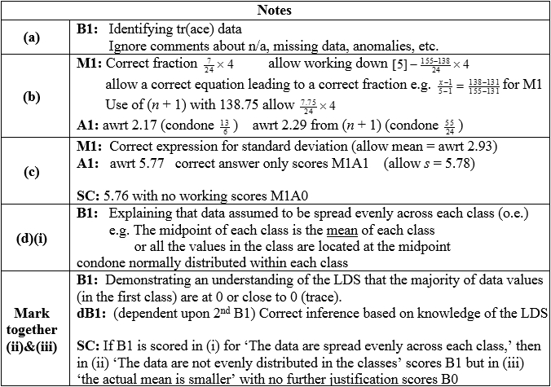
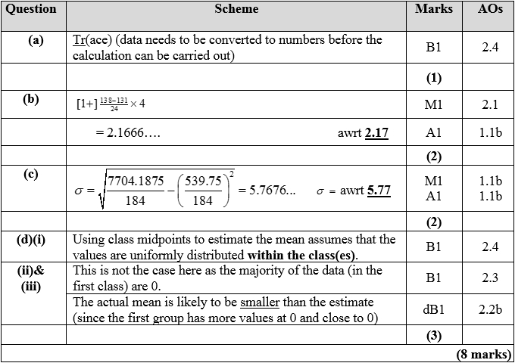
Q3
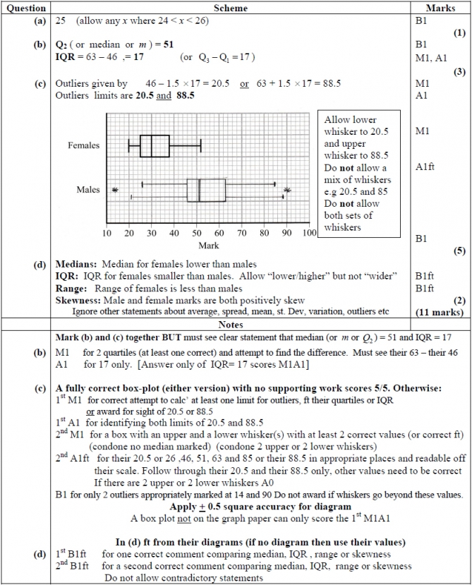
Q4

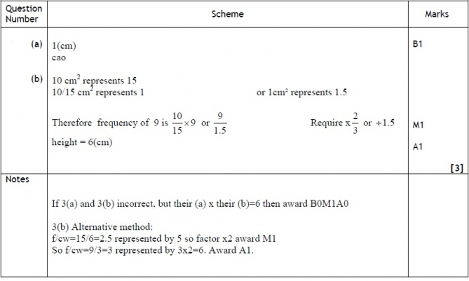
Q5

Gold Questions
Calculator
The total mark for this section is 33

Q1
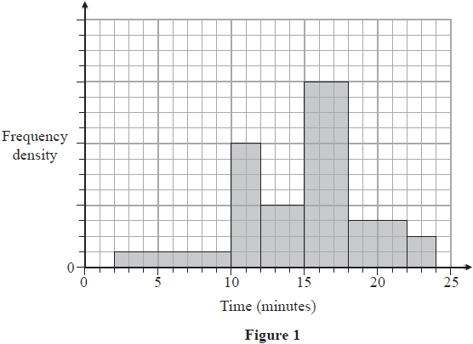
The histogram in Figure 1 shows the times taken to complete a crossword by a random sample of students.
The number of students who completed the crossword in more than 15 minutes is 78.
Estimate the percentage of students who took less than 11 minutes to complete the crossword.

(Total for Question 1 is 4 marks)
__________________________________________________________________________

Q2
The mark, x, scored by each student who sat a statistics examination is coded using
y = 1.4x − 20
The coded marks have mean 60.8 and standard deviation 6.60
Find the mean and the standard deviation of x.
(4)
(Total for Question 2 is 4 marks)
__________________________________________________________________________

Q3
The following table summarises the times, t minutes to the nearest minute, recorded for a group of students to complete an exam.
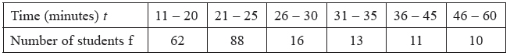
[You may use ft² = 134281.25]
(a) Estimate the mean and standard deviation of these data.
(5)

(b) Use linear interpolation to estimate the value of the median.
(2)

(c) Show that the estimated value of the lower quartile is 18.6 to 3 significant figures.
(1)

(d) Estimate the interquartile range of this distribution.
(2)

(e) Give a reason why the mean and standard deviation are not the most appropriate summary statistics to use with these data.
(1)
The person timing the exam made an error and each student actually took 5 minutes less than the times recorded above. The table below summarises the actual times.
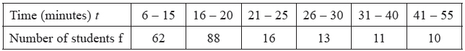

(f) Without further calculations, explain the effect this would have on each of the estimates found in parts (a), (b), (c) and (d).
(3)

(Total for Question 3 is 14 marks)
__________________________________________________________________________

Q4
A midwife records the weights, in kg, of a sample of 50 babies born at a hospital. Her results are given in the table below.
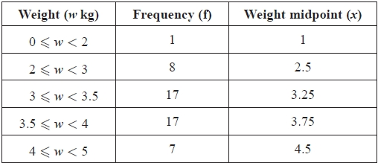
[You may use ∑ fx² = 611.375]

A histogram has been drawn to represent these data.
The bar representing the weight 2 ≤ w < 3 has a width of 1 cm and a height of 4 cm.
(a) Calculate the width and height of the bar representing a weight of 3 ≤ w < 3.5
(3)
(b) Use linear interpolation to estimate the median weight of these babies.
(2)
(c) (i) Show that an estimate of the mean weight of these babies is 3.43 kg.
(ii) Find an estimate of the standard deviation of the weights of these babies.
(3)
A newborn baby weighing 3.43 kg is born at the hospital.
(f) Without carrying out any further calculations, state, giving a reason, what effect the addition of this newborn baby to the sample would have on your estimate of the
(i) mean,
(ii) standard deviation.
(3)

(Total for Question 4 is 11 marks)
__________________________________________________________________________

Gold Mark Scheme

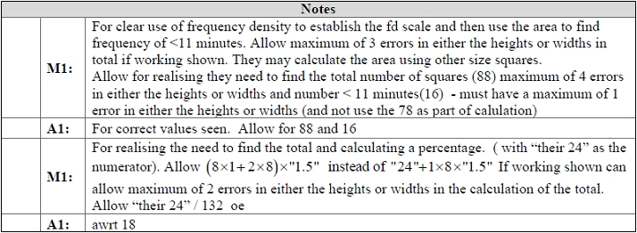
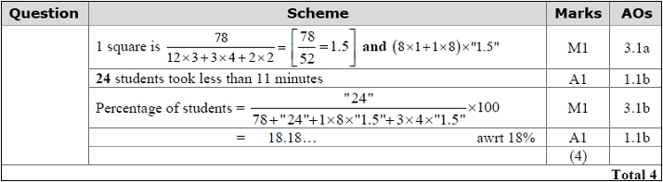
Q1.

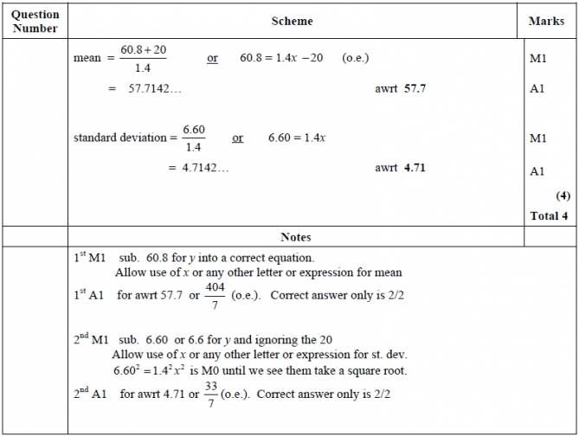
Q2.

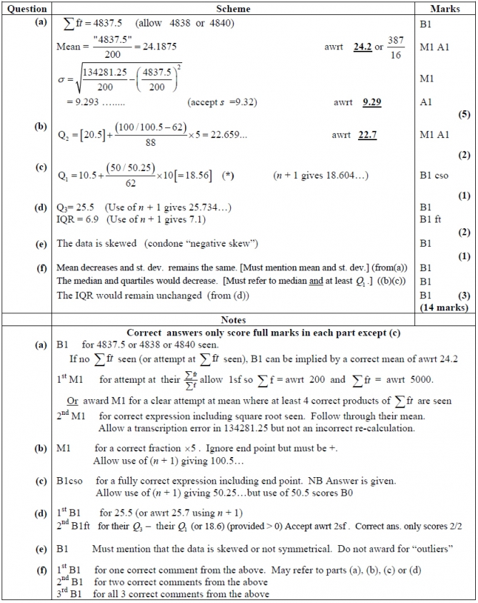
Q3.

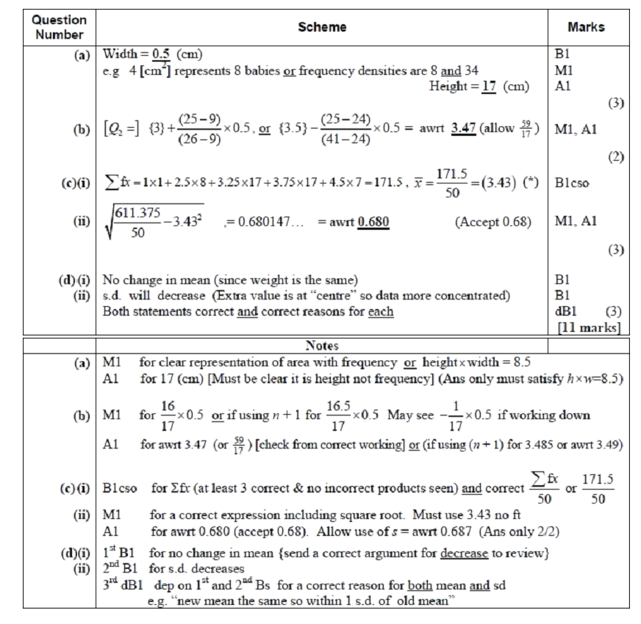
Q4.

