Topic 2 - Conditional Probability

Bronze, Silver and Gold Worksheets for

A Level Mathematics

Teacher Notes
These Bronze, Silver and Gold worksheets are designed to be used either straight after the content has been taught or as part of a skills gap analysis.
They are drawn from the latest specification questions and legacy questions. The papers are between approximately 25 and 45 marks.
The topic number on this worksheet relates to the corresponding chapter in the ‘Pearson Edexcel A Level Mathematics: Statistics and Mechanics Year 2’ textbook.

Quick Links
(Press Ctrl, as you click with your mouse to follow these links)
- Bronze Questions
- Bronze Mark Scheme
- Silver Questions
- Silver Mark Scheme
- Gold Questions
- Gold Mark Scheme

Extension and Enrichment
If you have students that have enjoyed the challenge of the Gold questions, then they should have a go at the more challenging question from our Advanced Extension Award (AEA) papers. The Mathematics AEA is a single, 3 hour non-calculator paper, taken at the end of year 13. It helps students to develop high level problem solving and proof skills. It is entirely based on the content of the A Level Mathematics Course. No extra material needs to be covered to take the AEA in Mathematics. A second important difference is that marks are awarded for the clarity and quality of their solution. Developing this key skill, alongside the extra problem-solving experience, can pay dividends in the way they approach A Level Mathematics and Further Mathematics problems.
More information about the Advanced Extension Award can be found here on the Pearson Edexcel Website, or here on the Maths Emporium

Bronze Questions
Calculator
The total mark for this section is 37
Q1
Three bags, A, B and C, each contain 1 red marble and some green marbles.
Bag A contains 1 red marble and 9 green marbles only
Bag B contains 1 red marble and 4 green marbles only
Bag C contains 1 red marble and 2 green marbles only
Sasha selects at random one marble from bag A.
If he selects a red marble, he stops selecting.
If the marble is green, he continues by selecting at random one marble from bag B.
If he selects a red marble, he stops selecting.
If the marble is green, he continues by selecting at random one marble from bag C.
(a) Draw a tree diagram to represent this information.
(2)
(b) Find the probability that Sasha selects 3 green marbles.
(2)
(c) Find the probability that Sasha selects at least 1 marble of each colour.
(2)
(d) Given that Sasha selects a red marble, find the probability that he selects it from bag B.
(2)
(Total for Question 1 is 8 marks)
__________________________________________________________________________

Q2
A survey of the reading habits of some students revealed that, on a regular basis, 25% read quality newspapers, 45% read tabloid newspapers and 40% do not read newspapers at all.
(a) Find the proportion of students who read both quality and tabloid newspapers.
(3)
(b) Draw a Venn diagram to represent this information.
(3)
A student is selected at random. Given that this student reads newspapers on a regular basis,
(c) find the probability that this student only reads quality newspapers.
(3)
(Total for Question 2 is 9 marks) __________________________________________________________________________

Q3
On a randomly chosen day the probability that Bill travels to school by car, by bicycle or on foot is , and respectively. The probability of being late when using these methods of travel is , and respectively.
(a) Draw a tree diagram to represent this information.
(3)
(b) Find the probability that on a randomly chosen day
(i) Bill travels by foot and is late,
(ii) Bill is not late.
(4)
(c) Given that Bill is late, find the probability that he did not travel on foot.
(4)
(Total for Question 3 is 11 marks)
___________________________________________________________________________
Q4
A and B are two events such that
P(B) = ¹⁄₂ P(A | B) = ²⁄₅ P(A ∪ B) = ¹³⁄₂₀
(a) Find P(A ∩ B).
(2)
(b) Draw a Venn diagram to show the events A, B and all the associated probabilities.
(3)
Find
(c) P(A)
(1)
(d) P(B | A)
(2)
(e) P(A' ∩ B)
(1)
(Total for Question 4 is 9 marks)
__________________________________________________________________________
End of questions

Bronze Mark Scheme
Q1
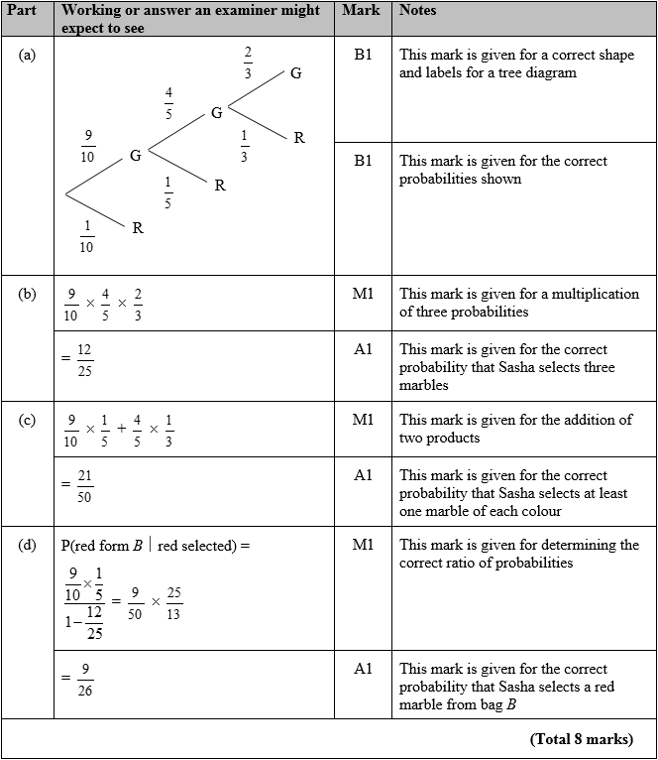

Q2

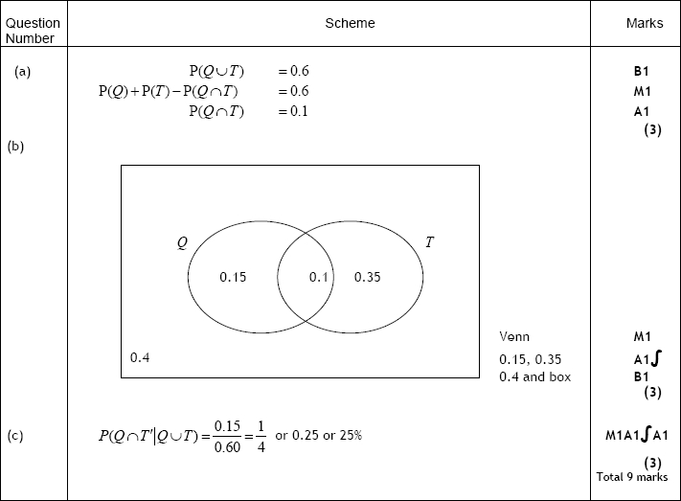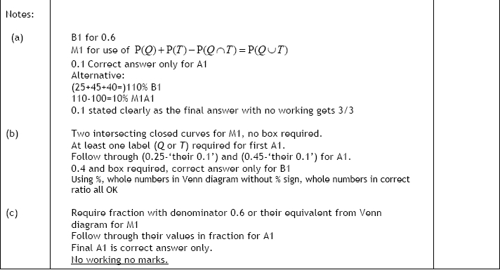

Q3

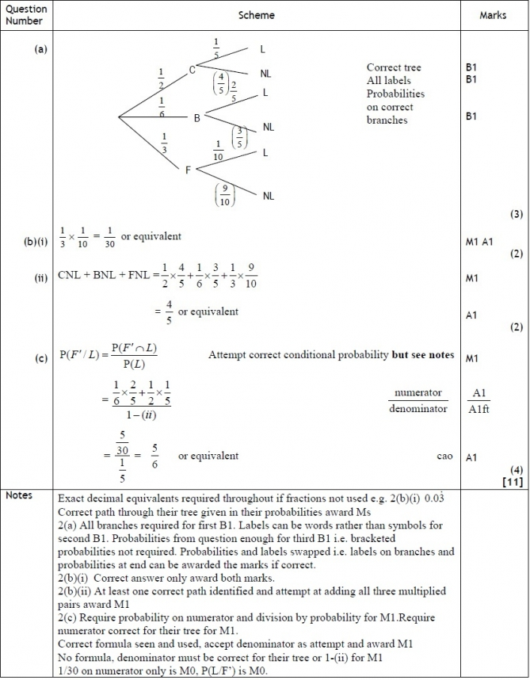

Q4
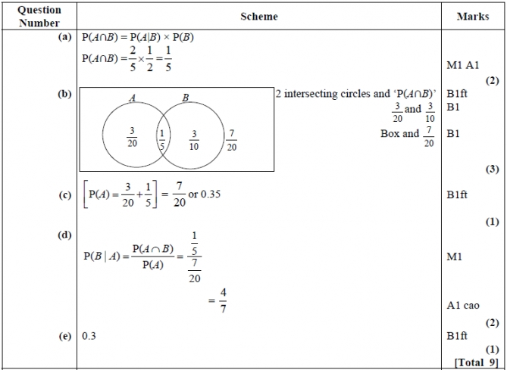
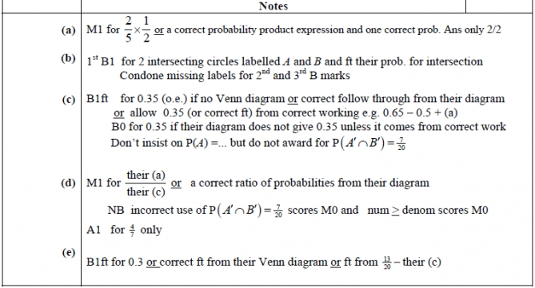


Silver Questions
Calculator
The total mark for this section is 34
Q1

The Venn diagram shows the probabilities associated with four events, A, B, C and D.
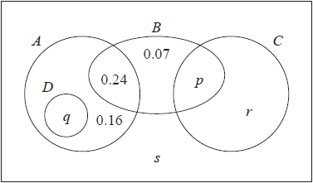
(a) Write down any pair of mutually exclusive events from A, B, C and D.
(1)
Given that P(B) = 0.4
(b) find the value of p.
(1)
Given also that A and B are independent
(c) find the value of q.
(2)
Given further that P( B' | C ) = 0.64
(d) find
(i) the value of r,
(ii) the value of s.
(4)

(Total for Question 1 is 8 marks)
__________________________________________________________________________

Q2
For the events A and B,
P(A' ∩ B) = 0.22 and P(A' ∩ B') = 0.18 .
(a) Find P(A).
(1)
(b) Find P(A ∪ B).
(1)
Given that P(A | B) = 0.6
(c) find P(A ∩ B).
(3)
(d) Determine whether or not A and B are independent.
(2)

(Total for Question 2 is 7 marks)
__________________________________________________________________________
Q3
A disease is known to be present in 2% of a population. A test is developed to help determine whether or not someone has the disease.
Given that a person has the disease, the test is positive with probability 0.95.
Given that a person does not have the disease, the test is positive with probability 0.03.
(a) Draw a tree diagram to represent this information.
(3)
A person is selected at random from the population and tested for this disease.
(b) Find the probability that the test is positive.
(3)
A doctor randomly selects a person from the population and tests him for the disease. Given that the test is positive,
(c) find the probability that he does not have the disease.
(2)
(d) Comment on the usefulness of this test.
(1)

(Total for Question 3 is 9 marks)
__________________________________________________________________________

Q4
The Venn diagram in Figure 1 shows the number of students in a class who read any of 3 popular magazines A, B and C.
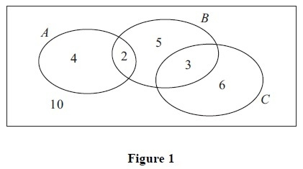
One of these students is selected at random.
(a) Show that the probability that the student reads more than one magazine is
(2)
(b) Find the probability that the student reads A or B (or both).
(2)
(c) Write down the probability that the student reads both A and C.
(1)
Given that the student reads at least one of the magazines,
(d) find the probability that the student reads C.
(2)
(e) Determine whether or not reading magazine B and reading magazine C are statistically independent.
(3)
(Total for Question 4 is 10 marks)
__________________________________________________________________________
End of questions
Silver Mark Scheme

Q1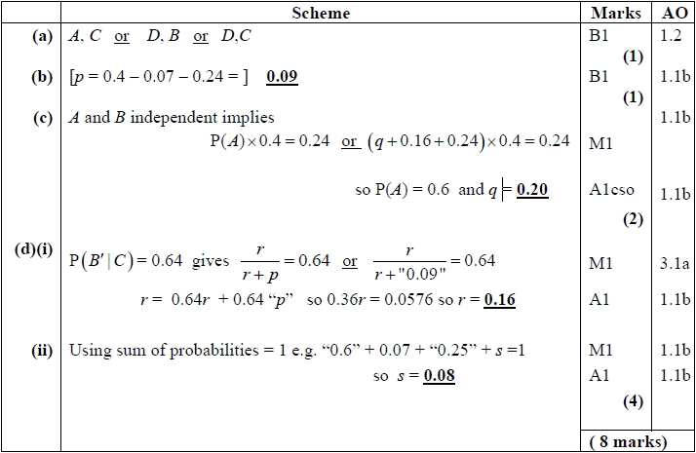
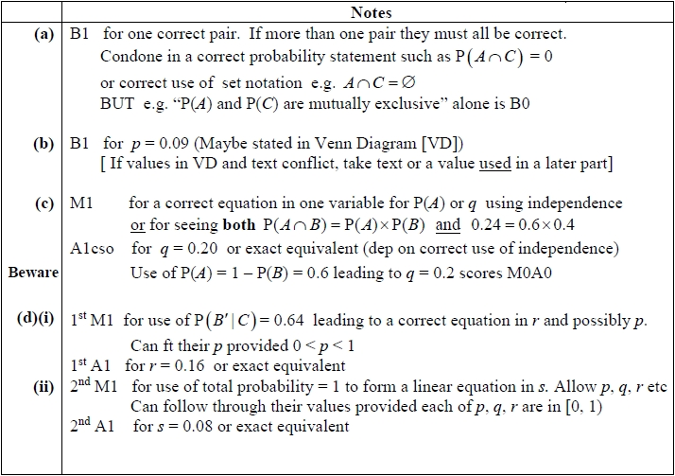

Q2
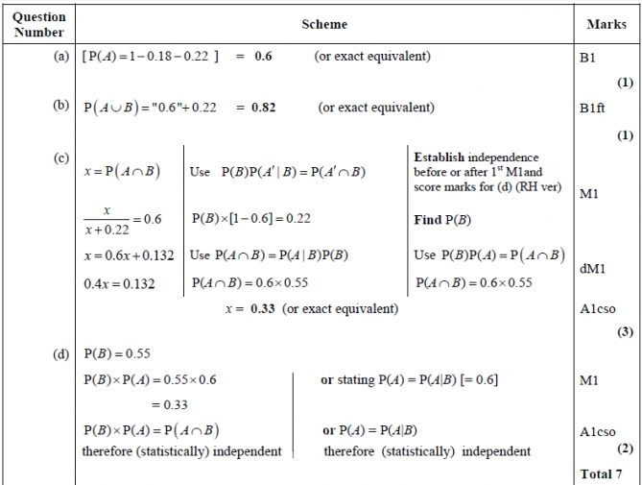
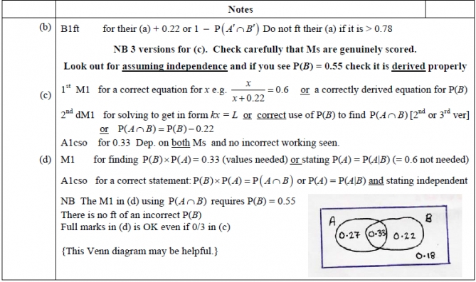

Q3
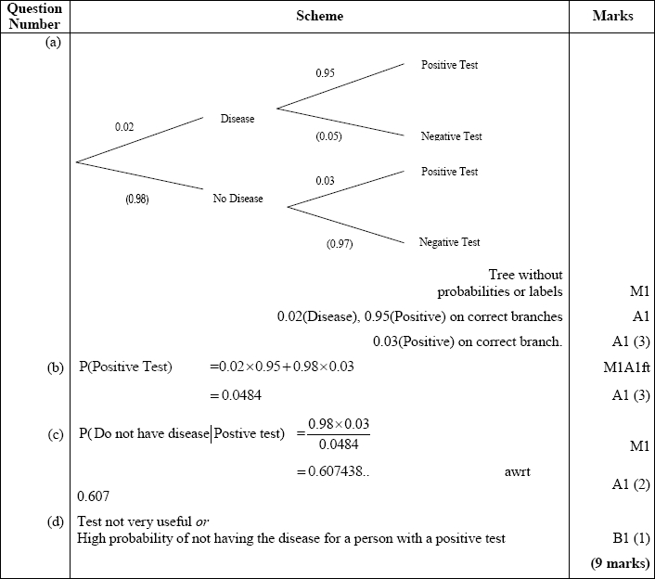

Q4
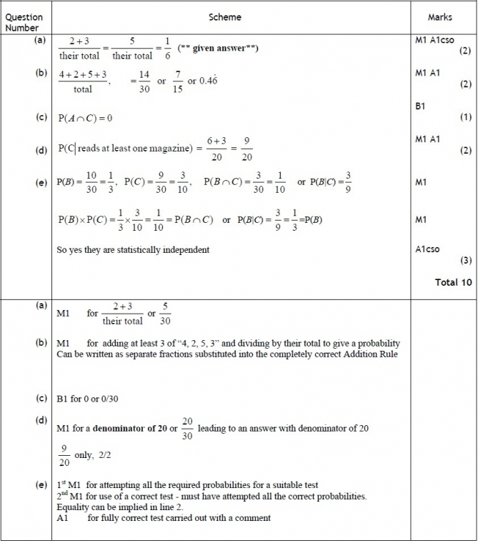

Gold Questions
Calculator
The total mark for this section is 30

Q1
Given that
find
(a) P(A′ | B′).
(2)
(b) Explain why the events A and B are not independent.
(1)
The event C has P(C) = 0.20.
The events A and C are mutually exclusive and the events B and C are statistically independent.
(c) Draw a Venn diagram to illustrate the events A, B and C, giving the probabilities for each region.
(5)
(d) Find P( [B ∪ C]′).
(2)
(Total for Question 1 is 10 marks)
__________________________________________________________________________

Q2
The Venn diagram shows the probabilities of customer bookings at Harry's hotel.
R is the event that a customer books a room
B is the event that a customer books breakfast
D is the event that a customer books dinner
u and t are probabilities.
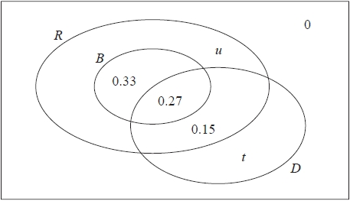
(a) Write down the probability that a customer books breakfast but does not book a room.
(1)
Given that the events B and D are independent
(b) find the value of t,
(4)
(c) hence find the value of u.
(2)
(d) Find
(i) P(D|R ∩ B),
(ii) P(D|R ∩ B′ ).
(4)
A coach load of 77 customers arrive at Harry's hotel.
Of these 77 customers
40 have booked a room and breakfast
37 have booked a room without breakfast
(e) Estimate how many of these 77 customers will book dinner.
(2)
(Total for Question 2 is 13 marks)
__________________________________________________________________________

Q3
(a) Given that P(A) = a and P(B) = b express P(A ∪ B) in terms of a and b when
(i) A and B are mutually exclusive,
(ii) A and B are independent.
(2)
Two events R and Q are such that
P(R ∩ Q´ ) = 0.15, P(Q) = 0.35 and P(R|Q) = 0.1
Find the value of
(b) P(R ∪ Q),
(1)
(c) P(R ∩ Q),
(2)
(d) P(R).
(2)
(Total for Question 3 is 7 marks)
__________________________________________________________________________
End of questions

Gold Mark Scheme

Q1
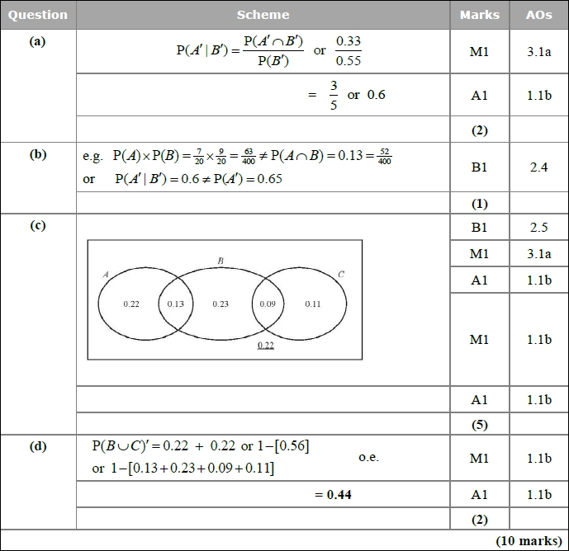
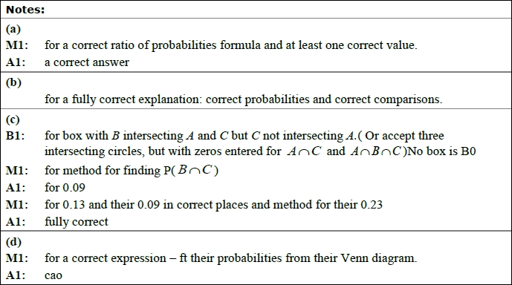

Q2

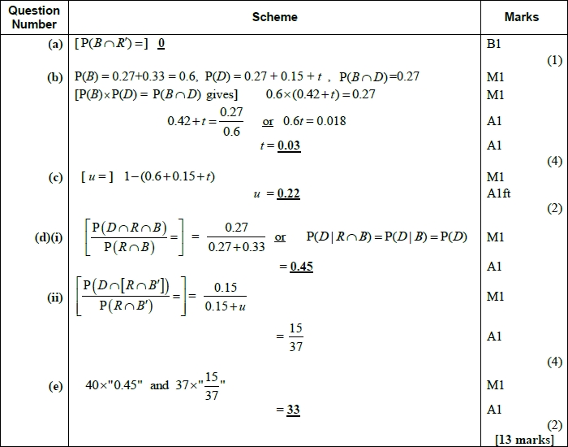
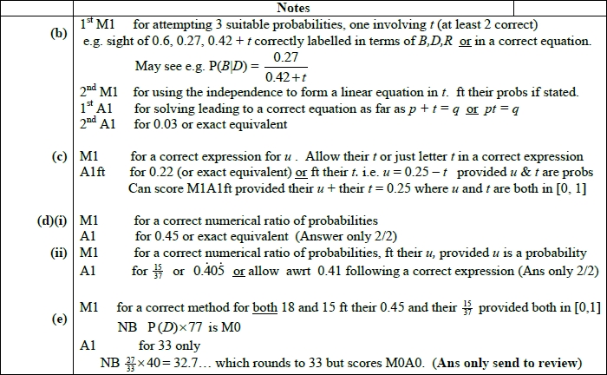

Q3
