Topic 4

Correlation

Bronze, Silver, Gold

Worksheets for

AS Level Mathematics

Teacher Notes
These Bronze, Silver and Gold worksheets are designed to be used either straight after the content has been taught or as part of a skills gap analysis, especially as students move into year 13.
They are drawn from the latest specification questions and legacy questions. The papers are between 25 and 35 marks.
The topic number on this worksheet relates to the corresponding chapter number in the ‘Pearson Edexcel AS and A Level Mathematics: Statistics and Mechanics Year 1/AS’ textbook.

Quick Links
(Press Ctrl, as you click with your mouse to follow these links)
- Bronze Questions
- Bronze Mark Scheme
- Silver Questions
- Silver Mark Scheme
- Gold Questions
- Gold Mark Scheme

Extension and Enrichment
If you have students that have enjoyed the challenge of the Gold questions, then they should have a go at the more challenging question from our Advanced Extension Award (AEA) papers. The Mathematics AEA is a single, 3 hour non-calculator paper, taken at the end of year 13. It helps students to develop high level problem solving and proof skills. It is entirely based on the content of the A Level Mathematics Course. No extra material needs to be covered to take the AEA in Mathematics. A second important difference is that marks are awarded for the clarity and quality of their solution. Developing this key skill, alongside the extra problem-solving experience, can pay dividends in the way they approach A Level Mathematics and Further Mathematics problems.
More information about the Advanced Extension Award can be found here on the Pearson Edexcel Website, or here on the Maths Emporium.

Bronze Questions
Calculator
The total mark for this section is 28

Q1
A beach cafe sells ice creams.
Each day the manager records the number of hours of sunshine and the number of
ice creams sold.
The scatter graph shows this information.
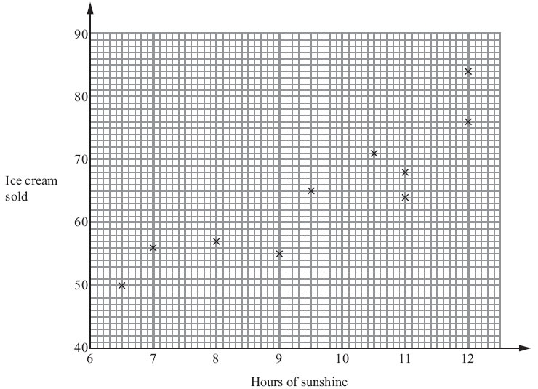

On another day there were 11.5 hours of sunshine and 73 ice creams sold.
(a) Show this information on the scatter graph.
(1)

(b) Describe the relationship between the number of hours of sunshine and the number
of ice creams sold.

(1)
One day had 10 hours of sunshine.
(c) Estimate how many ice creams were sold.
(2)

(Total for Question 1 is 4 marks)
__________________________________________________________________________

Q2
Mr Kent's students did a maths test and a science test.
The scatter graph shows the marks of 12 of these students.

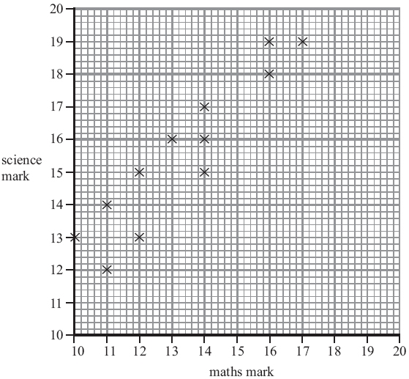
The table shows the marks of two more students.
Name | maths | science
Masood | 12 | 14
Nimer | 17 | 20

(a) Show this information on the scatter graph.
(1)
(b) What type of correlation does this scatter graph show?
.
(1)
David did the maths test.
He was absent for the science test.
David's mark in the maths test was 15
(c) Estimate a science mark for David.
(2)

(Total for Question 2 is 4 marks)
__________________________________________________________________________

Q3

Katie measured the length and the width of each of 10 pine cones from the same tree.
She used her results to draw this scatter graph.
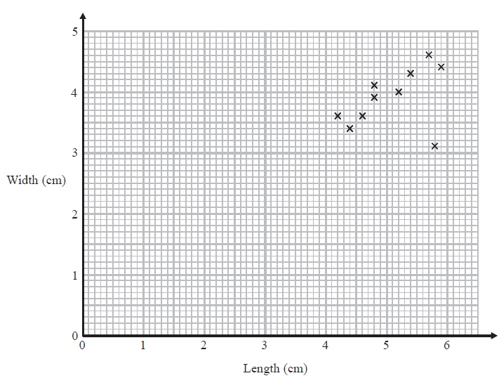
(a) Describe one improvement Katie can make to her scatter graph.
(1)
The point representing the results for one of the pine cones is an outlier.
(b) Explain how the results for this pine cone differ from the results for the other pine
cones.
(1)

(Total for Question 3 is 2 marks)
__________________________________________________________________________

Q4
Bill wants to compare the heights of pine trees growing in sandy soil with the heights of pine trees growing in clay soil.
The scatter diagram gives some information about the heights and the ages of some pine trees.
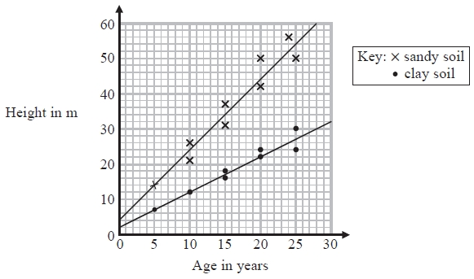
(a) Describe the relationship between the height of pine trees and the age of pine trees growing in sandy soil.

(1)
A pine tree growing in clay soil is 18 years old.
(b) Find an estimate for the height of this tree.
(1)
A pine tree is growing in sandy soil.
(c) Work out an estimate for how much the height of this tree increases in a year.
(2)
(d) Compare the rate of increase of the height of trees growing in clay soil with the rate of increase of the height of trees growing in sandy soil.
(2)

(Total for Question 4 is 6 marks)
__________________________________________________________________________

Q5
Oliver records the distance from London to each of eight cities in the USA.
He also records the time taken to fly from London to each of these cities.
The scatter graph shows this information.
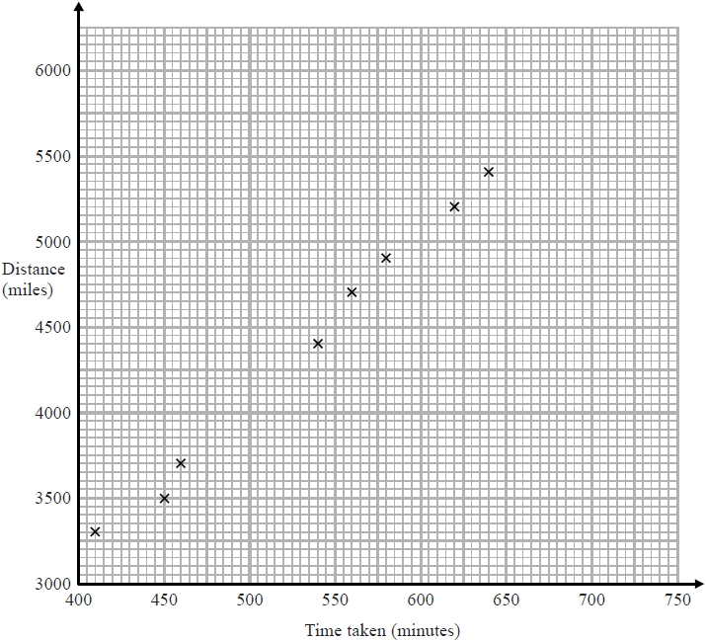
Chicago is a city in the USA.
Chicago is 4000 miles from London.
(a) (i) By drawing a line of best fit, find an estimate for the time taken to fly from London to Chicago.
(2)
(ii) Why is your answer to part (i) only an estimate?
(1)
(b) (i) Calculate the gradient of your line of best fit.
(2)

(ii) Give an interpretation of the gradient of your line of best fit.
(1)

(Total for Question 5 is 6 marks)
__________________________________________________________________________
Q6
The age, t years, and weight, w grams, of each of 10 coins were recorded.
Given that the equation of the regression line of w on t is w = 11.6 – 0.0263t

(a) State, with a reason, which variable is the explanatory variable.
(2)
(b) Using this model, estimate
(i) the weight of a coin which is 5 years old,
(ii) the effect of an increase of 4 years in age on the weight of a coin.
(2)
It was discovered that a coin in the original sample, which was 5 years old and weighed 20 grams, was a fake.
(c) State, without any further calculations, whether the exclusion of this coin would increase or decrease the value of the
correlation. Give a reason for your answer.
(2)

(Total for Question 6 is 6 marks)
__________________________________________________________________________

Bronze Mark Scheme
Q1.
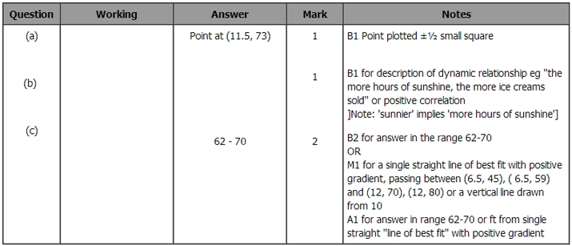

Q2.
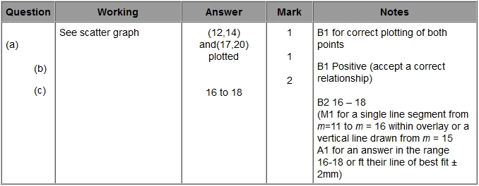

Q3.
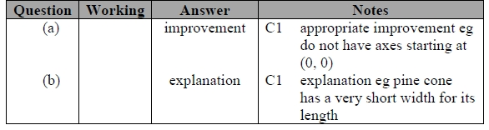
Q4.
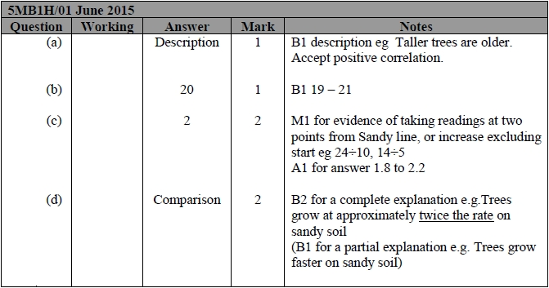

Q5.
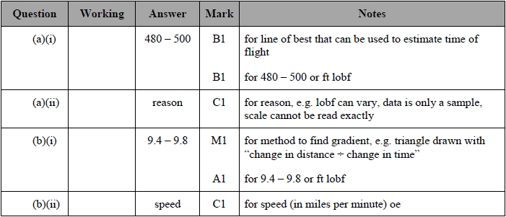
Q6.
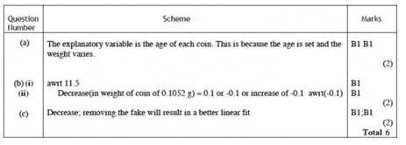


Silver Questions
Calculator
The total mark for this section is 28

Q1

A random sample of 15 days is taken from the large data set for Perth in June and July 1987.
The scatter diagram in Figure 1 displays the values of two of the variables for these 15 days.
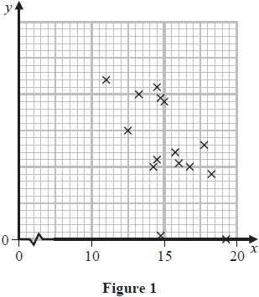
(a) Describe the correlation.
(1)
The variable on the x-axis is Daily Mean Temperature measured in °C.
(b) Using your knowledge of the large data set,
(i) suggest which variable is on the y-axis,
(ii) state the units that are used in the large data set for this variable.
(2)
Stav believes that there is a negative correlation between Daily Total Sunshine and Daily Maximum Relative Humidity at Heathrow.
On a random day at Heathrow the Daily Maximum Relative Humidity was 97%
(c) Comment on the number of hours of sunshine you would expect on that day,
giving a reason for your answer.
(1)

(Total for Question 1 is 4 marks)
__________________________________________________________________________

Q2

Sally looks after a children's paddling pool in a park.
Each day, Sally records the number of hours of sunshine and the number of children who use the paddling pool.
The scatter graph shows this information.
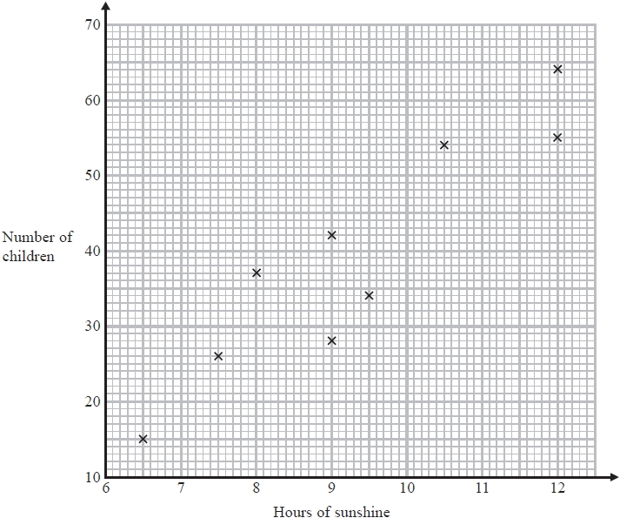

(a) Describe the correlation between the number of children who use the paddling pool and the number of hours of sunshine.
(1)

One day there were 10 hours of sunshine.
(b) Estimate how many children used the paddling pool.
(2)

On another day, there were 6.5 hours of sunshine and 45 children used the pool.
(c) (i) Show this information on the scatter graph.
This point is isolated on the scatter graph.
(ii) Explain what may have happened on this day.
(2)

(Total for Question 2 is 5 marks)
__________________________________________________________________________

Q3
A scientist is researching whether or not birds of prey exposed to pollutants lay eggs with thinner shells. He collects a random sample of egg shells from each of 6 different nests and tests for pollutant level, p, and measures the thinning of the shell, t. The results are shown in the table below.

p | 3 | 8 | 30 | 25 | 15 | 12
t | 1 | 3 | 9 | 10 | 5 | 6
(a) Draw a scatter diagram to represent these data.
(2)

(b) Explain why a linear regression model may be appropriate to describe the relationship between p and t.
(1)

The scientist reviews similar studies and finds that pollutant levels above 16 are likely to result in the death of a chick soon after hatching.
Given that t = 0.741+0.318p
(c) Estimate the minimum thinning of the shell that is likely to result in the death of a chick.
(2)
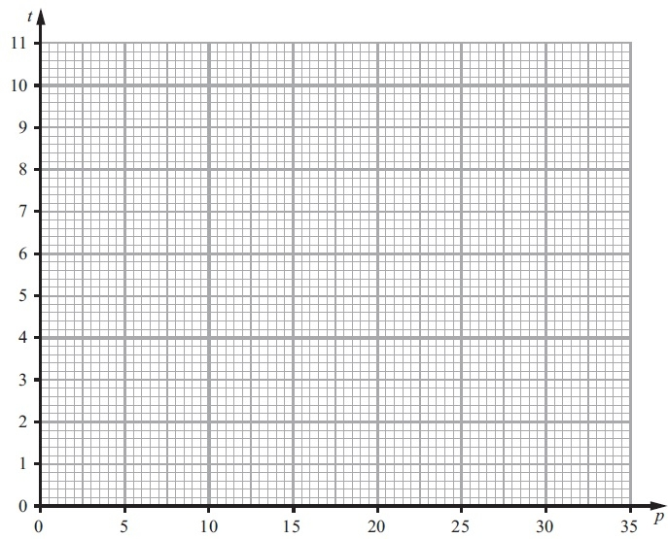

(Total for Question 3 is 5 marks)
__________________________________________________________________________

Q4
The scatter graph shows the maximum temperature and the number of hours of sunshine in fourteen British towns on one day.
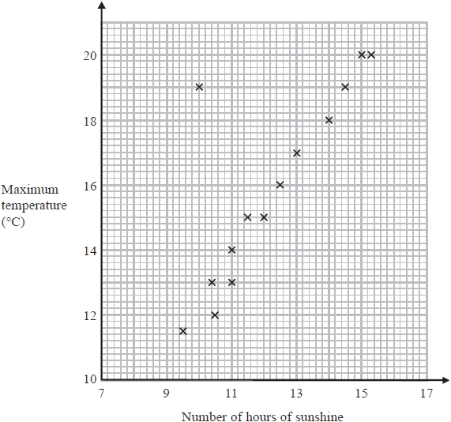

One of the points is an outlier.
(a) Write down the coordinates of this point.
(1)
(b) For all the other points write down the type of correlation.
(1)
On the same day, in another British town, the maximum temperature was 16.4°C.
(c) Estimate the number of hours of sunshine in this town on this day.
(2)
A weatherman says,
"Temperatures are higher on days when there is more sunshine."
(d) Does the scatter graph support what the weatherman says?
Give a reason for your answer.
(1)

(Total for Question 4 is 5 marks)
__________________________________________________________________________
Q5
Tessa owns a small clothes shop in a seaside town. She records the weekly sales figures, £ w, and the average weekly temperature, t °C, for 8 weeks during the summer.
There is a negative correlation for these data.
(a) Suggest a possible reason for this correlation.
(1)
Tessa suggests that a linear regression model could be used to model these data.
(b) State, giving a reason, whether or not the correlation coefficient is consistent with Tessa's suggestion.
(1)
(c) State, giving a reason, which variable would be the explanatory variable.
(1)
Tessa calculated the linear regression equation as w = 10 755 – 171t
(d) Give an interpretation of the gradient of this regression equation.
(1)

(Total for Question 5 is 4 marks)
__________________________________________________________________________

Q6
Jerry is studying visibility for Camborne using the large data set June 1987.
The table below contains two extracts from the large data set.
It shows the daily maximum relative humidity and the daily mean visibility.
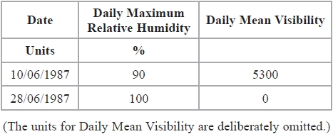

Given that daily mean visibility is given to the nearest 100,
(a) Write down the range of distances in metres that corresponds to the recorded value 0 for the daily mean visibility.
(1)
Jerry drew the following scatter diagram, Figure 2, and calculated some statistics using the June 1987 data for Camborne from the large data set.
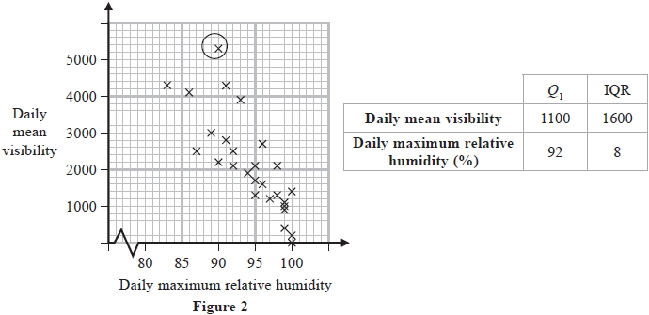
Jerry defines an outlier as a value that is more than 1.5 times the interquartile range above Q₃ or more than 1.5 times the interquartile range below Q₁.
(b) Show that the point circled on the scatter diagram is an outlier for visibility.
(2)

(c) Interpret the correlation between the daily mean visibility and the daily maximum relative humidity.
(1)

Jerry drew the following scatter diagram, Figure 3, using the June 1987 data for Camborne from the large data set, but forgot to label the x–axis.
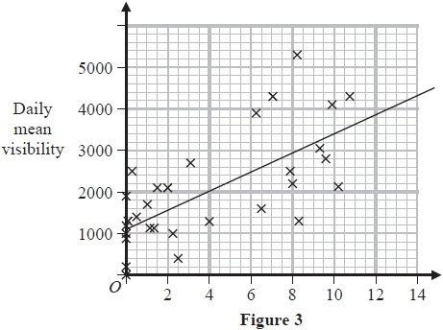

(d) Using your knowledge of the large data set, suggest which variable the x-axis on this scatter diagram represents.
(1)

(Total for Question 6 is 6 marks)
__________________________________________________________________________

Silver Mark Scheme

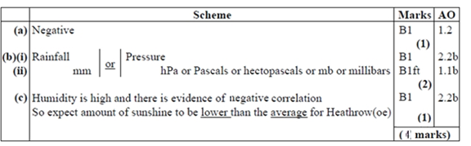
Q1.
Q2.
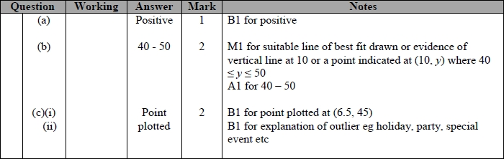

Q3.

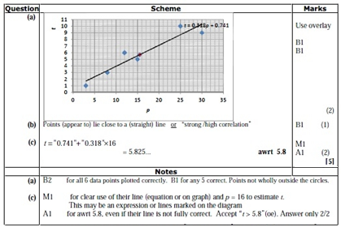
Q4.

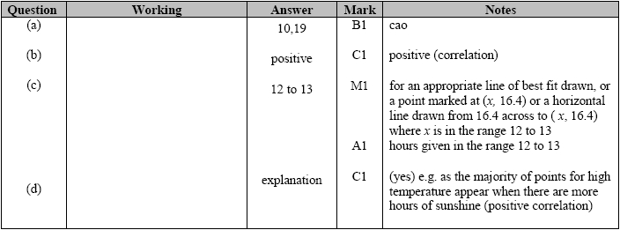
Q5.
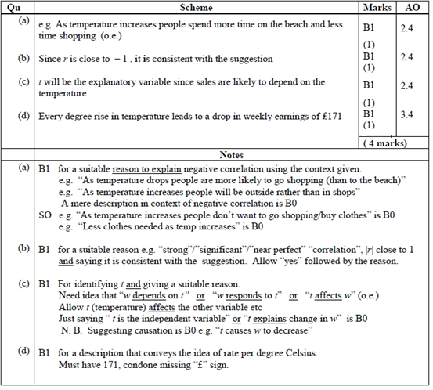

Q6.
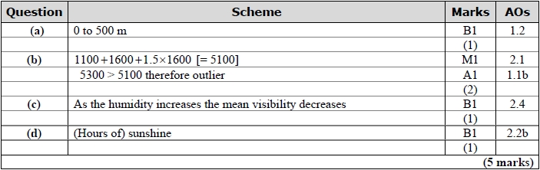

Gold Questions
Calculator
The total mark for this section is 26

Q1
Carlos has a cafe in Clacton.
Each day, he records the maximum temperature in degrees Celsius (°C) in Clacton and the number of hot chocolate drinks sold.
The scatter graph shows this information.
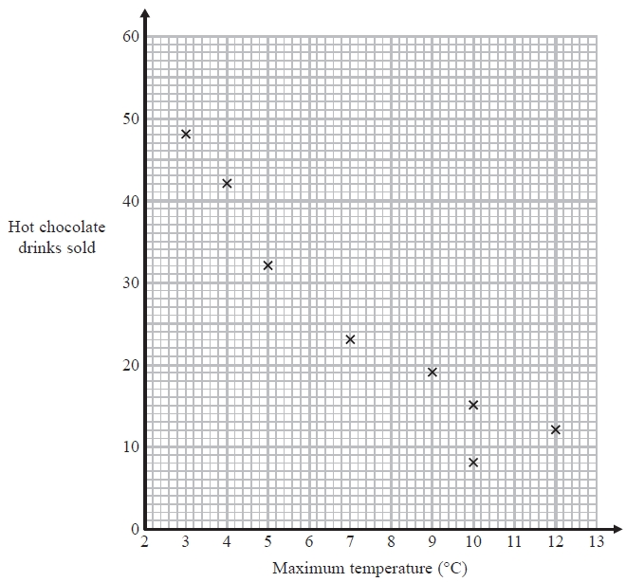

On another day the maximum temperature was 6 °C and 35 hot chocolate drinks were sold.
(a) Show this information on the scatter graph.
(1)
(b) Describe the relationship between the maximum temperature and the number of hot chocolate drinks sold.
(1)
(c) Draw a line of best fit on the scatter diagram.
(1)
One day the maximum temperature was 8 °C.
(d) Use your line of best fit to estimate how many hot chocolate drinks were sold.
(1)

(Total for Question 1 is 4 marks)
__________________________________________________________________________

Q2
In a survey, the outside temperature and the number of units of electricity used for heating were recorded for ten homes.
The scatter diagram shows this information.
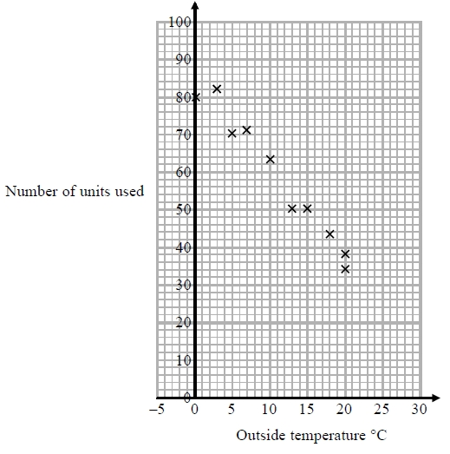
Molly says,
"On average the number of units of electricity used for heating decreases by 4 units for each °C increase in outside temperature."
(a) Is Molly right?
Show how you get your answer.
(3)

(b) You should not use a line of best fit to predict the number of units of electricity used for heating when the outside temperature is 30 °C.
Give one reason why.
(1)
(Total for Question 2 is 4 marks)
__________________________________________________________________________

Q3
A meteorologist believes that there is a positive correlation between the daily mean windspeed, w kn, and the daily mean temperature, t °C. A random sample of 9 consecutive days is taken from past records from a town in the UK in July and the relevant data is given in the table below.
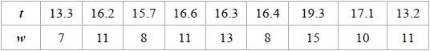
(a) Explain why a linear regression model based on these data is unreliable on a day when the mean temperature is 24 °C
(1)

Using the same 9 days a location from the large data set gave = 27.2 and = 3.5
(b) Using your knowledge of the large data set, suggest, giving your reason, the location that gave rise to these statistics.
(1)

(Total for Question 3 is 2 marks)
__________________________________________________________________________

Q4
A large company is analysing how much money it spends on paper in its offices every year. The number of employees, x, and the amount of money spent on paper, p (£ hundreds), in 8 randomly selected offices are given in the table below.
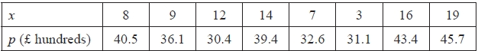

(a) Given that p= 28.3+0.824x
Estimate the amount of money spent on paper in an office with 10 employees.
(2)
(b) Explain the effect each additional employee has on the amount of money spent on paper.
(1)
Later the company realised it had made a mistake in adding up its costs, p. The true costs were actually half of the values recorded. The product moment correlation coefficient and the equation of the linear regression line are recalculated using this information.
(c) Write down the new value of the gradient of the regression line
(1)
(Total for Question 4 is 4 marks)
__________________________________________________________________________

Q5
A company is introducing a job evaluation scheme. Points (x) will be awarded to each job based on the qualifications and skills needed and the level of responsibility. Pay (£y) will then be allocated to each job according to the number of points awarded.
Before the scheme is introduced, a random sample of 8 employees was taken and the linear regression equation of pay on points was y = 4.5x – 47
(a) Describe the correlation between points and pay.
(1)
(b) Give an interpretation of the gradient of this regression line.
(1)
(c) Explain why this model might not be appropriate for all jobs in the company.
(1)

(Total for Question 5 is 3 marks)
__________________________________________________________________________
Q6
Sara was studying the relationship between rainfall, r mm, and humidity, h %, in the UK. She takes a random sample of 11 days from May 1987 for Leuchars from the large data set.
She obtained the following results.

Sara decided to exclude this day's reading and drew the following scatter diagram for the
remaining 10 days' values of r and h.
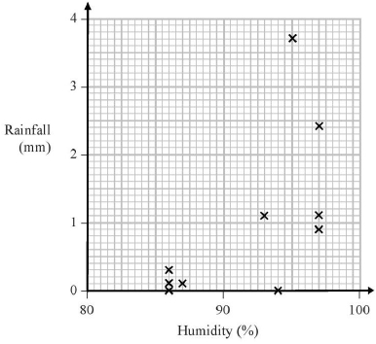

(a) Give an interpretation of the correlation between rainfall and humidity.
(1)
The equation of the regression line of r on h for these 10 days is r = –12.8 + 0.15h
(b) Give an interpretation of the gradient of this regression line.
(1)
(c) (i) Comment on the suitability of Sara's sampling method for this study.
(ii) Suggest how Sara could make better use of the large data set for her study.
(2)

(Total for Question 6 is 4 marks)
__________________________________________________________________________

Q7
A sixth form college has 84 students in Year 12 and 56 students in Year 13
The head teacher selects a stratified sample of 40 students, stratified by year group.
(a) Describe how this sample could be taken.
(3)

The head teacher is investigating the relationship between the amount of sleep, s hours,
that each student had the night before they took an aptitude test and their performance in
the test, p marks.
For the sample of 40 students, he finds the equation of the regression line of p on s to be
p = 26.1 + 5.60s

(b) With reference to this equation, describe the effect that an extra 0.5 hours of sleep
may have, on average, on a student's performance in the aptitude test.
(1)

(c) Describe one limitation of this regression model.
(1)

(Total for Question 7 is 5 marks)
__________________________________________________________________________

Gold Mark Scheme

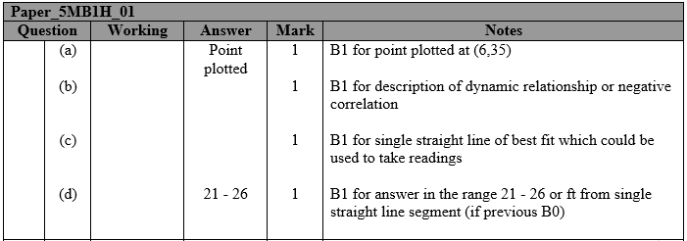
Q1.

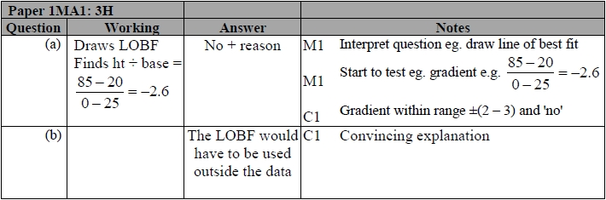
Q2.

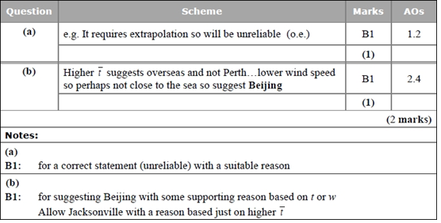
Q3.

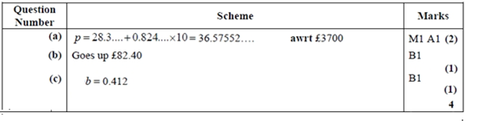
Q4.

Q5.

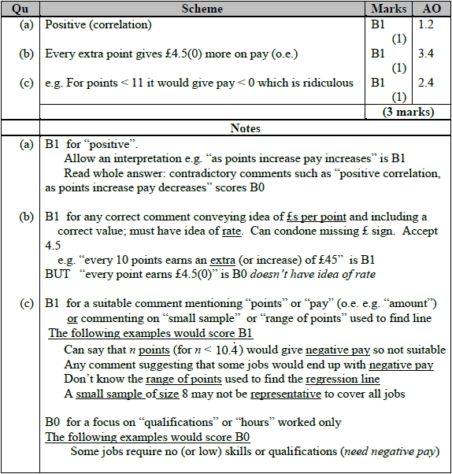

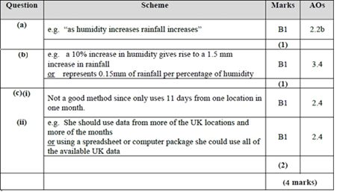
Q6.

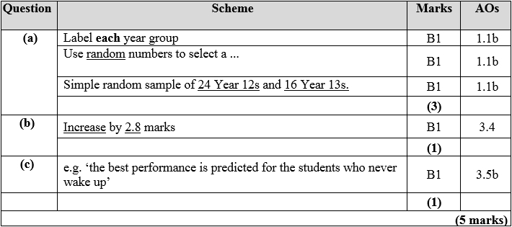
Q7.

