Topic 3 - Normal Distribution

Bronze, Silver and Gold Worksheets for

A Level Mathematics

Teacher Notes
These Bronze, Silver and Gold worksheets are designed to be used either straight after the content has been taught or as part of a skills gap analysis.
They are drawn from the latest specification questions and legacy questions. The papers are between approximately 25 and 45 marks.
The topic number on this worksheet relates to the corresponding chapter in the ‘Pearson Edexcel A Level Mathematics: Statistics and Mechanics Year 2’ textbook.

Quick Links
(Press Ctrl, as you click with your mouse to follow these links)
- Bronze Questions
- Bronze Mark Scheme
- Silver Questions
- Silver Mark Scheme
- Gold Questions
- Gold Mark Scheme

Extension and Enrichment
If you have students that have enjoyed the challenge of the Gold questions, then they should have a go at the more challenging question from our Advanced Extension Award (AEA) papers. The Mathematics AEA is a single, 3 hour non-calculator paper, taken at the end of year 13. It helps students to develop high level problem solving and proof skills. It is entirely based on the content of the A Level Mathematics Course. No extra material needs to be covered to take the AEA in Mathematics. A second important difference is that marks are awarded for the clarity and quality of their solution. Developing this key skill, alongside the extra problem-solving experience, can pay dividends in the way they approach A Level Mathematics and Further Mathematics problems.
More information about the Advanced Extension Award can be found here on the Pearson Edexcel Website, or here on the Maths Emporium

Bronze Questions
Calculator
The total mark for this section is 33
Q1

The random variable X has a normal distribution with mean 20 and standard deviation 4.
(a) Find P(X >25).
(3)
(b) Find the value of d such that P(20 < X < d) = 0.4641.
(4)

(Total for Question 1 is 7 marks)
__________________________________________________________________________

Q2
The time taken for a randomly selected person to complete a test is M minutes, where
M ~ N (14, σ²)
Given that 10% of people take less than 12 minutes to complete the test,
(a) find the value of σ.
(3)
Graham selects 15 people at random.
(b) Find the probability that fewer than 2 of these people will take less than 12 minutes to complete the test.
(3)
Jovanna takes a random sample of n people.
Using a normal approximation, the probability that fewer than 9 of these n people will take less than 12 minutes to complete the test is 0.3085 to 4 decimal places.
(c) Find the value of n.
(8)

(Total for Question 2 is 14 marks)
__________________________________________________________________________

Q3

A machine cuts strips of metal to length L cm, where L is normally distributed with standard deviation 0.5 cm.
Strips with length either less than 49 cm or greater than 50.75 cm cannot be used.
Given that 2.5% of the cut lengths exceed 50.98 cm,
(a) find the probability that a randomly chosen strip of metal can be used.
(5)
Ten strips of metal are selected at random.
(b) Find the probability fewer than 4 of these strips cannot be used.
(2)
A second machine cuts strips of metal of length X cm, where X is normally distributed with standard deviation 0.6 cm
A random sample of 15 strips cut by this second machine was found to have a mean length of 50.4 cm
(c) Stating your hypotheses clearly and using a 1% level of significance, test whether or not the mean length of all the strips, cut by the second machine, is greater than 50.1 cm
(5)
(Total for Question 3 is 12 marks)
__________________________________________________________________________
End of questions

Bronze Mark Scheme
Q1
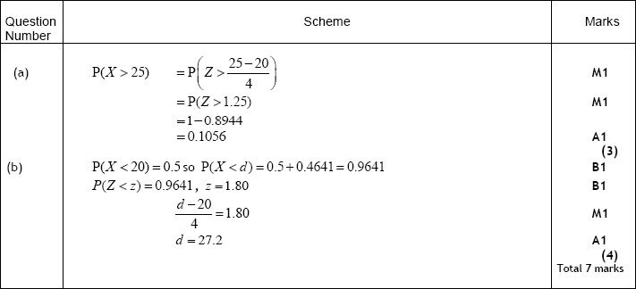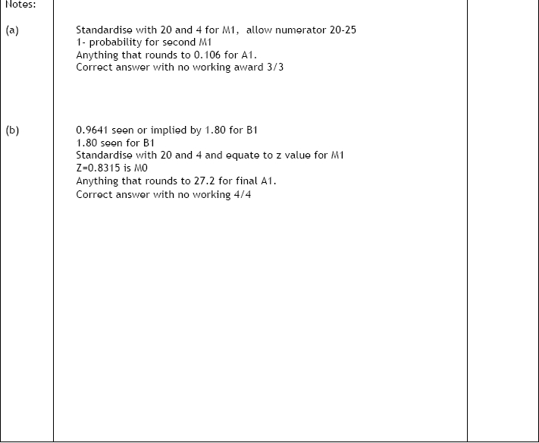

Q2
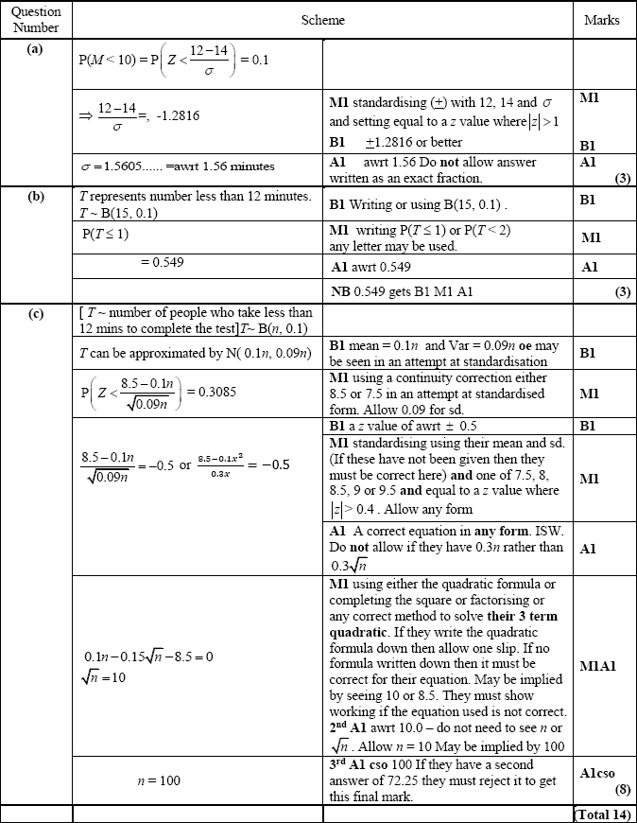

Q3
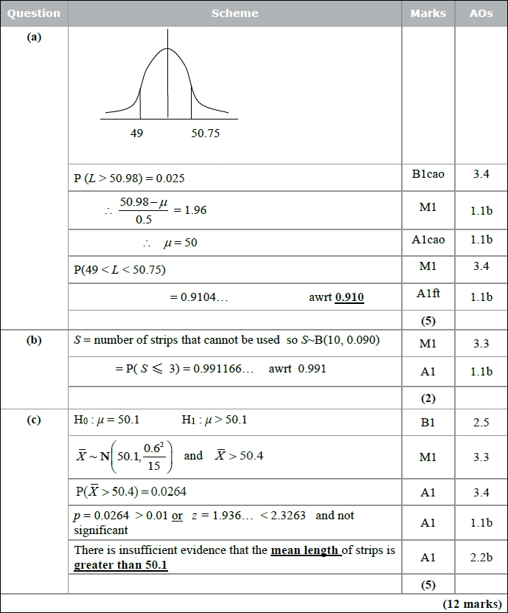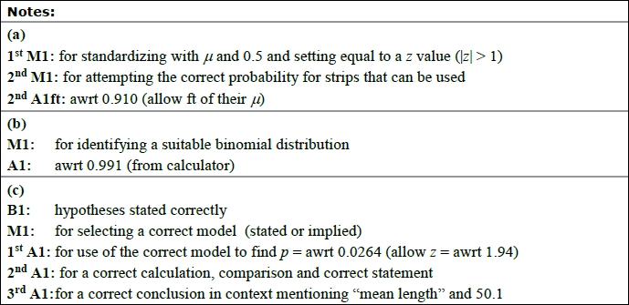


Silver Questions
Calculator
The total mark for this section is 37

Q1

A manufacturer fills jars with coffee. The weight of coffee, W grams, in a jar can be modelled by a normal distribution with mean 232 grams and standard deviation 5 grams.
(a) Find P(W < 224).
(3)
(b) Find the value of w such that P(232 < W < w) = 0.20
(4)
Two jars of coffee are selected at random.
(c) Find the probability that only one of the jars contains between 232 grams and w grams of coffee.
(3)

(Total for Question 1 is 10 marks)
__________________________________________________________________________

Q2

A shopkeeper knows, from past records, that 15% of customers buy an item from the display next to the till. After a refurbishment of the shop, he takes a random sample of 30 customers and finds that only 1 customer has bought an item from the display next to the till.
(a) Stating your hypotheses clearly, and using a 5% level of significance, test whether or not there has been a change in the proportion of customers buying an item from the display next to the till.
(6)
During the refurbishment a new sandwich display was installed. Before the refurbishment 20% of customers bought sandwiches. The shopkeeper claims that the proportion of customers buying sandwiches has now increased. He selects a random sample of 120 customers and finds that 31 of them have bought sandwiches.
(b) Using a suitable approximation and stating your hypotheses clearly, test the shopkeeper's claim. Use a 10% level of significance.
(8)

(Total for Question 2 is 14 marks)
__________________________________________________________________________

Q3
A machine puts liquid into bottles of perfume. The amount of liquid put into each bottle,
D ml, follows a normal distribution with mean 25 ml.
Given that 15% of bottles contain less than 24.63 ml
(a) find, to 2 decimal places, the value of k such that P(24.63 < D < k) = 0.45.
(5)
A random sample of 200 bottles is taken.
(b) Using a normal approximation, find the probability that fewer than half of these
bottles contain between 24.63 ml and k ml.
(3)
The machine is adjusted so that the standard deviation of the liquid put in the bottles is
now 0.16 ml.
Following the adjustments, Hannah believes that the mean amount of liquid put in each
bottle is less than 25 ml.
She takes a random sample of 20 bottles and finds the mean amount of liquid to be
24.94 ml.
(c) Test Hannah's belief at the 5% level of significance.
You should state your hypotheses clearly.
(5)

(Total for Question 3 is 13 marks)
__________________________________________________________________________
End of questions

Silver Mark Scheme
Q1
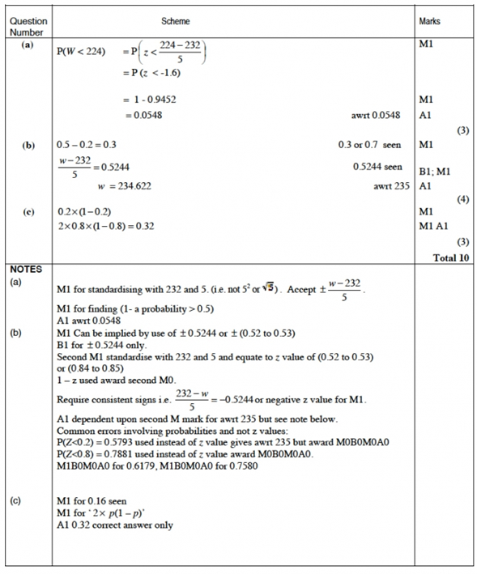

Q2
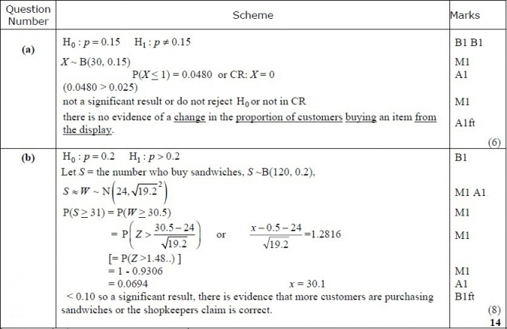
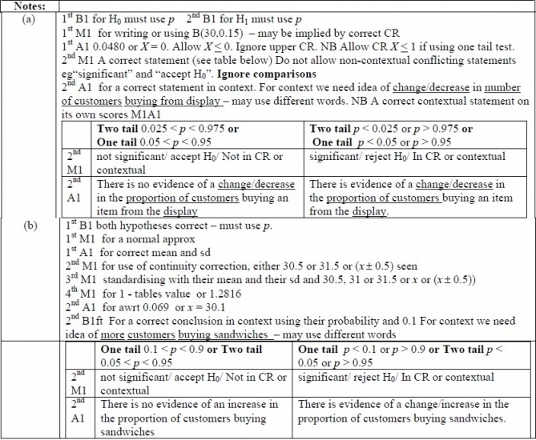
Q3

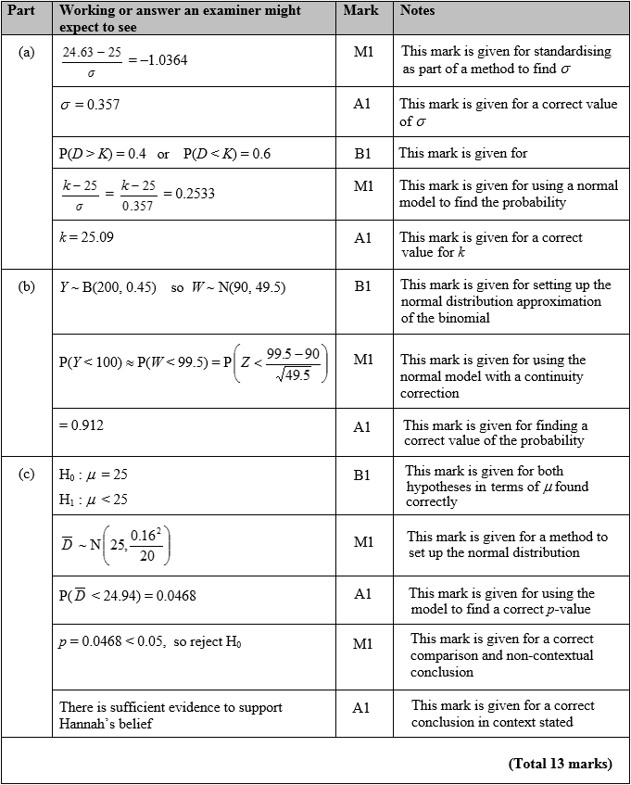

Gold Questions
Calculator
The total mark for this section is 35
Q1

The lifetimes of bulbs used in a lamp are normally distributed.
A company X sells bulbs with a mean lifetime of 850 hours and a standard deviation of 50 hours.
(a) Find the probability of a bulb, from company X, having a lifetime of less than 830 hours.
(3)
(b) In a box of 500 bulbs, from company X, find the expected number having a lifetime of less than 830 hours.
(2)
A rival company Y sells bulbs with a mean lifetime of 860 hours and 20% of these bulbs have a lifetime of less than 818 hours.
(c) Find the standard deviation of the lifetimes of bulbs from company Y.
(4)
Both companies sell the bulbs for the same price.
(d) State which company you would recommend. Give reasons for your answer.
(2)
(Total for Question 1 is 11 marks)
__________________________________________________________________________
Q2
The length of time, L hours, that a phone will work before it needs charging is normally distributed with a mean of 100 hours and a standard deviation of 15 hours.
(a) Find P (L > 127).
(3)
(b) Find the value of d such that P(L < d) = 0.10.
(3)
Alice is about to go on a 6 hour journey.
Given that it is 127 hours since Alice last charged her phone,
(c) find the probability that her phone will not need charging before her journey is completed.
(4)
(Total for Question 2 is 10 marks)
__________________________________________________________________________
Q3.
The lifetime, L hours, of a battery has a normal distribution with mean 18 hours and standard deviation 4 hours.
Alice's calculator requires 4 batteries and will stop working when any one battery reaches the end of its lifetime.
(a) Find the probability that a randomly selected battery will last for longer than 16 hours.
(1)
At the start of her exams Alice put 4 new batteries in her calculator.
She has used her calculator for 16 hours, but has another 4 hours of exams to sit.
(b) Find the probability that her calculator will not stop working for Alice's remaining exams.
(5)
Alice only has 2 new batteries so, after the first 16 hours of her exams, although her calculator is still working, she randomly selects 2 of the batteries from her calculator and replaces these with the 2 new batteries.
(c) Show that the probability that her calculator will not stop working for the remainder of her exams is 0.199 to 3 significant figures.
(3)
After her exams, Alice believed that the lifetime of the batteries was more than 18 hours. She took a random sample of 20 of these batteries and found that their mean lifetime was
19.2 hours.
(d) Stating your hypotheses clearly and using a 5% level of significance, test Alice's belief.
(5)
(Total for Question 3 is 14 marks)
__________________________________________________________________________
End of questions

Gold Mark Scheme

Q1
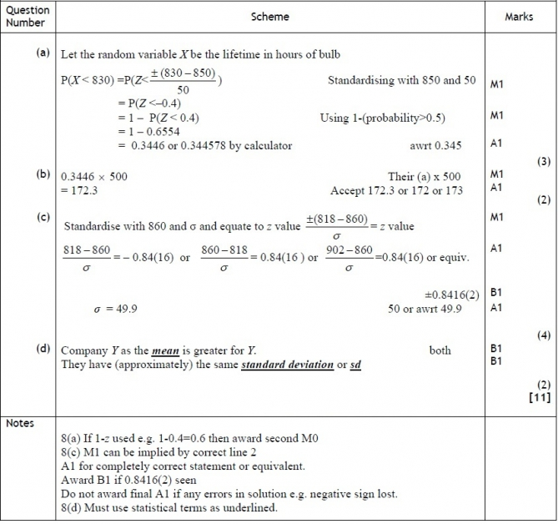

Q2
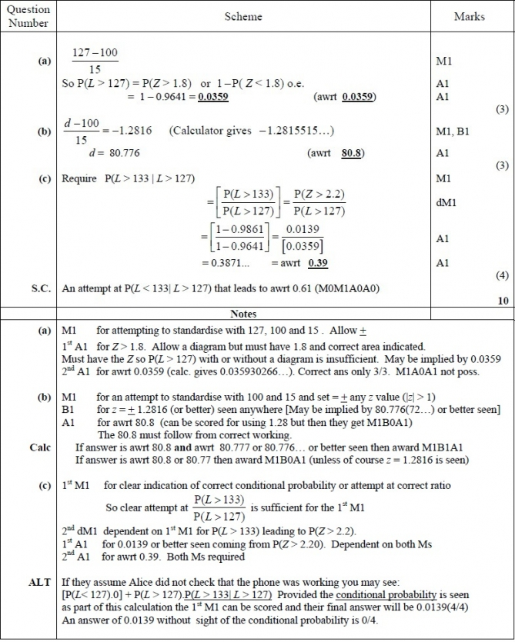

Q3
