Topic 5

Probability

Bronze, Silver, Gold

Worksheets for

AS Level Mathematics

Teacher Notes
These Bronze, Silver and Gold worksheets are designed to be used either straight after the content has been taught or as part of a skills gap analysis, especially as students move into year 13.
They are drawn from the latest specification questions and legacy questions. The papers are between 25 and 35 marks.
The topic number on this worksheet relates to the corresponding chapter number in the ‘Pearson Edexcel AS and A Level Mathematics: Statistics and Mechanics Year 1/AS’ textbook.

Quick Links
(Press Ctrl, as you click with your mouse to follow these links)
- Bronze Questions
- Bronze Mark Scheme
- Silver Questions
- Silver Mark Scheme
- Gold Questions
- Gold Mark Scheme

Extension and Enrichment
If you have students that have enjoyed the challenge of the Gold questions, then they should have a go at the more challenging question from our Advanced Extension Award (AEA) papers. The Mathematics AEA is a single, 3 hour non-calculator paper, taken at the end of year 13. It helps students to develop high level problem solving and proof skills. It is entirely based on the content of the A Level Mathematics Course. No extra material needs to be covered to take the AEA in Mathematics. A second important difference is that marks are awarded for the clarity and quality of their solution. Developing this key skill, alongside the extra problem-solving experience, can pay dividends in the way they approach A Level Mathematics and Further Mathematics problems.
More information about the Advanced Extension Award can be found here on the Pearson Edexcel Website, or here on the Maths Emporium

Bronze Questions
Calculator
The total mark for this section is 29

Q1
When a biased 6-sided dice is thrown once, the probability that it will land on 4 is 0.65
The biased dice is thrown twice.
Amir draws this probability tree diagram.
The diagram is not correct.
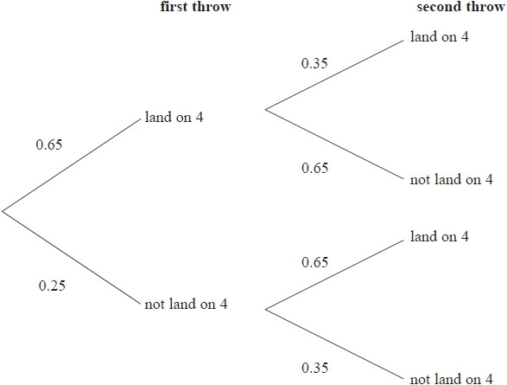

Write down two things that are wrong with the probability tree diagram.

(Total for Question 1 is 2 marks)
__________________________________________________________________________

Q2
The probability that it will rain on Monday is 0.6
When it rains on Monday, the probability that it will rain on Tuesday is 0.8
When it does not rain on Monday, the probability that it will rain on Tuesday is 0.5

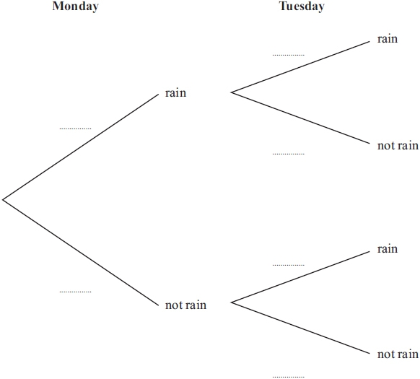
(a) Complete the probability tree diagram.
(2)
(b) Work out the probability that it will rain on both Monday and Tuesday.
.
(2)
(c) Work out the probability that it will rain on at least one of the two days.

(3)

(Total for Question 2 is 7 marks)
__________________________________________________________________________

Q3
An experiment consists of selecting a ball from a bag and spinning a coin. The bag contains 5 red balls and 7 blue balls. A ball is selected at random from the bag, its colour is noted and then the ball is returned to the bag.
When a red ball is selected, a biased coin with probability of landing heads is spun. When a blue ball is selected a fair coin is spun.
(a) Complete the tree diagram below to show the possible outcomes and associated probabilities.
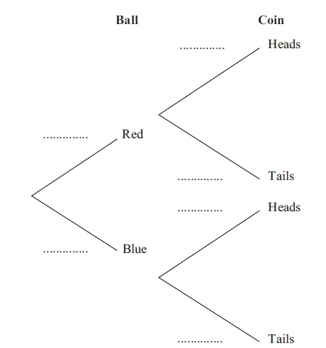
(2)
Shivani selects a ball and spins the appropriate coin.
(b) Find the probability that she obtains a head.
(2)

Shivani and Tom each repeat this experiment.
(c) Find the probability that the colour of the ball Shivani selects is the same as the colour of the ball Tom selects.
(3)
(Total for Question 3 is 7 marks)
__________________________________________________________________________

Q4
Sami asked 50 people which drinks they liked from tea, coffee and milk.
All 50 people like at least one of the drinks
19 people like all three drinks.
16 people like tea and coffee but do not like milk.
21 people like coffee and milk.
24 people like tea and milk.
40 people like coffee.
1 person likes only milk.
Sami selects at random one of the 50 people.
(a) Work out the probability that this person likes tea.
(4)
(b) Given that the person selected at random from the 50 people likes tea, find the probability that this person also likes exactly one other drink.

(2)

(Total for Question 4 is 6 marks)
__________________________________________________________________________

Q5
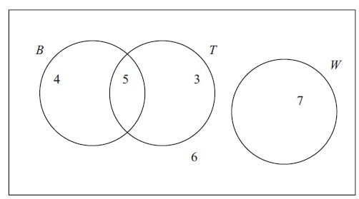
Figure 1
Figure 1 shows how 25 people travelled to work.
Their travel to work is represented by the events
B bicycle
T train
W walk
(a) Write down 2 of these events that are mutually exclusive. Give a reason for your answer.
(2)
(b) Determine whether or not B and T are independent events.
(3)

One person is chosen at random.
Find the probability that this person
(c) Walks to work,
(1)
(d) Travels to work by bicycle and train.
(1)

(Total for Question 5 is 7 marks)
__________________________________________________________________________

Bronze Mark Scheme

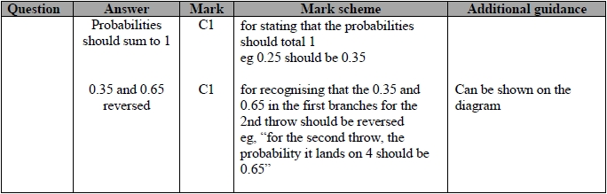
Q1.

Q2.
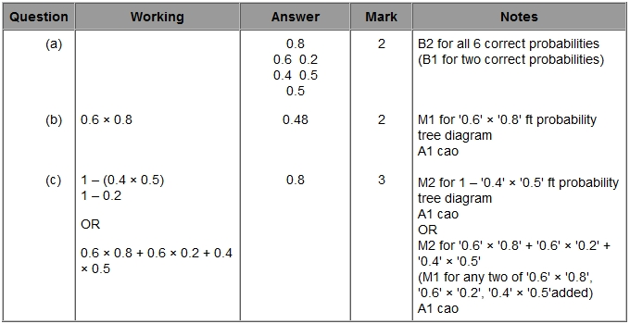

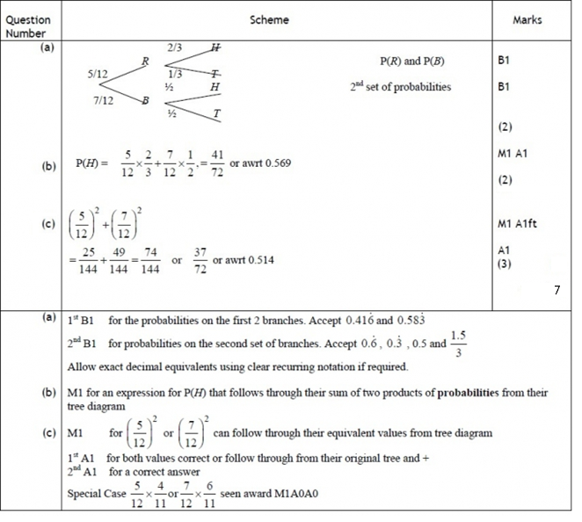
Q3.

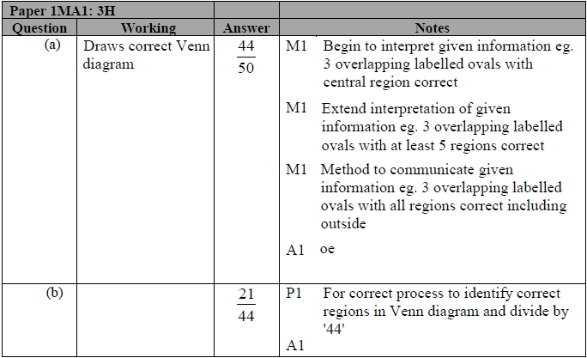
Q4.

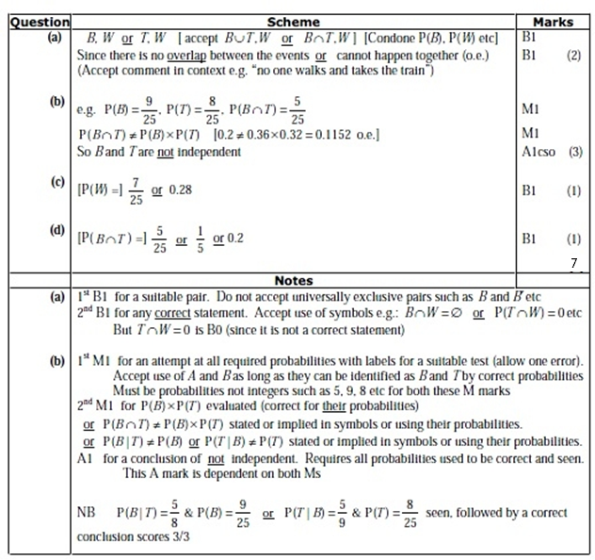
Q5.


Silver Questions
Calculator
The total mark for this section is 31

Q1
A jar contains 2 red, 1 blue and 1 green bead. Two beads are drawn at random from the jar without replacement.

(a) Draw a tree diagram to illustrate all the possible outcomes and associated probabilities. State your probabilities clearly.
(3)
(b) Find the probability that a blue bead and a green bead are drawn from the jar.
(2)

(Total for Question 1 is 5 marks)
__________________________________________________________________________

Q2
There are 8 counters in a box.
The letter A is on 6 of the counters.
The letter B is on the other 2 counters.
Sally takes at random a counter from the box.
She keeps the counter.
Then Tina takes at random a counter from the box.
(a) Complete the probability tree diagram.
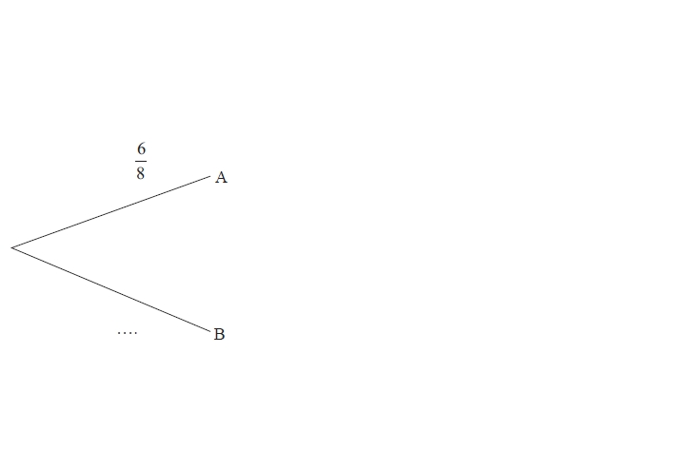
Sally Tina

(3)
(b) Work out the probability that both Sally and Tina take a counter with the letter A on it.

(2)
(c) Work out the probability that at least one counter with the letter A on it is taken.
(3)

(Total for Question 2 is 8 marks)
__________________________________________________________________________

Q3
The following shows the results of a wine tasting survey of 100 people.
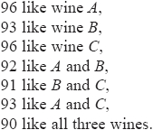
(a) Draw a Venn Diagram to represent these data.
(6)
Find the probability that a randomly selected person from the survey likes
(b) None of the three wines,
(1)
(c) Wine A but not wine B,
(2)
(d) Any wine in the survey except wine C,
(2)
(e) Exactly two of the three kinds of wine.
(2)

(Total for Question 3 is 3 marks)
__________________________________________________________________________

Q4
The Venn diagram shows three events, A, B and C, and their associated probabilities.

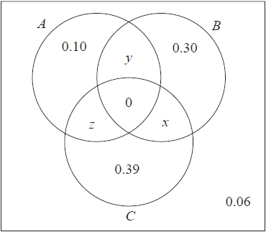

Events B and C are mutually exclusive.
Events A and C are independent.
Showing your working, find the value of x, the value of y and the value of z.

(Total for Question 4 is 5 marks)
__________________________________________________________________________

Silver Mark Scheme

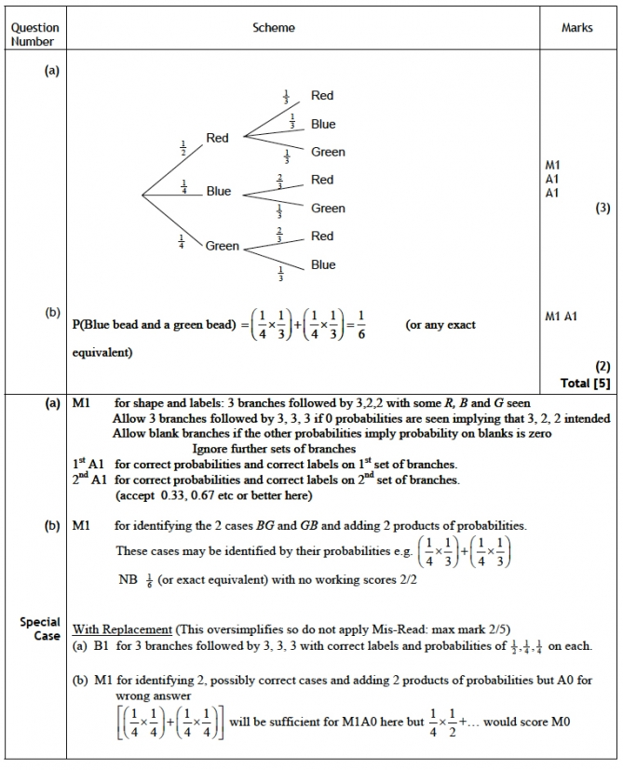
Q1.

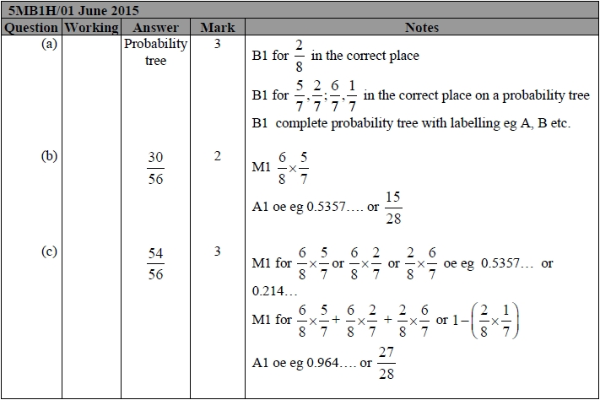
Q2.

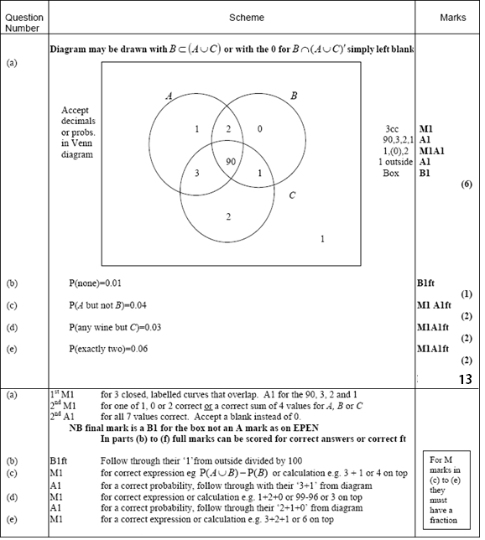
Q3.

Q4.
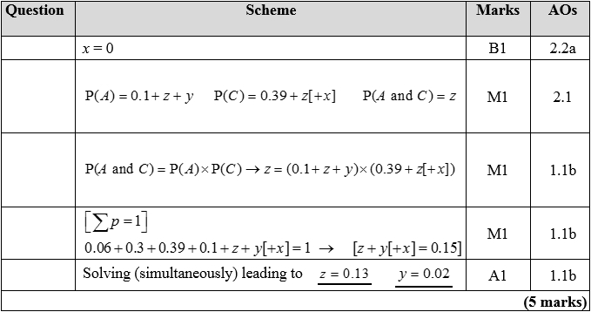
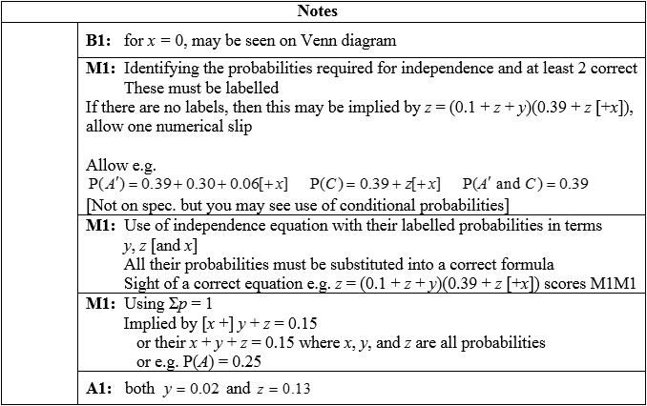

Gold Questions
Calculator
The total mark for this section is 31

Q1
On a randomly chosen day the probability that Bill travels to school by car, by bicycle or on
foot is , and respectively. The probability of being late when using these methods of
travel is , and respectively.
(a) Draw a tree diagram to represent this information.
(3)
(b) Find the probability that on a randomly chosen day
(i) Bill travels by foot and is late,
(ii) Bill is not late.
(4)
(Total for Question 1 is 7 marks)
__________________________________________________________________________

Q2
There are 180 students at a college following a general course in computing. Students on this course can choose to take up to three extra options.

112 take systems support,
70 take developing software,
81 take networking,
35 take developing software and systems support,
28 take networking and developing software,
40 take systems support and networking,
4 take all three extra options.

(a) Draw a Venn diagram to represent this information.
(5)
A student from the course is chosen at random.
Find the probability that this student takes

(b) None of the three extra options,
(1)
(c) Networking only.
(1)

(Total for Question 2 is 7 marks)
__________________________________________________________________________

Q3
A manufacturer carried out a survey of the defects in their soft toys. It is found that the probability of a toy having poor stitching is 0.03 and that a toy with poor stitching has a probability of 0.7 of splitting open. A toy without poor stitching has a probability of 0.02 of splitting open.
(a) Draw a tree diagram to represent this information.
(3)
(b) Find the probability that a randomly chosen soft toy has exactly one of the two defects, poor stitching or splitting open.
(3)
The manufacturer also finds that soft toys can become faded with probability 0.05 and that this defect is independent of poor stitching or splitting open. A soft toy is chosen at random.
(c) Find the probability that the soft toy has none of these 3 defects.
(2)
(d) Find the probability that the soft toy has exactly one of these 3 defects.
(4)

(Total for Question 3 is 12 marks)
__________________________________________________________________________

Q4
The Venn diagram shows the probabilities for students at a college taking part in various sports.
A represents the event that a student takes part in Athletics.
T represents the event that a student takes part in Tennis.
C represents the event that a student takes part in Cricket.
p and q are probabilities.
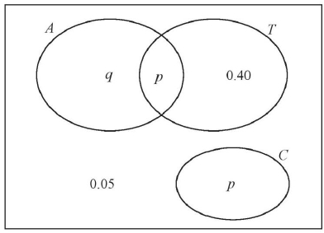

The probability that a student selected at random takes part in Athletics or Tennis is 0.75
(a) Find the value of p.
(1)
(b) State, giving a reason, whether or not the events A and T are statistically independent. Show your working clearly.
(3)
(c) Find the probability that a student selected at random does not take part in Athletics or Cricket.
(1)

(Total for Question 4 is 5 marks)
__________________________________________________________________________

Gold Mark Scheme

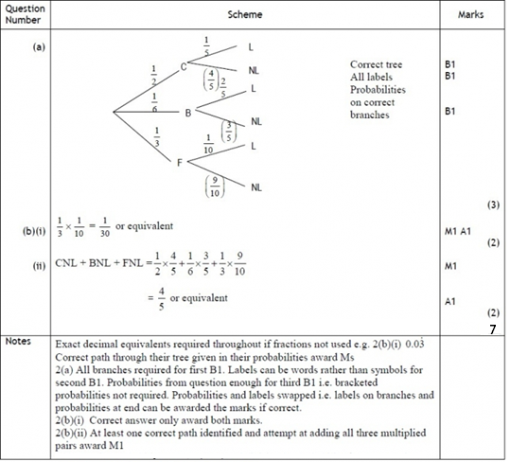
Q1.

Q2.
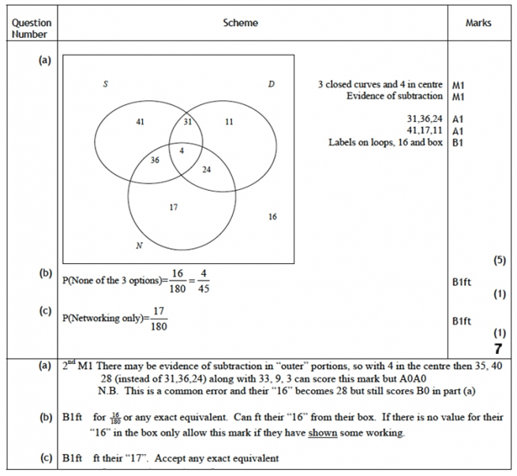

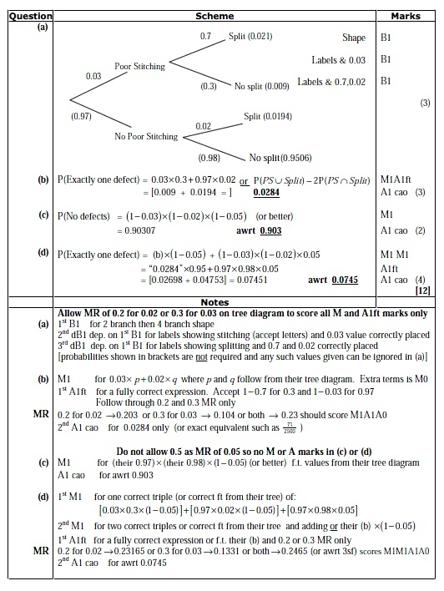
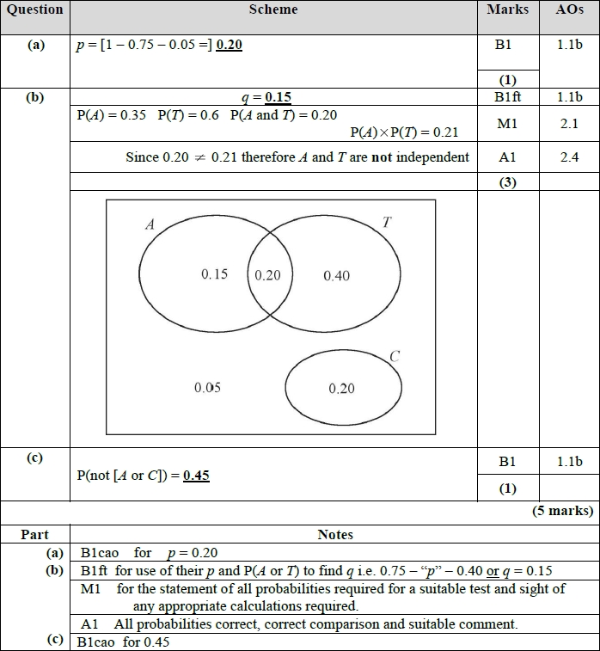
Q3.
Q4.

