Topics 6 and 7

Statistical Distributions and Hypothesis Testing

Bronze, Silver, Gold

Worksheets for

AS Level Mathematics

Teacher Notes
These Bronze, Silver and Gold worksheets are designed to be used either straight after the content has been taught or as part of a skills gap analysis, especially as students move into year 13.
They are drawn from the latest specification questions and legacy questions. The papers are between 25 and 35 marks.
The topic number on this worksheet relates to the corresponding chapter number in the ‘Pearson Edexcel AS and A Level Mathematics: Statistics and Mechanics Year 1/AS’ textbook.

Quick Links
(Press Ctrl, as you click with your mouse to follow these links)
- Bronze Questions
- Bronze Mark Scheme
- Silver Questions
- Silver Mark Scheme
- Gold Questions
- Gold Mark Scheme

Extension and Enrichment
If you have students that have enjoyed the challenge of the Gold questions, then they should have a go at the more challenging question from our Advanced Extension Award (AEA) papers. The Mathematics AEA is a single, 3 hour non-calculator paper, taken at the end of year 13. It helps students to develop high level problem solving and proof skills. It is entirely based on the content of the A Level Mathematics Course. No extra material needs to be covered to take the AEA in Mathematics. A second important difference is that marks are awarded for the clarity and quality of their solution. Developing this key skill, alongside the extra problem-solving experience, can pay dividends in the way they approach A Level Mathematics and Further Mathematics problems.
More information about the Advanced Extension Award can be found here on the Pearson Edexcel Website, or here on the Maths Emporium

Bronze Questions
Calculator
The total mark for this section is 31

Q1
The probability of a bolt being faulty is 0.3. Find the probability that in a random sample of 20 bolts there are
(a) Exactly 2 faulty bolts,
(2)
(b) More than 3 faulty bolts.
(2)
These bolts are sold in bags of 20. John buys 10 bags.
(c) Find the probability that exactly 6 of these bags contain more than 3 faulty bolts.
(3)

(Total for Question 1 is 7 marks)
__________________________________________________________________________

Q2
A fair 5-sided spinner has sides numbered 1, 2, 3, 4 and 5
The spinner is spun once and the score of the side it lands on is recorded.
(a) Write down the name of the distribution that can be used to model the score of the side it lands on.
(1)
The spinner is spun 28 times.
The random variable X represents the number of times the spinner lands on 2
(b) (i) Find the probability that the spinner lands on 2 at least 7 times.
(ii) Find P(4 ≤ X < 8)
(5)

(Total for Question 2 is 6 marks)
__________________________________________________________________________

Q3
In a game, a player can score 0, 1, 2, 3 or 4 points each time the game is played.
The random variable S, representing the player's score, has the following probability distribution where a, b and c
are constants.
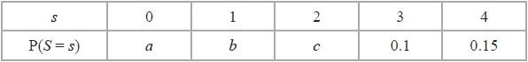
The probability of scoring less than 2 points is twice the probability of scoring at least 2 points.
Each game played is independent of previous games played.
John plays the game twice and adds the two scores together to get a total.
Calculate the probability that the total is 6 points.
(Total for Question 3 is 6 marks)
__________________________________________________________________________

Q4
Naasir is playing a game with two friends. The game is designed to be a game of chance so that the probability of Naasir winning each game is
Naasir and his friends play the game 15 times.
(a) Find the probability that Naasir wins
(i) exactly 2 games,
(ii) more than 5 games.
(3)
Naasir claims he has a method to help him win more than of the games. To test this claim, the three of them played the game again 32 times and Naasir won 16 of these games.
(b) Stating your hypotheses clearly, test Naasir's claim at the 5% level of significance.
(4)

(Total for Question 4 is 7 marks)
__________________________________________________________________________

Q5
A test statistic has a distribution B(25, p).
Given that
H₀ : p = 0.5 H₁ : p ≠ 0.5
(a) Find the critical region for the test statistic such that the probability in each tail is as close as possible to 2.5%.
(3)
(b) State the probability of incorrectly rejecting H₀ using this critical region.
(2)

(Total for Question 5 is 5 marks)
__________________________________________________________________________

Bronze Mark Scheme
Q1.
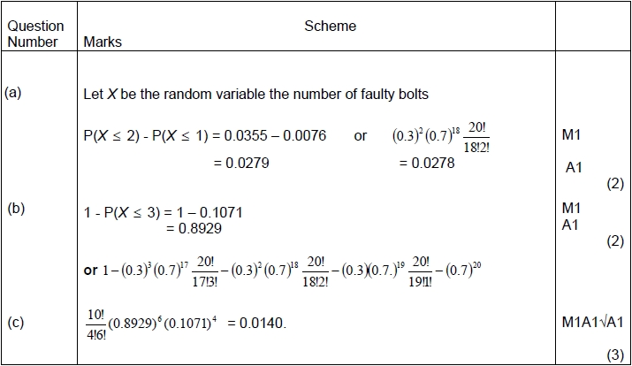
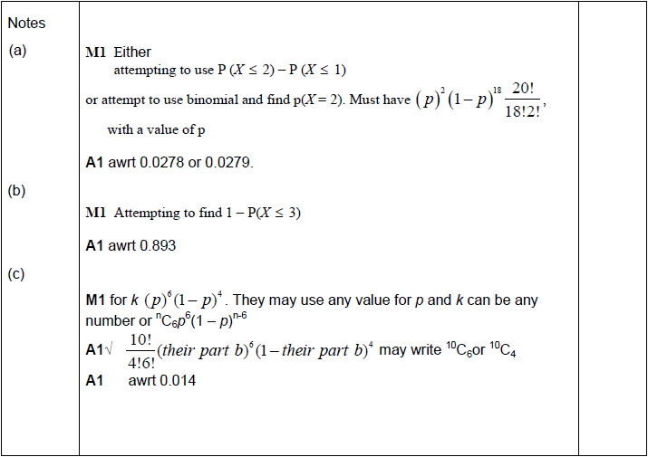

Q2.
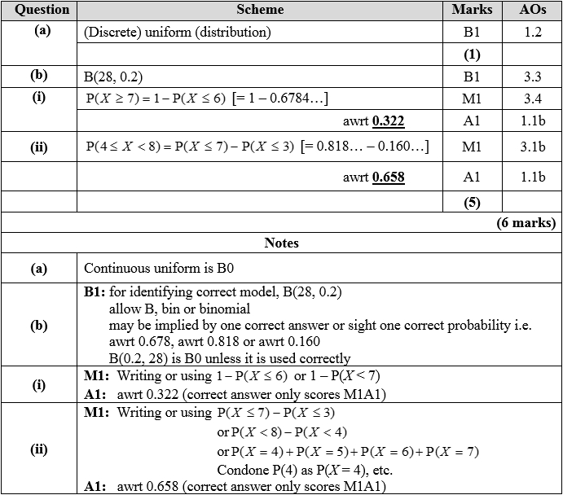

Q3.
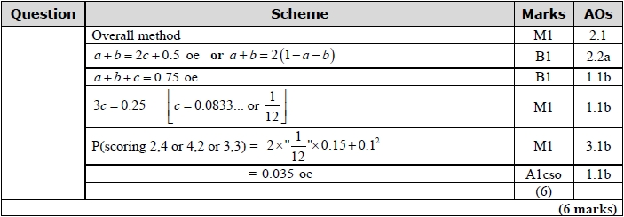
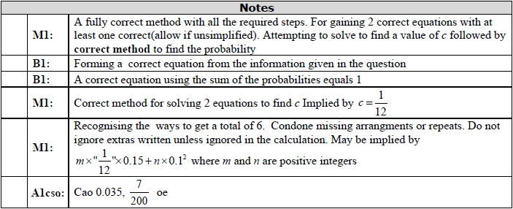

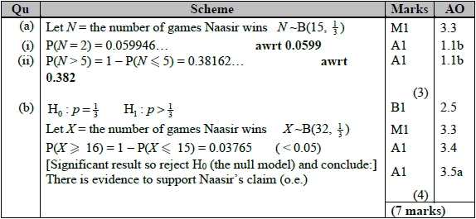
Q4.

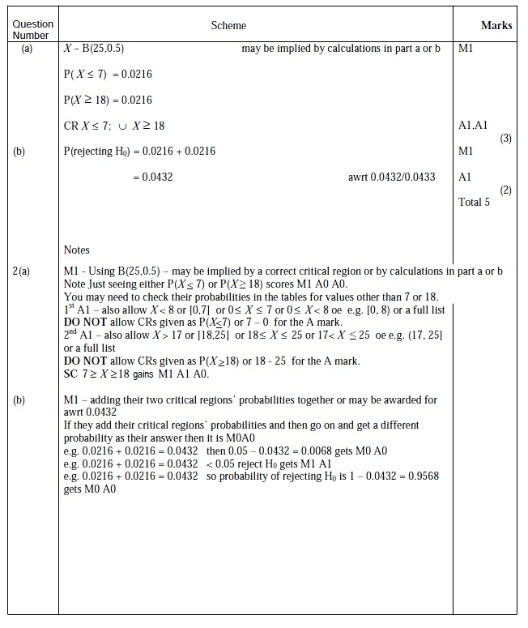
Q5.


Silver Questions
Calculator
The total mark for this section is 34

Q1
Linda regularly takes a taxi to work five times a week. Over a long period of time she finds the taxi is late once a week. The taxi firm changes her driver and Linda thinks the taxi is late more often. In the first week, with the new driver, the taxi is late 3 times.
You may assume that the number of times a taxi is late in a week has a Binomial distribution.
Test, at the 5% level of significance, whether or not there is evidence of an increase in the proportion of times the taxi is late. State your hypotheses clearly.

(Total for Question 1 is 7 marks)
__________________________________________________________________________

Q2
A potter believes that 20% of pots break whilst being fired in a kiln. Pots are fired in batches of 25.
(a) Let X denote the number of broken pots in a batch. A batch is selected at random. Using a 10% significance level, find the critical region for a two tailed test of the potter's belief. You should state the probability in each tail of your critical region.
(4)
The potter aims to reduce the proportion of pots which break in the kiln by increasing the size of the batch fired. He now fires pots in batches of 50. He then chooses a batch at random and discovers there are 6 pots which broke whilst being fired in the kiln.
(b) Test, at the 5% level of significance, whether or not there is evidence that increasing the number of pots in a batch has reduced the percentage of pots that break whilst being fired in the kiln. State your hypotheses clearly.
(5)

(Total for Question 2 is 9 marks)
__________________________________________________________________________

Q3
In a manufacturing process 25% of articles are thought to be defective. Articles are produced in batches of 20
(a) A batch is selected at random. Using a 5% significance level, find the critical region for a two tailed test that the probability of an article chosen at random being defective is 0.25
You should state the probability in each tail which should be as close as possible to 0.025
(5)
The manufacturer changes the production process to try to reduce the number of defective articles. She then chooses a batch at random and discovers there are 3 defective articles.
(b) Test at the 5% level of significance whether or not there is evidence that the changes to the process have reduced the percentage of defective articles. State your hypotheses clearly.
(5)

(Total for Question 3 is 10 marks)
__________________________________________________________________________

Q4
Afrika works in a call centre.
She assumes that calls are independent and knows, from past experience, that on each sales call
that she makes there is a probability of that it is successful.
Afrika makes 9 sales calls.
(a) Calculate the probability that at least 3 of these sales calls will be successful.
(2)
The probability of Afrika making a successful sales call is the same each day.
Afrika makes 9 sales calls on each of 5 different days.
(b) Calculate the probability that at least 3 of the sales calls will be successful on exactly 1 of these days.
(2)
Rowan works in the same call centre as Afrika and believes he is a more successful salesperson.
To check Rowan's belief, Afrika monitors the next 35 sales calls Rowan makes and finds that 11 of the sales calls are successful.
(c) Stating your hypotheses clearly test, at the 5% level of significance, whether or not
there is evidence to support Rowan's belief.
(4)

(Total for Question 4 is 8 marks)
__________________________________________________________________________

Silver Mark Scheme

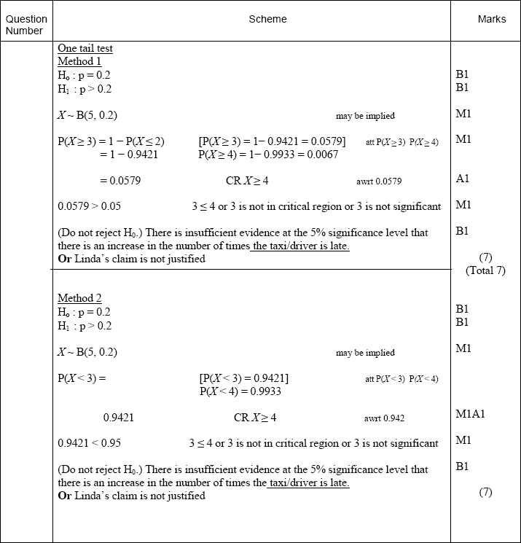
Q1.
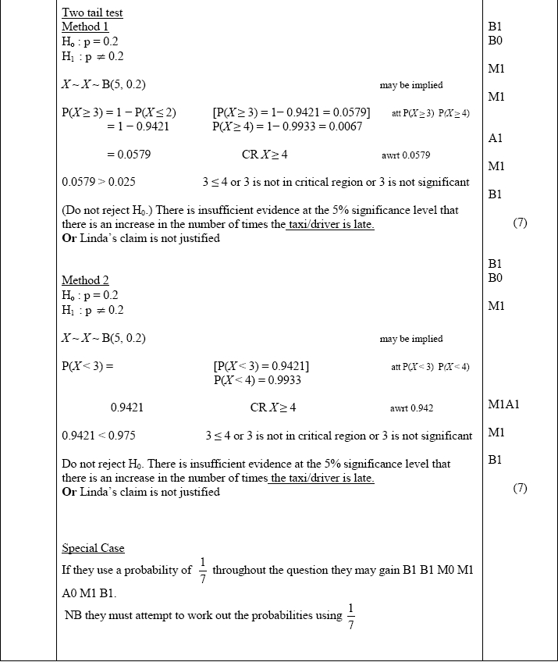

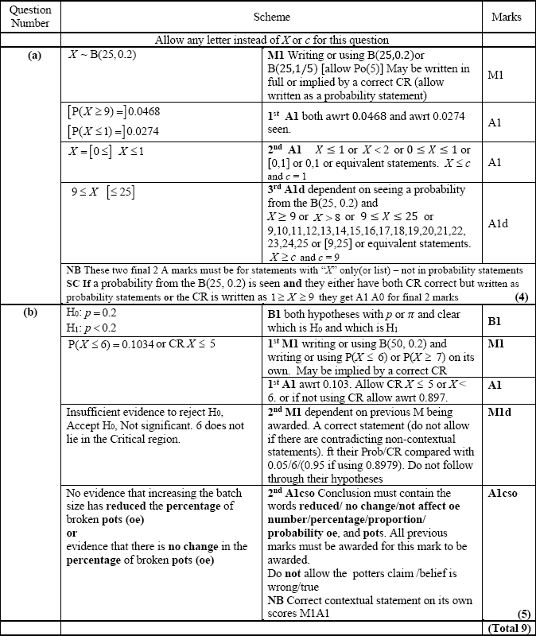
Q2.

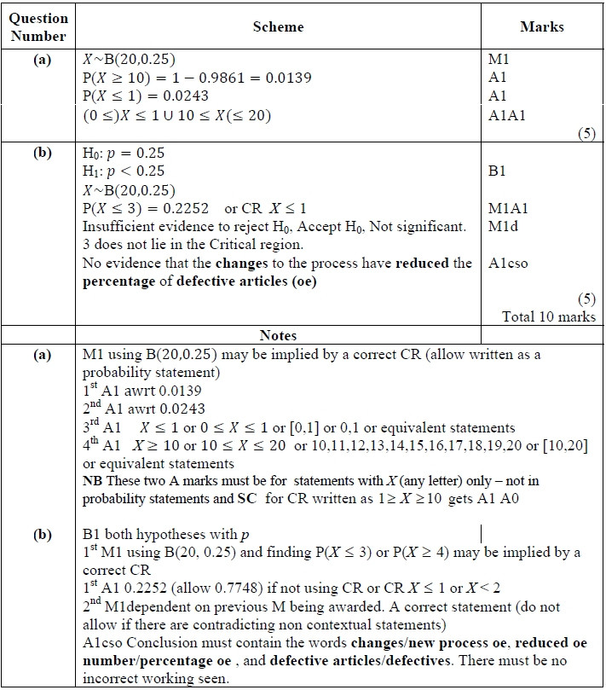
Q3.

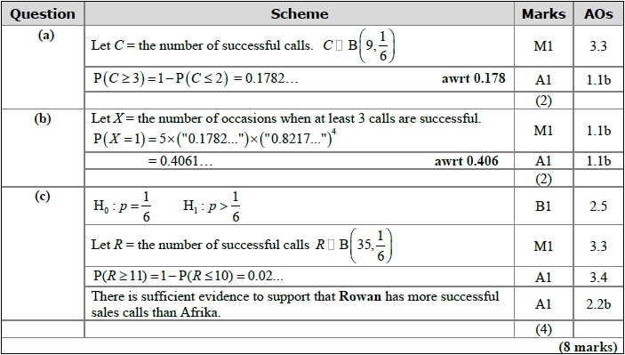
Q4.
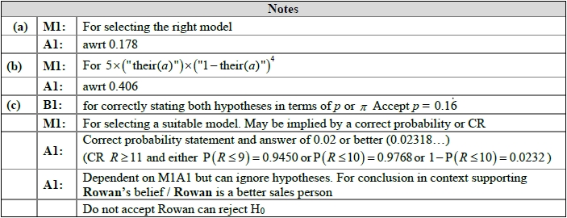

Gold Questions
Calculator
The total mark for this section is 31

Q1
(a) The discrete random variable X ~ B(40, 0.27)
Find P(X ≥ 16)
(2)
Past records suggest that 30% of customers who buy baked beans from a large supermarket buy them in single tins. A new manager suspects that there has been a change in the proportion of customers who buy baked beans in single tins. A random sample of 20 customers who had bought baked beans was taken.
(b) Write down the hypotheses that should be used to test the manager's suspicion.
(1)
(c) Using a 10% level of significance, find the critical region for a two-tailed test to answer the manager's suspicion. You should state the probability of rejection in each tail, which should be less than 0.05
(3)
(d) Find the actual significance level of a test based on your critical region from part (c).
(1)
One afternoon the manager observes that 12 of the 20 customers who bought baked beans, bought their beans in single tins.
(e) Comment on the manager's suspicion in the light of this observation.
(1)
Later it was discovered that the local scout group visited the supermarket that afternoon to buy food for their camping trip.
(f) Comment on the validity of the model used to obtain the answer to part (e), giving a reason for your answer.
(1)

(Total for Question 1 is 9 marks)
__________________________________________________________________________

Q2
The proportion of houses in Radville which are unable to receive digital radio is 25%.
In a survey of a random sample of 30 houses taken from Radville, the number, X, of
houses which are unable to receive digital radio is recorded.
(a) Find P(5 X < 11)
(3)
A radio company claims that a new transmitter set up in Radville will reduce the proportion
of houses which are unable to receive digital radio. After the new transmitter has been set
up, a random sample of 15 houses is taken, of which 1 house is unable to receive digital
radio.
(b) Test, at the 10% level of significance, the radio company's claim. State your
hypotheses clearly.
(5)

(Total for Question 2 is 8 marks)
__________________________________________________________________________

Q3
Past records show that 15% of customers at a shop buy chocolate. The shopkeeper believes
that moving the chocolate closer to the till will increase the proportion of customers buying
chocolate.
After moving the chocolate closer to the till, a random sample of 30 customers is taken
and 8 of them are found to have bought chocolate.
Julie carries out a hypothesis test, at the 5% level of significance, to test the shopkeeper's belief.
Julie's hypothesis test is shown below.
H₀ : p = 0.15
H₁ : p ≥ 0.15
Let X = the number of customers who buy chocolate.
X ~ B(30, 0.15)
P(X = 8) = 0.0420
0.0420 < 0.05 so reject H₀
There is sufficient evidence to suggest that the proportion of customers buying
chocolate has increased.
(a) Identify the first two errors that Julie has made in her hypothesis test.
(2)
(b) Explain whether or not these errors will affect the conclusion of her hypothesis test.
Give a reason for your answer.
(1)
(c) Find, using a 5% level of significance, the critical region for a one-tailed test of the
shopkeeper's belief. The probability in the tail should be less than 0.05
(2)
(d) Find the actual level of significance of this test.
(1)

(Total for Question 3 is 6 marks)
__________________________________________________________________________

Q4
A biased spinner can only land on one of the numbers 1, 2, 3 or 4. The random variable X represents the number that the spinner lands on after a single spin and
P(X = r) = P(X = r + 2) for r = 1, 2
Given that P(X = 2) = 0.35
(a) Find the complete probability distribution of X.
(2)
Ambroh spins the spinner 60 times.
(b) Find the probability that more than half of the spins land on the number 4
Give your answer to 3 significant figures.
(3)
The random variable 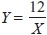
(c) Find P(Y – X ≤ 4)
(3)

(Total for Question 4 is 8 marks)
__________________________________________________________________________

Gold Mark Scheme

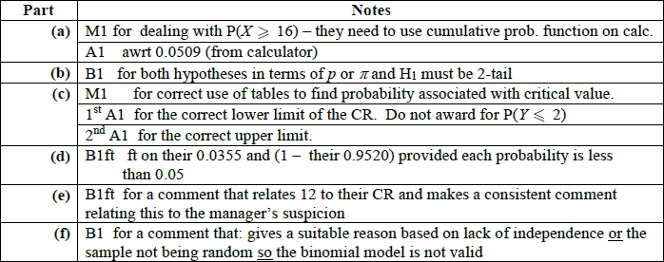
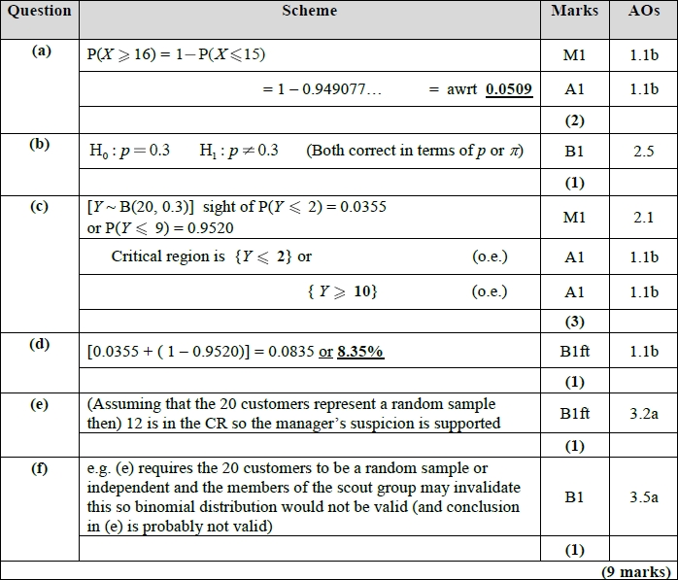
Q1.

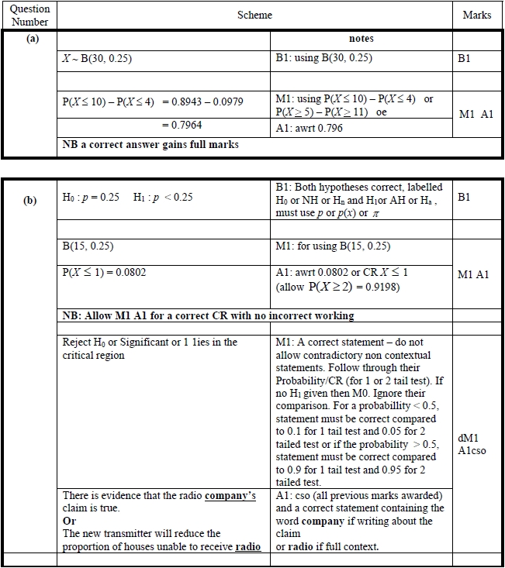
Q2.

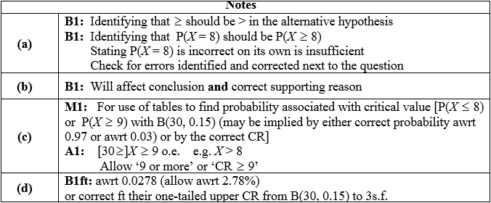
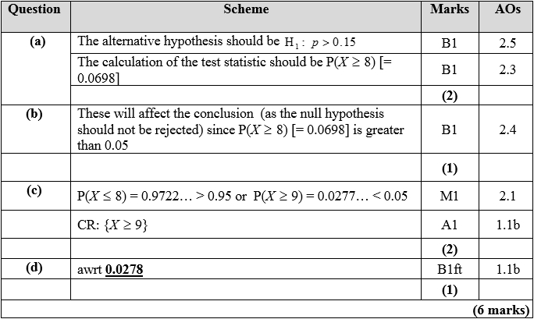
Q3.

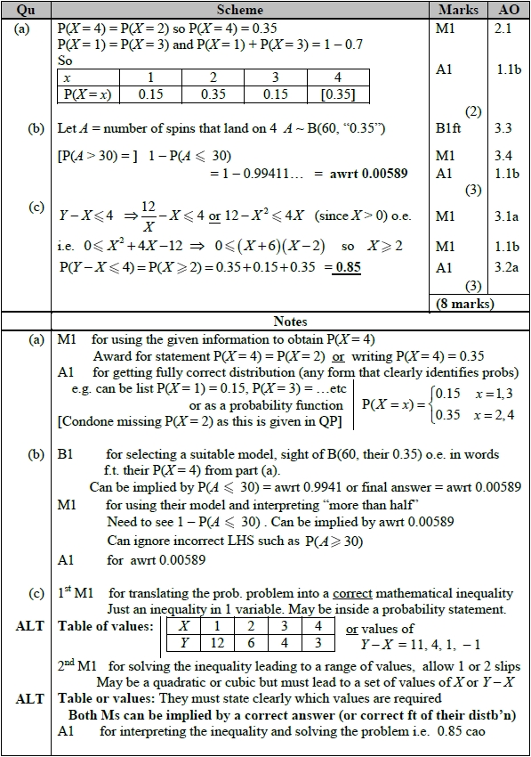
Q4.

