Topic 4 - Moments

Bronze, Silver and Gold Worksheets for

A Level Mathematics

Teacher Notes
These Bronze, Silver and Gold worksheets are designed to be used either straight after the content has been taught or as part of a skills gap analysis.
They are drawn from the latest specification questions and legacy questions. The papers are between approximately 25 and 45 marks.
The topic number on this worksheet relates to the corresponding chapter in the ‘Pearson Edexcel A Level Mathematics: Statistics and Mechanics Year 2’ textbook.

Quick Links
(Press Ctrl, as you click with your mouse to follow these links)
- Bronze Questions
- Bronze Mark Scheme
- Silver Questions
- Silver Mark Scheme
- Gold Questions
- Gold Mark Scheme

Extension and Enrichment
If you have students that have enjoyed the challenge of the Gold questions, then they should have a go at the more challenging question from our Advanced Extension Award (AEA) papers. The Mathematics AEA is a single, 3 hour non-calculator paper, taken at the end of year 13. It helps students to develop high level problem solving and proof skills. It is entirely based on the content of the A Level Mathematics Course. No extra material needs to be covered to take the AEA in Mathematics. A second important difference is that marks are awarded for the clarity and quality of their solution. Developing this key skill, alongside the extra problem-solving experience, can pay dividends in the way they approach A Level Mathematics and Further Mathematics problems.
More information about the Advanced Extension Award can be found here on the Pearson Edexcel Website, or here on the Maths Emporium

Bronze Questions 41 Marks
Calculator
The total mark for this section is 41
Q1
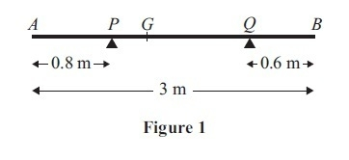
A non-uniform rod AB has length 3 m and mass 4.5 kg. The rod rests in equilibrium, in a horizontal position, on two smooth supports at P and at Q, where AP = 0.8 m and
QB = 0.6 m, as shown in Figure 1. The centre of mass of the rod is at G. Given that the magnitude of the reaction of the support at P on the rod is twice the magnitude of the reaction of the support at Q on the rod, find
(a) the magnitude of the reaction of the support at Q on the rod,
(3)
(b) the distance AG.
(4)

(Total for Question 1 is 7 marks)
__________________________________________________________________________

Q2

A plank AB has length 6m and mass 30kg. The point C is on the plank with CB = 2m. The plank rests in equilibrium in a horizontal position on supports at A and C. Two people, each of mass 75kg, stand on the plank. One person stands at the point P of the plank, where
AP = x metres, and the other person stands at the point Q of the plank, where AQ = 2x metres. The plank remains horizontal and in equilibrium with the magnitude of the reaction at C five times the magnitude of the reaction at A. The plank is modelled as a uniform rod and each person is modelled as a particle.
(a) Find the value of x.
(7)
(b) State two ways in which you have used the assumptions made in modelling the plank as a uniform rod.
(2)
(Total for Question 2 is 9 marks)
__________________________________________________________________________
Q3
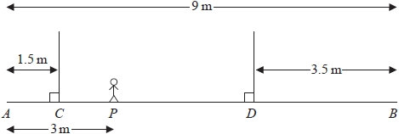
Figure 2
A wooden beam AB, of mass 150 kg and length 9 m, rests in a horizontal position supported by two vertical ropes. The ropes are attached to the beam at C and D, where AC = 1.5 m and BD = 3.5 m. A gymnast of mass 60 kg stands on the beam at the point P, where AP = 3 m, as shown in Figure 2. The beam remains horizontal and in equilibrium.
By modelling the gymnast as a particle, the beam as a uniform rod and the ropes as light inextensible strings,
(a) find the tension in the rope attached to the beam at C.
(3)
The gymnast at P remains on the beam at P and another gymnast, who is also modelled as a particle, stands on the beam at B. The beam remains horizontal and in equilibrium. The mass of the gymnast at B is the largest possible for which the beam remains horizontal and in equilibrium.
(b) Find the tension in the rope attached to the beam at D.
(4)
(Total for Question 3 is 7 marks)
__________________________________________________________________________

Q4
A beam AB has length 6 m and weight 200 N. The beam rests in a horizontal position on two supports at the points C and D, where AC =1 m and DB =1 m. Two children, Sophie and Tom, each of weight 500 N, stand on the beam with Sophie standing twice as far from the end B as Tom. The beam remains horizontal and in equilibrium and the magnitude of the reaction at D is three times the magnitude of the reaction at C. By modelling the beam as a uniform rod and the two children as particles, find how far Tom is standing from the end B.
(7)
(Total for Question 4 is 7 marks)
__________________________________________________________________________

Q5
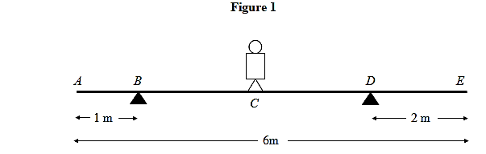
A plank AE, of length 6 m and mass 10 kg, rests in a horizontal position on supports at B and D, where AB = 1 m and DE = 2 m. A child of mass 20 kg stands at C, the mid-point of BD, as shown in Figure 1. The child is modelled as a particle and the plank as a uniform rod. The child and the plank are in equilibrium. Calculate

- the magnitude of the force exerted by the support on the plank at B, (4)
- the magnitude of the force exerted by the support on the plank at D. (3)

The child now stands at a point F on the plank. The plank is in equilibrium and on the point of tilting about D.

- Calculate the distance DF. (4)

(Total for Question 5 is 11 marks)
__________________________________________________________________________
End of questions

Bronze Mark Scheme
Q1
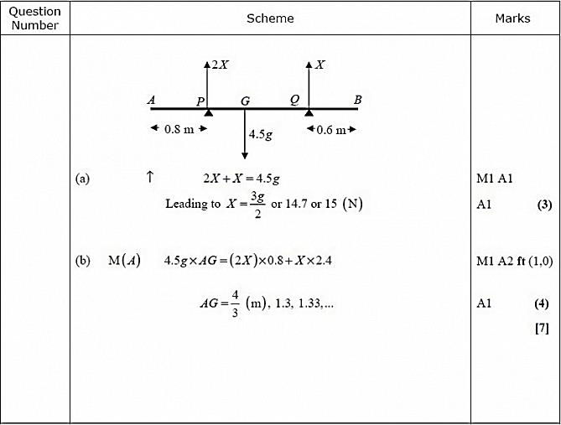
(a)
First M1 for a complete method for finding , either by resolving vertically, or taking moments twice, with usual criteria (allow M1 even if = 2 not substituted)
First A1 for a correct equation in either or ONLY.
Second A1 for 1.5g or 14.7 or 15 (A0 for a negative answer)
(b)
First M1 for taking moments about any point, with usual criteria.
A2 ft for a correct equation (A1A0 one error, A0A0 for two or more errors, ignoring consistent omission of g's) in terms of X and their x (which may not be AG at this stage)
Third A1 for AG = 4/3, 1.3, 1.33,.....(any number of decimal places, since g cancels) need 'AG =' or x marked on diagram.
N.B. if = 2 throughout, mark as a misread as follows:
(a) M1A1A0 (resolution method) (b) M1A0A1A1, assuming all work follows through correctly.

Q2

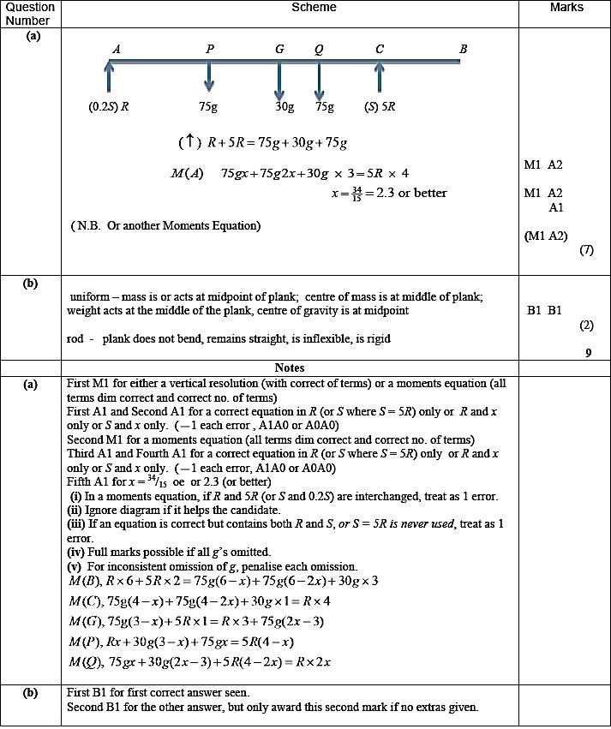

Q3
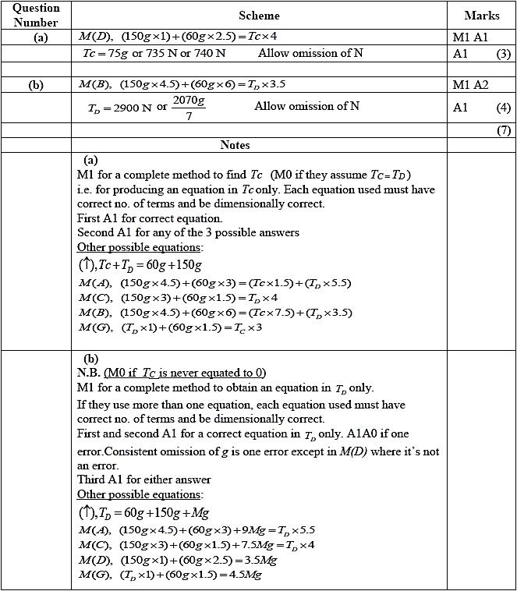

Q4
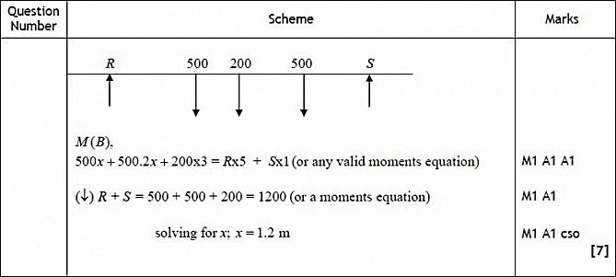
Q5
Scheme Marks
(a) M(D): 20g x 1.5 + 10g x 1 = R_{B} x 3 M1 A1
⇒ R_{B} = 40g/3 ≈ 131 or 130 N M1 A1
(4)
[NB For moments about another point, allow M1 A1 for moments equation dimensionally correct and with correct number of terms; second M1 is for complete method to find R_{B}.]

(b) R(↑): R_{D} + 40g/3 = 20g + 10g M1 A1√
⇒ R_{D} = 50g/3 ≈ 163 or 160 N A1
(3)

or M(B): 20g x 1.5 + 10g x 2 = R_{D} x 3 M1 A1

⇒ R_{D} = 50g/3 ≈ 163 or 160 N A1
(3)
[NB For moments about another point, allow M1 for a complete method to find R_{D}, A1 for a correct equation for R_{D}.]

(c) R_{B} = 0 M1

M(D): 20g X x = 10g X 1 M1 A1

x = DF = 0.5 m A1
(4)
For weight/mass confusion, A0 A0 in (a) but allow f.t. in (b) (ans 50/3 = 16.7)
General rule of deducting max. 1 per question for > 3 s.f
(c) 2nd M1: must have correct no. of non=zero terms, and equation in x only
If use value(s) of R’s from (a) or (b): M0. Total 11 Marks


Silver Questions
Calculator
The total mark for this section is 30
Q1

A steel girder AB, of mass 200 kg and length 12 m, rests horizontally in equilibrium on two smooth supports at C and at D, where AC = 2 m and DB = 2 m. A man of mass 80 kg stands on the girder at the point P, where AP = 4 m, as shown in Figure 1.
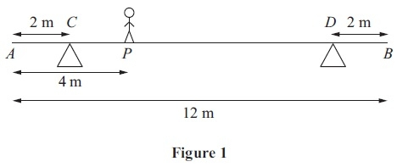
The man is modelled as a particle and the girder is modelled as a uniform rod.
(a) Find the magnitude of the reaction on the girder at the support at C.
(3)
The support at D is now moved to the point X on the girder, where XB = x metres. The man remains on the girder at P, as shown in Figure 2.
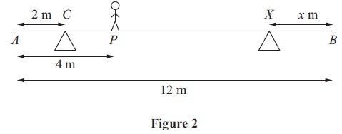
Given that the magnitudes of the reactions at the two supports are now equal and that the girder again rests horizontally in equilibrium, find
(b) the magnitude of the reaction at the support at X,
(2)
(c) the value of x.
(4)
(Total for Question 1 is 9 marks)
__________________________________________________________________________

Q2
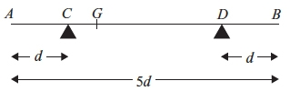
Figure 1
A non-uniform rod AB, of mass m and length 5d, rests horizontally in equilibrium on two supports at C and D, where AC = DB = d, as shown in Figure 1. The centre of mass of the rod is at the point G. A particle of mass m is placed on the rod at B and the rod is on the point of tipping about D.
(a) Show that GD = d.
(4)
The particle is moved from B to the mid-point of the rod and the rod remains in equilibrium.
(b) Find the magnitude of the normal reaction between the support at D and the rod.
(5)
(Total for Question 2 is 9 marks)
__________________________________________________________________________

Q3.
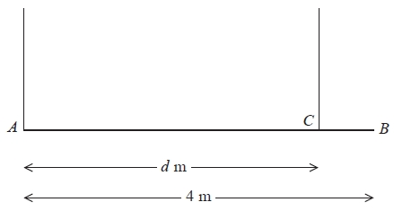
Figure 3
A beam AB has weight W Newtons and length 4 m. The beam is held in equilibrium in a horizontal position by two vertical ropes attached to the beam. One rope is attached to A and the other rope is attached to the point C on the beam, where AC = d metres, as shown in Figure 3. The beam is modelled as a uniform rod and the ropes as light inextensible strings. The tension in the rope attached at C is double the tension in the rope attached at A.
(a) Find the value of d.
(6)
A small load of weight kW Newtons is attached to the beam at B. The beam remains in equilibrium in a horizontal position. The load is modelled as a particle. The tension in the rope attached at C is now four times the tension in the rope attached at A.
(b) Find the value of k.
(6)
(Total for Question 3 is 12 marks)
__________________________________________________________________________
End of questions

Silver Mark Scheme

Q1
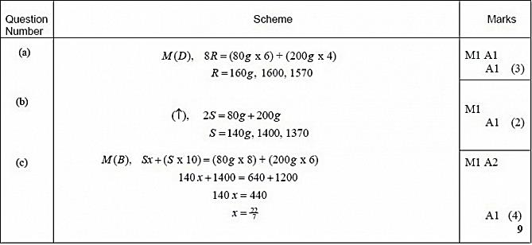

Q2
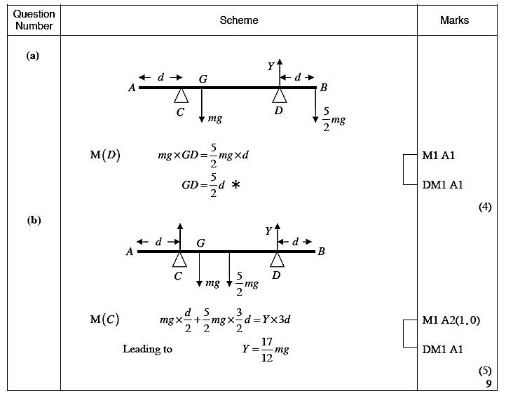
Q3
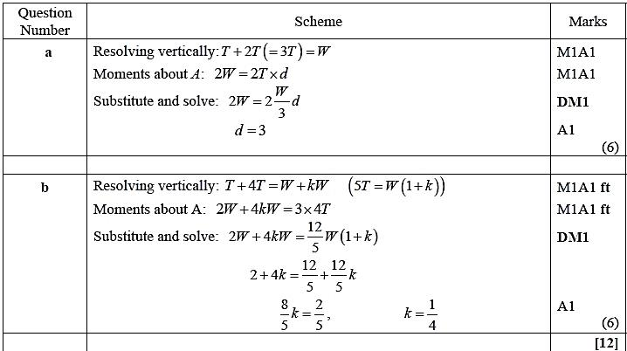
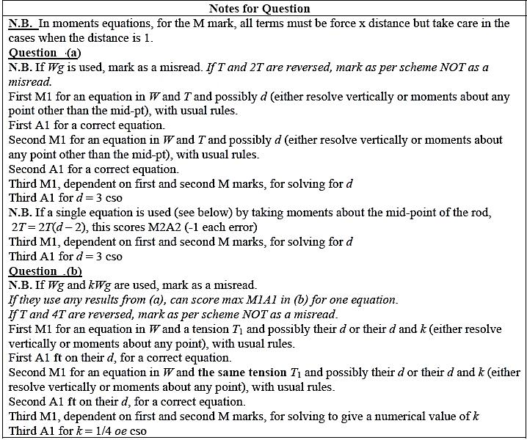
Gold Questions
Calculator
The total mark for this section is 45
Q1
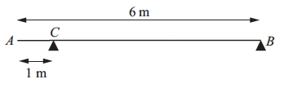
A uniform beam AB has mass 20 kg and length 6 m. The beam rests in equilibrium in a horizontal position on two smooth supports. One support is at C, where AC = 1 m, and the other is at the end B, as shown in the figure above. The beam is modelled as a rod.
(a) Find the magnitudes of the reactions on the beam at B and at C.
(5)
A boy of mass 30 kg stands on the beam at the point D. The beam remains in equilibrium. The magnitudes of the reactions on the beam at B and at C are now equal. The boy is modelled as a particle.
(b) Find the distance AD.
(5)

(Total for Question 1 is 10 marks)
__________________________________________________________________________

Q2
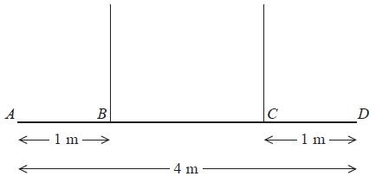
Figure 3
A non-uniform beam AD has weight W Newtons and length 4 m. It is held in equilibrium in a horizontal position by two vertical ropes attached to the beam. The ropes are attached to two points B and C on the beam, where AB = 1 m and CD = 1 m, as shown in Figure 3. The tension in the rope attached to C is double the tension in the rope attached to B. The beam is modelled as a rod and the ropes are modelled as light inextensible strings.
(a) Find the distance of the centre of mass of the beam from A.
(6)
A small load of weight kW Newtons is attached to the beam at D. The beam remains in equilibrium in a horizontal position. The load is modelled as a particle.
Find
(b) an expression for the tension in the rope attached to B, giving your answer in terms of k and W,
(3)
(c) the set of possible values of k for which both ropes remain taut.
(2)
(Total for Question 2 is 11 marks)
__________________________________________________________________________

Q3
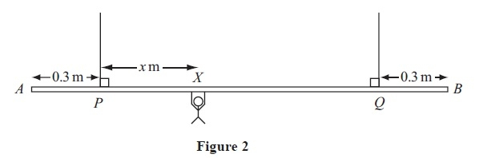
A beam AB is supported by two vertical ropes, which are attached to the beam at points P and Q, where AP = 0.3 m and BQ = 0.3 m. The beam is modelled as a uniform rod, of length 2 m and mass 20 kg. The ropes are modelled as light inextensible strings. A gymnast of mass
50 kg hangs on the beam between P and Q. The gymnast is modelled as a particle attached to the beam at the point X, where PX = x m, 0 < x < 1.4 as shown in Figure 2. The beam rests in equilibrium in a horizontal position.
(a) Show that the tension in the rope attached to the beam at P is (588 − 350x) N.
(3)
(b) Find, in terms of x, the tension in the rope attached to the beam at Q.
(3)
(c) Hence find, justifying your answer carefully, the range of values of the tension which could occur in each rope.
(3)
Given that the tension in the rope attached at Q is three times the tension in the rope attached at P,
(d) find the value of x.
(3)
(Total for Question 3 is 12 marks)
__________________________________________________________________________
End of questions

Gold Mark Scheme

Q1
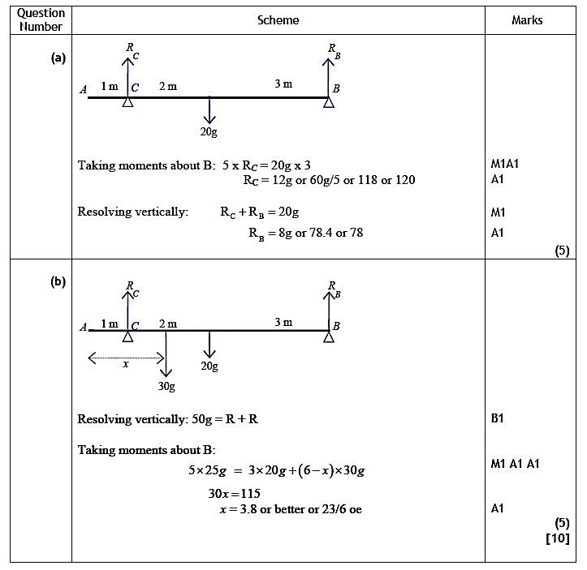

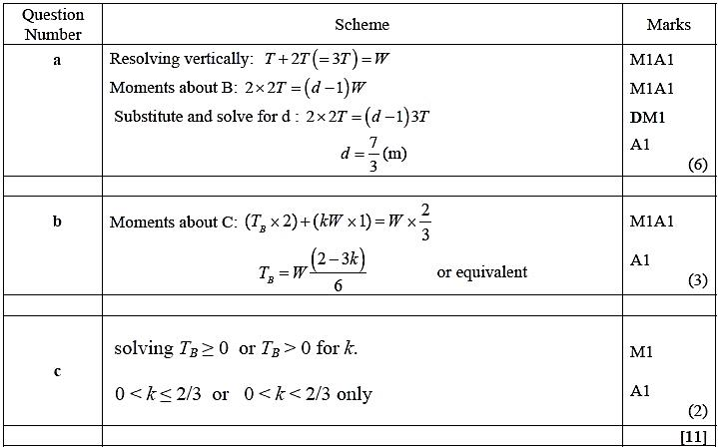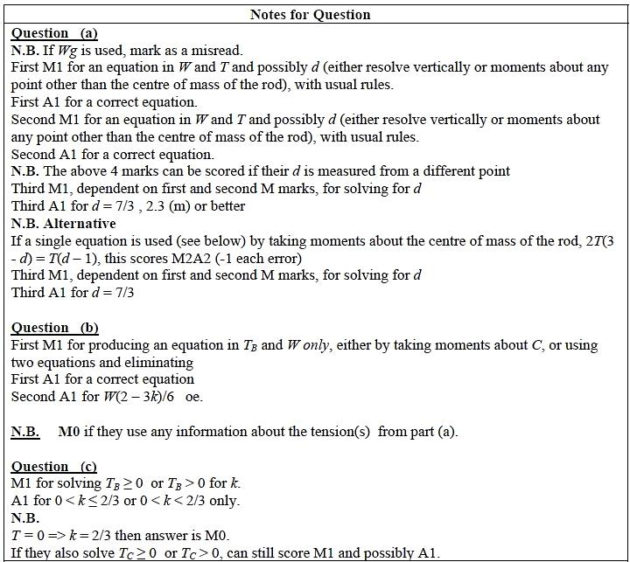
Q2
Q3
