Topic 9

Constant Acceleration

Bronze, Silver, Gold

Worksheets for

AS Level Mathematics

Teacher Notes
These Bronze, Silver and Gold worksheets are designed to be used either straight after the content has been taught or as part of a skills gap analysis, especially as students move into year 13.
They are drawn from the latest specification questions and legacy questions. The papers are between 25 and 35 marks.
The topic number on this worksheet relates to the corresponding chapter number in the ‘Pearson Edexcel AS and A Level Mathematics: Statistics and Mechanics Year 1/AS’ textbook.

Quick Links
(Press Ctrl, as you click with your mouse to follow these links)
- Bronze Questions
- Bronze Mark Scheme
- Silver Questions
- Silver Mark Scheme
- Gold Questions
- Gold Mark Scheme

Extension and Enrichment
If you have students that have enjoyed the challenge of the Gold questions, then they should have a go at the more challenging question from our Advanced Extension Award (AEA) papers. The Mathematics AEA is a single, 3 hour non-calculator paper, taken at the end of year 13. It helps students to develop high level problem solving and proof skills. It is entirely based on the content of the A Level Mathematics Course. No extra material needs to be covered to take the AEA in Mathematics. A second important difference is that marks are awarded for the clarity and quality of their solution. Developing this key skill, alongside the extra problem-solving experience, can pay dividends in the way they approach A Level Mathematics and Further Mathematics problems.
More information about the Advanced Extension Award can be found here on the Pearson Edexcel Website, or here on the Maths Emporium

Bronze Questions
Calculator
The total mark for this section is 35

Q1
A girl runs a 400 m race in a time of 84 s. In a model of this race, it is assumed that, starting from rest, she moves with constant acceleration for 4 s, reaching a speed of 5 m s⁻¹. She maintains this speed for 60 s and then moves with constant deceleration for 20 s, crossing the finishing line with a speed of V m s⁻¹.
(a) Sketch, in the space below, a speed-time graph for the motion of the girl during the
whole race.
(2)
(b) Find the distance run by the girl in the first 64 s of the race.
(3)
(c) Find the value of V.
(5)
(d) Find the deceleration of the girl in the final 20 s of her race.
(2)

(Total for Question 1 is 12 marks)
__________________________________________________________________________

Q2
A car is moving along a straight horizontal road with constant acceleration.
There are three points A, B and C, in that order, on the road, where AB = 22 m
and BC = 104 m.
The car takes 2 s to travel from A to B and 4 s to travel from B to C.
Find
(i) the acceleration of the car,
(ii) the speed of the car at the instant it passes A.
(Total for Question 2 is 7 marks)
__________________________________________________________________________

Q3
A cyclist is moving along a straight horizontal road and passes a point A. Five seconds later, at the instant when she is moving with speed 10 ms⁻¹, she passes the point B. She moves with constant acceleration from A to B.
Given that AB = 40m, find
(a) the acceleration of the cyclist as she moves from A to B,
(4)
(b) the time it takes her to travel from A to the midpoint of AB.
(5)

(Total for Question 3 is 9 marks)
__________________________________________________________________________

Q4
A small stone is projected vertically upwards from a point O with a speed of 19.6ms^{–1}.
Modelling the stone as a particle moving freely under gravity,
(a) find the greatest height above O reached by the stone,
(2)
(b) find the length of time for which the stone is more than 14.7 m above O.
(5)

(Total for Question 4 is 7 marks)
__________________________________________________________________________

End of Questions

Bronze Mark Scheme

Q1
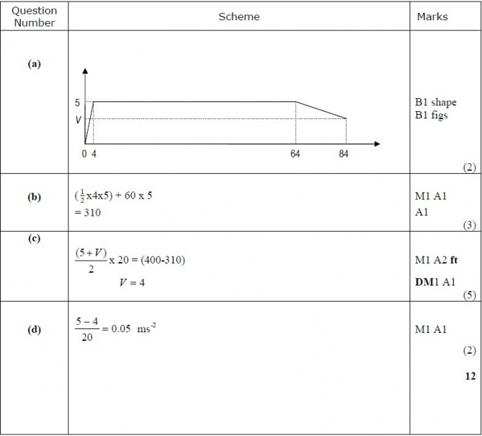

Q2
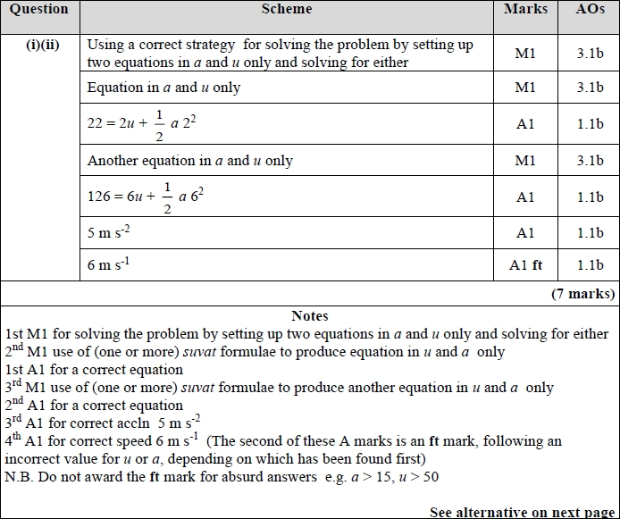

Q3
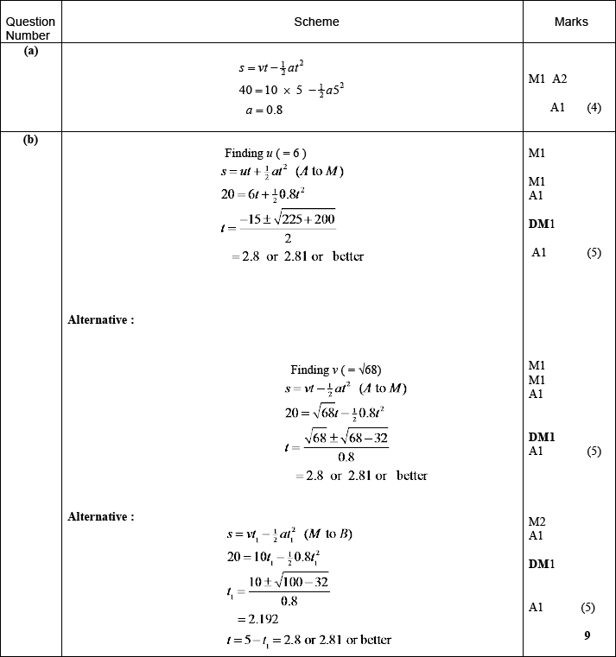

Q4
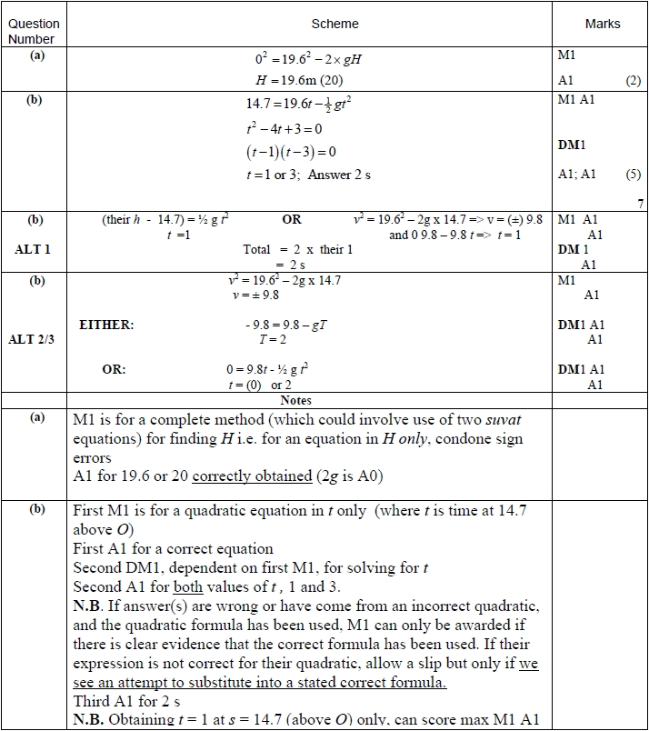


Silver Questions
Calculator
The total mark for this section is 36

Q1
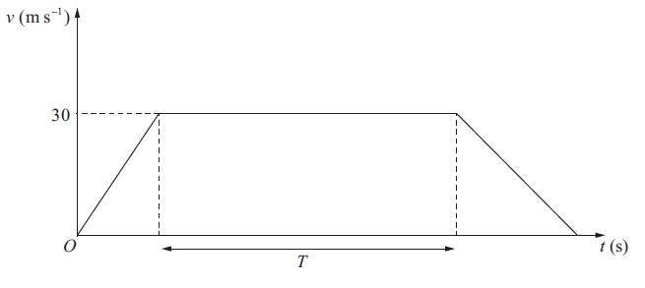
Figure 1

The velocity-time graph in Figure 1 represents the journey of a train P travelling along a straight horizontal track between two stations which are 1.5 km apart. The train P leaves the first station, accelerating uniformly from rest for 300 m until it reaches a speed of 30 m s⁻¹. The train then maintains this speed for T seconds before decelerating uniformly at 1.25 m s⁻², coming to rest at the next station.
(a) Find the acceleration of P during the first 300 m of its journey.
(2)
(b) Find the value of T.
(5)
A second train Q completes the same journey in the same total time. The train leaves the first station, accelerating uniformly from rest until it reaches a speed of V m s⁻¹ and then immediately decelerates uniformly until it comes to rest at the next station.
(c) Sketch on the diagram above, a velocity-time graph which represents the journey
of train Q.
(2)
(d) Find the value of V.
(6)
(Total for Question 1 is 15 marks)
__________________________________________________________________________

Q2
A ball is projected vertically upwards with a speed of 14.7 m s⁻¹ from a point which is 49 m above horizontal ground. Modelling the ball as a particle moving freely under gravity, find
(a) the greatest height, above the ground, reached by the ball,
(4)
(b) the speed with which the ball first strikes the ground,
(3)
(c) the total time from when the ball is projected to when it first strikes the ground.
(3)

(Total for Question 2 is 10 marks)
__________________________________________________________________________

Q3
At time t = 0, a small ball is projected vertically upwards with speed U m s^{–1} from a point A that is 16.8 m
above horizontal ground.
The speed of the ball at the instant immediately before it hits the ground for the first time is 19 m s^{–1}
The ball hits the ground for the first time at time t = T seconds.
The motion of the ball, from the instant it is projected until the instant just before it hits the ground for the first time, is modelled as that of a particle moving freely under gravity.
The acceleration due to gravity is modelled as having magnitude 10 m s^{–2}
Using the model,
(a) show that U = 5
(2)
(b) find the value of T,
(2)
(c) find the time from the instant the ball is projected until the instant when the ball
is 1.2 m below A.
(4)
(d) Sketch a velocity-time graph for the motion of the ball for 0 ≤ t ≤ T, stating the
coordinates of the start point and the end point of your graph.
(2)
In a refinement of the model of the motion of the ball, the effect of air resistance on the ball is included and this refined model is now used to find the value of U.
(e) State, with a reason, how this new value of U would compare with the value found in part (a), using the initial unrefined model.
(1)

(Total for Question 3 is 11 marks)
__________________________________________________________________________

End of Questions

Silver Mark Scheme

Q1
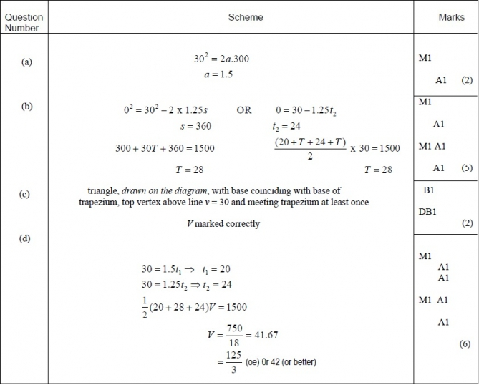

Q2

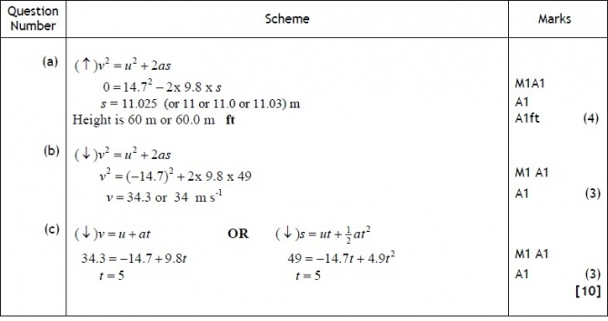
Q3
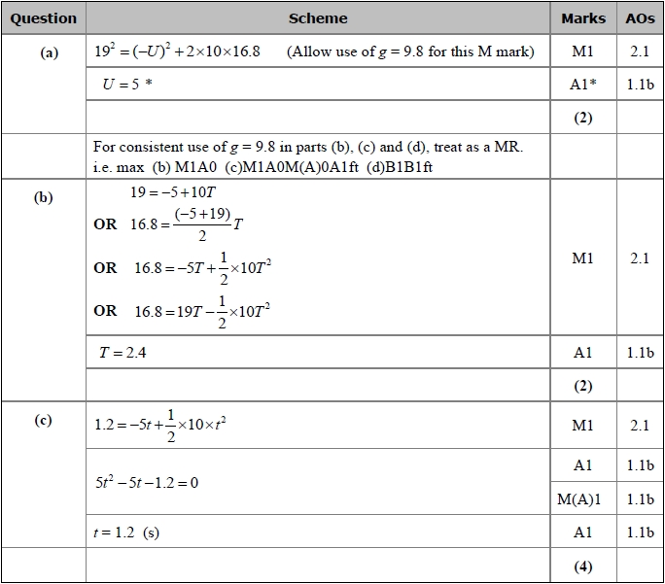
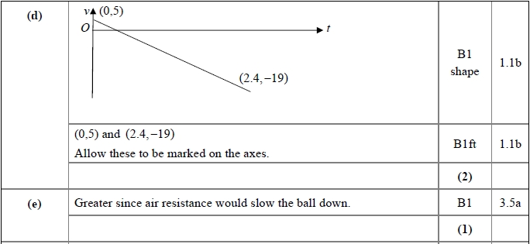
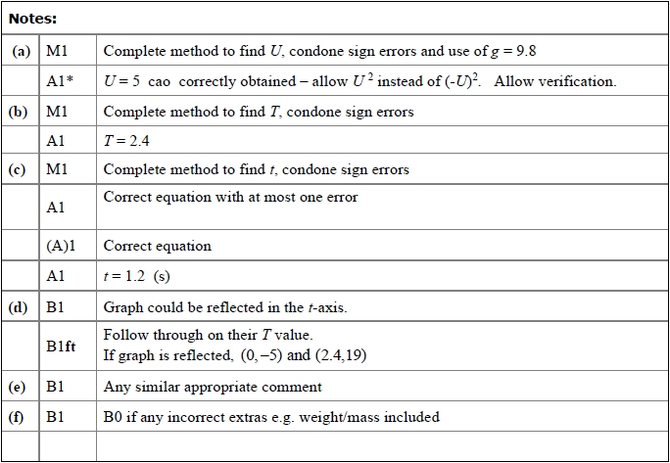
Gold Questions
Calculator
The total mark for this section is 35

Q1
A car is travelling along a straight horizontal road. The car takes 120 s to travel between two sets of traffic lights which are 2145 m apart. The car starts from rest at the first set of traffic lights and moves with constant acceleration for 30 s until its speed is 22 m s⁻¹. The car maintains this speed for T seconds. The car then moves with constant deceleration, coming to rest at the second set of traffic lights.
(a) Sketch, in the space below, a speed-time graph for the motion of the car between the two
sets of traffic lights.
(2)
(b) Find the value of T.
(3)
A motorcycle leaves the first set of traffic lights 10 s after the car has left the first set of traffic lights. The motorcycle moves from rest with constant acceleration, a m s⁻², and passes the car at the point A which is 990 m from the first set of traffic lights. When the motorcycle passes the car, the car is moving with speed 22 m s⁻¹.
(c) Find the time it takes for the motorcycle to move from the first set of traffic lights to the
point A.
(4)
(d) Find the value of a.
(2)

(Total for Question 1 is 11 marks)
__________________________________________________________________________

Q2
At time t = 0, two balls A and B are projected vertically upwards. The ball A is projected vertically upwards with speed 2 m s⁻¹ from a point 50 m above the horizontal ground. The ball B is projected vertically upwards from the ground with speed 20 m s⁻¹. At time t = T seconds, the two balls are at the same vertical height, h metres, above the ground. The balls are modelled as particles moving freely under gravity. Find
(a) the value of T,
(5)
(a) the value of h,
(2)

(Total for Question 2 is 7 marks)
__________________________________________________________________________

Q3
At time t = 0, a parachutist falls vertically from rest from a helicopter which is hovering
at a height of 550 m above horizontal ground.
The parachutist, who is modelled as a particle, falls for 3 seconds before her parachute opens.
While she is falling, and before her parachute opens, she is modelled as falling freely
under gravity.
The acceleration due to gravity is modelled as being 10 m s^{–2}.
(a) Using this model, find the speed of the parachutist at the instant her parachute opens.
(1)
When her parachute is open, the parachutist continues to fall vertically.
Immediately after her parachute opens, she decelerates at 12 m s^{–2} for 2 seconds before
reaching a constant speed and she reaches the ground with this speed.
The total time taken by the parachutist to fall the 550 m from the helicopter to the ground
is T seconds.
(b) Sketch a speed–time graph for the motion of the parachutist for 0 ≤ t ≤ T.
(2)
(c) Find, to the nearest whole number, the value of T.
(5)
In a refinement of the model of the motion of the parachutist, the effect of air resistance
is included before her parachute opens and this refined model is now used to find a new
value of T.
(d) How would this new value of T compare with the value found, using the initial model,
in part (c)?
(1)

(Total for Question 3 is 9 marks)
__________________________________________________________________________

Q4
At time t = 0, a particle is projected vertically upwards with speed u from a point A. The particle moves freely under gravity. At time T the particle is at its maximum height H above A.
(a) Find T in terms of u and g.
(2)
(b) Show that
(2)
The point A is at a height 3H above the ground.
(c) Find, in terms of T, the total time from the instant of projection to the instant when the particle hits the ground.
(4)
(4)
(Total for Question 4 is 8 marks)
__________________________________________________________________________

End of Questions

Gold Mark Scheme

Q1
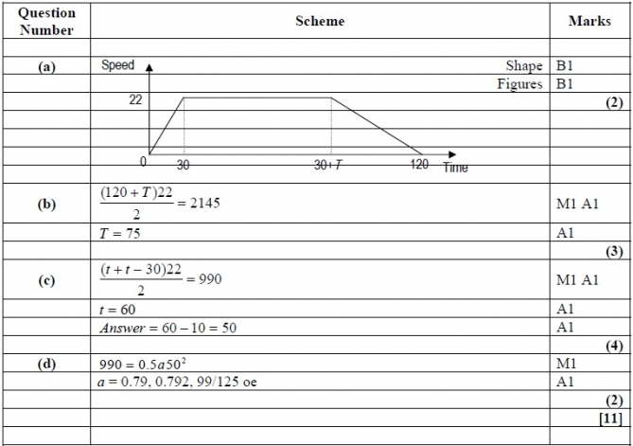

Q2

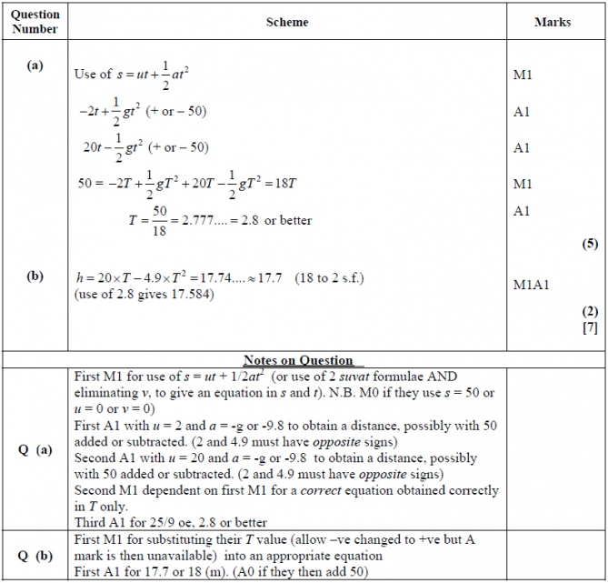
Q3
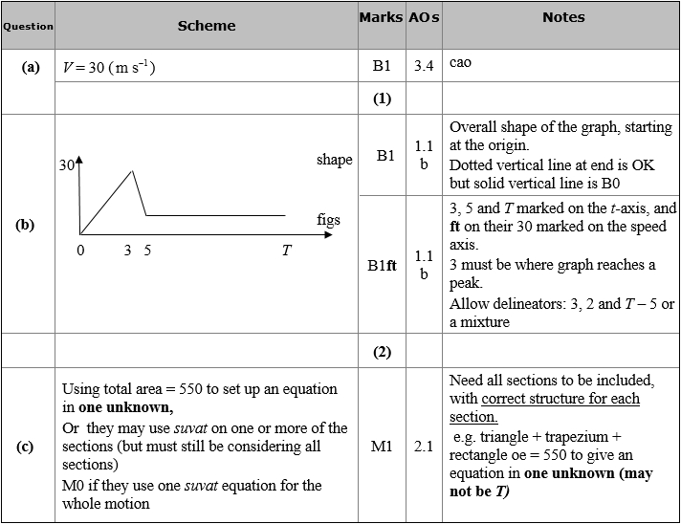
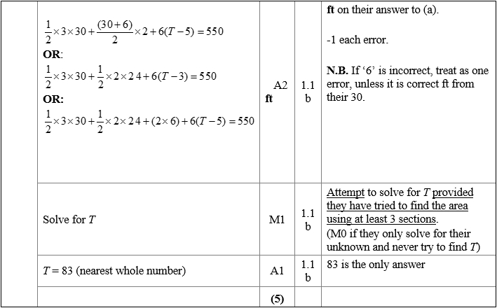
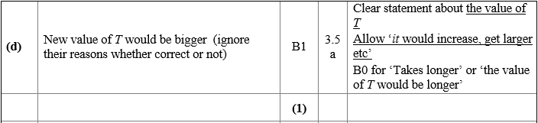
Q4
