Topic 5 - Forces and Friction

Bronze, Silver and Gold Worksheets for A Level Mathematics

Teacher Notes
These Bronze, Silver and Gold worksheets are designed to be used either straight after the content has been taught or as part of a skills gap analysis.
They are drawn from the latest specification questions and legacy questions. The papers are between approximately 25 and 45 marks.
The topic number on this worksheet relates to the corresponding chapter number in the ‘Pearson Edexcel A Level Mathematics: Statistics and Mechanics Year 2’ textbook.

Quick Links
(Press Ctrl, as you click with your mouse to follow these links)
- Bronze Questions
- Bronze Mark Scheme
- Silver Questions
- Silver Mark Scheme
- Gold Questions
- Gold Mark Scheme

Extension and Enrichment
If you have students that have enjoyed the challenge of the Gold questions, then they should have a go at the more challenging question from our Advanced Extension Award (AEA) papers. The Mathematics AEA is a single, 3 hour non-calculator paper, taken at the end of year 13. It helps students to develop high level problem solving and proof skills. It is entirely based on the content of the A Level Mathematics Course. No extra material needs to be covered to take the AEA in Mathematics. A second important difference is that marks are awarded for the clarity and quality of their solution. Developing this key skill, alongside the extra problem-solving experience, can pay dividends in the way they approach A Level Mathematics and Further Mathematics problems.
More information about the Advanced Extension Award can be found here on the Pearson Edexcel Website, or here on the Maths Emporium

Bronze Questions
Calculator
The total mark for this section is 34
Q1
Three forces, (15i + j) N, (5qi − pj) N and (−3pi − qj) N, where p and q are constants, act on a particle. Given that the particle is in equilibrium, find the value of p and the value of q.
(Total for Question 1 is 5 marks)
__________________________________________________________________________

Q2
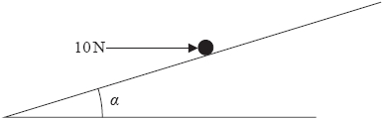
Figure 1
A particle P of mass 5kg is held at rest in equilibrium on a rough inclined plane by a horizontal force of magnitude 10N. The plane is inclined to the horizontal at an angle α where $\tan{α=\frac{3}{4}}$ , as shown in Figure 1. The line of action of the force lies in the vertical plane containing P and a line of greatest slope of the plane. The coefficient of friction between P and the plane is μ. Given that P is on the point of sliding down the plane, find the value of μ.
(Total for Question 2 is 9 marks)
__________________________________________________________________________

Q3
Two forces (4i − 2j) N and (2i + qj) N act on a particle P of mass 1.5 kg. The resultant of these two forces is parallel to the vector (2i + j).
(a) Find the value of q.
(4)
At time t = 0, P is moving with velocity (−2i + 4j)m s⁻¹.
(b) Find the speed of P at time t = 2 seconds.
(6)
(Total for Question 3 is 10 marks)
__________________________________________________________________________
Q4
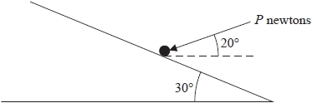
Figure 1
A particle of mass 2 kg lies on a rough plane. The plane is inclined to the horizontal at 30°.
The coefficient of friction between the particle and the plane is $\frac{1}{4}$. The particle is held in equilibrium by a force of magnitude P newtons. The force makes an angle of 20° with the horizontal and acts in a vertical plane containing a line of greatest slope of the plane, as shown in Figure 1. Find the least possible value of P.
(Total for Question 3 is 10 marks)
__________________________________________________________________________
End of questions

Bronze Mark Scheme
Q1
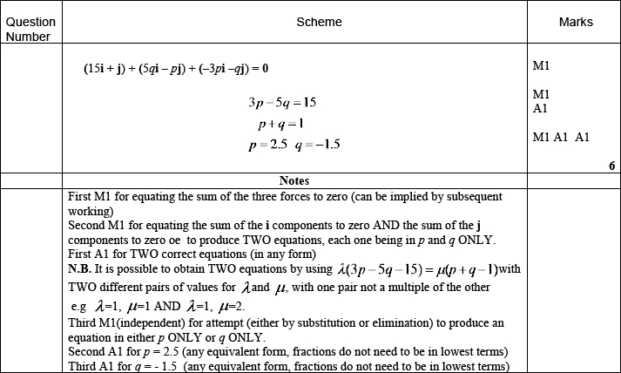
Q2
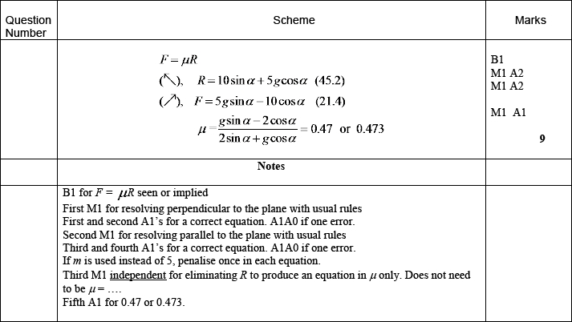

Q3

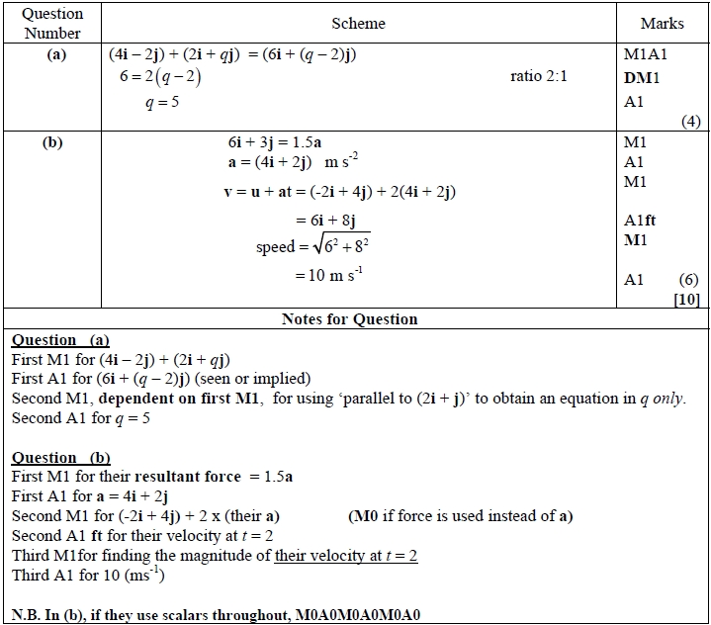

Q4

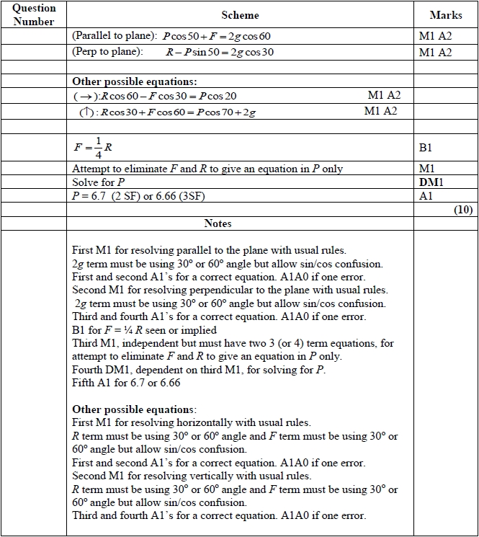


Silver Questions
Calculator
The total mark for this section is 27
Q1
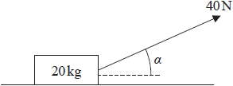
Figure 1
A wooden crate of mass 20 kg is pulled in a straight line along a rough horizontal floor using a handle attached to the crate.
The handle is inclined at an angle α to the floor, as shown in Figure 1, where .
The tension in the handle is 40 N.
The coefficient of friction between the crate and the floor is 0.14.
The crate is modelled as a particle and the handle is modelled as a light rod.
Using the model,
(a) find the acceleration of the crate.
(6)
The crate is now pushed along the same floor using the handle. The handle is again inclined at the same angle α to the floor, and the thrust in the handle is 40 N as shown in Figure 2 below.
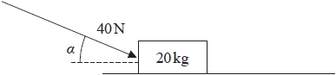
Figure 2
(b) Explain briefly why the acceleration of the crate would now be less than the acceleration of the crate found in part (a).
(2)
(Total for Question 1 is 8 marks)
__________________________________________________________________________

Q2
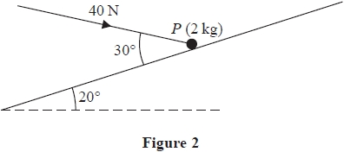
A particle P of mass 2 kg is held at rest in equilibrium on a rough plane by a constant force of magnitude 40 N. The direction of the force is inclined to the plane at an angle of 30°. The plane is inclined to the horizontal at an angle of 20°, as shown in Figure 2. The line of action of the force lies in the vertical plane containing P and a line of greatest slope of the plane. The coefficient of friction between P and the plane is μ.
Given that P is on the point of sliding up the plane, find the value of μ.
(Total for Question 2 is 10 marks)
__________________________________________________________________________

Q3
A rough plane is inclined to the horizontal at an angle α, where .
A brick P of mass m is placed on the plane.
The coefficient of friction between P and the plane is μ.
Brick P is in equilibrium and on the point of sliding down the plane.
Brick P is modelled as a particle.
Using the model,
(a) find, in terms of m and g, the magnitude of the normal reaction of the plane on brick P,
(2)
(b) show that .
(4)
For parts (c) and (d), you are not required to do any further calculations.
Brick P is now removed from the plane and a much heavier brick Q is placed on the plane.
The coefficient of friction between Q and the plane is also .
(c) Explain briefly why brick Q will remain at rest on the plane.
(1)
Brick Q is now projected with speed 0.5 m s⁻¹ down a line of greatest slope of the plane.
Brick Q is modelled as a particle.
Using the model,
(d) describe the motion of brick Q, giving a reason for your answer.
(2)
(Total for Question 3 is 9 marks)
__________________________________________________________________________
End of questions
Silver Mark Scheme
Q1
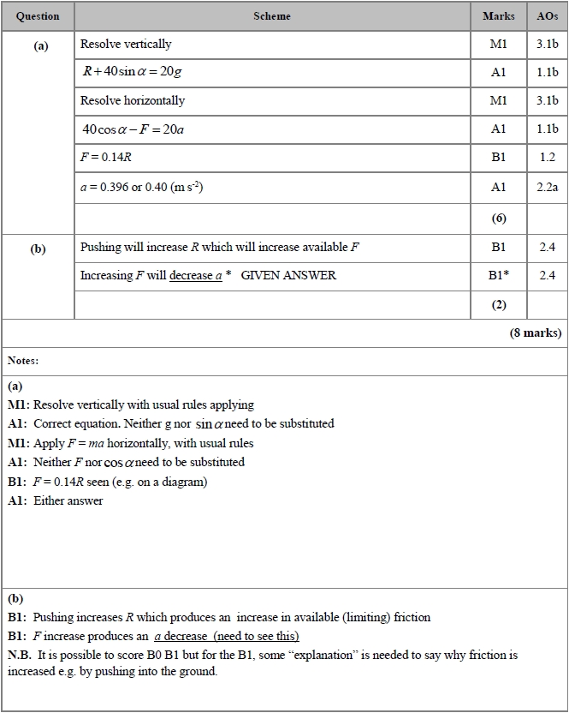

Q2
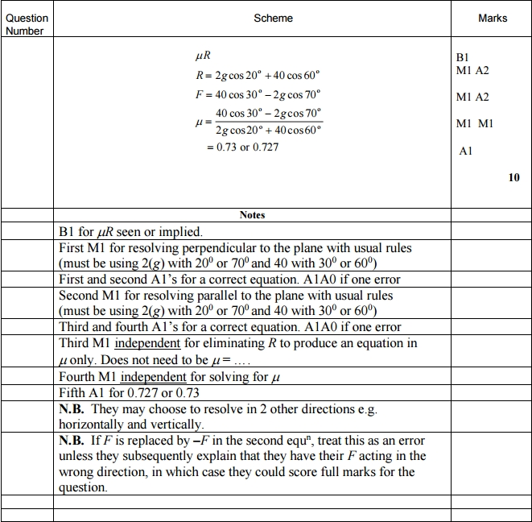

Q3
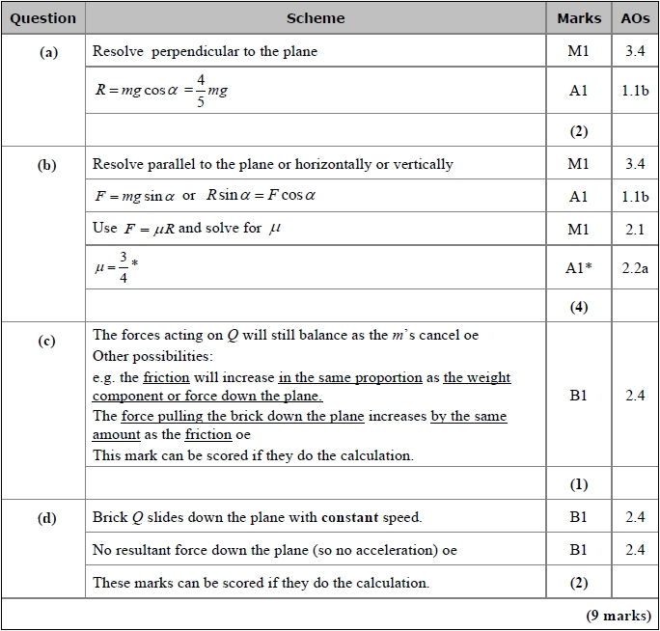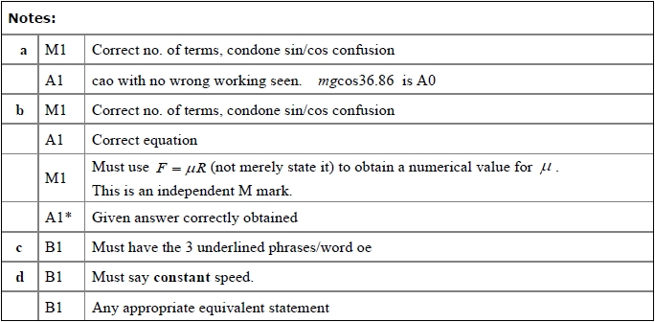

Gold Questions
Calculator
The total mark for this section is 38
Q1

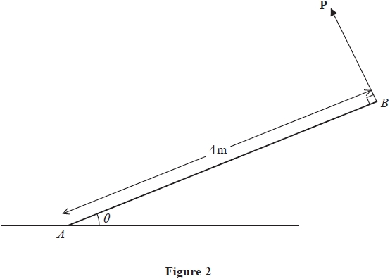
A non-uniform rod AB, of mass 5kg and length 4m, rests with one end A on rough horizontal ground. The centre of mass of the rod is d metres from A. The rod is held in limiting equilibrium at an angle θ to the horizontal by a force P, which acts in a direction perpendicular to the rod at B, as shown in Figure 2. The line of action of P lies in the same vertical plane as the rod.
(a) Find, in terms of d, g and θ,
(i) the magnitude of the vertical component of the force exerted on the rod by the ground,
(ii) the magnitude of the friction force acting on the rod at A.
(8)
Given that tan θ = and that the coefficient of friction between the rod and the ground
is ,
(b) find the value of d.
(4)

(Total for Question 1 is 12 marks)
__________________________________________________________________________

Q2
A rough plane is inclined to the horizontal at an angle α, where .
A particle of mass m is placed on the plane and then projected up a line of greatest slope of the plane.
The coefficient of friction between the particle and the plane is μ.
The particle moves up the plane with a constant deceleration of .
(a) Find the value of μ.
(6)
The particle comes to rest at the point A on the plane.
(b) Determine whether the particle will remain at A, carefully justifying your answer.
(2)

(Total for Question 2 is 8 marks)
__________________________________________________________________________
Q3
A particle P moves with acceleration (4i − 5j) m s⁻²
At time t = 0, P is moving with velocity (−2i + 2j) m s⁻¹
(a) Find the velocity of P at time t = 2 seconds.
(2)
At time t = 0, P passes through the origin O.
At time t = T seconds, where T > 0, the particle P passes through the point A.
The position vector of A is (λi − 4.5j)m relative to O, where λ is a constant.
(b) Find the value of T.
(4)
(c) Hence find the value of λ
(2)

(Total for Question 3 is 8 marks)
__________________________________________________________________________

Q4
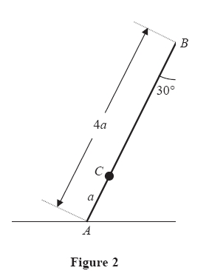
A ladder AB, of mass m and length 4a, has one end A resting on rough horizontal ground. The other end B rests against a smooth vertical wall. A load of mass 3m is fixed on the ladder at the point C, where AC = a. The ladder is modelled as a uniform rod in a vertical plane perpendicular to the wall and the load is modelled as a particle. The ladder rests in limiting equilibrium making an angle of 30° with the wall, as shown in Figure 2.
Find the coefficient of friction between the ladder and the ground.
(Total for Question 4 is 10 marks)
__________________________________________________________________________

Gold Mark Scheme
Q1
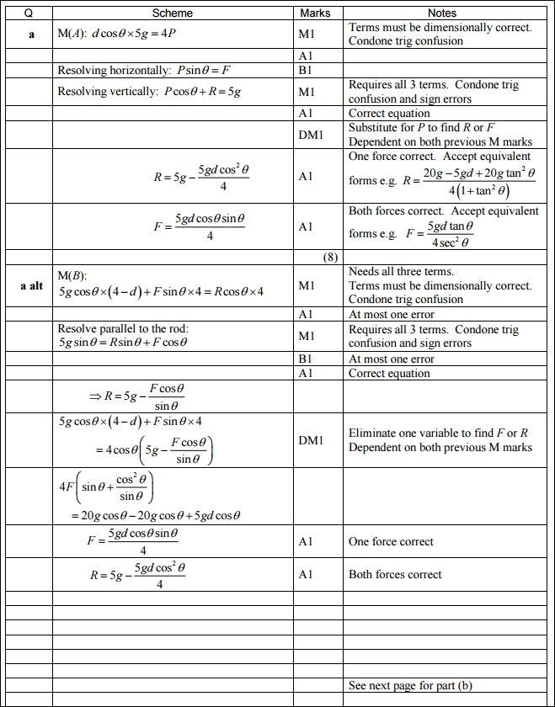
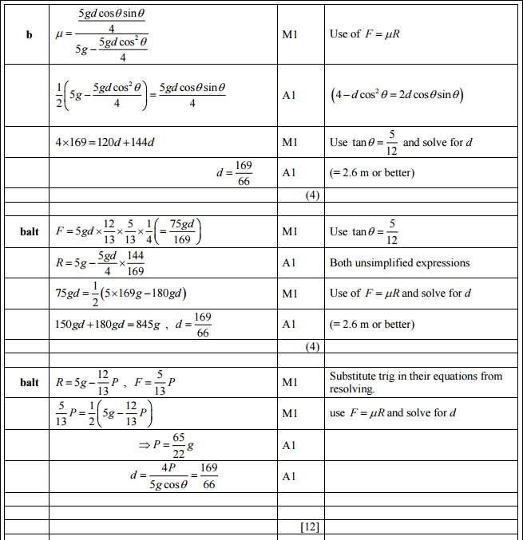

Q2
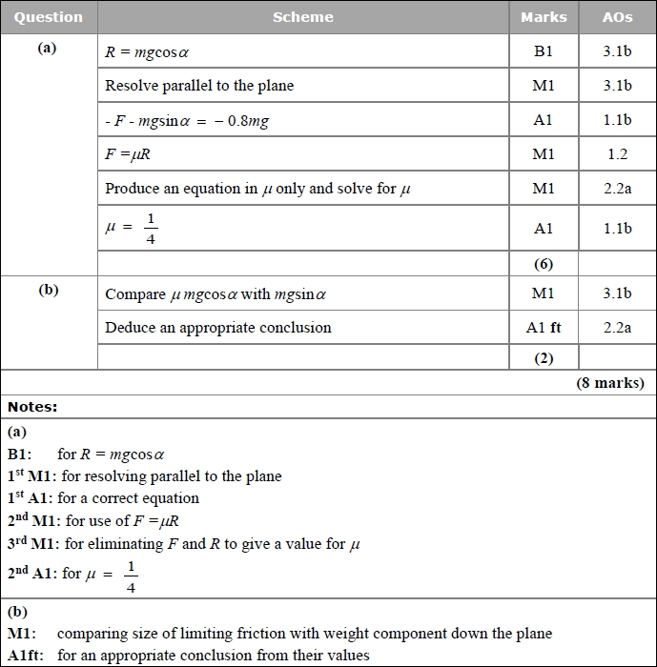

Q3

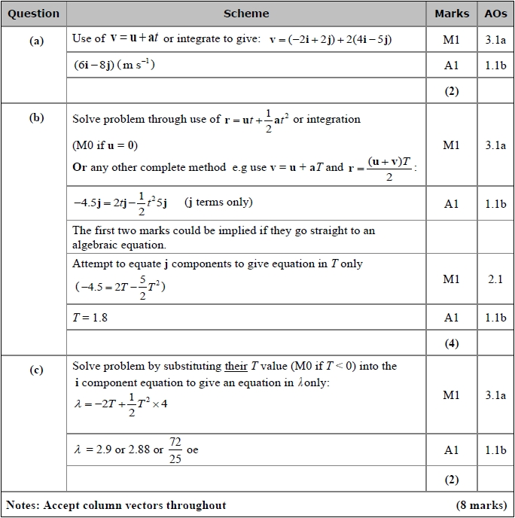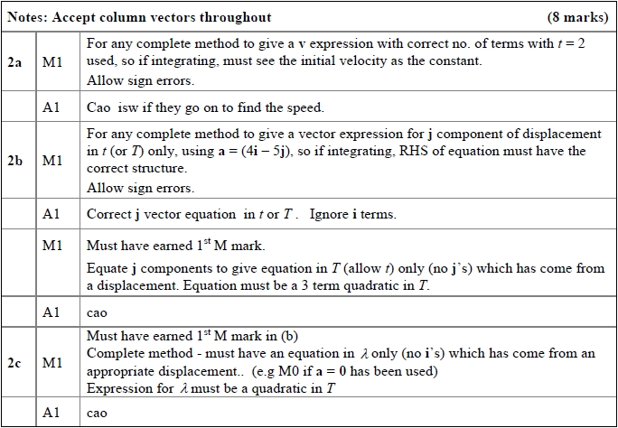
Q4

