Topic 10

Forces and Motion

Bronze, Silver, Gold

Worksheets for

AS Level Mathematics

Teacher Notes
These Bronze, Silver and Gold worksheets are designed to be used either straight after the content has been taught or as part of a skills gap analysis, especially as students move into year 13.
They are drawn from the latest specification questions and legacy questions. The papers are between 25 and 35 marks.
The topic number on this worksheet relates to the corresponding chapter number in the ‘Pearson Edexcel AS and A Level Mathematics: Statistics and Mechanics Year 1/AS’ textbook.

Quick Links
(Press Ctrl, as you click with your mouse to follow these links)
- Bronze Questions
- Bronze Mark Scheme
- Silver Questions
- Silver Mark Scheme
- Gold Questions
- Gold Mark Scheme

Extension and Enrichment
If you have students that have enjoyed the challenge of the Gold questions, then they should have a go at the more challenging question from our Advanced Extension Award (AEA) papers. The Mathematics AEA is a single, 3 hour non-calculator paper, taken at the end of year 13. It helps students to develop high level problem solving and proof skills. It is entirely based on the content of the A Level Mathematics Course. No extra material needs to be covered to take the AEA in Mathematics. A second important difference is that marks are awarded for the clarity and quality of their solution. Developing this key skill, alongside the extra problem-solving experience, can pay dividends in the way they approach A Level Mathematics and Further Mathematics problems.
More information about the Advanced Extension Award can be found here on the Pearson Edexcel Website, or here on the Maths Emporium

Bronze Questions
Calculator
The total mark for this section is 24

Q1
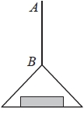
Figure 1

A vertical rope AB has its end B attached to the top of a scale pan. The scale pan has mass 0.5 kg and carries a brick of mass 1.5 kg, as shown in Figure 1. The scale pan is raised vertically upwards with constant acceleration 0.5 m s^{–2} using the rope AB. The rope is modelled as a light inextensible string.
(a) Find the tension in the rope AB.
(3)
(b) Find the magnitude of the force exerted on the scale pan by the brick.
(3)

(Total for Question 1 is 6 marks)
__________________________________________________________________________

Q2
A car of mass 1000 kg is towing a caravan of mass 750 kg along a straight horizontal road. The caravan is connected to the car by a tow-bar which is parallel to the direction of motion of the car and the caravan. The tow-bar is modelled as a light rod. The engine of the car provides a constant driving force of 3200 N. The resistances to the motion of the car and the caravan are modelled as constant forces of magnitude 800 newtons and R newtons respectively.
Given that the acceleration of the car and the caravan is 0.88 m s⁻²,
(a) show that R = 860,
(3)
(b) find the tension in the tow-bar.
(3)

(Total for Question 2 is 6 marks)
__________________________________________________________________________

Q3
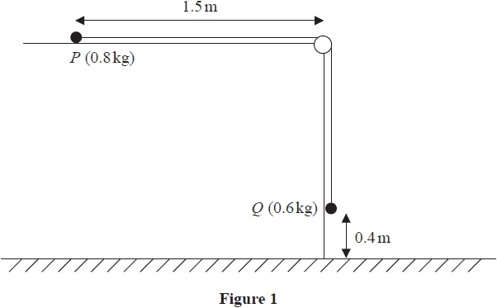
Figure 2

A small ball, P, of mass 0.8 kg, is held at rest on a smooth horizontal table and is attached
to one end of a thin rope.
The rope passes over a pulley that is fixed at the edge of the table.
The other end of the rope is attached to another small ball, Q, of mass 0.6 kg, that hangs
freely below the pulley.
Ball P is released from rest, with the rope taut, with P at a distance of 1.5 m from the
pulley and with Q at a height of 0.4 m above the horizontal floor, as shown in Figure 1.
Ball Q descends, hits the floor and does not rebound.
The balls are modelled as particles, the rope as a light and inextensible string and the pulley
as small and smooth.
Using this model,
(a) show that the acceleration of Q, as it falls, is 4.2 m s^{–2}
(5)
(b) find the time taken by P to hit the pulley from the instant when P is released.
(6)
(c) State one limitation of the model that will affect the accuracy of your answer to
part (a).
(1)

(Total for Question 3 is 12 marks)
__________________________________________________________________________

End of Questions

Bronze Mark Scheme

Q1

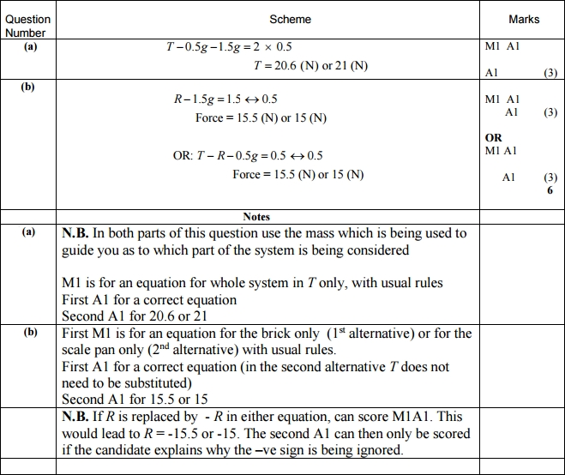
Q2
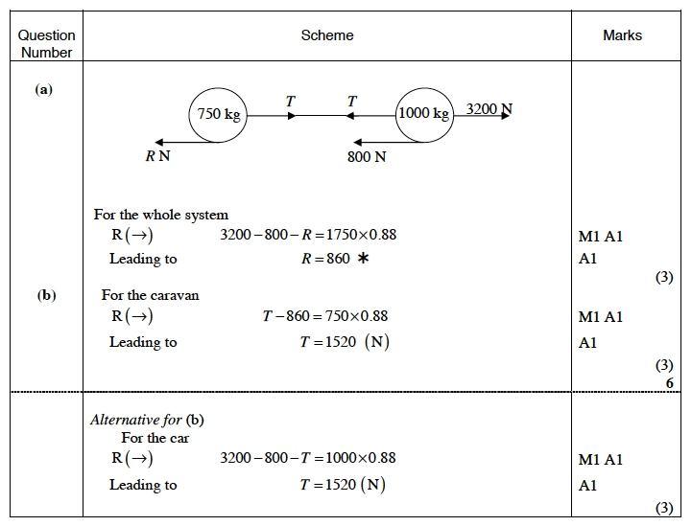

Q3
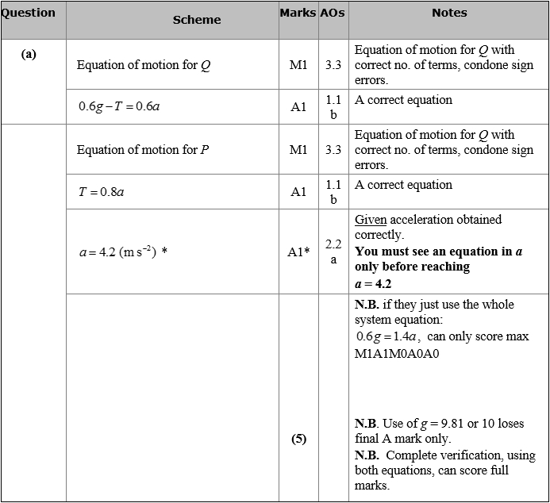
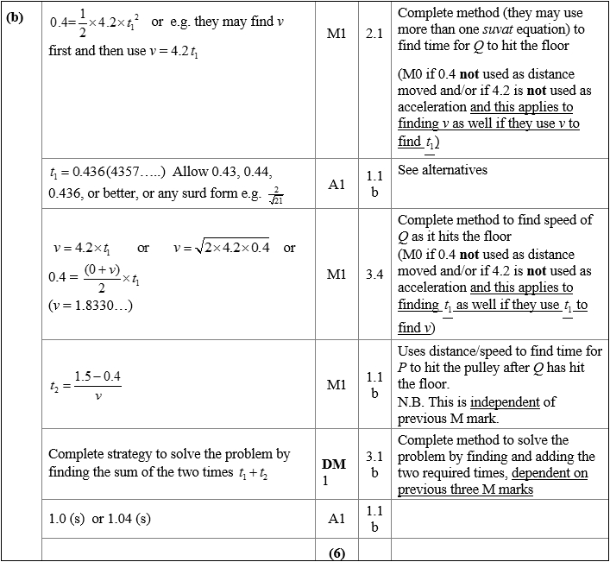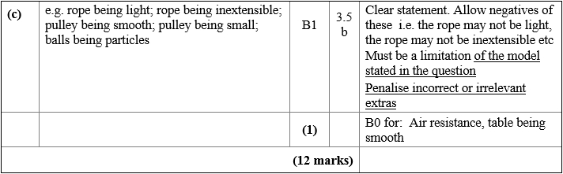

Silver Questions
Calculator
The total mark for this section is 35

Q1
A woman travels in a lift. The mass of the woman is 50 kg and the mass of the lift is 950 kg. The lift is being raised vertically by a vertical cable which is attached to the top of the lift. The lift is moving upwards and has constant deceleration of 2 m s⁻². By modelling the cable as being light and inextensible, find
(a) the tension in the cable,
(3)
(b) the magnitude of the force exerted on the woman by the floor of the lift.
(3)

(Total for Question 1 is 6 marks)
__________________________________________________________________________

Q2
A car of mass 800 kg pulls a trailer of mass 200 kg along a straight horizontal road using a light towbar which is parallel to the road. The horizontal resistances to motion of the car and the trailer have magnitudes 400 N and 200 N respectively. The engine of the car produces a constant horizontal driving force on the car of magnitude 1200 N. Find
(a) the acceleration of the car and trailer,
(3)
(b) the magnitude of the tension in the towbar.
(3)
The car is moving along the road when the driver sees a hazard ahead. He reduces the force produced by the engine to zero and applies the brakes. The brakes produce a force on the car of magnitude F newtons and the car and trailer decelerate. Given that the resistances to motion are unchanged and the magnitude of the thrust in the towbar is 100 N,
(c) find the value of F.
(7)

(Total for Question 2 is 13 marks)
__________________________________________________________________________

Q3

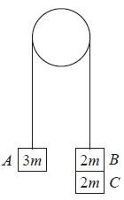
Figure 1

Three particles A, B and C have masses 3m, 2m and 2m respectively. Particle C is attached to particle B. Particles A and B are connected by a light inextensible string which passes over a smooth light fixed pulley. The system is held at rest with the string taut and the hanging parts of the string vertical, as shown in Figure 1. The system is released from rest and A moves upwards.
(a) (i) Show that the acceleration of A is
(ii) Find the tension in the string as A ascends.
(7)
At the instant when A is 0.7 m above its original position, C separates from B and falls away. In the subsequent motion, A does not reach the pulley.
(b) Find the speed of A at the instant when it is 0.7 m above its original position.
(2)
(c) Find the acceleration of A at the instant after C separates from B.
(4)
(d) Find the greatest height reached by A above its original position.
(3)
(Total for Question 3 is 16 marks)
__________________________________________________________________________

End of Questions

Silver Mark Scheme

Q1

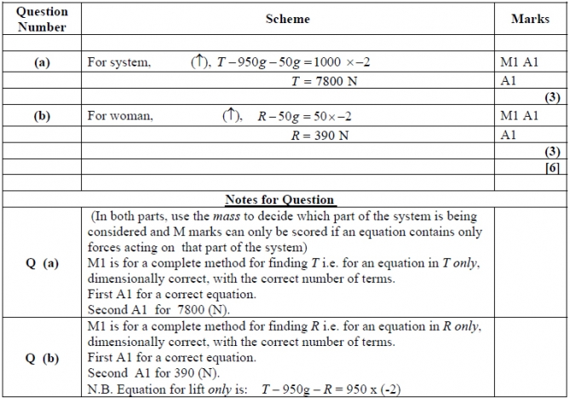
Q2
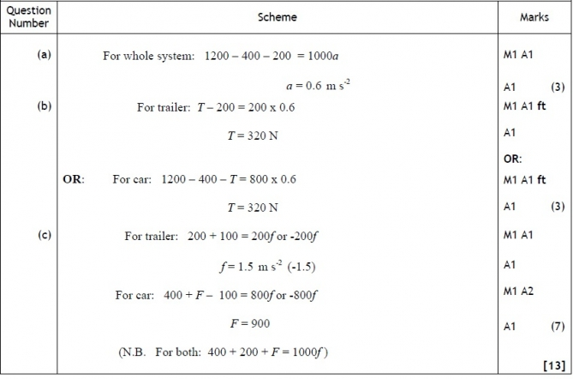

Q3

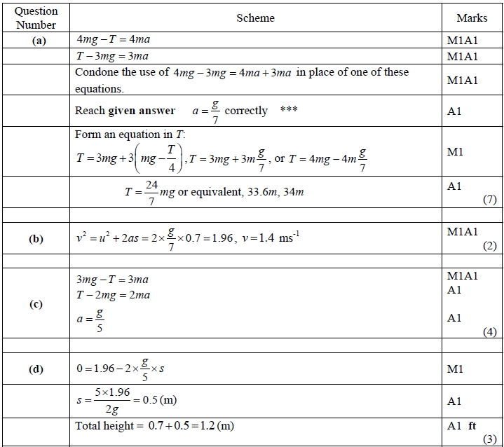

Gold Questions
Calculator
The total mark for this section is 30

Q1
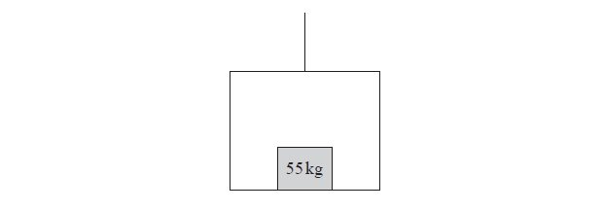
Figure 1
A lift of mass 200 kg is being lowered into a mineshaft by a vertical cable attached
to the top of the lift. A crate of mass 55 kg is on the floor inside the lift, as shown in
Figure 1. The lift descends vertically with constant acceleration. There is a constant
upwards resistance of magnitude 150 N on the lift. The crate experiences a constant
normal reaction of magnitude 473 N from the floor of the lift.
(a) Find the acceleration of the lift.
(3)
(b) Find the magnitude of the force exerted on the lift by the cable.
(4)

(Total for Question 1 is 7 marks)
__________________________________________________________________________

Q2
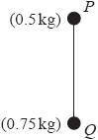

Figure 2
A vertical light rod PQ has a particle of mass 0.5kg attached to it at P and a particle of mass 0.75kg attached to it at Q, to form a system, as shown in Figure 2. The system is accelerated vertically upwards by a vertical force of magnitude 15N applied to the particle at Q. Find the thrust in the rod.

(Total for Question 2 is 6 marks)
__________________________________________________________________________

Q3
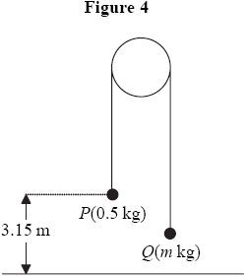

Figure 3

Two particles P and Q have mass 0.5 kg and m kg respectively, where m < 0.5. The particles are connected by a light inextensible string which passes over a smooth, fixed pulley, as shown in Figure 3. Initially P is 3.15 m above horizontal ground. The particles are released from rest with the string taut and the hanging parts of the string vertical, as shown in Figure 4. After P has been descending for 1.5 s, it strikes the ground. Particle P reaches the ground before Q has reached the pulley.
(a) Show that the acceleration of P as it descends is 2.8 m s^{–2}.
(3)
(b) Find the tension in the string as P descends.
(3)
(c) Show that m =
(4)
(d) State how you have used the information that the string is inextensible.
(1)
When P strikes the ground, P does not rebound and the string becomes slack. Particle Q then moves freely under gravity, without reaching the pulley, until the string becomes taut again.
(e) Find the time between the instant when P strikes the ground and the instant when the string becomes taut again.
(6)

(Total for Question 3 is 17 marks)
__________________________________________________________________________

End of Questions

Gold Mark Scheme
Q1
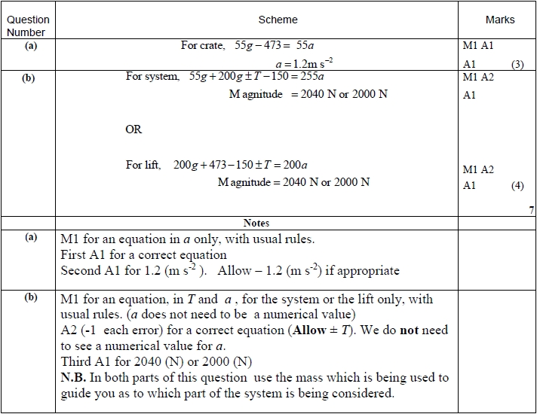

Q2
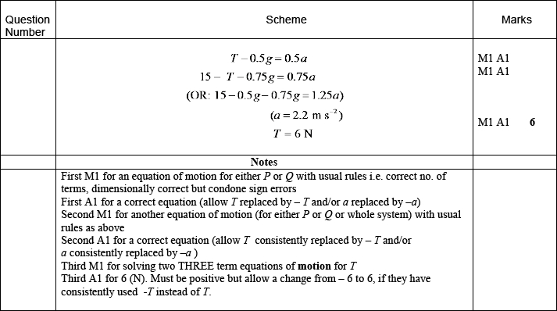
Q3

