Topic 6 - Projectiles

Bronze, Silver and Gold Worksheets for

A Level Mathematics

Teacher Notes
These Bronze, Silver and Gold worksheets are designed to be used either straight after the content has been taught or as part of a skills gap analysis.
They are drawn from the latest specification questions and legacy questions. The papers are between approximately 25 and 45 marks.
The topic number on this worksheet relates to the corresponding chapter number in the ‘Pearson Edexcel A Level Mathematics: Statistics and Mechanics Year 2’ textbook.

Quick Links
(Press Ctrl, as you click with your mouse to follow these links)
- Bronze Questions
- Bronze Mark Scheme
- Silver Questions
- Silver Mark Scheme
- Gold Questions
- Gold Mark Scheme

Extension and Enrichment
If you have students that have enjoyed the challenge of the Gold questions, then they should have a go at the more challenging question from our Advanced Extension Award (AEA) papers. The Mathematics AEA is a single, 3 hour non-calculator paper, taken at the end of year 13. It helps students to develop high level problem solving and proof skills. It is entirely based on the content of the A Level Mathematics Course. No extra material needs to be covered to take the AEA in Mathematics. A second important difference is that marks are awarded for the clarity and quality of their solution. Developing this key skill, alongside the extra problem-solving experience, can pay dividends in the way they approach A Level Mathematics and Further Mathematics problems.
More information about the Advanced Extension Award can be found here on the Pearson Edexcel Website, or here on the Maths Emporium

Bronze Questions
Calculator
The total mark for this section is 38
Q1

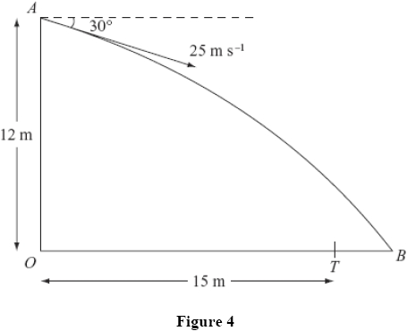
A ball is thrown from a point A at a target, which is on horizontal ground. The point A is
12 m above the point O on the ground. The ball is thrown from A with speed 25 m s^{–1} at an angle of 30° below the horizontal. The ball is modelled as a particle and the target as a point T. The distance OT is 15 m. The ball misses the target and hits the ground at the point B, where OTB is a straight line, as shown in Figure 4. Find
(a) the time taken by the ball to travel from A to B,
(5)
(b) the distance TB.
(4)
The point X is on the path of the ball vertically above T.
(c) Find the speed of the ball at X.
(5)
(Total for Question 1 is 14 marks)

Q2
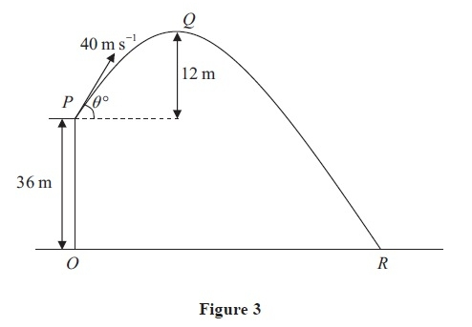
A ball is projected with speed 40 m s⁻¹ from a point P on a cliff above horizontal ground. The point O on the ground is vertically below P and OP is 36 m. The ball is projected at an angle θº to the horizontal. The point Q is the highest point of the path of the ball and is 12 m above the level of P. The ball moves freely under gravity and hits the ground at the point R, as shown in Figure 3. Find
(a) the value of θ,
(3)
(b) the distance OR.
(6)
(Total for Question 2 is 9 marks)

Q3
[In this question, the unit vectors i and j are horizontal and vertical respectively.]
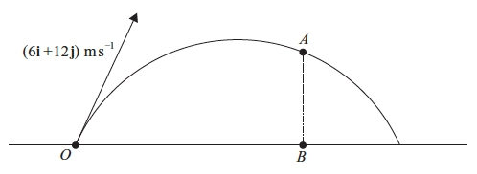
Figure 3
The point O is a fixed point on a horizontal plane. A ball is projected from O with velocity
(6i +12j) m s⁻¹, and passes through the point A at time t seconds after projection. The point B is on the horizontal plane vertically below A, as shown in Figure 3. It is given that OB = 2AB.
Find
(a) the value of t,
(7)
(b) the speed, V m s⁻¹, of the ball at the instant when it passes through A.
(5)
At another point C on the path the speed of the ball is also V m s⁻¹.
(c) Find the time taken for the ball to travel from O to C.
(3)

(Total for Question 3 is 15 marks)
End of questions

Bronze Mark Scheme
Q1

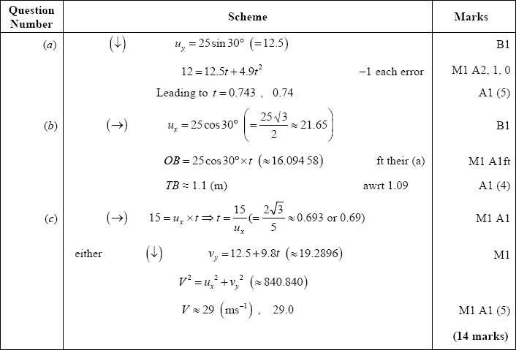
Q2
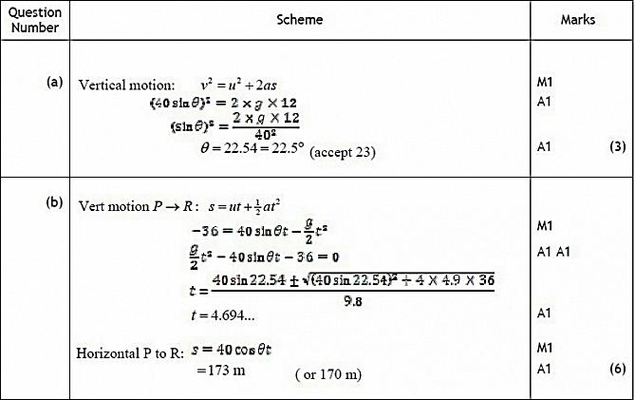
(9 marks)
Q3
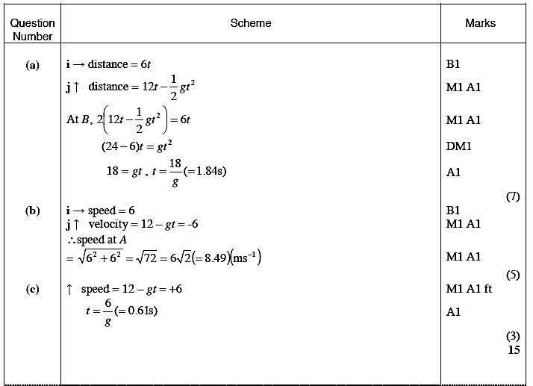


Silver Questions
Calculator
The total mark for this section is 45
Q1
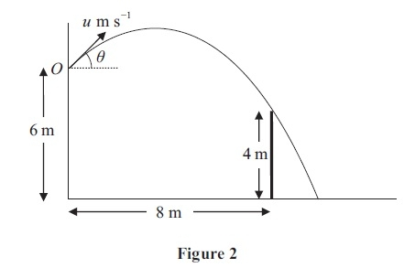
A ball is thrown from a point O, which is 6 m above horizontal ground. The ball is projected with speed u m s⁻¹ at an angle θ above the horizontal. There is a thin vertical post which is
4 m high and 8 m horizontally away from the vertical through O, as shown in Figure 2. The ball passes just above the top of the post 2 s after projection. The ball is modelled as a particle.
(a) Show that tan θ = 2.2
(5)
(b) Find the value of u.
(2)
The ball hits the ground T seconds after projection.
(c) Find the value of T.
(3)
Immediately before the ball hits the ground the direction of motion of the ball makes an angle α with the horizontal.
(d) Find α.
(5)
(Total for Question 1 is 15 marks)

Q2
A particle is projected from a point O with speed u at an angle of elevation α above the horizontal and moves freely under gravity. When the particle has moved a horizontal distance x, its height above O is y.
(a) Show that
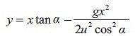
(4)
A girl throws a ball from a point A at the top of a cliff. The point A is 8 m above a horizontal beach. The ball is projected with speed 7 m s⁻¹ at an angle of elevation of 45º. By modelling the ball as a particle moving freely under gravity,
(b) find the horizontal distance of the ball from A when the ball is 1 m above the beach.
(5)
A boy is standing on the beach at the point B vertically below A. He starts to run in a straight line with speed v m s⁻¹, leaving B 0.4 seconds after the ball is thrown.
He catches the ball when it is 1 m above the beach.
(c) Find the value of v.
(4)
(Total for Question 2 is 13 marks)

Q3
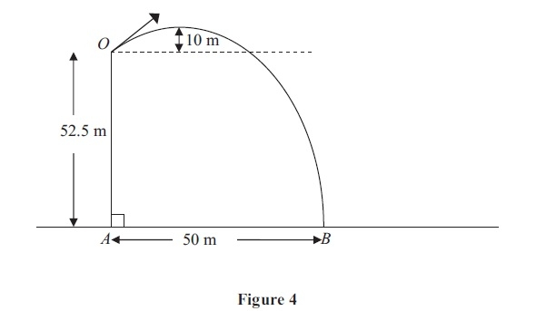
A small stone is projected from a point O at the top of a vertical cliff OA. The point O is
52.5 m above the sea. The stone rises to a maximum height of 10 m above the level of O before hitting the sea at the point B, where AB = 50 m, as shown in Figure 4. The stone is modelled as a particle moving freely under gravity.
(a) Show that the vertical component of the velocity of projection of the stone is 14 m s⁻¹.
(3)
(b) Find the speed of projection.
(9)
(c) Find the time after projection when the stone is moving parallel to OB.
(5)
(Total for Question 3 is 17 marks)
End of questions

Silver Mark Scheme

Q1
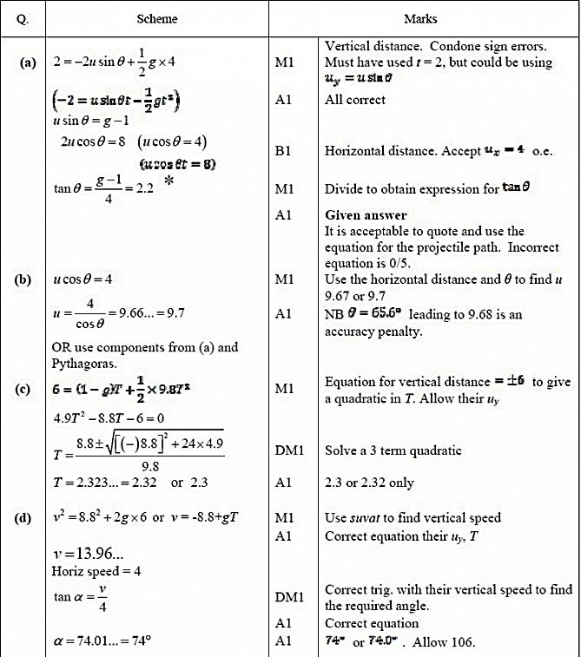

Q2
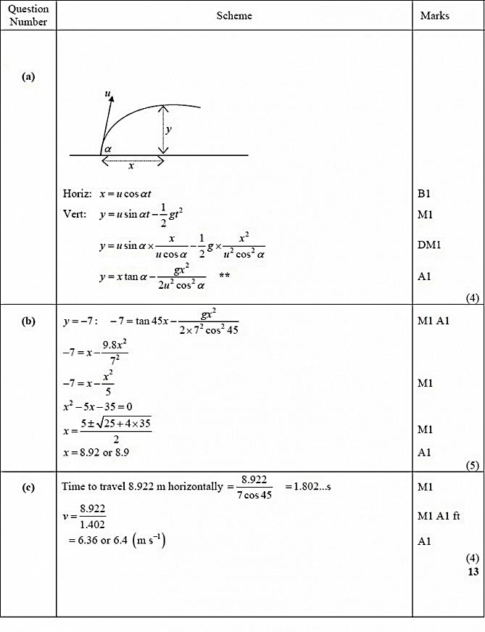

Q3
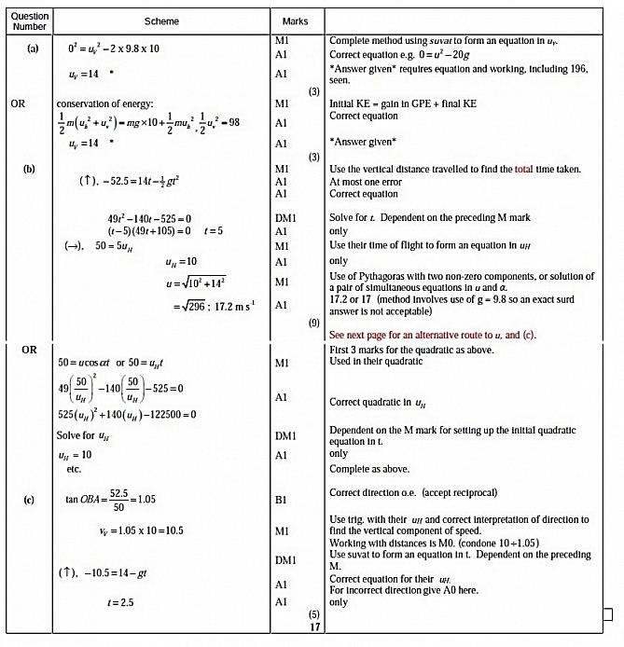

Gold Questions 40 Marks
Calculator
The total mark for this section is 40
Q1.
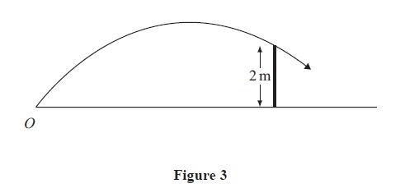
A child playing cricket on horizontal ground hits the ball towards a fence 10 m away. The ball moves in a vertical plane which is perpendicular to the fence. The ball just passes over the top of the fence, which is 2 m above the ground, as shown in Figure 3.
The ball is modelled as a particle projected with initial speed u m s⁻¹ from point O on the ground at an angle α to the ground.
(a) By writing down expressions for the horizontal and vertical distances, from O of the ball t seconds after it was hit, show that
.
(6)
Given that α = 45º,
(b) find the speed of the ball as it passes over the fence.
(6)
(Total for Question 1 is 12 marks)

Q2
[In this question, the unit vectors i and j are in a vertical plane, i being horizontal and j being vertically upwards.]
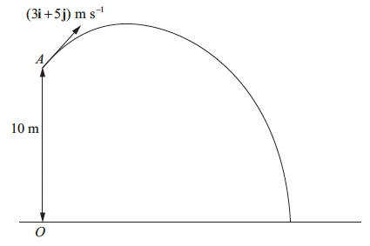
Figure 1
At time t = 0, a particle P is projected from the point A which has position vector 10j metres with respect to a fixed origin O at ground level. The ground is horizontal. The velocity of projection of P is (3i + 5j) m s⁻¹, as shown in Figure 1. The particle moves freely under gravity and reaches the ground after T seconds.
(a) For , show that, with respect to O, the position vector, r metres, of P at time t seconds is given by
r = (3t)i + (10 + 5t − 4.9t²)j .
(3)
(b) Find the value of T.
(3)
(c) Find the velocity of P at time t seconds ().
(2)
When P is at the point B, the direction of motion of P is 45° below the horizontal.
(d) Find the time taken for P to move from A to B.
(2)
(e) Find the speed of P as it passes through B.
(2)

(Total for Question 2 is 12 marks)

Q3
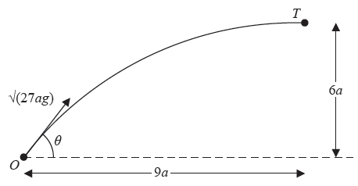
Figure 4
A small ball is projected from a fixed point O so as to hit a target T which is at a horizontal distance 9a from O and at a height 6a above the level of O. The ball is projected with speed √(27ag) at an angle θ to the horizontal, as shown in Figure 4. The ball is modelled as a particle moving freely under gravity.
(a) Show that tan²θ − 6 tan θ + 5 = 0
(7)
The two possible angles of projection are θ₁ and θ₂, where θ₁ > θ₂.
(b) Find tan θ₁ and tan θ₂.
(3)
The particle is projected at the larger angle θ₁.
(c) Show that the time of flight from O to T is .
(3)
(d) Find the speed of the particle immediately before it hits T.
(3)
(Total for Question 3 is 16 marks)
End of questions

Gold Mark Scheme

Q1
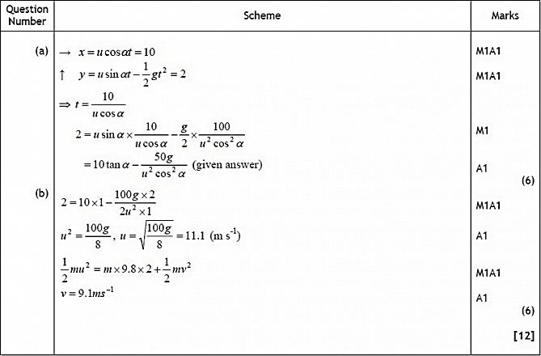

Q2
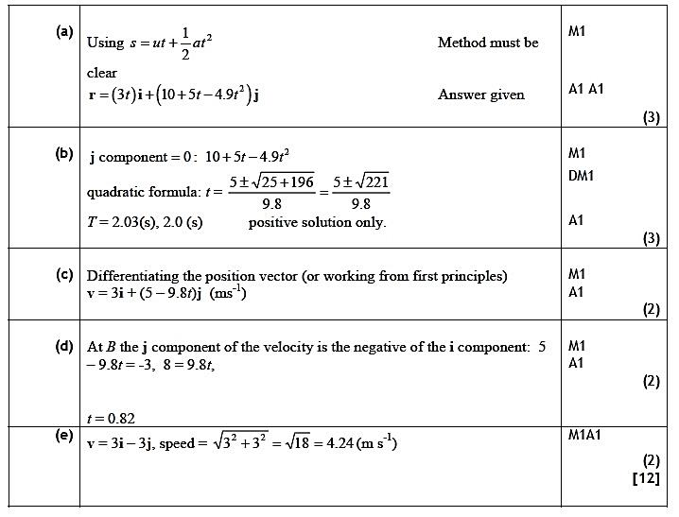

Q3
