Topic 11

Variable Acceleration

Bronze, Silver, Gold

Worksheets for

AS Level Mathematics

Teacher Notes
These Bronze, Silver and Gold worksheets are designed to be used either straight after the content has been taught or as part of a skills gap analysis, especially as students move into year 13.
They are drawn from the latest specification questions and legacy questions. The papers are between 25 and 35 marks.
The topic number on this worksheet relates to the corresponding chapter number in the ‘Pearson Edexcel AS and A Level Mathematics: Statistics and Mechanics Year 1/AS’ textbook.

Quick Links
(Press Ctrl, as you click with your mouse to follow these links)
- Bronze Questions
- Bronze Mark Scheme
- Silver Questions
- Silver Mark Scheme
- Gold Questions
- Gold Mark Scheme

Extension and Enrichment
If you have students that have enjoyed the challenge of the Gold questions, then they should have a go at the more challenging question from our Advanced Extension Award (AEA) papers. The Mathematics AEA is a single, 3 hour non-calculator paper, taken at the end of year 13. It helps students to develop high level problem solving and proof skills. It is entirely based on the content of the A Level Mathematics Course. No extra material needs to be covered to take the AEA in Mathematics. A second important difference is that marks are awarded for the clarity and quality of their solution. Developing this key skill, alongside the extra problem-solving experience, can pay dividends in the way they approach A Level Mathematics and Further Mathematics problems.
More information about the Advanced Extension Award can be found here on the Pearson Edexcel Website, or here on the Maths Emporium

Bronze Questions
Calculator
The total mark for this section is 30

Q1
A particle P moves along a straight line such that at time t seconds, t ≥ 0, after leaving the point O on the line,
the velocity, v m s^{–1}, of P is modelled as
v = (7 – 2t)(t + 2)
(a) Find the value of t at the instant when P stops accelerating.
(4)
(b) Find the distance of P from O at the instant when P changes its direction of motion.
(5)
In this question, solutions relying on calculator technology are not acceptable.

(Total for Question 1 is 9 marks)
__________________________________________________________________________

Q2
At time t = 0 a particle P leaves the origin O and moves along the x-axis. At time t seconds the velocity of P is v m s⁻¹, where
v = 8t − t².
(a) Find the maximum value of v.
(4)
(b) Find the time taken for P to return to O.
(5)

(Total for Question 2 is 9 marks)
__________________________________________________________________________

Q3
At time t = 0 a particle P leaves the origin O and moves along the x-axis. At time t seconds, the velocity of P is v m s⁻¹ in the positive x direction, where
v = 3t² − 16t + 21
The particle is instantaneously at rest when t = t₁ and when t = t₂ (t₁ < t₂).
(a) Find the value of t₁ and the value of t₂.
(2)
(b) Find the magnitude of the acceleration of P at the instant when t = t₁.
(3)
(c) Find the distance travelled by P in the interval t₁ ≤ t ≤ t₂.
(4)
(d) Show that P does not return to O.
(3)

(Total for Question 1 is 12 marks)
__________________________________________________________________________

End of Questions
Bronze Mark Scheme

Q1
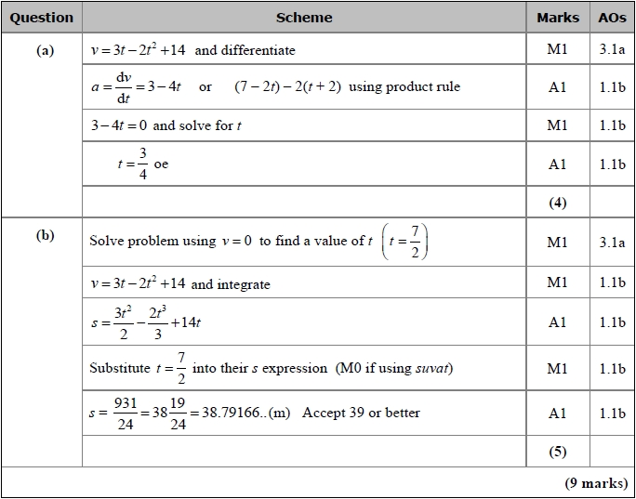
Q2
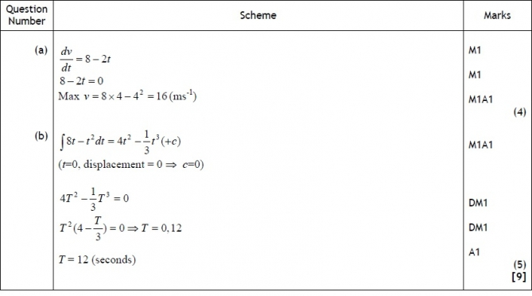
Q3

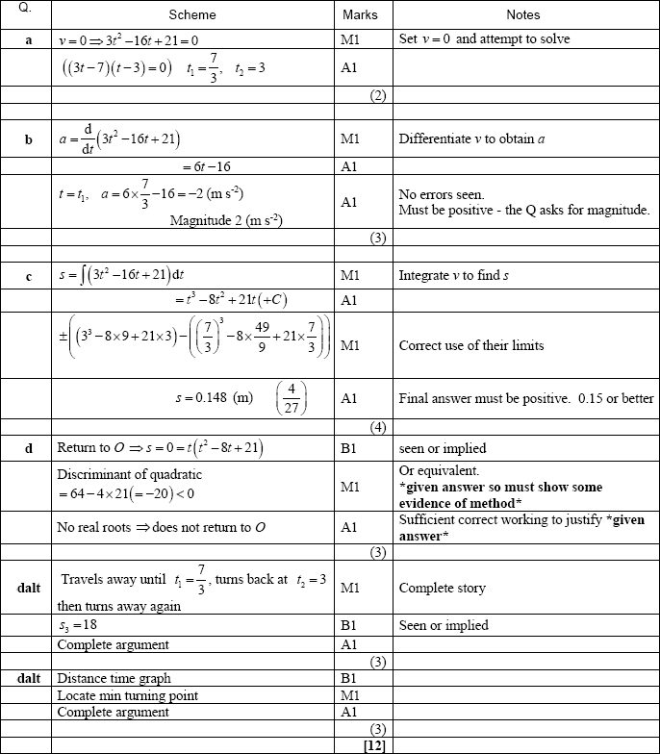


Silver Questions
Calculator
The total mark for this section is 26

Q1
A bird leaves its nest at time t = 0 for a short flight along a straight line.
The bird then returns to its nest.
The bird is modelled as a particle moving in a straight horizontal line.
The distance, s metres, of the bird from its nest at time t seconds is given by

(a) Explain the restriction, 0 ≤ t ≤ 10
(3)
(b) Find the distance of the bird from the nest when the bird first comes to instantaneous
rest.
(6)

(Total for Question 1 is 9 marks)
__________________________________________________________________________

Q2
A particle P moves on the x-axis. The acceleration of P at time t seconds, t ≥ 0, is (3t + 5) m s⁻² in the positive x-direction. When t = 0, the velocity of P is 2 m s⁻¹ in the positive x-direction. When t = T, the velocity of P is 6 m s⁻¹ in the positive x-direction. Find the value of T.

(Total for Question 2 is 6 marks)
__________________________________________________________________________

Q3
A particle P moves on the x-axis. The acceleration of P at time t seconds is (t − 4) m s⁻² in the positive x-direction. The velocity of P at time t seconds is v m s⁻¹. When t = 0, v = 6.
Find
(a) v in terms of t,
(4)
(b) the values of t when P is instantaneously at rest,
(3)
(c) the distance between the two points at which P is instantaneously at rest.
(4)

(Total for Question 3 is 11 marks)
__________________________________________________________________________

End of Questions

Silver Mark Scheme

Q1

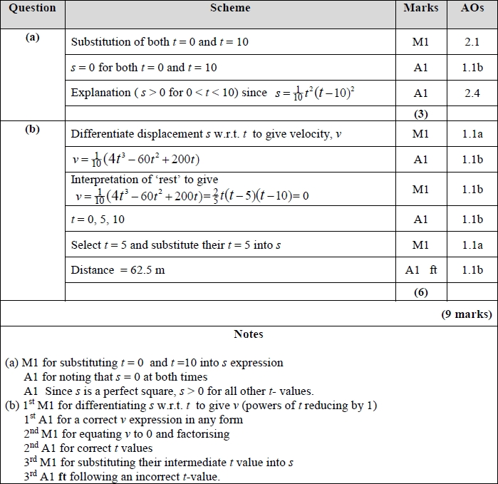
Q2
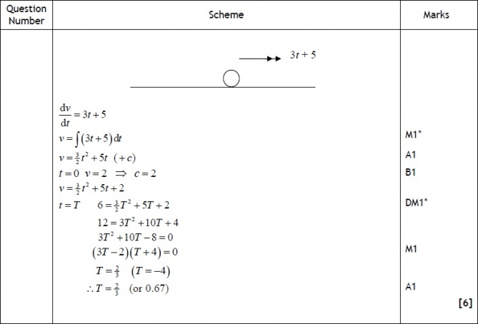

Q3

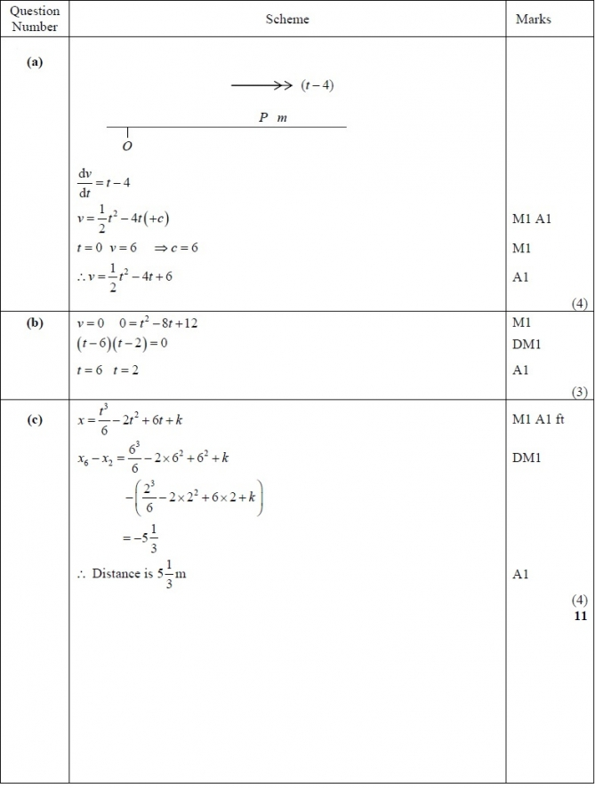
Gold Questions
Calculator
The total mark for this section is 30

Q1
A particle P moves along a straight line in such a way that at time t seconds its velocity v m s⁻¹ is given by
Find
(a) the times when P is at rest,
(4)
(b) the total distance travelled by P between t = 0 and t = 4.
(5)

(Total for Question 1 is 9 marks)
__________________________________________________________________________

Q2
A particle P moves along a straight line. The speed of P at time t seconds (t ≥ 0) is v m s^{–1}, where v = (pt² + qt + r) and p, q and r are constants. When t = 2 the speed of P has its minimum value. When t = 0, v = 11 and when t = 2 , v = 3
Find
(a) the acceleration of P when t = 3
(8)
(b) the distance travelled by P in the third second of the motion.
(5)

(Total for Question 2 is 13 marks)
__________________________________________________________________________

Q3
A particle P moves along the x-axis in a straight line so that, at time t seconds, the velocity of P is v m s⁻¹, where

At t = 0, P is at the origin O. Find the displacement of P from O when

(a) t = 6,
(3)

(b) t = 10.
(5)

(Total for Question 3 is 8 marks)
__________________________________________________________________________

End of Questions

Gold Mark Scheme

Q1.

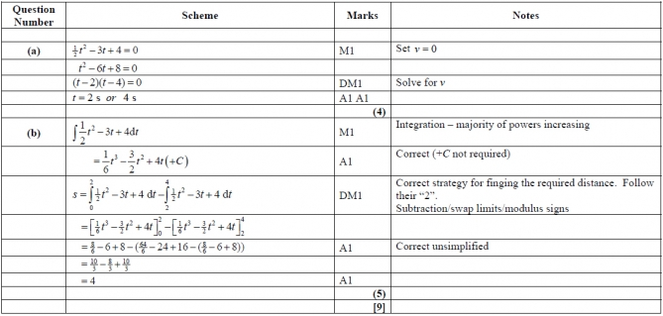

Q2

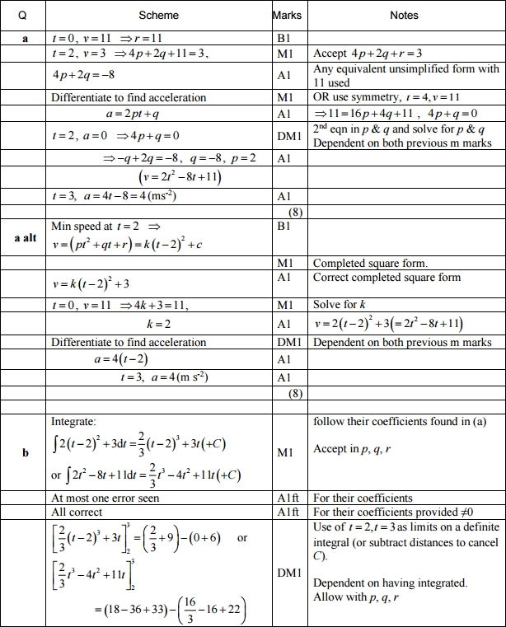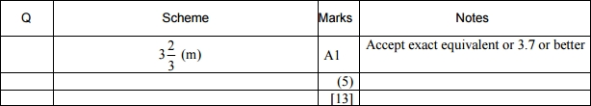
Q3

