Topic 7 - Applications of Forces

Bronze, Silver and Gold Worksheets for

A Level Mathematics

Teacher Notes
These Bronze, Silver and Gold worksheets are designed to be used either straight after the content has been taught or as part of a skills gap analysis.
They are drawn from the latest specification questions and legacy questions. The papers are between approximately 25 and 45 marks.
The topic number on this worksheet relates to the corresponding chapter number in the ‘Pearson Edexcel A Level Mathematics: Statistics and Mechanics Year 2’ textbook.

Quick Links
(Press Ctrl, as you click with your mouse to follow these links)
- Bronze Questions
- Bronze Mark Scheme
- Silver Questions
- Silver Mark Scheme
- Gold Questions
- Gold Mark Scheme

Extension and Enrichment
If you have students that have enjoyed the challenge of the Gold questions, then they should have a go at the more challenging question from our Advanced Extension Award (AEA) papers. The Mathematics AEA is a single, 3 hour non-calculator paper, taken at the end of year 13. It helps students to develop high level problem solving and proof skills. It is entirely based on the content of the A Level Mathematics Course. No extra material needs to be covered to take the AEA in Mathematics. A second important difference is that marks are awarded for the clarity and quality of their solution. Developing this key skill, alongside the extra problem-solving experience, can pay dividends in the way they approach A Level Mathematics and Further Mathematics problems.
More information about the Advanced Extension Award can be found here on the Pearson Edexcel Website, or here on the Maths Emporium

Bronze Questions
Calculator
The total mark for this section is 38
Q1
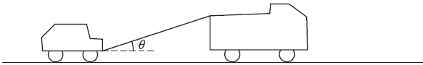
Figure 4
A truck of mass 1750 kg is towing a car of mass 750 kg along a straight horizontal road. The two vehicles are joined by a light towbar which is inclined at an angle θ to the road, as shown in Figure 4. The vehicles are travelling at 20 m s⁻¹ as they enter a zone where the speed limit is 14 m s⁻¹. The truck's brakes are applied to give a constant braking force on the truck. The distance travelled between the instant when the brakes are applied and the instant when the speed of each vehicle is 14 m s⁻¹ is 100 m.
(a) Find the deceleration of the truck and the car.
(3)
The constant braking force on the truck has magnitude R Newtons. The truck and the car also experience constant resistances to motion of 500 N and 300 N respectively. Given that
cos θ = 0.9, find
(b) the force in the towbar,
(4)
(c) the value of R.
(4)
(Total for Question 1 is 11 marks)
__________________________________________________________________________

Q2 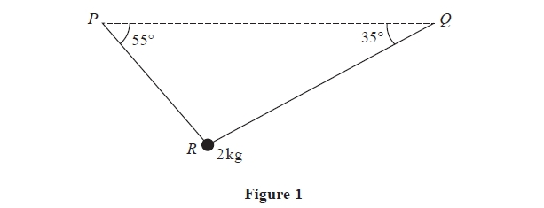
A particle of mass 2 kg is suspended from a horizontal ceiling by two light inextensible
strings, PR and QR. The particle hangs at R in equilibrium, with the strings in a vertical
plane. The string PR is inclined at 55° to the horizontal and the string QR is inclined at
35° to the horizontal, as shown in Figure 1.
Find
(i) the tension in the string PR,
(ii) the tension in the string QR.
(Total for Question 2 is 7 marks)
__________________________________________________________________________

Q3

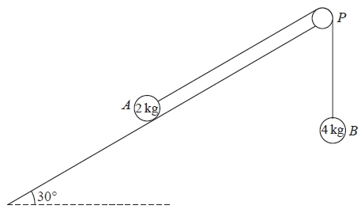
Figure 2
A fixed rough plane is inclined at 30° to the horizontal. A small smooth pulley P is fixed at the top of the plane. Two particles A and B, of mass 2 kg and 4 kg respectively, are attached to the ends of a light inextensible string which passes over the pulley P. The part of the string from A to P is parallel to a line of greatest slope of the plane and B hangs freely below P, as shown in Figure 2. The coefficient of friction between A and the plane is . Initially A is held at rest on the plane. The particles are released from rest with the string taut and A moves up the plane.
Find the tension in the string immediately after the particles are released.
(9)
(Total for Question 3 is 9 marks)
__________________________________________________________________________

Q4
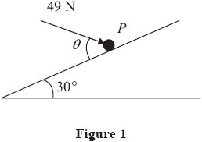
A particle P of mass 6 kg lies on the surface of a smooth plane. The plane is inclined at an angle of 30° to the horizontal. The particle is held in equilibrium by a force of magnitude
49 N, acting at an angle θ to the plane, as shown in Figure 1. The force acts in a vertical plane through a line of greatest slope of the plane.
(a) Show that .
(3)
(b) Find the normal reaction between P and the plane.
(4)
The direction of the force of magnitude 49 N is now changed. It is now applied horizontally to P so that P moves up the plane. The force again acts in a vertical plane through a line of greatest slope of the plane.
(c) Find the initial acceleration of P.
(4)
(Total for Question 4 is 11 marks)
__________________________________________________________________________
End of questions

Bronze Mark Scheme

Q1
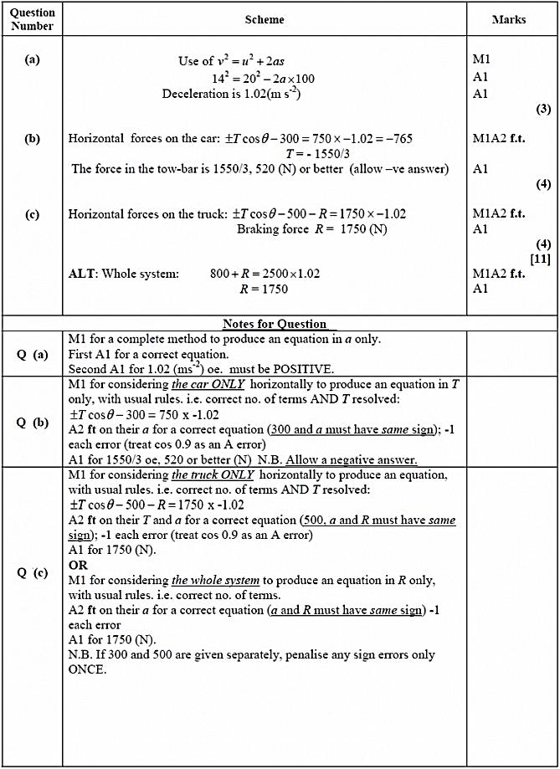
Q2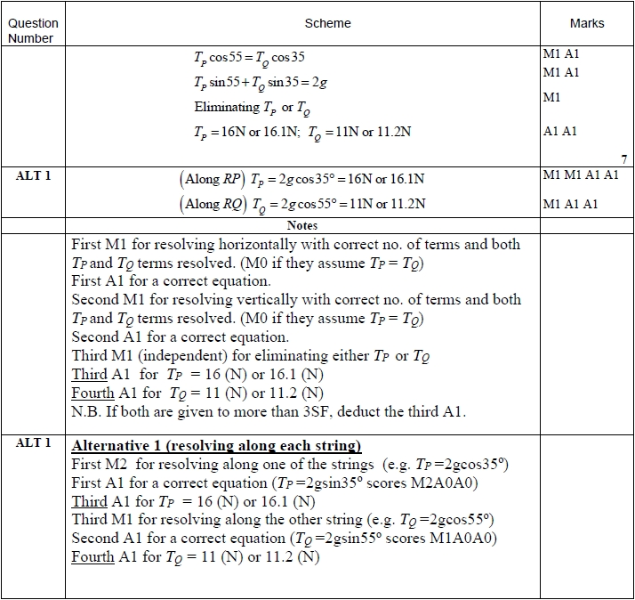

Q3
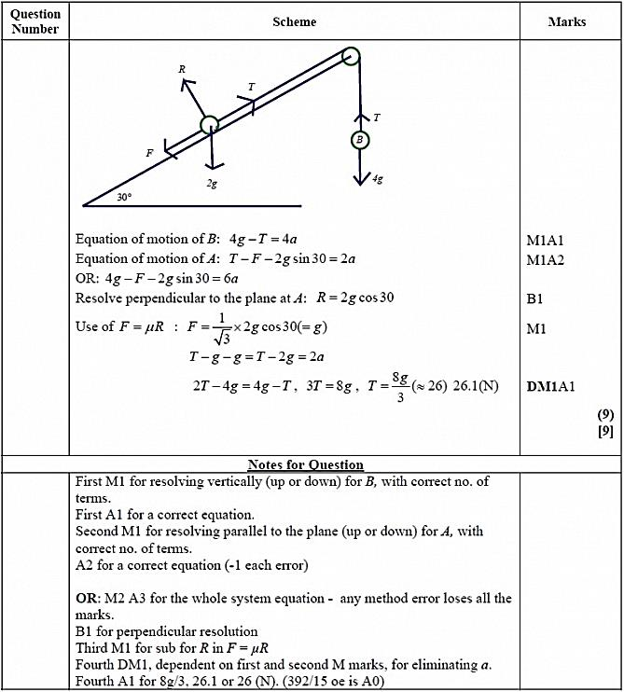

Q4
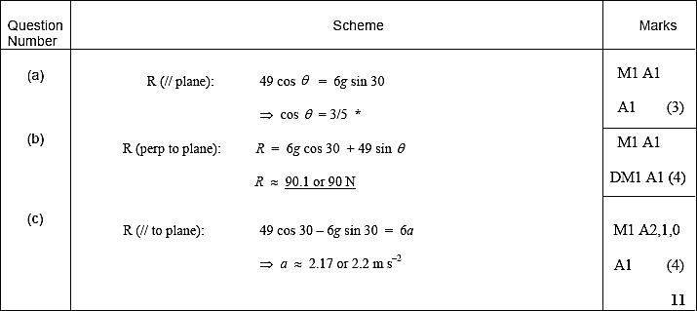


Silver Questions
Calculator
The total mark for this section is 35
Q1
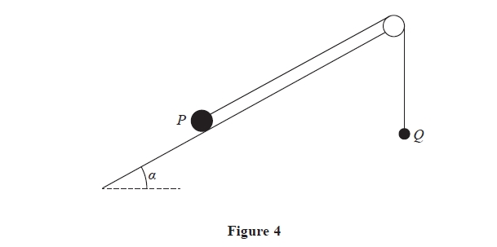
Two particles P and Q have mass 4 kg and 0.5 kg respectively. The particles are attached
to the ends of a light inextensible string. Particle P is held at rest on a fixed rough plane,
which is inclined to the horizontal at an angle α where . The coefficient of
friction between P and the plane is 0.5. The string lies along the plane and passes over a
small smooth light pulley which is fixed at the top of the plane. Particle Q hangs freely
at rest vertically below the pulley. The string lies in the vertical plane which contains the
pulley and a line of greatest slope of the inclined plane, as shown in Figure 4. Particle P
is released from rest with the string taut and slides down the plane.
Given that Q has not hit the pulley, find
(a) the tension in the string during the motion,
(11)
(b) the magnitude of the resultant force exerted by the string on the pulley.
(4)
(Total for Question 1 is 15 marks)
__________________________________________________________________________

Q2

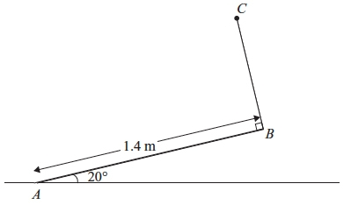
Figure 2
A uniform rod AB has mass 4 kg and length 1.4 m. The end A is resting on rough horizontal ground. A light string BC has one end attached to B and the other end attached to a fixed point C. The string is perpendicular to the rod and lies in the same vertical plane as the rod. The rod is in equilibrium, inclined at 20° to the ground, as shown in Figure 2.
(a) Find the tension in the string.
(4)
Given that the rod is about to slip,
(b) find the coefficient of friction between the rod and the ground.
(7)
(Total for Question 2 is 11 marks)
__________________________________________________________________________

Q3
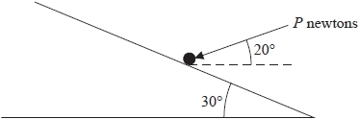
Figure 1
A particle of mass 2 kg lies on a rough plane. The plane is inclined to the horizontal at 30°.
The coefficient of friction between the particle and the plane is . The particle is held in equilibrium by a force of magnitude P Newtons. The force makes an angle of 20° with the horizontal and acts in a vertical plane containing a line of greatest slope of the plane, as shown in Figure 1. Find the least possible value of P.
(Total for Question 3 is 10 marks)
__________________________________________________________________________
Q4
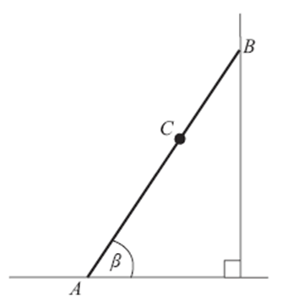
Figure 1
Figure 1 shows a ladder AB, of mass 25 kg and length 4 m, resting in equilibrium with one end A on rough horizontal ground and the other end B against a smooth vertical wall. The ladder is in a vertical plane perpendicular to the wall. The coefficient of friction between the ladder and the ground is . The ladder makes an angle β with the ground. When Reece, who has mass 75 kg, stands at the point C on the ladder, where AC = 2.8 m, the ladder is on the point of slipping. The ladder is modelled as a uniform rod and Reece is modelled as a particle.
(a) Find the magnitude of the frictional force of the ground on the ladder. (3)
(b) Find, to the nearest degree, the value of β. (6)
(Total for Question 4 is 9 marks)

Silver Mark Scheme
Q1
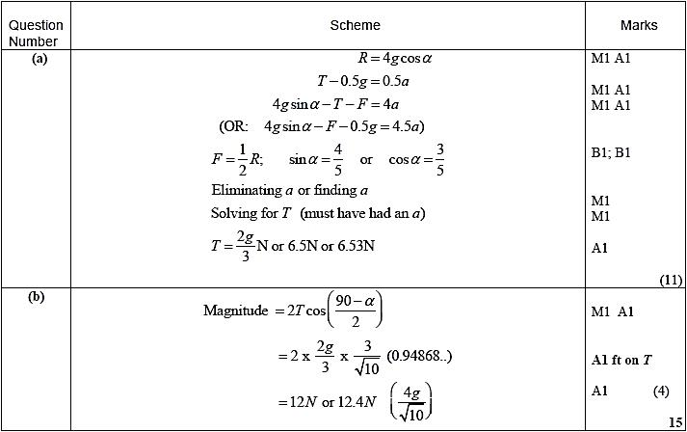
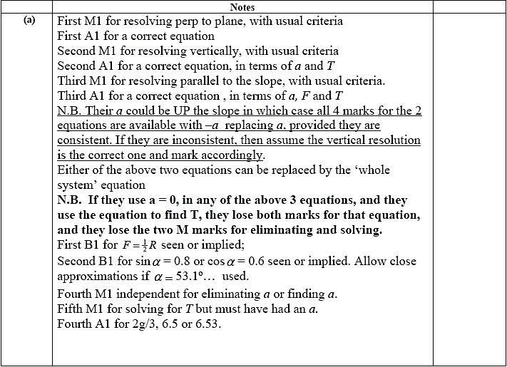
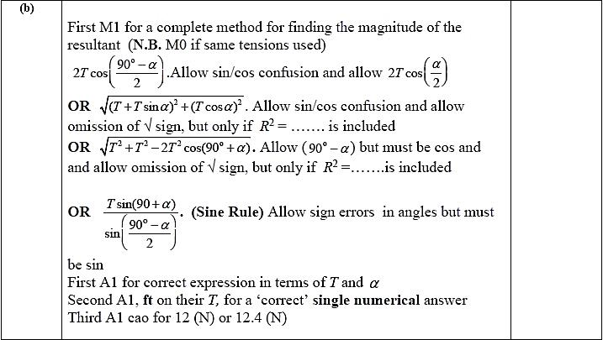
Q2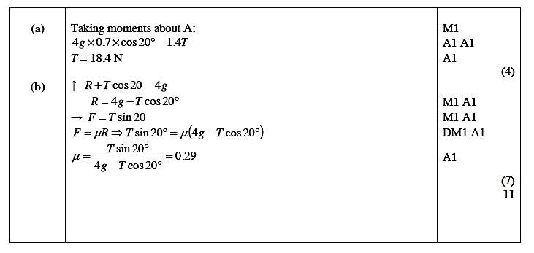

Q3
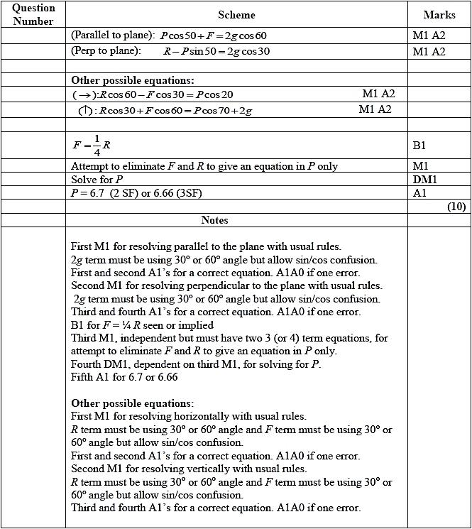

Q4
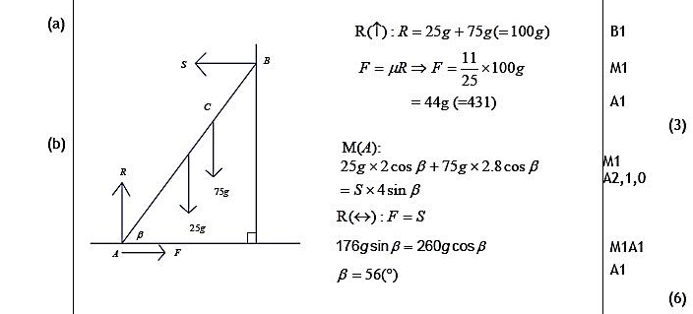

Gold Questions
Calculator
The total mark for this section is 37
Q1
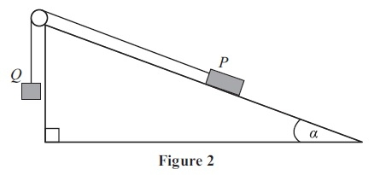
Two particles P and Q have masses 0.3 kg and m kg respectively. The particles are attached to the ends of a light inextensible string. The string passes over a small smooth pulley which is fixed at the top of a fixed rough plane. The plane is inclined to the horizontal at an angle α, where . The coefficient of friction between P and the plane is .
The string lies in a vertical plane through a line of greatest slope of the inclined plane. The particle P is held at rest on the inclined plane and the particle Q hangs freely below the pulley with the string taut, as shown in Figure 2.
The system is released from rest and Q accelerates vertically downwards at 1.4 m s⁻².
Find
(a) the magnitude of the normal reaction of the inclined plane on P,
(2)
(b) the value of m.
(8)
When the particles have been moving for 0.5 s, the string breaks. Assuming that P does not reach the pulley,
(c) find the further time that elapses until P comes to instantaneous rest.
(6)

(Total for Question 1 is 16 marks)

Q2
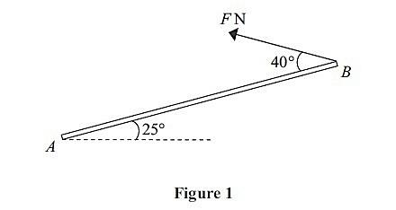
A uniform rod AB, of mass 5 kg and length 4 m, has its end A smoothly hinged at a fixed point. The rod is held in equilibrium at an angle of 25º above the horizontal by a force of magnitude F Newtons applied to its end B. The force acts in the vertical plane containing the rod and in a direction which makes an angle of 40º with the rod, as shown in Figure 1.
(a) Find the value of F.
(4)
(b) Find the magnitude and direction of the vertical component of the force acting on the rod at A.
(4)

(Total for Question 2 is 8 marks)

Q3

Figure 1

A uniform ladder AB, of length 2a and weight W, has its end A on rough horizontal ground.

The coefficient of friction between the ladder and the ground is . The end B of the ladder is resting against a smooth vertical wall, as shown in Figure 1.

A builder of weight 7W stands at the top of the ladder. To stop the ladder from slipping, the builder’s assistant applies a horizontal force of magnitude P to the ladder at A, towards the wall. The force acts in a direction which is perpendicular to the wall.

The ladder rests in equilibrium in a vertical plane perpendicular to the wall and makes an angle α with the horizontal ground, where tan α = . The builder is modelled as a particle and the ladder is modelled as a uniform rod.

(a) Show that the reaction of the wall on the ladder at B has magnitude 3W.
(5)
(b) Find, in terms of W, the range of possible values of P for which the ladder remains in equilibrium.
(5)

Often in practice, the builder’s assistant will simply stand on the bottom of the ladder.

(c) Explain briefly how this helps to stop the ladder from slipping.
(3)
(Total for Question 3 is 13 marks)

End of questions

Gold Mark Scheme

Q1

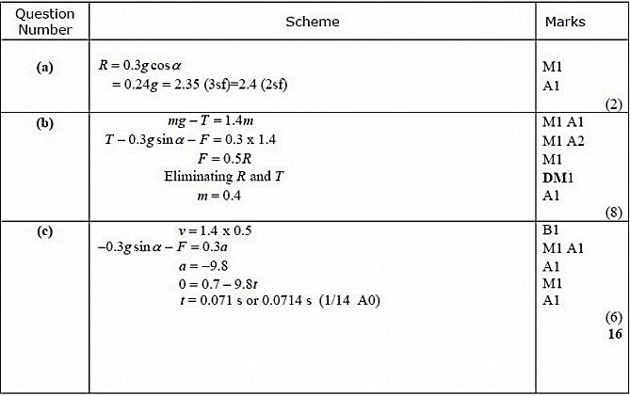
Q2

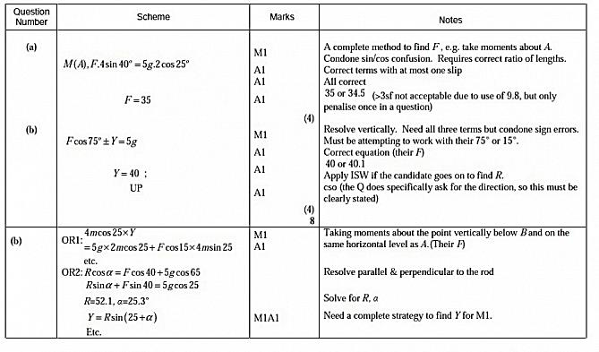
Q3
Question | Scheme | Marks | AOs
(a) | Take moments about A  (or any other complete method to  produce an equation in S , W and α only) | M1 | 3.3
(a) | Wacosα + 7W2acosα = S 2asinα | A1  A1 | 1.1b  1.1b
(a) | Use of tanα = to obtain S | M1 | 2.1
(a) | S = 3W * | A1* | 2.2a
(a) |  | (5)
(b) | R = 8W | B1 | 3.4
(b) | F = R (= 2W) | M1 | 3.4
(b) | P_{MAX} = 3W + F or P_{MIN} = 3W - F | M1 | 3.4
(b) | P_{MAX} = 5W or P_{MIN} = W | A1 | 1.1b
(b) | W ≤ P ≤ 5W | A1 | 2.5
(b) |  | (5)
(c) | M(A) shows that the reaction on the ladder at B is unchanged | M1 | 2.4
(c) | also R increases (resolving vertically) | M1 | 2.4
(c) | which increases max F available | M1 | 2.4
(c) |  | (3)
(13 marks)

Question 9 continued
Notes:
(a)
1st M1: for producing an equation in S, W and a only
1st A1: for an equation that is correct, or which has one error or omission
2nd A1: for a fully correct equation
2nd M1: for use of tana = to obtain S in terms of W only
3rd A1*:for given answer S = 3W correctly obtained
(b)
B1: for R = 8W
1st M1: for use of F = R
2nd M1: for either P = (3W + their F) or P = (3W - their F)
1st A1: for a correct max or min value for a correct range for P
2nd A1: for a correct range for P
(c)
1st M1: for showing, by taking moments about A, that the reaction at B is unchanged by the builder’s assistant standing on the bottom of the ladder
2nd M1: for showing, by resolving vertically, that R increases as a result of the builder’s assistant standing on the bottom of the ladder
3rd M1: for concluding that this increases the limiting friction at A

