Topic 8 - Further Kinematics

Bronze, Silver and Gold Worksheets for

A Level Mathematics

Teacher Notes
These Bronze, Silver and Gold worksheets are designed to be used either straight after the content has been taught or as part of a skills gap analysis.
They are drawn from the latest specification questions and legacy questions. The papers are between approximately 25 and 45 marks.
The topic number on this worksheet relates to the corresponding chapter number in the ‘Pearson Edexcel A Level Mathematics: Statistics and Mechanics Year 2’ textbook.

Quick Links
(Press Ctrl, as you click with your mouse to follow these links)
- Bronze Questions
- Bronze Mark Scheme
- Silver Questions
- Silver Mark Scheme
- Gold Questions
- Gold Mark Scheme

Extension and Enrichment
If you have students that have enjoyed the challenge of the Gold questions, then they should have a go at the more challenging question from our Advanced Extension Award (AEA) papers. The Mathematics AEA is a single, 3 hour non-calculator paper, taken at the end of year 13. It helps students to develop high level problem solving and proof skills. It is entirely based on the content of the A Level Mathematics Course. No extra material needs to be covered to take the AEA in Mathematics. A second important difference is that marks are awarded for the clarity and quality of their solution. Developing this key skill, alongside the extra problem-solving experience, can pay dividends in the way they approach A Level Mathematics and Further Mathematics problems.
More information about the Advanced Extension Award can be found here on the Pearson Edexcel Website, or here on the Maths Emporium

Bronze Questions
Calculator
The total mark for this section is 34
Q1
A particle P is moving in a plane. At time t seconds, P is moving with velocity v m s⁻¹, where v = 2ti - 3t²j.
Find
(a) the speed of P when t = 4,
(2)
(b) the acceleration of P when t = 4.
(3)
Given that P is at the point with position vector (−4i + j) m when t = 1,
(c) find the position vector of P when t = 4.
(5)

(Total for Question 1 is 10 marks)

Q2
A particle P of mass 2 kg is moving under the action of a constant force F Newtons.
When t = 0, P has velocity (3i + 2j) m s^{–1} and at time t = 4 s, P has velocity (15i – 4j) m s^{–1}.
Find
(a) the acceleration of P in terms of i and j,
(2)
(b) the magnitude of F,
(4)
(c) the velocity of P at time t = 6 s.
(3)
(Total for Question 2 is 9 marks)

Q3
[In this question, the unit vectors i and j are due east and due north respectively. Position vectors are relative to a fixed origin O.]
A boat P is moving with constant velocity (−4i + 8j) km h⁻¹.
(a) Calculate the speed of P.
(2)
When t = 0, the boat P has position vector (2i − 8j) km. At time t hours, the position vector of P is p km.
(b) Write down p in terms of t.
(1)
A second boat Q is also moving with constant velocity. At time t hours, the position vector of Q is q km, where
q = 18i + 12j − t(6i + 8j) .
Find
(c) the value of t when P is due west of Q,
(3)
(d) the distance between P and Q when P is due west of Q.
(3)

(Total for Question 3 is 9 marks)

Q4

At time t seconds, where t ≥ 0, a particle P moves so that its acceleration a m s⁻² is given by

a = 5t i – j .

When t = 0, the velocity of P is 20i m s⁻¹.

Find the speed of P when t = 4.
(Total for Question 4 is 6 marks)

End of questions

Bronze Mark Scheme

Q1
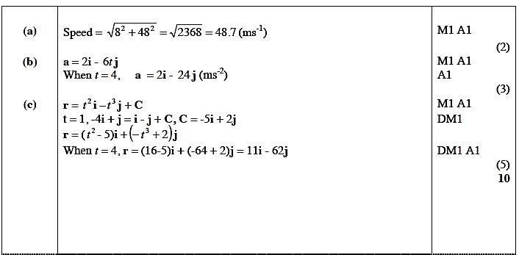

Q2
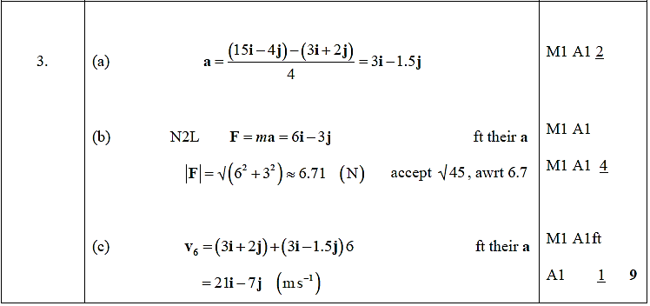

Q3
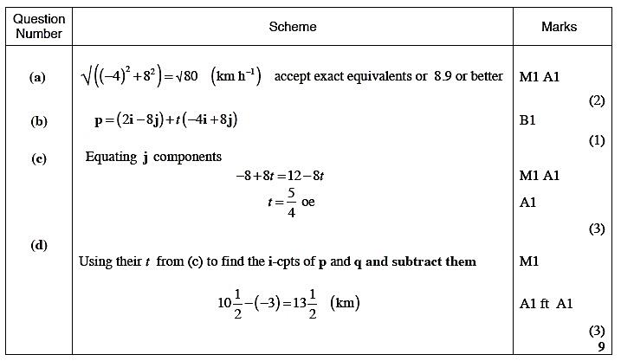

Q4
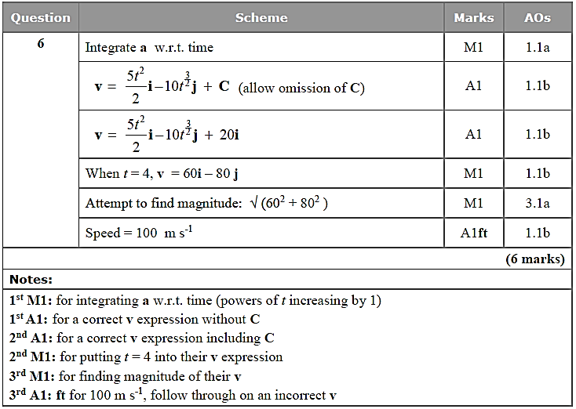

Silver Questions
Calculator
The total mark for this section is 29
Q1
At time t seconds, where t ≥ 0, a particle P is moving on a horizontal plane with acceleration [(3t² − 4t)i + (6t − 5)j] m s⁻².
When t = 3 the velocity of P is (11i + 10j) m s⁻¹.
Find
(a) the velocity of P at time t seconds,
(5)
(b) the speed of P when it is moving parallel to the vector i.
(4)
(Total for Question 1 is 9 marks)

Q2
[In this question i and j are perpendicular horizontal unit vectors.]
A particle P of mass 2 kg moves under the action of two forces, (2i + 3j) N and (4i − 5j) N.
(a) Find the magnitude of the acceleration of P.
(4)
At time t = 0, P has velocity (−ui + uj) m s⁻¹, where u is a positive constant.
At time t = T seconds, P has velocity (10i + 2j) m s⁻¹.
(b) Find
(i) the value of T,
(ii) the value of u.
(5)

(Total for Question 2 is 9 marks)

Q3
[In this question i and j are unit vectors due east and due north respectively. Position vectors are given relative to a fixed origin O.]
Two ships P and Q are moving with constant velocities. Ship P moves with velocity
(2i − 3j) km h⁻¹ and ship Q moves with velocity (3i + 4j) km h⁻¹.
(a) Find, to the nearest degree, the bearing on which Q is moving.
(2)
At 2 pm, ship P is at the point with position vector (i + j) km and ship Q is at the point with position vector (−2j) km.
At time t hours after 2 pm, the position vector of P is p km and the position vector of Q is
q km.
(b) Write down expressions, in terms of t, for
(i) p,
(ii) q,
(iii) . (5)
(c) Find the time when
(i) Q is due north of P,
(ii) Q is north-west of P.
(4)

(Total for Question 3 is 11 marks)

End of questions

Silver Mark Scheme
Q1
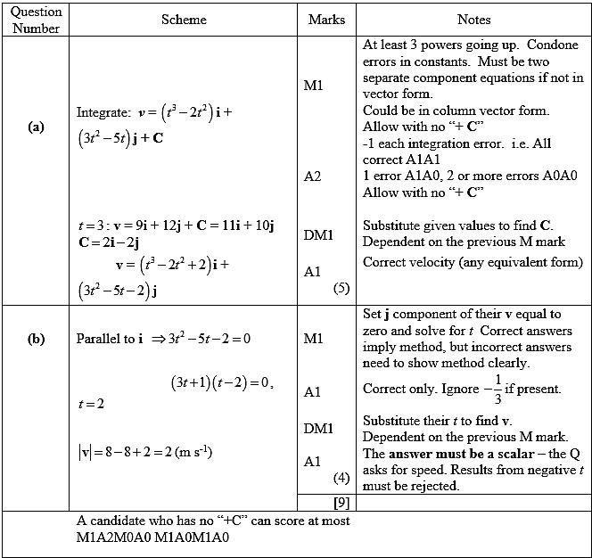

Q2
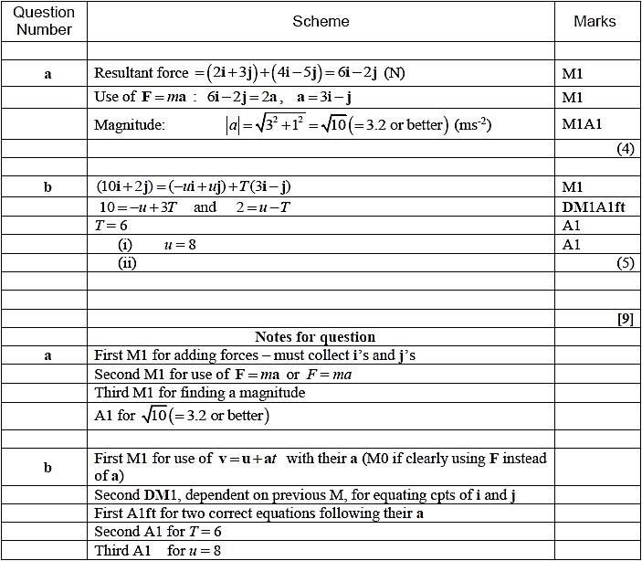

Q3
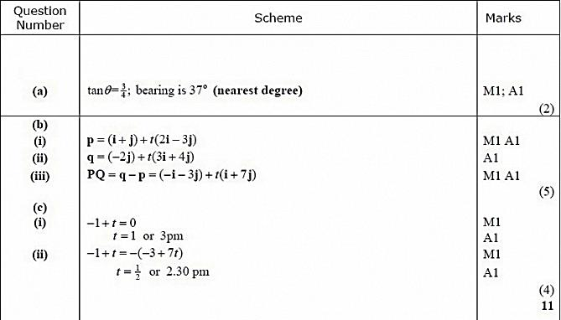

Gold Questions
Calculator
The total mark for this section is 38
Q1
A particle P of mass 0.5 kg moves under the action of a single force F Newtons. At time t seconds, t ≥ 0, P has velocity v m s^{–1}, where
v = (4t – 3t²)i + (t² – 8t – 40)j .
(a) Find
(i) the magnitude of F when t = 3,
(ii) the acceleration of P at the instant when it is moving in the direction of the –i – j.
(9)
When t = 1, P is at the point A. When t = 2, P is at the point B.
(b) Find, in terms of i and j, the vector .
(5)

(Total for Question 1 is 14 marks)

Q2

[In this question, i and j are horizontal unit vectors due east and due north respectively and position vectors are given with respect to a fixed origin.]
A ship S is moving along a straight line with constant velocity. At time t hours the position vector of S is s km. When t = 0, s = 9i − 6j. When t = 4, s = 21i + 10j. Find
(a) the speed of S,
(4)
(b) the direction in which S is moving, giving your answer as a bearing.
(2)
(c) Show that s = (3t + 9)i + (4t − 6)j.
(2)
A lighthouse L is located at the point with position vector (18i + 6j) km. When t = T, the ship S is 10 km from L.
(d) Find the possible values of T.
(6)

(Total for Question 2 is 14 marks)

Q3

[In this question i and j are horizontal unit vectors due east and due north respectively.]

A radio controlled model boat is placed on the surface of a large pond. The boat is modelled as a particle.

At time t = 0, the boat is at the fixed point O and is moving due north with speed 0.6 m s⁻¹.

Relative to O, the position vector of the boat at time t seconds is r metres. At time t = 15, the velocity of the boat is (10.5i – 0.9j) m s⁻¹. The acceleration of the boat is constant.

(a) Show that the acceleration of the boat is (0.7i – 0.1j) m s⁻².
(2)
(b) Find r in terms of t.
(2)
(c) Find the value of t when the boat is north-east of O.
(3)
(d) Find the value of t when the boat is moving in a north-east direction.
(3)

(Total for Question 3 is 10 marks)

End of questions

Gold Mark Scheme

Q1

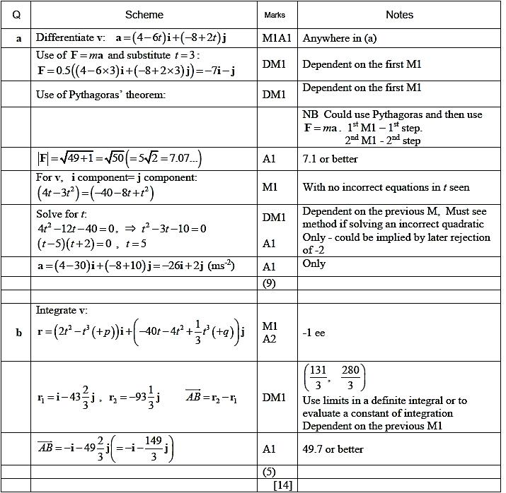

Q2

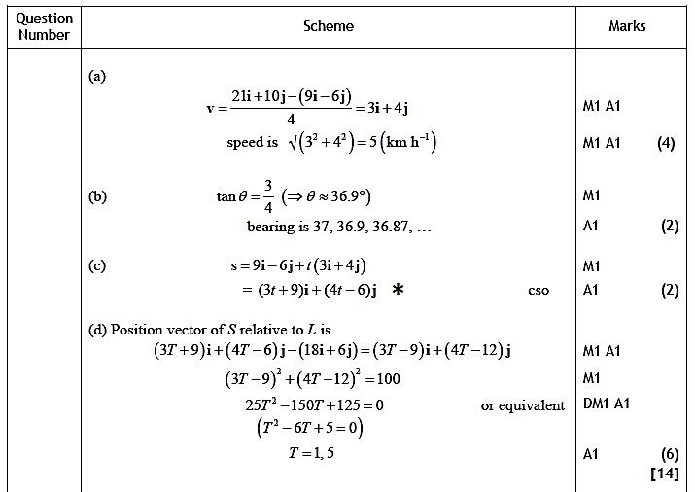

Q3

