11: Materials
Hooke’s Law and the Young Modulus
Paper 1
1: Particles 1  Atomic Structure and the SNF | - Density, $ρ=\frac{m}{V}$  - Hooke’s law, elastic limit,  - $F=kΔL$ , k as stiffness and spring constant.  - Tensile strain and tensile stress.  - Elastic strain energy, breaking stress.  - energy stored = $\frac{1}{2}FΔL$ = area under force−extension graph  - Description of plastic behaviour, fracture and brittle behaviour linked to force–extension graphs.  - Quantitative and qualitative application of energy conservation to examples involving elastic strain energy and energy to deform.  - Spring energy transformed to kinetic and gravitational potential energy.  - Interpretation of simple stress–strain curves.  - Appreciation of energy conservation issues in the context of ethical transport design.  - $Young modulus=\frac{tensile stress}{tensile strain}=\frac{FL}{A∆L}$  - Use of stress–strain graphs to find the Young modulus.  - (One simple method of measurement is required.)  Required practical 4: Determination of the Young modulus by a simple method  
2: Particles 2
Particle Classification
3: Particles 3
Particle Interaction
4: Quantum
Photoelectric, Energy Levels and WPD
5: Waves 1
Wave Basics and Stationary Waves
6: Waves 2
Interference and Diffraction
7: Waves 3
Refraction and Fibre Optics
8: Mechanics 1
Scalars, Vectors and Moments
9: Mechanics 2
Motion and Newton’s Laws
10: Mechanics 3
Momentum and Energy
11: Materials
Hooke’s Law and the Young Modulus
12: Electricity 1
Resistivity and Superconductivity
13: Electricity 2
Series, Parallel and Potential Dividers
14: Electricity 3
Energy, EMF and Internal Resistance
15: Further Mechanics 1
Circular Motion
16: Further Mechanics 2
Simple Harmonic Motion

Monday: Density Notes
The equation below is used to calculate density; rearrange the equation to make the following the subject:
$$ρ=\frac{m}{V}$$ | $V=$ | $m=$

Symbol $ρ$ Quantity …………………………………………………………………………………………… Units ………………………
Symbol $m$ Quantity …………………………………………………………………………………………… Units ………………………
Symbol $V$ Quantity …………………………………………………………………………………………… Units ………………………
What does it physically mean if a material has a high density?
………………………………………………………………….…………….……………………………………………………….………………..
……………………………………………………………………….……….………………………………….……………………………………..
Complete these tables by calculating the missing values.
ρ | m | V |  | ρ | m | V
 | 160 | 0.06 |  |  | 0.5 | 4.1
11 × 10³ |  | 0.032 |  | 992 | 0.23 × 10⁻²
7.7 × 10³ | 60 |  |  | 2.1 × 10⁹ | 8.4

An alloy contains 40% zinc and 60% copper by volume. If the alloy has a volume of 5.3 m³ calculate the mass of each metal.
The density of zinc is 7135 kg/m³ and the density of copper is 8940 kg/m³.
Calculate the actual volume of zinc. | Use the volume and density to calculate the mass of zinc.
Calculate the actual volume of copper. | Use the volume and density to calculate the mass of copper.
Add these two masses together to get the mass of the alloy.

An alloy contains 88% copper and 12% tin by mass. If the alloy has a mass of 74 kg calculate the volume of each metal.
The density of copper is 8940 kg/m³ and the density of tin is 7280 kg/m³.
Calculate the actual mass of copper. | Use the mass and density to calculate the volume of copper.
Calculate the actual mass of tin. | Use the mass and density to calculate the volume of tin.
Add these two volumes together to get the volume of the alloy.

Monday: Stress and Strain Notes
We have seen in Hooke’s law that when a force is applied to an object it extends in length; in this set up the forces are putting the object under tension or are ‘tensile’ forces. There are two problems with using Hooke’s law to compare different materials or objects:
Problem 1: Shape
Two springs are made from the same material, are the same length and have the same mass suspended from them; which spring will extend the most? | The spring made from a thinner wire.
 | The spring made from a thicker wire.
Instead of just considering the force applied to the object we now calculate the tensile stress on the object.
The tensile stress can be calculated using the following equation; rearrange the equation to make the following the subject:
$$stress=\frac{F}{A}$$ | $F=$ | $A=$
Symbol $F$ Quantity …………………………………………………………………………………………… Units ………………………
Symbol $A$ Quantity …………………………………………………………………………………………… Units ………………………
Use the equation to help you write a definition of tensile stress and to determine its unit.
……………………………………………………………………………….…………………………………………………………………………
……………………………………………………………………………….…………………………………………………………………………
Stress is calculated using the same equation that is used to calculate ……………….…………… so we can also use the units ………
Complete these tables by calculating the missing values.
Stress | F | A |  | Stress | F | A
 | 16000 | 200 |  |  | 440 | 53
60 |  | 180 |  | 316 |  | 79
2400 | 500 000 |  |  | 1825 | 175 000
Problem 2: Original Length
Two springs are made from the same material, are the same thickness and have the same mass suspended from them; which spring will extend the most? | The spring that is initially shorter.
 | The spring that is initially longer.
Instead of just considering the extension of the object we now calculate the tensile strain of the object.
The tensile strain can be calculated using the following equation; rearrange the equation to make the following the subject:
$$strain=\frac{∆L}{L}$$ | $∆L=$ | $L=$
Symbol $∆L$ Quantity …………………………………………………………………………………………… Units ………………………
Symbol $L$ Quantity …………………………………………………………………………………………… Units ………………………
Use the equation to help you write a definition of tensile strain and to determine its unit.
……………………………………………………………………………….…………………………………………………………………………
……………………………………………………………………………….…………………………………………………………………………
Complete these tables by calculating the missing values.
Strain | ∆L | L |  | Strain | ∆L | L
 | 18 | 180 |  |  | 0.6 | 36
3 |  | 57 |  | 0.015 |  | 107
0.4 | 160 |  |  | 0.7 | 40

Tuesday: Hooke’s Law Exam Questions
Q51. A type of exercise device is used to provide resistive forces when a person applies compressive forces to its handles. The stiff spring inside the device compresses.
Q51(a) The force exerted by the spring over a range of compressions was measured. The results are plotted on the grid below.
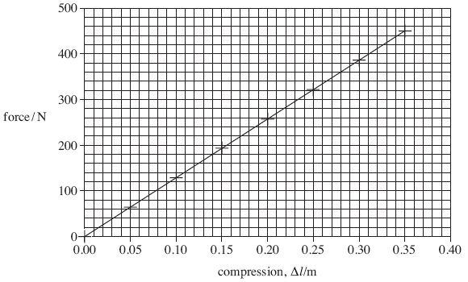
Q51(ai) State Hooke’s law.
..................................................................................................................................................................................................
.................................................................................................................................................................................................. (2)
Q51(aii) State which two features of the graph confirm that the spring obeys Hooke’s law over the range of values tested.
..................................................................................................................................................................................................
.................................................................................................................................................................................................. (2)
Q51(aiii) Use the graph to calculate the spring constant, stating an appropriate unit.

answer ..................................................... (3)
Q51(bi) The formula for the energy stored by the spring is $E=\frac{1}{2}F∆L$, explain how this formula can be derived from a graph of force against extension.
..................................................................................................................................................................................................
..................................................................................................................................................................................................
..................................................................................................................................................................................................
.................................................................................................................................................................................................. (3)
Q51(bii) The person causes a compression of 0.28 m in a time of 1.5 s. Use the graph in part (a) to calculate the average power developed.

answer ..............................................W (3)
(Total 13 marks)
Q52. A manufacturer of springs tests the properties of a spring by measuring the load applied each time the extension is increased. The graph of load against extension is shown below.
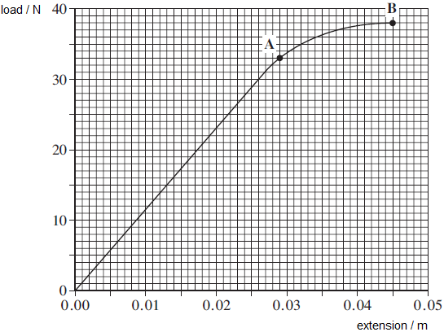
Q52(a) State Hooke’s law.
..................................................................................................................................................................................................
.................................................................................................................................................................................................. (2)
Q52(b) Calculate the spring constant, k, for the spring. State an appropriate unit.

spring constant ............................................ unit ............... (3)
Q52(c) Use the graph to find the work done in extending the spring up to point B.

work done ............................................... J (3)
Q52(d) Beyond point A the spring undergoes plastic deformation. Explain the meaning of the term plastic deformation.
..................................................................................................................................................................................................
.................................................................................................................................................................................................. (1)
Q52(e) When the spring reaches an extension of 0.045 m, the load on it is gradually reduced to zero. On the graph above sketch how the extension of the spring will vary with load as the load is reduced to zero. (2)
Q52(f) Without further calculation, compare the total work done by the spring when the load is removed with the work that was done by the load in producing the extension of 0.045 m.
..................................................................................................................................................................................................
.................................................................................................................................................................................................. (1)
(Total 12 marks)

Wednesday: Stress and Strain Extended Writing

Spider’s silk is nearly as strong as stainless steel but they have never made something out of both materials that are the same size to carry out a comparison. The stress and strain of an object is used to compare different materials; explain what this means and how it is carried out. Your explanation should include:
- What stress and strain are
- Details of how measurements of stress and strain could be taken
- A description of how a stress-strain graph could be used to find the Young modulus
- What the following mean and how they can be assessed from a stress-strain graph:
A) stiffness B) strength C) brittle D) ductile.
..................................................................................................................................................................................................
..................................................................................................................................................................................................
..................................................................................................................................................................................................
..................................................................................................................................................................................................
..................................................................................................................................................................................................
..................................................................................................................................................................................................
..................................................................................................................................................................................................
..................................................................................................................................................................................................
..................................................................................................................................................................................................
..................................................................................................................................................................................................
..................................................................................................................................................................................................
..................................................................................................................................................................................................
..................................................................................................................................................................................................
..................................................................................................................................................................................................
..................................................................................................................................................................................................
..................................................................................................................................................................................................
..................................................................................................................................................................................................
..................................................................................................................................................................................................
..................................................................................................................................................................................................
..................................................................................................................................................................................................
..................................................................................................................................................................................................
..................................................................................................................................................................................................
..................................................................................................................................................................................................
..................................................................................................................................................................................................
..................................................................................................................................................................................................
..................................................................................................................................................................................................
..................................................................................................................................................................................................
..................................................................................................................................................................................................
..................................................................................................................................................................................................
Wednesday: Materials Definitions

Tensile | The opposite to compressive forces. This means to stretch.
Elastic Limit | The point beyond which a material will no longer return to its original length when the force is removed.
Spring Constant | The constant of proportionality between force and extension.
Gradient | On a graph of stress against strain this represents the Young modulus of a material.
Stress | The force applied to a material divided by the cross-sectional area.
Non-Linear | The relationship between force and extension for a material like rubber.
Stretchier | This describes a material with a lower spring constant. This can be achieved by connecting identical springs in series.
Directly Proportional | Hooke’s law states that force and extension are connected in this way.
Plastic | A material that doesn’t go back to its original shape after a force is removed is said to be this.
Micrometer | A piece of equipment suitable for measuring the diameter of a wire.
Stiffness | The spring constant of a material can be thought of as this property of a material.
Brittle | A material that fractures before deforming plastically.
Gradient | On a graph of force against extension this represents the spring constant.
X-Intercept | On a graph of force against extension this represents the permanent extension of a stretched material.
Yield Point | The point when the material suddenly starts to stretch without any extra load being added.
Strain | A measure of the extension of a material compared to its original length.
Stiffer | This describes a material with a higher spring constant. This can be achieved by connecting identical springs in parallel.
Density | A measure of how much mass is in each metre cubed of the material.
Necking | When the cross-sectional area of a material gets smaller as it is extended.
Limit of Proportionality | The point where force and extension no longer have a linear relationship.
Area Under the Line | On a graph of force against extension this represents the energy stored by a stretched material.
Area Under the Line | On a graph of stress against strain this represents the strain energy per unit volume.
Deformation | This happens when a metal is stretched beyond its elastic limit.
Elastic | A material that returns to its original shape after a stretching or squashing force is removed.
Ruler | A piece of equipment suitable for measuring the length of a wire.
Braking Stress | The stress at which a fracture occurs.

Area Under the Line | Area Under the Line | Braking Stress | Brittle
Deformation | Density | Directly Proportional | Elastic
Elastic Limit | Gradient | Gradient | Limit of Proportionality
Micrometer | Necking | Non-Linear | Plastic
Ruler | Spring Constant | Stiffer | Stiffness
Strain | Stress | Stretchier | Tensile
X-Intercept | Yield Point

Thursday: Bulk Properties of Solids Notes

Explain what the following terms meant:
Limit of proportionality ….…….………………………………….……………………………….……………………………………………..…..
………………………………………………………………….…………….……………………………………………………….………………..
Elastic limit …………………….………………………………….……………………………….……………………………………………..…..
………………………………………………………………….…………….……………………………………………………….………………..
……………………………………………………………………….……….………………………………….……………………………………..
Plastic behaviour …….…………….……...……………………………………………………………………………………………………..…..
…………………………………………………………………………..…….………………………………………………………………………..
Yield point …….…………….……………...……………………………………………………………………………………………………..…..
…………………………………………………………………………..…….………………………………………………………………………..
Necking …….……………………...………………………………….…………………………………………………………………………..…..

Ultimate tensile stress ….……...………………………………….…………………………………………………………………………..…..
…………………………………………………………………………..…….………………………………………………………………………..
Breaking stress …….……………………...……………………………………………………………………………………………………..…..
…………………………………………………………………………..…….………………………………………………………………………..
Explain what is meant by a ‘brittle’ material.
………………………………………………………………………..……….……….
………………………………………………………………………..……….……….
………………………………………………………………………..……….……….
Give examples of brittle materials.
………………………………………………………………………..……….………..
- Sketch the stress-strain graph that could be obtained by a brittle material and label it A.
- Sketch a second line that represents a material than is stiffer but isn’t as strong and label it B.
Explain what is meant by a ‘ductile’ material.
………………………………………………………………………..……….……….
………………………………………………………………………..……….……….
………………………………………………………………………..……….……….
Give examples of ductile materials.
………………………………………………………………………..……….………..
- Sketch the stress-strain graph that could be obtained by a ductile material and label it C.
- Sketch a second line that represents a material than is initially stiffer but as it plastically deforms it isn’t as strong and label it D.
Describe what this stress-strain graph is showing you about the material that was tested.
Make sure that you annotate the graph with the key terms from the previous page.
………………………………………………………………
………………………………………………………………
………………………………………………………………
………………………………………………………………
………………………………………………………………
………………………………………………………………
………………………………………………………………
………………………………………………………………
………………………………………………………………
Describe what the stress-strain graph is showing you about this material.
………………………………………………………………………..……….……….
………………………………………………………………………..……….……….
………………………………………………………………………..……….……….
………………………………………………………………………..……….……….
What does the shaded area represent?
………………………………………………………………………..……….……….
………………………………………………………………………..……….……….
Describe what the stress-strain graph is showing you about this material.
………………………………………………………………………..……….……….
………………………………………………………………………..……….……….
………………………………………………………………………..……….……….
What does the shaded area represent?
………………………………………………………………………..……….……….
………………………………………………………………………..……….……….
What does the distance X represent?
………………………………………………………………………..……….……….
A catapult is stretched back to fire a projectile, of mass m, directly upwards.
The elastic strain energy is converted to kinetic energy and eventually gravitational potential energy.
Calculate the maximum speed immediately after being released and the maximum height reached if no energy is lost to the surroundings.
F | ΔL | m | v | ∆h
30 | 0.1 | 0.01
1650 | 0.32 | 0.25
50 | 62 × 10⁻² | 0.03
519 | 9.2 × 10⁻² | 0.40
4500 | 0.47 | 5.2

Friday: The Young Modulus Exam Questions
Q55. The figure below shows a stress-strain graph for a copper wire.
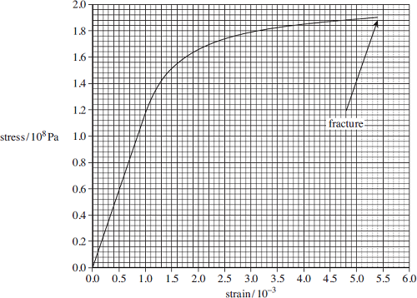
Q55(a) Define tensile strain.
..................................................................................................................................................................................................
.................................................................................................................................................................................................. (1)
Q55(b) State the breaking stress of this copper wire.

answer = ........................................ Pa (1)
Q55(c) Mark on the figure above a point on the line where you consider plastic deformation may start. Label this point A. (1)
Q55(d) Use the graph to calculate the Young modulus of copper. State an appropriate unit for your answer.

answer = ...................................................... (3)
Q55(e) The area under the line in a stress-strain graph represents the work done per unit volume to stretch the wire.
Q55(ei) Use the graph to find the work done per unit volume in stretching the wire to a strain of 3.0 × 10^{–3}.

answer = .........................................J m^{–3} (2)
Q55(eii) Calculate the work done to stretch a 0.015 kg sample of this wire to a strain of 3.0 × 10^{–3}.
The density of copper = 8960 kg m^{–3}.

answer = ............................................J (2)
Q55(f) A certain material has a Young modulus greater than copper and undergoes brittle fracture at a stress of 176 MPa.
On the figure above draw a line showing the possible variation of stress with strain for this material. (2)
(Total 12 marks)
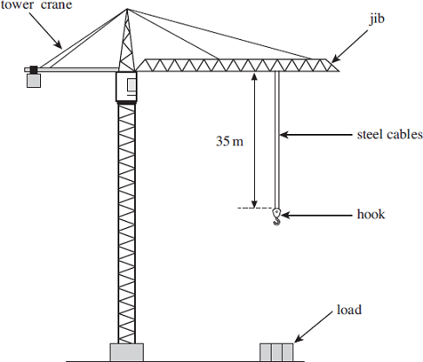
Q56. The diagram below shows a tower crane that has two identical steel cables. The length of each steel cable is 35 m from the jib to the hook.
Q56(a) Each cable has a mass of 4.8 kg per metre. Calculate the weight of a 35 m length of one cable.

weight = ................................. N (2)
Q56(b) The cables would break if the crane attempted to lift a load of 1.5 × 10⁶ N or more. Calculate the breaking stress of one cable. The cross-sectional area of each cable = 6.2 × 10⁻⁴ m²

breaking stress = ................................ Pa (2)
Q56(c) When the crane supports a load each cable experiences a stress of 400 MPa. Each cable obeys Hooke’s law. Ignore the weight of the cables. Young modulus of steel = 2.1 × 10¹¹ Pa
Q56(ci) Calculate the weight of the load.

weight = ................................. N (2)
Q56(cii) The unstretched length of each cable is 35 m. Calculate the extension of each cable when supporting the load.

extension = ................................. m (3)
Q56(ciii) Calculate the combined stiffness constant, k, for the two cables.

stiffness constant = ........................... Nm⁻¹ (2)
Q56(civ) Calculate the total energy stored in both stretched cables.

energy stored = ................................... J (2)
(Total 13 marks)

Saturday: Hooke’s Law and the Young Modulus Checklist
# |  | I can…
1 |  | Calculate density using the density equation.
2/3 |  | Rearrange the density equation to find the unknown and recall/deduce the units of density.
4 |  | Calculate the volume of regular shapes (cubes, cuboids, spheres and cylinders).
5 |  | Describe how the volume of an irregular shape could be found.
6/7 |  | Calculate the volume or mass of a metal in an alloy.
8/9 |  | Describe Hooke’s law and explain how you know if Hooke’s law is being followed from a force-extension graph.
10/11 |  | Calculate force using Hooke’s law and rearrange the Hooke’s law equation to find the unknown.
12 |  | Recall or deduce the units of spring constant.
13/4 |  | Define the term spring constant and explain what a high/low value of spring constant means.
15 |  | Sketch and label the set-up needed to find the spring constant of a material.
16 |  | Describe how to accurately measure the extension of a material.
17/8 |  | Explain how spring constant can be calculated from a force-extension graph and calculate it.
19 |  | Sketch a force-extension graph for a material with a higher/lower value of spring constant.
20/1 |  | Explain what is meant by the limit of proportionality and how it can be found from a force-extension graph.
22 |  | Explain what is meant by the elastic limit of a material.
23 |  | Calculate the elastic strain energy stored in a stretched spring using the spring energy equation.
24 |  | Derive a second spring energy equation using Hooke’s law.
25 |  | Rearrange the spring energy equation to find the unknown.
26 |  | Explain how to calculate elastic strain energy using a force-extension graph.
27 |  | Calculate the elastic strain energy stored in a stretched spring using a force-extension graph.
28 |  | Describe what happens to the effective spring constant as identical springs are added in series.
29 |  | Calculate the effective spring constant of n springs in series.
30 |  | Describe what happens to the effective spring constant as identical springs are added in parallel.
31 |  | Calculate the effective spring constant of n springs in parallel.
32 |  | Compare the energy stored in springs in series with springs in parallel.
33 |  | Define the term tensile stress.
34/5 |  | Calculate tensile stress using the stress equation and rearrange the stress equation to find the unknown.
36 |  | Recall or deduce the units of stress.
37 |  | Describe how to measure the stress on a material.
38 |  | Define the term tensile strain.
39/40 |  | Calculate tensile strain using the strain equation and rearrange the strain equation to find the unknown.
41 |  | Recall or deduce the units of strain.
42 |  | Describe how to measure the strain of a material.
43 |  | Describe what the area under a stress-strain graph represents.
44 |  | Explain what a high/low value of the area under a stress-strain graph represents.
45 |  | Sketch a stress-strain graph of a stiffer material.
46 |  | Explain what is meant by elastic behaviour.
47 |  | Explain how you know from a stress-strain graph that a material is demonstrating elastic behaviour.
48 |  | Sketch a loading-unloading stress-strain graph showing elastic behaviour of elastic or rubber.
49 |  | Explain what is meant by plastic behaviour.
50 |  | Sketch a loading-unloading stress-strain graph showing plastic behaviour.
51 |  | Explain the significance of the x-intercept on a graph showing plastic behaviour.
52 |  | Define the term breaking stress.
53 |  | Calculate breaking stress from a stress-strain graph.
54/5 |  | Explain what is meant by the term yield point and identify the yield point on a stress-strain graph.
56 |  | Explain what is meant by a brittle material.
57 |  | Sketch a stress-strain or force-extension graph showing brittle behaviour.
58 |  | Explain what is meant by a ductile material.
59 |  | Sketch a stress-strain or force-extension graph showing ductile behaviour.
60 |  | Justify which material is the most suitable for a given use.
61/2 |  | Calculate the maximum possible height or speed reached from elastic strain energy.
63/4 |  | Calculate the Young modulus using the stress-strain or full equation.
65 |  | Rearrange the Young modulus equation to find the unknown.
66/7 |  | Recall or deduce the units of the Young modulus and explain what a high/low value of Young modulus means.
68/71 |  | Sketch and label the set-up needed to find the Young modulus of a material – horizontally and vertically
69/72 |  | Describe the measurements that need to be taken in required practical 4.
70/73 |  | Describe ways to decrease the uncertainty in each measurement in required practical 4.
74 |  | Evaluate which method for finding the Young modulus is better.
75/6 |  | Explain how to calculate the Young modulus from a stress-strain graph and calculate it.
77/8 |  | Explain how to calculate the Young modulus from a force-extension graph and calculate it.
79/80 |  | Explain what ‘necking’ is and describe how to check if ‘necking’ has happened.
81 |  | Explain the effect on a stress-strain graph if ‘necking’ has happened.

