16: Further Mechanics 2
Simple Harmonic Motion
Paper 1
1: Particles 1  Atomic Structure and the SNF | - Analysis of characteristics of simple harmonic motion (SHM).  - Condition for SHM: $a∝-x$  - Defining equation: $a=-ω^{2}x$  - $x=A\cos{ωt}$ and $v=±ω\sqrt{\left(A^{2}-x^{2}\right)}$  - Graphical representations linking the variations of x, v and a with time.  - Appreciation that the v − t graph is derived from the gradient of the x − t graph and that the a − t graph is derived from the gradient of the v − t graph.  - Maximum speed = $ωA$  - Maximum acceleration = $ω^{2}A$  - Study of mass-spring system: $T=2π\sqrt{\frac{m}{k}}$  - Study of simple pendulum: $T=2π\sqrt{\frac{l}{g}}$  - Questions may involve other harmonic oscillators (eg liquid in U-tube) but full information will be provided in questions where necessary.  - Variation of E_{k}, E_{p}, and total energy with both displacement and time.  Required practical 7: Investigation into simple harmonic motion using a mass–spring system and a simple pendulum.  - Effects of damping on oscillations.  - Qualitative treatment of free and forced vibrations.  - Resonance and the effects of damping on the sharpness of resonance.    - Examples of these effects in mechanical systems and situations involving stationary waves.
2: Particles 2
Particle Classification
3: Particles 3
Particle Interaction
4: Quantum
Photoelectric, Energy Levels and WPD
5: Waves 1
Wave Basics and Stationary Waves
6: Waves 2
Interference and Diffraction
7: Waves 3
Refraction and Fibre Optics
8: Mechanics 1
Scalars, Vectors and Moments
9: Mechanics 2
Motion and Newton’s Laws
10: Mechanics 3
Momentum and Energy
11: Materials
Hooke’s Law and the Young Modulus
12: Electricity 1
Resistivity and Superconductivity
13: Electricity 2
Series, Parallel and Potential Dividers
14: Electricity 3
Energy, EMF and Internal Resistance
15: Further Mechanics 1
Circular Motion
16: Further Mechanics 2
Simple Harmonic Motion

Monday: Simple Harmonic Motion Notes
What are the conditions needed for something to be classed as undergoing SHM?
1………………………………………………………………….…………….……………………………
…………………………….………………………………………………………………………………...
2……………………………………………………………………….……….……………………………
…………………………….………………………………………………………………………………...
Sketch a graph to represent the above conditions.
What is meant by the following terms?
Amplitude …...……………………………………..……………………….…………………………………………………………………………
………………..……………………………………..……………………….…………………………………………………………………………
Frequency …..……………………………………..……………………….…………………………………………………………………………
………………..……………………………………..……………………….…………………………………………………………………………
Restoring Force …………………………………..……………………….…………………………………………………………………………
………………..……………………………………..……………………….…………………………………………………………………………
The displacement of an object at time, t, is given by the equation:
$$x=A\cos{(ωt)}$$
Symbol $x$ Quantity …………………………………………………………………………………………… Units ………………………
Symbol $A$ Quantity …………………………………………………………………………………………… Units ………………………
Symbol $ω$ Quantity …………………………………………………………………………………………… Units ………………………
Symbol $t$ Quantity …………………………………………………………………………………………… Units ………………………
The velocity of an object at displacement, x, is given by the equation:
$$v=±ω\sqrt{(A^{2}-x^{2})}$$
Symbol $v$ Quantity …………………………………………………………………………………………… Units ………………………
Symbol $ω$ Quantity …………………………………………………………………………………………… Units ………………………
Symbol $A$ Quantity …………………………………………………………………………………………… Units ………………………
Symbol $x$ Quantity …………………………………………………………………………………………… Units ………………………
Justify the use of the symbol ± in the equation.
………………………………………………………………….…………….……………………………………………………….………………..
……………………………………………………………………….……….……………………………….………………………………………..
The acceleration of an object at displacement, x, is given by the equation:
$$a=-ω^{2}x$$
Symbol $a$ Quantity …………………………………………………………………………………………… Units ………………………
Symbol $ω$ Quantity …………………………………………………………………………………………… Units ………………………
Symbol $x$ Quantity …………………………………………………………………………………………… Units ………………………
Sketch the graphs of how the velocity and acceleration would vary over the same two oscillations.
How is the x-t graph connected to the v-t graph?
………………………………………………………………….…………….……………………………………………………….………………..
……………………………………………………………………….……….……………………………….………………………………………..
What is the phase difference between displacement and velocity? …………………………………..
How is the v-t graph connected to the a-t graph?
………………………………………………………………….…………….……………………………………………………….………………..
……………………………………………………………………….……….……………………………….………………………………………..
What is the phase difference between velocity and acceleration? …………………………………..
How is the x-t graph connected to the a-t graph?
………………………………………………………………….…………….……………………………………………………….………………..
……………………………………………………………………….……….……………………………….………………………………………..
What is the phase difference between displacement and acceleration? …………………………………..

Tuesday: Simple Harmonic Motion Questions 1
Q77. A body moves with simple harmonic motion of amplitude 0.90 m and period 8.9 s. What is the speed of the body when its displacement is 0.70 m?
A 0.11 m s^{–1} B 0.22 m s^{–1} C 0.40 m s^{–1} D 0.80 m s^{–1}
Q78. Which one of the following statements is true when an object performs simple harmonic motion about a central point O?
A The acceleration is always directed away from O.
B The acceleration and velocity are always in opposite directions.
C The acceleration and the displacement from O are always in the same direction.
D The graph of acceleration against displacement is a straight line.
Q79. Which graph, A to D, shows the variation of the kinetic energy, E_{k}, with displacement x for a particle performing simple harmonic motion?
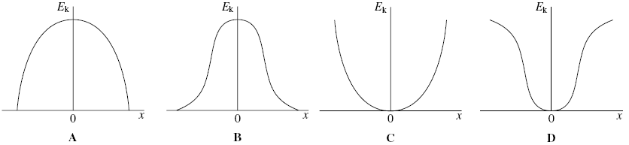
Q80. The time period of oscillation of a simple pendulum of length l is the same as the time period of oscillation of a mass M attached to a vertical spring. The length and mass are then changed.
Which row, A to D, in the table would give a simple pendulum with a time period twice that of the spring oscillations?
 | new pendulum length | new mass on spring
A | $$2l$$ | $$2M$$
B | $$2l$$ | $$\frac{M}{2}$$
C | $$\frac{l}{2}$$ | $$2M$$
D | $$\frac{l}{2}$$ | $$\frac{M}{2}$$
Q81. A mechanical system is oscillating at resonance with a constant amplitude. Which one of the following statements is not correct?
A The applied force prevents the amplitude from becoming too large.
B The frequency of the applied force is the same as the natural frequency of oscillation of the system.
C The total energy of the system is constant.
D The amplitude of oscillations depends on the amount of damping.
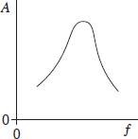
Q82. A periodic force is applied to a lightly-damped object causing the object to oscillate.
The graph shows how the amplitude A of the oscillations varies with the frequency f of the periodic force.
Which one of the following statements best describes how the shape of the curve would differ if the damping had been greater?
A the curve would be lower at all frequencies
B the curve would be higher at all frequencies
C the curve would be unchanged except at frequencies above the resonant frequency where it would be lower
D the curve would be unchanged except at frequencies above the resonant frequency where it would be higher

Q83. The tip of each prong of a tuning fork emitting a note of 320 Hz vibrates in simple harmonic motion with an amplitude of 0.50 mm.
What is the speed of each tip when its displacement is zero?
A zero B 0.32π mm s^{–1} C 160π mm s^{–1} D 320π mm s^{–1}
Q84. Which one of the following graphs shows how the acceleration, a, of a body moving with simple harmonic motion varies with its displacement, x?
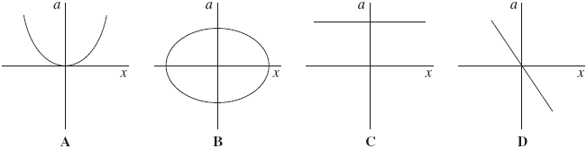
Q85. A body executes simple harmonic motion. Which one of the graphs, A to D, best shows the relationship between the kinetic energy, E_{k}, of the body and its distance from the centre of oscillation?
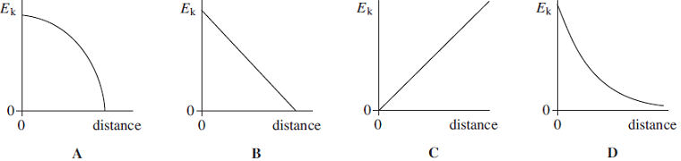
Q86. A simple pendulum and a mass-spring system both have the same time period T at the surface of the Earth. If taken to another planet where the acceleration due to gravity is twice that on Earth, which line, A to D, in the table gives the correct new time periods?
 | simple pendulum | mass-spring
A | $$T\sqrt{2}$$ | $$\frac{T}{\sqrt{2}}$$
B | $$T\sqrt{2}$$ | $$T$$
C | $$\frac{T}{\sqrt{2}}$$ | $$T$$
D | $$\frac{T}{\sqrt{2}}$$ | $$T\sqrt{2}$$
Q87. Which one of the following statements always applies to a damping force acting on a vibrating system?
A It is in the same direction as the acceleration.
B It is in the same direction as the displacement.
C It is in the opposite direction to the velocity.
D It is proportional to the displacement.
Q88. An oscillatory system, subject to damping, is set into vibration by a periodic driving force of frequency f. The graphs, A to D, which are to the same scale, show how the amplitude of vibration A of the system might vary with f, for various degrees of damping.
Which graph best shows the lightest damping?
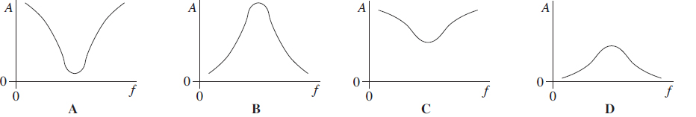

Wednesday: Pendulums Extended Writing

A ball on the end of a string is an example of a simple pendulum. Pendulums are an example of devices that can perform simple harmonic motion; they can vibrate freely or be forced to vibrate by an external device.
Discuss the principles involved with the simple harmonic motion of a simple pendulum. You should include the following:
- The characteristics of simple harmonic motion
- How the velocity, acceleration and energy vary over a complete oscillation
- An account of how the time period could be measured accurately
- A description and explanation of what would happen to the pendulum as the driving frequency is altered.
..................................................................................................................................................................................................
..................................................................................................................................................................................................
..................................................................................................................................................................................................
..................................................................................................................................................................................................
..................................................................................................................................................................................................
..................................................................................................................................................................................................
..................................................................................................................................................................................................
..................................................................................................................................................................................................
..................................................................................................................................................................................................
..................................................................................................................................................................................................
..................................................................................................................................................................................................
..................................................................................................................................................................................................
..................................................................................................................................................................................................
..................................................................................................................................................................................................
..................................................................................................................................................................................................
..................................................................................................................................................................................................
..................................................................................................................................................................................................
..................................................................................................................................................................................................
..................................................................................................................................................................................................
..................................................................................................................................................................................................
..................................................................................................................................................................................................
..................................................................................................................................................................................................
..................................................................................................................................................................................................
..................................................................................................................................................................................................
..................................................................................................................................................................................................
..................................................................................................................................................................................................
..................................................................................................................................................................................................
..................................................................................................................................................................................................
..................................................................................................................................................................................................
Wednesday: Simple Harmonic Motion Definitions

Maximum | When displacement is maximum, acceleration is …
Increase | As the driving frequency is increased towards the natural frequency the amplitude of oscillation will…
Displacement | One of the conditions for SHM is that acceleration is proportional to …
Decrease | As damping increases the sharpness of a resonance graph will …
Resonance | When the driving frequency is equal to the natural frequency.
Acceleration | For SHM, displacement and ……….. are always in the opposite direction.
Zero | When displacement is maximum, velocity is …
Forced Vibration | When an object is being driven to oscillate.
Maximum | When velocity is zero, acceleration is ...
Displacement-Time | The gradient of this graph gives us the velocity.
Zero | When velocity is maximum, acceleration is …
Decrease | As the driving frequency is increased past the natural frequency the amplitude of oscillation will…
Amplitude | The maximum displacement from the equilibrium or rest position.
Amplitude | This quantity has no effect on the time period of a mass-spring system.
Zero | When displacement is zero, acceleration is …
Free Vibration | When an object is initially displaced and then allowed to oscillate.
Velocity-Time | The gradient of this graph gives us the acceleration.
Mass | This quantity has no effect on the time period of a simple pendulum.
Natural Frequency | The frequency that an object vibrates at when allowed to vibrate freely.
Damping | Forces that reduce SHM.
Maximum | When displacement is zero, velocity is …
Equilibrium | The acceleration in SHM is always to this point.

Acceleration | Amplitude | Amplitude | Damping
Decrease | Decrease | Displacement | Displacement-Time
Equilibrium | Forced Vibration | Free Vibration | Increase
Mass | Maximum | Maximum | Maximum
Natural Frequency | Resonance | Velocity-Time | Zero
Zero | Zero

Thursday: Time Periods, Resonance and Damping Notes
The time period of a simple pendulum is given by the equation: $T=2π\sqrt{\frac{l}{g}}$
Symbol $l$ Quantity …………………………………………………………………………………………… Units ………………………
Symbol $g$ Quantity …………………………………………………………………………………………… Units ………………………
The time period of a simple pendulum is given by the equation: $T=2π\sqrt{\frac{m}{k}}$
Symbol $m$ Quantity …………………………………………………………………………………………… Units ………………………
Symbol $k$ Quantity …………………………………………………………………………………………… Units ………………………
Describe the energy transformations that occur in a simple pendulum.
…………………………………………………………………………...……
…………………………………………………………………………...……
…………………………………………………………………………...……
…………………………………………………………………………...……
…………………………………………………………………………...……
Sketch graphs of how the different types of energy vary with distance from the centre of oscillation.
The first graph shows how the displacement varies with time for an object performing SHM.
Sketch the graphs for how the kinetic energy and gravitational potential energy vary with time.

Explain what is meant by the term ‘natural frequency’.
……………………………………………………………………….……….……………………………….………………………………………..
………………………………………………………………….…………….……………………………………………………….………………..
Describe what happens as the driving frequency of a system is increased. Complete the graph to support your description.
………………………………………………………………….…………….……….
……………………………………………………………………….……….……….
………………………………………………………………….…………….……….
……………………………………………………………………….……….……….
………………………………………………………………….…………….……….
……………………………………………………………………….……….……….

What is the phase difference between the driver and the driven at resonance? …….…………………………..
What is damping? Give examples of what causes it.
………………………………………………………………….…………….……………………………………………………….………………..
……………………………………………………………………….……….……………………………….………………………………………..
……………………………………………………………………….……….……………………………….………………………………………..
………………………………………………………………….…………….……………………………………………………….………………..
What effect does light damping have?
………………………………………………………………….…………….……………………………………………………….………………..
……………………………………………………………………….……….……………………………….………………………………………..
What effect does heavy damping have?
………………………………………………………………….…………….……………………………………………………….………………..
……………………………………………………………………….……….……………………………….………………………………………..
Describe the effect that damping has on resonance. Add to this diagram to support your description.
………………………………………………………………….…………….……….
……………………………………………………………………….……….……….
………………………………………………………………….…………….……….
……………………………………………………………………….……….……….
………………………………………………………………….…………….……….
……………………………………………………………………….……….……….
Consider a simple pendulum; describe the connection between the damping force and the displacement.
………………………………………………………………….…………….……………………………………………………….………………..
………………………………………………………………….…………….……………………………………………………….………………..
Describe the connection between the damping force and the velocity.
………………………………………………………………….…………….……………………………………………………….………………..
………………………………………………………………….…………….……………………………………………………….………………..

Friday: Simple Harmonic Motion Exam Questions 2
Q89(a) Describe the energy changes that take place as the bob of a simple pendulum makes one complete oscillation, starting at its maximum displacement.
..................................................................................................................................................................................................
..................................................................................................................................................................................................
.................................................................................................................................................................................................. (2)
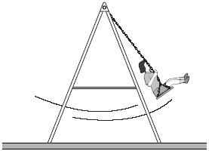
Q89(b) Figure 1 shows a young girl swinging on a garden swing. You may assume that the swing behaves as a simple pendulum. Ignore the mass of chains supporting the seat throughout this question, and assume that the effect of air resistance is negligible.
15 complete oscillations of the swing took 42s.
Q89(bi) Calculate the distance from the top of the chains to the centre of mass of the girl and seat. Express your answer to an appropriate number of significant figures.

answer = .......................... m (4)
Q89(bii) To set her swinging, the girl and seat were displaced from equilibrium and released from rest. This initial displacement of the girl raised the centre of mass of the girl and seat 250 mm above its lowest position. If the mass of the girl was 18 kg, what was her kinetic energy as she first passed through this lowest point?

answer = ............................ J (2)
Q89(biii) Calculate the maximum speed of the girl during the first oscillation.

answer = ..................... m s^{–1} (1)
Q89(c) Figure 2
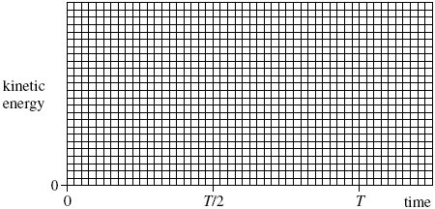
On Figure 2 draw a graph to show how the kinetic energy of the girl varied with time during the first complete oscillation, starting at the time of her release from maximum displacement. On the horizontal axis of the graph, T represents the period of the swing. You do not need to show any values on the vertical axis. (3)
(Total 12 marks)
Q90. A trolley of mass 0.80 kg rests on a horizontal surface attached to two identical stretched springs, as shown in Figure 1. Each spring has a spring constant of 30Nm^{–1}, can be assumed to obey Hooke’s law, and to remain in tension as the trolley moves.
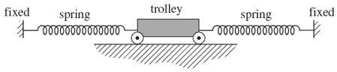
Q90(ai) The trolley is displaced to the left by 60 mm and then released. Show that the magnitude of the resultant force on it at the moment of release is 3.6 N.

(2)
Q90(aii) Calculate the acceleration of the trolley at the moment of release and state its direction.

answer = ............................m s^{–2}
direction ................................................... (2)
Q90(bi) The oscillating trolley performs simple harmonic motion. State the two conditions which have to be satisfied to show that a body performs simple harmonic motion.
..................................................................................................................................................................................................
..................................................................................................................................................................................................
.................................................................................................................................................................................................. (2)
Q90(c) Copper ions in a crystal lattice vibrate in a similar way to the trolley, because the inter-atomic forces act in a similar way to the forces exerted by the springs. Figure 2 shows how this model of a vibrating ion can be represented.
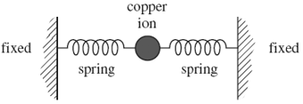
Q90(ci) The spring constant of each inter-atomic ‘spring’ is about 200Nm^{–1}. The mass of the copper ion is 1.0 × 10^{–25} kg. Show that the frequency of vibration of the copper ion is about 10¹³ Hz.

(1)
Q90(cii) If the amplitude of vibration of the copper ion is 10^{–11} m, estimate its maximum speed.

answer = ............................m s^{–1} (1)
Q90(ciii) Estimate the maximum kinetic energy of the copper ion.

answer = ...................................J (1)
(Total 12 marks)

Saturday: Simple Harmonic Motion Checklist

