18: Thermal Physics 2
Gas Laws and the Molecular Kinetic Theory Model
Paper 2
17: Thermal Physics 1  Specific Heat Capacity and Latent Heat | - Gas laws as experimental relationships between p, V, T and the mass of the gas.  - Concept of absolute zero of temperature.  Required practical 8: Investigation of Boyle's law (constant temperature) and Charles’s law (constant pressure) for a gas.  - Ideal gas equation: $pV=nRT$ for n moles and $pV=NkT$ for N molecules.  - $Work done=p∆V$  - Avogadro constant N_{A}, molar gas constant R, Boltzmann constant k  - Molar mass and molecular mass.  - Explanation of relationships between p, V and T in terms of a simple molecular model.  - Students should understand that the gas laws are empirical in nature whereas the kinetic theory model arises from theory.  - Assumptions leading to $pV=\frac{1}{3}Nm{\left(c_{rms}\right)}^{2}$ including derivation of the equation and calculations.  - A simple algebraic approach involving conservation of momentum is required.  - Appreciation that for an ideal gas internal energy is kinetic energy of the atoms.  - Use of average molecular kinetic energy = $\frac{1}{2}m{\left(c_{rms}\right)}^{2}=\frac{3}{2}kT=\frac{3RT}{2N_{A}}$  - Appreciation of how knowledge and understanding of the behaviour of a gas has changed over time.  
18: Thermal Physics 2
Gas Laws and the MKTM
19: Gravitational Fields
Field Strength and Potential
20: Electric Fields
Fields Strength and Potential
21: Fields Comparisons
Orbits and Comparisons
22: Capacitors
Energy Stored and Exponential Decay
23: Magnetic Fields 1
Magnetic Forces and Flux
24: Magnetic Fields 2
Induction and Transformers
25: Radioactivity 1
Nuclear Radius and Types of Radiation
26: Radioactivity 2
Modes and Rate of Decay
27: Nuclear Physics
Binding Energy, Fission and Fusion
Paper 3
28: Electron Discovery
Specific Charge and Millikan
29: Wave-Particle Duality
Waves, Quantum and Microscopes
30: Special Relativity
Michelson-Morley & Relativistic Speed

Monday: Gas Laws Notes
What causes a gas pressure? ………………………………….……….……………………………….……………………………………....…
……………………………………………………………………….……….……………………………….……………………………………..…
……………………………………………………………………….……….……………………………….……………………………………..…
Boyle’s Law
Mass and ………………………………………………………..…. are constant.
Describe how the other two quantities are connected.
……………………………………………………………………………………………..
……………………………………………………………………………………………..
Represent this mathematically.  $$∝$$ | Sketch a graph to represent this.  Label the axes.
Explain why they are connected in this way (as the horizontal quantity increases).
As .………………………………… increases .…………….…………….……………………………………………………….………………..
……………………………………………………………………….……….……………………………….………………………………………..
Charles’ Law
Mass and ………………………………………………………..…. are constant.
Describe how the other two quantities are connected.
……………………………………………………………………………………………..
……………………………………………………………………………………………..
Represent this mathematically.  $$∝$$ | Sketch a graph to represent this.  Label the axes.
Explain why they are connected in this way (as the horizontal quantity increases).
As .………………………………… increases .…………….…………….……………………………………………………….………………..
……………………………………………………………………….……….……………………………….………………………………………..
Pressure Law
Mass and ………………………………………………………..…. are constant.
Describe how the other two quantities are connected.
……………………………………………………………………………………………..
……………………………………………………………………………………………..
Represent this mathematically.  $$∝$$ | Sketch a graph to represent this.  Label the axes.
Explain why they are connected in this way (as the horizontal quantity increases).
As .………………………………… increases .…………….…………….……………………………………………………….………………..
……………………………………………………………………….……….……………………………….………………………………………..

What is meant by the term ‘absolute zero of temperature’?
……………………………………………………………………….……….……………………………….………………………………………..
……………………………………………………………………….……….……………………………….………………………………………..
……………………………………………………………………….……….……………………………….………………………………………..
Describe how the value of absolute zero can be found. Complete the graph to support your description.
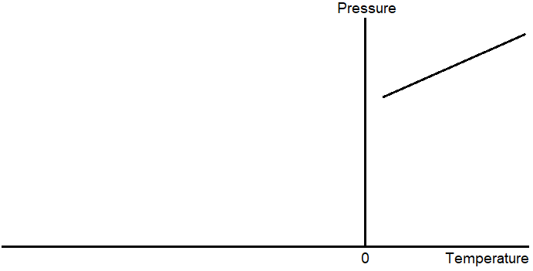
………………………………………………………………….……….
………………………………………………………………….……….
………………………………………………………………….……….
……………………………………………………………….………….
……………………………………………………………….………….
…………………………………………………………….…………….
……………………………………………………………………….……….……………………………….………………………………………..
……………………………………………………………………….……….……………………………….………………………………………..

The separate gas laws can be combined into one equation called the ideal gas equation:
$$pV=nRT$$
Symbol $p$ Quantity …………………………………………………………………………………………… Units ………………………
Symbol $V$ Quantity …………………………………………………………………………………………… Units ………………………
Symbol $n$ Quantity …………………………………………………………………………………………… Units ………………………
Symbol $R$ Quantity …………………………………………………………………………………………… Units ………………………
Symbol $T$ Quantity …………………………………………………………………………………………… Units ………………………
What is meant by the following terms?
Mole ……………………………………………………………….……….……………………………….…………………………..……………..
……………………………………………………………………….……….……………………………….………………………………………..
Molecular mass ..………………………………………………….……….……………………………….………………………………………..
Molar mass .……………………………………………………….……….……………………………….………………………………………..
Since n and N are connected we can rewrite the ideal gas equation as:
$$pV=NkT$$
Symbol $N$ Quantity …………………………………………………………………………………………… Units ………………………
Symbol $k$ Quantity …………………………………………………………………………………………… Units ………………………
What is the difference between an actual gas and an ideal gas?
……………………………………………………………………….……….……………………………….………………………………………..
……………………………………………………………………….……….……………………………….………………………………………..
……………………………………………………………………….……….……………………………….………………………………………..
Tuesday: Gas Laws Exam Questions
Q3(a) Outline what is meant by an ideal gas.
..................................................................................................................................................................................................
..................................................................................................................................................................................................
..................................................................................................................................................................................................
.................................................................................................................................................................................................. (2)
Q3(b) An ideal gas at a temperature of 22 °C is trapped in a metal cylinder of volume 0.20 m³ at a pressure of 1.6 × 10⁶ Pa.
Q3(bi) Calculate the number of moles of gas contained in the cylinder.

number of moles ....................................... mol (2)
Q3(bii) The gas has a molar mass of 4.3 × 10⁻² kg mol⁻¹.
Calculate the density of the gas in the cylinder. State an appropriate unit for your answer.

density ......................... unit .............. (3)
Q3(biii) The cylinder is taken to high altitude where the temperature is −50 °C and the pressure is 3.6 × 10⁴ Pa. A valve on the cylinder is opened to allow gas to escape.
Calculate the mass of gas remaining in the cylinder when it reaches equilibrium with its surroundings.
Give your answer to an appropriate number of significant figures.

mass .......................................... kg (3)
(Total 10 marks)

Q4(a) ‘The pressure of an ideal gas is inversely proportional to its volume’, is an incomplete statement of Boyle’s law.
State two conditions necessary to complete the statement.
1................................................................................................................................................................................................
2................................................................................................................................................................................................. (2)
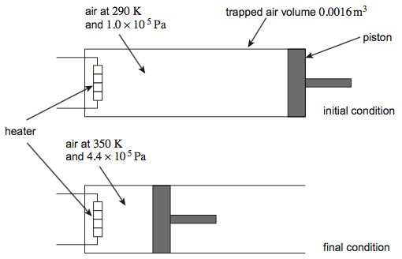
Q4(b) A volume of 0.0016 m³ of air at a pressure of 1.0 × 10⁵ Pa and a temperature of 290 K is trapped in a cylinder.
Under these conditions the volume of air occupied by 1.0 mol is 0.024 m³.
The air in the cylinder is heated and at the same time compressed slowly by a piston.
The initial condition and final condition of the trapped air are shown in the diagram.
In the following calculations treat air as an ideal gas having a molar mass of 0.029 kg mol^{–1}.

Q4(bi) Calculate the final volume of the air trapped in the cylinder.
volume of air = ............................................ m³ (2)
Q4(bii) Calculate the number of moles of air in the cylinder.
number of moles = ............................................ (1)
Q4(biii) Calculate the initial density of air trapped in the cylinder.
density = ............................................ kg m^{–3} (2)
Q4(c) State and explain what happens to the speed of molecules in a gas as the temperature increases.
..................................................................................................................................................................................................
..................................................................................................................................................................................................
..................................................................................................................................................................................................
..................................................................................................................................................................................................
.................................................................................................................................................................................................. (2)
(Total 9 marks)

Wednesday: Ideal Gases Extended Writing

By considering the motion of the molecules explain how an ideal gas exerts a pressure and how the pressure, volume and temperature are linked by Boyle’s and Charles’ Laws. Your answer should include:
- The assumption made to model the motion of an ideal gas
- An explanation of what an ideal gas is
- An explanation of how a gas exerts a pressure
- A written and graphical description of the gas laws mentioned
- An explanation of why these gas laws are true or how they work.
..................................................................................................................................................................................................
..................................................................................................................................................................................................
..................................................................................................................................................................................................
..................................................................................................................................................................................................
..................................................................................................................................................................................................
..................................................................................................................................................................................................
..................................................................................................................................................................................................
..................................................................................................................................................................................................
..................................................................................................................................................................................................
..................................................................................................................................................................................................
..................................................................................................................................................................................................
..................................................................................................................................................................................................
..................................................................................................................................................................................................
..................................................................................................................................................................................................
..................................................................................................................................................................................................
..................................................................................................................................................................................................
..................................................................................................................................................................................................
..................................................................................................................................................................................................
..................................................................................................................................................................................................
..................................................................................................................................................................................................
..................................................................................................................................................................................................
..................................................................................................................................................................................................
..................................................................................................................................................................................................
..................................................................................................................................................................................................
..................................................................................................................................................................................................
..................................................................................................................................................................................................
..................................................................................................................................................................................................
..................................................................................................................................................................................................
..................................................................................................................................................................................................
Wednesday: Gas Laws Definitions

Molar Mass | The mass of one mole of a substance; the units are kg mol⁻¹.
By | When a gas expands, work is done ………… the gas.
Molecules | The N in PV=NkT stands for the number of …
Pressure | This is caused by the rate of change of momentum of the molecule colliding with their container.
Point Masses | The molecular kinetic theory model assumes that the gas molecules are …
Inversely | Pressure and volume are this type of proportional when temperature and mass are constant.
Isothermic | A change where the temperature remains constant.
Boyle’s | This law connects the pressure and volume when temperature and mass are constant.
Mass Number | The number of protons and neutrons in the nucleus of an atom, isotope or ion.
Negligible | The molecular kinetic theory model assumes that the time for each collision is …
Avogadro | This person’s constant is the number of molecules in one mole.
Random | The molecular kinetic theory model assumes that the gas molecule motion is …
Directly | Temperature and pressure are this type of proportional when volume and mass are constant.
Isobaric | A change where the pressure remains constant.
Molecular Mass | A value equal to the molar mass multiplied by the number of moles.
Absolute Zero | The point at which particles will lose all of their kinetic energy.
Ideal | A gas that follows all gas laws at all temperatures and pressures; it can’t be liquefied.
Directly | Temperature and volume are this type of proportional when pressure and mass are constant.
Moles | The n in PV=nRT stands for the number of …
Isochoric | A change where the volume remains constant.
Elastic | The molecular kinetic theory model assumes that collisions are …
On | When a gas is compressed, work is done ………… the gas.
Charles’ | This law connects the volume and temperature when pressure and mass are constant.
Kelvin | Other than temperature differences these units must be used for temperature.

Absolute Zero | Avogadro | Boyle’s | By
Charles’ | Directly | Directly | Elastic
Ideal | Inversely | Isobaric | Isochoric
Isothermic | Kelvin | Mass Number | Molar Mass
Molecular Mass | Molecules | Moles | Negligible
On | Point Masses | Pressure | Random

Thursday: Molecular Kinetic Theory Model Notes
In both versions of the ideal gas equation pressure, volume and temperature are connect by two other terms that are constant if the container holding the gas is sealed. We can rearrange the equation to become:
$$\frac{p_{1}V_{1}}{T_{1}}= \frac{p_{2}V_{2}}{T_{2}}$$
Complete this table by calculating the missing values.
$$p_{1}$$ | $$V_{1}$$ | $$T_{1}$$ | $$p_{2}$$ | $$V_{2}$$ | $$T_{2}$$
 | 0.50 | 293 | 1.1 × 10³ | 3.0 | 600
9800 |  | 290 | 47 × 10³ | 4.1 × 10⁻⁴ | 350
1.8 × 10⁵ | 3.2 × 10⁻³ |  | 3.2 × 10⁵ | 0.0019 | 301
An isothermal change is a change when ………………..………………………….. is constant.
An isobaric change is a change when ………………..………………………….. is constant.
Work Done
When a gas is compressed work is done ……………..……. the gas ……………..……. the surroundings.
When a gas expanded work is done ……………..……. the gas ……………..……. the surroundings.
The work done to change the volume of a gas by a small amount (so the pressure is constant) is given by:
$$W=p∆V$$
The gas laws were first observed and then explained mathematically.
The molecular kinetic theory model was first theorised and then observed.
Assumptions
1.……………………………………………………………….…………….……………………………………………………….………………..
2.……………………………………………………………….…………….……………………………………………………….………………..
3.……………………………………………………………….…………….……………………………………………………….………………..
4.……………………………………………………………….…………….……………………………………………………….………………..
5.……………………………………………………………….…………….……………………………………………………….………………..
6.……………………………………………………………….…………….……………………………………………………….………………..
7.……………………………………………………………….…………….……………………………………………………….………………..
8.……………………………………………………………….…………….……………………………………………………….………………..
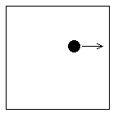
Derivation
$pV=\frac{1}{3}Nm{\left(c_{rms}\right)}^{2}$
To derive the above equation we first start by considering one molecule of mass $m$, moving in a cube of length $l$, travelling back and forth in only the $x$ direction at a speed of $v_{x}$.
Calculate the change in momentum when the molecule collides elastically with the wall. | $$p=mv$$
Calculate the time between collisions with the same wall. | $$v=\frac{∆s}{∆t}$$
Calculate the force that this molecule applied to the wall. | $$F=\frac{∆mv}{t}$$
Calculate the pressure that the molecule applied to the wall. | $$p=\frac{F}{A}$$
The container is a cube. | -
This is the pressure due to one molecule on one wall. Change this to the pressure due to all the particles on one wall. | $$N$$
Move the $V$ with the $p$. | $$pV$$
Use 3D Pythagoras to find the mean speed in all directions. | -
Since the motion is random the mean speeds in x, y and z are equal. | $$v_{x}=v_{y}$$  and  $$v_{x}=v_{z}$$
Substitute this into the $pV$ equation.
The kinetic energy of one gas molecule can be calculated using the kinetic energy equation:
$$E_{k}=\frac{1}{2}m{\left(c_{rms}\right)}^{2}$$
The kinetic energy of one gas molecule can also be calculated using this equation derived from the molecular kinetic theory model::
$$E_{k}=\frac{3}{2}kT$$
What is the significance of the above equation?
……………………………………………………………………….……….……………………………….………………………………………..
……………………………………………………………………….……….……………………………….………………………………………..
How could the energy of the entire gas (the internal energy) be calculated from its temperature?
……………………………………………………………………….……….……………………………….………………………………………..
…………………………………………………………………….……….……………………………….…………………………………………..
A sample of gas consists of a mixture of oxygen and hydrogen atoms. State and explain how the mean-square speed of oxygen atoms in the gas compares with that of the hydrogen atoms at the same temperature.
……………………………………………………………………….……….……………………………….………………………………………..
……………………………………………………………………….……….……………………………….………………………………………..
……………………………………………………………………….……….……………………………….………………………………………..

Friday: Molecular Kinetic Theory Model Exam Questions
Q5. A fixed mass of ideal gas at a low temperature is trapped in a container at constant pressure. The gas is then heated and the volume of the container changes so that the pressure stays at 1.00 × 10⁵ Pa. When the gas reaches a temperature of 0 °C the volume is 2.20 × 10^{–3} m³.
Q5(a) Draw a graph on the axes below to show how the volume of the gas varies with temperature in °C.
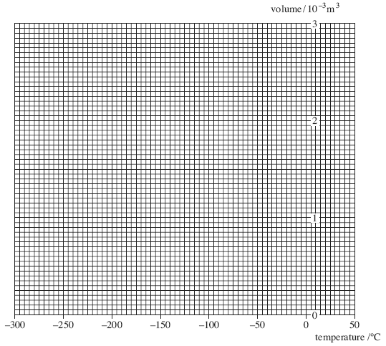 (2)
Q5(b) Calculate the number of moles of gas present in the container.

answer = .................................moles (2)
Q5(c) Calculate the average kinetic energy of a molecule when this gas is at a temperature of 50.0 °C. Give your answer to an appropriate number of significant figures.

answer = .........................................J (3)
Q5(d) Calculate the total internal energy of the gas at a temperature of 50.0 °C.

answer = .........................................J (1)
(Total 8 marks)
Q6(a) Define the Avogadro constant.
..................................................................................................................................................................................................
..................................................................................................................................................................................................
..................................................................................................................................................................................................
.................................................................................................................................................................................................. (1)
Q6(bi) Calculate the mean kinetic energy of krypton atoms in a sample of gas at a temperature of 22 °C.

mean kinetic energy ........................................... J (1)
Q6(bii) Calculate the mean-square speed, (c_{rms})², of krypton atoms in a sample of gas at a temperature of 22 °C.
State an appropriate unit for your answer.
mass of 1 mole of krypton = 0.084 kg

mean-square speed..................................... unit .......................... (3)
Q6(c) A sample of gas consists of a mixture of krypton and argon atoms.
The mass of a krypton atom is greater than that of an argon atom.
State and explain how the mean-square speed of krypton atoms in the gas compares with that of the argon atoms at the same temperature.
..................................................................................................................................................................................................
..................................................................................................................................................................................................
..................................................................................................................................................................................................
..................................................................................................................................................................................................
.................................................................................................................................................................................................. (2)
Q6(d) State two assumptions about the movement of molecules that are used when deriving the equation of state, $pV=\frac{1}{3}Nm{(c_{rms})}^{2}$ for an ideal gas.
1................................................................................................................................................................................................
..................................................................................................................................................................................................
2................................................................................................................................................................................................
.................................................................................................................................................................................................. (2)
(Total 9 marks)

Saturday: Gas Laws and MKTM Checklist

