|  |  |
| --- | --- |
| 19: Gravitational Fields  Field Strength and Potential | |
|  | |
| Paper 2 |  |
| 17: Thermal Physics 1  Specific Heat Capacity and Latent Heat | 1. Gravity as a universal attractive force acting between all matter. 2. Magnitude of force between point masses: $F=\frac{Gm_{1}m_{2}}{r^{2}}$ where *G* is the gravitational constant. 3. Representation of a gravitational field by gravitational field lines. 4. *g* as force per unit mass as defined by 5. Magnitude of g in a radial field given by 6. Understanding of definition of gravitational potential, including zero value at infinity. 7. Understanding of gravitational potential difference. 8. Work done in moving mass *m* given by 9. Equipotential surfaces. 10. Idea that no work is done when moving along an equipotential surface. 11. *V* in a radial field given by 12. Significance of the negative sign. 13. Graphical representations of variations of *g* and *V* with *r*. 14. *V* related to *g* by: 15. *ΔV* from area under graph of *g* against *r*. |
| 18: Thermal Physics 2  Gas Laws and the MKTM |
| 19: Gravitational Fields  Field Strength and Potential |
| 20: Electric Fields  Fields Strength and Potential |
| 21: Fields Comparisons  Orbits and Comparisons |
| 22: Capacitors  Energy Stored and Exponential Decay |
| 23: Magnetic Fields 1  Magnetic Forces and Flux |
| 24: Magnetic Fields 2  Induction and Transformers |
| 25: Radioactivity 1  Nuclear Radius and Types of Radiation |
| 26: Radioactivity 2  Modes and Rate of Decay |
| 27: Nuclear Physics  Binding Energy, Fission and Fusion |
| Paper 3 |
| 28: Electron Discovery  Specific Charge and Millikan |
| 29: Wave-Particle Duality  Waves, Quantum and Microscopes |
| 30: Special Relativity  Michelson-Morley & Relativistic Speed |

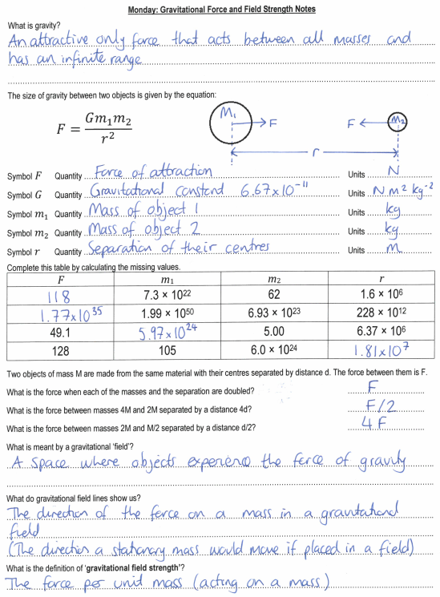

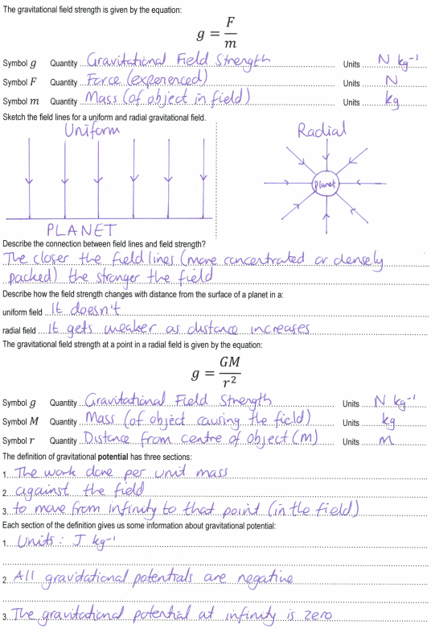

**Tuesday: Gravitational Force and Field Strength Exam Questions**

**M7.         A**

**M8.           A**

**M9.           B**

**M10.         C**

**M11.         B**

**M21.         C**

**M22.          B**

**M23.          B**

**M24.          B**

Year 13 Physics: Gravitational Fields Extended Writing Task 24: **To the Moon and Back**

This work was done by ________________________________________ and was marked by __________________________________________

|  |  |  |  |  |  |  |  |  |  |  |  |  |  |
| --- | --- | --- | --- | --- | --- | --- | --- | --- | --- | --- | --- | --- | --- |
| S |  | | | | | | | | | | | | |
| **D answer** | | | | **B answer** | | | **A* answer** | | | | | | |
| E and M exert forces of attraction on the spacecraft in opposite directions... | |  |  | ...the force of attraction (or weight or gravity) on the surface of E is much greater than on M... |  |  | ...because E is much more massive than M. | | | | |  |  |
| On the outward journey the force is towards E before X and towards M after X. On the return journey the **\*** force is towards M before X and towards E after X... | |  |  | ...since X is closer to M than E... |  |  | ...the spacecraft spends longer on the outward journey travelling in the **opposite** direction to the force and longer on the return journey in the **same** direction as the force... | | | | |  |  |
| **\*** resultant (owtte). |
| During the outward journey E’s gravitational field becomes weaker and M’s becomes stronger... | |  |  | ...at X these two component fields are equal and opposite, giving zero (resultant) field strength... |  |  | ...beyond X the spacecraft will be attracted to M by M’s gravitational field. On the return journey the spacecraft will ‘fall’ to E once it has passed X. | | | | |  |  |
| Field strength is a vector quantity... | |  |  | ...and the sum of those due to E and M separately. |  |  |
| The gravitational potential due E decreases as the spacecraft moves away from E. | |  |  | The gravitational potential due E increases (i.e. becomes less negative) as the spacecraft moves away from E... |  |  | ...at X the gravitational potential reaches a maximum value before decreasing as M is approached. | | | | |  |  |
| There is a simple statement that the gravitational potential is different on (the surface of) E and M. | |  |  | In order to reach M on the outward journey, the spacecraft has to be given at least enough energy to reach X, and vice-versa for the return journey... |  |  | ...much more work is needed to move the spacecraft from E to X than from M to X, since a larger force has to be overcome over a larger distance. | | | | |  |  |
| T |  | | | | | | | **Develop…** | | **Grade** | **Effort** | | |
| Range ↓ |  |  |  | | |
| Depth → |  |
| Order ⁝ |  |
| Relevant ! |  |
| E | …………………………………………………………………………………………………………………………………………….………………………..  ……………………………………………………………………………………………………………………………………….……………………………..  ………………………………………………………………………………………………………………………………….…………………………………..  …………………………………………………………………………………………………………………………….………………………………………..  ………………………………………………………………………………………………………………………………………………….………………….. | | | | | | | | | | | | |

**Wednesday: Gravitational Fields Definitions**

|  |  |
| --- | --- |
| Field Strength | The force per unit mass acting at that point in the field. |
| Gradient | On a graph of gravitational potential against distance this represents the field strength. |
| Is Constant | In a uniform field, as distance from planet surface increase field strength …. |
| N/kg | The units of gravitational field strength. |
| Zero | The amount of work done when moving along a line of equipotential. |
| Quarter | If the distance from a planet is doubled the field strength will be ….…. the initial value. |
| Negative | Gravitational potentials (other than at infinity) are this. |
| Half | If the distance from a planet is doubled the gravitational potential will be ….…. the initial value. |
| Area Under the Line | On a graph of gravitational field strength against distance this represents the potential. |
| Potential | The work done per unit mass against the field to bring a point mass from infinity to the point. |
| Scalar | Gravitational potential is this type of quantity. |
| Against | Potentials will be positive when working ….…. the field. |
| Radial | The type of field where field strength changes with distance. |
| Centre | When calculating forces, field strength or potentials we use the distance from the … |
| Zero | The gravitational potential at infinity. |
| Surface | When dealing with heights of orbit we could we given the distance from the … |
| Concentration | Field strengths can be compared using the ……….. of the field lines. |
| Escape Velocity | The speed an object must be launched at to leave the surface of a planet. |
| Vector | Gravitational field strength is this type of quantity. |
| J/kg | The units of gravitational potential. |
| Is Smaller | In a radial field, as distance from planet surface increase field strength …. |
| Uniform | The type of field where field strength is constant. |
| With | Potentials will be negative when working ….…. the field. |
| Equipotential | A line where the value of gravitational potential is the same all the way along it. |

|  |  |  |  |
| --- | --- | --- | --- |
| Against | Field Strength | N/kg | Surface |
| Area Under the Line | Gradient | Negative | Uniform |
| Centre | Half | Potential | Vector |
| Concentration | Is Constant | Quarter | With |
| Equipotential | Is Smaller | Radial | Zero |
| Escape Velocity | J/kg | Scalar | Zero |

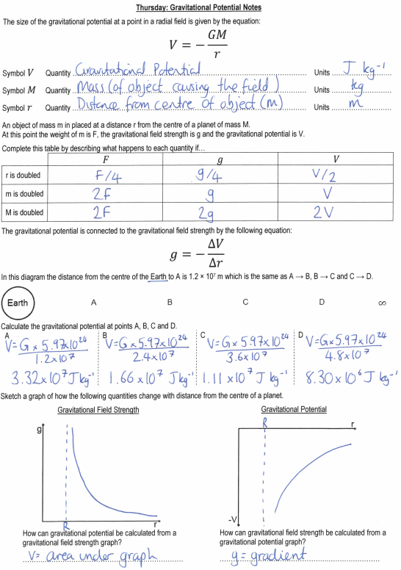

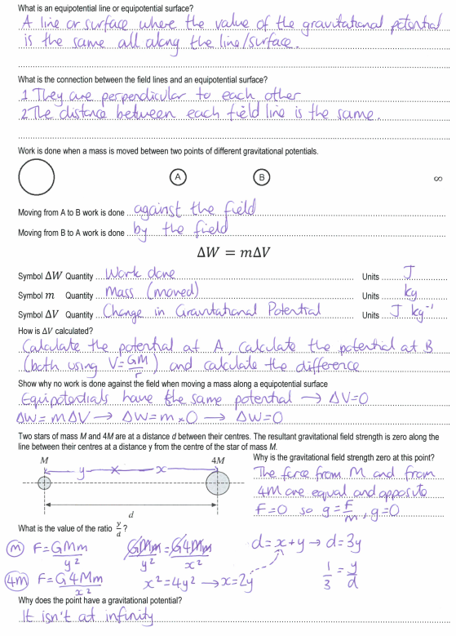

**Friday: Gravitational Potential Exam Questions**

**M25.**          (a)     (i)      relationship between them is *E*p = *mV* (allow Δ*E*p = *m*Δ*V*) [or *V*is energy per unit mass (or per kg)] **(1)**

**1**

(ii)     value of *E*p is doubled **(1)**

value of *V* is unchanged **(1)**

**2**

(b)     (i)      use of *V* =  gives *r*A =  **(1)**

= 3.3(2) × 107 (m) **(1)**

**2**

(ii)     since *V*  **(1)**

(which is ≈ 1.1 × 104 km)

**1**

(iii)     centripetal acceleration *g*B =  **(1)**

[allow use of 1.1 × 107 m from (b)(ii)]

= 3.2 (m s–2) **(1)**

[**alternatively**, since *g*B = (–) **(1)**

= 3.2 (m s–2) **(1)**]

**2**

(iv)    use of Δ*E*p = *m*Δ*V* gives Δ*E*p = 330 × (–12.0 – (–36.0)) × 106 **(1)**

(which is 7.9 × 109 J or ≈ 8 GJ)

**1**

(c)     *g* is not constant over the distance involved

(**or** *g* decreases as height increases  
**or** work done per metre decreases as height increases  
**or** field is radial and/or not uniform) **(1)**

**1**

**[10]**

**M26.         A**

**M27.         A**

**M28.          A**

**M29.         C**

**M30.          C**