Prac2
Physics Practical

Y12 Core Practical
Stationary Waves

 | Skills Assessed |  | Met?
 | 1. Follows written procedures | a. Correctly follows instructions to carry out experimental techniques or procedures.
 | 2. Applies investigative approaches and methods when using instruments and equipment | a. Correctly uses appropriate instrumentation, apparatus and materials (including ICT) to carry out investigative activities, experimental techniques and procedures with minimal assistance or prompting.
 |  | b. Carries out techniques or procedures methodically, in sequence and in combination, identifying practical issues and making adjustments when necessary.
 | 3. Safely uses a range of practical equipment and materials | b. Uses appropriate safety equipment and approaches to minimise risks with minimal prompting.
 | 4. Makes and records observations | a. Makes accurate observations relevant to the experimental or investigative procedure.
 |  | b. Obtains accurate, precise and sufficient data for experimental and investigative procedures and records this methodically using appropriate units and conventions.

Introduction

In this investigation you will determine the wave speed of a standing wave. This will be determined by variation of the frequency and length of the stationary wave on a vibrating string under tension and with a set mass per unit length and comparing it to a separately determined value.
Equipment  - Signal generator  - Vibration generator  - Stand  - 2kg mass  - 1.5m length of string (eg 1.5mm thick)  - Pulley which can be clamped to the bench  - Wooden bridge slightly higher than the pulley  - 100g masses on a holder  - Metre ruler  - An electronic top pan balance with precision 0.1g or better | Method  - Set up the apparatus as shown in the diagram.  - Adjust the position of the bridge so that l is 1.000m measured using the metre ruler.  - Increase the frequency of the signal generator from zero until the string resonates at its fundamental frequency (as indicated in the diagram with a node at each end and a central antinode).  - Read the frequency f, on the signal generator dial.  - Repeat the procedure with l = 0.900, 0.800, 0.700, 0.600 and 0.500m.  - Obtain a second and third set of results by repeating the experiment and find the mean value of f for each value of l.  - Plot a graph of mean 1/f against l.  - Draw the best straight line of fit though the points and find the gradient (the graph should be a straight line through the origin).
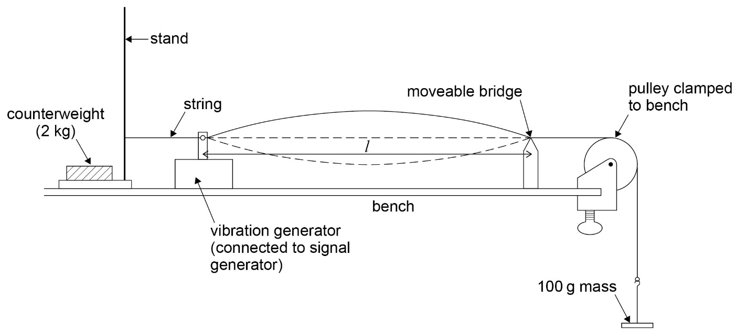
Diagram

Analysis
- The speed of the travelling waves on the string is c = fλ where λ is the wavelength. When the string is vibrating in its fundamental mode, λ = 2l. Hence c = 2fl. Using the graph of 1/f against l the gradient will be 1/ fl so c is given by 2/gradient in ms⁻¹.
- The speed is also given by c = √(T/m) where T is the tension in the string in N and m is the mass per unit length of the string in kgm⁻¹
- With a 100g mass hanging from the string, T = 0.981N. m can be found by weighing the 1.5m length of string on an electronic balance, converting this into kg, and dividing by 1.5. These values can then be substituted into the above equation to find another value for c, which can be compared to the value obtained from the graph.
- Compare the two values of c by find in the percentage difference between them.

