|  |  |
| --- | --- |
| 20: Electric Fields  Field Strength and Potential | |
|  | |
| Paper 2 |  |
| 17: Thermal Physics 1  Specific Heat Capacity and Latent Heat | 1. Force between point charges in a vacuum: 2. Permittivity of free space, *ε*0 3. Appreciation that air can be treated as a vacuum when calculating force between charges. 4. For a charged sphere, charge may be considered to be at the centre. 5. Comparison of magnitude of gravitational and electrostatic forces between subatomic particles. 6. Representation of electric fields by electric field lines. 7. Electric field strength. 8. *E* as force per unit charge defined by 9. Magnitude of *E* in a uniform field given by 10. Derivation from work done moving charge between plates: 11. Trajectory of moving charged particle entering a uniform electric field initially at right angles. 12. Magnitude of *E* in a radial field given by 13. Understanding of definition of absolute electric potential, including zero value at infinity, and of electric potential difference. 14. Work done in moving charge *Q* given by 15. Equipotential surfaces. 16. No work done moving charge along an equipotential surface. 17. Magnitude of *V* in a radial field given by 18. Graphical representations of variations of *E* and *V* with *r*. 19. *V* related to *E* by 20. *ΔV* from the area under graph of *E* against *r*. |
| 18: Thermal Physics 2  Gas Laws and the MKTM |
| 19: Gravitational Fields  Field Strength and Potential |
| 20: Electric Fields  Fields Strength and Potential |
| 21: Fields Comparisons  Orbits and Comparisons |
| 22: Capacitors  Energy Stored and Exponential Decay |
| 23: Magnetic Fields 1  Magnetic Forces and Flux |
| 24: Magnetic Fields 2  Induction and Transformers |
| 25: Radioactivity 1  Nuclear Radius and Types of Radiation |
| 26: Radioactivity 2  Modes and Rate of Decay |
| 27: Nuclear Physics  Binding Energy, Fission and Fusion |
| Paper 3 |
| 28: Electron Discovery  Specific Charge and Millikan |
| 29: Wave-Particle Duality  Waves, Quantum and Microscopes |
| 30: Special Relativity  Michelson-Morley & Relativistic Speed |

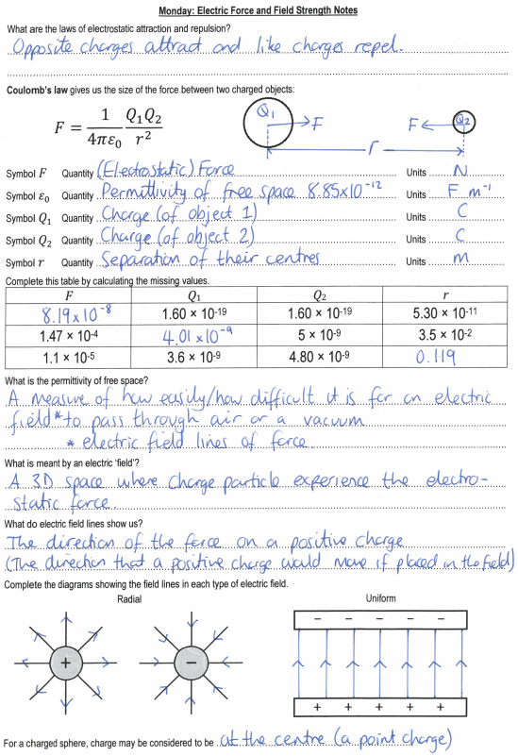

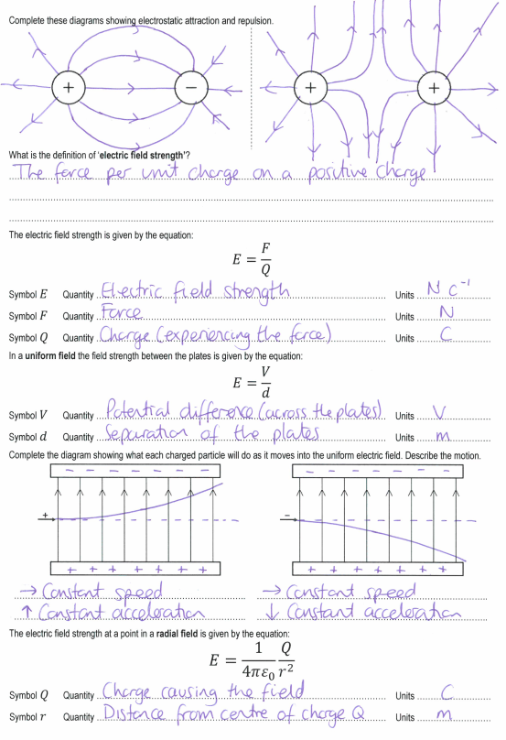

**Tuesday: Electric Force and Field Strength Exam Questions**

**M41.**          C

**M42.**           B

**M43.**          B

**M44.**           C

**M46.**         (a)      (i)     horizontal arrow to the left 

**1**

(ii)     the electrostatic force is unchanged 

**2**

because electric field strength is constant 

(b)     (i)     forces are equal in magnitude but opposite in direction 

(*E* is the same for both and) *Q* has same magnitude but opposite sign 

**2**

(ii)     acceleration of proton is (much) smaller (than acceleration of electron) 

because mass of proton is (much) greater (than mass of electron) 

**2**

(iii)     acceleration of proton increases and acceleration of electron decreases 

correct reference to changing strength of electric field (for either or both) 

**2**

**[9]**

Year 13 Physics: Electric Fields Extended Writing Task 26: **Electric Fields**

This work was done by ________________________________________ and was marked by __________________________________________

|  |  |  |  |  |  |  |  |  |  |  |  |  |  |
| --- | --- | --- | --- | --- | --- | --- | --- | --- | --- | --- | --- | --- | --- |
| S |  | | | | | | | | | | | | |
| **D answer** | | | | **B answer** | | | **A* answer** | | | | | | |
| Coulomb’s law gives the force that is experienced between two charges (or charged particles)... | |  |  | ...a negative force means attractive and a positive force means repulsive...  ...it is proportional to the sizes of each charge... |  |  | ...the force obeys the inverse square law (this could be expressed mathematically).  ...the distances are measured from their centres. | | | | |  |  |
|  |  |  |  |
| Electric field lines show the direction in which a charge will feel a force... | |  |  | ...the arrow shows the direction that a positive charge will experience a force... |  |  | ...electric field lines flow from positive and towards negative or towards less positive. | | | | |  |  |
|  |  |
| Electric field strength is defined as the force per unit charge (acting on a test charge)... | |  |  | ...electric field strength is a vector quantity... |  |  | ...because force is a vector quantity. | | | | |  |  |
| Electric field strength is constant in a uniform field but decreases as you move outwards from the centre of a radial field... | |  |  | ...field strength is highest when the field lines are most concentrated (or most dense)... |  |  | ...field strength in a radial field obeys the inverse square law (this could be described or a mathematical example given). | | | | |  |  |
| Electric potential (at a point in the field) is defined as the work done per unit charge to bring a test charge from infinity to that point... | |  |  | ...electric potential is zero at infinity (because it is already at infinity and takes no work to keep it there)... |  |  | ...electric potentials are positive for repulsion as you do work against the field (accept the opposite). | | | | |  |  |
| ...electric potential is a scalar quantity... |  |  | ...because work done (energy) is a scalar. | | | | |  |  |
| Equipotentials are lines where the electric potential is the same at all points on the line... | |  |  | ...straight lines parallel to the plates in a uniform field and circles around *Q* for a radial field... |  |  | ...no work is done (against the field) when moving a charge along an equipotential. | | | | |  |  |
| T |  | | | | | | | **Develop…** | | **Grade** | **Effort** | | |
| Range ↓ |  |  |  | | |
| Depth → |  |
| Order ⁝ |  |
| Relevant ! |  |
| E | …………………………………………………………………………………………………………………………………………….………………………..  ……………………………………………………………………………………………………………………………………….……………………………..  ………………………………………………………………………………………………………………………………….…………………………………..  …………………………………………………………………………………………………………………………….………………………………………..  ………………………………………………………………………………………………………………………………………………….………………….. | | | | | | | | | | | | |

**Wednesday: Electric Fields Definitions**

|  |  |
| --- | --- |
| Positive | Working against the field will mean that electric potentials are … |
| Towards | Electric field lines flow ……….. a negative charge. |
| Point | The object experiencing the field is assumed to be this type of charge. |
| Potential | The work done per unit charge against the field to bring a point mass from infinity to the point. |
| Constant | The field strength as distance increases from the bottom of two charge, parallel plates is … |
| Zero | The electric potential at infinity. |
| More Positive | As a proton moves towards a positive charge the electric potential will become … |
| Radial | The type of field where field strength changes with distance. |
| Negative | Working with the field will mean that electric potentials are … |
| From | Electric field lines flow ……….. a positive charge. |
| Equipotential | A line where the value of electric potential is the same all the way along it. |
| N/C | The units of electric field strength. |
| Field Strength | The force per unit charge acting at that point in the field. |
| More Positive | As an electron moves towards a negative charge the electric potential will become … |
| Uniform | The type of field where field strength is constant. |
| J/C | The units of electric potential. |
| Double | If the distance from a point charge is halved the electric potential will be ..…… the initial value. |
| Area Under the Line | On a graph of electric field strength against distance this represents the potential. |
| Against | An electron in an electric field will move ………… a field line. |
| More Negative | As an electron moves towards a positive charge the electric potential will become … |
| Along | A proton in an electric field will move ………… a field line. |
| Coulomb’s | This person’s law describes the force |
| More Negative | As a proton moves towards a negative charge the electric potential will become … |
| Gradient | On a graph of electric potential against distance this represents the field strength. |
| Quadrupole | If the distance from a point charge is halved the field strength will be ..…… the initial value. |
| Not Constant | The field strength as distance from a point charge increases is … |

|  |  |  |  |
| --- | --- | --- | --- |
| Against | Field Strength | More Positive | Potential |
| Along | From | N/C | Quadrupole |
| Area Under the Line | Gradient | Negative | Radial |
| Constant | J/C | Not Constant | Towards |
| Coulomb’s | More Negative | Point | Uniform |
| Double | More Negative | Positive | Zero |
| Equipotential | More Positive |  |  |

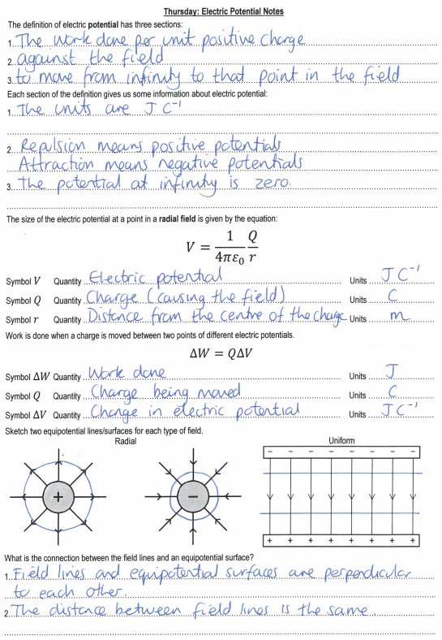

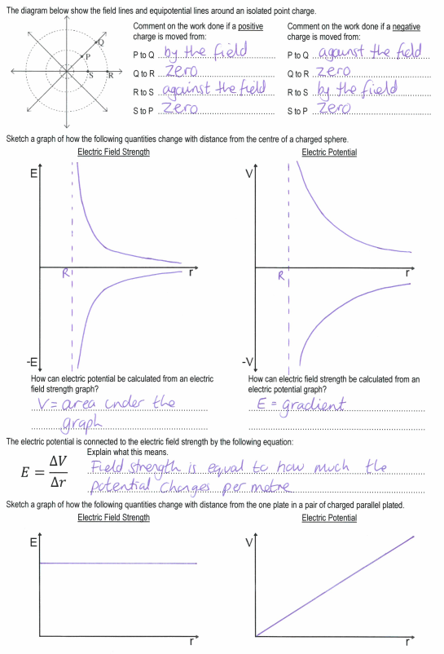

**Friday: Electric Potential Exam Questions**

**M51.         C**

**M52.          D**

**M53.         C**

**M54.         A**

**M56.**          (a)    work done [or energy needed] per unit charge [**or** (change in) electric pe per unit charge]  

on [or of] a (small) positive (test) charge  

in moving the charge from infinity (to the point)  

[**not** from the point to infinity]  

**3**

(b)     (i)      gives Q (= 4π*ε0rV*) = 4π × 8.85 × 10–12 × 0.30 × 3.0  

= 1.0 × 10–10 (C)  

to **2 sf** only  

**3**

(ii)     use of V ∞  gives VM =   (= (+) 1.0 V)

**1**

(iii)     =   (= 2.50 V m–1)

**1**

(c)     (i)     uniformly spaced vertical parallel lines which start and end on plates 

relevant lines with arrow(s) pointing only downwards 

**2**

(ii)     = 3.3(3) (V m–1) 

**1**

**[11]**