|  |  |
| --- | --- |
| 21: Fields Comparison  Orbits and Comparisons | |
|  | |
| Paper 2 |  |
| 17: Thermal Physics 1  Specific Heat Capacity and Latent Heat | 1. Orbital period and speed related to radius of circular orbit; derivation of 2. Energy considerations for an orbiting satellite. 3. Total energy of an orbiting satellite. 4. Escape velocity. 5. Synchronous orbits. 6. Use of satellites in low orbits and geostationary orbits, to include plane and radius of geostationary orbit. 7. Concept of a force field as a region in which a body experiences a non-contact force. 8. Students should recognise that a force field can be represented as a vector, the direction of which must be determined by inspection. 9. Force fields arise from the interaction of mass, of static charge, and between moving charges. 10. Similarities and differences between gravitational and electrostatic forces: 11. Similarities: Both have inverse-square force laws that have many characteristics in common, eg use of field lines, use of potential concept, equipotential surfaces etc 12. Differences: masses always attract, but charges may attract or repel. |
| 18: Thermal Physics 2  Gas Laws and the MKTM |
| 19: Gravitational Fields  Field Strength and Potential |
| 20: Electric Fields  Fields Strength and Potential |
| 21: Fields Comparisons  Orbits and Comparisons |
| 22: Capacitors  Energy Stored and Exponential Decay |
| 23: Magnetic Fields 1  Magnetic Forces and Flux |
| 24: Magnetic Fields 2  Induction and Transformers |
| 25: Radioactivity 1  Nuclear Radius and Types of Radiation |
| 26: Radioactivity 2  Modes and Rate of Decay |
| 27: Nuclear Physics  Binding Energy, Fission and Fusion |
| Paper 3 |
| 28: Electron Discovery  Specific Charge and Millikan |
| 29: Wave-Particle Duality  Waves, Quantum and Microscopes |
| 30: Special Relativity  Michelson-Morley & Relativistic Speed |

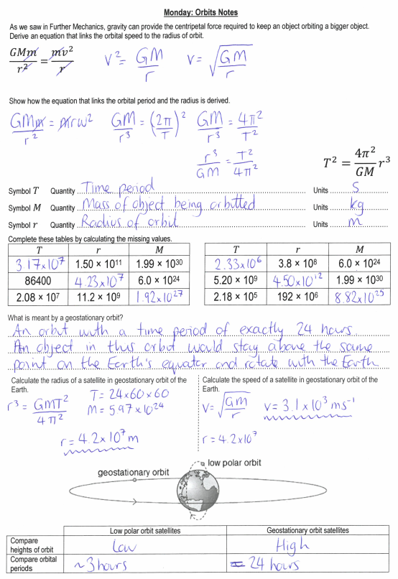

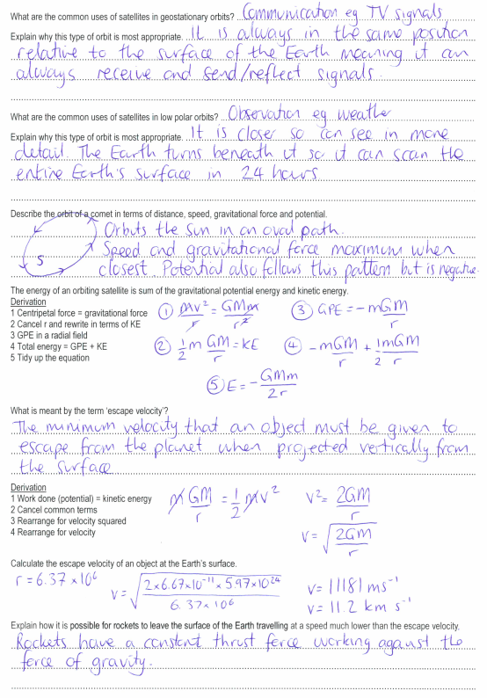

**Tuesday: Orbits Exam Questions**

**M31.**(a)     (i)        

from which    = 5.73

and *r*E (= 5.73 × 7370) = 42 200 (km)   

height above surface = 42 200 − 6370 = 35 800 or 35 900 (km)     
answer to **3SF** only  

*Full solution derived from Newton’s law of gravitation is acceptable for all 4 marks.*

[**or** Newton ’s law approach for 1st two marks:

  

∴*r*E3 =   (=7.54 × 1022)

from which *r*E = 42 200 (km)   ]

*For 3 rd mark, final answer* ***must*** *be expressed in km.****3SF*** *mark is independent.*

**4**

(ii)     centripetal force (= *m* *ɷ*2*r*) =    
  
= 4800 (4760) (N) 

*If* ***both*** *T and r values for the* ***geosynchronous*** *satellite are substituted, award 0 marks for (ii).*

[**or** centripetal force       and   *v* =  

gives *v* = 7350 (m s−1) and centripetal force =  

= 4800 (4760) (N)   ]

[**or** centripetal force     

= 4800 (4770) (N)   ]

*If only one correct T or r value for the* ***polar*** *satellite is substituted, mark (ii) to max 1.*

**2**

**[6]**

**M32.         C**

**M33.        D**

**M34.** (b)    (i)       ✓

        = 2.45 × 103 (N) ✓                                 to **3SF** ✓

*1st mark: all substituted numbers must be to at least 3SF.   
If 1.39 × 107 is used as the complete denominator, treat as AE with ECF available.   
3rd mark:* ***SF mark is independent.***

**3**

(ii)     *F* = *mω2 (R + h)* gives *ω*2 =  ✓

        from which *ω* = 2.19 × 10–4 (rad s–1) ✓

time period     **or**  = 2.87 ✓ 104 s ✓

[**or** *F* =  gives *v*2  ✓

        from which *v* = 4.40 ✓ 103 (m s–1) ✓

time period *T* **or** = 2.87 × 104 s ✓ ]

[**or** *T*2 =  ✓

     =  ✓

                gives time period T = 2.87 × 104s ✓ ]

        =  = 7.97 (hours) ✓

number of transits in 1 day =  = 3.01 ( ≈ 3) ✓

*Allow ECF from wrong F value in (i) but mark to max 4 (because final answer won’t agree with value to be shown).*

*First 3 marks are for determining time period (or frequency). Last 2 marks are for relating this to the number of transits.*

*Determination of f = 3.46 × 10–5 (s–1) is equivalent to finding T by any of the methods.*

**5**

(c)     acceptable use ✓   
satisfactory explanation ✓   
e.g. monitoring weather **or** surveillance:   
            whole Earth may be scanned **or** Earth rotates under orbit   
            **or** information can be updated regularly   
**or** communications: limited by intermittent contact   
**or** gps: several satellites needed to fix position on Earth

*Any reference to equatorial satellite should be awarded 0 marks.*

**2**

**[10]**

**M35.**          A **M36.**         B

Year 13 Physics: Gravitational Fields Extended Writing Task 25: **Satellites**

This work was done by ________________________________________ and was marked by __________________________________________

|  |  |  |  |  |  |  |  |  |  |  |  |  |  |
| --- | --- | --- | --- | --- | --- | --- | --- | --- | --- | --- | --- | --- | --- |
| S |  | | | | | | | | | | | | |
| **D answer** | | | | **B answer** | | | **A* answer** | | | | | | |
| The time period of a geosynchronous orbit is given as 24 hours (or the same as the Earth) and a polar orbit is only a few hours... | |  |  | ...geosynchronous are much higher (than polar)...  ...geosynchronous move at higher speeds...  ...polar can have more than one orbital radius... |  |  | ...geosynchronous maintains same position relative to Earth (above equator) and the Earth rotates relative to polar orbit. | | | | |  |  |
|  |  |
|  |  |
| One geosynchronous use is given... | |  |  | ...two geosynchronous uses are given... |  |  | One use for each type of orbit is justified in terms of position relative to the transmitter or receiver, coverage of the Earth’s surface or signal strength. | | | | |  |  |
| Suitable uses: telecommunications generally, radio, cable and satellite TV and digital information. | | | | | | |
| One polar use is given... | |  |  | ...two polar uses are given... |  |  |  |  |
| Suitable uses: surveillance of conditions/installations on Earth, mapping (GPS), weather & environmental monitoring. | | | | | | |
| Kepler’s third law is stated as $T^{2}=\frac{4π^{2}}{GM}r^{3}$... | |  |  | ...the derivation is explained as the centripetal force is equal to the gravitational force... |  |  | ... $\frac{GMm}{r^{2}}=mω^{2}r$**and $ω=\frac{2π}{T}$** present. | | | | |  |  |
| Use of $\frac{GMT^{2}}{4π^{2}}=r^{3}$ with substitutions of *G* and *M*... | |  |  | ...*T* calculated as 24 × 60 × 60 = 86400 s and substituted into the equation... |  |  | ...height of orbit given as 4.23 × 107 m minus the radius (6.40 × 106) = 3.59 × 107 m. | | | | |  |  |
| Escape velocity is the speed that an object must be travelling (at the surface) to completely ‘break free’ of the gravitational field of the planet... | |  |  | ...it is calculated by equating kinetic energy to the (gravitational) potential at the surface... |  |  | ... $\frac{GMm}{r}=\frac{1}{2}mv^{2}$ → $\frac{2GM}{r}=v^{2}$ → 11183 m/s. | | | | |  |  |
| Objects leaving the surface have (multistage) rockets/engines... | |  |  | ...they travel at speed lower than the escape velocity... |  |  | ...because the rockets provide continuous energy to overcome the gravitational attraction. | | | | |  |  |
| T |  | | | | | | | **Develop…** | | **Grade** | **Effort** | | |
| Range ↓ |  |  |  | | |
| Depth → |  |
| Order ⁝ |  |
| Relevant ! |  |
| E | …………………………………………………………………………………………………………………………………………….………………………..  ……………………………………………………………………………………………………………………………………….……………………………..  ………………………………………………………………………………………………………………………………….…………………………………..  …………………………………………………………………………………………………………………………….………………………………………..  ………………………………………………………………………………………………………………………………………………….………………….. | | | | | | | | | | | | |

**Wednesday: Fields Comparisons and Orbits Definitions**

|  |  |
| --- | --- |
| Field Strength | The force per unit mass/charge acting at that point in the field. |
| Gradient | On a graph of potential against distance this represents the field strength. |
| More Positive | As an electron moves towards a negative charge the electric potential will become … |
| Towards | Electric field lines flow ……….. a negative charge. |
| Along | A proton in an electric field will move ………… a field line. |
| More Positive | As a proton moves towards a positive charge the electric potential will become … |
| Radial | The type of field where field strength changes with distance. |
| More Negative | As a proton moves towards a negative charge the electric potential will become … |
| Area Under the Line | On a graph of field strength against distance this represents the potential. |
| Potential | The work done per unit mass/charge against the field to bring a point mass/charge from infinity to the point. |
| Scalar | Gravitational potential is this type of quantity. |
| Against | Potentials will be positive when working ………. the field. |
| Against | An electron in an electric field will move ………… a field line. |
| Centre | When calculating gravitational forces, field strength or potentials we use the distance from the … |
| Zero | The potential at infinity. |
| Surface | When dealing with heights of orbit we could we given the distance from the … |
| Concentration | Field strengths can be compared using the ……….. of the field lines. |
| Escape Velocity | The speed an object must be launched at to leave the surface of a planet. |
| Geostationary | A higher satellite orbit primarily used for communication. |
| Vector | Field strength is this type of quantity. |
| From | Electric field lines flow ……….. a positive charge. |
| More Negative | As an electron moves towards a positive charge the electric potential will become … |
| Polar | A low satellite orbit primarily used for observing. |
| Uniform | The type of field where field strength is constant. |
| With | Potentials will be negative when working ………. the field. |
| Equipotential | A line where the value of potential is the same all the way along it. |

|  |  |  |  |
| --- | --- | --- | --- |
| Against | Against | Along | Area Under the Line |
| Centre | Concentration | Equipotential | Escape Velocity |
| Field Strength | From | Geostationary | Gradient |
| More Negative | More Negative | More Positive | More Positive |
| Polar | Potential | Radial | Scalar |
| Surface | Towards | Uniform | Vector |
| With | Zero |  |  |

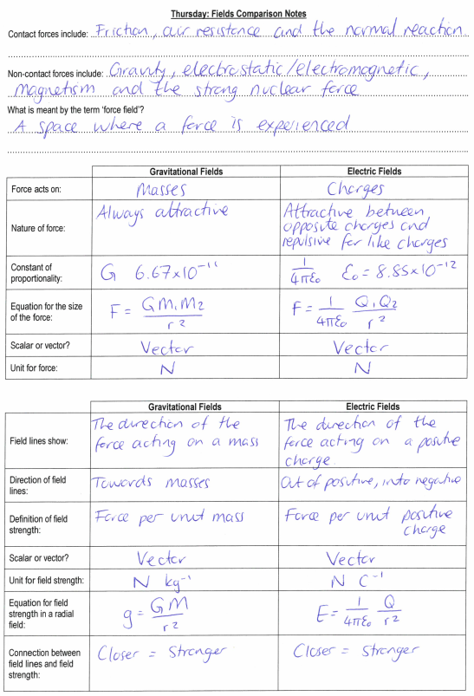

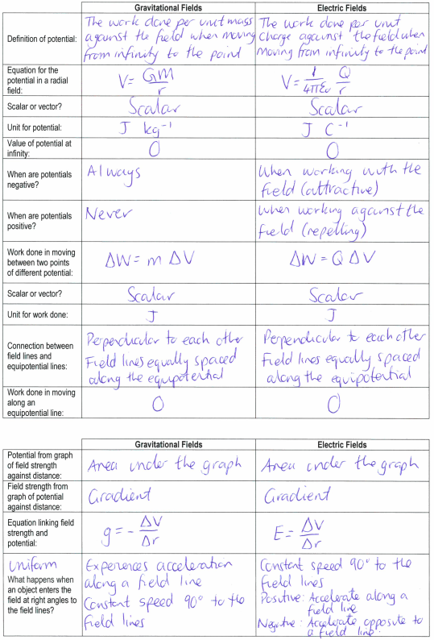

**Friday: Fields Comparison Exam Questions**

**M57.         D**

**M58.          B**

**M59.          C**

**M60.         C**

**M61.         A**

**M62.          A**