23: Magnetic Fields 1
Magnetic Forces and Flux
Paper 2
17: Thermal Physics 1  Specific Heat Capacity and Latent Heat | - Force on a current-carrying wire in a magnetic field: $F=BIl$ when field is perpendicular to current.  - Fleming’s left hand rule.  - Magnetic flux density B and definition of the tesla.  Required practical 10: Investigate how the force on a wire varies with flux density, current and length of wire using a top pan balance.  - Force on charged particles moving in a magnetic field, $F=BQv$ when the field is perpendicular to velocity.  - Direction of force on positive and negative charged particles.  - Circular path of particles; application in devices such as the cyclotron.  - Magnetic flux defined by $Φ=BA$ where B is normal to A.  - Flux linkage as $NΦ$ where N is the number of turns cutting the flux.  - Flux and flux linkage passing through a rectangular coil rotated in a magnetic field: flux linkage $NΦ= BAN\cos{θ}$    Required practical 11: Investigate, using a search coil and oscilloscope, the effect on magnetic flux linkage of varying the angle between a search coil and magnetic field direction.
18: Thermal Physics 2
Gas Laws and the MKTM
19: Gravitational Fields
Field Strength and Potential
20: Electric Fields
Fields Strength and Potential
21: Fields Comparisons
Orbits and Comparisons
22: Capacitors
Energy Stored and Exponential Decay
23: Magnetic Fields 1
Magnetic Forces and Flux
24: Magnetic Fields 2
Induction and Transformers
25: Radioactivity 1
Nuclear Radius and Types of Radiation
26: Radioactivity 2
Modes and Rate of Decay
27: Nuclear Physics
Binding Energy, Fission and Fusion
Paper 3
28: Electron Discovery
Specific Charge and Millikan
29: Wave-Particle Duality
Waves, Quantum and Microscopes
30: Special Relativity
Michelson-Morley & Relativistic Speed

Monday: Magnetic Forces Notes
What is the difference between current and ‘conventional current’?
………………………………………………………………….…………….…………………………
………………………………………………………………….…………….…………………………
………………………………………………………………….…………….…………………………
……………………………………………………………………….……….…………………………
The right hand grip rule can be used to help describe the magnetic field produced around a current flowing through a straight conductor.
Deduce if the current is flowing into or out of the page for the two diagrams.
When a current carrying wire is placed inside a magnetic field and perpendicular to the field lines is experiences a force.
This is called the motor effect.
Complete the diagram and use it to explain why the motor effect happens.
………………………………………………….…………….………………………
………………………………………………….…………….………………………
………………………………………………….…………….………………………
………………………………………………….…………….………………………
………………………………………………….…………….………………………
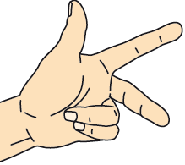
The direction of the force is given by Fleming’s left hand rule:
The thumb represents .........…………………………………………………………….…….…….
The first finger represents .........……………………………………………………………………..….
The second finger represents .........………………………………………………………………………...
If the question simply tells us that a ‘current’ is flowing in a certain direction we use this as conventional current. If the question shows us the flow of electrons we must treat this at the opposite.
Use Fleming’s left hand rule to deduce the direction that these current carrying wires will experience.
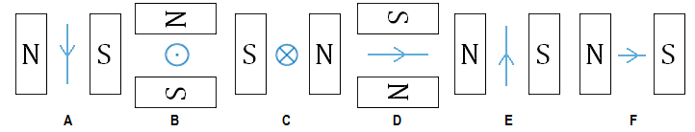
A …………………………...……………… C ………….…………..…………………… E ………….………………..………………
B ………………………..………….……… D ………….……..………………………… F …………….……………..………………
The size of the force is given by the equation:
$$F=BIl$$
Symbol $F$ Quantity …………………………………………………………………………………………… Units ………………………
Symbol $B$ Quantity …………………………………………………………………………………………… Units ………………………
Symbol $I$ Quantity …………………………………………………………………………………………… Units ………………………
Symbol $l$ Quantity …………………………………………………………………………………………… Units ………………………
What is the definition of ‘the Tesla’? (what is 1 Tesla?)
………………………………………………………………….…………….……………………………………………………….………………..
………………………………………………………………….…………….……………………………………………………….………………..
……………………………………………………………………….……….……………………………….………………………………………..
The motor effect can be investigated using the set-up
as shown in the diagram
The wire was clamped at A and B.
If a current flows from B to A will the reading on the
balance be positive or negative?
…………………………………………………….…….
Explain your answer
………………………….………………………………………………….……….
………………………………………………………………………………………………………………………………………………………….
Here is a diagram of a simple motor.
Side A will be forced …………….…..… and side C will be forced ……………………
Why doesn’t side B experience a force? …………………………………………………
…………………………………………………………………………………………………
What is the purpose of X? …………………………………………………………………
…………………………………………………………………………………………………
…………………………………………………………………………………………………
…………………………………………………………………………………………………
A current in a wire is the flow of electrons (charge); instead of considering the whole current we can look at the force on one particle.
The direction of the force is given by Fleming’s left hand rule:
The thumb represents .........…………………………………………………………….…….…….
The first finger represents .........……………………………………………………………………..….
The second finger represents .........………………………………………………………………………...
What do we do if a question tells us that a particle with the opposite charge is moving?
………………………………………………………………….…………….……………………………………………………….………………..
The size of the force is given by the equation:
$$F=BQv$$
Symbol $F$ Quantity …………………………………………………………………………………………… Units ………………………
Symbol $B$ Quantity …………………………………………………………………………………………… Units ………………………
Symbol $Q$ Quantity …………………………………………………………………………………………… Units ………………………
Symbol $v$ Quantity …………………………………………………………………………………………… Units ………………………
Show how this equation is derived from:
$$F=BIl$$

Tuesday: Magnetic Force Exam Questions
Q86. The diagram shows a rigidly-clamped straight horizontal current-carrying wire held mid-way between the poles of a magnet on a top pan balance. The wire is perpendicular to the magnetic field direction.
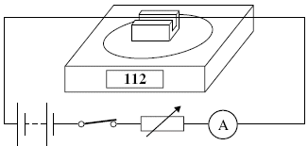
The balance, which was zeroed before the switch was closed, reads 112 g after the switch is closed. If the current is reversed and doubled, what will be the new reading on the balance?
A –224 g B –112 g C zero D 224 g (Total 1 mark)
Q87. The diagram shows a horizontal conductor of length 50 mm carrying a current of 3.0 A at right angles to a uniform horizontal magnetic field of flux density 0.50 T.
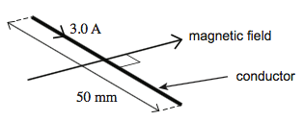
What is the magnitude and direction of the magnetic force on the conductor?
A 0.075 N vertically upwards C 75 N vertically upwards
B 0.075 N vertically downwards D 75 N vertically downwards
(Total 1 mark)
Q88. Four rectangular loops of wire A, B, C and D are each placed in a uniform magnetic field of the same flux density B. The direction of the magnetic field is parallel to the plane of the loops as shown.
When a current of 1 A is passed through each of the loops, magnetic forces act on them. The lengths of the sides of the loops are as shown.
Which loop experiences the largest couple?
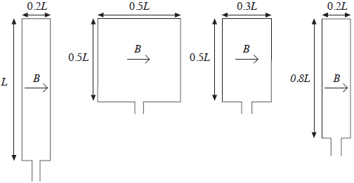
A B C D
(Total 1 mark)
Q89. A horizontal straight wire of length 0.30 m carries a current of 2.0 A perpendicular to a horizontal uniform magnetic field of flux density 5.0 × 10^{–2} T. The wire ‘floats’ in equilibrium in the field.
What is the mass of the wire?
A 8.0 × 10^{–4} kg B 3.1 × 10^{–3} kg C 3.0 × 10^{–2} kg D 8.2 × 10^{–1} kg
(Total 1 mark)
Q99. An electron moving with a constant speed enters a uniform magnetic field in a direction at right angles to the field. What is the subsequent path of the electron?
A A straight line in the direction of the field.
B A straight line in a direction opposite to that of the field.
C A circular arc in a plane perpendicular to the direction of the field.
D An elliptical arc in a plane perpendicular to the direction of the field.
(Total 1 mark)
Q100. A negatively charged particle moves at right angles to a uniform magnetic field. The magnetic force on the particle acts
A in the direction of the field.
B in the opposite direction to that of the field.
C at an angle between 0° and 90° to the field.
D at right angles to the field.
(Total 1 mark)
Q101. Charged particles, each of mass m and charge Q, travel at a constant speed in a circle of radius r in a uniform magnetic field of flux density B. Which expression gives the frequency of rotation of a particle in the beam?
A 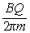
B 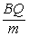
C 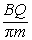
D 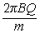
(Total 1 mark)
Q102. The path followed by an electron of momentum p, carrying charge –e, which enters a magnetic field at right angles, is a circular arc of radius r.
What would be the radius of the circular arc followed by an α particle of momentum 2p, carrying charge +2e, which entered the same field at right angles?
A $\frac{r}{2}$
B $r$
C $2r$
D $4r$ (Total 1 mark)
Q103. Which line, A to D, in the table correctly describes the trajectory of charged particles which enter separately, at right angles, a uniform electric field, and a uniform magnetic field?
 | uniform electric field | uniform magnetic field
A | parabolic | circular
B | circular | parabolic
C | circular | circular
D | parabolic | parabolic
(Total 1 mark)

Wednesday: Cyclotrons Extended Writing

Many of the discoveries in the field of particle physics have come from the work carried out at CERN and other laboratories with particle accelerators; all accelerators use the concepts of electromagnetism.
The two type of particle accelerator are linear and circular; the cyclotron is a simple circular particle accelerator.
Describe and explain how a cyclotron works. Your answer should include:
- How a charged particle will move when entering:*A gravitational field *An electric field *A magnetic field
- A description of the structure of a cyclotron
- An explanation of how it accelerates particles
- Relevant equations to determine the radius and time period of a particle in the cyclotron.
..................................................................................................................................................................................................
..................................................................................................................................................................................................
..................................................................................................................................................................................................
..................................................................................................................................................................................................
..................................................................................................................................................................................................
..................................................................................................................................................................................................
..................................................................................................................................................................................................
..................................................................................................................................................................................................
..................................................................................................................................................................................................
..................................................................................................................................................................................................
..................................................................................................................................................................................................
..................................................................................................................................................................................................
..................................................................................................................................................................................................
..................................................................................................................................................................................................
..................................................................................................................................................................................................
..................................................................................................................................................................................................
..................................................................................................................................................................................................
..................................................................................................................................................................................................
..................................................................................................................................................................................................
..................................................................................................................................................................................................
..................................................................................................................................................................................................
..................................................................................................................................................................................................
..................................................................................................................................................................................................
..................................................................................................................................................................................................
..................................................................................................................................................................................................
..................................................................................................................................................................................................
..................................................................................................................................................................................................
..................................................................................................................................................................................................
Wednesday: Magnetic Force and Flux Definitions

Flux | The amount of magnetic field passing through an area; the product of flux density and area.
Current | In Fleming’s left hand rule the second finger represents the direction of the …
Charge | Increasing this quantity decreases the radius of a charged particle in a magnetic field.
Weber | The units of flux.
Flux Linkage | The total flux flowing through a coil of wire.
Perpendicular | The motor effect happens when a current and field are ………..
Search Coil | A device used to measure the magnetic flux at a point in a field.
Field | In Fleming’s left hand rule the first finger represents the direction of the …
Circular | The field shape produced by a current flowing in a straight conductor.
Left | This left hand rule shows the direction of the motor effect.
Motor | The effect can be demonstrated with a current in a horseshoe magnet.
Circular | The path a charged particle takes when travelling perpendicular to a magnetic field.
Magnetic Flux Density | The strength of a magnetic field; represented by the concentration of field lines.
Attract | Parallel wired with currents in the same direction will do this.
Velocity | Increasing this quantity increases the radius of a charged particle in a magnetic field.
Repel | Parallel wires with currents in opposite directions will do this.
90° | There is a maximum flux when area of wire and the field are at this angle to each other.
Cyclotron | An example of a particle accelerator.
Area | The two dimensional space enclosed by a loop of wire.
Positive Charge | Fleming’s left hand rule describes the motion of a ……….. in a magnetic field.
South | When a current is flowing clockwise you are looking at the ………. end of a solenoid.
Tesla | The units of magnetic flux density.
Right | This hand grip rule shows the direction of the field around a current in a straight conductor.
0° | There is zero flux when area of wire and the field are at this angle to each other.
North | When a current is flowing anti-clockwise you are looking at the ………. end of a solenoid.
Force | In Fleming’s left hand rule the thumb represents the direction of the …

0° | 90° | Area | Attract
Charge | Circular | Circular | Current
Cyclotron | Field | Flux | Flux Linkage
Force | Left | Magnetic Flux Density | Motor
North | Perpendicular | Positive Charge | Repel
Right | Search Coil | South | Tesla
Velocity | Weber
Thursday: Magnetic Force and Flux Notes
State two situations in which a charged particle will experience no magnetic force when placed in a magnetic field.
………………………………………………………………….…………….……………………………………………………….………………..
………………………………………………………………….…………….……………………………………………………….………………..
When a charged particle enters a magnetic field at right angles to the field lines it moves in a circular path; the magnetic force provides a centripetal force.
Derive equations for the following quantities:
Time of orbit
$$BQv=mvω$$

Radius of orbit
$$BQv=\frac{mv^{2}}{r}$$

Cyclotron
A cyclotron has two D-shaped regions where the magnetic flux density is
constant.
The D-shaped regions are separated by a small gap and there is an
alternating electric field between the D-shaped regions.
The magnetic field causes the charged particles to follow a circular path.
The diagram shows the path followed by a proton that starts from O.
In which direction is the magnetic field? ………………….…………….…………….
What is the purpose of the electric field? ………………………………………………
………………………………………………………………….……………....………..……
………………………………………………………………….……………....………..……
Why can’t the magnetic field cause the speed of the protons to change?
………………………………………………………………….…………….……………………………………………………….………………..
………………………………………………………………….…………….……………………………………………………….………………..
………………………………………………………………….…………….……………………………………………………….………………..
Why is the proton always accelerating?
………………………………………………………………….…………….……………………………………………………….………………..
………………………………………………………………….…………….……………………………………………………….………………..
………………………………………………………………….…………….……………………………………………………….………………..
Show why the radius must increase.
………………………………………………………………….…………….……………………………………………………….………………..
………………………………………………………………….…………….……………………………………………………….………………..
In the Large Hadron Collider the accelerating track is a circle of a fixed length, how is proton acceleration possible?
………………………………………………………………….…………….……………………………………………………….………………..
………………………………………………………………….…………….……………………………………………………….………………..
Pair Production
If pair production happens within a cloud chamber which is in a magnetic field, tracks similar to the diagram can be observed.
Explain why they take this shape.
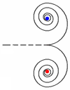
………………………………………………………………….…………….……………………………………………….
………………………………………………………………….…………….……………………………………………….
………………………………………………………………….…………….……………………………………………….
………………………………………………………………….…………….……………………………………………….
What is meant by the term ‘magnetic flux’?
………………………………………………………………….…………….……………………………………………………….………………..
………………………………………………………………….…………….……………………………………………………….………………..
……………………………………………………………………….……….……………………………….………………………………………..
The size of the flux is given by the equation:
$$Φ=BA$$
Symbol $Φ$ Quantity …………………………………………………………………………………………… Units ………………………
Symbol $B$ Quantity …………………………………………………………………………………………… Units ………………………
Symbol $A$ Quantity …………………………………………………………………………………………… Units ………………………
What is meant by the term ‘magnetic flux linkage’?
………………………………………………………………….…………….……………………………………………………….………………..
………………………………………………………………….…………….……………………………………………………….………………..
……………………………………………………………………….……….……………………………….………………………………………..
The amount of flux (and flux linkage) also depends on the angle that the wire loop makes with the magnetic field lines.
Flux Linkage
The size of the flux linkage is given by the equation:
$$NΦ=BAN\cos{θ}$$
Symbol $NΦ$ Quantity …………………………………………………………………………………………… Units ………………………
Symbol $N$ Quantity …………………………………………………………………………………………… Units ………………………
Symbol $θ$ Quantity …………………………………………………………………………………………… Units ………………………

Friday: Induction and Flux Exam Questions
Q106. The figure below shows an end view of a simple electrical generator. A rectangular coil is rotated in a uniform magnetic field with the axle at right angles to the field direction. When in the position shown in the figure below the angle between the direction of the magnetic field and the normal to the plane of the coil is θ.
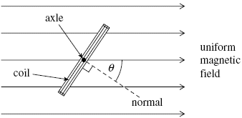
Q106(a) The coil has 50 turns and an area of 1.9 × 10^{–3} m². The flux density of the magnetic field is 2.8 × 10^{–2} T. Calculate the flux linkage for the coil when θ is 35°, expressing your answer to an appropriate number of significant figures.

answer = ...................................... Wb turns (3)
Q106(b) The coil is rotated at constant speed, causing an emf to be induced.
Q106(bi) Sketch a graph on the outline axes to show how the induced emf varies with angle θ during one complete rotation of the coil, starting when θ = 0. Values are not required on the emf axis of the graph.
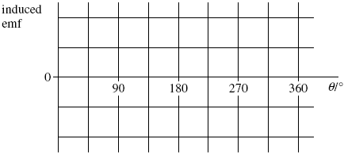
(1)
Q106(bii) Give the value of the flux linkage for the coil at the positions where the emf has its greatest values.
answer = ...................................... Wb turns (1)
Q106(biii) Explain why the magnitude of the emf is greatest at the values of θ shown in your answer to part (bi).
..................................................................................................................................................................................................
..................................................................................................................................................................................................
..................................................................................................................................................................................................
..................................................................................................................................................................................................
..................................................................................................................................................................................................
..................................................................................................................................................................................................
.................................................................................................................................................................................................. (3)
(Total 8 marks)
Q107(a) Figure 1 shows two coils, P and Q, linked by an iron bar. Coil P is connected to a battery through a variable resistor and a switch S. Coil Q is connected to a centre-zero ammeter.
Figure 1
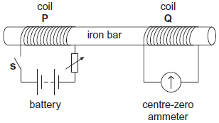
Q107(ai) Initially the variable resistor is set to its minimum resistance and S is open.
Describe and explain what is observed on the ammeter when S is closed.
..................................................................................................................................................................................................
..................................................................................................................................................................................................
..................................................................................................................................................................................................
..................................................................................................................................................................................................
.................................................................................................................................................................................................. (3)
Q107(aii) With S still closed, the resistance of the variable resistor is suddenly increased.
Compare what is now observed on the ammeter with what was observed in part (ai).
Explain why this differs from what was observed in part (ai).
..................................................................................................................................................................................................
..................................................................................................................................................................................................
..................................................................................................................................................................................................
.................................................................................................................................................................................................. (2)
Q107(b) Figure 2 shows a 40-turn coil of cross-sectional area 3.6 × 10^{–3} m² with its plane set at right angles to a uniform magnetic field of flux density 0.42 T. Figure 2
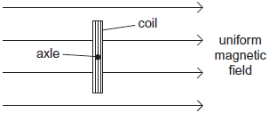
Q107(bi) Calculate the magnitude of the magnetic flux linkage for the coil.
State an appropriate unit for your answer.

flux linkage ....................................................... unit ..................... (2)
Q107(bii) The coil is rotated through 90° in a time of 0.50 s.
Determine the mean emf in the coil.

mean emf ................................................. V (2)
(Total 9 marks)

Saturday: Magnetic Force and Flux Checklist

