24: Magnetic Fields 2
Induction and Transformers
Paper 2
17: Thermal Physics 1  Specific Heat Capacity and Latent Heat | - Simple experimental phenomena.  - Faraday’s and Lenz’s laws.  - Magnitude of induced emf = rate of change of flux linkage  - $ε=N\frac{∆Φ}{∆t}$  - Applications such as a straight conductor moving in a magnetic field.  - emf induced in a coil rotating uniformly in a magnetic field: $ε=BANω\sin{ωt}$  - Sinusoidal voltages and currents only; root mean square, peak and peak-to-peak values for sinusoidal waveforms only.  - $I_{\text{rms}}=\frac{I_{0}}{\sqrt{2}}$; $V_{\text{rms}}=\frac{V_{0}}{\sqrt{2}}$  - Application to the calculation of mains electricity peak and peak-to-peak voltage values.  - Use of an oscilloscope as a dc and ac voltmeter, to measure time intervals and frequencies, and to display ac waveforms.  - No details of the structure of the instrument are required but familiarity with the operation of the controls is expected.  - The transformer equation: $\frac{N_{\text{s}}}{N_{\text{p}}}=\frac{V_{\text{s}}}{V_{\text{p}}}$  - Transformer efficiency $=\frac{I_{\text{s}}V_{\text{s}}}{I_{\text{p}}V_{\text{p}}}$  - Production of eddy currents.  - Causes of inefficiencies in a transformer.    - Transmission of electrical power at high voltage including calculations of power loss in transmission lines.
18: Thermal Physics 2
Gas Laws and the MKTM
19: Gravitational Fields
Field Strength and Potential
20: Electric Fields
Fields Strength and Potential
21: Fields Comparisons
Orbits and Comparisons
22: Capacitors
Energy Stored and Exponential Decay
23: Magnetic Fields 1
Magnetic Forces and Flux
24: Magnetic Fields 2
Induction and Transformers
25: Radioactivity 1
Nuclear Radius and Types of Radiation
26: Radioactivity 2
Modes and Rate of Decay
27: Nuclear Physics
Binding Energy, Fission and Fusion
Paper 3
28: Electron Discovery
Specific Charge and Millikan
29: Wave-Particle Duality
Waves, Quantum and Microscopes
30: Special Relativity
Michelson-Morley & Relativistic Speed

Monday: Induction and Alternating Currents Notes
Describe how a potential difference can be induced by a simple method.
………………………………………………………………….…………….……………………………………………………….………………..
………………………………………………………………….…………….……………………………………………………….………………..
Faraday’s Law tells us the ……………………………… of the induced emf.
………………………………………………………………….…………….……………………………………………………….………………..
………………………………………………………………….…………….……………………………………………………….………………..
……………………………………………………………………….……….……………………………….………………………………………..
Faraday’s law is given by the equation:
$$ε=N\frac{∆Φ}{∆t}$$
Symbol $ε$ Quantity …………………………………………………………………………………………… Units ………………………
Symbol $N$ Quantity …………………………………………………………………………………………… Units ………………………
Symbol $∆Φ$ Quantity …………………………………………………………………………………………… Units ………………………
Symbol $∆t$ Quantity …………………………………………………………………………………………… Units ………………………
An emf can be induced by rotating a coil of wire in a magnetic field.
Flux Linkage
EMF

The size of the emf of a rotating coil is given by the equation:
$$ε=BANω\sin{ωt}$$
Symbol $ω$ Quantity …………………………………………………………………………………………… Units ………………………
Symbol $t$ Quantity …………………………………………………………………………………………… Units ………………………
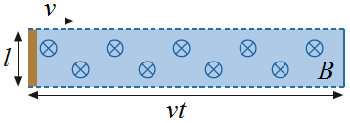
An emf can also be induced by a straight conductor moving through a magnetic field.
If s wire of length l moves at a speed v through a magnetic field of flux density B we need to use a new equation:
Start | Distance the wire travels in t seconds | Area of a rectangle | Substitute into starting equation | New equation
$$ε=\frac{∆BA}{∆t}$$
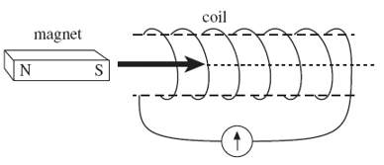
Lenz’s Law tells us the ……………………………… of the induced emf.
………………………………………………………………….…………….…..…….
………………………………………………………………….…………….…..…….
……………………………………………………………………….……….………...
What happens when the magnet is inserted? ………………………………………………………………………………………………...
Why? ………………………………………………………….…………….……………………………………………………….………………..
………………………………………………………………….…………….……………………………………………………….………………..
What happens when the magnet is stationary? ………………………………………………………………………………………………...
Why? ………………………………………………………….…………….……………………………………………………….………………..
………………………………………………………………….…………….……………………………………………………….………………..
What happens when the magnet is removed? ………………………………………………………………………………………………...
Why? ………………………………………………………….…………….……………………………………………………….………………..
………………………………………………………………….…………….……………………………………………………….………………..
What is the peak voltage?
………………………………………………………………….…………….……………………………………………………….………………..
……………………………………………………………………….……….……………………………….………………………………………..
What is the peak-to-peak voltage?
………………………………………………………………….…………….……………………………………………………….………………..
……………………………………………………………………….……….……………………………….………………………………………..
What is meant by the root mean square voltage?
………………………………………………………………….…………….……………………………………………………….………………..
………………………………………………………………….…………….……………………………………………………….………………..
………………………………………………………………….…………….……………………………………………………….………………..
……………………………………………………………………….……….……………………………….………………………………………..
The root mean square voltage is given by the equation:
$$V_{rms}=\frac{V_{0}}{\sqrt{2}}$$
Symbol $V_{0}$ Quantity …………………………………………………………………………………………… Units ……………………..
Symbol $V_{rms}$ Quantity …………………………………………………………………………………………… Units ……………………..
An alternating voltage (or potential difference) can cause an alternating current to flow.
The root mean square current is given by the equation:
$$I_{rms}=\frac{I_{0}}{\sqrt{2}}$$
Symbol $I_{0}$ Quantity …………………………………………………………………………………………… Units ………………………
Symbol $I_{rms}$ Quantity …………………………………………………………………………………………… Units ………………………

Tuesday: Induction Exam Questions
Q108. An aircraft, of wing span 60 m, flies horizontally at a speed of 150 m s^{–1}. If the vertical component of the Earth’s magnetic field in the region of the plane is 1.0 × 10^{–5} T, what is the magnitude of the magnetic flux cut by the wings in 10 s?
A 1.0 × 10^{–5} Wb B 1.0 × 10^{–4} Wb C 9.0 × 10^{–2} Wb D 9.0 × 10^{–1} Wb
(Total 1 mark)
Q109. Three vertical tubes, made from copper, lead and rubber respectively, have identical dimensions. Identical, strong, cylindrical magnets P, Q and R are released simultaneously from the same distance above each tube. Because of electromagnetic effects, the magnets emerge from the bottom of the tubes at different times.
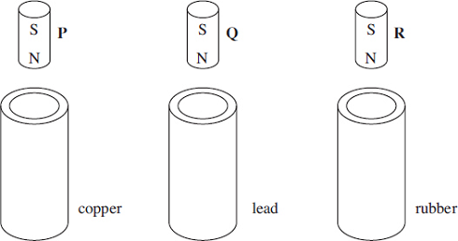
Which line, A to D, in the table shows the correct order in which they will emerge?
resistivity of copper = 1.7 × 10^{–8} Ωm resistivity of lead = 22 × 10^{–8} Ωm resistivity of rubber = 50 × 10¹³ Ωm
 | emerges first | emerges second | emerges third
A | P | Q | R
B | R | P | Q
C | P | R | Q
D | R | Q | P
(Total 1 mark)
Q110. A bar magnet is pushed into a coil connected to a sensitive ammeter, as shown in the diagram, until it comes to rest inside the coil.
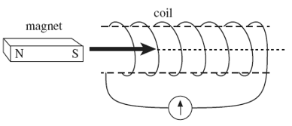
Why does the ammeter briefly show a non-zero reading?
A The magnetic flux linkage in the coil increases then decreases.
B The magnetic flux linkage in the coil increases then becomes constant.
C The magnetic flux linkage in the coil decreases then increases.
D The magnetic flux linkage in the coil decreases then becomes constant.
(Total 1 mark)
Q111. The graph shows how the magnetic flux passing through a loop of wire changes with time.
What feature of the graph represents the magnitude of the emf induced in the coil?
A the area enclosed between the graph line and the time axis
B the area enclosed between the graph line and the magnetic flux axis
C the inverse of the gradient of the graph
D the gradient of the graph
(Total 1 mark)
Q105(a) State, in words, the two laws of electromagnetic induction.
Law 1 .......................................................................................................................................................................................
..................................................................................................................................................................................................
..................................................................................................................................................................................................
Law 2 .......................................................................................................................................................................................
..................................................................................................................................................................................................
.................................................................................................................................................................................................. (3)
Q105(b) The diagram below illustrates the main components of one type of electromagnetic braking system. A metal disc is attached to the rotating axle of a vehicle. An electromagnet is mounted with its pole pieces placed either side of the rotating disc, but not touching it. When the brakes are applied, a direct current is passed through the coil of the electromagnet and the disc slows down.
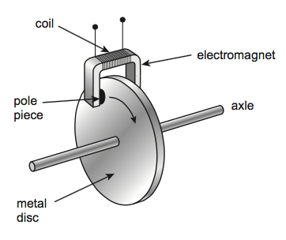
Q105(bi) Explain, using the laws of electromagnetic induction, how the device in the diagram acts as an electromagnetic brake.
..................................................................................................................................................................................................
..................................................................................................................................................................................................
..................................................................................................................................................................................................
..................................................................................................................................................................................................
..................................................................................................................................................................................................
..................................................................................................................................................................................................
..................................................................................................................................................................................................
.................................................................................................................................................................................................. (3)
Q105(bii) A conventional braking system has friction pads that are brought into contact with a moving metal surface when the vehicle is to be slowed down.
State one advantage and one disadvantage of an electromagnetic brake compared to a conventional brake.
Advantage ….............................................................................................................................................................................
..................................................................................................................................................................................................
..................................................................................................................................................................................................
Disadvantage ...........................................................................................................................................................................
..................................................................................................................................................................................................
.................................................................................................................................................................................................. (2)
(Total 8 marks)

Wednesday: Oscilloscopes Extended Writing

An alternating current power supply provides an output voltage of 12 V rms at a frequency of 50 Hz. Describe how you could use an oscilloscope to check the accuracy of the rms output voltage and the frequency of the supply. Your answer should include the following:
- Details of how the controls of the oscilloscope will affect the trace which is shown
- Details of measurements you would take
- An account of how you would use your measurements to determine the values
- Details of how to improve the precision of your measurements and values.
..................................................................................................................................................................................................
..................................................................................................................................................................................................
..................................................................................................................................................................................................
..................................................................................................................................................................................................
..................................................................................................................................................................................................
..................................................................................................................................................................................................
..................................................................................................................................................................................................
..................................................................................................................................................................................................
..................................................................................................................................................................................................
..................................................................................................................................................................................................
..................................................................................................................................................................................................
..................................................................................................................................................................................................
..................................................................................................................................................................................................
..................................................................................................................................................................................................
..................................................................................................................................................................................................
..................................................................................................................................................................................................
..................................................................................................................................................................................................
..................................................................................................................................................................................................
..................................................................................................................................................................................................
..................................................................................................................................................................................................
..................................................................................................................................................................................................
..................................................................................................................................................................................................
..................................................................................................................................................................................................
..................................................................................................................................................................................................
..................................................................................................................................................................................................
..................................................................................................................................................................................................
..................................................................................................................................................................................................
..................................................................................................................................................................................................
..................................................................................................................................................................................................
Wednesday: Induction and Transformers Definitions

Peak | This is the maximum current or voltage in an alternating supply.
Alternating | Transformers will only work if they are connected to this type of supply.
Resistance | Reducing this quality of the wires will increase the efficiency of a transformer.
Root Mean Square | The current and voltage which would provide the same heating effect as a d.c. supply.
Primary | The coil in a transformer that is connected to the input supply.
EMF | This is induced when there is a rate of change of flux linkage.
Secondary | The EMF (and current) is induced in this coil of a transformer.
Smaller | Compared to the peak current the root mean squared current will be …
Step-Up | This type of transformer has a higher flux linkage through the secondary coil.
Magnetic Losses | A source of transformer inefficiency due to the separation of the primary and secondary coils.
Step-Down | This type of transformer has a higher current in the secondary coil.
Increase | Moving a wire faster through a magnetic will cause the current to …
Horizontal Line | Displayed on an oscilloscope with the time-base on and connected to a d.c. supply.
Faraday’s | This law calculates the magnitude of an induced EMF.
90° | There is zero EMF when area of wire and the field are at this angle to each other.
Sinusoidal Line | Displayed on an oscilloscope with the time-base on and connected to an a.c. supply.
Time-base | This dial controls to horizontal values on an oscilloscope.
Vertical Line | Displayed on an oscilloscope with the time-base off and connected to an a.c. supply.
Peak-to-Peak | This is the easiest voltage to take a reading of from an oscilloscope.
0° | There is a maximum EMF when area of wire and the field are at this angle to each other.
Core | The primary and secondary coils of a transformer are wrapped around this.
Current | If an EMF is induced in a complete circuit this as also induced.
Soft | The core of a transformer is made from iron to reduce energy losses since it is magnetically …
Reverse | Moving a wire in the opposite direction will cause the current to …
Dot | Displayed on an oscilloscope with the time-base off and connected to a d.c. supply.
Eddy Currents | A source of transformer inefficiency – reduced by laminating the core.
Volts per Division | This dial controls to vertical values on an oscilloscope.
Lenz’s | This law states that the induced EMF is in a direction to oppose the change that created it.

0° | 90° | Alternating | Core
Current | Dot | Eddy Currents | EMF
Faraday’s | Horizontal Line | Increase | Lenz’s
Magnetic Losses | Peak | Peak-to-Peak | Primary
Resistance | Reverse | Root Mean Square | Secondary
Sinusoidal Line | Smaller | Soft | Step-Down
Step-Up | Time-base | Vertical Line | Volts per Division
Thursday: Oscilloscopes and Transformers Notes
Oscilloscopes can be used as an ammeter and voltmeter for both DC and AC supplies.
Sketch the oscilloscope traces that would be observed for the following:
A DC supply with the time base switched off | A DC supply with the time base switched on | An AC supply with the time base switched off | An AC supply with the time base switched on
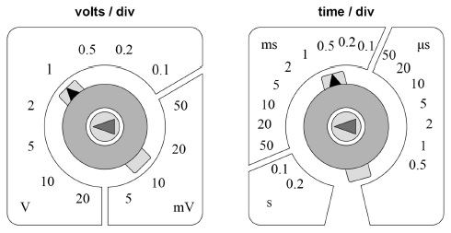
What does this dial do? ………………………………………………………………………………………...
………………………………………………………………………...…………………………………………..
What would happen to the trace of an AC supply if it was turned clockwise from its current setting?
……………………………………………………………………………………………………………………..
What would happen if it was turned anticlockwise from its current setting?
……………………………………………………………………………………………………………………..
What does this dial do? ………………………………………………………………………………………...
………………………………………………………………………...…………………………………………..
What would happen to the trace of an AC supply if it was turned clockwise from its current setting?
……………………………………………………………………………………………………………………..
What would happen if it was turned anticlockwise from its current setting?
……………………………………………………………………………………………………………………..
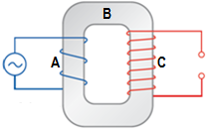
Describe the basic structure of a transformer.
………………………………………………………………….…………….………….…………………….
……………………………………………………………………….……….………………………………..
………………………………………………………………….…………….………….…………………….
How does a transformer work? AABCAACC
….……………………………………………………………….…………….……………………………………………………….……………….
.....…………………………………………………………………….……….……………………………….……………………………………….
.....……………………………………………………………….…………….……………………………………………………….……………….
.....……………………………………………………………….…………….……………………………………………………….……………….
.....…………………………………………………………………….……….……………………………….……………………………………….
There are two types of transformer: step-up and step-down.
Step-up transformers increase the …………………….…………………… and decrease the …………………….……………………
Step-down transformers decrease the …………………….…………………… and increase the …………………….……………………
You can tell if a transformer is a step-up or step-down transformer based on its appearance:
Step-up transformers have more turns on the ………………………………………… coil.
Step-down transformers have more turns on the ………………………………………… coil.
Explain why a step-up transformer changes the potential difference (emf).
……………………………………………………………………….……….……………………………….………………………………………..
………………………………………………………………….…………….……………………………………………………….………………..
……………………………………………………………………….……….……………………………….………………………………………..
Explain why a step-down transformer changes the potential difference (emf).
……………………………………………………………………….……….……………………………….………………………………………..
………………………………………………………………….…………….……………………………………………………….………………..
……………………………………………………………………….……….……………………………….………………………………………..
What would happen if a transformer was set up with a direct current connected to the primary coil?
………………………………………………………………….…………….……………………………………………………….………………..
……………………………………………………………………….……….……………………………….………………………………………..
………………………………………………………………….…………….……………………………………………………….………………..
The transformer equation is:
$$\frac{N_{s}}{N_{p}}=\frac{V_{s}}{V_{p}}$$
Symbol $N_{s}$ Quantity …………………………………………………………………………………………… Units ………………………
Symbol $N_{p}$ Quantity …………………………………………………………………………………………… Units ………………………
Symbol $V_{s}$ Quantity …………………………………………………………………………………………… Units ………………………
Symbol $V_{p}$ Quantity …………………………………………………………………………………………… Units ………………………
Describe the main energy losses in transformers and the things we can put in place to reduce these losses.
……………………………………………………………………….……….……………………………….………………………………………..
………………………………………………………………….…………….……………………………………………………….………………..
……………………………………………………………………….……….……………………………….………………………………………..
………………………………………………………………….…………….……………………………………………………….………………..
……………………………………………………………………….……….……………………………….………………………………………..
………………………………………………………………….…………….……………………………………………………….………………..
……………………………………………………………………….……….……………………………….………………………………………..
..……………………………………………………………….…………….…………………………….………………………….………………..
The efficiency of a transformer is given by the equation:
$$efficiency=\frac{I_{s}V_{s}}{I_{p}V_{p}}$$
Symbol $I_{s}$ Quantity …………………………………………………………………………………………… Units ………………………
Symbol $V_{s}$ Quantity …………………………………………………………………………………………… Units ………………………
Symbol $I_{p}$ Quantity …………………………………………………………………………………………… Units ………………………
Symbol $V_{p}$ Quantity …………………………………………………………………………………………… Units ………………………
Friday: Transformers Exam Questions
Q120. Which one of the following is not a cause of energy loss in a transformer?
A good insulation between the primary and secondary coil
B induced currents in the soft iron core
C reversal of magnetism in the soft iron core
D resistances in the primary and secondary coil
(Total 1 mark)
Q121. Using the circuit shown, and with the switch closed, a small current was passed through the coil X. The current was slowly increased using the variable resistor. The current reached a maximum value and was then switched off.
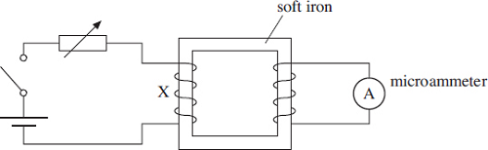
The maximum reading on the microammeter occurred when
A the small current flowed at the start.
B the current was being increased.
C the current was being switched off.
D the current in X was zero.
(Total 1 mark)
Q122. A transformer, which is not perfectly efficient, is connected to a 230 V rms mains supply and is used to operate a 12 V rms, 60 W lamp at normal brightness. The secondary coil of the transformer has 24 turns.
Which line, A to D, in the table is correct?
 | number of turns on primary coil | rms current in primary coil
A | 92 | less than 0.26 A
B | 92 | more than 0.26 A
C | 460 | less than 0.26 A
D | 460 | more than 0.26 A
(Total 1 mark)
Q123. A transformer has 1200 turns on the primary coil and 500 turns on the secondary coil. The primary coil draws a current of 0.25 A from a 240 V ac supply. If the efficiency of the transformer is 83%, what is the current in the secondary coil?
A 0.10 A
B 0.21 A
C 0.50 A
D 0.60 A
(Total 1 mark)
Q124. A transformer has 1150 turns on the primary coil and 500 turns on the secondary coil.
The primary coil draws a current of 0.26 A from a 230 V ac supply. The current in the secondary coil is 0.50 A. What is the efficiency of the transformer?
A 42%
B 50%
C 84%
D 100%
(Total 1 mark)
Q130(ai) Outline the essential features of a step-down transformer when in operation.
..................................................................................................................................................................................................
..................................................................................................................................................................................................
..................................................................................................................................................................................................
.................................................................................................................................................................................................. (2)
Q130(b) Electronic equipment, such as a TV set, may usually be left in ‘standby’ mode so that it is available for instant use when needed. Equipment left in standby mode continues to consume a small amount of power. The internal circuits operate at low voltage, supplied from a transformer. The transformer is disconnected from the mains supply only when the power switch on the equipment is turned off. This arrangement is outlined in the diagram below.
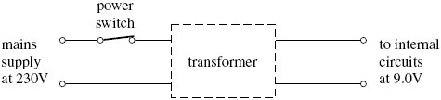
When in standby mode, the transformer supplies an output current of 300 mA at 9.0V to the internal circuits of the TV set.
Q130(bi) Calculate the power wasted in the internal circuits when the TV set is left in standby mode.

answer = .......................... W (1)
Q130(bii) If the efficiency of the transformer is 0.90, show that the current supplied by the 230 V mains supply under these conditions is 13 mA.

(2)
Q130(biii) The TV set is left in standby mode for 80% of the time. Calculate the amount of energy, in J, that is wasted in one year through the use of the standby mode.
1 year = 3.15 × 10⁷ s

answer = ............................ J (1)
Q130(biv) Show that the cost of this wasted energy will be about £4, if electrical energy is charged at 20 p per kWh.

(2)
(Total 8 marks)

Saturday: Induction and Transformers Checklist

