

Name ______________________________

Teacher ______________________________

fields

Gravitational

# *Newton’s Law of Gravitation*

Gravitational fields

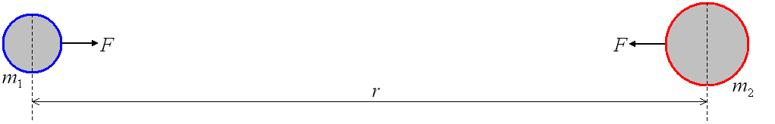Gravity is an attractive force that acts between all masses. It is the masses themselves that cause the force to exist. The force that acts between two masses, *m*1 and *m*2, whose centres are separated by a distance of *r* is given by:



This was tested experimentally in a lab using large lead spheres and was refined to become:



**G is the Gravitational Constant, *G* = 6.67 x 10-11 N m2 kg-2**

When one of the masses is of planetary size, *M*, the force between it and a test mass, *m*, whose centres are separated by a distance of *r* is given by:



The minus sign means that the force is attractive, the force is in the opposite direction to the distance from the mass (displacement). This will become clearer when we look at the electric force.

Negative = Attractive

Positive = Repulsive

**Force is measured in Newtons, N**

# *Gravitational Fields*

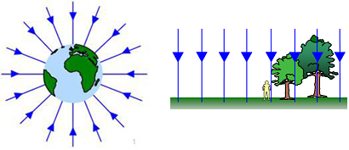A gravitational field is the area around a mass where any other mass will experience a force. We can model a field with field lines or lines of force.

***Radial Fields***

The field lines end at the centre of a mass and tail back to infinity. We can see that they become more spread out the further from the mass we go.

***Uniform Fields***

The field lines are parallel in a uniform field. At the surface of the Earth we can assume the field lines are parallel, even thou they are not.

# *Gravitational Field Strength, g*

We can think of gravitational field strength as the concentration of the field lines at that point. We can see from the diagrams above that the field strength is constant in a uniform field but drops quickly as we move further out in a radial field.

The gravitational field strength at a point is a vector quantity and is defined as:

*The force per unit mass acting on a small mass placed at that point in the field.*

We can represent this with the equation: 

If we use our equation for the gravitational force at a distance *r* and substitute this in for *F* we get:

 which simplifies to: 

**Gravitational Field Strength is measured in Newtons per kilogram, N kg-1**

Useful data

*G* = 6.67 × 10–11 N m2 kg–2

Earth’s mass = 5.97 × 1024 kg

Moon’s mass = 7.34 × 1022 kg

Sun’s mass is 2.0 × 1030 kg

Radius of the Moon = 1.64 × 106 m

Radius of the Earth = 6.37 × 106 m

Earth–Moon distance = 3.8 × 105 km

Earth–Sun distance = 1.5 × 108 km

1. Communications satellites orbit the Earth at a height of 36 000 km. How far is this from the centre of the Earth? If such a satellite has a mass of 250 kg, what is the force of attraction on it from the Earth?

It is (3.6 x 107 m + 6.4 x 106 m) = 4.24 x 107 m from the centre of the Earth.

The force is F = Gm1m2/r2 = (6.67 x 10-11 x 6.0 x 1024 x 250)/ (4.24 x 107)2. This gives an answer of about 56 N.

1. The average force of attraction on the Moon from the Sun is 4.4 × 1020 N. Taking the distance from the Sun to the Moon to be about the same as that from the Sun to the Earth, what value of mass does this give for the Moon?

m2 = Fr2/Gm1 = (4.4 x 1020 x (1.5 x 1011)2)/(6.67 x 10-11 x 2.0 x 1030) = 7.4 x 1022 kg

1. Using the mass of the Moon you calculated in question 2, what is the pull of the Earth on the Moon, if the Moon is 380 000 km away? How does this compare with the pull of the Sun on the Moon?

F = Gm1m2/r2 = (6.67 x 10-11 x 6.0 x 1024 x 7.4 x 1022)/ (3.8 x 108)2 = 2.1 x 1020 N

This is actually smaller than the pull of the Sun on the Moon. You could discuss whether that means the Moon is orbiting the Sun rather than the Earth. In fact, it depends on the most useful frame of reference in a particular situation – from the Sun’s point of view, the Moon and the Earth orbit the Sun, in a way that is affected by the presence of the other; from the Moon’s point of view, both the Sun and the Earth orbit the Moon, in a way that is affected by the presence of the other, etc.

1. What is the force of attraction between two people, one of mass 80 kg and the other 100 kg if they are 0.5m apart?

F = Gm1m2/r2

F = G x 100 x 80 / 0.52 = 2.14 x 10-6 N.

1. What is the force of attraction between the Earth and the Sun?

Mass of the Sun = 2 x 1030 kg, mass of the Earth = 6 x 1024 kg, distance from the Earth to the Sun = 1.5 x 1011 m

F = Gm1m2/r2

F = G x 2 x 1030 x 6 x 1024/ [1.5 x 1011]2 = 6.7 x 1011 N

1. You may sometimes find it difficult to get up from the sofa after watching a TV programme. Assuming the force of gravity acts between the centre of your body and the centre of the sofa, estimate the attraction between you and your sofa.

For the values estimated in the answers:



1. Calculate the size of the gravitational pull of a sphere of mass 10 kg on a mass 2.0 kg when their centres are 200 mm apart. What is the force of the 2.0 kg mass on the 10 kg mass?

Pull on the 2.0 kg mass



The pull on the 10 kg mass will be equal but opposite in direction.

1. At what distance apart would two equal masses of 150 kg need to be placed for the force between them to be 2.0 × 10–5 N?



1. Calculate the gravitational pull of the Earth on each of the following bodies:
2. The Moon



1. Satellite A with mass 100 kg at a distance from the Earth’s centre 4.2 × 107 m



1. Satellite B mass 80 kg at a distance from the Earth’s centre 8.0 × 106 m



1. Show that the unit for *G*, the universal gravitational constant, can be expressed as m3 s–2 kg–1.



1. Calculate the weight of an astronaut whose mass (including spacesuit) is 72 kg on the Moon? What is the astronaut's weight on Earth? Comment on the difference.

Moon



Earth



1. Show that pull of the Sun on the Moon is about 2.2 times larger than the pull of the Earth on the Moon.

Sun–Moon



Earth–Moon





1. The American space agency, NASA, plans to send a manned mission to Mars later this century. Mars has a mass 6.42 x 1023 kg and a radius 3.38 x 106 m. G = 6.67 x 1011 N m2 kg-2
2. The mass of a typical astronaut plus spacesuit is 80 kg. What would be the gravitational force acting on such an astronaut standing on the surface of Mars?

F = (Gmastrom x Mmars) / r2

F = (6.67 x 1011 N m2 kg-2) x 80 kg x (6.42 x 1023 kg) / (3.38 x 106 m) 2 = 300 N

1. State whether an astronaut on Mars would feel lighter or heavier than on Earth.

Would feel lighter.

**Q1.**

The planet Venus may be considered to be a sphere of uniform density 5.24 × 103 kg m−3.

The gravitational field strength at the surface of Venus is 8.87 N kg−1.

(a)     (i)      Show that the gravitational field strength *g*s at the surface of a planet is related to the the density *ρ* and the radius *R* of the planet by the expression



where *G* is the gravitational constant.

**(2)**

(ii)     Calculate the radius of Venus.

Give your answer to an appropriate number of significant figures.

radius = ____________________ m

**(3)**

(b)     At a certain time, the positions of Earth and Venus are aligned so that the distance between them is a minimum.

Sketch a graph on the axes below to show how the magnitude of the gravitational field strength *g* varies with distance along the shortest straight line between their surfaces.

Consider only the contributions to the field produced by Earth and Venus.

Mark values on the vertical axis of your graph.

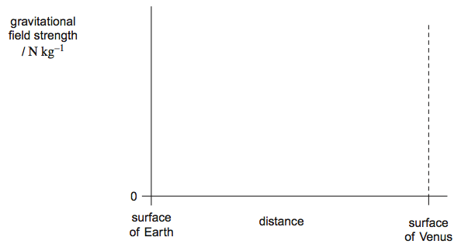

**(3)**

**(Total 8 marks)**

**Q1.**

(a)     (i)      *M* =  *π R*3 *ρ* ✔

combined with *g*s =  (gives *g*s =  *πGRρ*) ✔

*Do not allow r instead of R in final answer but condone in early stages of working.*

*Evidence of combination, eg cancelling R2 required for second mark.*

**2**

(ii)      ✔

gives *R* = 6.06 × 106 (m) ✔

answer to **3SF** ✔

*SF mark is independent but may only be awarded after some working is presented.*

**3**

(b)     line starts at 9.81 and ends at 8.87 ✔

correct shape curve which falls and rises ✔

falls to zeo value near centre of and to right of centre of distance scale ✔

[*Minimum of graph in 3rd point to be >0.5 and <0.75 SE-SV distance]*

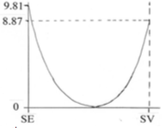

*For 3rd mark accept flatter curve than the above in central region.*

**3**

**[8]**

***Gravitational Potential, V***

Gravitational potential

The gravitational potential at a point *r* from a planet or mass is defined as:

*The work done per unit mass against the field to move a point mass from infinity to that point.*

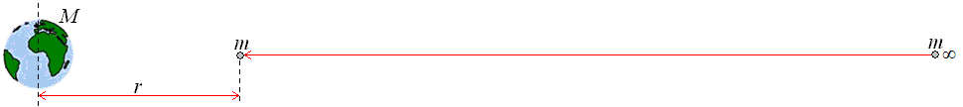

The gravitational potential at a distance *r* from a mass *M* is given by: 

The value is negative because the potential at infinity is zero and as we move to the mass we lose potential or energy. Gravitational potential is a scalar quantity.

The gravitational field is attractive so work is done **by** the field in moving the mass, meaning energy is given out.

**Gravitational Potential is measured in Joules per kilogram, J kg-1**

# *Gravitational Potential Energy*

In Unit 2 we calculated the gravitational potential energy of an object of mass *m* at a height of *h* with:



This is only true when the gravitational field strength does not change (or is constant) such as in a uniform field.

For radial fields the gravitational field strength is given by 

We can use this to help us calculate the gravitational potential energy in a radial field at a height *r*.

 🡪  🡪 

*(We have dropped the negative sign because energy is a scalar quantity)*

If we look at the top equation for gravitational potential we can see that the gravitational potential energy can be calculated using: 

The work done to move an object from potential *V*1 to potential *V*2 is given by:

 which can be written as 

**Gravitational Potential Energy is measured in Joules, J**

# *Graphs*

Here are the graphs of how gravitational field strength and gravitational potential vary with distance from the centre of a mass (eg. planet). In both cases R is the radius of the mass (planet).

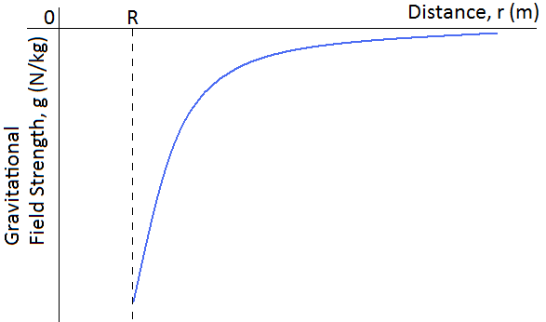 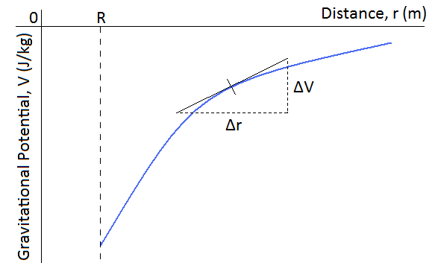

The gradient of the gravitational potential graph gives us the gravitational field strength at that point. To find the gradient at a point on a curve we must draw a tangent to the line then calculate the gradient of the tangent:

 🡪 

If we rearrange the equation we can see where we get the top equation for gravitational potential.

 🡪  sub in the equation for *g* 🡪  🡪  🡪 

An **equipotential** is a surface of constant potential. Because of this, no work needs to be done to move along an equipotential surface.

Equipotentials are at right angles to the radial field lines.

Image an equipotential to be similar to contour lines of a mountain. Walking up the mountain would take a lot of energy (work). Moving down the mountain you would gain energy.

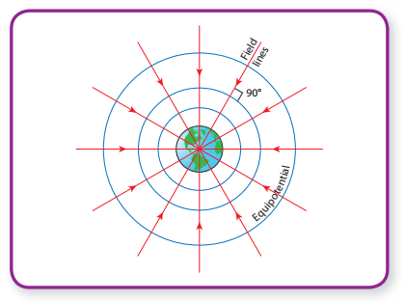

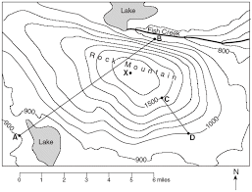

Data required:

G = 6.67 × 10-11 N m2 kg-2

mass of the Earth = 6.0 × 1024 kg

radius of the Earth = 6.4 × 106 m

gravitational field strength close to the surface of the Earth is 9.8 N kg-1

1. Why can the equation for gravitational potential energy, , not be used to describe gravitational potential?

***because the value for ‘g’ is not constant for large changes in h; the Earth’s field is a radial field and so for only small changes of h (or r) can the field be considered uniform***

1. Give the expression for gravitational potential in a radial field and give its units.

***V = − GM/R; J kg−1***

1. What is the value of V at the Earth’s surface and why is it negative?

*− 63MJkg-1; the potential is defined as zero at infinity and therefore becomes increasingly negative as it approaches Earth; work*

1. How is the gravitational field strength defined in terms of V?

***It is the gradient of a V – r graph at the point r, i.e. g = − ΔV/ Δr***

1. What does an equipotential surface represent?

*lines along which a mass experiences no change in gravitational potential*

1. What is the connection between an equipotential surface and a field line?

***They are always perpendicular***

1. What is the change in gravitational potential energy when travelling along an equipotential?

***zero***

1. How is the change in energy ΔE calculated for an object of mass m when going from a potential V1 to a potential V2?

***ΔE= m(V2 – V1)***

1. Calculate the gravitational potential of a star of mass 4.7 × 1035 kg at a distance of 8.2 × 1015 m from its centre.

***-3.8 × 109 J/kg***

1. The gravitational potential at 7.0 × 107 m from the centre of a planet is 1.8 × 109 J/kg. Determine the mass of the planet.

***1.9 × 1027 kg***

1. In the above question, determine the gravitational field strength at this height.

***25.7 N/kg***

1. For a satellite in a circular orbit around the Earth, why is the speed of the satellite constant.

***The satellite moves along an equipotential and there is thus no change in potential energy; as total energy is conserved, there is no change in kinetic energy, so speed remains constant***

1. What is the gravitational potential energy of a 60 kg student on the surface of the Earth? What then, is the minimum energy that would be required to get this student completely out of the Earth’s gravitational field?

GPE = -GMm/r = (- 6.67 x 10-11 x 6.0 x 1024 x 60) / 6.4 x 106 = - 3.8 x 109 J

To get the student away from the Earth’s field completely will require taking him to infinity where his GPE will be zero. Thus we need to give him at least 3.8 x 109 J of energy somehow.

1. What is the potential you experience at the surface of the Earth? How would the answer be different if your friend who weighs more than you worked it out?

V = -GM/r = (-6.67 x 10-11 x 6.0 x 1024) / 6.4 x 106 = - 6.3 x 107 J kg-1 or - 63 MJ kg-1

The answer is the same for everyone – potential is a property of the field and all objects at the same point in the field are subject to the same potential, even though their potential energies may be different.

1. What is the potential at a height of 36 000 km from the Earth’s surface? This is the height of a geostationary orbit. What is the potential difference between the surface of the Earth, and geostationary orbit height?

V = -GM/r = (-6.67 x 10-11 x 6.0 x 1024) / (6.4 x 106 + 3.6 x 107) = -9.4 x 106 J kg-1 or

-9.4 MJ kg-1

The potential difference is then - 9.4 – (- 63) = 53 MJ kg-1 (or 5.3 x 107 J kg-1).

Note that this potential difference is positive; indicating that to get to geostationary height, a large amount of energy would be required. There is no problem with potential differences being positive, but absolute values of potential themselves must always be negative.

1. So, what minimum energy is required to launch a 150 kg satellite into geostationary orbit? Why is the actual value a lot more?

Well, we now know that the potential difference between the Earth’s surface and the geostationary orbit height is + 5.3 x 107 J kg-1. In other words, for each kg of mass lifted from Earth to geostationary orbit, 5.3 x 107 J of energy is required. Therefore, for a satellite of mass 150 kg, energy required = 150 x 5.3 x 107= 8.0 x 109 J or (or 8.0 GJ).

Actually, much more energy is required because there is drag with the Earth’s atmosphere to overcome on the way up, and also the rocket itself (and its fuel) have mass that needs to be lifted into orbit too! The answer we’ve arrived at is only the energy required to lift the satellite against the gravitational pull of the Earth.

1. What is the potential difference between the top and bottom of an office block on the surface of the Earth that has a height of 50 m? (Hint – this close to the surface of the Earth, the field is roughly uniform, so you can use simple equations for change in GPE or change in potential).

For a uniform field, change in potential = gh = 9.8 x 50 = 490 J kg-1

For a 60 kg student, the energy required to climb to the top of the building is then 60 x 490 = 2.94 x 104 = 2.9 x 104 J or 29 kJ. For information, that’s about 7 kcal where a kcal is what is referred to as a ‘calorie’ on diet adverts. A chocolate bar is typically 200 calories or more! Students can rest assured that they use up more energy than this in climbing to the top of the building because their bodies are not 100 % efficient, and they warm up.

**Q1.**

(a)     Explain what is meant by the *gravitational potential* at a point in a gravitational field.

___________________________________________________________________

___________________________________________________________________

___________________________________________________________________

___________________________________________________________________

**(2)**

(b)     Use the following data to calculate the gravitational potential at the surface of the Moon.

mass of Earth   = 81  × mass of Moon  
radius of Earth  = 3.7 × radius of Moon  
gravitational potential at surface of the Earth = –63 MJ kg–1

___________________________________________________________________

___________________________________________________________________

___________________________________________________________________

___________________________________________________________________

___________________________________________________________________

___________________________________________________________________

**(3)**

(c)     Sketch a graph on the axes below to indicate how the gravitational potential varies with distance along a line outwards from the surface of the Earth to the surface of the Moon.

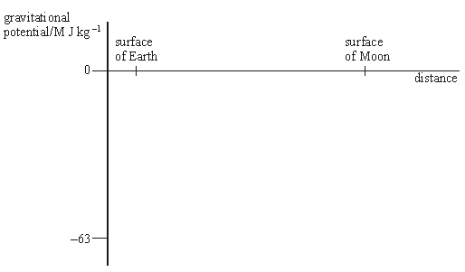

**(3)**

**(Total 8 marks)**

**Q2.**

(a)     The graph shows how the gravitational potential varies with distance in the region above the surface of the Earth. *R* is the radius of the Earth, which is 6400 km. At the surface of the Earth, the gravitational potential is −62.5 MJ kg–1.

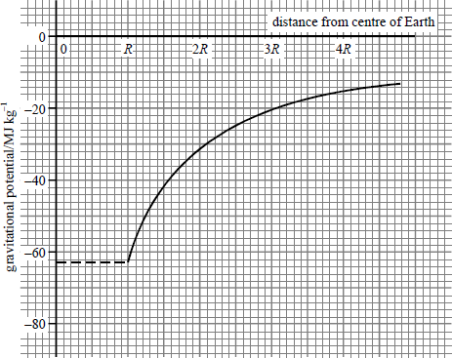

Use the graph to calculate

(i)      the gravitational potential at a distance 2*R* from the centre of the Earth,

______________________________________________________________

(ii)     the increase in the potential energy of a 1200 kg satellite when it is raised from the surface of the Earth into a circular orbit of radius 3*R*.

______________________________________________________________

______________________________________________________________

______________________________________________________________

**(4)**

(b)     (i)      Write down an equation which relates gravitational field strength and gravitational potential.

______________________________________________________________

(ii)     **By use of the graph** in part (a), calculate the gravitational field strength at a distance 2*R* from the centre of the Earth.

______________________________________________________________

______________________________________________________________

______________________________________________________________

______________________________________________________________

(iii)    Show that your result for part (b)(ii) is consistent with the fact that the surface gravitational field strength is about 10 N kg–1.

______________________________________________________________

______________________________________________________________

______________________________________________________________

______________________________________________________________

**(5)**

**(Total 9 marks)**

**Q1.**

(a)     work done/energy change (against the field) per unit mass **(1)**when moved from infinity to the point **(1)**

**2**

(b)     *V*E = – and *V*M = – **(1)**

*V*M = – *G* ×  ×  =  *V*E **(1)**

 = 4.57 × 10–2 × (–63) = –2.9 MJ kg–1 **(1)**        (2.88 MJ kg–1)

**3**

(c)

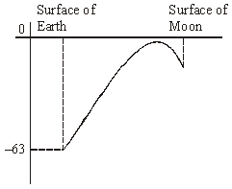

limiting values (–63,–*V*M) on correctly curving line **(1)**rises to value close to but below zero **(1)**falls to Moon **(1)**from point much closer to M than E **(1)**

**max 3**

**[8]**

**Q2.**

(a)     (i)      –31 MJ kg–1 **(1)**

(ii)     increase in potential energy = *m*Δ*V* **(1)**                                             = 1200 × (62 – 21) × 106 **(1)**                                             = 4.9 × 1010 J **(1)**

**(4)**

(b)     (i)      *g* = –  **(1)**

(ii)     *g* is the gradient of the graph =  **(1)**

                                                        = 2.44 N kg–1 **(1)**

(iii)    *g* ∝  and *R* is doubled **(1)**

expect *g* to be  = 2.45 N kg–1 **(1)**

[*alternative (iii)*

*g* ∝  and *R* is halved **(1)**

expect *g* to be 2.44 × 4 = 9.76 N kg–1 **(1)**]

**(5)**

**[9]**

# *Orbits*

Orbits and escape velocity

For anything to stay in orbit it requires two things:

* A centripetal force, caused by the gravitational force acting between the object orbiting and the object being orbited
* To be moving at a high speed

We now know equations for calculating the centripetal force of an object moving in a circle of radius *r* and for calculating the gravitational force between two masses separated by a distance of *r*.

Centripetal force at distance *r*:  *or*  *or* 

Gravitational force at distance *r*: 

These forces are equal to each other, since it is the force of gravity causing the centripetal force.

From these we can calculate many things about an orbiting object:

***The speed needed for a given radius***

 🡪  🡪  🡪 

***The time of orbit for a given radius (Kepler’s third law)***

 🡪  🡪  🡪 

🡪  🡪  🡪  🡪 

# *Energy of Orbit*

The total energy of a body in orbit is given by the equation:

Total energy = Kinetic energy + Potential energy or 

 🡪  🡪  🡪 

# *Geostationary Orbits*

Geostationary orbiting satellites orbit around the equator from West to East. They stay above the same point on the equator meaning that the time period is 24 hours. They are used for communication satellites such as television or mobile phone signals.

# *Escape Velocity*

For an object to be thrown from the surface of a planet and escape the gravitational field (to infinity) the initial kinetic energy it has at the surface must be equal to the potential energy (work done) to take it from the surface to infinity.

Potential energy:  Kinetic energy: 

 🡪  🡪  🡪 

For an object to be escape the Earth…..

  *v* = 11183 m/s

This calculation is unrealistic. It assumes that all the kinetic energy must be provided instantaneously. We have multistage rockets that provide a continuous thrust.

*Data required:*

*G* = 6.67 × 10-11 N m2 kg-2

mass of the Earth = 6.0 × 1024 kg

radius of the Earth = 6.4 × 106 m

mass of Jupiter = 1.9 × 1027 kg

radius of Jupiter = 7.2 × 107 m

Jupiter’s day length = 10 hours

1. What is the only force acting on a single planet orbiting a star? Write down an expression for this force. If the planet moves in a circular orbit of radius *r*, at constant speed *v*, write down an expression for this speed in terms of the period *T* of the orbit.

Because the orbit is circular, the planet must experience a centripetal force of size mv2/r. Use this fact and the 2 expressions you have written down to prove Kepler’s third law, which states that the square of the time period of the planet’s orbit is proportional to the cube of the radius of the orbit.

Gravitational attraction GMm/r2.

v = 2r/T

GMm/r2 = mv2/r

GM/r = m (2r/T)2

GM/r = 42r2m/T2

T2 = (42/GM) r3

1. Use Kepler’s third law, T2 ∝ r3, to answer this question. Two Earth satellites, A and B, orbit at radii of 7.0 × 106 m and 2.8 × 107 m respectively. Which satellite has the longer period of orbit? What is the ratio of orbital radii for the two satellites? What, therefore, is the ratio of the cubes of the orbital radii? What, therefore, is the ratio of the squares of the orbital periods? Finally therefore, what is the ratio of the satellites’ orbital periods?

By Kepler’s third law, orbital period increases with orbital radius. Thus B has the longer orbital period.

rB/rA = 2.8 x 107/ 7.0 x 106 = 4

(rB/rA)3 = 43 = 64

By Kepler’s third law, (TB/TA)2 = (rB/rA)3 = 64

Thus TB/TA = square root of 64 = 8

1. What is a geostationary satellite? Describe and explain the orbit of such a satellite. What might such a satellite be used for? With the help of your final expression in question 1, work out the orbital radius of such a satellite. What height is this above the Earth’s surface?

A satellite that appears to be stationary over a point on the Earth’s equator. The orbit of such a satellite is circular and over the Earth’s equator as the satellite’s orbital centre is the centre of the Earth, and the only points on Earth that orbit its centre are those on the equator.

Such a satellite might be used for communications, e.g. satellite broadcasting.

T2 = (42/GM) r3

r3 = (GM/42) T2

= (6.67 x 10-11 x 6.0 x 1024 / 42) x (24 x 60 x 60)2

= 7.567 x 1022 m3 (4sf)

Therefore, r = 4.23 x 107 m (3sf)

Height above Earth’s surface is 4.23 x 107 – 6.4 x 106 = 3.59 x 107 m or 36,000 km.

1. Suppose we wanted to place a satellite in “jovi-stationary” orbit around Jupiter (the same as geostationary, but around Jupiter, not Earth). What orbital period would it need? What orbital radius would this correspond to?

10 hours

r3 = (GM/42) T2 (see previous question)

= (6.67 x 10-11 x 1.9 x 1027 / 42) x (10 x 60 x 60)2

= 4.160 x 1024 m3 (4sf)

Therefore, r = 1.61 x 108 m (3sf)

1. The radius of a geostationary orbit is 42 200 km. Use this fact together with the constancy of R3 / T2 to estimate the height above the Earth’s surface of a satellite whose circular orbit is completed in 90 minutes. How many times a day would such a satellite orbit the Earth?



so



Therefore





1. Low-orbiting Earth satellites usually have orbital periods in the range 90 to 105 minutes. What range of heights does this correspond to?



1. 90 minutes is a typical orbital period for a military reconnaissance satellite, and 100 minutes for a civilian Earth observation satellite. Can you suggest a reason for this difference?

Low orbits give smaller image detail (is it a battlefield tank?); higher orbits give greater coverage and endurance (because there is less atmospheric friction).

1. Kepler’s laws were formulated for *elliptical* orbits (of which the circular orbit is a simple special case). The ‘*R*’ of the third law is the semi-major axis (found as the average of the maximum and minimum distances between a satellite and the body it orbits). You can see how this works by looking at data for Sputnik 1, the first artificial satellite, which was launched on 4 October 1957 and, was slowed due to the effects of atmospheric friction, spiralled back to Earth 3 months later. Complete the following table of data:

|  | **4 October 1957** | **25 October 1957** | **25 December 1957** |
| --- | --- | --- | --- |
| Orbital period / minutes | 96.2 | 95.4 | 91.0 |
| Minimum height / km | 219 | 216 | 196 |
| Maximum height / km | 941 | 866 | 463 |
| Mean height / km |  |  |  |
| Mean radius / km |  |  |  |
| R3 / T2  three significant figures |  |  |  |

Did the orbit become less elliptical as time passed?

|  | **4 October 1957** | **25 October 1957** | **25 December 1957** |
| --- | --- | --- | --- |
| Orbital period / minutes | 96.2 | 95.4 | 91.0 |
| Minimum height / km | 219 | 216 | 196 |
| Maximum height / km | 941 | 866 | 463 |
| Mean height / km | 580 | 541 | 330 |
| Mean radius / km | 6950 | 6911 | 6700 |
| R3 / T2  three significant figures | 36 x 106 | 36 x 106 | 36 x 106 |

The Kepler ratio for each case is the same; the deviation from the mean height decreases, so the orbit becomes more like a circle.

Average orbit time was 93.6 minutes. In 3 months (90 days) it made approximately 

**Q1.**

(a)     State, in words, Newton’s law of gravitation.

___________________________________________________________________

___________________________________________________________________

___________________________________________________________________

___________________________________________________________________

___________________________________________________________________

**(3)**

(b)     By considering the centripetal force which acts on a planet in a circular orbit,  
show that *T*2  *R*3, where *T* is the time taken for one orbit around the Sun and *R* is the radius of the orbit.

___________________________________________________________________

___________________________________________________________________

___________________________________________________________________

___________________________________________________________________

___________________________________________________________________

**(3)**

(c)     The Earth’s orbit is of mean radius 1.50 × 1011 m and the Earth’s year is 365 days long.

(i)      The mean radius of the orbit of Mercury is 5.79 × 1010 m. Calculate the length of Mercury’s year.

______________________________________________________________

______________________________________________________________

______________________________________________________________

______________________________________________________________

______________________________________________________________

______________________________________________________________

______________________________________________________________

______________________________________________________________

(ii)     Neptune orbits the Sun once every 165 Earth years.

Calculate the ratio .

______________________________________________________________

______________________________________________________________

______________________________________________________________

______________________________________________________________

______________________________________________________________

______________________________________________________________

______________________________________________________________

______________________________________________________________

**(4)**

**(Total 10 marks)**

**Q1.**

(a)     attractive **force** between point masses **(1)**proportional to (product of) the masses **(1)**inversely proportional to square of separation/distance apart **(1)**

**3**

(b)     *mω*2*R* = (–) **(1)**

(use of *T* =  gives)  **(1)**

*G* and *M* are constants, hence *T*2  *R*3 **(1)**

**3**

(c)     (i)      (use of *T*2  *R*3 gives)  **(1)**

*T*m = 87(.5) days **(1)**

(ii)     **(1)** (gives *R*N = 4.52 × 1012 m)

ratio =  = 30(.1) **(1)**

**4**

**[10]**

**Escape velocity questions:**

1. By using equations for potential and kinetic energy, derive the equation for escape velocity 
2. Calculate the escape velocity for the following planets:
3. Mars: mass = 6.46 × 1023 kg, radius = 3.39 × 106 m

5.04 × 103 m/s

1. Mercury: mass = 3.35 × 1023 kg, radius = 2.44 × 106 m

4.28 × 103 m/s

1. Venus: mass = 4.90 × 1023 kg, radius = 6.06 × 106 m

1.04 × 104 m/s

**Q1.**

(a)     Derive an expression to show that for satellites in a circular orbit

*T* 2 ∝ *r* 3

where *T* is the period of orbit and *r* is the radius of the orbit.

**(2)**

(b)     Pluto is a dwarf planet. The mean orbital radius of Pluto around the Sun is 5.91 × 109 km compared to a mean orbital radius of 1.50 × 108 km for the Earth.

Calculate in years the orbital period of Pluto.

orbital period of Pluto = ____________________ yr

**(2)**

(c)     A small mass released from rest just above the surface of Pluto has an acceleration of 0.617 m s–2.

Assume Pluto has no atmosphere that could provide any resistance to motion.

Calculate the mass of Pluto.

Give your answer to an appropriate number of significant figures.

radius of Pluto = 1.19 × 106 m

mass of Pluto = ____________________ kg

**(3)**

(d)     The graph shows the variation in gravitational potential with distance from the centre of Pluto for points at and above its surface.

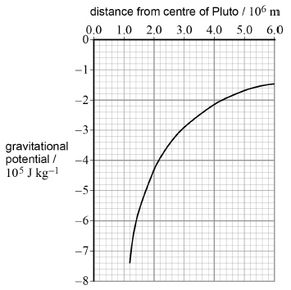

A meteorite hits Pluto and ejects a lump of ice from the surface that travels vertically at an initial speed of 1400 m s–1.

Determine whether this lump of ice can escape from Pluto.

___________________________________________________________________

___________________________________________________________________

**(3)**

**(Total 10 marks)**

**Q2.**

(a)     (i)      State what is meant by the term **escape velocity**.

______________________________________________________________

______________________________________________________________

**(1)**

(ii)     Show that the escape velocity, *v*, at the Earth’s surface is given by *v* = 

     where *M* is the mass of the Earth

     and *R* is the radius of the Earth.

**(2)**

(iii)     The escape velocity at the Moon’s surface is 2.37 × 103 m s–1 and the radius of the Moon is 1.74 × 106 m.

Determine the mean density of the Moon.

mean density ____________________ kg m–3

**(2)**

(b)     State **two** reasons why rockets launched from the Earth’s surface do **not** need to achieve escape velocity to reach their orbit.

___________________________________________________________________

___________________________________________________________________

___________________________________________________________________

___________________________________________________________________

**(2)**

**(Total 7 marks)**

**Q1.**

(a)     (centripetal) force = *m r* ( 2 *π* / *T* )2 Or m r (*ω*)2

(is given by the gravitational) force = *G m M / r*2 ✔ (mark for both equations)

(equating both expressions and substituting for *ω* if required) *T*2 = (4*π*2 / *GM*) *r*3 ✔ (4*π*2 / *GM* is constant, the constants may be on either side of equation but *T* and *r* must be numerators)

*First mark is for two equations (gravitational and centripetal)*

*The second mark is for combining.*

**2**

(b)     (use of *T*2 ∝ *r*3 so (*TP* / TE)2 = (*rP* / *rE*)3)

(*TP* /1.00)2 = (5.91 × 109 /1.50 × 108)3 ✔ (mark is for substitution of given data into any equation that corresponds to the proportional equation given above)

(*TP*2 = 61163)

*TP* = 250 (yr) ✔ (247 yr)

*Answer only gains both marks*

*The calculation may be performed using data for the Sun in T2 = (4π2 / GM) r3 easily spotted from Ms = 1.99 × 1030 kg giving a similar answer 247 – 252 yr.*

**2**

(c)     using *M* (= *g r*2 / *G*) = 0.617 × (1.19 × 106)2 / 6.67 × 10–11 ✔

M = 1.31 × 1022 kg ✔

answer to 3 sig fig ✔ (this mark stands alone)

*The last mark may be given from an incorrect calculation but not lone wrong answer.*

**3**

(d)     Initial KE = ½ (m) 14002 = 9.8 × 105 (m) J✔

Energy needed to escape = 7.4 × 105 (m) J ✔

So sufficient energy to escape. ✔

**OR** For object on surface escape speed given by 7.4 × 105 = ½ *v*2 ✔

escape speed = 1200 m s–1 ✔ (if correct equation is shown the previous mark is awarded without substitution)

So sufficient (initial) speed to escape. ✔

**OR** escape velocity =  substituting *M* from part (c) ✔

escape speed = 1200 m s–1 ✔ (1210 m s–1)

So sufficient (initial) speed to escape. ✔

**OR** escape velocity =  substituting from data in (c) ✔

*Third alternative may come from a CE from (c)*

*(1.06 × 10–8 × )*

*Conclusion must be explicit for third mark and cannot be awarded from a CE*

**3**

**[10]**

**Q2.**

(a)     (i)      (Minimum) Speed (given at the Earth’s surface) that will allow an object to leave / escape the (Earth’s) gravitational field (with no further energy input)

*Not gravity*

*Condone gravitational pull / attraction*

B1

**1**

(ii)     ½ *mv*2 = 

B1

Evidence of correct manipulation

*At least one other step before answer*

B1

**2**

(iii)    Substitutes data and obtains *M* = 7.33 × 1022(kg)  
or  
Volume = (1.33 × 3.14 × (1.74 × 106)3 or 2.2 × 1019

*or ρ = *

C1

3300 (kg m-3 )

A1

**2**

(b)     (Not given all their KE at Earth’s surface) energy continually  
added in flight / continuous thrust provided / can use fuel  
(continuously)

B1

Less energy needed to achieve orbit than to escape from  
Earth’s gravitational field / it is not leaving the gravitational  
field

B1

**2**

**[7]**

*Acknowledgements:*

The notes in this booklet come from TES user dwyernathaniel. The original notes can be found here:

<https://www.tes.com/teaching-resource/a-level-physics-notes-6337841>

Questions in the gravitational fields section are from the IoP TAP project. The original resources can be found here:

<https://spark.iop.org/episode-401-newtons-law-universal-gravitation#gref>

Questions in the gravitational potential section are from the IoP TAP project. The original resources can be found here:

<https://spark.iop.org/episode-404-energy-and-gravitational-fields>

Questions in the orbits and escape velocity section are from the IoP TAP project. The original resources can be found here:

<https://spark.iop.org/episode-403-orbital-motion>