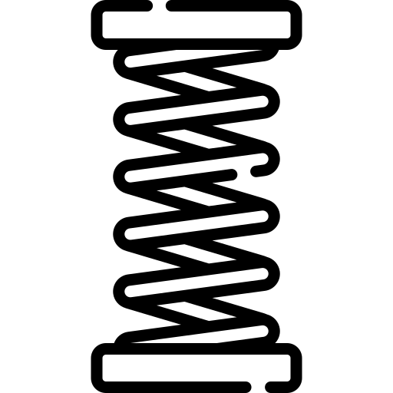

Materials

Name ______________________________

Teacher ______________________________

# *Hooke’s Law*

Hooke’s Law

If we take a metal wire or a spring and hang it from the ceiling it will have a natural, unstretched length of *l* metres. If we then attach masses to the bottom of the wire is will begin to increase in length (stretch). The amount of length it has increased by we will call the extension and represent by *e*.

If the extension increases proportionally to the force applied it follows Hooke’s Law:

*The force needed to stretch a spring is directly proportional to the extension of the spring from its natural length*

So it takes twice as much force to extend a spring twice as far and half the force to extend it half as far.

We can write this in equation form:  or 

Here *k* is the constant that shows us how much extension in length we would get for a given force. It is called...

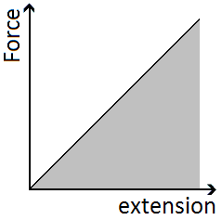

# *The Spring Constant*

The spring constant gives us an idea of the stiffness (or stretchiness) of the material.

If we rearrange Hooke’s Law we get:

If we record the length of a spring, add masses to the bottom and measure its extension we can plot a graph of force against extension. The gradient of this graph will be equal to the spring constant.

A small force causes a large extension the spring constant will be *small* – *very stretchy*

A large force causes a small extension the spring constant will be *large* – *not stretchy*

**Spring Constant is measured in Newtons per metre, N/m**

# *Springs in Series*

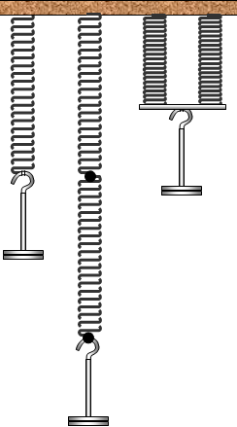The combined spring constant of spring *A* and spring *B* connected in series is given by:

 If *A* and *B* are identical this becomes:

 🡪  🡪 

Since this gives us a smaller value for the spring constant, applying the same force produces a larger extension. *It is stretchier*

# *Springs in Parallel*

The combined spring constant of spring *A* and spring *B* connected in parallel is:

 so if *A* and *B* are identical this becomes:

 🡪 

Since this gives us a larger value for the spring constant applying the same force produces a smaller extension. *It is less stretchy*

# *Energy Stored*

We can calculate the energy stored in a stretched material by considering the work done on it.

We defined work done as the force x distance moved in the direction of the force or 

Work done is equal to the energy transferred, in this case transferred to the material, so: 

The distance moved is the extension of the material, *e*, making the equation: 

The force is not constant; it increases from zero to a maximum of *F*. The average force is given by: 

If we bring these terms together we get the equation which simplifies to: 

*This is also equal to the area under the graph of force against extension.*

We can write a second version of this equation by substituting our top equation of  into the one above.

 🡪  🡪 

**Hooke’s Law and Springs**

1. State what is meant by elastic and plastic deformation.

.................................................................................................................................

.................................................................................................................................

.................................................................................................................................

.................................................................................................................................

[Total 2 marks]

2. Fig. 1 shows a spring that is fixed at one end and is hanging vertically.



**Fig. 1**

**A** mass **M** has been placed on the free end of the spring and this has produced an extension of 250 mm. The weight of the mass **M** is 2.00 N.

Fig. 2 shows how the force *F* applied to the spring varies with extension ** up to an extension of ** = 250 mm.

**Fig. 2**

(a) (i) Calculate the spring constant of the spring.

spring constant = ............................ unit ................ [3]

(ii) Calculate the strain energy in the spring when the extension is 250 mm.

strain energy = ............................ J [2]

(b) The mass **M** is pulled down a further 150 mm by a force *F* additional to its weight.

(i) Determine the force *F*.

*F* = ............................ N [1]

(ii) State any assumption made.

................................................................................................................

................................................................................................................ [1]

3. (i) Sketch on the figure below a graph to show the relationship between the tensile force *F* applied to a copper wire and the extension *x* produced. Continue the graph to the breaking point of the wire.



[1]

(ii) Label your graph to show the regions where the wire is undergoing

**1** elastic deformation

**2** plastic deformation. [2]

[Total 3 marks]

4. A manufacturer of springs tests the properties of a spring by measuring the load applied each time the extension is increased. The graph of load against extension is shown below.

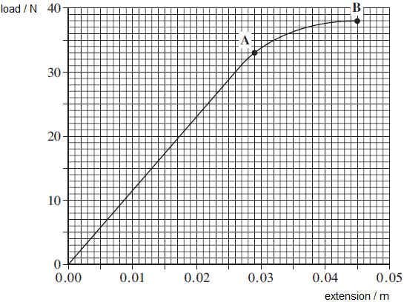

(a)     State Hooke’s law.

........................................................................................................................

........................................................................................................................

........................................................................................................................ **(2)**

(b)     Calculate the spring constant, *k*, for the spring. State an appropriate unit.

spring constant ......................................... unit ............... **(3)**

(c)     Use the graph to find the work done in extending the spring up to point **B**.

 work done ............................................ J **(3)**

(d)     Beyond point **A** the spring undergoes *plastic deformation*.

Explain the meaning of the term plastic deformation.

........................................................................................................................

........................................................................................................................ **(1)**

(e)     When the spring reaches an extension of 0.045 m, the load on it is gradually reduced to zero. On the graph above sketch how the extension of the spring will vary with load as the load is reduced to zero. **(2)**

(f)     Without further calculation, compare the total work done by the spring when the load is removed with the work that was done by the load in producing the extension of 0.045 m.

........................................................................................................................

........................................................................................................................

........................................................................................................................ **(1)**

**(Total 12 marks)**

# *Deforming Solids*

Stress and strain

Forces can be used to change the speed, direction and shape of an object. This section of Physics looks at using forces to change of shape of a solid object, either temporarily or permanently.

If a pair of forces are used to *squash* a material we say that they are *compressive* forces.

If a pair of forces is used to *stretch* a material we say that they are *tensile* forces.

# *Tensile Stress, σ*

Tensile stress is defined as the force applied per unit cross-sectional area (which is the same as pressure).

This is represented by the equations:

 

The largest tensile stress that can be applied to a material before it breaks is called the ultimate tensile stress (UTS). Nylon has an UTS of 85 MPa whilst Stainless steel has a value of 600 MPa and Kevlar a massive 3100 MPa

**Stress is measured in Newtons per metre squared, N/m2 or N m-2**

**Stress can also be measured in Pascals, Pa**

A tensile stress will cause a tensile strain. *Stress causes Strain*

# *Tensile Strain, ε*

Tensile strain is a measure of how the extension of a material compares to the original, unstretched length.

This is represented by the equations:

 

Steel wire will undergo a strain of 0.01 before it breaks. This means it will stretch by 1% of its original length then break. Spider silk has a breaking strain of between 0.15 and 0.30, stretching by 30% before breaking

**Strain has no units, it is a ratio of two lengths**

# *Stress-Strain Graphs*

A stress-strain graph is very useful for comparing different materials.

Here we can see how the strain of two materials, **a** and **b**, changes when a stress is applied.

If we look at the dotted lines we can see that the same amount of stress causes a bigger strain in **b** than in **a**. This means that **b** will increase in length more than **a** (compared to their original lengths).

# *Elastic Strain Energy*

We can work out the amount of elastic strain energy that is stored *per unit volume* of the material.

It is given by the equation: 

There are two routes we can take to arrive at this result:

***Equations***

If we start with the equation for the total energy stored in the material: 

The volume of the material is given by:

Now divide the total energy stored by the volume:  which can be written as: 

If we compare the equation to the equations we know for stress and strain we see that: 

***Graphs***

The area under a stress-strain graph gives us the elastic strain energy per unit volume (m3). The area is given by:

 🡪  or  🡪 

Calculations on stress, strain

A strip of rubber originally 75 mm long is stretched until it is 100 mm long.

1. What is the tensile strain?

2. Why does the answer have no units?

3. The greatest tensile stress which steel of a particular sort can withstand without breaking is about 109 N m-2. A wire of cross-sectional area 0.01 mm2 is made of this steel. What is the greatest force that it can withstand?

4. Find the minimum diameter of an alloy cable, tensile strength 75 MPa, needed to support a load of 15 kN.

5. Calculate the tensile stress in a suspension bridge supporting cable, of diameter of 50 mm, which pulls up on the roadway with a force of 4 kN.

6. Calculate the tensile stress in a nylon fishing line of diameter 0.36 mm which a fish is pulling with a force of 20 N

7. Calculate the tensile stress in a nylon fishing line of diameter 0.36 mm which a fish is pulling with a force of 20 N A long strip of rubber whose cross section measures 12 mm by 0.25 mm is pulled with a force of 3.0 N. What is the tensile stress in the rubber?

8. Another strip of rubber originally 90 mm long is stretched until it is 120 mm long. What is the tensile strain?

The marble column in a temple has dimensions 140 mm by 180 mm.

9. What is its cross-sectional area in mm2?

10. Now change each of the initial dimensions to metres – what is the cross-sectional area in m2?

11. If the temple column supports a load of 10 kN, what is the compressive stress, in N m-2?

12. The column is 5.0 m tall, and is compressed by 0.1 mm. What is the compressive strain when this happens?

A 3.0 m length of copper wire of diameter 0.4 mm is suspended from the ceiling. When a 0.5 kg mass is suspended from the bottom of the wire it extends by 0.9 mm.

13. Calculate the strain of the wire.

14. Calculate the stress in the wire.

**Q1.**

The figure below shows a person of weight 800 N, crossing the gap between two buildings on a nylon rope.

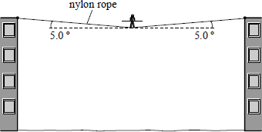

Before the crossing commenced the rope was horizontal and just taut. When the person is halfway across the rope sags by 5.0°.

(a)     Explain briefly why, however taut the rope is, the rope must sag when the person is on it.

___________________________________________________________________

___________________________________________________________________

___________________________________________________________________

**(1)**

(b)     By calculation or scale drawing, determine the tension in the rope when the person is half way across.

**(3)**

(c)     The nylon rope has an ultimate tensile stress of 7.0 × 107 Pa. Calculate the minimum diameter of the rope that could be used.

**(3)**

**(Total 7 marks)**

**Q2.**

One end of a steel wire of length 1.2 m and 2.0 mm diameter is attached to a rigid beam. A 25 g mass is attached to the free end of the steel wire and placed against the underside of the beam as shown.

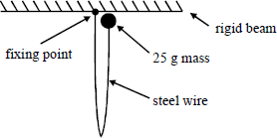

The 25 g mass is released and falls freely until the wire becomes taut. The kinetic energy of the falling mass is converted to elastic potential energy in the wire as the wire extends to a maximum of 1.0 mm. Energy converted to other forms is negligible.

For **maximum** extension of the wire, complete parts (a) to (e).

(a)     Show that the elastic potential energy stored by the extended wire is 0.29 J.

___________________________________________________________________

___________________________________________________________________

(b)     Calculate the tension in the wire.

___________________________________________________________________

___________________________________________________________________

(c)     Calculate the stress in the wire.

___________________________________________________________________

___________________________________________________________________

(d)     Calculate the strain of the wire.

___________________________________________________________________

___________________________________________________________________

**(Total 8 marks)**

**Q3.**

The figure below shows a stress-strain graph for a copper wire.

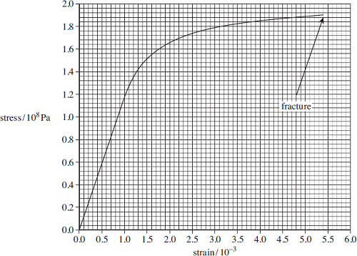

(a)     Define tensile strain.

___________________________________________________________________

___________________________________________________________________

**(1)**

(b)     State the breaking stress of this copper wire.

answer = ______________________ Pa

**(1)**

(c)     Mark on the figure above a point on the line where you consider plastic deformation may start.  
Label this point **A**.

**(1)**

(d)     The area under the line in a stress-strain graph represents the work done per unit volume to stretch the wire.

(i)      Use the graph to find the work done per unit volume in stretching the wire to a strain of 3.0 × 10–3.

answer = ______________________J m–3

**(2)**

(ii)     Calculate the work done to stretch a 0.015 kg sample of this wire to a strain of  
3.0 × 10–3.

The density of copper = 8960 kg m–3.

answer = ______________________J

**(2)**

**(Total 7 marks)**

# *Density, ρ*

Bulk properties of solids

Density is the *mass per unit volume of a material*, a measure of how much mass each cubic metre of volume contains. Density if given by the equation:

Where *ρ* is density, *m* is mass in kilograms and *V* is volume in metres cubed.

**Density is measured in kilograms per metre cubed, kg/m3 or kg m-3**

# *Elasticity*

Materials extend in length when a stress is applied to them (masses hung from them). A material can be described as elastic if it returns to its original length when the stress is removed. They obey Hooke’s Law as extension is proportional to the force applied.

# *Limit of Proportionality, P*

Up to this point the material obeys Hooke’s Law; extension is proportional to the force applied.

# *Elastic Limit, E*

The elastic limit is the final point where the material will return to its original length if we remove the stress which is causing the extension (take the masses off). There is no change to the shape or size of the material.

We say that the material acts plastically beyond its elastic limit.

# *Yield Point, Y*

Beyond the elastic limit a point is reached where small increases in stress cause a massive increase in extension (strain). The material will not return to its original length and behaves like a plastic.

# *Plasticity*

Materials extend in length when a stress is applied to them (masses hung from them). A material can be described as plastic if it does not return to its original length when the stress is removed. There is a permanent change to its shape

# *Breaking Stress – Ultimate Tensile Strength, UTS*

This is the maximum amount of stress that can be applied to the material without making it break. It is sometimes referred to as the strength of the material.

# *Breaking Point, B*

This is (surprisingly?) the point where the material breaks.

# *Stiffness*

If different materials were made into wires of equal dimensions, the stiffer materials bend the least.

Stiff materials have low flexibility

# *Ductility*

A ductile material can be easily and permanently stretched. Copper is a good example, it can easily be drawn out into thin wires. This can be seen in graph **d** below.

# *Brittleness*

A brittle material will extend obeying Hooke’s Law when a stress is applied to it. It will suddenly fracture with no warning sign of plastic deformation. Glass, pottery and chocolate are examples of brittle materials.

# *Stress-Strain Graphs*

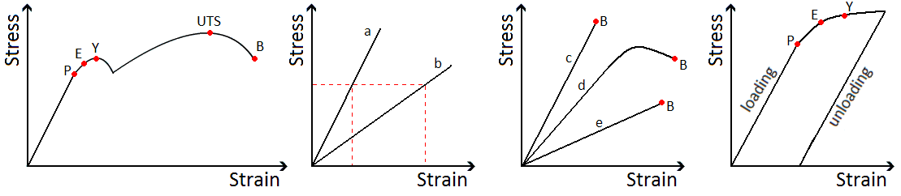

In the first graph we see a material that stretches, shows plastic behaviour and eventually breaks.

In the second graph we can see that material **a** is stiffer than material **b** because the same stress causes a greater strain in **b**.

In the third graph we see materials **c** and **e** are brittle because they break without showing plastic behaviour.

The fourth graph shows how a material can be permanently deformed, the wire does not return to its original length when the stress is removed (the masses have been removed).

***Density questions***

1. 1 kg of nitrogen is used to fill a balloon. If the density of nitrogen is 1.25 kg m-3, what is going to be the volume of the balloon?

2. What will be the mass of air in a classroom that is 15 m long, 10 m wide and 4 m high? (Density of air = 1.3 kg m-3).

3. A tank measures 60 cm long and 45 cm wide. If 72 kg of water is enough to fill the tank, how deep is the tank? (Density of water = 1000 kg m-3).

4. A solid of steel cylinder has a diameter of 12 mm and a length of 85 mm . Calculate:

a)  Its volume in  m3.

b) Its mass in kg, density of steel  = 7800kg/m3.

5. In the diagram below, the piston contains 0.2 kg of oxygen, which has a density of 1.43 kg m-3.

a) If the plunger is at a height of 40 cm, what is the cross-sectional area of the plunger?

b)The gas is heated and the plunger rises a further 20 cm. What is the density of the oxygen now?

Oxygen

40 cm

Oxygen

40 cm

Oxygen

40 cm

**Q1.**

(a)     Define the *density* of a material.

___________________________________________________________________

___________________________________________________________________

**(1)**

(b)     Brass, an alloy of copper and zinc, consists of 70% **by volume** of copper and 30% **by volume** of zinc.

density of copper    = 8.9 × 103 kg m–3density of zinc         = 7.1 × 103 kg m–3

(i)      Determine the mass of copper and the mass of zinc required to make a rod of brass of volume 0.80 × 10–3 m3.

______________________________________________________________

______________________________________________________________

______________________________________________________________

______________________________________________________________

(ii)     Calculate the density of brass.

______________________________________________________________

______________________________________________________________

**(4)**

**(Total 5 marks)**

**Q2.**

A seismometer is a device that is used to record the movement of the ground during an earthquake. A simple seismometer is shown in the diagram.

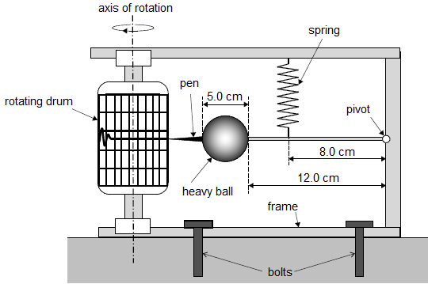

A heavy spherical ball is attached to a pivot by a rod so that the rod and ball can move in a vertical plane. The rod is suspended by a spring so that, in equilibrium, the spring is vertical and the rod is horizontal. A pen is attached to the ball. The pen draws a line on graph paper attached to a drum rotating about a vertical axis. Bolts secure the seismometer to the ground so that the frame of the seismometer moves during the earthquake.

(a)     The ball is made of steel of density 8030 kg m−3 and has a diameter of 5.0 cm.

Show that the weight of the ball is approximately 5 N.

**(3)**

(b)     The distance from the surface of the ball to the pivot is 12.0 cm, as shown in the diagram above.

Calculate the moment of the weight of the ball about the pivot when the rod is horizontal. Give an appropriate unit for your answer.

moment = ____________________ unit = __________

**(3)**

(c)     The spring is attached at a distance of 8.0 cm from the pivot and the spring has a stiffness of 100 N m−1.

Calculate the extension of the spring when the rod is horizontal and the spring is vertical. You may assume the mass of the pen and the mass of the rod are negligible.

extension = ____________________ m

**(3)**

(d)     Before an earthquake occurs, the line being drawn on the graph paper is horizontal.

Explain what happens to the line on the graph paper when an earthquake is detected and the frame of the seismometer accelerates rapidly downwards.

___________________________________________________________________

___________________________________________________________________

___________________________________________________________________

___________________________________________________________________

___________________________________________________________________

___________________________________________________________________

___________________________________________________________________

**(2)**

**(Total 11 marks)**

***Properties of materials:***

1. Write a definition for each of the following terms:
2. Brittle:

___________________________________________________________________

___________________________________________________________________

1. Tough:

___________________________________________________________________

___________________________________________________________________

1. Strong:

___________________________________________________________________

___________________________________________________________________

1. Elastic:

___________________________________________________________________

___________________________________________________________________

1. Plastic:

___________________________________________________________________

___________________________________________________________________

1. Hard:

___________________________________________________________________

___________________________________________________________________

1. Soft:

___________________________________________________________________

___________________________________________________________________

1. Stiff:

___________________________________________________________________

___________________________________________________________________

1. Breaking stress:

___________________________________________________________________

___________________________________________________________________

1. Yield point:

___________________________________________________________________

___________________________________________________________________

1. Elastic limit:

___________________________________________________________________

___________________________________________________________________

1. Limit of proportionality:

___________________________________________________________________

___________________________________________________________________

**2.** In this question, two marks are available for the quality of written communication.

The diagram below shows stress-strain graphs up to the point of fracture for three different materials.



Use the terms *plastic*, *elastic*, *brittle*, and *ductile*, where appropriate, to describe the behaviour of the materials represented by the graphs.

*cast iron* ...................................................................................................................

..................................................................................................................................

..................................................................................................................................

..................................................................................................................................

..................................................................................................................................

..................................................................................................................................

..................................................................................................................................

..................................................................................................................................

..................................................................................................................................

..................................................................................................................................

*copper* ......................................................................................................................

..................................................................................................................................

..................................................................................................................................

..................................................................................................................................

..................................................................................................................................

..................................................................................................................................

..................................................................................................................................

..................................................................................................................................

..................................................................................................................................

..................................................................................................................................

*polythene* .................................................................................................................

..................................................................................................................................

..................................................................................................................................

..................................................................................................................................

..................................................................................................................................

..................................................................................................................................

..................................................................................................................................

..................................................................................................................................

..................................................................................................................................

..................................................................................................................................

[8]

Quality of Written Communication [2]

[Total 10 marks]

# *The Young Modulus, E*

The Young modulus

The Young Modulus can be thought of as the stiffness constant of a material, a measure of how much strain will result from a stress being applied to the material. It can be used to compare the stiffness of different materials even though their dimensions are not the same.

The Young Modulus only applies up to the limit of proportionality of a material.

 or in equation terms we have 

We have equations for stress  and strain  which makes the equation look like this: 

An easier way of writing this is  which becomes: 

**The Young Modulus is measured in Newtons per metre squares, N/m2 or N m-2**

# *Stress-Strain Graphs*

The Young Modulus of a material can be found from its stress-strain graph.

Since, this becomes  for our graph. Our top equation stated that  so we see that the gradient of a stress-strain graph gives us the Young Modulus.

This only applied to the straight line section of the graph, where gradient (and Young Modulus) are constant.

# *Measuring the Young Modulus*

Here is a simple experimental set up for finding the Young Modulus of a material.

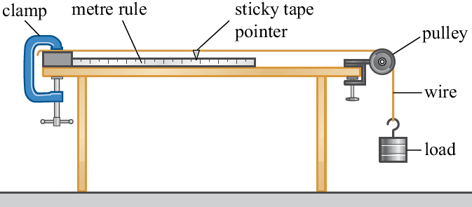

* A piece of wire is held by a G-clamp, sent over a pulley with the smallest mass attached to it. This should keep it straight without extending it.
* Measure the length from the clamp to the pointer. This is the original length (unstretched).
* Use a micrometer to measure the diameter of the wire in several places. Use this to calculate the cross-sectional area of the wire.
* Add a mass to the loaded end of the wire.
* Record the extension by measuring how far the pointer has moved from its start position.
* Repeat for several masses but ensuring the elastic limit is not reached.
* Remove the masses, one at a time taking another set of reading of the extension.
* Calculate stress and strain for each mass.
* Plot a graph of stress against strain and calculate the gradient of the line which gives the Young Modulus.

Here is a more precise way of finding the Young Modulus but involves taking the same measurements of extension and force applied.

It is called Searle’s apparatus.

***Stress, Strain and the Young Modulus***

**1.** The four bars **A**, **B**, **C** and **D** have diameters, lengths and loads as shown. They are all made of the same material.

Which bar has the greatest extension?

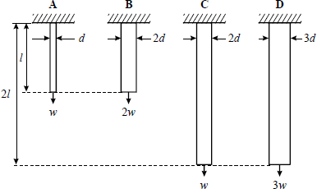

**(Total 1 mark)**

**2.** Define the quantities

(i) *stress*

......................................................................................................................... [1]

(ii) *strain.*

......................................................................................................................... [1]

**3.** The figure below shows one possible method for determining the Young modulus of a metal in the form of a wire.



Describe how you can use this apparatus to determine the Young modulus of the metal. The sections below should be helpful when writing your answers.

The **measurements** to be taken:

 *In your answer, you should use appropriate technical terms, spelled correctly*.

..................................................................................................................................

..................................................................................................................................

..................................................................................................................................

..................................................................................................................................

..................................................................................................................................

..................................................................................................................................

The **equipment** used to take the measurements:

 *In your answer, you should use appropriate technical terms, spelled correctly.*

..................................................................................................................................

..................................................................................................................................

..................................................................................................................................

..................................................................................................................................

..................................................................................................................................

..................................................................................................................................

How you would **determine** Young modulus from your measurements:

..................................................................................................................................

..................................................................................................................................

..................................................................................................................................

..................................................................................................................................

..................................................................................................................................

..................................................................................................................................

[Total 8 marks]

5. Below is a stress-strain graph up to the point of fracture for a rod of cast iron.



(a) The rod of cast iron has a cross-sectional area of 1.5 × 10–4m2.

Calculate

(i) the force applied to the rod at the point of fracture

force = ............................ N [2]

(ii) the Young modulus of cast iron.

Young modulus ............................. = N m–2 [3]

(b) Use the graph or otherwise to describe the stress-strain behaviour of cast iron up to and including the fracture point.

.........................................................................................................................

.........................................................................................................................

.........................................................................................................................

.........................................................................................................................

......................................................................................................................... [3]

6. A metal wire of length 1.2 m is clamped vertically. A weight is hung from the lower end of the wire. The extension of the wire is 0.35 mm. The cross-sectional area of the wire is 1.4 × 10–7 m2 and the Young modulus of the metal is 1.9 × 1011 Pa.

Calculate

(i) the strain of the wire

strain = ......................................................... [1]

(ii) the tension in the wire.

tension = ...................................................... N [2]

[Total 3 marks]

**7.** The table below shows the results of an experiment where a force was applied to a sample of metal.

(a)     On the axes below, plot a graph of stress against strain using the data in the table.

|  |  |  |  |  |  |  |  |  |  |  |  |
| --- | --- | --- | --- | --- | --- | --- | --- | --- | --- | --- | --- |
| Strain / 10–3 | 0 | 1.00 | 2.00 | 3.00 | 4.00 | 5.00 | 6.00 | 7.00 | 8.00 | 9.00 | 10.00 |
| Stress /108 Pa | 0 | 0.90 | 2.15 | 3.15 | 3.35 | 3.20 | 3.30 | 3.50 | 3.60 | 3.60 | 3.50 |

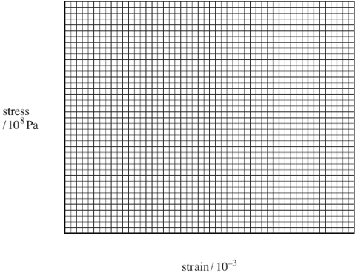 **(3)**

(b)     Use your graph to find the Young modulus of the metal.

answer = ...................................... Pa **(2)**

(c)     A 3.0 m length of steel rod is going to be used in the construction of a bridge. The tension in the rod will be 10 kN and the rod must extend by no more than 1.0mm. Calculate the minimum cross-sectional area required for the rod.

Young modulus of steel = 1.90 × 1011 Pa

answer = ...................................... m2  **(3)**

**Synoptic Questions**

**1.** The results given in the table below are obtained in an experiment to determine the Young modulus of a metal in the form of a wire. The wire is loaded in steps of 5.0 N  
up to 25.0 N and then unloaded.

|  |  |  |
| --- | --- | --- |
|  | loading | unloading |
| load / N | extension / mm | extension /mm |
| 0.0 | 0.00 | 0.00 |
| 5.0 | 0.24 | 0.24 |
| 10.0 | 0.47 | 0.48 |
| 15.0 | 0.71 | 0.71 |
| 20.0 | 0.96 | 0.95 |
| 25.0 | 1.20 | 1.20 |

(i) Using the results in the table and without plotting a graph, state and explain whether the deformation of the wire

**1** is plastic or elastic

.........................................................................................................................

.........................................................................................................................

......................................................................................................................... [1]

**2** obeys Hooke’s law.

.........................................................................................................................

.........................................................................................................................

......................................................................................................................... [2]

(ii) Explain how the extension and length of the wire may be determined experimentally.

.........................................................................................................................

.........................................................................................................................

.........................................................................................................................

......................................................................................................................... [2]

(iii) The wire tested is 1.72 m long and has a cross-sectional area of 1.80 × 10–7 m2. Use the extension value given in the table for a load of 25.0 N to calculate the Young modulus of the metal of the wire.

Young modulus = .............................. Pa [3]

[Total 8 marks]

2. The figure below shows a mechanism for firing a table tennis ball vertically into the air.



The spring has a force constant of 75 N m–1. The ball is placed on the platform at the top of the spring.

(i) The spring is compressed by 0.085 m by pulling the platform. Calculate the force exerted by the compressed spring on the ball **immediately** after the spring is released. Assume both the spring and the platform have negligible mass.

force = .......................................................N [2]

(ii) The mass of the ball is 2.5 × 10–3 kg. Calculate the initial acceleration of the ball.

acceleration = .................................................m s–2 [1]

(iii) Calculate the maximum height that could be gained by the ball. Assume all the elastic potential energy of the spring is converted into gravitational potential energy of the ball.

height = ......................................................m [3]

[Total 6 marks]

3. The figure below shows a violin.



Two of the wires used on the violin, labelled **A** and **G** are made of steel. The two wires are both 500 mm long between the pegs and support. The 500 mm length of wire labelled **G** has a mass of 2.0 × 10 –3 kg. The density of steel is 7.8 × 10 3 kg m –3.

(i) Show that the cross-sectional area of wire **G** is 5.1 × 10 –7 m2.

[2]

(ii) The wires are put under tension by turning the wooden pegs shown in the figure. The Young modulus of steel is 2.0 × 1011 Pa.

Calculate the tension required in wire **G** to produce an extension of 4.0  10–4 m.

tension = ................................N [3]

(iii) Wire **A** has a diameter that is half that of wire **G**. Determine the tension required for wire **A** to produce an extension of 16 × 10–4 m.

tension = ................................N [1]

(iv) State the law that has been assumed in the calculations in **(ii)** and **(iii)**.

......................................................................................................................... [1]

[Total 7 marks]

**4.** (a) State Hooke’s law.

.........................................................................................................................

......................................................................................................................... [2]

(b) The diagram below shows the variation of the applied force *F* with the extension  
*x* for a particular spring.



(i) Use the diagram to determine the force constant of the spring.

force constant = ..................................N m–1 [2]

(ii) Determine the elastic potential energy stored in the spring when a force of 20 N is applied.

energy stored = ......................................... J [2]

(iii) State one assumption made in your calculation of the energy in (ii).

................................................................................................................

................................................................................................................ [1]

(iv) The energy stored in the spring is used to propel a metal ball of mass *m* horizontally. There is 100% transfer of energy from the spring to the ball. Show how the speed *v* of the metal ball is proportional to the extension *x* of the spring. Find the constant of proportionality.

................................................................................................................

................................................................................................................

................................................................................................................ [2]

[Total 9 marks]

5. (a)     State *Hooke’s* *law* for a material in the form of a wire and state the conditions under which this law applies.

......................................................................................................................

...................................................................................................................... **(2)**

(b)     A length of steel wire and a length of brass wire are joined together. This combination is suspended from a fixed support and a force of 80 N is applied at the bottom end, as shown in the figure below.

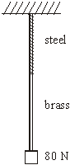

Each wire has a cross-sectional area of 2.4 × 10–6 m2.

length of the steel wire = 0.80 m  
length of the brass wire = 1.40 m  
the Young modulus for steel = 2.0 × 1011 Pa  
the Young modulus for brass = 1.0 × 1011 Pa

(i)      Calculate the total extension produced when the force of 80 N is applied.

.............................................................................................................

.............................................................................................................

.............................................................................................................

.............................................................................................................

(ii)     Show that the mass of the combination wire = 4.4 × 10–2 kg.

density of steel = 7.9 × 103 kg m–3density of brass = 8.5 × 103 kg m–3

.............................................................................................................

.............................................................................................................

.............................................................................................................

.............................................................................................................

............................................................................................................. **(7)**

(c)     A single brass wire has the same mass and the same cross-sectional area as the combination wire described in part (b). Calculate its length.

......................................................................................................................

......................................................................................................................

......................................................................................................................

......................................................................................................................

**(2)**

**(Total 11 marks)**

***Acknowledgements:***

The notes in this booklet come from TES user dwyernathaniel. The original notes can be found here:

<https://www.tes.com/teaching-resource/a-level-physics-notes-6337841>

Questions in the Hooke’s Law and Young’s modulus sections come from Bernard Rand’s resources (@BernardRand). His original resources can be found here:

<https://drive.google.com/drive/folders/1-2qNVLwGzJ_7AjQK9N0z4BQBIRmSHAwG>

Questions on stress and strain are from the IoP TAP project. The original resources can be found here:

<https://spark.iop.org/collections/materials>

Questions on density are originally from TES user HKhan67. The original resources can be found here:

<https://www.tes.com/teaching-resource/aqa-as-physics-differentiated-density-worksheet-6426678>