Prac6
Physics Practical
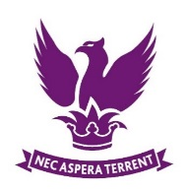
Y12 Core Practical
The Young Modulus

 | Skills Assessed |  |  | Met?
 | 3. Safely uses a range of practical equipment and materials | a. Identifies hazards and assesses risks associated with these hazards, making safety adjustments as necessary, when carrying out experimental techniques and procedures in the lab or field.  b. Uses appropriate safety equipment and approaches to minimise risks with minimal prompting.
 | 4. Makes and records observations | a. Makes accurate observations relevant to the experimental or investigative procedure.
 | 5. Researches, references and reports | b. Cites sources of information demonstrating that research has taken place, supporting planning and conclusions.
 | Introduction | In this investigation you will research methods of determining the Young Modulus of a material by a simple method. You will plan a method choosing suitable equipment and plan for safety in the experiment. Your teacher will then demonstrate one method, and provide you with some results to analyse.

Introduction

