Prac6
Physics Practical
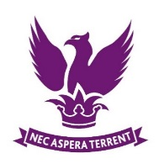
Y12 Core Practical
The Young Modulus

 | Skills Assessed |  |  | Met?
 | 4. Makes and records observations | a. Makes accurate observations relevant to the experimental or investigative procedure.
 | 5. Researches, references and reports | b. Cites sources of information demonstrating that research has taken place, supporting planning and conclusions.

Introduction

In this investigation you will research methods of determining the Young Modulus of a material by a simple method. Your teacher will then demonstrate one method, and provide you with some results to analyse

