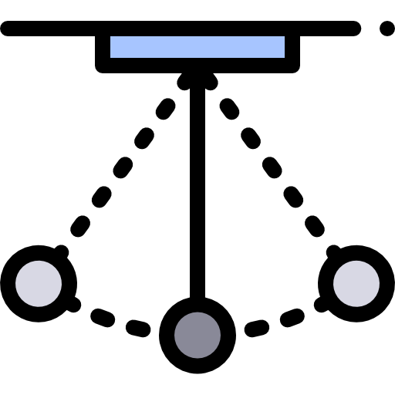

mechanics

Further

Name ______________________________

Teacher ______________________________

# 

Circular Motion

To the right is the path a car is taking as it moves in a circle of radius *r*.

# *Angular Displacement, θ*

As the car travels from X to Y it has travelled a distance of *s* and has covered a section of the complete circle it will make. It has covered and angle of *θ* which is called the angular displacement.

 

**Angular Displacement is measured in radians, rad**

# *Radians*

1 radian is the angle made when the arc of a circle is equal to the radius.

For a complete circle  🡪  🡪  🡪 

A complete circle is 360° so 360° = 2π rad

1° = 0.017 rad 57.3° = 1 rad

# *Angular Speed, ω*

Angular speed is the rate of change of angular displacement, or the angle that is covered every second.



**Angular Speed is measured in radians per second, rad/s or rad s-1**

# *Frequency, f*

Frequency is the number of complete circles that occur every second.

For one circle; , if we substitute this into the equation above we get 

This equation says that the angular speed (angle made per second) is equal to one circle divided by the time taken to do it. Very similar to speed = distance/time

Since  the above equation can be written as 

**Frequency is measures in Hertz, Hz**

# *Speed, v*

The velocity of the car is constantly changing because the direction is constantly changing. The speed however, is constant and can be calculated.

 If we rearrange the top equation we can get , the speed then becomes

 Now if we rearrange the second equation we get , the equation becomes

 Cancel the *t*’s and we finally arrive at our equation for the speed.



**Speed is measured in metres per second, m/s or m s-1**

*Radians and angular speed*

1. Use a calculator to complete the table of q in degrees and radians, sin q, cos q, and tan q when q has values in degrees shown in the table:

|  |  |  |  |  |
| --- | --- | --- | --- | --- |
| q degree | q in radians | sin q | cos q | tan q |
| 0.01 |  |  |  |  |
| 0.1 |  |  |  |  |
| 0.5 |  |  |  |  |
| 1 |  |  |  |  |
| 5 |  |  |  |  |
| 10 |  |  |  |  |
| 20 |  |  |  |  |
| 70 |  |  |  |  |

When q (in radians) is small what are suitable approximations for:

sin q, tan q, cos q?

The set of questions below consider a simple example of an object moving in a circle at constant speed.

2. Write down the angle in radians if the object moves in one complete circle, and then deduce the number of radians in a right angle.

3. The object rotates at 15 revolutions per minute. Calculate the angular speed in radian per second.

4. A high tower has a rotating restaurant that moves slowly round in a circle while the diners are eating. The restaurant is designed to give a full 360° view of the sky line in the two hours normally taken by diners.

Calculate the angular speed in radians per second.

5. The diners are sitting at 20 m from the central axis of the tower.

Calculate their speed in metres per second.

Do you think they will be aware of their movement relative to the outside?

6. Calculate the angular velocity of a point on the surface of the Earth.

7. Use the answer to question 6 to calculate the linear velocity of a point on the surface of the Earth (radius of Earth = 6.4 × 106 m.)

8. What is the frequency for the rotation of the Earth?

9. A big wheel at a fairground has a radius of 23 m and takes 5 mins to turn once.

a) What fraction of a rotation does it do in 1 second?

b) What is the angular speed of the fairground wheel?

c) What speed does a point on the edge of the wheel have?

**Q1.**

What is the angular speed of a car wheel of diameter 0.400 m when the speed of the car is 108 km h−1?

|  |  |
| --- | --- |
| **A** | 75 rad s−1 |
| **B** | 150 rad s−1 |
| **C** | 270 rad s−1 |
| **D** | 540 rad s−1 |

**(Total 1 mark)**

**Q2.**

A model car moves in a circular path of radius 0.80 m at an angular speed of   rad s–1.

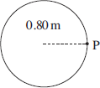

What is its displacement from point P 6.0 s after passing P?

**A**        zero

**B**        0.4*π* m

**C**        1.6 m

**D**        1.6*π* m

**(Total 1 mark)**

**Q3.**

The Earth moves around the Sun in a circular orbit with a radius of 1.5 × 108 km.  
What is the Earth’s approximate speed?

**A**       1.5 × 103ms–1

**B**       5.0 × 103ms–1

**C**       1.0 × 104ms–1

**D**       3.0 × 104ms–1

**(Total 1 mark)**

**Q4.**

The diagram shows a disc of diameter 120 mm that can turn about an axis through its centre.

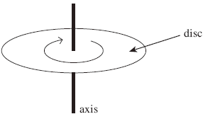

The disc is turned through an angle of 30° in 20 ms. What is the average speed of a point on the edge of the disc during this time?

**A**       0.5π m s–1

**B**       π m s–1

**C**       1.5π m s–1

**D**       2π m s–1

**(Total 1 mark)**

**Q5.**

A fairground roundabout makes nine revolutions in one minute.  What is the angular speed of the roundabout?

**A**       0.15 rad s–1

**B**       0.34 rad s–1

**C**       0.94 rad s–1

**D**       2.1 rad s–1

**(Total 1 mark)**

**Q6.**

**Figure 1** shows a side view of an act performed by two acrobats. **Figure 2** shows the view from above.

|  |  |
| --- | --- |
| **Figure 1** | **Figure 2** |
|  |  |

The acrobats, each of mass 85 kg, are suspended from ropes attached to opposite edges of a circular platform that is at the top of a vertical pole. The platform has a diameter of 2.0 m

A motor rotates the platform so that the acrobats move at a constant speed in a horizontal circle, on opposite sides of the pole.

When the period of rotation of the platform is 5.2 s, the centre of mass of each acrobat is 5.0 m below the platform and the ropes are at an angle of 28.5° to the vertical as shown in **Figure 1**.

(a)     Show that the linear speed of the acrobats is about 4.5 m s–1

**(2)**

(b)     Determine the tension in each rope that supports the acrobats.

tension = ____________________ N

**(3)**

(c)     Discuss the consequences for the forces acting on the pole when one acrobat has a much greater mass than the other.

___________________________________________________________________

___________________________________________________________________

___________________________________________________________________

___________________________________________________________________

___________________________________________________________________

___________________________________________________________________

___________________________________________________________________

___________________________________________________________________

___________________________________________________________________

___________________________________________________________________

___________________________________________________________________

**(3)**

**(Total 8 marks)**

# *Moving in a Circle*

Centripetal force and acceleration

For an object to continue to move in a circle a force is needed that acts on the object towards the centre of the circle. This is called the centripetal force and is provided by a number of things:

For a satellite orbiting the Earth it is provided by gravitational attraction.

For a car driving around a roundabout it is provided by the friction between the wheels and the road.

For a ball on a string being swung in a circle it is provided by the tension in the string.

**Centripetal force acts from the body to the centre of a circle**

Since *F=ma* the object must accelerate in the same direction as the resultant force. The object is constantly changing its direction towards the centre of the circle.

**Centripetal acceleration has direction from the body to the centre of the circle**

# *Centrifugal Force*

Some people thought that an object moving in a circle would experience the centripetal force acting from the object towards the centre of the circle and the centrifugal force acting from the object away from the centre of the circle.

They thought this because if you sit on a roundabout as it spins it feels like you are being thrown off backwards.

If someone was watching from the side they would see you try and move in a straight line but be pulled in a circle by the roundabout.

**The centrifugal force does not exist in these situations.**

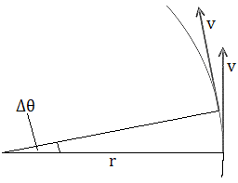

# *Centripetal Acceleration*

The centripetal acceleration of an object can be derived if we look at the situation to the right. An object of speed v makes an angular displacement of ∆*θ* in time ∆*t*.



If we look at the triangle at the far right we can use  when *θ* is small. This becomes: 

We can rearrange this to give: 

Acceleration is given by substitute the above equation into this one

 this is the same as 

We have previously established that, this substituted into the equation above gives



If we use we can derive two more equations for acceleration

  

**Centripetal Acceleration is measured in metres per second squared, m/s2 or m s-2**

# *Centripetal Force*

We can derive three equations for the centripetal force by using and the three equations of acceleration from above.

  

**Centripetal Force is measured in Newtons, N**

***Centripetal force and acceleration questions***

1. A child of mass 25kg sits on a playground roundabout of radius 1.2m. If the child moves with the roundabout at a speed of 2.4ms-1, what centripetal force is needed?
2. A bucket moves in a horizontal circle at the end of a length of string. The tension in the string is 12N, the bucket mass is 2.5kg and it moves at a speed of 0.37ms-1. What is the radius of the circle?
3. A object moves in a circle of radius 0.24m at a speed of 12ms-1 causes a tension force of 63N. What is its mass?
4. If a metal block of mass 0.035kg moves in a circle of radius 0.9m and requires a force of 0.85N, at what speed is it moving ?
5. A car corners at 28ms-1 and the radius of the corner is 380m. What is the acceleration of a passenger in the car?
6. If the passenger in a car has a mass of 60kg and the centripetal acceleration is 3ms-2 , what centripetal force do they experience ?
7. A satellite of mass 285kg moves at a speed of 3076 ms-1 at a distance of 4.23 x 107m from the centre of the earth. What is the size of the force of gravity on the satellite?
8. How long will it take the satellite in the previous question to complete one orbit of earth?
9. A satellite in a low polar orbit circles the earth every 2 hours at a distance of 8.07 x 106m from the centre of the earth. What speed is it moving at?
10. What is the centripetal force acting on the satellite in the previous question if its mass is 350kg?

**Q1.**

The Hubble space telescope was launched in 1990 into a circular orbit near to the Earth.  
It travels around the Earth once every 97 minutes.

(a)     Calculate the angular speed of the Hubble telescope, stating an appropriate unit.

answer = ______________________

**(3)**

(b)     (i)      Calculate the radius of the orbit of the Hubble telescope.

answer = ______________________ m

**(3)**

(ii)     The mass of the Hubble telescope is 1.1 × 104 kg. Calculate the magnitude of the centripetal force that acts on it.

answer = ______________________ N

**(2)**

**(Total 8 marks)**

**Q2.**

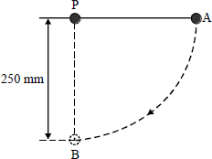

A 150 g mass is attached to one end of a light inextensible string and the other end of the string is fixed at a point P as shown in the diagram above. The mass is held at point A so that the string is taut and horizontal. The mass is released so that it moves freely along a circular arc of 250 mm radius.

When the string moves through the vertical position, the mass is at point B. Neglecting the effect of air resistance, calculate

(a)     the kinetic energy of the mass,

___________________________________________________________________

___________________________________________________________________

___________________________________________________________________

___________________________________________________________________

(b)     the velocity of the mass,

___________________________________________________________________

___________________________________________________________________

(c)     the centripetal force acting on the mass,

___________________________________________________________________

___________________________________________________________________

(d)     the tension in the string.

___________________________________________________________________

___________________________________________________________________

**(Total 6 marks)**

**Q3.**

The figure below shows a dust particle at position **D** on a rotating vinyl disc. A combination of electrostatic and frictional forces act on the dust particle to keep it in the same position.

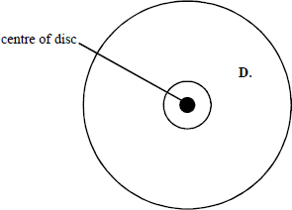

The dust particle is at a distance of 0.125 m from the centre of the disc. The disc rotates at 45 revolutions per minute.

1. Calculate the linear speed of the dust particle at **D**.

**(3)**

(b)     (i)      Mark on the diagram above an arrow to show the direction of the resultant horizontal force on the dust particle.

**(1)**

(ii)     Calculate the centripetal acceleration at position **D**.

**(2)**

(c)     On looking closely at the rotating disc it can be seen that there is more dust concentrated on the inner part of the disc than the outer part. Suggest why this should be so.

___________________________________________________________________

___________________________________________________________________

___________________________________________________________________

___________________________________________________________________

___________________________________________________________________

___________________________________________________________________

**(3)**

# *Oscillations*

Simple Harmonic Motion

In each of the cases below there is something that is oscillating, it vibrates back and forth or up and down.

Each of these systems is demonstrating Simple Harmonic Motion (SHM).

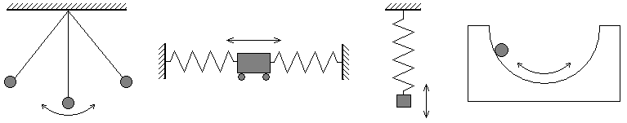

# *SHM Characteristics*

The equilibrium point is where the object comes to rest, in the simple pendulum it at its lowest point.

If we displace the object by a displacement of *x* there will be a force that brings the object back to the equilibrium point. We call this the restoring force and it always acts in the opposite direction to the displacement.

We can represent this as: 

Since  we can also write: 

For an object to be moving with simple harmonic motion, its acceleration must satisfy two conditions:

1. The acceleration is proportional to the displacement
2. The acceleration is in the opposite direction to the displacement (towards the equilibrium point)

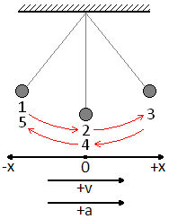

# *Equations*

The following equations are true for all SHM systems but let us use the simple pendulum when thinking about them.

The pendulum bob is displaced in the negative direction when at point 1, it is released and swings through point 2 at its maximum speed until it reaches point 3 where it comes to a complete stop. It then swings to the negative direction, reaches a maximum speed at 4 and completes a full cycle when it stops at 5.

# *Displacement, x*

The displacement of the bob after a time *t* is given by the equation:  **(CALCS IN RAD)**

Since  the equation can become:  🡪 

(where *t* is the time into the cycle and *T* is the time for one complete cycle)

The maximum displacement is called the amplitude, *A*.  🡨 MAXIMUM

# *Velocity, v*

The velocity of the bob at a displacement of *x* is given by the equation: 

The maximum velocity occurs in the middle of the swing (2 and 4) when displacement is zero (x = 0)

 🡪  🡪  🡪  🡨 MAXIMUM

# *Acceleration, a*

The acceleration of the bob at a displacement of *x* is given by the equation: 

As discussed before the acceleration acts in the opposite direction to the displacement.

The maximum acceleration occurs at the ends of the swing (1, 3 and 5) when the displacement is equal to the amplitude (*x = A*).

 🡪  🡨 MAXIMUM  
  
***Simple Harmonic Motion questions***

1. A mass oscillates such that its displacement x in mm is represented by the equation

$$x=40cos(0.6t)$$

Determine the values of the amplitude and frequency of this motion.

1. What is the value of x when t = 5 s?
2. Calculate the maximum velocity of the mass.
3. Calculate the maximum acceleration of the mass.

2. Write an equation relating displacement x and time t for oscillations of amplitude 0.2 m and frequency 0.5 Hz, for a mass whose initial displacement is +0.2 m.

a) Calculate the displacement of the mass when t = 0.3 s.

b) Calculate the maximum velocity of the mass.

c) Calculate the maximum acceleration of the mass.

3. A pendulum swings from side to side. At what point in its oscillation is its speed greatest? At what point is its acceleration greatest?

4. A mass is oscillating vertically on a spring, with a maximum amplitude of 10.0 cm.

a) If it has a frequency of oscillation of 5.0 Hz, find its velocity at 5.0 cm from equilibrium.

b) Calculate the velocity of the same mass on a spring when it is at equilibrium

5. An oscillator undergoes SHM with a frequency of 7.2 Hz. If the maximum amplitude of 1.0 m, find the velocity at half the maximum amplitude.

6. An oscillator undergoes SHM with a frequency of 7.2 Hz. If its velocity is 12 m/s at a displacement of 40 cm, what is the maximum amplitude?

7. An object oscillates with simple harmonic motion and its motion can be described by the equation

$$x=0.16cos(8πt)$$

1. What is the amplitude and period of the oscillations?
2. Calculate the displacement when t = 0.0625 s.
3. Calculate the displacement when t = 0.125 s.

8. A body oscillates with simple harmonic motion at a frequency of 5 Hz and a amplitude of 2.5 cm.

a) Calculate the maximum velocity.

b) Calculate the maximum acceleration.

9. A tuning fork is vibrating at 440 Hz. Each tip or prong of mass 0.0136 kg is vibrating with simple harmonic motion with an amplitude of 0.62 mm. The initial displacement is 0.62 mm.

a) What is meant by simple harmonic motion?

b) Write an equation for the displacement of the tuning fork prong as a function of its frequency.

c) Calculate the maximum velocity of the tip of the prong?

d) Calculate the maximum acceleration of the tip of the prong?

**Q1.**

A pirate ship is a type of amusement park pendulum ride in which a gondola carrying passengers is made to oscillate. The ride can be modelled using a simple pendulum consisting of a mass on a string.

The figure below shows how the displacement x of the mass varies with time *t*.

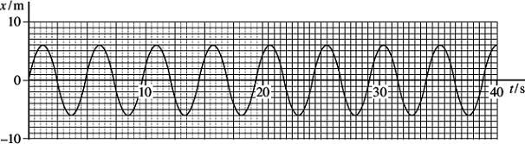

(a)     (i)      Define amplitude.

______________________________________________________________

______________________________________________________________

**(1)**

(ii)     Determine the amplitude of the oscillations of the mass.

amplitude ____________________ m

**(1)**

(iii)    Calculate the period of the pendulum.

period ____________________ s

**(2)**

(b)     Another model was constructed using a pendulum of frequency 0.25 Hz with the mass having an initial amplitude of 4.5 m.

(i)      Calculate the maximum velocity of the mass.

maximum velocity ____________________ ms–1

**(2)**

(ii)     Calculate the maximum acceleration of the mass.

maximum acceleration ____________________ ms–2

**(2)**

**Q2.**

A trolley of mass 0.80 kg rests on a horizontal surface attached to two identical stretched springs, as shown in **Figure 1**. Each spring has a spring constant of 30Nm–1, can be assumed to obey Hooke’s law, and to remain in tension as the trolley moves.

**Figure 1**

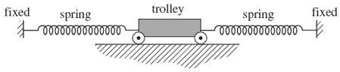

(a)     (i)      The trolley is displaced to the left by 60 mm and then released. Show that the magnitude of the resultant force on it at the moment of release is 3.6 N.

**(2)**

(ii)     Calculate the acceleration of the trolley at the moment of release and state its direction.

answer = ______________________m s–2

direction _______________________________

**(2)**

(b)     (i)      The oscillating trolley performs simple harmonic motion. State the **two** conditions which have to be satisfied to show that a body performs simple harmonic motion.

______________________________________________________________

______________________________________________________________

______________________________________________________________

______________________________________________________________

______________________________________________________________

______________________________________________________________

**(2)**

(ii)     The frequency *f* of oscillation of the trolley is given by



where *m* = mass of the trolley

*k* = spring constant of one spring.

Calculate the period of oscillation of the trolley, stating an appropriate unit.

answer = ______________________

**(3)**

(c)     Copper ions in a crystal lattice vibrate in a similar way to the trolley, because the inter-atomic forces act in a similar way to the forces exerted by the springs. **Figure 2** shows how this model of a vibrating ion can be represented.

**Figure 2**

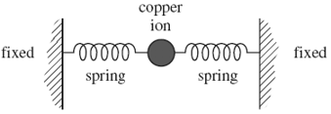

(i)      The spring constant of each inter-atomic ‘spring’ is about 200Nm–1. The mass of the copper ion is 1.0 × 10–25 kg. Show that the frequency of vibration of the copper ion is about 1013 Hz.

**(1)**

(ii)     If the amplitude of vibration of the copper ion is 10–11m, estimate its maximum speed.

answer = ______________________m s–1

**(1)**

(iii)     Estimate the maximum kinetic energy of the copper ion.

answer = ______________________J

**(1)**

**(Total 12 marks)**

**Q3.**

(a)     A body is moving with simple harmonic motion. State **two** conditions that must be satisfied concerning the *acceleration* of the body.

condition 1 __________________________________________________________

___________________________________________________________________

condition 2 __________________________________________________________

___________________________________________________________________

**(2)**

(b)     A mass is suspended from a vertical spring and the system is allowed to come to rest.  
When the mass is now pulled down a distance of 76 mm and released, the time taken for 25 oscillations is 23 s.

Calculate

(i)      the frequency of the oscillations,

______________________________________________________________

______________________________________________________________

(ii)     the maximum acceleration of the mass,

______________________________________________________________

______________________________________________________________

(iii)     the displacement of the mass from its rest position 0.60 s after being released.   
State the direction of this displacement.

______________________________________________________________

______________________________________________________________

______________________________________________________________

______________________________________________________________

**(6)**

# *Pendulum*

SHM graphs

Consider the simple pendulum drawn below. When released from A the bob accelerates and moves to the centre point. When it reached B it has reached a maximum velocity in the positive direction and then begins to slow down. At C it has stopped completely so the velocity is zero, it is at a maximum displacement in the positive and accelerates in the negative direction. At D it is back to the centre point and moves at maximum velocity in the negative direction. By E the velocity has dropped to zero, maximum negative displacement and a massive acceleration as it changes direction.

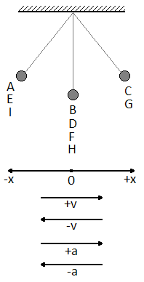This repeats as the pendulum swings through F, G, H and back to I.

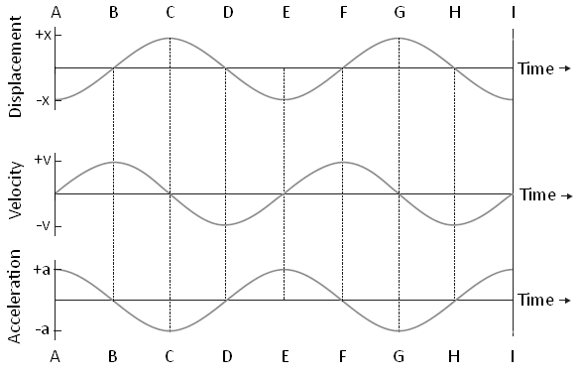Below are the graphs that represent this:

# *Gradients*

Since the gradient of the displacement graph gives us velocity. At C the gradient is zero and we can see that the velocity is zero.

Also since the gradient of the velocity graph gives us acceleration. At C the gradient is a maximum in the negative direction and we can see that the acceleration is a maximum in the negative direction.

# *Energy*

In all simple harmonic motion systems there is a conversion between kinetic energy and potential energy. The total energy of the system remains constant. (This is only true for isolated systems)

For a simple pendulum there is a transformation between kinetic energy and gravitational potential energy.

At its lowest point it has minimum gravitational and maximum kinetic, at its highest point (when displacement is a maximum) it has no kinetic but a maximum gravitational. This is shown in the graph.

For a mass on a spring there is a transformation between kinetic energy, gravitational potential energy and the energy stored in the spring (elastic potential). At the top there is maximum elastic and gravitational but minimum kinetic. In the middle there is maximum kinetic, minimum elastic but it still has some gravitational. At its lowest point it has no kinetic, minimum gravitational but maximum elastic.

*SHM graphs questions*

1. For an oscillating mass, define:
2. The period.
3. 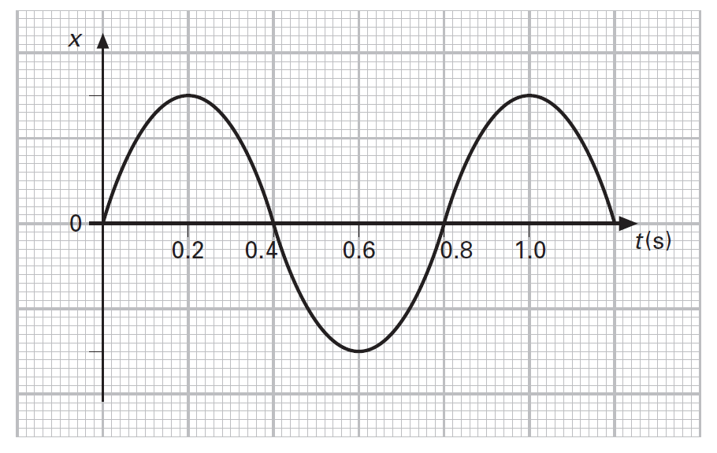The frequency.
4. The graph of displacement against time for an object executing simple harmonic motion is shown to the right.
5. Suggest a time at which the object has maximum speed. Explain your answer.
6. Suggest a time at which the magnitude of the object’s acceleration is a maximum. Explain your answer.
7. An apple is hung vertically from a length of string to form a simple pendulum. The apple is pulled to one side and then released. It executes 12 oscillations in a time of 13.2 s. For this oscillating apple, calculate:
8. Its period.
9. Its frequency.
10. 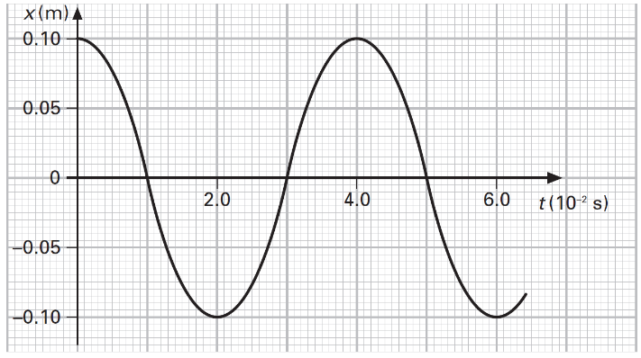The diagram to the left shows the displacement against time graph for an oscillating object. Use the graph to determine the following:
11. The amplitude of the oscillation.
12. The period.
13. The frequency in hertz (Hz).
14. The angular frequency in radians per second (rad/s).
15. Two objects A and B have the same period of oscillation. In each case a and b below, determine the phase difference between the motions of the objects A and B.

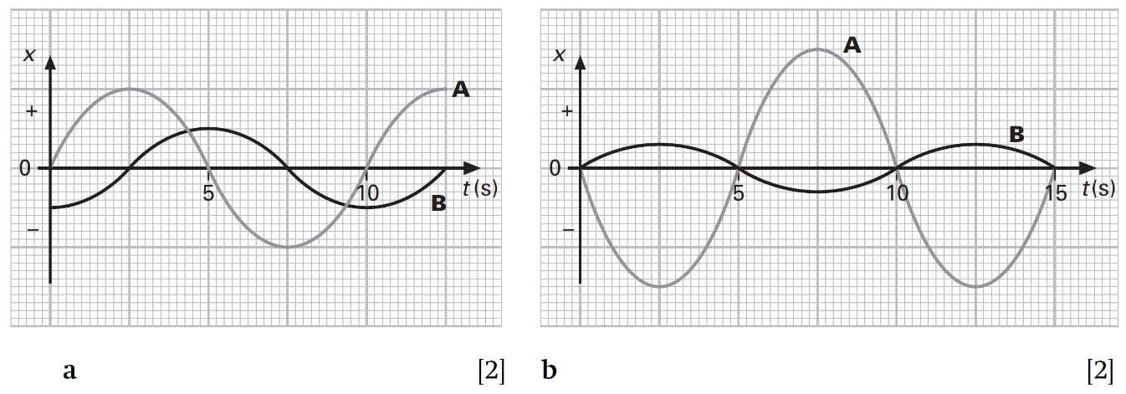

1. A mass at the end of a spring oscillates with a period of 2.8 s. The maximum displacement of the mass from its equilibrium position is 16 cm.
2. What is the amplitude of oscillations?
3. For this oscillating mass, calculate:
4. Its angular frequency. ii) Its maximum acceleration.
5. A small toy boat is floating on the water’s surface. It is gently pushed down and then released. The toy executes simple harmonic motion. Its displacement against time graph is shown here.

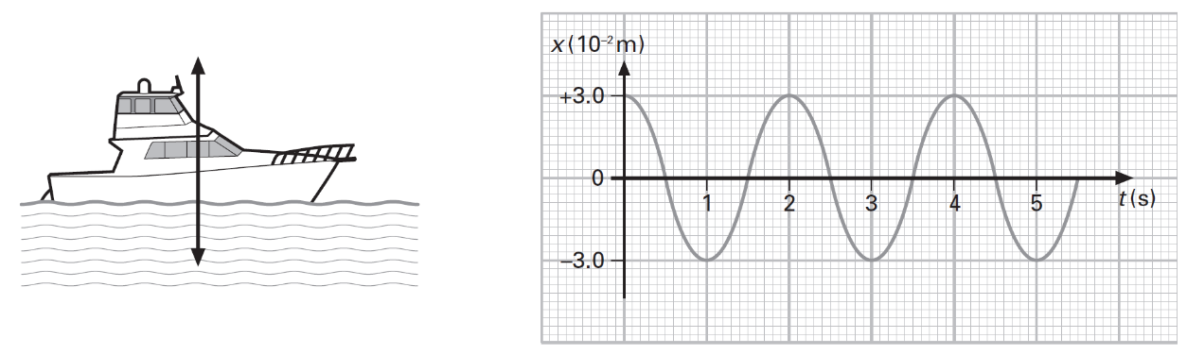

For this oscillating toy boat, calculate:

1. Its angular frequency.
2. Its maximum acceleration.
3. Its displacement after a time of 6.7s, assuming that the effect of damping on the boat is negligible.
4. 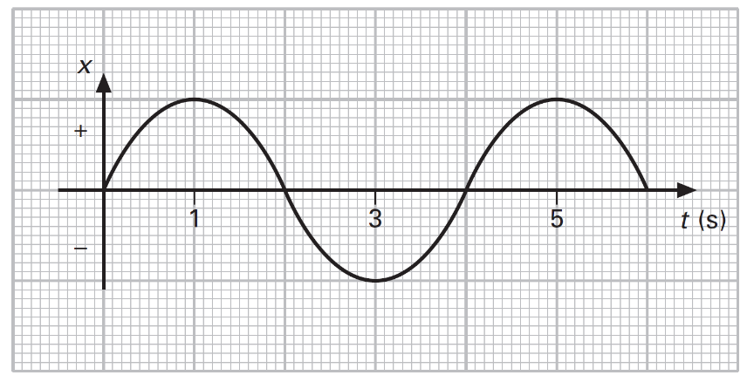The diagram to the right shows the displacement-time graph for a particle executing simple harmonic motion. Sketch the following graphs for the oscillating particle:
5. Velocity-time graph.
6. Acceleration-time graph.
7. Kinetic energy-time graph.
8. Potential energy-time graph.
9. A piston in a car engine executes simple harmonic motion. The acceleration a of the piston is related to its displacement x by:
$$a=-6.4×{10}^{5}x$$

10. Calculate the frequency of the motion.
11. The piston has a mass of 700g and a maximum displacement of 8.0 cm. Calculate the maximum force on the piston.
12. The diagram shows a trolley of mass m attached to a spring of force constant k. When the trolley is displaced to one side and then released, the trolley executes simple harmonic motion.
13. Show that the acceleration a of the trolley is given by:

$$a=-\left(\frac{k}{m}\right)x$$

where x is the displacement of the trolley from its equilibrium position.

1. Use the expression in a to show that the frequency f of the motion is given by:
$$f=\frac{1}{2π}\sqrt{\frac{k}{m}}$$

2. The springs in a cars suspension act in a similar way to the springs on the trolley. For a car of mass 850 kg, the natural frequency of oscillation is 0.40 s. Determine the force constant k of the car’s suspension.
3. a) Define the amplitude of motion of an oscillator.
4. Define simple harmonic motion.
5. Sketch a graph of acceleration a against displacement x for an object executing simple harmonic motion.
6. A metal strip is clamped to the edge of a table and a mass is attached to its free end. The mass is gently pushed down and then released. A graph of the position of the mass measured from the floor against time is shown below.

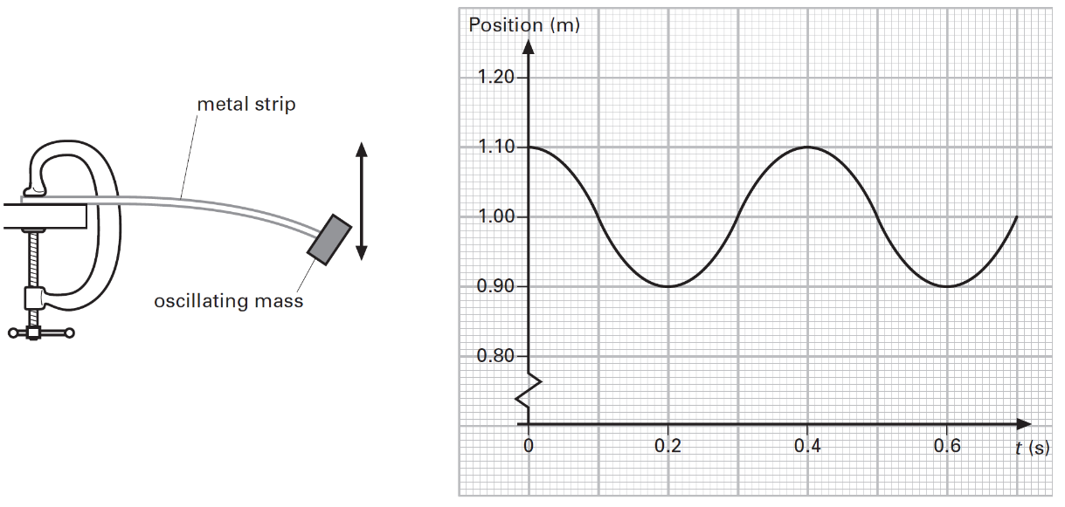

1. On the graph above, mark with a letter X the point at which the oscillating mass has maximum speed.
2. Use the graph of position against time to determine the maximum speed of the mass.
3. For the oscillating mass, determine i) its frequency ii) its angular frequency.
4. The atoms in a solid may be assumed to vibrate with simple harmonic motion.
5. 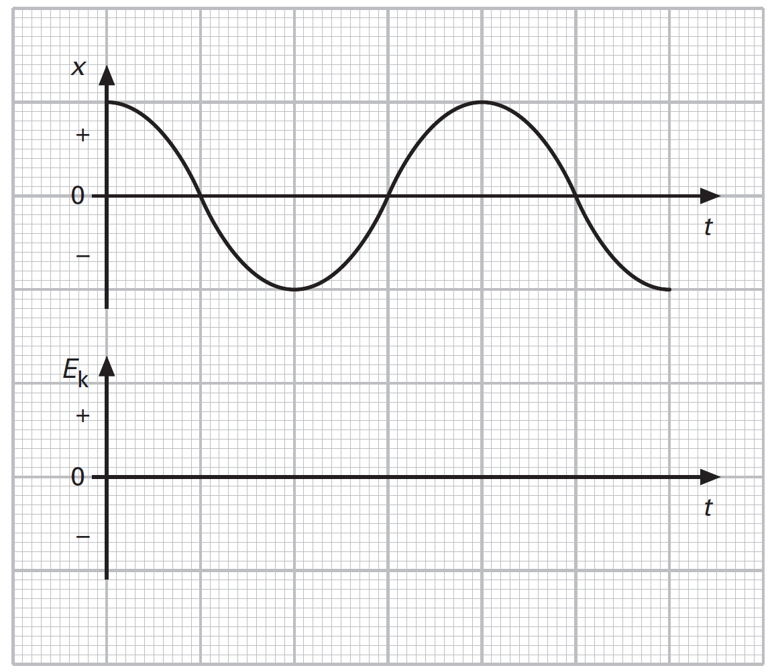For a single atom oscillating at a frequency f, write an equation for the acceleration a in terms of its displacement x from its equilibrium position.
6. For a single oscillating atom, the amplitude of the motion is 1.2×10-11 m and the frequency is 2.0×1014 Hz. Calculate:
7. The maximum acceleration of the atom.
8. The maximum force acting on the atom given that its mass is 1.1×10-25 kg.
9. The displacement-time graph is shown to the right. Show the corresponding variation with time of the kinetic energy E­k of the oscillating atom.

**Q1.**

The diagram below shows how the kinetic energy of a simple pendulum varies with displacement.

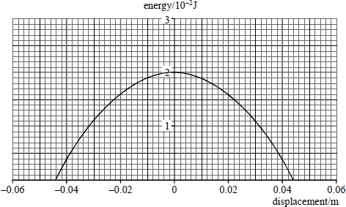

(a)     Sketch on the diagram above a graph to show how the potential energy of the pendulum varies with displacement.

**(2)**

(b)    (i)      State the amplitude of the oscillation.

______________________________________________________________

**(1)**

(ii)     The frequency of vibration of the pendulum is 3.5 Hz. Write down the equation that models the variation of position with time for the simple harmonic motion of **this** pendulum.

______________________________________________________________

**(1)**

(iii)    Calculate the maximum acceleration of the simple pendulum.

**(2)**

**(Total 6 marks)**

**Q2.**

(a)     State the conditions for simple harmonic motion.

___________________________________________________________________

___________________________________________________________________

___________________________________________________________________

___________________________________________________________________

**(2)**

(b)     A rigid flat plate is made to vibrate vertically with simple harmonic motion. The frequency of the vibration is controlled by a signal generator as shown in **Figure 1**.

**Figure 1**

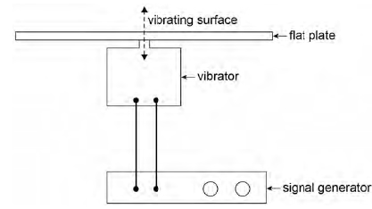

The velocity−time (*v*−*t*) graph for the vibrating plate at one frequency is shown in **Figure 2**.

**Figure 2**

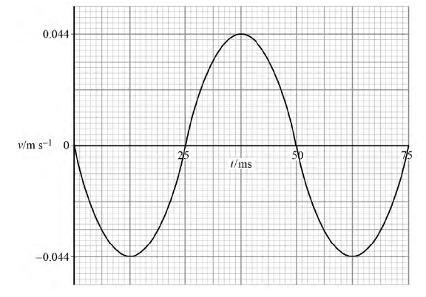

Show that the maximum displacement of the plate is 3.5 × 10−4 m.

**(2)**

(c)     Draw on **Figure 3** the displacement−time (*s−t*) graph between 0 and 75 ms.

**Figure 3**

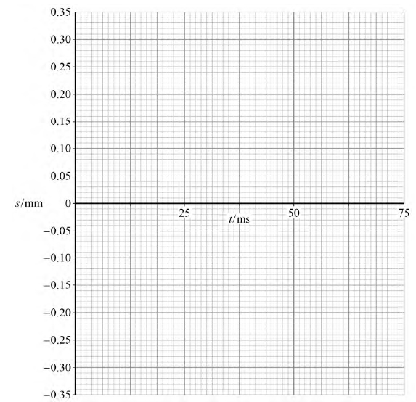

**(1)**

(d)     State **one** time at which the plate has maximum potential energy.

time = _____________________ s

**(1)**

(e)     A small quantity of fine sand is placed onto the surface of the plate. Initially the sand grains stay in contact with the plate as it vibrates. The amplitude of the vibrating surface remains constant at 3.5 × 10−4 m over the full frequency range of the signal generator. Above a particular frequency the sand grains lose contact with the surface.

Explain how and why this happens.

___________________________________________________________________

___________________________________________________________________

___________________________________________________________________

___________________________________________________________________

___________________________________________________________________

___________________________________________________________________

___________________________________________________________________

___________________________________________________________________

**(3)**

(f)     Calculate the lowest frequency at which the sand grains lose contact with the surface of the plate.

frequency = _____________________ Hz

**(2)**

**(Total 11 marks)**

# *The Simple Pendulum*

SHM time periods

In the diagram we can see that the restoring force of the pendulum is: 

When *θ* is less than 10° (in radians) so the equation can become: 

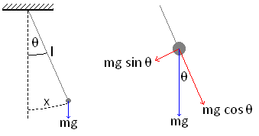Since both and (for SHM) the equation now becomes: 

This simplifies to: 

Rearranging for *f* gives us 

And since  then: 

**Time is measured in seconds, s**

# *Mass on a Spring*

When a spring with spring constant *k* and length *l* has a mass *m* attached to the bottom it extends by an extension *e*, this is called the static extension and is the new equilibrium point. The tension in the spring is balanced by the weight. We can represent this as: 

If the mass is pulled down by a displacement *x* and released it will undergo SHM.

The net upwards force will be: 

This can be multiplied out to become: 

Since  this can become: 

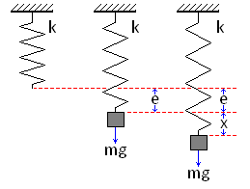It simplify to: 

Since both and (for SHM) the equation now becomes: 

This simplifies to: 

Rearranging for *f* gives us: 

And since  the equation becomes: 

**Time is measured in seconds, s**

# *Finding g*

We can find the value of the gravitational field strength, *g*, on Earth by carrying out the following experiment.

Set up a simple pendulum of length *l* and measure the time for one oscillation.

If we measure the time taken for 20 oscillations and divide it by 20 we reduce the percentage human error of the reading and make our experiment more accurate.

If we look at the equation  and rearrange it to become: , by plotting a graph of *T*2 against *l* we can find the value of *g* from the gradient which will be = .

**SHM and time period**

1. A simple pendulum of length 0.60m oscillates backwards and forwards, what is its time period?
2. A simple pendulum of length 25cm swings backwards and forwards, what is its time period?
3. A simple pendulum oscillates with a time period of 3 seconds, what is its length?
4. A simple pendulum of length 0.40m shows simple harmonic motion. What is the frequency of the oscillation?
5. What is the length of a simple pendulum of time period 1.25s?
6. What is the time period of an oscillating spring with a mass of 0.2kg. The spring constant is 30 Nm-1.

1. What is the frequency of an oscillating spring (k=30Nm-1) carrying a mass of 0.5kg.
2. A spring with a mass of 400g oscillates with a time period of 3 seconds, what is the value of the spring constant of the spring?
3. An oscillating spring with a spring constant of 15Nm-1 has a time period of 1.75 seconds, what is the mass on the spring?
4. What is the spring constant of a spring carrying a mass of 750g oscillating with a time period of 1.75 seconds?

**Q1.**

(a)    A simple pendulum is given a small displacement from its equilibrium position and performs *simple harmonic motion*.

State what is meant by simple harmonic motion.

___________________________________________________________________

___________________________________________________________________

___________________________________________________________________

___________________________________________________________________

**(2)**

(b)    (i)       Calculate the frequency of the oscillations of a simple pendulum of length 984 mm. Give your answer to an appropriate number of significant figures.

frequency ____________________ Hz

**(3)**

(ii)     Calculate the acceleration of the bob of the simple pendulum when the displacement from the equilibrium position is 42 mm.

acceleration ____________________ ms–2

**(2)**

(c)     A simple pendulum of time period 1.90 s is set up alongside another pendulum of time period 2.00 s. The pendulums are displaced in the same direction and released at the same time.

Calculate the time interval until they next move in phase. Explain how you arrive at your answer.

___________________________________________________________________

___________________________________________________________________

___________________________________________________________________

___________________________________________________________________

time interval ____________________ s

**(3)**

**(Total 10 marks)**

**Q2.**

**Figure 1** shows a mass suspended on a spring.

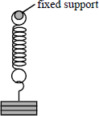

**Figure 1**

The mass is pulled down by a distance *A* below the equilibrium position and then released at time *t* = 0. It undergoes simple harmonic motion.

(a)     Taking upward displacements as being positive, draw graphs on **Figure 2** to show the variation of displacement, velocity and the acceleration with time. Use the same time scale for each of the three graphs.

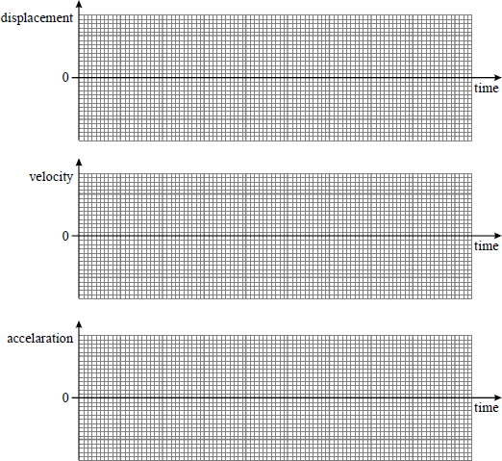

**Figure 2**

**(4)**

(b)     The spring stiffness, *k*, is 32 N m–1. The spring is loaded with a mass of 0.45 kg.  
Calculate the frequency of the oscillation.

**(3)**

**(Total 7 marks)**

**Q3.**

**Figure 1** shows a spring loaded with a mass of 0.15 kg. When the mass is displaced vertically it oscillates up and down. **A** and **C** show the extreme positions of the mass and **B** is its equilibrium position.

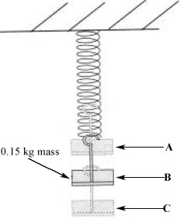

**Figure 1**

(a)     The 0.15 kg mass extends the spring by 0.040 m. Calculate the elastic potential energy stored in the spring when it is extended by this amount.

gravitational field strength, *g* = 9.8 N kg–1

Elastic potential energy = ____________________

**(2)**

(b)     (i)      Mark and label on the diagram the amplitude of the motion.

**(1)**

(ii)     Describe the energy changes that occur during one cycle when the mass is pulled down to position **C** and then released. You should consider the motion to be undamped during this cycle.

______________________________________________________________

______________________________________________________________

______________________________________________________________

______________________________________________________________

______________________________________________________________

**(2)**

**(Total 5 marks)**

# *Free Vibration*

Resonance and damping

Free vibration is where a system is given an initial displacement and then allowed to vibrate/oscillate freely. The system will oscillate at a set frequency called the natural frequency, *f*0. We have seen from the last lesson that the time period for a pendulum only depends on the length and gravitational field strength whilst the time period of a mass and spring only depends on the mass and the spring constant. These factors govern the natural frequency of a system.

# *Forced Vibration*

Forced vibration is where a driving force is continuously applied to make the system vibrate/oscillate. The thing that provides the driving force will be moving at a certain frequency. We call this the driving frequency.

# *Resonance*

If I hold one end of a slinky and let the other oscillate freely we have a free vibration system. If I move my hand up and down I force the slinky to vibrate. The frequency of my hand is the driving frequency.

When the driving frequency is lower than the natural frequency the oscillations have a low amplitude

When the driving frequency is the same as the natural frequency the amplitude increases massively, maybe even exponentially.

When the driving frequency is higher than the natural frequency the amplitude of the oscillations decreases again.

# *Phase Difference between driver and driven*

When the driving force begins to oscillate the driven object the phase difference is 0.

When resonance is achieved the phase difference between them is π.

When the driving frequency increases beyond the natural frequency the phase difference increases to π/2.

# *Damping*

Damping forces oppose the motion of the oscillating body, they slow or stop simple harmonic motion from occurring. *Damping forces act in the opposite direction to the velocity*.

Galileo made an important observation while watching lamps swing in Pisa cathedral. He noticed that the swinging gradually died away but the time taken for each swing stayed roughly the same. The swing of the lamp was being damped by air resistance.

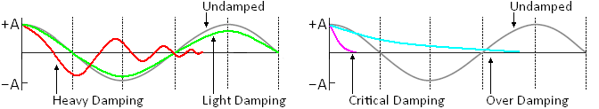

***Light damping*** slowly reduces the amplitude of the oscillations, but keeps the time period almost constant.

***Heavy damping*** allows the body to oscillate but brings it quickly to rest.

***Critical damping*** brings the body back to the equilibrium point very quickly with out oscillation.

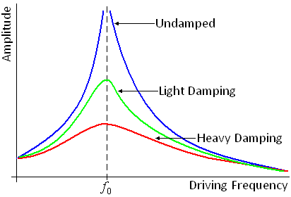***Over damping*** also prevent oscillation but makes the body take a longer time to reach equilibrium.

# *Damping and Resonance*

Damping reduces the size of the oscillations at resonance. There is still a maximum amplitude reached but it is much lower than when the system is undamped. We say that damping reduces the sharpness of resonance. This becomes clearer if we look at the graph on the right.

It shows the amplitude of oscillation against frequency for different levels of damping.

***Resonance and damping questions***

1. Define what is meant by a natural frequency.
2. What is the difference between a free vibration and a forced vibration?
3. When a system is oscillating at its maximum amplitude, what is the phase difference between the displacement and the periodic force causing resonance?
4. What is meant by critical damping?
5. What is resonance and when does it occur?
6. Give two examples of resonance in a physics context.
7. What is meant by a damping force?
8. Give an example of where critical damping is used.
9. A dimple mass-spring system undergoes simple harmonic motion. A large circular sheet of negligible mass is then placed on the mass and lies horizontally. Describe the nature of the oscillations.
10. What is meant by the term “overdamping” and give an example.
11. a) State what is meant by light damping, heavy damping and critical damping.

A person of mass 65 kg is undertaking a bungee jump from a bridge. They are attached to an elastic nylon rope of length 10m and spring constant 200 N/m; the other end is attached to a bridge and the initial amplitude of oscillation is 8.6 m

1. Assuming the motion can be described as simple harmonic, calculate the period and frequency of the oscillations.
2. Determine the maximum velocity and maximum acceleration during one of these initial oscillations.
3. The oscillations encountered by a bungee jumper do not continue in this way and eventually the jumper comes to rest in the equilibrium position. Determine the distance of the jumper below the bridge in this position.
4. Explain the processes that occur from the initial jump to when the jumper finally stops oscillating.
5. Infrared radiation is strongly absorbed by carbon monoxide molecules. As a result of this absorption, the oscillations of the carbon atoms or oxygen atoms increase significantly, depending on their orientation as they sit on a platinum surface.
6. What is the name given to this phenomenon?
7. What condition must be fulfilled for it to occur?
8. The range of wavelengths of infrared radiation extends from 2.0 μm to 20 μm but the above phenomenon only occurs at 2.7 μm. Determine the frequency of this particular value of infrared radiation.
9. If the mass of a carbon atom is 2.0 × 10-26 kg, determine the stiffness of the carbon monoxide bond, assuming that it can be modelled by a spring.

**Q1.**

(a)     State what is meant by

(i)      a free vibration,

______________________________________________________________

______________________________________________________________

(ii)     a forced vibration.

______________________________________________________________

______________________________________________________________

**(2)**

(b)     A car and its suspension can be treated as a simple mass-spring system. When four people of total weight 3000 N get into a car of weight 6000 N, the springs of the car are compressed by an extra 50 mm.

(i)      Calculate the spring constant, *k*, of the system.

______________________________________________________________

______________________________________________________________

(ii)     Show that, when the system is displaced vertically and released, the time period of the oscillations is 0.78 s.

______________________________________________________________

______________________________________________________________

______________________________________________________________

**(3)**

(c)     The loaded car in part (b) travels at 20 m s–1 along a road with humps spaced 16 m apart.

(i)      Calculate the time of travel between the humps.

______________________________________________________________

______________________________________________________________

(ii)     Hence, state and explain the effect the road will have on the oscillation of the car.

______________________________________________________________

______________________________________________________________

______________________________________________________________

**(3)**

**(Total 8 marks)**

**Q2.**

**Figure 1** shows three stages during the oscillations of a loaded spring. The positions shown are when the mass attached to the spring is at the top, equilibrium (middle) position and bottom of its motion.

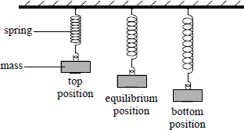

**Figure 1**

(a)    (i)      Describe what is meant by the *period* of this oscillation.

______________________________________________________________

______________________________________________________________

**(1)**

(ii)     Mark and label the *amplitude* of the oscillation on **Figure 1**.

**(1)**

(b)    Explain how you would determine an accurate value for the period of the oscillation.

___________________________________________________________________

___________________________________________________________________

___________________________________________________________________

___________________________________________________________________

___________________________________________________________________

**(2)**

(c)    The mass is displaced from its equilibrium position in the air and then released. The graph in **Figure 2** shows the displacement-time graph from the moment of release. The mass-spring system is then submerged in water and set oscillating with the same initial displacement.

Sketch **on the same set of axes** the displacement-time graph for the motion in the water.

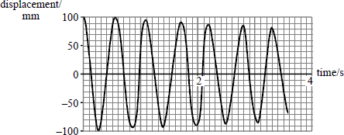

**Figure 2**

**(2)**

**(Total 6 marks)**

**Q3.**

To celebrate the Millennium in the year 2000, a footbridge was constructed across the River Thames in London. After the bridge was opened to the public it was discovered that the structure could easily be set into oscillation when large numbers of pedestrians were walking across it.

(a)     What name is given to this kind of physical phenomenon, when caused by a periodic driving force?

___________________________________________________________________

**(1)**

(b)     Under what condition would this phenomenon become particularly hazardous? Explain your answer.

___________________________________________________________________

___________________________________________________________________

___________________________________________________________________

___________________________________________________________________

___________________________________________________________________

___________________________________________________________________

**(4)**

(c)     Suggest **two** measures which engineers might adopt in order to reduce the size of the oscillations of a bridge

measure 1 __________________________________________________________

___________________________________________________________________

measure 2 __________________________________________________________

___________________________________________________________________

**(2)**

**(Total 7 marks)**

*Acknowledgements:*

The notes in this booklet come from TES user dwyernathaniel. The original notes can be found here:

<https://www.tes.com/teaching-resource/a-level-physics-notes-6337841>

Questions in the circular motion section are from the IoP TAP project. The original resources can be found here:

<https://spark.iop.org/collections/circular-motion>

Questions in multiple sections (including on centripetal force and acceleration and SHM time periods) come from Bernard Rand’s resources (@BernardRand). His original resources can be found here:

<https://drive.google.com/drive/folders/1-2qNVLwGzJ_7AjQK9N0z4BQBIRmSHAwG>