Prac8
Physics Practical

Y13 Core Practical
Boyle’s and Charles’s Law

 | Skills Assessed |  | Met?
 | - Follows written procedures | a. Correctly follows instructions to carry out experimental techniques or procedures.
 | 2. Applies investigative approaches and methods when using instruments and equipment | a. Correctly uses appropriate instrumentation, apparatus and materials (including ICT) to carry out investigative activities, experimental techniques and procedures with minimal assistance or prompting.
 |  | b. Carries out techniques or procedures methodically, in sequence and in combination, identifying practical issues and making adjustments when necessary.
 | 3. Safely uses a range of practical equipment and materials | a. Identifies hazards and assesses risks associated with these hazards, making safety adjustments as necessary, when carrying out experimental techniques and procedures in the lab or field.
 |  | b. Uses appropriate safety equipment and approaches to minimise risks with minimal prompting.
 | 4. Makes and records observations | a. Makes accurate observations relevant to the experimental or investigative procedure.
 |  | b. Obtains accurate, precise and sufficient data for experimental and investigative procedures and records this methodically using appropriate units and conventions.

Introduction

Investigation of Boyle’s (constant temperature) law and Charles’s (constant pressure) law for a gas.
Boyle’s Law
Equipment  - stand and clamp  - 10 ml syringe with 0.5 ml divisions  - 5 cm length of thin-walled rubber or silicone tubing to fit nozzle of syringe  - pinch clip  - 2 kg mass  - loop of string  - 9 × 100 g masses on a 100 g mass holder  - micrometer. | Diagram  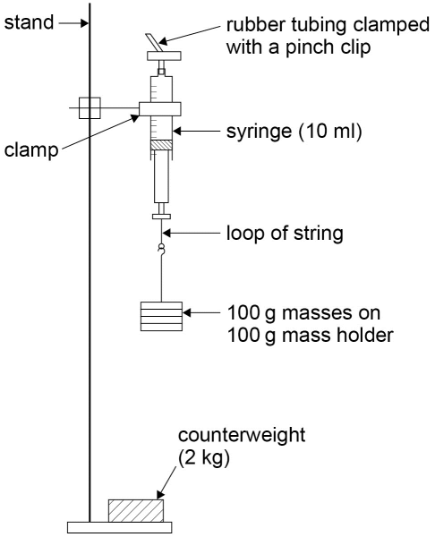
Relevant equations:

$$F=ma$$

$$P=F/A$$
Method

- Remove the plunger from the syringe and measure the diameter of the rubber seal, d, using the micrometer. Convert this into metres and calculate the cross-sectional area of the seal A = πd²/4 in m².
- Replace the plunger and draw in 4.0 ml of air.
- Fit the rubber tubing over the nozzle, fold the tubing over and clamp it with the pinch clip as close to the nozzle as possible.
- Set up the apparatus as shown in the diagram initially with the 100 g mass holder carrying one 100 g mass. Ensure that the string is securely attached to the plunger handle. The clamp should be above the plunger so that the scale can be read. Gently move the plunger up and down a few millimetres to ensure it is not sticking.
- Read the new volume on the syringe scale (fractions of a division should be estimated).
- Repeat the procedure with an extra two 100 g masses added each time, up to a total mass of 1000 g.
- The whole experiment should then be repeated to obtain a second set of results, and the mean volumes found.
- Calculate the force exerted by the masses using $\text{F = mg}$ and then the pressure exerted by this force on the air using F/A in Pascals (Pa). Convert this into kPa.
- This should be subtracted from standard atmospheric pressure, 101 kPa, to obtain the pressure of the air sample, P. (The initial volume of the air with no masses will be at standard atmospheric pressure).
- Plot an appropriate straight line graph.

Charles’s Law
Equipment  - A 25ml length of capillary tubing with a small drop of concentrated sulfuric acid about half way down its length, with the lower end sealed using contact adhesive  - 30 cm ruler  - 2 elastic bands  - thermometer (eg –10 to 110 °C)  - 2 litre beaker  - 250 ml glass beaker  - paper towels  - kettle | Diagrams  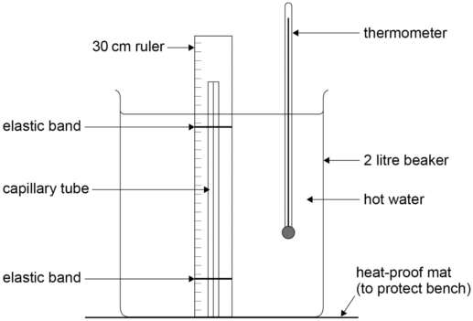  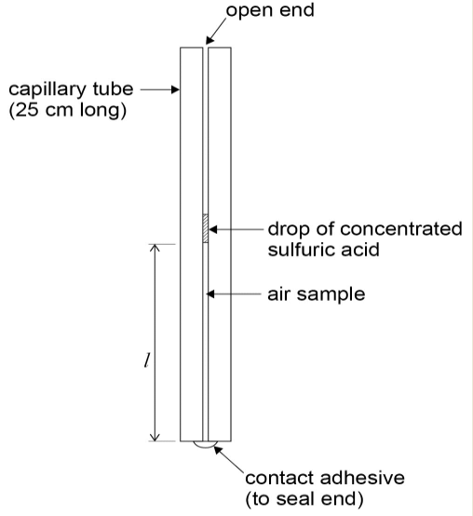
Relevant equations;

l = mθ + c

Method

- Set up the apparatus as shown in the diagram above with the open end of the capillary tube at the top. Allow the boiled water from the kettle to cool a little before pouring it into the beaker. The hot water should cover the air sample.
- Stir the water well using the thermometer, read the value of its temperature, θ, and the length of the air sample, l, on the 30 cm ruler (again see diagram above).
- Allow the water to cool by 5 °C and repeat the procedure until room temperature has been reached. (The cooling process can be speeded up by pouring a little water out of the beaker and topping it up with cold water.)
- Plot a graph of l against θ. Start the axes at a convenient value, and use a scale which will give a spread of points over at least half the graph paper in both directions.
- Draw the best straight line of fit though the points and find the gradient, m.
- The form of the graph is l = mθ + c, where c is the value of l when θ = 0 °C.
- The value of c can be found by reading a pair of values for length and temperature for a point on the straight line (l₁ and θ₁, say). Then c = l₁ - mθ₁.
- An estimate of the value of absolute zero, θ₀, can then be found by substituting l = 0 into the equation for the form of the graph: 0 = mθ₀ + c so θ₀ = -c/m.

