

physics

Nuclear

Name ______________________________

Teacher ______________________________

Rutherford scattering

# *Rutherford’s Scattering Experiment*

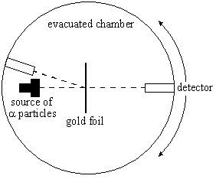Hans Geiger and Ernest Marsden worked with Ernest Rutherford in his Manchester laboratories in 1909. They fired alpha particles (which they knew to have a positive charge) of a few MeV into a thin piece of gold foil. This was done in an evacuated chamber connected to a vacuum pump.

When the alpha particles passed through the gold foil they hit a zinc sulphide screen which emits light whenever an alpha particle strikes it. This screen was observed using a moving microscope in a dark room.

At the time the accepted structure of the atom was like a plum pudding: positive dough spread evenly with negative electrons scattered through out it like plums in a pudding.

# *Results*

Geiger and Marsden found that almost all of the alpha particles passed through with little or no deflection. Rutherford suggested moving the microscope in front of the foil, when they did they found that about 1 in every 8000 was ‘reflected’ back or scattered through an angle of more that 90°.

If the plum pudding model was the structure of the atom this would be like firing a bullet at a piece of toilet paper and it bouncing back!

# *The Nuclear Model*

Rutherford used these results to make the following conclusions:

Most of the mass must be gathered in one small volume – the nucleus.

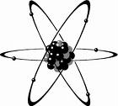

*They can repel a fast moving alpha particle*

The nucleus must be positively charged.



*They repel positive alpha particles*

Most of the atom is empty space.



*Only 1 in 8000 alpha particles are deflected*

Negative electrons orbit the nucleus at a large distance from it.



*Negative charges are needed to keep the atom neutral*

# *Which Particle to Use?*

There are two things to consider when using scattering to find the structure of things: the particle and the energy

***Alpha Scattering***: Rutherford used alpha particles with energies around 4MeV, any higher and it would be close enough to the nucleus to experience the strong nuclear force.

***Electron Scattering***: Electrons are accelerated to high energies of around 6GeV. They have enough energy to be scattered within protons and neutrons; discovering quarks. Electrons travelling at this speed have a de Broglie wavelength 1000 times smaller than visible light meaning we can see more detail.

***X-ray Scattering***: X-ray photons have short wavelengths and can be scattered or completely absorbed by atomic electrons. If the electron is tightly bound or the photon has very little energy the electron remains in the atom and the photon loses no energy. This is known as elastic or coherent scattering. If the photon has enough energy it knocks the electron out of orbit (ionisation) and does lose energy.

***Neutron Scattering***: Very useful because they are not charged but this limits the energies they can be accelerated to. Neutrons interact weakly with other nuclei and do not interact with electrons at all, because of this they can penetrate further. Their wavelengths are similar to that of atomic spacing, meaning that diffraction will occur.

1. State what may be concluded about the structure of the atom from the following observations made in the Rutherford α-scattering experiment:
2. Most of the α-particles went straight through the gold foil with much scatter.
3. 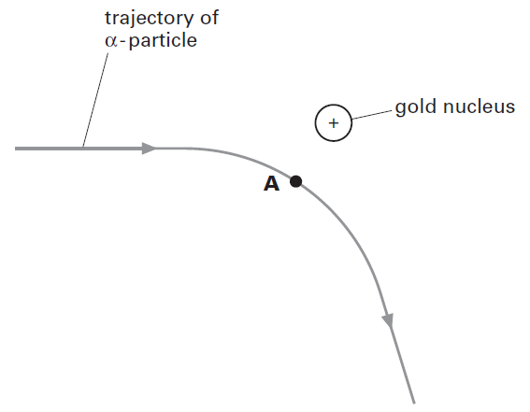A very small percentage of the positively charged α-particles were scattered through larger angles by the gold foil.
4. The diagram shows the trajectory of an α-particle as it travels past the nucleus of a gold atom.
5. Copy the diagram, adding arrows to show the directions and magnitudes of the forces experienced by the gold nucleus and the α-particle when the α-particle is at point A.
6. State a value for the typical size (diameter) of the nucleus.
7. Name three techniques for investigating the crystalline structure of matter.
8. High speed electrons are diffracted by atomic nuclei.
9. Suggest what electron diffraction demonstrates about the nature of high-speed electrons.
10. Suggest a typical wavelength for the high-speed electrons used to investigate the size of atomic nuclei.
11. Th e spacing between atoms in a solid is typically 2.0 × 10-10 m. For diffraction of either X-rays or particles by the solid, the incident wavelength must be comparable to or less than this spacing. For a wavelength of 2.0 × 10-10 m, calculate:
12. The frequency of the X-rays.
13. The speed of electrons.
14. The speed of neutrons.
15. 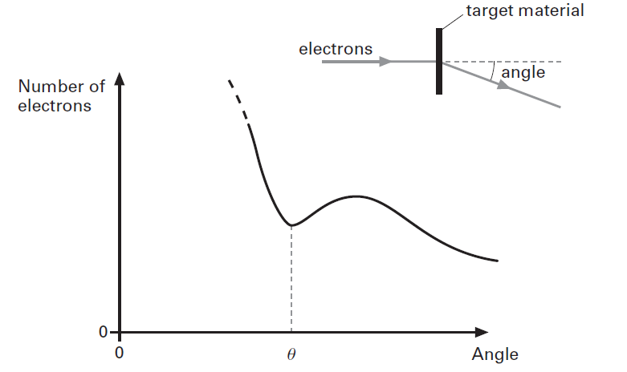The diagram shows the typical diffraction pattern formed when high-speed electrons are diffracted by the nuclei of a target material. The angle θ for the “first diffraction minimum” is related to the diameter d of a single nucleus and the de Broglie wavelength λ of a high-speed electron by the equation:

$$\text{sin}θ=\frac{1.22λ}{d}$$

The wavelength λ of a high speed electron is related to its kinetic energy E, the Planck constant h and the speed of light in vacuum c by the equation: $λ=\frac{hc}{E}$

1. The angle θ is 52° for 420 MeV electrons fired into carbon. Determine the diameter of a nucleus of carbon (1 eV = 1.6 × 10-19 J).
2. The mass of a single nucleus of carbon is 2.0 × 10-26 kg. Determine the mean density of the carbon nucleus.
3. 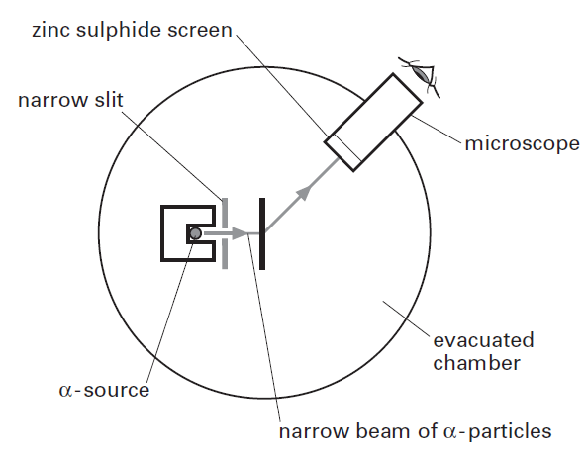The density of matter is about 103 kg/m3. What does your value for the density of the nucleus suggest about the structure of atoms?
4. The diagram shows the apparatus used by Rutherford in his α-scattering experiment. Explain why:
5. The gold foil and the α-source were placed in a vacuum.
6. The gold foil had to be very thin.
7. List three key conclusions about the nature of the atom that can be drawn from the α-scattering experiment.
8. 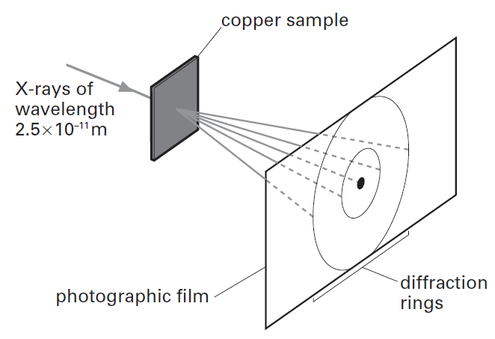The diagram shows the diffraction “rings” produced when X-rays of wavelength 2.5 × 10-11 m are diffracted by a thin sample of copper.
9. What causes the diffraction of the X-rays?
10. State the approximate size (diameter) of an atom in metres.
11. A similar diffraction pattern is obtained when electrons are fired into the copper sample. Estimate the speed of an electron with a de Broglie wavelength the same as that for the X-rays.
12. Explain why the diffraction pattern formed by the electrons of wavelength 2.5 × 10-11 m cannot be due to the atomic nuclei of copper.

**Q1.**

The figure below represents an experiment on Rutherford scattering in which *α* particles are directed at a gold foil. The detector is shown in two positions in the evacuated chamber.

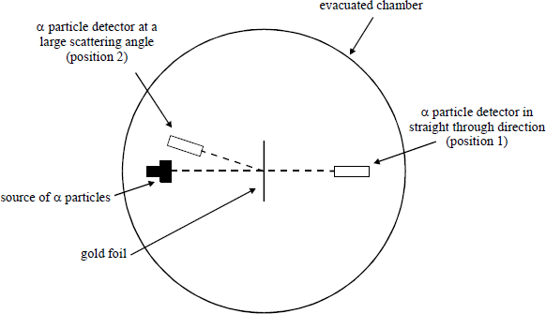

(a)     Why is it necessary to remove the air from the apparatus?

___________________________________________________________________

___________________________________________________________________

(b)     Explain why the gold foil should be very thin.

___________________________________________________________________

___________________________________________________________________

(c)     Explain why the count rate from the *α* particle detector in position 1 is much greater than that in position 2.  
What can be deduced from this observation about the structure of the atom and the properties of the nucleus of gold?

___________________________________________________________________

___________________________________________________________________

___________________________________________________________________

___________________________________________________________________

___________________________________________________________________

**(Total 6 marks)**

**Q2.**

In an experiment to investigate the structure of the atom, α particles are directed normally at a thin metal foil which causes them to be scattered.

(a)     (i)      In which direction will the number of α particles per second be a maximum?

______________________________________________________________

(ii)     State what this result suggests about the structure of the atoms in the metal.

______________________________________________________________

______________________________________________________________

**(2)**

(b)     A small number of α particles are scattered through 180°.

Explain what this suggests about the structure of the atoms in the metal.

___________________________________________________________________

___________________________________________________________________

___________________________________________________________________

**(2)**

(c)     The figure shows the path of an α particle passing near a nucleus.

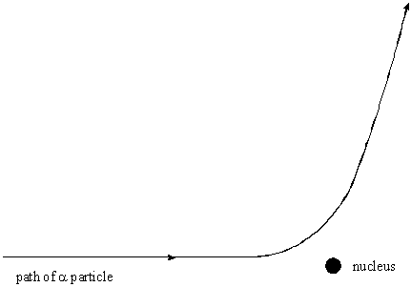

(i)      Name the force that is responsible for the deflection of the α particle.

______________________________________________________________

(ii)     Draw an arrow on the diagram in the direction of the force on the α particle in the position where the force is a maximum.

(iii)     The nucleus is replaced with one which has a larger mass number and a smaller proton number.

Draw on the diagram the path of an α particle that starts with the same velocity and position as that of the α particle drawn.

**Q3.**

(a)     The radius of a nucleus may be determined by electron diffraction. In an electron diffraction experiment a beam of electrons is fired at oxygen-16 nuclei. Each electron has an energy of 5.94 × 10−11 J.

The approximation, momentum =  can be used for electrons at this energy.

(i)      Show that the de Broglie wavelength *λ* of each electron in the beam is about 3.3 × 10−15 m.

**(2)**

(ii)     The graph shows how the relative intensity of the scattered electrons varies with angle due to diffraction by the oxygen-16 nuclei. The angle is measured from the original direction of the beam.

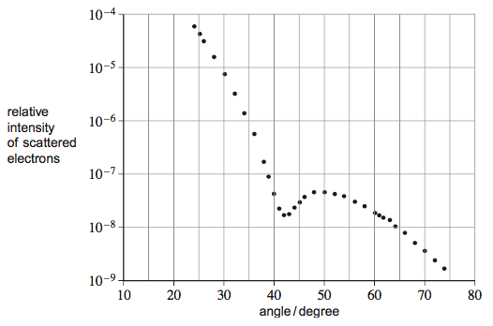

The angle *θ* of the first minimum in the electron-diffraction pattern is given by



Calculate the radius of an oxygen-16 nucleus using information from the graph.

radius = ____________________ m

**(1)**

(b)     Rutherford used the scattering of α particles to provide evidence for the structure of the atom.

(i)      Sketch a labelled diagram showing the experimental arrangement of the apparatus used by Rutherford.

**(2)**

(ii)     State and explain the results of the scattering experiment.

Your answer should include the following:

•        the main observations

•        the significance of each observation

•        how the observtions placed an upper limit on the nuclear radius.

The quality of your written communication will be assessed in your answer.

______________________________________________________________

______________________________________________________________

______________________________________________________________

______________________________________________________________

______________________________________________________________

______________________________________________________________

______________________________________________________________

______________________________________________________________

______________________________________________________________

______________________________________________________________

______________________________________________________________

______________________________________________________________

**(6)**

**(Total 11 marks)**

Ionising radiation

# *Ionisation*

The process of ionisation involves the removal of one or more electron from an atom. When radiation enters a GM tube it may ionise the atoms inside, the electrons are attracted to a positive wire and a small current flows. There are three types of radiation, each with its own properties, uses and dangers.

# *Alpha:* *A Helium nucleus – two protons and two neutrons*

**Relative mass:** 4 **Relative charge:** +2 **Deflection by E/M field:** Yes

**Ionising power:** High **Penetrating power:** Low **Range in air:** 5cm **Stopped by:** Skin, paper

**Uses:** Smoke detectors, radiotherapy to treat cancer

**Danger out of body:** Low **Danger in body:** Cell death, mutation and cancer

# *Beta:* *A fast moving electron*

**Relative mass:** 1/2000 **Relative charge:** -1 **Deflection by E/M field:** Yes

**Ionising power:** Medium **Penetrating power:** Medium **Range in air:** 2-3m **Stopped by:** Aluminium

**Uses:** Thickness control in paper production

**Danger out of body:** Damage to skin **Danger in body:** Similar to alpha but less damage

# *Gamma:* *A high frequency electromagnetic wave*

**Relative mass:** 0 **Relative charge:** 0 **Deflection by E/M field:** No

**Ionising power:** Low **Penetrating power:** High **Range in air:** 15m **Slowed by:** Lead, concrete

**Uses:** Tracers: medical and industrial, sterilising surgical equipment

**Danger out of body:** Cell death, mutation and cancer **Danger in body:** Low

# *The Inverse-Square Law*

Gamma radiation from a source will spread out. The radiation from a small source can be considered the same in all directions (isotropic), imagine a sphere around the source. As we move further away from the source the bigger the sphere gets. The same amount of energy is shared over a greater surface area. The further we move from the source the less intensity of the gamma radiation.

**Intensity is measured in Watts, W**

The intensity, *I*, of the radiation at a distance *x* from the source is given as

Where *I*0 is the intensity at the source and *k* is a constant.

We do not always need to know the intensity at the source to find it at a given distance.

Consider two points, A and B, a certain distance away from a gamma source.

 🡪  and  🡪 

We can combine these to give  🡪 

# *Background Radiation*

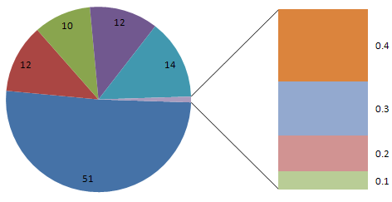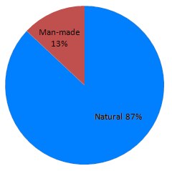We are continuously exposed to a certain level of background radiation. In the lessons to come **you must remember to subtract the background radiation from the recorded radiation** level to get the true (or corrected) reading. The main contributors to background radiation are:

Radon and Thoron gas: 51%

Ground, rocks and buildings: 14%

Food and drink: 12%

Medical: 12%

Cosmic rays: 10%

Air travel: 0.4%

Nuclear weapons testing: 0.3%

Occupational: 0.2%

Nuclear power: 0.1%

1. Complete the table

|  |  |  |  |  |  |  |
| --- | --- | --- | --- | --- | --- | --- |
| **Type of radiation** | **What it consists of** | **What happens to the number of protons and neutrons in the nucleus** | **Ionising effect** | **Charge (e)** | **Mass (u)** | **Typically absorbed by** |
| Alpha |  |  |  |  |  |  |
| Beta plus |  |  |  |  |  |  |
| Beta minus |  |  |  |  |  |  |
| Gamma |  |  |  |  |  |  |

2.(a) Which ionizing radiation produces the greatest number of ion pairs per mm in air? Tick (✓) the correct answer.

|  |  |  |
| --- | --- | --- |
|  | α particles |  |
|  | β particles |  |
|  | γ rays |  |
|  | X−rays |  |

(b)     (i)      Complete the table showing the typical maximum range in air for α and β particles.

|  |  |  |
| --- | --- | --- |
|  | **Type of radiation** | **Typical range in air / m** |
|  | α |  |
|  | β |  |

(ii)     γ rays have a range of at least 1 km in air.  
However, a γ ray detector placed 0.5 m from a γ ray source detects a noticeably smaller count-rate as it is moved a few centimetres further away from the source.

Explain this observation.

(c)     Following an accident, a room is contaminated with dust containing americium which is an α−emitter.

Explain the most hazardous aspect of the presence of this dust to an unprotected human entering the room.

**Q1.**

A radioactive nucleus decays with the emission of an alpha particle and a gamma-ray photon.

(a)     Describe the changes that occur in the proton number and the nucleon number of the nucleus.

proton number ______________________________________________________

nucleon number _____________________________________________________

**(2)**

(b)     Comment on the relative penetrating powers of the two types of ionizing radiation.

___________________________________________________________________

___________________________________________________________________

**(1)**

(c)     Gamma rays from a point source are travelling towards a detector. The distance from the source to the detector is changed from 1.0 m to 3.0 m.

Calculate

intensity of radiation at 3.0 m

intensity of radiation at 1.0 m

answer ____________________

**(2)**

**(Total 5 marks)**

**Q2.**

(a)     The exposure of the general public to background radiation has changed substantially over the past 100 years.

State **one** source of radiation that has contributed to this change.

___________________________________________________________________

___________________________________________________________________

**(1)**

(b)     A student measures background radiation using a detector and determines that background radiation has a mean count-rate of 40 counts per minute. She then places a γ ray source 0.15 m from the detector as shown below.

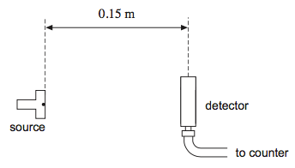

With this separation the average count per minute was 2050.

The student then moves the detector further from the γ ray source and records the count-rate again.

(i)      Calculate the average count-rate she would expect to record when the source is placed 0.90 m from the detector.

count-rate = ____________________ min–1

**(3)**

(ii)     The average count per minute of 2050 was determined from a measurement over a period of 5 minutes. Explain why the student might choose to record for longer than 5 minutes when the separation is 0.90 m.

______________________________________________________________

______________________________________________________________

______________________________________________________________

______________________________________________________________

**(1)**

(iii)     When the detector was moved to 0.90 m the count-rate was lower than that calculated in part **(b)(i)**. It is suggested that the source may also emit β particles.

Explain how this can be checked.

______________________________________________________________

______________________________________________________________

______________________________________________________________

______________________________________________________________

______________________________________________________________

______________________________________________________________

______________________________________________________________

______________________________________________________________

**(2)**

**(Total 7 marks)**

**Q3.**

(a)     Suggest, with a reason, which type of radiation is likely to be the most appropriate for the sterilisation of metallic surgical instruments.

___________________________________________________________________

___________________________________________________________________

___________________________________________________________________

**(1)**

(b)     Explain why the public need not worry that irradiated surgical instruments become radioactive once sterilised.

___________________________________________________________________

___________________________________________________________________

___________________________________________________________________

**(1)**

(c)     A student detects the counts from a radioactive source using a G-M radiation detector as shown in the diagram.

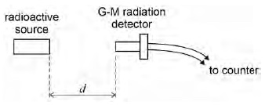

The student measures the count rate for three different distances *d*. The table shows the count rate, in counts per minute, corrected for background for each of these distances.

|  |  |  |  |  |
| --- | --- | --- | --- | --- |
| ***d*/m** | **Corrected count rate / counts per minute** |  |  |  |
| 0.20 | 9013 |  |  |  |
| 0.50 | 1395 |  |  |  |
| 1.00 | 242 |  |  |  |

Explain, with the aid of suitable calculations, why the data in the table are **not** consistent with an inverse-square law. You may use the blank columns for your working.

___________________________________________________________________

___________________________________________________________________

___________________________________________________________________

___________________________________________________________________

**(2)**

(d)     State **two** possible reasons why the results do **not** follow the expected inverse-square law.

Reason 1 __________________________________________________________

___________________________________________________________________

Reason 2 __________________________________________________________

___________________________________________________________________

**(2)**

**(Total 6 marks)**

**Q4.**

A student has access to a radioactive source that decays by emitting alpha, beta and gamma radiation. The student wishes to investigate whether the count rate due to the gamma radiation varies with distance from the source according to an inverse square law and sets up the source and detector as shown in **Figure 1**.

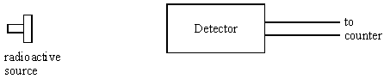

(a)     State and explain how the student can ensure that only gamma radiation is detected during the investigation.

___________________________________________________________________

___________________________________________________________________

___________________________________________________________________

___________________________________________________________________

**(2)**

(b)     The corrected count rate due to gamma radiation is 64 counts per second at a distance of 50 mm from the source. Assuming that an inverse square law is obeyed calculate the expected corrected count rate at a distance of 80 mm from the source.

Count rate at 80 mm ____________________

**(2)**

(c)     Using the data from part (b) sketch, on the axes in **Figure 2**, the graph the student would expect if an inverse square law were obeyed. The corrected count rate at 50 mm has been plotted already.

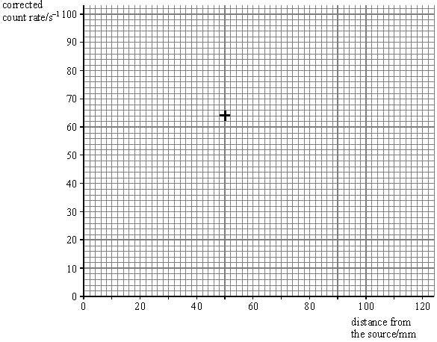

**Figure 2**

**(2)**

**(Total 6 marks)**

# *Decay*

Radioactive decay

Something that is radioactive will decay into something that is stable. Radioactive decay happens randomly and spontaneously: there is no way of predicting when a radioactive nucleus will decay and external factors do not influence it at all (e.g. pressure and temperature).

What we can do is give a probability that a nucleus will decay in a given time.

# *Decay Constant, λ*

Every radioactive isotope has its own probability that a nucleus will decay, called the decay constant.

# *Activity, A*

The activity of a radioactive source is the number of decays that happen every second.

1 becquerel is equal to one decay per second, 50 becquerels is equal to 50 decay per second,

**Activity is measured in becquerels, Bq (decays per second, s-1)**

During a certain amount of time, Δ*t*, some radioactive atoms (Δ*N*) decay from a sample of *N* atoms.

The change in the number of nuclei in a certain time is this can be written as 

The minus sign is there because we are losing nuclei, the number we have left is getting smaller.

***Exponential Decay***

As time passes the number of nuclei that decay every second will decrease.

To calculate the number of nuclei that we have left after a time, *t*, is given by:

Where *N*0 is the number of nuclei at the start and *N* is the current number of nuclei. This is similar to the exponential decay equation of a discharging capacitor.

The equation for calculating the activity looks similar:

# *Half-Life*

Each radioactive isotopes has its own half-life. We already know that it is:

*The time it takes for the number of atoms in a sample to drop to half of its original sample* or

*The time it takes for the activity of a substance to drop to half of its original activity*

**Half-Life is measured in seconds, s**

The half life of a substance is linked to the decay constant.

If there is a high probability that a nucleus will decay (λ = BIG) then it will not take long before half the sample has decayed to stability (half-life = short).

If there is a low probability that a nucleus will decay (λ = small) then it will take a long time for half of the sample to have decayed (half-life = LONG).

 where is the half life

# *Graphs*

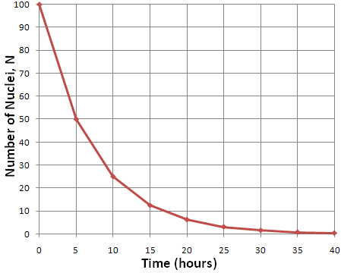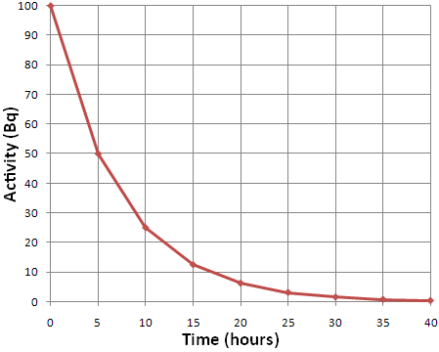We can calculate the half-life from activity and number of nuclei graphs. Choose a starting value and then find how long it takes to fall to half this value. In the graphs we can see that both fall from 50 to 25 and take 5 hours to do this. Therefore the half-life is 5 hours. Knowing this we can then calculate the decay constant.

Radioactive decay and half life

1. What is meant by the term “decay constant” and how is it related to half life? Give its units.
2. What is meant by the term “half-life”?
3. What type of curve describes radioactive decay?
4. Give an equation that relates activity to the decay constant and give the units for activity.
5. How are the decay constant and half-life related?

Radioactive decay with exponentials

1. The half-life of one radioactive isotope of sodium is 2.6 years. Show that its decay constant is 8.4 × 10–9 s–1.

2. Calculate the activity of a sample containing one mole of the sodium. (One mole contains 6.02 × 1023 atoms.)

A scientist wishes to find the age of a sample of rock. Realising that it contains radioactive potassium, which decays to give a stable form of argon, the scientist started by making the following measurements:

decay rate of the potassium in the sample = 0.16 Bq

mass of potassium in the sample = 0.6 × 10–6 g

mass of argon in the sample = 4.2 × 10–6 g

3. The molar mass of the potassium is 40 g. Show that the decay constant l for potassium is 1.8 × 10–17 s–1 and its half life is 1.2 × 109 years.

4. Calculate the age of the rock, assuming that originally there was no argon in the sample and the total mass has not changed. Show the steps in your calculation.

5. Identify and explain a difficulty involved in measuring the decay rate of 0.16 Bq given above.

6. Iodine 124, which is used in medical diagnosis, has a half-life of 4.2 days. Estimate the fraction remaining after 10 days.

7. Explain how you would find the half-life of a substance when it is known to be more than 10 000 years. Assume that a sample of the substance can be isolated.

In an experiment to find the half-life of zinc-63, a sample containing a sample of the radioactive zinc was placed close to a GM tube and the following readings were recorded. The background count rate was 30 min–1.

| **Time / hours** | **Counts**  **/ min–1** |
| --- | --- |
| 0 | 259 |
| 0.5 | 158 |
| 1.0 | 101 |
| 1.5 | 76 |
| 2.0 | 56 |
| 2.5 | 49 |
| 3.0 | 37 |

8. Plot a graph of count rate against time and use this to find the average time for the count rate to fall to one-half of its previous value.

9. Plot a second graph, ln (count rate) against time, and use it to find the half-life.

10. Discuss which method, 8 or 9, provides a more reliable value.

**Q1.**

The age of an ancient boat may be determined by comparing the radioactive decay of  from living wood with that of wood taken from the ancient boat.  
A sample of 3.00 × l023 atoms of carbon is removed for investigation from a block of living wood. In living wood one in 1012 of the carbon atoms is of the radioactive isotope , which has a *decay constant* of 3.84 × 10–12 s–1.

(a)     What is meant by the decay constant?

___________________________________________________________________

___________________________________________________________________

___________________________________________________________________

**(1)**

(b)     Calculate the half-life of  in years, giving your answer to an appropriate number of significant figures.

          1 year = 3.15 × 107 s

answer = ______________________ years

**(3)**

(c)     Show that the rate of decay of the  atoms in the living wood sample is 1.15 Bq.

**(2)**

(d)     A sample of 3.00 × 1023 atoms of carbon is removed from a piece of wood taken

from the ancient boat. The rate of decay due to the  atoms in this sample is 0.65 Bq.  
Calculate the age of the ancient boat in years.

answer = ______________________ years

**(3)**

(e)     Give **two** reasons why it is difficult to obtain a reliable age of the ancient boat from the carbon dating described.

___________________________________________________________________

___________________________________________________________________

___________________________________________________________________

___________________________________________________________________

___________________________________________________________________

___________________________________________________________________

**(2)**

**(Total 11 marks)**

**Q2.**

The decay of a radioactive substance can be represented by the equation

*A* = *A*0*e–λt*

where *A* = the activity of the sample at time *t*          *A*0 = the initial activity at time *t* = 0  
            λ = the decay constant

The half life, *T*½ of the radioactive substance is given by

*T*½ = 

An experiment was performed to determine the half-life of a radioactive substance which was a beta emitter. The radioactive source was placed close to a detector. The total count for exactly 5 minutes was recorded. This was repeated at 20 minute intervals. The results are shown in the table below.

|  |  |  |  |  |
| --- | --- | --- | --- | --- |
| **time, *t* / minutes** | **total count, *C*, recorded in 5 minutes** | **count rate, *R* / counts minute–1** | **corrected count rate, *RC* / counts minute–1** | **ln (*RC* / minute–1)** |
| 0 | 1016 | 203 | 183 | 5.21 |
| 20 | 892 | 178 | 158 | 5.06 |
| 40 | 774 | 155 | 135 | 4.90 |
| 60 | 665 | 133 | 113 | 4.73 |
| 80 | 608 | 122 | 102 | 4.62 |
| 100 | 546 | 109 | 89 | 4.49 |

(a)     A correction has been made to the count rate, *R*, to give the corrected count rate, *RC*.  
Explain why this correction has been made and deduce its value from the table.

___________________________________________________________________

___________________________________________________________________

**(2)**

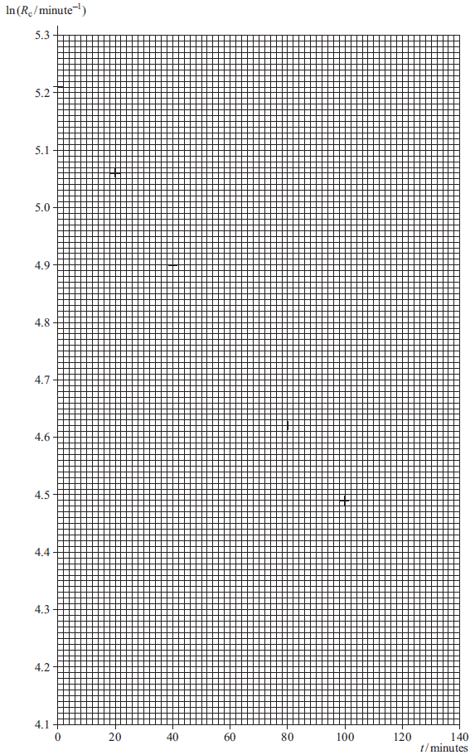

(b)     Draw an appropriate straight line through the plotted points.

**(1)**

(c)     Determine the gradient *G* of your graph.

___________________________________________________________________

___________________________________________________________________

___________________________________________________________________

___________________________________________________________________

___________________________________________________________________

___________________________________________________________________

**(3)**

(d)     Use your graph to determine the half-life in minutes of the radioactive substance used in this experiment.

___________________________________________________________________

___________________________________________________________________

___________________________________________________________________

___________________________________________________________________

half-life, *T*½ ______________________ minutes

**(2)**

(e)     Due to the nature of a radioactive decay there will be an uncertainty in the total count recorded. What type of error is this called?

___________________________________________________________________

**(1)**

(f)     (i)      It can be shown that the error in the total count *C*, is given by

uncertainty in total count *C* = ± √*C*

Using data from the table, calculate the uncertainty **in the smallest total count, *C***.

______________________________________________________________

______________________________________________________________

**(1)**

(ii)      Hence calculate the percentage uncertainty **in the smallest total count, *C***.

______________________________________________________________

______________________________________________________________

______________________________________________________________

**(1)**

(iii)    Another student performed the same experiment with identical equipment but took total counts over a 1 minute period rather than a 5-minute period. The total count, *C*, at 140 minutes was equal to 84 counts. Estimate the percentage uncertainty in this total count, and hence explain the advantage of using a larger time.

______________________________________________________________

______________________________________________________________

______________________________________________________________

______________________________________________________________

______________________________________________________________

______________________________________________________________

**(2)**

**(Total 13 marks)**

**Q3.**

An isotope of technetium is a gamma emitter used by doctors as a tracer in the human body. It is injected into the patient’s blood stream. Scanners outside the body measure the gamma activity, enabling the blood flow to be monitored.

(a)     The graph shows the variation of activity with time, *t*, for a sample of the isotope.

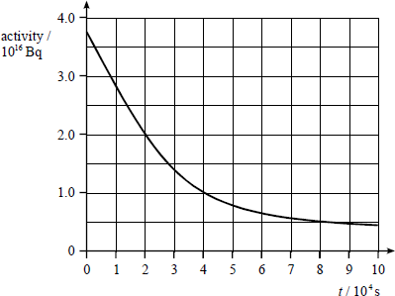

(i)      Use data from the graph to determine the half-life of the technetium isotope.

**(3)**

(ii)     The decay constant of the technetium isotope is 3.2 × 10−5 s−1. Use data from the graph and the equation *A* = *λN* to calculate the number of nuclei of the radioactive technetium isotope present at time *t* = 0.

**(2)**

(b)     (i)      State why an alpha emitter would not be suitable in this application.

______________________________________________________________

______________________________________________________________

**(1)**

(ii)     State why the half-life of the technetium isotope makes it suitable for this application.

______________________________________________________________

______________________________________________________________

**(1)**

(c)     State and explain how the presence of the technetium isotope may do some damage to the patient.

___________________________________________________________________

___________________________________________________________________

___________________________________________________________________

___________________________________________________________________

**(2)**

**(Total 9 marks)**

**Q4.**

The radioisotope iodine-131 () is used in medicine to treat over-active thyroid glands. It decays into an *isotope* of xenon (Xe) by *β*– emission with a *half-life* of 8.1 days. The xenon subsequently emits a *γ* ray.

(a)     Explain what is meant by:

(i)      *isotope;*

______________________________________________________________

______________________________________________________________

**(2)**

(ii)     *half-life.*

______________________________________________________________

______________________________________________________________

**(1)**

(b)     Write down the equation which represents the nuclear reaction.

___________________________________________________________________

___________________________________________________________________

___________________________________________________________________

___________________________________________________________________

___________________________________________________________________

___________________________________________________________________

**(3)**

(c)     Calculate the time (in days) for a sample of iodine to decay to 1% of its initial activity.

**(4)**

(d)     State and explain which decay product can be detected outside the body during treatment.

___________________________________________________________________

___________________________________________________________________

___________________________________________________________________

___________________________________________________________________

**(2)**

**(Total 12 marks)**

# *N Against Z Graph*

Modes of decay

Here is a graph of the number of neutrons against the number of protons in a nucleus. It shows stable and unstable nuclei.

Stable nuclei/isotopes are found on the black line/dots.

The shaded areas above and below the line of stability represent radioactive isotopes.

***Why doesn’t it follow N=Z?***

Protons repel each other with the electromagnetic force but the strong nuclear force is stronger at small distances and keeps them together in the nucleus. We can see the line of stability follows N=Z at low values.

As the nucleus gets bigger there are more protons, when they become a certain distance apart they no longer experience the strong nuclear force that keeps them together, only the electromagnetic which pushes them apart. To keep the nucleus together we need more neutrons which feel no electromagnetic repulsion only the attraction of the strong nuclear force.

***Points to remember***

Follows N=Z around Z=20, then curves to go through Z=80 N=120

β- emitters above the line, β+ emitters below the line and α at the top

# *Alpha Decay*

An alpha particle (a Helium nucleus) is ejected from the parent nucleus.

 **Loss:** 2 protons, 2 neutrons

# *Beta Minus Decay*

A neutron is transformed into a proton (that stays in the nucleus) and an electron (which is emitted).

 **Loss:** 1 neutron **Gain:** 1 proton

# *Beta Plus Decay*

A proton is transformed into a neutron and a positron.

 **Loss:** 1 proton **Gain:** 1 neutron

# *Electron Capture*

A nucleus can capture one of the orbiting electrons. A proton changes into a neutron.

 **Loss:** 1 proton **Gain:** 1 neutron

# *Nucleon Emission Decay*

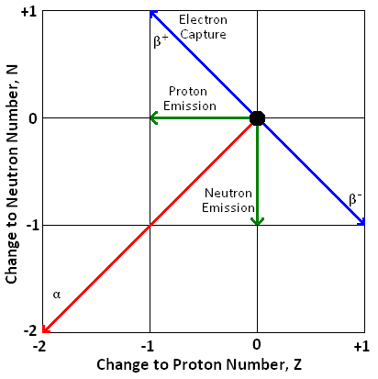It is possible for an unstable isotope to emit a nucleon from the nucleus.

In proton-rich or proton-heavy nuclei it is possible (though rare) for a proton to be emitted.

 **Loss:** 1 proton

In neutron-rich or neutron-heavy nuclei it is possible (though rare) for a neutron to be emitted.

 **Loss:** 1 neutron

# *Gamma Ray Emission*

Alpha emission is often followed by gamma ray emission. The daughter nuclei are left in an excited state which they will at some point fall from to the ground state, emitting a gamma photon. There is no nuclear structure change, just a change of energy.

 **Loss:** Energy

**Q1.**

(a)     Sketch, using the axes provided, a graph of neutron number, *N*, against proton number, *Z*, for stable nuclei over the range *Z* = 0 to *Z* = 80. Show suitable numerical values on the *N* axis.

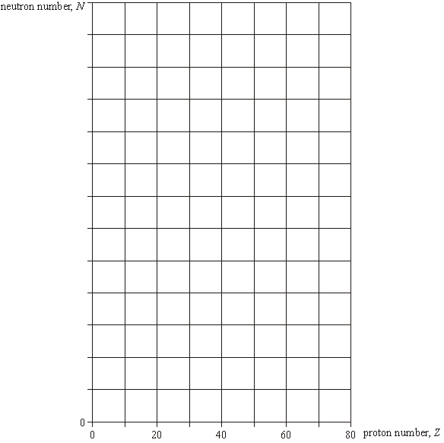

**(2)**

(b)     On the graph indicate, for each of the following, a possible position of a nuclide that may decay by

(i)      α emission, labelling the position with **W**,

(ii)     *β*– emission, labelling the position with **X**,

(iii)     *β*+ emission, labelling the position with **Y**.

**(3)**

(c)     The isotope  decays sequentially by emitting *α* particles and *β*– particles,

eventually forming the isotope . Four *α* particles are emitted in the sequence.

Calculate the number of *β*– particles in the sequence.

___________________________________________________________________

___________________________________________________________________

___________________________________________________________________

___________________________________________________________________

**(2)**

(d)     A particular nuclide is described as proton-rich. Discuss **two** ways in which the nuclide may decay. You may be awarded marks for the quality of written communication in your answer.

___________________________________________________________________

___________________________________________________________________

___________________________________________________________________

___________________________________________________________________

___________________________________________________________________

___________________________________________________________________

___________________________________________________________________

**(3)**

**(Total 10 marks)**

**Q2.**

A nucleus of polonium Po may decay to the stable isotope of lead  through a chain of emissions following the sequence α β– β– α.

The graph shows the position of the isotope  on a grid of neutron number *N* against proton number *Z*.

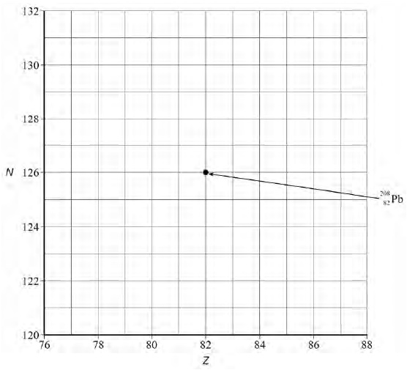

(a)     Draw **four** arrows on the graph to show the sequence of changes to *N* and *Z* that occur as the polonium nucleus is transformed into  .

**(2)**

(b)     A nucleus of the stable isotope  has more neutrons than protons.

Explain why there is this imbalance between proton and neutron numbers by referring to the forces that operate within the nucleus. Your explanation should include the range of the forces and which particles are affected by the forces.

___________________________________________________________________

___________________________________________________________________

___________________________________________________________________

___________________________________________________________________

___________________________________________________________________

___________________________________________________________________

___________________________________________________________________

___________________________________________________________________

___________________________________________________________________

___________________________________________________________________

___________________________________________________________________

___________________________________________________________________

___________________________________________________________________

___________________________________________________________________

___________________________________________________________________

___________________________________________________________________

**(4)**

(c)     Many, but not all, isotopes of lead are stable. For example,  decays by electron capture to become an isotope of thallium, Tl.

Write the equation to represent this decay, including the isotope of thallium produced.

**(1)**

(d)     The thallium nucleus is formed in an excited state. Electromagnetic radiation is emitted from the thallium atom following its formation.

Explain the origin and location of **two** sources of this radiation.

Source 1 ___________________________________________________________

___________________________________________________________________

___________________________________________________________________

___________________________________________________________________

___________________________________________________________________

Source 2 ___________________________________________________________

___________________________________________________________________

___________________________________________________________________

___________________________________________________________________

___________________________________________________________________

**(2)**

(e)     Other nuclides also emit electromagnetic radiation.

Explain why the metastable form of the isotope of technetium   is a radioactive source suitable for use in medical diagnosis.

___________________________________________________________________

___________________________________________________________________

___________________________________________________________________

___________________________________________________________________

___________________________________________________________________

___________________________________________________________________

___________________________________________________________________

**(2)**

**(Total 11 marks)**

**Q3.**

(a)     (i)      Explain why, despite the electrostatic repulsion between protons, the nuclei of most atoms of low nucleon number are stable.

______________________________________________________________

______________________________________________________________

______________________________________________________________

______________________________________________________________

______________________________________________________________

______________________________________________________________

(ii)     Suggest why stable nuclei of higher nucleon number have greater numbers of neutrons than protons.

______________________________________________________________

______________________________________________________________

______________________________________________________________

______________________________________________________________

______________________________________________________________

______________________________________________________________

(iii)     All nuclei have approximately the same density.  State and explain what this suggests about the nature of the strong nuclear force.

______________________________________________________________

______________________________________________________________

______________________________________________________________

______________________________________________________________

______________________________________________________________

______________________________________________________________

______________________________________________________________

______________________________________________________________

______________________________________________________________

______________________________________________________________

______________________________________________________________

**(6)**

Rutherford gave us an idea of the size of the nucleus compared to the atom but more experimental work has been done to find a more accurate measurement.

Nuclear radius

# *Closest Approach of Alpha Particles*

Rutherford fired alpha particles at gold atoms in a piece of foil. They approach the nucleus but slow down as the electromagnetic repulsive force become stronger. Eventually they stop moving, all the kinetic energy has been converted into potential energy as the particles come to rest at a distance *r* from the centre of the nucleus.

 🡪  where *V* is the electric potential at a distance of *r* from the centre

 🡪  🡪 

This gives us the upper limit of the radius of a nucleus.

Calculating the nuclear radius this way gives us a value of *r* = 4.55 x 10-14 m or 45.5 fm (where 1 fm = 1 x 10-15 m)

Modern measurements give us values of approximately *r* = 6.5 fm

(Remember that 1 eV of energy is equal to 1.6 x 10-19 J)

# *Electron Diffraction*

A beam of electrons were fired at a thin sample of atoms and the diffraction pattern was detected and then examined.

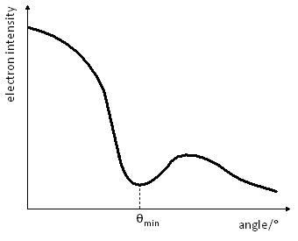

The graph shows a minimum at a value of *θ*min. We can use this to find a value of the nuclear radius.



Where *D* is the nuclear radius and *λ* is the de Broglie wavelength of the beam of electrons. We can calculate this as follows:

The kinetic energy gained by the electrons is  where *e* is the charge on the electron and *V* is the potential difference used to accelerate it. So we now have:

 🡪  🡪  🡪  🡪 

We can now substitute this into the equation for de Broglie wavelength:  🡪 

# *Nuclear Radius*

From the experimental results a graph was plotted of *R* against *A*. A graph like the one to the right was obtained. They saw that *R* depends not on *A*, but on *A*⅓.

When they plotted the graph of *R* against *A*⅓ they found a straight line that cut the origin and had a gradient of *r*0. (*r*0 is a constant representing the radius of a single nucleon and has a value of between 1.2 and 1.5 fm)

The radius of a nucleus has been found to be: 

# *Nuclear Density*

Now that we have an equation for the nuclear radius we can calculate the density of a nucleus.

If we have a nucleus of *A* nucleons, we can assume the mass is *Au* and the volume is the volume of a sphere:

 🡪  🡪  🡪  🡪 

We can see that the density is independent of the nucleon number and gives a value of: 3.4 x 1017 kg m-3.

*Rutherford scattering: Energy and closest approach*

Scattering of alpha particles

Rutherford did not have a particle accelerator. Instead he used alpha particles, typically of energy 5 MeV, from radioactive decay. These questions are about how close an alpha particle can get to different nuclei.

An alpha particle has charge 2e, where *e* = 1.60  10–19 C. A nucleus has charge Ze, where Z is the number of protons in the nucleus (and the number of electrons in the atom). The electrical potential energy of the two charges at a distance ris:



where ϵ0 = 8.85 × 10–12 C2 J–1 m–1.

The electrical potential energy in electron volts is obtained by dividing by 1.60 × 10–19 J eV–1

Calculating the potential energy

1. Show that the units of energy from the expression



are joules.

2. Show that the energy in MeV is given by



Alpha scattering by gold

This graph shows the energy in MeV of an alpha particle at distances rfrom a gold nucleus, Z = 79.



3. Make an arithmetical check to show that at distance r= 1.0 × 10–14 m the electrical potential energy is between 20 MeV and 25 MeV, as shown by the graph.

4. How does the electrical potential energy change if the distance ris doubled?

5. From the graph, at what distance *r* will an alpha particle with initial kinetic energy 5 MeV colliding head-on with the nucleus, come to rest momentarily?

6. From the graph, at what distance rwill a 5 MeV alpha particle have lost half its initial kinetic energy?

7. From the graph, what energy would an alpha particle need to approach as close as 2.0 × 10–14 m in a head-on collision?

Alpha scattering by tin

The next graph shows, on the same scale as before, the electrical potential energy of an alpha particle near a nucleus of tin, Z = 50.



8. Why are the values of the electrical potential energy smaller at the same values of rin this second graph?

9. At r= 5.0 × 10–14 m the electrical potential energies of an alpha particle are 4.55 MeV for gold, Z = 79 and 2.88 MeV for tin, Z = 50. Explain the ratio, 1.58, of the two energies.

10. Approximately how close can a 5 MeV alpha particle get to a tin nucleus, in a head-on collision?

Alpha scattering by aluminium

The next graph shows the potential energy of an alpha particle close to an aluminium nucleus, Z = 13.



11. From the graph, how close could a 5 MeV alpha particle get to a nucleus of charge? Z = 13, in a head-on collision?

12. The radius of an aluminium nucleus is approximately 3 × 10–15 m. Does a 5 MeV alpha particle get close to the nucleus, compared with the dimensions of the nucleus itself? Could the pattern of scattering be affected?

Heavy ion colliders

Recently, to investigate very high-energy collisions, accelerators have been used to make head-on collisions between lead nuclei travelling in opposite directions.

1. How much kinetic energy is needed to get two lead nuclei, *Z* = 82, within 1.0 × 10–14 m of one another? (Assume that electrical forces are the only forces operating.)

*Electrons measure the size of nuclei*

Scattering by small particles

Hold a glass plate smeared with a little milk, or dusted with lycopodium powder, in front of a point source of light and you may see rings of light round the source. The photons are diffracted by globules of fat in the milk or by the lycopodium spores.

Similarly to diffraction by a small hole of diameter d, there is a first minimum intensity at an angle θ of order of magnitude given by sin θ = λ / d. (For circular objects or apertures a more exact expression is sin θ = 1.22 λ / d.)

Angles and wavelengths

1. Show that if you see a first dark ring at θ = 30°, the circular objects have diameter approximately twice the wavelength.

2. Use the expression sin θ = 1.22 λ / d to find the angle of the first dark ring for particles four wavelengths in diameter.

Wavelengths for electrons

The de Broglie wavelength λ of an electron of momentum *p* is given by λ = h / p, where *h* is the Planck constant, 6.6 × 10–34 J Hz–1. Since the rest energy of an electron is 0.5 MeV, at energies of hundreds of MeV, the rest energy can be ignored as part of the total energy *E*. In this case the momentum *p* is given to a good approximation by p = E / c.

3. Calculate the energy in joules of an electron with energy 100 MeV

(take 1 eV = 1.6 × 10–19 J).

4. Use the value of the energy from question 3 to calculate the momentum of the electron.

5. Use the value of the momentum from question 4 to calculate the de Broglie wavelength of 100 MeV electrons.

6. The radius of a single proton or neutron is of the order 1.2 × 10–15 m. What approximately is the ratio of the wavelength of the electrons to the diameter of a proton or neutron?

7. Using the relations p = E / c and λ = h / p show that the de Broglie wavelength is inversely proportional to the energy E.

8. Use the result of question 7 and the answer to question 5 to show that the de Broglie wavelength for 400 MeV electrons is about 3.0 × 10–15 m.

Electron scattering by nuclei

You have seen that electrons of a few hundred MeV have de Broglie wavelengths comparable to the diameter of a nucleus. Suppose that in an experiment a beam of 400 MeV electrons is scattered by carbon-12 nuclei. The angle θ at which the scattering is first a minimum is 42°, for which sin θ = 0.67.

9. Calculate the ratio λ / d of the de Broglie wavelength to the diameter of a carbon-12 nucleus.

10. Use the de Broglie wavelength of 400 MeV electrons from question 8 to show that the radius of a carbon-12 nucleus is about 2.7 × 10–15 m.

11. You might expect the volume occupied by the 12 nucleons of carbon-12 to be 12 times the volume occupied by one nucleon. The radius of a nucleon is about 1.2 × 10–15 m. Show that the ratio of the volumes is about 12 (expect some rounding error in these figures).

12. A uranium-238 nucleus has a radius of about 7.4 × 10–15 m. What roughly would be a good energy of electrons to use to determine its radius by scattering?

**Q1.**

An *α* particle with an initial kinetic energy of 4.9 MeV is directed towards the centre of a gold nucleus of radius *R* which contains 79 protons. The *α* particle is brought to rest at point **S**, a distance *r* from the centre of the nucleus as shown in the diagram below.

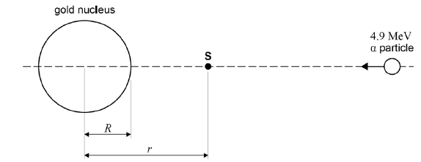

(a)     Calculate the electric potential energy, in J, of the *α* particle at point **S**.

electric potential energy = ___________________ J

**(2)**

(b)     Calculate *r*, the distance of closest approach of the *α* particle to the nucleus.

*r* = ___________________ m

**(3)**

(c)     Determine the number of nucleons in the gold nucleus.

*R*, radius of the gold nucleus = 7.16 × 10−15 m

*R*0 = 1.23 × 10−15 m

number of nucleons = ________________

**(3)**

(d)     The target nucleus is changed to one that has fewer protons. The α particle is given the same initial kinetic energy.

Explain, without further calculation, any changes that occur to the distance *r*. Ignore any recoil effects.

___________________________________________________________________

___________________________________________________________________

___________________________________________________________________

___________________________________________________________________

**(2)**

**(Total 10 marks)**

**Q2.**

(a)     The radius of a nucleus may be determined by electron diffraction. In an electron diffraction experiment a beam of electrons is fired at oxygen-16 nuclei. Each electron has an energy of 5.94 × 10−11 J.

The approximation, momentum =  can be used for electrons at this energy.

(i)      Show that the de Broglie wavelength *λ* of each electron in the beam is about 3.3 × 10−15 m.

**(2)**

(ii)     The graph shows how the relative intensity of the scattered electrons varies with angle due to diffraction by the oxygen-16 nuclei. The angle is measured from the original direction of the beam.



The angle *θ* of the first minimum in the electron-diffraction pattern is given by



Calculate the radius of an oxygen-16 nucleus using information from the graph.

radius = ____________________ m

**(1)**

(b)     Rutherford used the scattering of α particles to provide evidence for the structure of the atom.

(i)      Sketch a labelled diagram showing the experimental arrangement of the apparatus used by Rutherford.

**(2)**

(ii)     State and explain the results of the scattering experiment.

Your answer should include the following:

•        the main observations

•        the significance of each observation

•        how the observtions placed an upper limit on the nuclear radius.

The quality of your written communication will be assessed in your answer.

______________________________________________________________

______________________________________________________________

______________________________________________________________

______________________________________________________________

______________________________________________________________

______________________________________________________________

______________________________________________________________

______________________________________________________________

______________________________________________________________

______________________________________________________________

______________________________________________________________

______________________________________________________________

**(6)**

**(Total 11 marks)**

**Q3.**

(a)     Scattering experiments are used to investigate the nuclei of gold atoms.  
In one experiment, alpha particles, all of the same energy (monoenergetic), are incident on a foil made from a single isotope of gold.

(i)      State the main interaction when an alpha particle is scattered by a gold nucleus.

______________________________________________________________

______________________________________________________________

**(1)**

(ii)     The gold foil is replaced with another foil of the same size made from a mixture of isotopes of gold. Nothing else in the experiment is changed.

Explain whether or not the scattering distribution of the monoenergetic alpha particles remains the same.

______________________________________________________________

______________________________________________________________

______________________________________________________________

**(1)**

(b)     Data from alpha−particle scattering experiments using elements other than gold allow scientists to relate the radius *R*, of a nucleus, to its nucleon number, *A*.  
The graph shows the relationship obtained from the data in a graphical form, which obeys

the relationship *R* = *r*0 

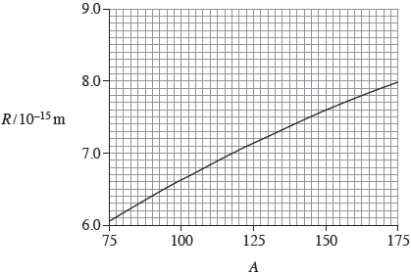

(i)      Use information from the graph to show that *r*0 is about 1.4 × 10–15 m.

**(1)**

(ii)     Show that the radius of a V nucleus is about 5 × 10–15 m.

**(2)**

(c)     Calculate the density of a V nucleus.

State an appropriate unit for your answer.

density ____________________ unit __________

**(3)**

**(Total 8 marks)**

# *Disappearing Mass*

Mass and energy

The mass of a nucleus is less than the mass of the protons and neutrons that it is made of.

(mass of protons + mass of neutrons) – mass of nucleus = ∆*m*

*∆m* is the difference in the masses and is called the ***mass defect***.

Let us look at the nucleus of a Helium atom to see this in action. It is made up of 2 protons and 2 neutrons:

Mass of nucleons = 2 x (mass of proton) + 2 x (mass of neutron)

Mass of nucleons = 2 x (1.673 x 10-27) + 2 x (1.675 x 10-27)

Mass of nucleons = 6.696 x 10-27 kg Mass of nucleus = 6.648 x 10-27 kg

Mass defect = mass of nucleons – mass of nucleus

Mass defect = 6.696 x 10-27 – 6.648 x 10-27 = 0.048 x 10-27 kg

|  |  |  |
| --- | --- | --- |
| **Particle** | **Mass (kg)** | **Mass (u)** |
| Proton | 1.673 x 10-27 | 1.00728 |
| Neutron | 1.675 x 10-27 | 1.00867 |
| Electron | 9.11 x 10-31 | 0.00055 |

As we can see, we are dealing with tiny masses. For this reason we will use the **atomic mass unit, u**

1u = 1.661 x 10-27 kg

The mass defect now becomes = 0.029 u

# *Einstein to the Rescue*

In 1905, Einstein published his theory of special relativity. In this it is stated that:

 Energy is equal to the mass multiplied by the speed of light squared.

This means gaining energy means a gain in mass, losing energy means losing mass. The reverse must be true.

Gaining mass means a gain in energy, losing mass means a loss in energy.

The energy we are losing is the binding energy.

 where ∆*m* is the mass defect and *E* is binding energy

# *Binding Energy*

As the protons and neutrons come together the strong nuclear force pulls them closer and they lose potential energy. (Like how an object loses its gravitational potential energy as it falls to the Earth.)

Energy must be done against the s.n.f. to separate the nucleus into the nucleons it is made of. This is called the binding energy (although ‘*un*binding’ energy would be a better way to think of it).

The binding energy of the Helium nucleus from above would be: *E* = *m* *c*2 🡪 *E* = (0.048 x 10-27) x (3.0 x 108)2

*E* = 4.32 x 10-12 J

The Joule is too big a unit to use at the atomic scale. We will use the electron Volt.

1u = 1.5 x 10-10 J and 1eV = 1.60 x 10-19 J 🡪 1u = 931.3 MeV

We can now calculate the binding energy of the Helium nucleus to be: *E* = 27 MeV (27 million eV)

# *Binding Energy Graph*

The binding energy is the energy required to separate a nucleus into its constituent nucleons. The binding energy per nucleon gives us the energy required to remove one proton or neutron from the nucleus.

The graph of binding energy per nucleon against nucleon number looks like this.

There is an increase in the energy required to remove one nucleon up until the peak of 8.8 MeV at Iron 56. The line then gently decreases. This means Iron is the most stable nucleus because it requires the largest amount of energy to remove one nucleon. This will also mean that there is the greatest mass defect.

*Change in energy: Change in mass*

Calculating using Erest = mc2

These questions show you how to calculate changes in energy from changes in mass, using Einstein’s relation Erest = mc2 linking the rest energy of a particle to its mass.

Transmutation of chemical elements

The dream of the ancients was alchemy: turning base metals into gold. Although this is chemically impossible, at the end of the nineteenth century radioactivity was discovered by Henri Becquerel. When alpha and beta radiation are emitted atomic nuclei are ‘transmuted’ from one element to another. For example:



In 1932 using protons (hydrogen nuclei) accelerated through a potential difference of 800 000 V, two English physicists, Cockcroft and Walton, carried out the first artificial transmutation: by bombarding lithium with the protons they produced two helium nuclei:



Change in mass

Notice that in both these reactions the mass number and charge (proton number) are conserved. Energy, however, is only conserved if you take account of changes to the rest energy – in effect of changes to the masses – of the particles.

In Cockcroft and Walton’s experiment, the masses of the particles are:

* H: 1.0073 atomic mass units
* Li: 7.0160 atomic mass units
* He: 4.0015 atomic mass units.

An atomic mass unit, symbol u, is equal to 1.6605 × 10–27 kg.

1 Show that the mass decreases in this reaction.  
 

Calculate Δ*m* in atomic mass units and in kilograms.

Change in energy

2 The energy of the protons was 800 000 electron volts (800 keV). The lithium was in solid form so the nuclei would only have been vibrating with an energy of less than an electron volt.

The reaction was captured in this photograph:

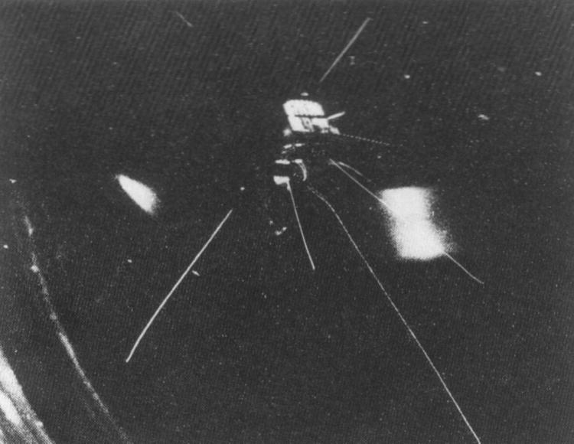

Two pairs of alpha particles, emerging in opposite directions, can be seen in the photograph.

From the range of the tracks through the cloud chamber the energy of the alpha particles was measured to be 8.5 MeV each.

Show that the total kinetic energy of the particles increases, and calculate ΔE in MeV and in joules.

3 If the increase in kinetic energy comes from the decrease in rest energy you should expect ΔE = Δmc2. Calculate the ratio of the change in kinetic energy to the change in mass Δ*E*/Δ*m* in J kg–1.

4 Show that the value of the ratio ΔE/Δm is approximately consistent with the relationship ΔE = Δmc2.

The large value of *c* 2 (9 × 1016 J kg–1: use this value from now on in calculations) means that a small change in mass represents a vast change in rest energy. This relationship between mass and energy is why particle physicists measure masses in MeV / c2; any unit of energy divided by c2 is a unit of mass.

Creating massive particles

Energy is ‘materialised’ in matter–antimatter production. A photon of electromagnetic radiation can produce an electron and a positron. In this case, the energy of the photon vanishes and the rest energy of the particles appears. (This reaction needs to take place near to the nucleus of a heavy atom to conserve momentum but this is not going to affect your calculations here.)

In this bubble chamber photograph a photon enters from the bottom. It is uncharged and so produces no observable track. After some distance the photon disappears and produces the electron–positron pair. These two charged particles ionise the liquid in the chamber and bubbles form near the ions and are photographed.

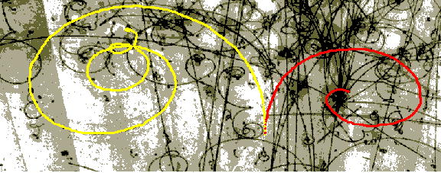

In this case the chamber is filled with liquid hydrogen mixed with liquid neon. It is held under pressure which is released just as the particles enter the chamber to encourage bubbles to form and enlarge near the ions.

5 The bubble chamber is in a magnetic field, so charged particles bend due to the force Bqvon a moving charge. How does the photograph show that the two particles have opposite charges?

6 The mass of the electron is 5.5 × 10–4 u. What is the minimum energy photon that will produce an electron–positron pair? From what part of the electromagnetic spectrum is this? (Planck constant h = 6.63 × 10–34 J Hz–1.)

Nuclear binding energy

If protons and neutrons (together known as nucleons) are bound together in a nucleus, the bound nucleus must have less rest energy than the rest energy of the nucleons of which it is made. In turn, this means that the mass of the nucleus must be less than the sum of the masses of its nucleons.

The simplest compound nucleus is the deuteron, the nucleus of hydrogen-2. It consists of a proton and a neutron bound together by the strong nuclear force. The masses of these particles are:

* proton: 1.0073 u
* neutron: 1.0087 u
* deuteron: 2.0136 u.

7 Calculate the difference in mass between a deuteron and one proton and one neutron.

8 Calculate the binding energy of the deuteron in J and in MeV.

9 Calculate the binding energy per nucleon of the deuteron.

10 Express the difference in mass as a percentage of the sum of the masses of the proton and neutron.

Mass change in nuclear fission

A possible reaction for the nuclear fission of uranium-235 is:



The masses of the particles are

* U-235 = 235.0439 u
* Sb-133 = 132.9152 u
* Nb-99 = 98.9116 u
* neutron (n) = 1.0087 u.

11 Show that the energy change per atom of uranium is about 200 MeV and calculate Δm/m.

Summary

Einstein's famous equation Erest = mc2 reveals a Universe that is not as simple as it seems at first sight. The mass of a particle is generally a very large part of its total energy. The existence of rest energy was not suspected until after Einstein had predicted it, because the change in mass is usually so small, because changes in energy are usually a small fraction of the rest energy. Only in nuclear reactions where Δm/m ~ 0.1% or more are you able to see the change in mass, accompanied by what appears to be a huge change in energy.

**Q1.**

You may be awarded marks for the quality of written communication provided in your answers to part (a)

(a)     In the context of an atomic nucleus,

(i)      state what is meant by *binding energy*, and explain how it arises,

______________________________________________________________

______________________________________________________________

______________________________________________________________

______________________________________________________________

______________________________________________________________

______________________________________________________________

______________________________________________________________

(ii)     state what is meant by *mass difference*,

______________________________________________________________

______________________________________________________________

______________________________________________________________

______________________________________________________________

______________________________________________________________

______________________________________________________________

______________________________________________________________

(iii)     state the relationship between binding energy and mass difference.

______________________________________________________________

______________________________________________________________

**(4)**

(b)     Calculate the average binding energy per nucleon, in MeV nucleon–1, of the zinc nucleus .

mass of  atom    =         63.92915 u

mass of proton           =        1.00728 u

mass of neutron         =        1.00867 u

mass of electron        =         0.00055 u

___________________________________________________________________

___________________________________________________________________

___________________________________________________________________

___________________________________________________________________

___________________________________________________________________

___________________________________________________________________

___________________________________________________________________

___________________________________________________________________

**(5)**

(c)     Why would you expect the zinc nucleus to be very stable?

___________________________________________________________________

___________________________________________________________________

___________________________________________________________________

___________________________________________________________________

**(1)**

**(Total 10 marks)**

**Q2.**

(a)     Calculate the binding energy, in MeV, of a nucleus of .

nuclear mass of  = 58.93320 u

binding energy = ____________________ MeV

**(3)**

(b)     A nucleus of iron Fe-59 decays into a stable nucleus of cobalt Co-59. It decays by β– emission followed by the emission of *γ*-radiation as the Co-59 nucleus de-excites into its ground state.

The total energy released when the Fe-59 nucleus decays is 2.52 × 10–13 J.

The Fe-59 nucleus can decay to one of three excited states of the cobalt-59 nucleus as shown below. The energies of the excited states are shown relative to the ground state.

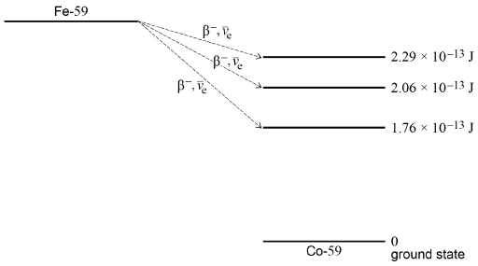

Calculate the maximum possible kinetic energy, in MeV, of the β– particle emitted when the Fe-59 nucleus decays into an excited state that has energy above the ground state.

maximum kinetic energy = ____________________ MeV

**(2)**

(c)     Following the production of excited states of  , *γ*-radiation of discrete wavelengths is emitted.

State the maximum number of discrete wavelengths that could be emitted.

maximum number = ____________________

**(1)**

(d)     Calculate the longest wavelength of the emitted *γ*-radiation.

Longest wavelength = ____________________ m

**(3)**

**(Total 9 marks)**

**Q3.**

The isotope of uranium, , decays into a stable isotope of lead, , by means of a series of α and *β*– decays.

(a)     In this series of decays, α decay occurs 8 times and *β*– decay occurs *n* times.  
Calculate *n*.

answer = ____________________

**(1)**

(b)     (i)      Explain what is meant by the binding energy of a nucleus.

______________________________________________________________

______________________________________________________________

______________________________________________________________

**(2)**

(ii)     **Figure 1** shows the binding energy per nucleon for some stable nuclides.

**Figure 1**

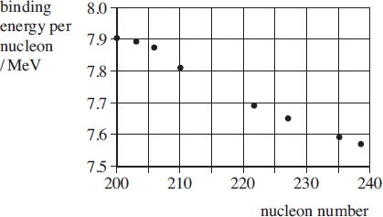

Use **Figure 1** to estimate the binding energy, in MeV, of the  nucleus.

answer = ____________________ MeV

**(1)**

(c)     The half-life of  is 4.5 × 109 years, which is much larger than all the other half-lives of the decays in the series.

A rock sample when formed originally contained 3.0 × 1022 atoms of  and no atoms.

At any given time most of the atoms are either  or with a negligible number of atoms in other forms in the decay series.

(i)      Sketch on **Figure 2** graphs to show how the number of  atoms and the number of atoms in the rock sample vary over a period of 1.0 × 1010 years from its formation.  
Label your graphs U and Pb.

**Figure 2**

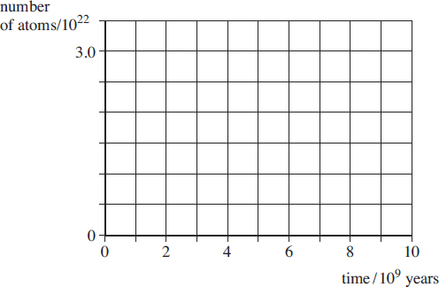

**(2)**

(ii)     A certain time, *t*, after its formation the sample contained twice as many  atoms as atoms.  
Show that the number of  atoms in the rock sample at time *t* was 2.0 × 1022.

**(1)**

(ii)     Calculate *t* in years.

answer = ____________________ years

**(3)**

**(Total 10 marks)**

# *Nuclear Fission*

Fission and fusion

*Fission occurs when a nucleus splits into two smaller nuclei*

We make fission happen by firing slow moving neutrons at Uranium 235, Plutonium 239 or Thorium 232 nuclei. We call this *induced fission*. In this processes the nucleus absorbs a neutron then splits to form two lighter nuclei, releases energy and any neutrons left over, usually 2 or 3.

Here is a possible equation for the fission of Uranium 235:

${}_{92}^{235}U+{}_{0}^{1}n→{}_{56}^{144}Ba+{}_{36}^{90}Kr+2{}_{0}^{1}n+\text{energy released,E}$

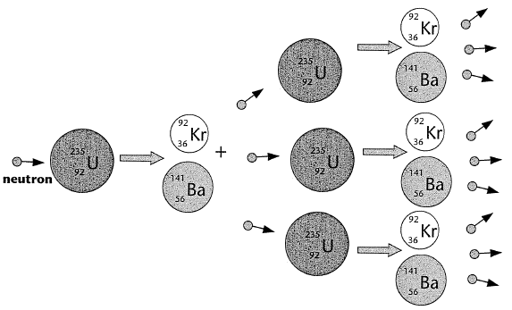

# *Chain Reaction*

In the above reaction two free neutrons were released, these can also be absorbed by two heavy nuclei and cause a fission process. These nuclei would release more neutrons which could cause further fissions and so on.

# *Critical Mass*

For a chain reaction to happen the mass of the fissionable material must be greater than a certain minimum value. This minimum value is known as the *critical mass* and is when the surface area to mass ratio is too small.

If mass < critical mass: more neutrons are escaping than are produced. Stops

If mass = critical mass: number of neutrons escaping = number of neutrons produced. Steady

If mass > critical mass: more neutrons are produced than are escaping. Meltdown

# *Nuclear Fusion*

*Fusion occurs when two nuclei join to form a bigger nucleus*

The two nuclei must have very high energies to be moving fast enough to overcome the electrostatic repulsion of the protons then, when close enough, the strong nuclear force will pull the two nuclei together.

Here is an example of the fusing of two hydrogen isotopes:

${}_{1}^{2}H+{}_{1}^{3}H→{}_{2}^{4}He+{}_{0}^{1}n+\text{energy released,E}$

# *Which Will Happen?*

Looking at the graph we can see the Iron 56 has the highest binding energy per nucleon, the most energy required to remove one proton or neutron from the nucleus. This makes it the most stable.

*Nuclei lighter than Iron will undergo fusion.*

Protons and neutrons feel the attraction of the strong nuclear force but only protons feel the repulsion of the electrostatic force. For light nuclei, adding an extra proton increases the strong nuclear force to pull the nucleon together. This is because at this range the s.n.f. force is stronger than the other three fundamental forces.

The nucleons move closer together 🡪 potential energy is lost 🡪 energy is given out

*Nuclei heavier than Iron will undergo fission.*

Beyond Iron, each proton that is added to the nuclei adds to the electrostatic repulsion. The bigger the nucleus become the less the outer protons feel the strong nuclear force from the other side. We can see the binding energy per nucleon decrease for heavier nuclei.

A big nucleus will break into two smaller nuclei, each being stronger bonded together due to the smaller size.

The nucleons move closer together 🡪 potential energy is lost 🡪 energy is given out.

*Fission – practice questions*

The process of fission in one type of nuclear reactor proceeds as follows: a nucleus of uranium  captures a single neutron. The resulting nucleus is unstable and splits into two or more fragments. These fragments could typically be a pair of nuclei,  and  for example. Neutrons are also ejected as a result of the fission. It is these neutrons that go on to cause subsequent fission events and maintain the chain reaction.

1. Write down two balanced equations (the first to the unstable uranium; the second to the final products) that represent this fission process.

2. Calculate the total mass of the original uranium isotope and the neutron. The table gives the atomic masses (in atomic mass units) of the particles found in this question. (1 atomic mass unit (u) = 931 MeV.)

| Particle | Mass (u) |
| --- | --- |
|  | 1.008 665 |
|  | 89.919 528 |
|  | 91.926 153 |
|  | 95.934 284 |
|  | 137.911 011 |
|  | 137.905 241 |
|  | 143.922 941 |
|  | 235.043 923 |

3. Calculate the total mass of the four products.

4. Calculate the change in mass. Does this represent energy gained or lost by the system?

5. Convert the mass change into the energy released (in MeV) in the fission event.

6. These particular barium and krypton isotopes are not the only products possible in nuclear fission. Repeat the calculation steps 1–5 with the following possible products: caesium-138 and rubidium-96.

*Fusion in a kettle?*

One of the reactions that fuel the stars is the fusion of two protons to give deuterium. In turn the deuterium goes through a series of reactions, the end product being helium. This is also a process that releases energy. In this question you are asked to consider the energy that would be released if all the deuterium in the water contained in an electric kettle were to be converted by fusion into helium.

The kettle contains 1 litre of water. The data you need are listed below.

1 atomic mass unit (u) = 931 MeV

1 eV = 1.6 × 10–19 J

NA = 6.02 × 1023 mol–1

| Particle | Mass / u |
| --- | --- |
|  | 1.007 825 |
|  | 2.014 102 |
|  | 3.016 030 |
|  | 1.008 665 |

1 Two deuterium nuclei can fuse to give one nucleus of helium  with the ejection of one other particle. Write down the balanced equation that represents this reaction.

2 Calculate the mass change that occurs in this reaction.

3 Convert this energy into joules.

This gives you the energy released when two deuterium nuclei fuse. The next steps take you through the calculation of the total energy released if all the deuterium in the kettle water were to fuse to make helium-3. The ratio of deuterium atoms to hydrogen in water is roughly 1 to 7000.

4 What is the mass of 1 mole of water (H = 1 u; O = 16 u roughly)?

5 How many moles of water are contained in the litre?

6 How many molecules of water (H2O) are in the kettle?

7 How many molecules of deuterium oxide (D2O) are in the kettle?

8 Each heavy water molecule has two atoms of deuterium; what total energy is released if all the deuterium in the kettle is converted to helium-3?

Now to put this number in a new perspective. It requires 4200 J to increase the temperature of 1kg of water by 1K.

9 How many litres of water could be heated through 100 K by the fusion energy you calculated in question 8?

**Q1.**

(a)     The unstable uranium nucleus  is produced in a nuclear reactor.

(i)      Complete the equation which shows the formation of .



(ii)      can decay by nuclear fission in many different ways. Complete the equation which shows one possible decay channel.



**(2)**

(b)     Calculate the energy released, in MeV, in the fission reaction.

atomic mass of  = 144.92694 u

___________________________________________________________________

___________________________________________________________________

___________________________________________________________________

___________________________________________________________________

**(3)**

**(Total 5 marks)**

**Q2.**

(a)     In the reactor at a nuclear power station, uranium nuclei undergo *induced fission* with *thermal neutrons*. Explain what is meant by each of the terms in italics.

___________________________________________________________________

___________________________________________________________________

___________________________________________________________________

___________________________________________________________________

___________________________________________________________________

**(3)**

(b)     A typical fission reaction in the reactor is represented by



(i)      Calculate *N*.

______________________________________________________________

(ii)     How do the neutrons produced by this reaction differ from the initial neutron that goes into the reaction?

______________________________________________________________

______________________________________________________________

(iii)    Calculate the energy released in MeV when one uranium nucleus undergoes fission in this reaction. Use the following data.

mass of neutron                                = 1.00867 u  
mass of 235U nucleus                        = 234.99333 u  
mass of 92Kr nucleus                        = 91.90645 u  
mass of 141Ba nucleus                      = 140.88354 u  
1 u is equivalent to 931 MeV

______________________________________________________________

______________________________________________________________

______________________________________________________________

______________________________________________________________

______________________________________________________________

**(5)**

**(Total 8 marks)**

**Q3.**

The diagram shows how the binding energy per nucleon varies with nucleon number.

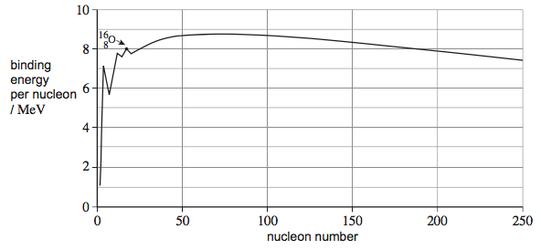

(a)     (i)      Fission and fusion are two nuclear processes in which energy can be released. Explain why nuclei that undergo fission are restricted to a different part of the graph than those that undergo fusion.

______________________________________________________________

______________________________________________________________

______________________________________________________________

______________________________________________________________

______________________________________________________________

______________________________________________________________

______________________________________________________________

**(2)**

(ii)     Explain, with reference to the diagram, why the energy released per nucleon from fusion is greater than that from fission.

______________________________________________________________

______________________________________________________________

______________________________________________________________

______________________________________________________________

______________________________________________________________

______________________________________________________________

______________________________________________________________

**(2)**

(b)     (i)      Calculate the mass difference, in kg, of the  nucleus.

mass of  nucleus = 15.991 u

mass difference = ____________________ kg

**(2)**

(ii)     Using your answer to part **(b)(i)**, calculate the binding energy, in MeV, of an oxygen  nucleus.

binding energy = ____________________ MeV

**(1)**

(iii)     Explain how the binding energy of an oxygen  nucleus can be calculated with information obtained from the diagram.

______________________________________________________________

______________________________________________________________

______________________________________________________________

**(1)**

**(Total 8 marks)**

**Q4.**

(a)     State what is meant by the binding energy of a nucleus.

___________________________________________________________________

___________________________________________________________________

___________________________________________________________________

**(2)**

(b)     (i)      When a  nucleus absorbs a slow-moving neutron and undergoes fission one possible pair of fission fragments is technetium  and indium .  
   
Complete the following equation to represent this fission process.



**(1)**

(ii)     Calculate the energy released, in MeV, when a single  nucleus undergoes fission in this way.

    binding energy per nucleon of  = 7.59 MeV

    binding energy per nucleon of  = 8.36 MeV

    binding energy per nucleon of  = 8.51 MeV

energy released ____________________ MeV

**(3)**

(iii)     Calculate the loss of mass when a  nucleus undergoes fission in this way.

loss of mass ____________________ kg

**(2)**

(c)     (i)      On the figure below sketch a graph of neutron number, *N*, against proton number, *Z*, for stable nuclei.

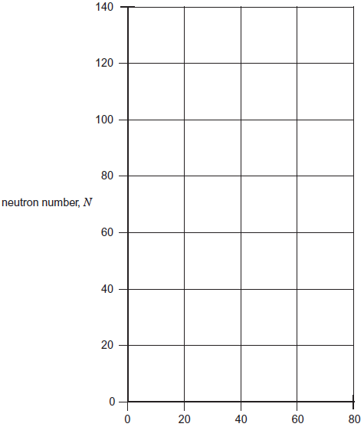                      
                proton number, *Z*

**(1)**

(ii)     With reference to the figure, explain why fission fragments are unstable and explain what type of radiation they are likely to emit initially.

______________________________________________________________

______________________________________________________________

______________________________________________________________

______________________________________________________________

______________________________________________________________

______________________________________________________________

______________________________________________________________

**(3)**

**(Total 12 marks)**

# *Making Electricity*

Nuclear reactors

This is a typical nuclear fission reactor.

A nuclear power station is similar to a power station powered by the combustion of fossil fuels or biomass. In such a station the fuel is burnt in a boiler, the heat this produces it uses to heat water into steam in the pipes that cover the roof and walls of the boiler. This steam is used to turn a turbine which is connected to a generator that produces electricity. Steam enters the cooling towers where is it condensed into water to be used again.

In a nuclear fission reactor the heat is produced in a different way.

# *Components of a Nuclear Reactor*

***Fuel Rods***

This is where nuclear fission reactions happen. They are made or Uranium and there are hundreds of them spread out in a grid like pattern.

Natural Uranium is a mixture of different isotope. The most common are U238 which accounts for 99.28% and U235 which accounts for only 0.72% of it. 238 will only undergo fission when exposed to very high-energy neutrons whilst 235 will undergo fission much more easily. The Uranium that is used in fuel rods has a higher percentage of 235 and is said to be ***enriched***. This is so more fission reactions may take place.

***Moderator***

**Role:** The neutrons that are given out from nuclear fission are travelling too fast to cause another fission process. They are released at 1 x 107 m/s and must be slowed to 2 x 103 m/s, losing 99.99975% of their kinetic energy. The neutrons collide with the atoms of the moderator which turns the kinetic energy into heat.

Neutrons that are travelling slow enough to cause a fission process are called ***thermal neutrons***, this is because they have the same amount of kinetic energy as the atoms of the moderator (about 0.025 eV at 20°C).

**Factors affecting the choice of materials:** Must have a low mass number to absorb more kinetic energy with each collision and a low tendency to absorb neutrons so it doesn’t hinder the chain reaction.

**Typical materials**: graphite and water.

***Coolant***

**Role:** Heat is carried from the moderator to the heat exchanger by the coolant. The pressuriser and the pump move the hot coolant to the heat exchanger, here hot coolant touches pipes carrying cold water. Heat flows from hot coolant to cold water turning the water into steam and cooling the coolant. The steam then leaves the reactor (and will turn a turbine) as the coolant return to the reactor.

**Factors affecting the choice of materials**: Must be able to carry large amounts of heat (L11 The Specifics), must be gas or liquid, non-corrosive, non-flammable and a poor neutron absorber (less likely to become radioactive).

**Typical materials:** carbon dioxide and water.

***Control rods***

**Role:** For the reactor to transfer energy at a constant rate each nuclear fission reaction must lead to one more fission reaction. Since each reaction gives out two or more we must remove some of the extra neutrons. The control rods absorb neutrons, reducing the amount of nuclear fission processes occurring and making the power output constant. They can be lowered further into the fuel rods to absorb more neutrons and further reduce the amount of fission occurring. Some neutrons leave the reactor without interacting, some travel too fast while other are absorbed by U238 nuclei. If we need more neutrons we can raise the control rods.

**Factors affecting the choice of materials:** Ability to absorb neutrons and a high melting point.

**Typical materials:** boron and cadmium.

**Q1.** Fill in the blanks below.

N___________ reactors use rods of u___________ that are rich in ²³⁵U as “fuel” for f___________ reactions. These fission reactions produce more n___________ which induce other nuclei to fission – this is called a c__________ r___________.

The neutrons will only cause a chain reaction if they are s___________ down, which allows them to be captured by the uranium nuclei. Fuel rods need to be placed in a moderator (for example water or g___________) to slow down and/or absorb neutrons. Coolant is sent around the reactor to remove heat produced by the fission. Often, the same w_________ that is being used in the reactor as a m___________ is used. The heat from the reactor can be used to make s___________ for powering e___________ generating turbines.

The chain reaction needs to continue at a steady rate. C__________ r_________ control the chain reaction by limiting the number of neutrons in the reactor. They are made of a material that a__________ neutrons, such as boron, and can be inserted by varying amounts to control the chain reaction. The nuclear reactor is surrounded by a thick c___________ case, which acts as shielding. This prevents radiation escaping and reaching the people working in the power station.

In an e___________, the r___________ can be shut down automatically by the release of control rods into the reactor. The control rods are l___________ fully into the reactor, which slows down the reaction as quickly as possible.

**emergency absorb lowered neutrons graphite electricity chain reaction reactor fission steam concrete control rods slowed nuclear uranium moderator water**

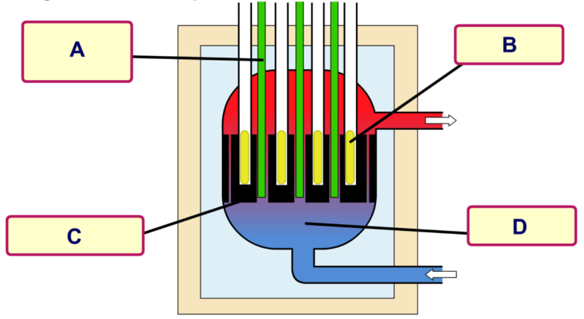**Q2.** From the words below label the nuclear reactor.

**Control rods, fuel rods, moderator, coolant**

**Q3.** State the purpose of each of the labels in Q1.

**Q4.** Why is the reactor encased in thick concrete?

**Q5.** Why is the cooling water contained within the reactor instead of it being allowed to cool in the cooling towers?

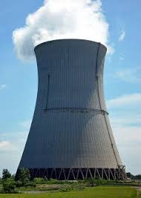**Q6.** Explain the roles of the turbine and generator.

**Q7.** You drive past a nuclear power plant that looks like the image to the right. What is coming out of the tower and entering the air? Is it radioactive?

Congratulations! The owners of the school nuclear power plant are impressed with your knowledge of nuclear reactors and want you to be in charge of the school’s very own reactor.

**Q8**. a) Uh-oh! It’s your first day and the reactor is overheating and in danger of going into meltdown. Describe what you need to do to the control rods to slow the chain reaction down. Explain why.

b) Success! The reaction has been slowed down but is now not generating enough electricity for the school. What do you need to do to the control rods now?

**Q9.** All nuclear power plants have backup generators in case the plant stops producing electricity. Why is this necessary? What exactly are the generators providing power for? What might happen if these backup generators fail?

Fission in a nuclear reactor – how the mass changes

Some rather harder questions

These extended questions will test your ability to deal with calculations involving the physics of nuclear fission.

Use the following conversions and values for some of the questions:

* 1 eV = 1.6 × 10–19 J
* 1 atomic mass unit = 1.66 × 10–27 kg
* *c* = 3 × 108 m s–1

| Particle | Mass (u) |
| --- | --- |
|  | 235.043 94 |
|  | 1.007 825 |
|  | 3.016 030 |
|  | 1.008 665 |

Magnox power stations can transfer about 20 TW h of energy electrically in the UK every year due to the fission of uranium. (This is sufficient, approximately, to meet the electrical needs of Greater London.)

1 The moving fission fragments heat the gas that circulates in the reactor core, increasing the energy stored thermally. The process of shifting the energy stored thermally to the energy transferred electrically has an efficiency of 40%. How much energy, in joules, is transferred each second from the company’s reactors?

2 Each fission releases about 200 MeV of energy. How many atoms of  need to fission in each second to transfer the energy you calculated in question 1?

3 What was the mass of these atoms before they underwent fission?

4 What is the total mass change due to fission in Magnox reactors each second?

In the pressurised water reactor (PWR) the fuel rods do not contain pure. The uranium comes from mined ore that contains a mixture of  and. The fuel delivered to the reactor contains 0.7% of. The fuel rod stays in the reactor for about 3 years and is then removed to allow reprocessing.

This time consider just **one** reactor with an output of 1 GW.

5 Calculate the number of uranium nuclei disintegrating every second.

6 Calculate the mass of  that undergoes fission every second.

7 Estimate the mass of  required in the core for a 3 year cycle.

8 Estimate the total mass of both uranium isotopes required in the core for a 3 year cycle.

9 Is your estimate in question 8 likely to be an upper or a lower limit?

**Q1.**

(a)    Describe the changes made inside a nuclear reactor to reduce its power output and explain the process involved.

___________________________________________________________________

___________________________________________________________________

___________________________________________________________________

___________________________________________________________________

**(2)**

(b)     State the main source of the highly radioactive waste from a nuclear reactor.

___________________________________________________________________

___________________________________________________________________

**(1)**

(c)     In a nuclear reactor, neutrons are released with high energies. The first few collisions of a neutron with the moderator transfer sufficient energy to excite nuclei of the moderator.

(i)      Describe and explain the nature of the radiation that may be emitted from an excited nucleus of the moderator.

______________________________________________________________

______________________________________________________________

______________________________________________________________

______________________________________________________________

**(2)**

(ii)     The subsequent collisions of a neutron with the moderator are elastic.

Describe what happens to the neutrons as a result of these subsequent collisions with the moderator.

______________________________________________________________

______________________________________________________________

______________________________________________________________

______________________________________________________________

**(2)**

**(Total 7 marks)**

**Q2.**

A rod made from uranium−238 (U) is placed in the core of a nuclear reactor where it absorbs free neutrons.  
When a nucleus of uranium−238 absorbs a neutron it becomes unstable and decays to neptunium−239 (Np), which in turn decays to plutonium−239 (Pu).

(a)     Write down the nuclear equation that represents the decay of neptunium−239 into plutonium−239.

**(2)**

(b)     A sample of the rod is removed from the core and its radiation is monitored from time *t* = 0 s.  
The variation of the activity with time is shown in the graph.

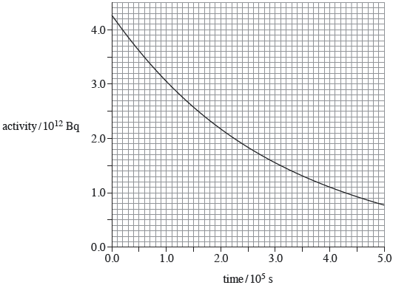

(i)      Show that the decay constant of the sample is about 3.4 × 10–6 s–1.

**(2)**

(ii)     Assume that the activity shown in the graph comes only from the decay of neptunium.

Estimate the number of neptunium nuclei present in the sample at time *t* = 5.0 × 105 s.

number of nuclei ____________________

**(1)**

(c)     (i)      A chain reaction is maintained in the core of a thermal nuclear reactor that is operating normally.

Explain what is meant by a chain reaction, naming the materials and particles involved.

______________________________________________________________

______________________________________________________________

______________________________________________________________

______________________________________________________________

**(2)**

(ii)     Explain the purpose of a moderator in a thermal nuclear reactor.

______________________________________________________________

______________________________________________________________

______________________________________________________________

______________________________________________________________

______________________________________________________________

______________________________________________________________

**(2)**

(iii)    Substantial shielding around the core protects nearby workers from the most hazardous radiations. Radiation from the core includes α and β particles, γ rays, X−rays, neutrons and neutrinos.

Explain why the shielding becomes radioactive.

______________________________________________________________

______________________________________________________________

______________________________________________________________

______________________________________________________________

**(2)**

**(Total 11 marks)**

# *Nuclear Reactor Safety*

Nuclear safety aspects

There are many safety features and controls in place designed to minimise the risk of harm to humans and the surrounding environment.

***Fuel Used***

Using solids rather than liquids avoids the danger of leaks or spillages. They are inserted and removed from the reactor by remote controlled handling devices.

***Shielding***

The reactor core (containing the fuel, moderator and control rods) is made from steel and designed to withstand high temperatures and pressures.

The core itself is inside a thick, leak proof concrete box which absorbs escaping neutrons and gamma radiation.

Around the concrete box is a safety area, not to be entered by humans.

***Emergency Shut-down***

There are several systems in place to make it impossible for a nuclear disaster to take place:

If the reactor needs stopping immediately the control rods are inserted fully into the core, they absorb any neutrons present and stop any further reactions from happening.

Some reactors have a secondary set of control rods held up by an electromagnet, so if a power cut happens the control rods fall into the core.

If there is a loss of coolant and the temperature of the core rises beyond the safe working limits an emergency cooling system floods the core (with nitrogen gas or water) to cool it and absorb any spare neutrons.

# *Nuclear Waste Disposal*

There are three levels of waste, each is produced, handled and disposed of in different ways:

***High-level Radioactive Waste***

**What it is?** Spent fuel rods from the reactor and unwanted, highly radioactive material separated from the spent fuel rods.

**How do we get rid?** The spent fuel rods are taken from the reactor and stored in cooling ponds with in the power station to allow most of the short-term radioactivity to die away. It is then transported to a processing plant. Here it is encased in steel containers and kept under water.

The cladding is eventually removed and the fuel rods are separated into unused uranium and plutonium and highly radioactive waste.

The uranium and plutonium is kept in sealed container for possible future use.

The waste is converted into powder, fused into glass blocks, sealed in air-cooled containers for around 50 years before being stored deep underground in a stable rock formation.

**Time scale?** Up to a year in the cooling ponds. Radioactive waste can remain at dangerous levels for thousands of years.

***Intermediate-level Radioactive Waste***

**What it is?** Fuel element cladding, sludge from treatment processes, contaminated equipment, hospital radioisotopes and containers of radioactive materials.

**How do we get rid?** Sealed in steel drums that are encased in concrete and stored in buildings with reinforced concrete. Also stored deep underground in a suitable location that has a stable rock formation and low water flow.

**Time scale?** Thousands of years.

***Low-level Radioactive Waste***

**What is it?** Worn-out laboratory equipment, used protective clothing, wrapping material and cooling pond water.

**How do we get rid?** Sealed in metal drums and buried deep underground in a supervised repository. Treated cooling pond water is released into the environment.

**Time scale?** A few months.

**Q1.**

The core of a thermal nuclear reactor contains a number of components that are exposed to moving neutrons.

(a)     State what happens to a neutron that is incident on the moderator.

___________________________________________________________________

___________________________________________________________________

**(1)**

(b)     State what happens to a neutron that is incident on a control rod.

___________________________________________________________________

___________________________________________________________________

**(1)**

(c)     A slow-moving neutron is in collision with a nucleus of an atom of the fuel which causes fission.

Describe what happens in the process.

___________________________________________________________________

___________________________________________________________________

___________________________________________________________________

___________________________________________________________________

___________________________________________________________________

___________________________________________________________________

___________________________________________________________________

___________________________________________________________________

**(3)**

(d)     A thermal nuclear reactor produces radioactive waste.

State the source of this waste and discuss some of the problems faced in dealing with the waste at various stages of its treatment.

Your answer should include:

•        the main source of the most dangerous waste

•        a brief outline of how waste is treated

•        problems faced in dealing with the waste, with suggestions for overcoming these problems.

___________________________________________________________________

___________________________________________________________________

___________________________________________________________________

___________________________________________________________________

___________________________________________________________________

___________________________________________________________________

___________________________________________________________________

___________________________________________________________________

___________________________________________________________________

___________________________________________________________________

___________________________________________________________________

___________________________________________________________________

**(6)**

***Acknowledgements:***

The notes in this booklet come from TES user dwyernathaniel. The original notes can be found here:

<https://www.tes.com/teaching-resource/a-level-physics-notes-6337841>

Some questions in the ionising radiation section come from Bernard Rand (@BernardRand). His original resources can be found here:

<https://drive.google.com/drive/folders/1-2qNVLwGzJ_7AjQK9N0z4BQBIRmSHAwG>

Questions in the radioactive decay section come from the IoP TAP project. The original resources can be found here:

<https://spark.iop.org/episode-515-radioactive-decay-formula#gref>

Questions in the size of the nucleus section come from the IoP TAP project. The original resources can be found here:

<https://spark.iop.org/episode-522-size-nucleus#gref>

Questions in the mass and energy section come from the IoP TAP project. The original resources can be found here:

<https://spark.iop.org/episode-525-binding-energy>

Questions in the nuclear fission section come from the IoP TAP project. The original resources can be found here:

<https://spark.iop.org/collections/nuclear-fission>