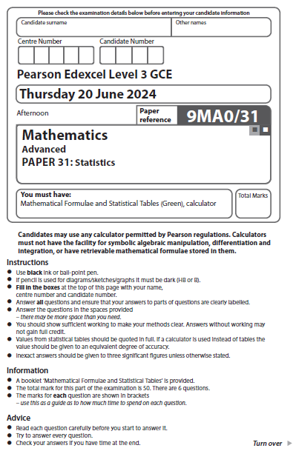
Hypothesis testing
1.
An ordinary six sided die is suspected of being biased.
It is believed that the probability of getting a 6 is 10%.
The die is rolled 10 times.
Explain why there is no critical region for a test at the 5% significance level unless it is rolled more times.
(Total 2 Marks) ___________________________________________________________________________

2.
A researcher wants to investigate whether there is a positive linear correlation between the number of hours students spend studying per week and their exam scores.
He collects data from a random sample of 12 students and calculates the product moment correlation coefficient, r, to be 0.63
For a 1-tailed test at the 5% significance level the critical value of r is 0.4973
State the conclusion to this test in context. Give a reason for your answer.
(Total 2 Marks) ___________________________________________________________________________

3.
A single observation is taken from the distribution X ~B(35, p).
It is assumed that p = 0.3
The observation is found to be 15
Test, at the 5% level of significance, whether there is evidence to suggest that p > 0.3
(Total 4 marks) ___________________________________________________________________________

4.
A rugby coach measured the height and weight of all 30 players in their squad.
The product moment correlation coefficient between height and weight was calculated to be 0.57
Stating your hypotheses clearly, test, at the 5% significance level, whether there is evidence of any correlation between height and weight of the rugby players.
(Total 4 Marks) ___________________________________________________________________________

5.
A manufacturing company believes that one of their machines is producing f faulty parts, with probability p.
A faulty part is defined as one that cannot withstand a force of 50Nm.
To test their belief the company takes a random sample of 40 parts produced by the machine and tests them to destruction.
- Give two reasons why the company could model their findings using a binomial distribution.
(2)
- Explain why the company would not test every part that the machine produces.
(1)
The company will only operate the machine if the chance of it producing a faulty item is at most 0.05
Following the testing the company finds that 5 of the parts were faulty.
- Test at the 5% significance level, whether the company should stop operating the machine.
State your hypotheses clearly.
(5)
(Total 8 Marks) ___________________________________________________________________________

6.
The proportion of adults in a population that have a particular allergy increases with the levels of pollution.
In a particular town, 20% of adults have the allergy. A researcher regularly selects 50 adults at random and uses them as a pollution indicator.
What number of adults with the allergy will need to be found in the sample so that they can say, at the 5% significance level, that the pollution level has increased?
State your hypotheses clearly.
(Total 5 Marks) ___________________________________________________________________________

7.
All the adult members of a gym were surveyed.
It was found that their weights were normally distributed with a mean of 86.4kg and standard deviation 4.2kg
(a) Find the proportion of adult gym members that weigh less than 88kg.
(1)
An instructor at the gym claimed that the mean weight of adults in the local area who were not gym members was different to those that are.
A random sample of 30 adults who were not gym members had a mean weight of 88kg. The standard deviation for both gym members and non-members was 4.2kg.
(b) Use a suitable test to assess the instructor’s claim. Use a 5% level of significance and state your hypotheses clearly.
(5)
(c) Find the p-value for the test in part (b)
(1)
(Total 7 Marks) ___________________________________________________________________________

8.
Past data shows that the time taken by students at a school to run 200m can be modelled using the normal distribution $N\left(32.6, {4.9}^{2}\right)$.
Following a change to the track surface, the mean time to run the 200m by a random sample of 40 students is found to be 31.3 seconds.
Assuming that the standard deviation remains at 4.9, test at the 5% significance level whether there is evidence of a change in the mean time taken by students to run 200m.
State your hypotheses clearly.
(Total 6 Marks) ___________________________________________________________________________

9.
Following a staff survey a company states that employees spend a mean of 86 minutes every working day responding to emails.
The mean time follows a normal distribution and the standard deviation is found to be 16 minutes.
The company takes a random sample of 80 employees and finds their mean time responding to emails every working day to be 82 minutes.
The company claims that the mean time employees spend replying to emails each working day is less than the 86 minutes reported in the survey.
Test the claim at the 5% significance level.
State your hypotheses clearly.
(Total 6 Marks) ___________________________________________________________________________

10.
A company packs herbal tea into sachets.
The amount of tea in each sachet follows a normal distribution with a mean of 2.5g and standard deviation 0.05g.
The packaging machine is recalibrated and the standard deviation is now 0.06g.
Following the recalibration, Lucas suspects that the mean amount of tea in the sachets has decreased.
He takes a sample of 30 sachets and finds that the mean amount of tea in the sample is 2.47g.
Test Lucas' suspicion at the 1% level of significance.
You should state your hypotheses clearly.
(Total 6 Marks) ___________________________________________________________________________
___________________________________________________________________________
TOTAL FOR PAPER: 50 MARKS

