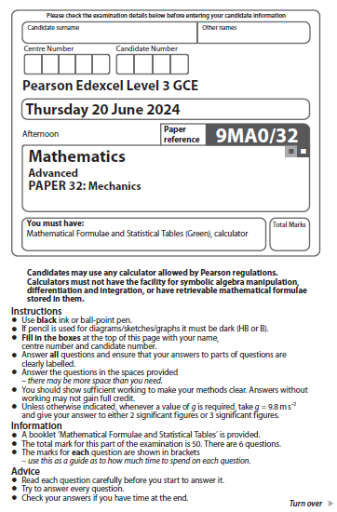
Forces and Newton’s Laws

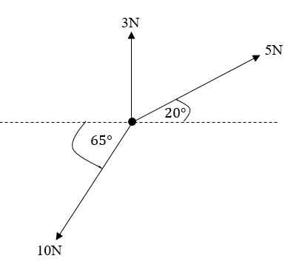
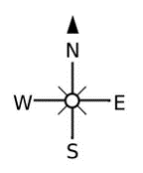
- A particle has three horizontal forces acting on it, as shown in Figure 1 below.
Figure 1

Find the magnitude of the resultant of the three forces.
(Total for Question 1 is 5 marks)
_____________________________________________________________________

- A scooter of mass 80 kg accelerates in a straight line along a rough horizontal plane at 0.8 ms⁻². The scooter exerts a driving force of 265 N and experiences a constant air resistance of 42 N. Modelling the scooter as a particle, find the coefficient of friction, $μ,$ between the scooter and the plane.
(Total for Question 2 is 5 marks)
_____________________________________________________________________

- A toy truck of mass 0.5 kg sits at the top of a rough ramp with an incline of $30°$ to the horizontal, as shown in Figure 2. The truck is released from rest.
The coefficient of friction between the ramp and the truck is 0.4
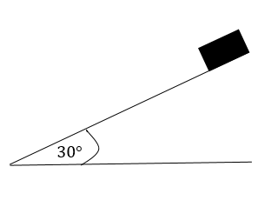

Figure 2
Assuming no air resistance,
- find the acceleration of the truck.
(6)
In reality there will be air resistance.
- What effect will this have on your answer to part a) ?
(1)
(Total for Question 3 is 7 marks) _____________________________________________________________________
- Two particles, A and B, are attached to the ends of a light inextensible string. The string passes over a small fixed smooth pulley and the particles hang vertically on either side of with the string taut.
Particles A and B have masses 6 kg and x kg respectively.
The system is released from rest and A accelerates downwards at 1.4 ms⁻².
Given that in the subsequent motion, A does not reach the ground and B does not reach the pulley find,

- the tension in the string
(3)
- the value of x.
(2)
(Total for Question 4 is 5 marks) _____________________________________________________________________

- A car of mass 1200 kg is towing a trailer of mass 850 kg along a straight horizontal road. The car experiences a constant resistance of magnitude 180 N and the trailer a constant resistance of magnitude 240 N. The tow rope is light and inextensible and remains taut and horizontal throughout.
Given that the driving force acting on the car is 850 N, find

- the acceleration of the system, giving your answer to 2 d.p.
(2)
- the tension in the tow rope.
(2)
(Total for Question 5 is 4 marks) _____________________________________________________________________

- Two blocks, A and B, are attached to the ends of a light inextensible string. The string passes over a small smooth fixed pulley. Block A is held at rest on a rough inclined plane which is at angle of 26º to the horizontal and block B hangs vertically over the pulley, as shown in Figure 3. Blocks A and B are modelled as particles with masses of 5 kg and 4 kg respectively. The coefficient of friction between the plane and A is 0.3.
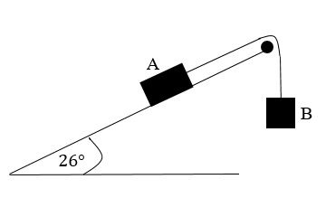

Figure 3

The system is released from rest and block B descends.
Find
- the acceleration of block A.
- the tension in the string.
(Total for Question 6 is 11 marks) _____________________________________________________________________

- A trailer of mass 500 kg is towed up a hill by a car of mass 1000 kg. The car drives up a line of greatest slope of the hill which is inclined at$θ$ to the horizontal, where $\sin{(}θ)= \frac{5}{13}$. The tow rope is modelled as light and inextensible.

The trailer experiences a constant resistance to motion of magnitude 220 N and the car a constant resistance of magnitude 175 N.
Given that the tow rope remains taut and the car accelerates at $0.8 ms^{-2}$, find
- the tension in the tow rope
(3)
- the driving force of the car
(3)
(Total for Question 7 is 6 marks) _____________________________________________________________________
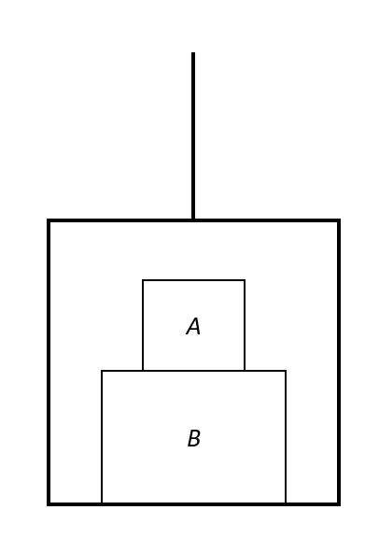
8.

Figure 4
Two stacked boxes A and B are placed in a lift being hoisted by a cable, as shown in Figure 4. The masses of A and B are 4 kg and 6 kg respectively and the lift has a mass of 10 kg.
Given that the system is accelerating upwards at $2 m s^{-2}$ find,
- the tension in the cable,
(2)
- the magnitude of the normal reaction exerted by B on A,
(2)
- the magnitude of the normal reaction exerted by the platform on B.
(3)
(Total for Question 8 is 7 marks) ___________________________________________________________________________
___________________________________________________________________________
TOTAL FOR PAPER: 50 MARKS

