9MA0-32 – Forces and Newton’s Laws
Worked Solutions

$x=5\cos\left(20\right)-10\cos\left(65\right)=0.4722…$

$y=3+5\sin\left(20\right)-10\sin\left(65\right)= -4.3529…$

$$R^{2}=x^{2}+y^{2 }=19.1714…$$

$$R=4.3785…$$

The resultant force has magnitude 4.38N

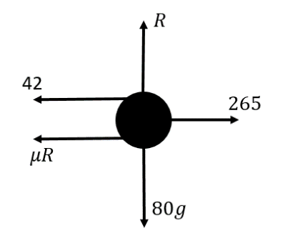
- Normal reaction force = 80g

Using Newton’s 2nd law
$$265-42-μ\left(80g\right)=80*0.8$$
$$μ\left(80g\right)=265-42-80*0.8=159$$
$$μ= \frac{159}{80g}=0.2028…$$
$$μ=0.203$$

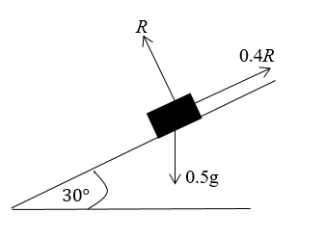
- $R=0.5g\cos\left(30\right)=\frac{49\sqrt{3}}{20}$

$0.5g\sin\left(30\right)-0.4R=0.5a$
$$a=1.5051…$$
The acceleration of the truck is 1.51ms⁻²
- The value of $a$ will decrease.
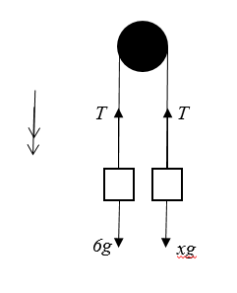
- a) $6g-T=6*1.4$
$$T=6\left(9.8-1.4\right)=50.4$$
The tension is 50.4N
b) $T-xg=x*1.4$
$x=\frac{50.4}{9.8+1.4}=4.5$

- a) For the entire system:
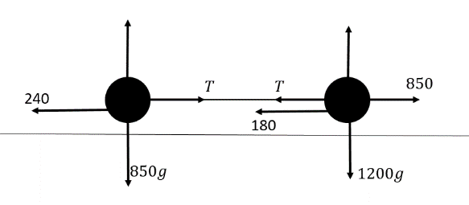
$850-420=2050a$
$$a=0.2097…$$
The acceleration is 0.21ms⁻² to 2d.p.

b) For the trailer:
$$T-240=850a$$
$$T=418.292…$$
The tension is 420N to 2d.p.

- a) For A:

$$R=5g\cos\left(26\right)$$
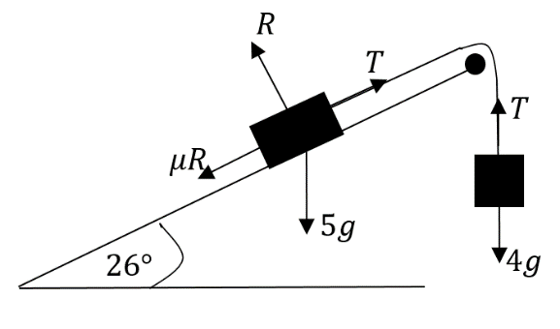
$$T-5g\sin\left(26\right)-0.3*5g\cos\left(26\right)=5a$$

For B:
$$4g-T=4a$$

Adding gives
$$9a=4.5075…$$
$$a=0.5008…$$
The acceleration is 0.501 ms⁻² to 3sf.
b) $T=4\left(a+g\right)=37.196$
The tension is 37.2N to 3sf.
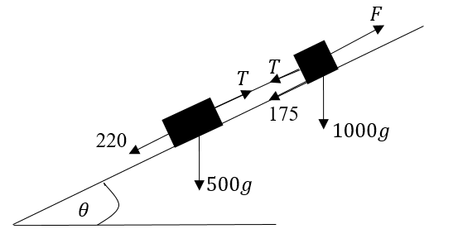
- a) For the trailer:
$$T-220-500g\sin\left(θ\right)=500*0.8$$
$T=2504.615…$
The tension is 2500N to 3sf.

b) For the car alone:
$$F-T-175-1000g*\frac{5}{13}=1000*0.8$$
$$F=7248.846…$$
The driving force is 7250N to 3sf.

- a) $T-20g=20*2$
$$T=236$$
The tension is 236N

b) $R-4g=4*2$
$R=47.2$
The normal reaction is 47.2N

c) $S-R-6g=6*2$
$$S=R+6g+12=118$$
The Normal reaction is 118N

