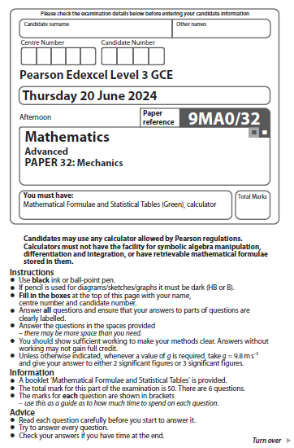
Moments

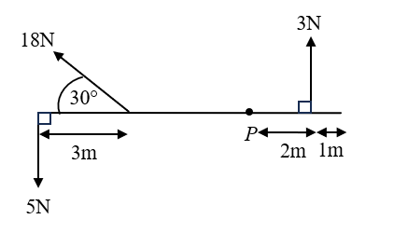
1.

Figure 1
Figure 1 shows three forces acting on a light rod of length 10 m. The rod and the three forces all lie in the same vertical plane. The 5 N and 3 N forces are perpendicular to the rod.
Calculate the magnitude of the resultant moment of the three forces about P, stating the units of your answer.
(Total for Question 1 is 5 marks)
___________________________________________________________________________
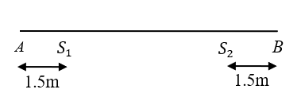
2.

Figure 2
A beam AB has length 7 m and mass 15 kg. The beam rests in equilibrium in a horizontal position on two supports at the points $S_{1}$ and $S_{2}$, where A$S_{1}$ = 1.5 m and $S_{2}$B = 1.5 m, as shown in Figure 2.
When Tracey, who has mass M kg, stands on the beam at a point which is 1m from A, the beam remains horizontal and in equilibrium and the magnitude of the normal reaction on the beam at $S_{2}$ is 49 N.
- The beam is modelled as a uniform rod
- Tracey is modelled as a particle

- Draw a diagram to show all forces acting on the beam.
(2)
- Find the value of M.
(4)
- Find the magnitude of the normal reaction on the beam at $S_{1}$
(2)
- State how you have used the fact that the beam is modelled as a rod.
(1)
- State how you have used the fact that Tracey is modelled as a particle.
(1)
(Total for Question 2 is 10 marks)
_______________________________________________________________________________
3.
5 m

A M B

Figure 3
Steve and Helen are playing on a seesaw in a playground. The seesaw consists of a beam $AB$of length 5 m and mass 25 kg which is supported by a smooth pivot at its midpoint $M$, as shown in Figure 3.
Helen has mass 28 kg and sits at end $A$.
Steve has mass 32 kg. He assumes that the beam is uniform and calculates where he must sit for the seesaw to be horizontal and in equilibrium.
- State what is implied by Steve’s assumption
(1)
- How far from $B$ does Steve calculate he must sit?
(4)
In fact, when Steve does sit at this calculated point the seesaw starts to tilt.
Given that the resultant moment about $M$is 98 Nm clockwise,
- find the distance of the centre of mass of the beam from $A$ .
(4)
(Total for Question 3 is 9 marks)
___________________________________________________________________________

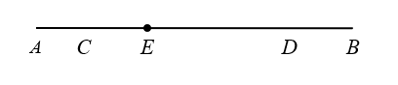
4.

Figure 4
A non-uniform rod has length 10 m and mass 18 kg. The centre of mass of the rod is at the point E. The rod is suspended by two light inextensible strings, one at $C$ and one at $D$, and hangs in equilibrium in a horizontal position. The string at C is inclined at an angle $θ$ to the rod and the string at D is inclined at an angle $α$ to the rod, as shown in Figure 4.
$AC=CE= DB=2$m and $\tan{θ}=\frac{3}{4}$
- Show that the tension in the string at C is 196 N.
(4)
- Find the value of $\tan{α}$
(6)
When a mass of M kg is attached to the rod at $B,$ the rod is on the point of tilting about $D$.
- Find the value of $M$
(4)
(Total for Question 4 is 14 marks)
___________________________________________________________________________
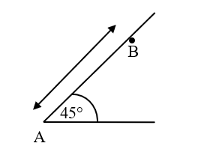
5.
$4.5a$

Figure 5
A ladder is resting in limiting equilibrium with its end A on rough horizontal ground. The ladder rests against a branch of a tree at B. The ladder is inclined at $45°$ to the ground, as shown in Figure 5.
The coefficient of friction between the ladder and the ground is.
- The ladder is modelled as a uniform rod of length 6$a$and mass 21 kg
- The branch is modelled as a small smooth horizontal peg
- The rod lies in a vertical plane perpendicular to the peg.
(a) Find the magnitude of the normal reaction of the branch on the ladder.
(3)
- Find the value of .
(6)
- State three ways in which the model could be refined.
(3)
(Total for Question51 is 12 marks)
___________________________________________________________________________
___________________________________________________________________________
TOTAL FOR PAPER: 50 MARKS

