1 A light see-saw is 10 m long with the pivot 3 m from the left.
Figure 1
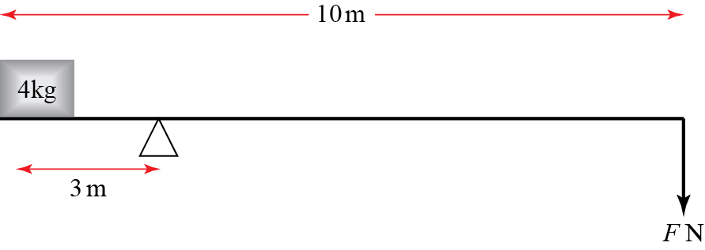
a A 4 kg weight is placed on the left-hand end of the see-saw. Write down the anticlockwise moment about the pivot. (3 marks)
b A force of magnitude F N is applied to the right-hand end of the see-saw. The force acts vertically downwards. Write down the clockwise moment about the pivot due to this weight. (1 mark)
c Find the value of F for which the system is in equilibrium. (3 marks)
2 Alice, who weighs 50 kg, sits on the right-hand end of a light see-saw. Bob, who weighs 80 kg, stands on the opposite side at a distance x m from the end. The length of the see-saw is 4 m and it pivots about its centre.
Figure 2
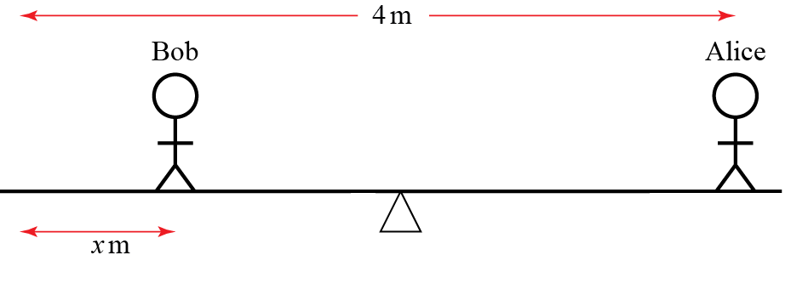

a Draw a diagram showing the forces acting on the see-saw due to the two people. Label the value of each force in newtons. (2 marks)
b Write down the total clockwise moment about the centre in terms of x. (5 marks)
c Find the value of x for which the see-saw is in equilibrium. (2 marks)
d Given that Bob remains on the opposite side to Alice, describe with inequalities the range of x for which the see-saw tilts towards Alice. (2 marks)
e Describe one limitation of this model. (1 mark)

3 A 5000 kg bus hangs 12 m over the edge of a cliff and has 1000 kg of gold at the front. The gold sits on a wheeled cart. A group of n people, each weighing 70 kg, stands at the other end. The bus is 20 m long.
Figure 3
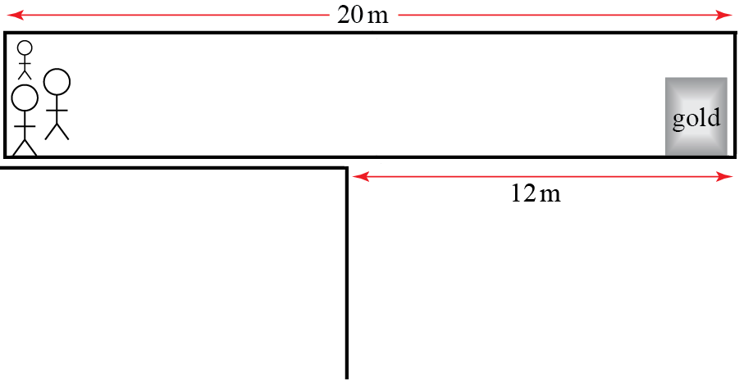
a Write down the total clockwise moment about the cliff edge in terms of n. (7 marks)
b Find the smallest number of people needed to stop the bus falling over the cliff. (2 marks)
c One person needs to walk to the end of the bus to retrieve the gold. Find the smallest number of people needed to stop the bus falling over the cliff in this situation, including the one retrieving the gold. (4 marks)
4 Two interlocking gears are in equilibrium. The gear on the right has a radius of 10 cm and has a loop 8 cm from the centre. The loop is to the right of, and level with the centre of the gear. A 10 kg mass hangs from the loop. The other gear has a radius of 5 cm and a loop 2 cm from the centre. The loop is to the left of, and level with the centre of the gear. A mass M kg hangs from the left loop.
Figure 4
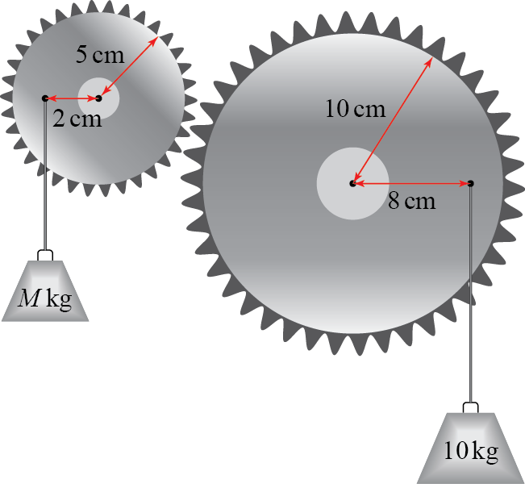
Find the value of M. (10 marks)

5 Two identical 5 m light see-saws are joined at their ends. Robert, who weighs 80 kg, stands on top of the joint. The distance between Robert and each of the pivots is 2 m. Poppy and Quentin stand on the two remaining ends of the see-saws. Poppy weighs p kg and Quentin weighs q kg. The system is in equilibrium.
Figure 5
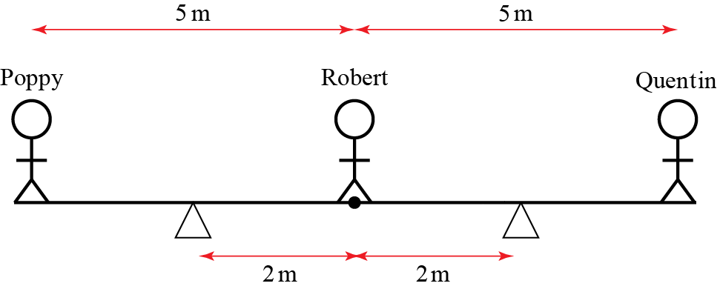
Show that, to the nearest whole number, p + q = 53 (8 marks)

