1 The distributions for the heights for a sample of females and males at a UK university can be modelled using normal distributions with mean 165 cm, standard deviation 9 cm and mean 178 cm, standard deviation 10 cm respectively.
A female’s height of 177 cm and a male’s height of 190 cm are both 12 cm above their means. By calculating z-values, or otherwise, explain which is relatively taller. (4 marks)
2 A certain type of cabbage has a mass M which is normally distributed with mean 900 g and standard deviation 100 g.
a Find P(M < 850) (1 mark)
10% of the cabbages are too light and 10% are too heavy to be packaged and sold at a fixed price.
b Find the minimum and maximum weights of the cabbages that are packaged. (3 marks)
3 In a town, 54% of the residents are female and 46% are male. A random sample of 200 residents is chosen from the town. Using a suitable approximation, find the probability that more than half the sample are female. (6 marks)
4 The heights of a population of men are normally distributed with mean μ cm and standard deviation σ cm. It is known that 20% of the men are taller than 180 cm and 5% are shorter than 170 cm.
a Sketch a diagram to show the distribution of heights represented by this information. (3 marks)
b Find the value of μ and σ. (7 marks)
c Three men are selected at random, find the probability that they are all taller than 175 cm. (2 marks)
5 a State the conditions under which the normal distribution may be used as an appoximation to the binomial distribution X ~ B(n, p). (2 marks)
b Write down the mean and variance of the normal approximation to X in terms of n and p. (2 marks)
A manufacturer claims that more than 55% of its batteries last for at least 15 hours of continuous use.
c Write down a reason why the manufacturer should not justify their claim by testing all the batteries they produce. (1 mark)
To test the manufacturer’s claim, a random sample of 300 batteries were tested.
d State the hypotheses for a one-tailed test of the manufacturer’s claim. (1 mark)
e Given that 184 of the 300 batteries lasted for at least 15 hours of continuous use a normal approximation to test, at the 5% level of significance, whether or not the manufacturer’s claim is justified. (7 marks)
6 The summary statistics and histogram are an extract from statistical software output for the distribution of the daily mean pressure for Beijing, May to August (inclusive) 2015.
Figure 1
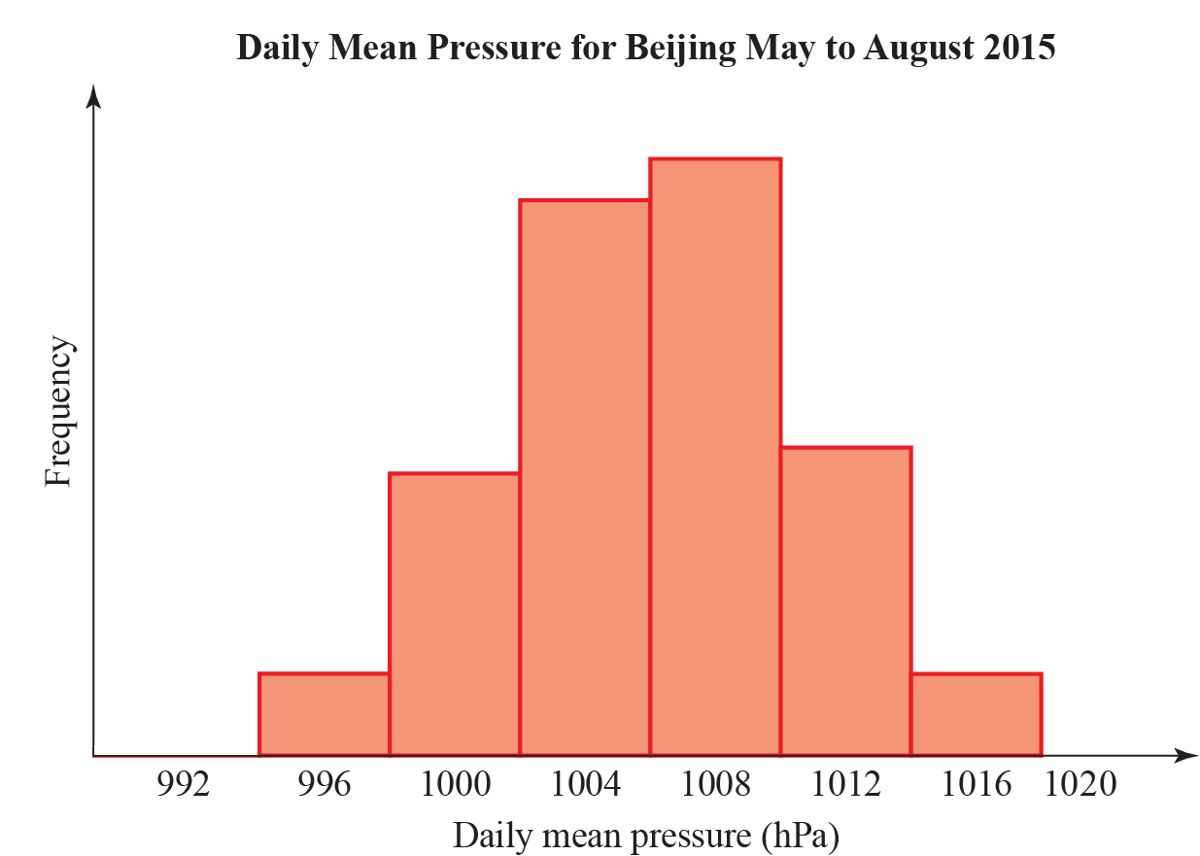

Variable | N | Mean | Standard deviation | Q₁ | Q₂ | Q₃
Daily Mean Pressure | 123 | 1006 | 4.4 | 1003 | 1006 | 1010

a Explain why it is reasonable to model the daily mean pressure for Beijing, during May to August using a normal distribution. (1 mark)
The distribution for the daily mean pressure for Beijing, May to August 2015, X, can be modelled by a normal distribution.

Daily mean pressure (hPa) | Suggests
Above 1013 | Good weather
Between 1013 and 1000 | Fair weather
Less than 1000 | Poor or bad weather
Less than 980 | Hurricane

b Based on the statistical output and the information in the table above, what is the chance of poor or bad weather in Beijing during May to August? (2 marks)

c Although very unlikely, based on the model in part a, give a reason why we cannot say there is no chance of a hurricane in Beijing during May to August. (1 mark)
The distribution for daily mean pressure for Jacksonville during May to August can also be considered normally distributed with mean 1017 hPa and standard deviation 3.26 hPa. A student claims that you can depend on better weather in Jacksonville than in Beijing during May to August.
d State, giving reasons, whether the information in this question supports this claim. (4 marks)

7 The mean body temperature for women is normally distributed with mean 36.73°C with variance 0.1482 (°C)². Kay has a temperature of 38.1°C.
a Calculate the probability of a woman having a temperature greater than 38.1°C. (2 marks)
b Advise whether should Kay get medical advice. Give a reason for your advice. (1 mark)

