Biodiversity, Natural Selection and Classification Questions
Q1.
Scientists have studied behavioural, anatomical and genetic variation in elephants.
The table shows some information about two populations of African elephants.
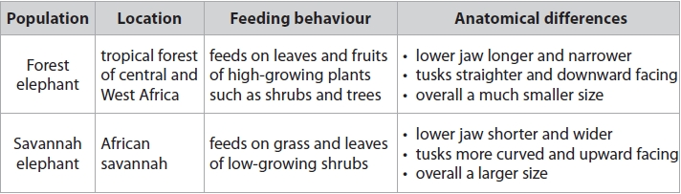
The photographs show elephants from the two populations.
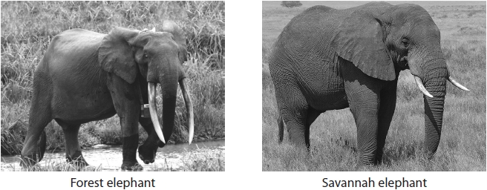
DNA samples were collected from these two populations of elephants.
One of the genes showing variation was the GBA gene. The table shows the frequency of the alleles of the GBA gene in the two populations.
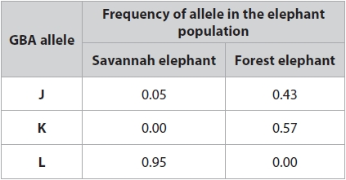
(i) State what is meant by the term allele.
(1)
.............................................................................................................................................
.............................................................................................................................................
.............................................................................................................................................
(ii) Use the Hardy-Weinberg equation to show that more than 50% of the forest elephant population are homozygous for the GBA gene.
(3)
Answer ...........................................................

(Total for question = 4 marks)

Q2.
Madagascar is an island rich in biodiversity.
Lemurs are a diverse group of primates endemic to Madagascar.
Scientist suggest there may be as many as 100 different species of lemur.
(i) State what is meant by the term endemic.
(1)
.............................................................................................................................................
.............................................................................................................................................
.............................................................................................................................................
(ii) Describe what is meant by biodiversity.
(2)
.............................................................................................................................................
.............................................................................................................................................
.............................................................................................................................................
.............................................................................................................................................
.............................................................................................................................................
(iii) Explain how the biodiversity of lemurs in two different parts of Madagascar could be compared.
(3)
.............................................................................................................................................
.............................................................................................................................................
.............................................................................................................................................
.............................................................................................................................................
.............................................................................................................................................
.............................................................................................................................................
.............................................................................................................................................
.............................................................................................................................................
.............................................................................................................................................
.............................................................................................................................................
.............................................................................................................................................

Q3.
(i) A study compared the diversity of species at different places on a shore.
On the upper shore the following data were obtained.
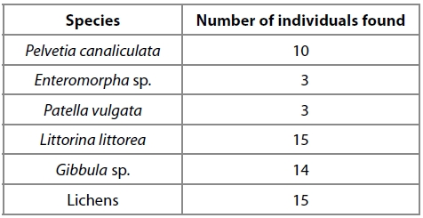
Calculate an index of diversity (D) for this site using the formula below.
(3)
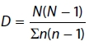
n = total number of organisms of a particular species
N = total number of organisms of all species
Answer ...........................................................
(ii) On the middle shore the index was found to be 7.74 with a total individual count of 37.
Comment on the relationship between diversity and the total number of individuals on these two parts of the shore.
(2)
.............................................................................................................................................
.............................................................................................................................................
.............................................................................................................................................
.............................................................................................................................................

(Total for question = 5 marks)

Q4.
In the 1970s, a theory for a new system of taxonomy was proposed by a scientist called Woese.
Describe the process by which the scientific community critically evaluates new theories.
(3)
.............................................................................................................................................
.............................................................................................................................................
.............................................................................................................................................
.............................................................................................................................................
.............................................................................................................................................
.............................................................................................................................................
.............................................................................................................................................
.............................................................................................................................................
.............................................................................................................................................

Q5.
In the 1970s, a theory for a new system of taxonomy was proposed by a scientist called Woese.
This new system of taxonomy identified three domains, J, K and L.
The table gives some of the characteristics of each of these three domains.
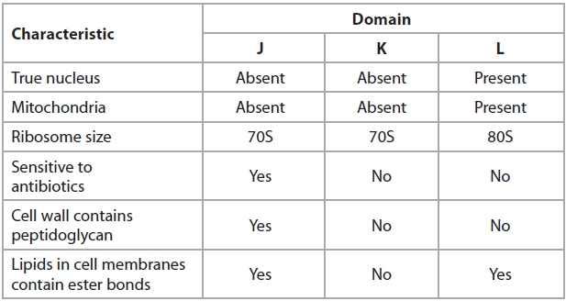
(i) Which of the following rows identifies the three domains in the table?
(1)
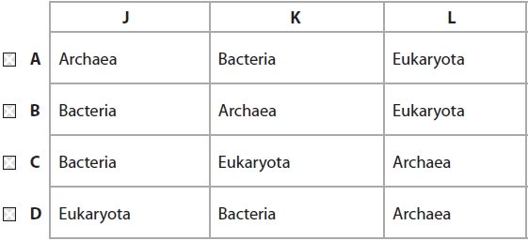
(ii) Describe how molecular phylogeny can be used to determine similarities and differences between the three domains.
(3)
.............................................................................................................................................
.............................................................................................................................................
.............................................................................................................................................
.............................................................................................................................................
.............................................................................................................................................
.............................................................................................................................................
.............................................................................................................................................
.............................................................................................................................................
.............................................................................................................................................
.............................................................................................................................................
.............................................................................................................................................

Q6.
Some grass plants possess an allele for copper tolerance. This allele allows them to grow in areas where there is a high concentration of copper ions in the soil.
Describe how natural selection has brought about different allele frequencies in the grass plants growing in these sites.
(5)
.............................................................................................................................................
.............................................................................................................................................
.............................................................................................................................................
.............................................................................................................................................
.............................................................................................................................................
.............................................................................................................................................

(Total for question = 5 marks)

Mark Scheme
Q1.
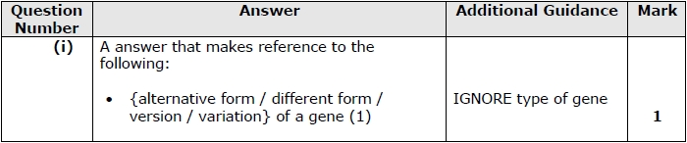
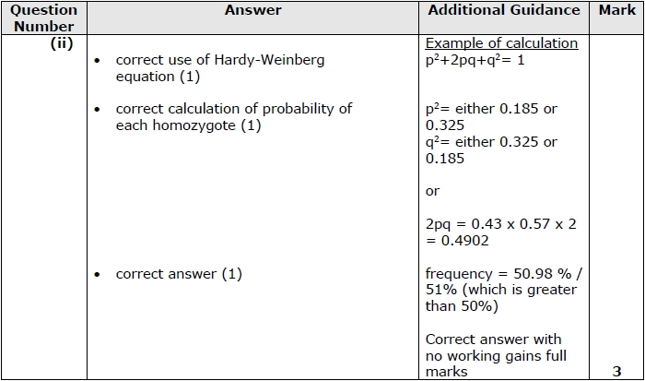

Q2.
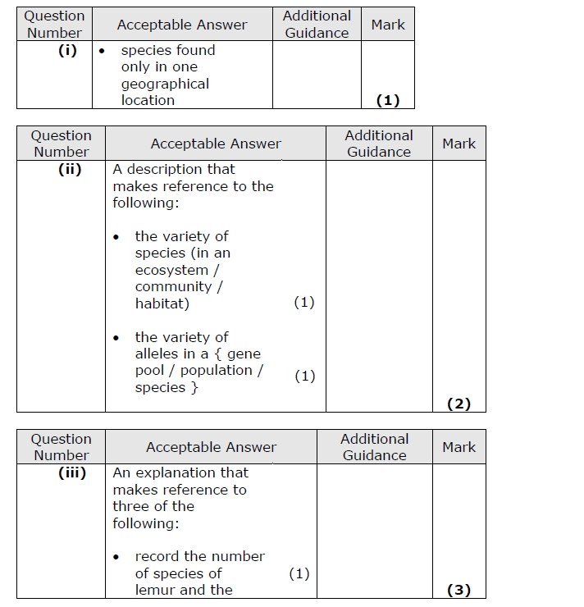
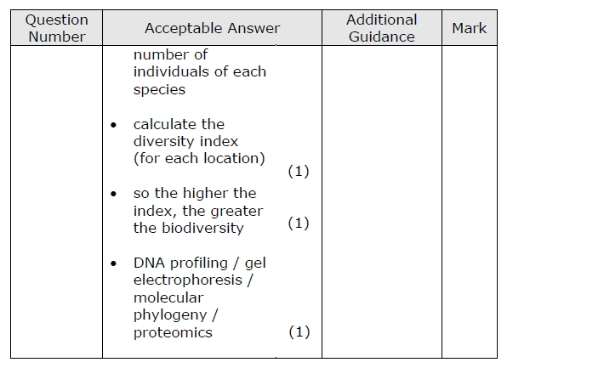

Q3.
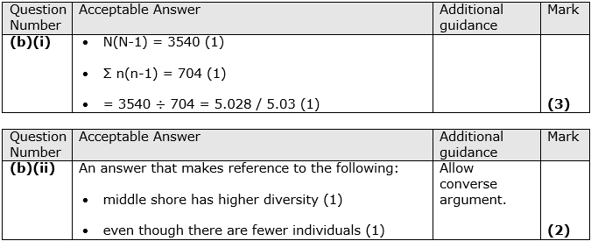

Q4.
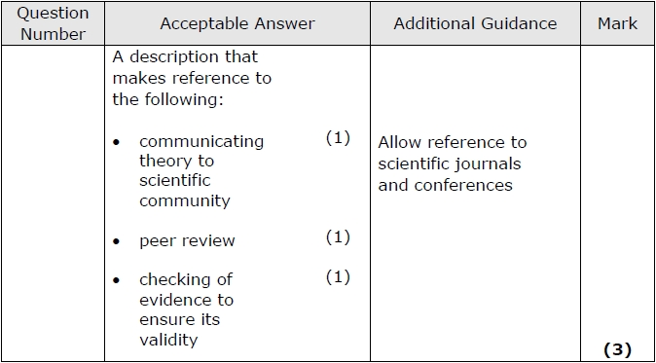

Q5.
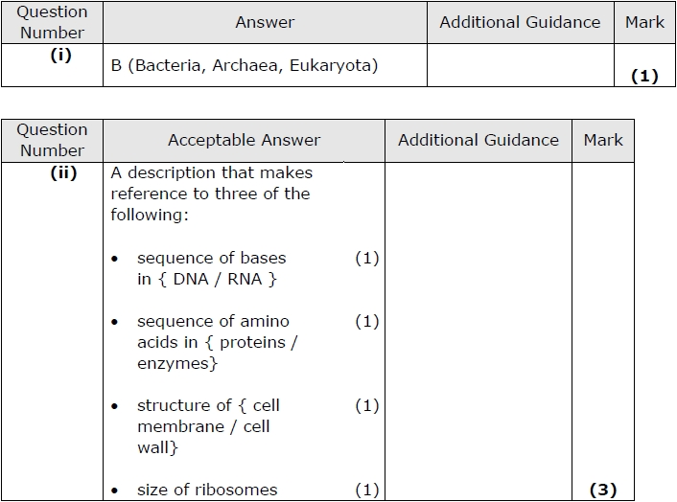

Q6.
