The Brain and Brain Imaging Questions
Q1.
There are various ways of investigating brain structure and function.
(a) Describe how scans from magnetic resonance imaging (MRI) may be used to investigate brain tumours.
(2)
.............................................................................................................................................
.............................................................................................................................................
.............................................................................................................................................
.............................................................................................................................................
.............................................................................................................................................
.............................................................................................................................................
(b) An investigation was carried out to study brain activity when eating chocolate.
Functional magnetic resonance imaging (fMRI) was used to study the brain activity of people eating chocolate.
It was found that certain areas in their brains became more active when they ate chocolate.
(i) Suggest two variables that should be taken into account when selecting the people for this investigation.
(1)
.............................................................................................................................................
.............................................................................................................................................
(ii) Suggest how fMRI was able to show that certain areas in the brain became more active when people ate chocolate.
(3)
.............................................................................................................................................
.............................................................................................................................................
.............................................................................................................................................
.............................................................................................................................................
.............................................................................................................................................
.............................................................................................................................................
(iii) Some of these more active areas were in the cerebral hemispheres of the brain. The cerebral hemispheres have a number of functions.
State two functions associated with the cerebral hemispheres.
(2)
.............................................................................................................................................
.............................................................................................................................................
.............................................................................................................................................
.............................................................................................................................................
(Total for Question = 8 marks)

Q2.
The photograph shows a female gymnast on a narrow beam.
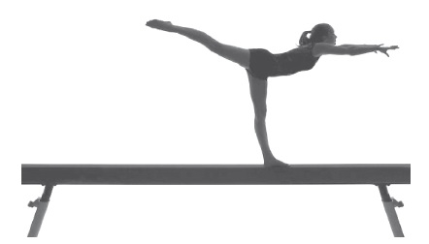
(a) The table below refers to two regions of the brain.
Complete the table by describing one role of each region of the brain, while she is on the beam.
(2)
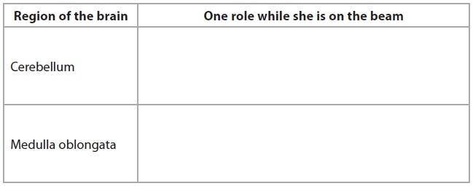
(b) This gymnast will generate a lot of heat while she is on the beam.
Describe and explain how changes in blood flow in the skin will help her to control her body temperature.
(4)
.............................................................................................................................................
.............................................................................................................................................
.............................................................................................................................................
.............................................................................................................................................
.............................................................................................................................................
.............................................................................................................................................
.............................................................................................................................................
.............................................................................................................................................
(c) Gymnasts can damage their cruciate ligaments. This is an injury that can be repaired using keyhole surgery.
(i) Explain what is meant by the term cruciate ligament.
(2)
.............................................................................................................................................
.............................................................................................................................................
.............................................................................................................................................
.............................................................................................................................................
.............................................................................................................................................
.............................................................................................................................................
(ii) A gymnast was offered keyhole surgery to repair her damaged cruciate ligament.
Suggest and explain two reasons why she might choose this type of surgery.
(2)
.............................................................................................................................................
.............................................................................................................................................
.............................................................................................................................................
.............................................................................................................................................
.............................................................................................................................................
.............................................................................................................................................
(Total for question = 10 marks)

Q3.
Scientists have investigated the influence of both nature and nurture on brain development. They used several pairs of identical twins and several pairs of non-identical twins.
(a) In one investigation, each twin was shown a number of human faces and then asked to identify them amongst a group of unfamiliar faces.
The agreement in face identification between each pair of twins was recorded.
The results were used to calculate the mean percentage agreement in face identification for the two types of twin. This is shown in the table below.
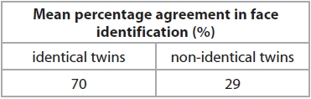
(i) From these results, the scientists concluded that face identification has a genetic component.
Explain how these results support this conclusion.
(4)
.............................................................................................................................................
.............................................................................................................................................
.............................................................................................................................................
.............................................................................................................................................
.............................................................................................................................................
.............................................................................................................................................
.............................................................................................................................................
.............................................................................................................................................
.............................................................................................................................................
.............................................................................................................................................
.............................................................................................................................................
.............................................................................................................................................
(ii) This investigation was repeated using written words rather than faces. The mean percentage agreement in word identification for the two types of twin suggested that this involved an environmental component.
Suggest how the results of this investigation might differ from the results shown in the table.
(1)
.............................................................................................................................................
.............................................................................................................................................
.............................................................................................................................................
.............................................................................................................................................
.............................................................................................................................................
(b) Functional magnetic resonance imaging (fMRI) was used in another investigation.
Brain activity was recorded whilst carrying out face identification.
Suggest why fMRI was used in this investigation.
(4)
.............................................................................................................................................
.............................................................................................................................................
.............................................................................................................................................
.............................................................................................................................................
.............................................................................................................................................

(Total for question = 9 marks)

Q4.
Visual development requires exposure of the visual cortex to environmental signals during a critical period.
The diagram shows parts of the brain, including the visual cortex.
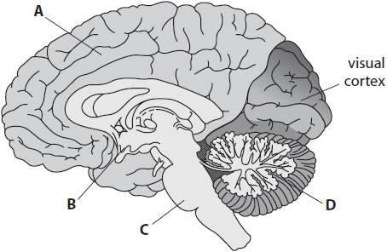
The visual cortex processes information received from the retina.
(i) The non-protein part of the light-absorbing pigment in the rod cells of the retina is called
(1)
A IAA
B opsin
C retinal
D rhodopsin
(ii) The part of the brain involved in interpreting the information processed in the visual cortex is
(1)
A
B
C
D
(iii) Explain how fMRI can be used to identify the part of the brain involved in interpreting information from the visual cortex.
(3)
.............................................................................................................................................
.............................................................................................................................................
.............................................................................................................................................
.............................................................................................................................................
.............................................................................................................................................
.............................................................................................................................................
.............................................................................................................................................
.............................................................................................................................................
.............................................................................................................................................
.............................................................................................................................................
.............................................................................................................................................

(Total for question = 5 marks)

Q5.
Answer the question with a cross in the box you think is correct . If you change your mind about an answer, put a line through the box and then mark your new answer with a cross .
There are many reasons why humans may lose muscle mass.
Two known causes are hip replacement surgery and some genetically inherited conditions.
Muscles can be scanned using magnetic resonance imaging (MRI) to investigate the loss of muscle mass.
It is safer to use MRI than computed tomography (CT) because
(1)
A CT uses X-rays that can cause mutations in the DNA of muscle fibres
B CT uses X-rays that can cause mutations in the protein in the muscle fibres
C CT uses magnets that can cause mutations in the DNA of muscle fibres
D CT uses magnets that can cause mutations in the protein in the muscle fibres

(Total for question = 1 mark)

Mark Scheme
Q1.
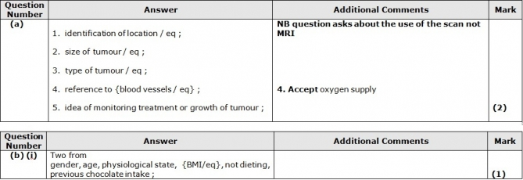
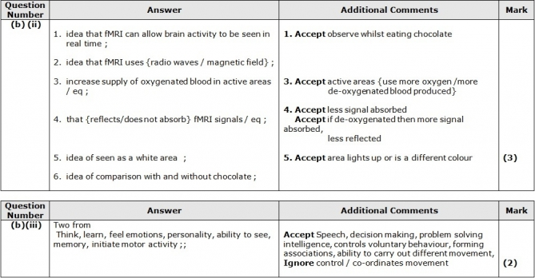

Q2.
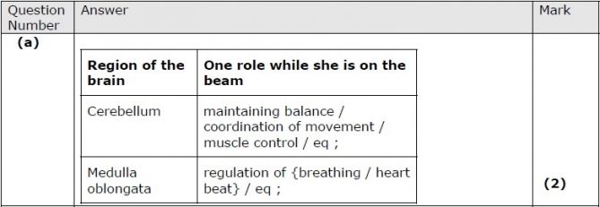
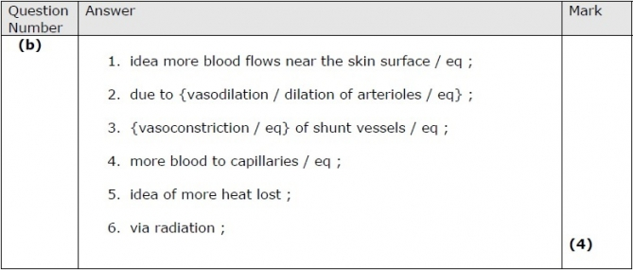
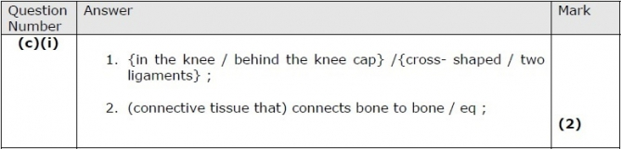
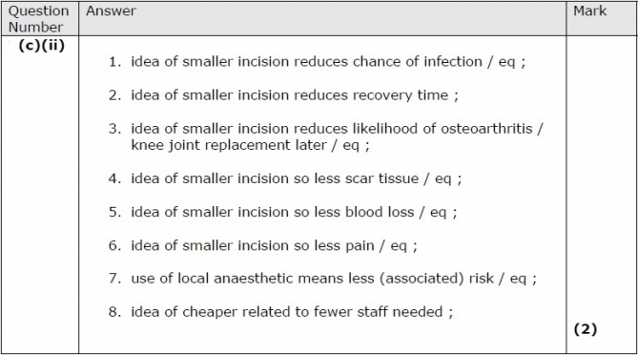

Q3.
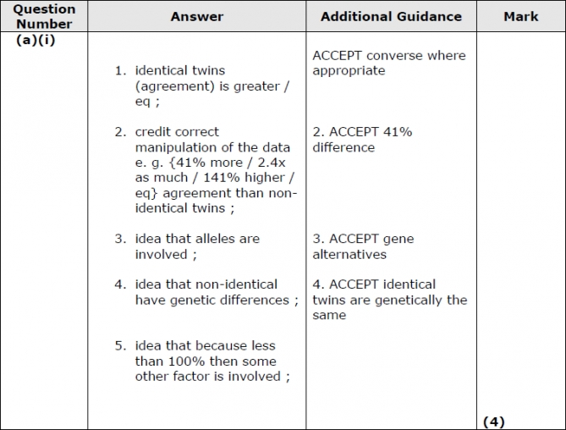
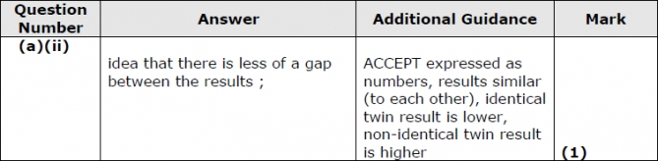
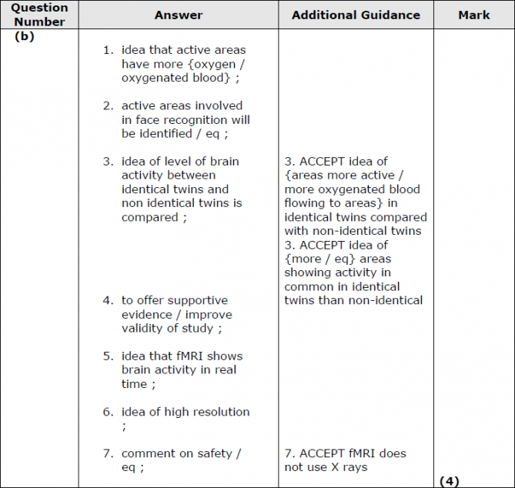

Q4.
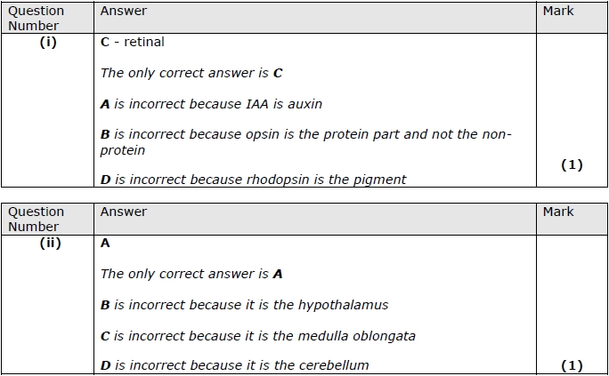
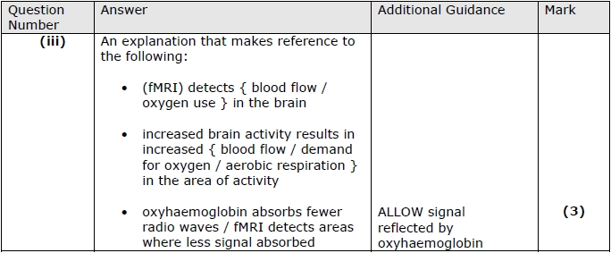

Q5.
