Carbon Cycle and Biofuel Questions
Q1.
Climate change has been linked to the release of carbon dioxide from some power stations.
Some power stations burn wood chips instead of fossil fuels to produce electricity.
The photograph shows wood chips at a power station.
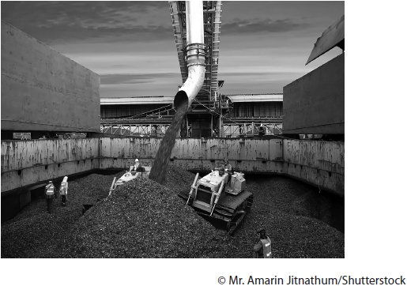
It is thought that burning wood chips is more beneficial to the environment because in the long term it does not add carbon dioxide to the atmosphere.
Explain why burning wood chips does not increase carbon dioxide to the atmosphere in the long term.
(4)
.............................................................................................................................................
.............................................................................................................................................
.............................................................................................................................................
.............................................................................................................................................
.............................................................................................................................................
.............................................................................................................................................
.............................................................................................................................................
.............................................................................................................................................
.............................................................................................................................................
.............................................................................................................................................
.............................................................................................................................................
.............................................................................................................................................

(Total for question = 4 marks)

Q2.
Eukaryotic cells contain membrane-bound organelles.

The graph shows the changes in biomass, gross primary productivity and the energy used in respiration during succession from grassland to mature forest.
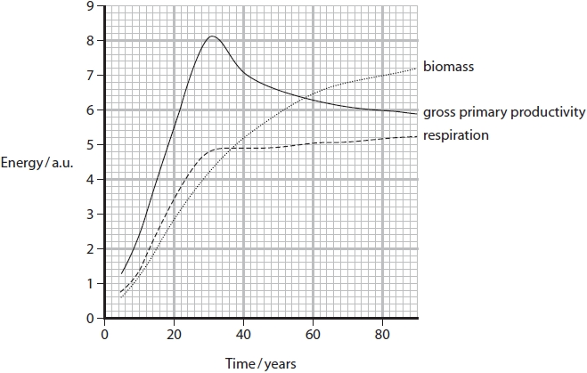
(i) Add shading to the graph to show the area that represents net primary productivity.
(1)
(ii) Describe what is meant by the term succession.
(2)
.............................................................................................................................................
.............................................................................................................................................
.............................................................................................................................................
.............................................................................................................................................
.............................................................................................................................................
.............................................................................................................................................
(iii) Deduce the effect of succession on the level of carbon dioxide in the atmosphere.
(3)
.............................................................................................................................................
.............................................................................................................................................
.............................................................................................................................................
.............................................................................................................................................
.............................................................................................................................................
.............................................................................................................................................
.............................................................................................................................................
.............................................................................................................................................

(Total for question = 6 marks)

Q3.
Anthropogenic activities are contributing to global warming.
Scientists from the IPCC (Intergovernmental Panel on Climate Change) say that changes to diet can have a major impact on greenhouse gas emissions. The method of farming affects the level of impact.
The Paris Agreement of 2015 committed countries to reduce carbon emissions.
The table shows the mass of greenhouse gas released in the production of one serving of a variety of sources of protein.
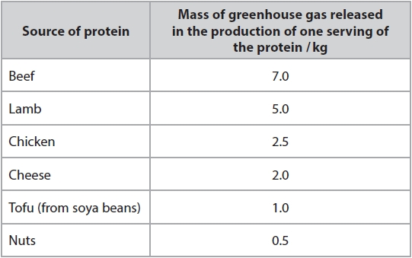
(i) Explain why a diet based on plant protein produces lower greenhouse gas emissions than a diet based on animal protein.
(3)
.............................................................................................................................................
.............................................................................................................................................
.............................................................................................................................................
.............................................................................................................................................
.............................................................................................................................................
.............................................................................................................................................
.............................................................................................................................................
.............................................................................................................................................
.............................................................................................................................................
(ii) Beef cattle are traditionally reared by grazing on natural pastures (grassland).
In recent years, large areas of rainforest have been cleared to produce beef.
Explain why the farming of beef cattle on deforested land produces more greenhouse gas emissions than from those reared on natural pastures.
(3)
.............................................................................................................................................
.............................................................................................................................................
.............................................................................................................................................
.............................................................................................................................................
.............................................................................................................................................
.............................................................................................................................................
.............................................................................................................................................
.............................................................................................................................................
.............................................................................................................................................

(Total for question = 6 marks)

Q4.
Forests are important habitats.
Many forests are exploited by humans.
(i) Describe how forests can be managed as a sustainable resource.
(2)
.............................................................................................................................................
.............................................................................................................................................
.............................................................................................................................................
.............................................................................................................................................
.............................................................................................................................................
.............................................................................................................................................
(ii) Explain the impact of cutting down trees on climate change.
(4)
.............................................................................................................................................
.............................................................................................................................................
.............................................................................................................................................
.............................................................................................................................................
.............................................................................................................................................
.............................................................................................................................................
.............................................................................................................................................
.............................................................................................................................................
.............................................................................................................................................
.............................................................................................................................................
.............................................................................................................................................
.............................................................................................................................................
.............................................................................................................................................

(Total for question = 6 marks)

Mark Scheme
Q1.
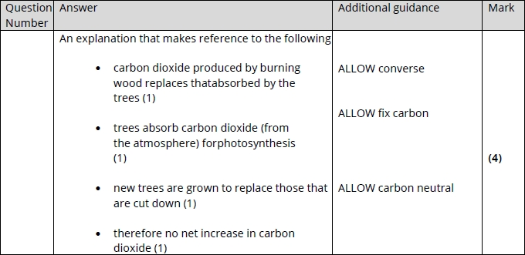

Q2.
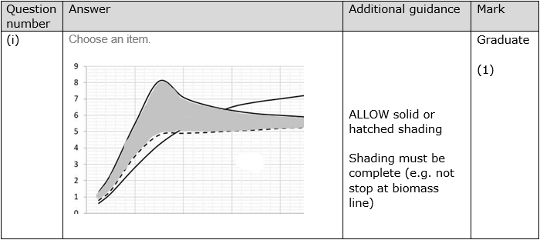
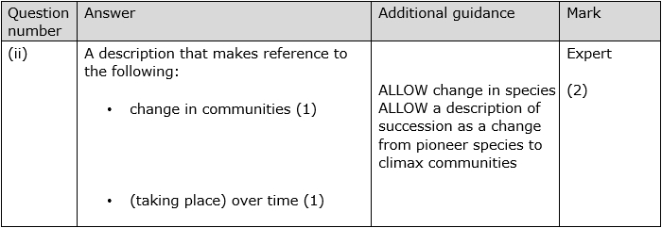
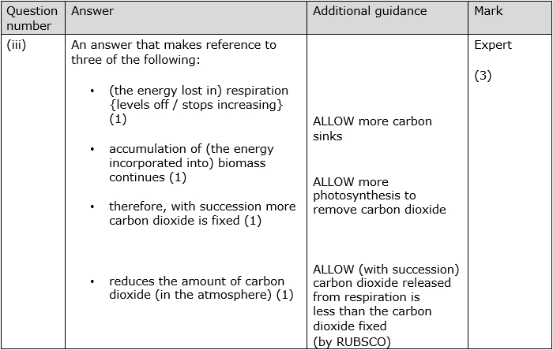

Q3.
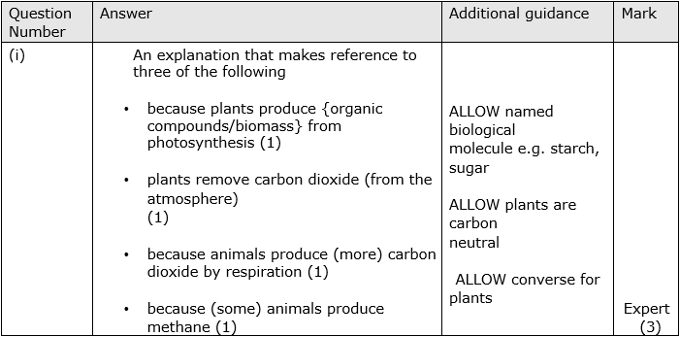
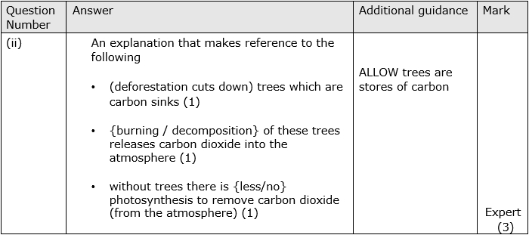

Q4.
