Cardiac Cycle Revision Questions
Q1.
During the development of the mammalian heart, there is a hole between the left ventricle and the right ventricle.
This hole usually becomes sealed before the mammal is born. If it is not sealed, the mammal will become easily tired due to a lack of energy.
Explain why a mammal born with a hole between the two ventricles will have these symptoms.
(3)
.............................................................................................................................................
.............................................................................................................................................
.............................................................................................................................................
.............................................................................................................................................
.............................................................................................................................................
.............................................................................................................................................
.............................................................................................................................................
.............................................................................................................................................

(Total for question = 3 marks)

Q2.
During the cardiac cycle, there are pressure changes in the left atrium, left ventricle and aorta.
The graph shows these pressure changes in the left atrium, left ventricle and aorta of a person.
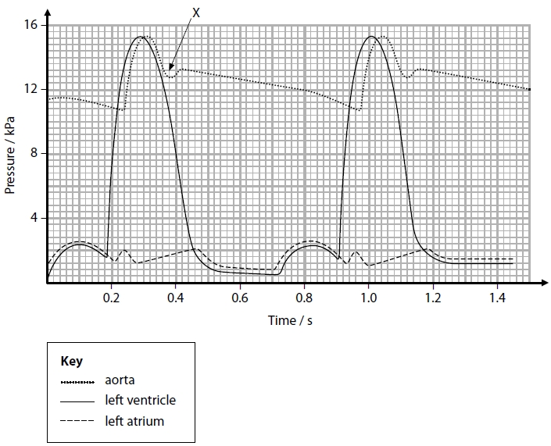
(a) (i) Which time period corresponds with ventricular systole?
(1)
A 0.52 to 0.72
B 0.72 to 0.92
C 0.92 to 1.20
D 0.24 to 0.98
(ii) Which of the following is occurring in the heart at 1.0 second on the graph?
(1)
A semilunar valve is closed and atrioventricular valve is closed
B semilunar valve is closed and atrioventricular valve is open
C semilunar valve is open and atrioventricular valve is closed
D semilunar valve is open and atrioventricular valve is open
(iii) Use the information on the graph to calculate the heart rate of this person.
(2)
Answer ........................................................... beats per minute
(b) When the heart valves close, they make a sound. This sound can be detected and recorded.
(i) State a time from the graph when the sound of an atrioventricular valve closing would be detected.
(1)
.............................................................................................................................................
.............................................................................................................................................
(ii) Explain why the atrioventricular valves need to close.
(2)
.............................................................................................................................................
.............................................................................................................................................
.............................................................................................................................................
.............................................................................................................................................

(Total for question = 7 marks)

Q3.
The diagram shows a section of a human heart and blood vessels.
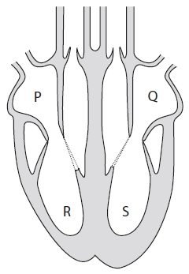
A scientist investigated the volume of blood pumped by the heart of a healthy individual.
The graph shows the volume of blood measured in the left ventricle.
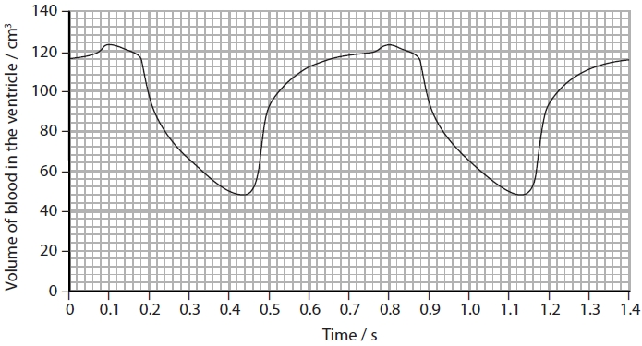
(i) Calculate the heart rate.
(2)
Answer ........................................................... beats min⁻¹
(ii) Calculate the volume of blood, in dm³, pumped by the left ventricle each minute.
(3)
Answer ........................................................... dm³

Q4.
Nicotine is a drug found in the smoke of cigarettes.
The effect of inhaling nicotine on the circulatory system of rats was investigated.
In this investigation, three variables were considered:
• the concentration of nicotine in blood plasma
• the diameter of the lumen of one artery
• blood pressure
Two groups of rats were treated as shown in the table.
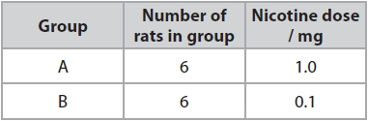
(i) The concentration of nicotine in the blood plasma of the group A rats was recorded at different times and
the means calculated.
The means are shown in the table along with the range of data for each mean.
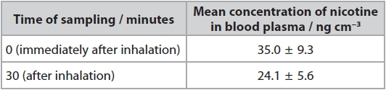
Determine the maximum rate of decrease in the concentration of nicotine in
the blood plasma per minute after being given the nicotine.
(2)
Answer ........................................................... ng cm⁻³ min⁻¹
(ii) The diameter of the lumen of one artery, in each of the 12 rats, was measured
when the rats were resting. The blood pressure of each rat was also measured
and the mean blood pressure calculated.
The diameter of the lumen of the artery and the blood pressure of each rat
were then recorded at intervals, for a total of 30 minutes. The rats inhaled
nicotine for the first minute (0.0 to 1.0).
The table shows the results for the mean diameter of the lumen of the artery.
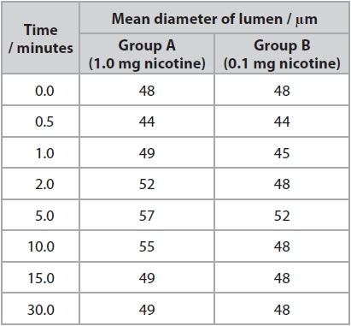
Determine the effect of nicotine concentration on the percentage change in
lumen diameter in the first minute.
(2)
.............................................................................................................................................
.............................................................................................................................................
*(iii) The graph shows the results for the mean blood pressure for the two groups
of rats. Nicotine was inhaled for the first minute.
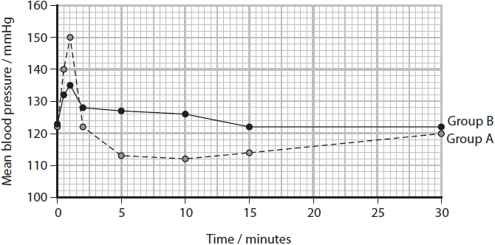
It has been stated that:
'Nicotine gained from smoking cigarettes in humans causes an increase in
blood pressure and a decrease in the lumen of arteries.'
Analyse all the data from this investigation using rats to evaluate the validity
of this statement.
(6)
.............................................................................................................................................
.............................................................................................................................................
.............................................................................................................................................
.............................................................................................................................................
.............................................................................................................................................
.............................................................................................................................................
.............................................................................................................................................
.............................................................................................................................................
.............................................................................................................................................
.............................................................................................................................................
.............................................................................................................................................
.............................................................................................................................................
.............................................................................................................................................
.............................................................................................................................................
.............................................................................................................................................
.............................................................................................................................................
.............................................................................................................................................
.............................................................................................................................................
.............................................................................................................................................
.............................................................................................................................................
.............................................................................................................................................
.............................................................................................................................................
.............................................................................................................................................
.............................................................................................................................................
.............................................................................................................................................

(Total for question = 10 marks)

Mark Scheme
Q1.
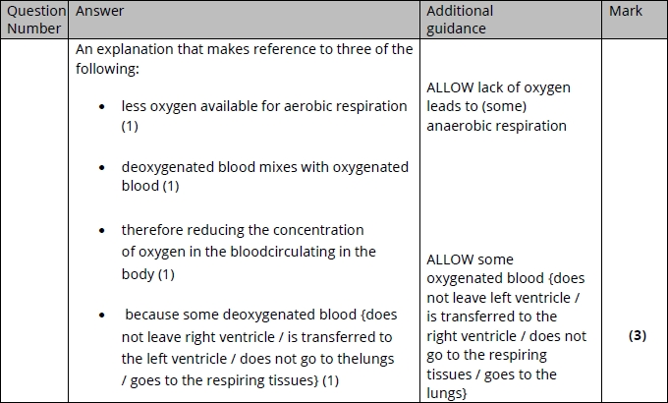

Q2.
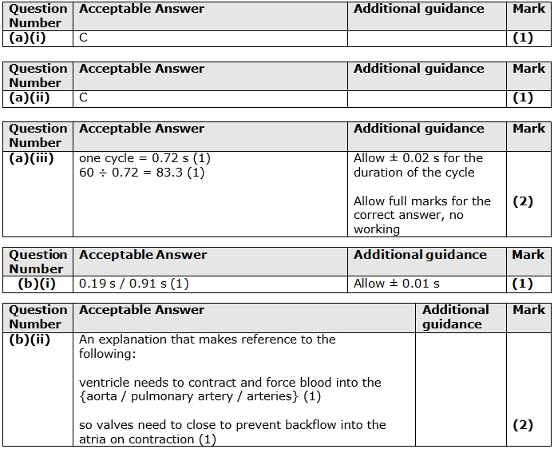

Q3.
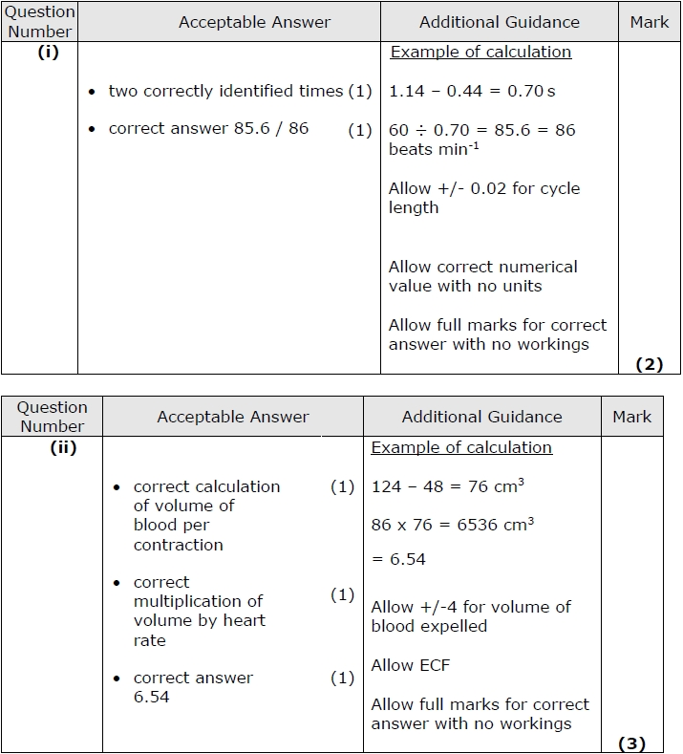

Q4.
