Cell Membrane and Cell Cycle Exam Questions
Q1.
The movement of materials into and out of a cell needs to be controlled.
Describe what is meant by the term fluid mosaic with reference to cell membranes.
(2)
.............................................................................................................................................
.............................................................................................................................................
.............................................................................................................................................
.............................................................................................................................................
.............................................................................................................................................
.............................................................................................................................................

Q2.
All cells have a cell surface membrane.
Explain how phospholipids form a cell surface membrane.
(3)
.............................................................................................................................................
.............................................................................................................................................
.............................................................................................................................................
.............................................................................................................................................
.............................................................................................................................................
.............................................................................................................................................
.............................................................................................................................................
.............................................................................................................................................
.............................................................................................................................................
.............................................................................................................................................

(Total for question = 3 marks)

Q3.
Answer the questions with a cross in the boxes you think are correct . If you change your mind about an answer, put a line through the box and then mark your new answer with a cross .
The structure of the cell surface membrane can be described by the fluid mosaic model.
The diagram shows the fluid mosaic model of the cell surface membrane.
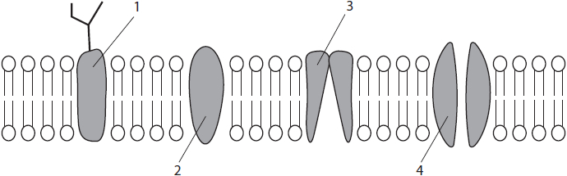
(i) Which of the shaded structures transport charged molecules or ions across the membrane?
(1)
A 1 and 2 only
B 3 and 4 only
C 1, 2 and 3 only
D 1, 2, 3 and 4
(ii) Which of the shaded structures contain both hydrophilic regions and hydrophobic regions?
(1)
A 1 and 2 only
B 3 and 4 only
C 1, 2 and 3 only
D 1, 2, 3 and 4
(iii) A student measured the width of the phospholipid bilayer shown on the
diagram as 2.5 cm. The actual size of this bilayer is 5 nm.
What is the approximate magnification of the diagram?
(1)
A × 5000
B × 50 000
C × 500 000
D × 5 000 000

(Total for question = 3 marks)

Q4.
Cystic fibrosis is an inherited condition.
It is caused by mutations in the gene coding for the cystic fibrosis transmembrane conductance regulator (CFTR) protein.
Some of the mutations cause a change in the primary structure of the CFTR protein.
(i) The CFTR protein is produced in cells of the lung and is involved in the transport of chloride ions.
Describe the location of the CFTR protein in the cell membrane of one of these cells.
(2)
.............................................................................................................................................
.............................................................................................................................................
.............................................................................................................................................
.............................................................................................................................................
.............................................................................................................................................
.............................................................................................................................................
(ii) Describe how the CFTR protein is transported from the ribosome to the cell membrane.
(3)
.............................................................................................................................................
.............................................................................................................................................
.............................................................................................................................................
.............................................................................................................................................
.............................................................................................................................................
.............................................................................................................................................
.............................................................................................................................................
.............................................................................................................................................
.............................................................................................................................................

(Total for question = 5 marks)

Q5.
The structure of the cell surface membrane can be explained using the fluid mosaic model.
This model suggests that there are a variety of different proteins and glycoproteins present in a phospholipid bilayer.
* The ratio of lipid to protein in a cell surface membrane is approximately 1:1.
Scientists have studied the proteins present within human cells. Proteins in a cell are found in several locations.
The table shows the percentage of protein found in some locations in a cell.
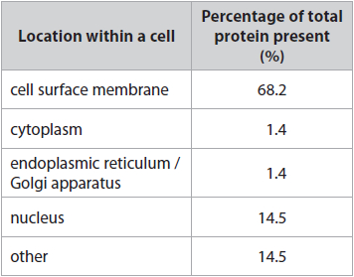
The proteins within the cell surface membrane were further analysed for their function.
The graph shows some of the results of this analysis.
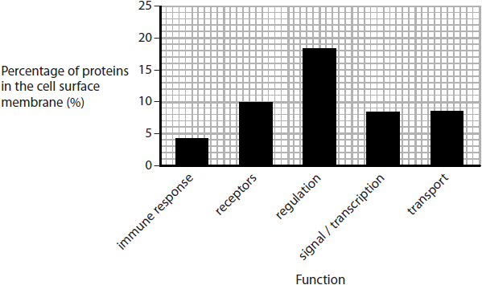
Analyse the data to evaluate the following statement.
'The variety of different proteins present in the cell surface membrane makes them more important than the phospholipid bilayer to the functioning of that cell.'
(9)
.............................................................................................................................................
.............................................................................................................................................
.............................................................................................................................................
.............................................................................................................................................
.............................................................................................................................................
.............................................................................................................................................
.............................................................................................................................................
.............................................................................................................................................
.............................................................................................................................................
.............................................................................................................................................
.............................................................................................................................................
.............................................................................................................................................
.............................................................................................................................................
.............................................................................................................................................
.............................................................................................................................................
.............................................................................................................................................
.............................................................................................................................................
.............................................................................................................................................
.............................................................................................................................................
.............................................................................................................................................
.............................................................................................................................................
.............................................................................................................................................

(Total for question = 9 marks)

Q6.
During growth, cells divide by mitosis. Many organisms also carry out meiosis to enable sexual reproduction.
(i) In which stage of cell division do spindle fibres attach to the centromeres?
(1)
A anaphase
B interphase
C metaphase
D telophase
(ii) In which stage of the cell division does the nuclear membrane start to break down?
(1)
A interphase
B metaphase
C prophase
D telophase
(iii) In which stage of cell division are chromatids first visible when using a light microscope?
(1)
A interphase
B metaphase
C prophase
D telophase

(Total for question = 3 marks)

Q7.
During growth, cells divide by mitosis. Many organisms also carry out meiosis to enable sexual reproduction.
Meiosis is involved in the production of sperm cells.
Crossing over during meiosis can result in genetic variation.
Explain how crossing over can lead to genetic variation.
(3)
.............................................................................................................................................
.............................................................................................................................................
.............................................................................................................................................
.............................................................................................................................................
.............................................................................................................................................
.............................................................................................................................................
.............................................................................................................................................
.............................................................................................................................................
.............................................................................................................................................

(Total for question = 3 marks)

Q8.
Sperm are produced from stem cells in a process that involves several cycles of mitosis and a single cycle of meiosis, as shown in the diagram.
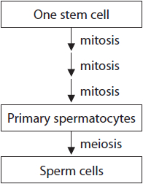
(i) State what is meant by the term stem cell.
(2)
.............................................................................................................................................
.............................................................................................................................................
.............................................................................................................................................
.............................................................................................................................................
.............................................................................................................................................
.............................................................................................................................................
(ii) Compare and contrast the results of mitosis and meiosis in the production of sperm cells from stem cells.
(4)
.............................................................................................................................................
.............................................................................................................................................
.............................................................................................................................................
.............................................................................................................................................
.............................................................................................................................................
.............................................................................................................................................
.............................................................................................................................................
.............................................................................................................................................
.............................................................................................................................................
.............................................................................................................................................
.............................................................................................................................................
.............................................................................................................................................

(Total for question = 6 marks)

Q9.
The scientific article you have studied is adapted from The Biologist.
Use the information from the scientific article and your own knowledge to answer the following question.
Describe how a 'single fertilised egg' can produce many different cell types (paragraph 2).
(3)
.............................................................................................................................................
.............................................................................................................................................
.............................................................................................................................................
.............................................................................................................................................
.............................................................................................................................................
.............................................................................................................................................
.............................................................................................................................................
.............................................................................................................................................
.............................................................................................................................................

(Total for question = 3 marks)

Q10.
Meiosis is involved in the production of haploid nuclei in mammalian gametes.
(i) Which of the following is the best description of the term haploid nucleus?
(1)
A nucleus with 23 pairs of chromosomes
B nucleus with twice the number of chromosomes as a somatic cell
C nucleus with homologous pairs of chromosomes
D nucleus with half the number of chromosomes as a somatic cell
(ii) Describe how crossing over gives rise to different combinations of alleles in gametes.
(2)
.............................................................................................................................................
.............................................................................................................................................
.............................................................................................................................................
.............................................................................................................................................
.............................................................................................................................................
.............................................................................................................................................
.............................................................................................................................................
(iii) Explain how independent assortment gives rise to genetically varied gametes.
(2)
.............................................................................................................................................
.............................................................................................................................................
.............................................................................................................................................
.............................................................................................................................................
.............................................................................................................................................
.............................................................................................................................................
.............................................................................................................................................

Q11.
DNA synthesis in bacterial cell cultures has been investigated.
In an experiment, a mixture of radioactive bases was added to a culture of dividing bacteria.
The results are shown in the graph.
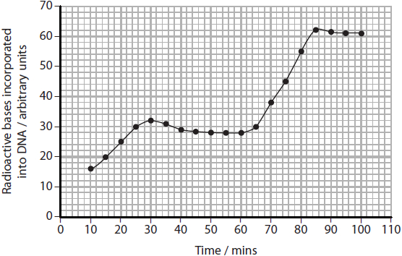
(i) Calculate the fastest rate of uptake of bases by these bacteria.
(2)
Answer ...........................................................
(ii) Deduce how many times the bacteria in the culture have divided during this experiment.
(2)
.............................................................................................................................................
.............................................................................................................................................
.............................................................................................................................................
.............................................................................................................................................
.............................................................................................................................................
.............................................................................................................................................
(iii) Explain why the experiment would be improved if all the bases were provided but only the thymine was radioactive.
(2)
.............................................................................................................................................
.............................................................................................................................................
.............................................................................................................................................
.............................................................................................................................................
.............................................................................................................................................
.............................................................................................................................................

(Total for question = 6 marks)

Q12.
Studies have provided evidence for a link between heart rate when a person is at rest and various medical conditions.
Cancer can be due to body cells continuing to undergo mitosis and cell division. Prophase is one stage of mitosis.
Describe the events that occur during prophase in an animal cell.
(3)
.............................................................................................................................................
.............................................................................................................................................
.............................................................................................................................................
.............................................................................................................................................
.............................................................................................................................................
.............................................................................................................................................
.............................................................................................................................................
.............................................................................................................................................

(Total for question = 3 marks)

Mark Scheme
Q1.
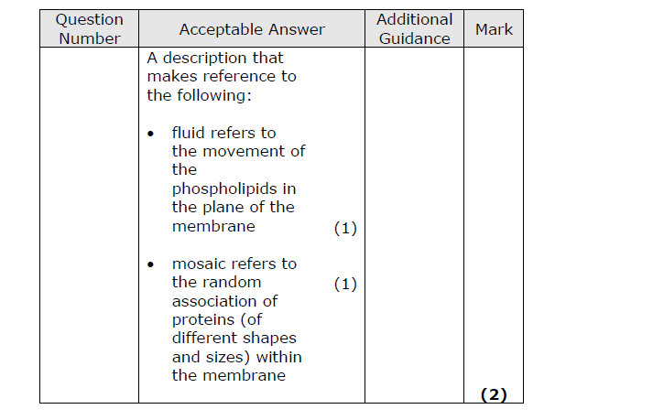

Q2.
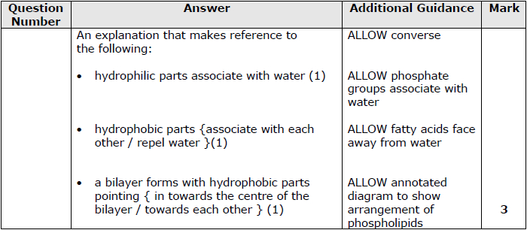

Q3.
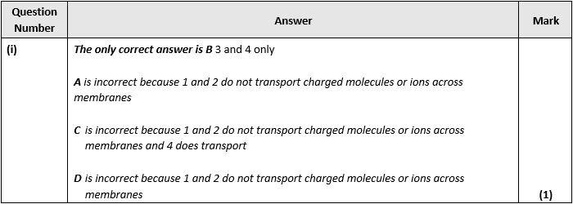
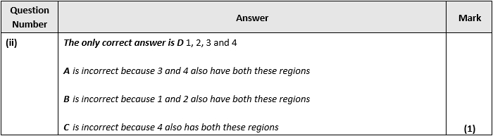
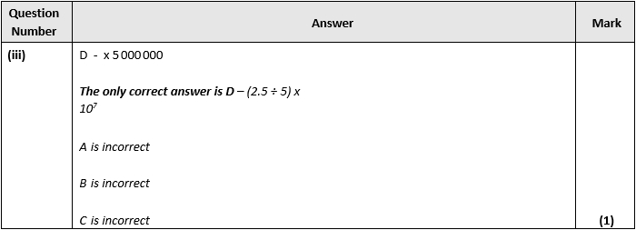

Q4.
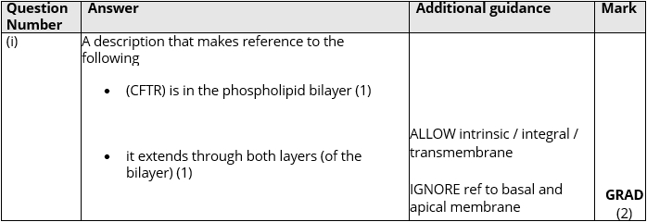
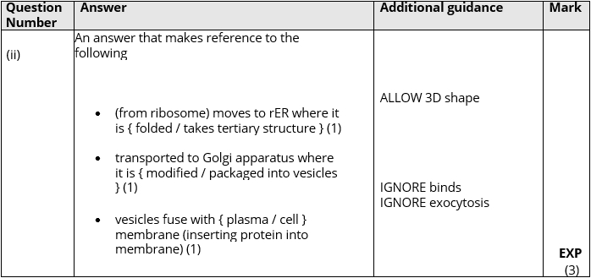

Q5.
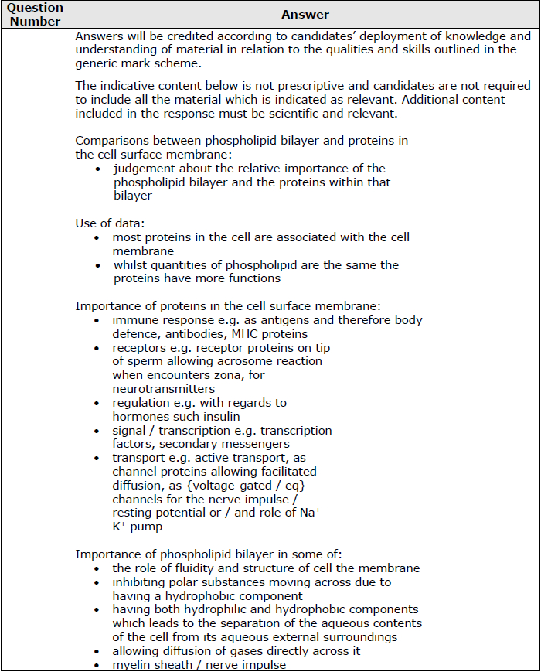
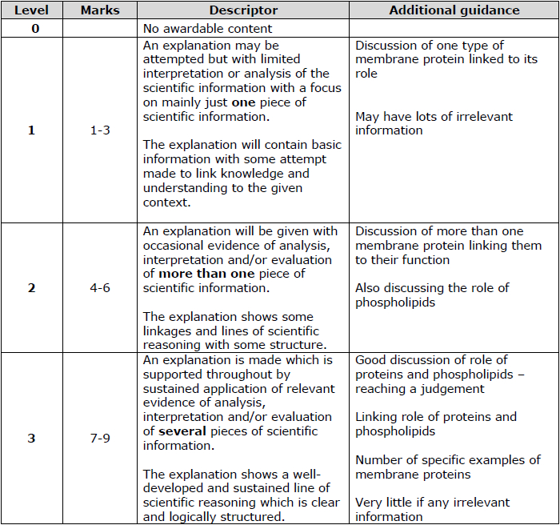

Q6.
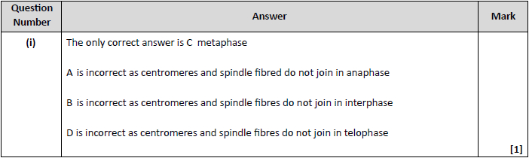
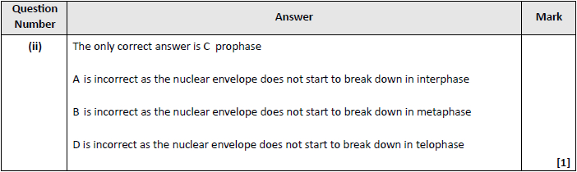
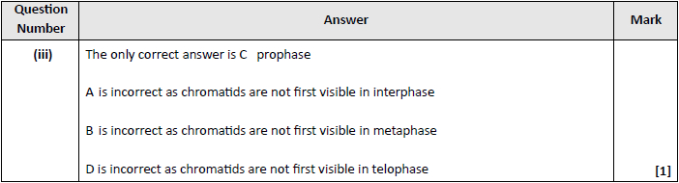

Q7.
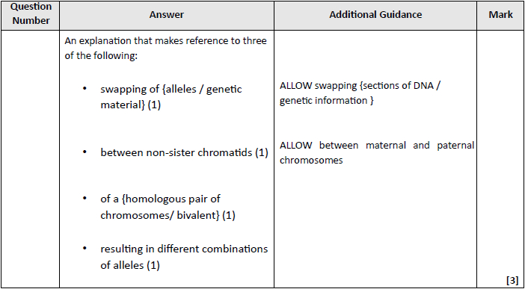

Q8.
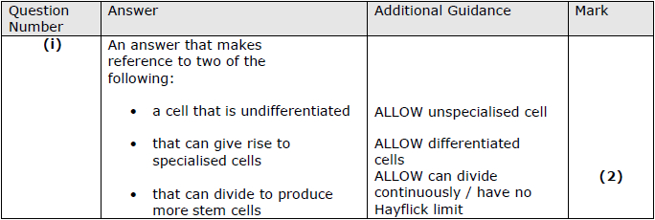
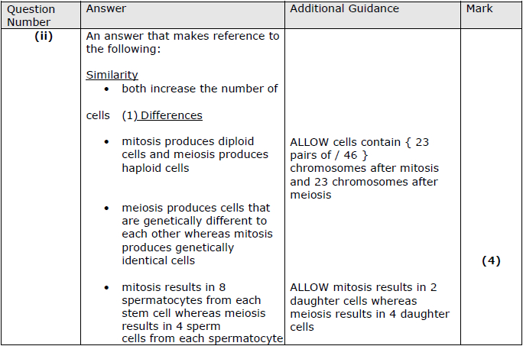

Q9.
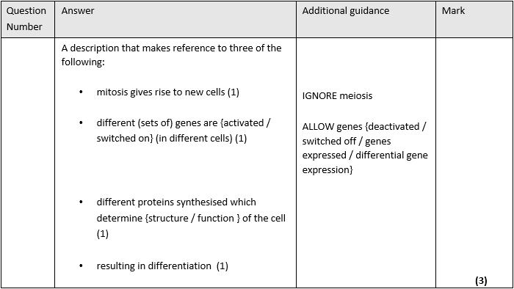

Q10.
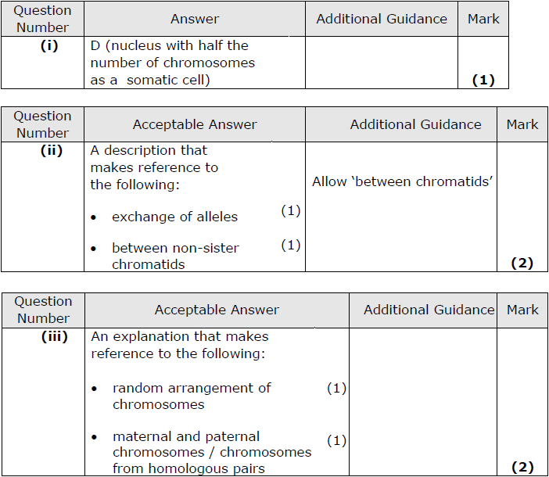

Q11.
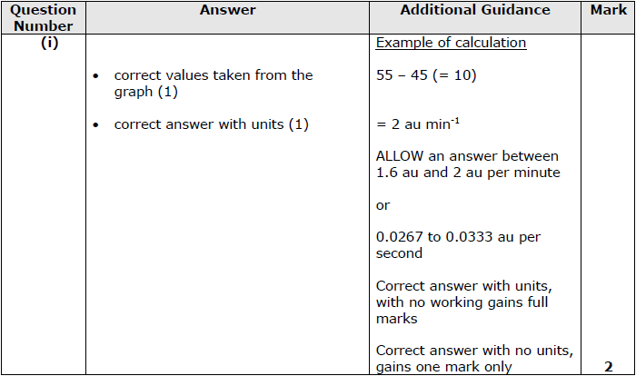
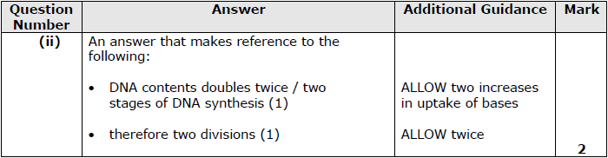
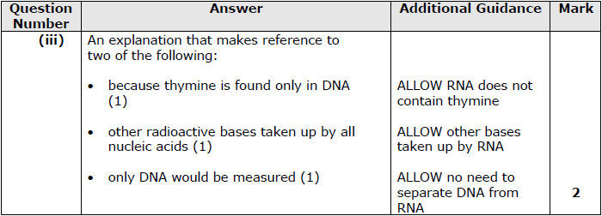

Q12.
