Questions
Q1.
Cholera is a disease caused by a bacterial infection that affects the absorption of water in the small intestine.
The bacteria that cause cholera release a toxin.
This toxin affects the CFTR protein found in the membrane of intestinal epithelium cells.
The toxin causes the CFTR protein to pump more chloride ions out of these cells into the intestine. This causes a lot of water to be lost in the faeces.
Explain how the toxin causes this water loss.
(3)
.............................................................................................................................................
.............................................................................................................................................
.............................................................................................................................................
.............................................................................................................................................
.............................................................................................................................................
.............................................................................................................................................
.............................................................................................................................................
.............................................................................................................................................

(Total for question = 3 marks)

Q2.
The structure of a lipid relates to its role in living organisms.
Cell membranes contain lipids that have a phosphate group attached to the glycerol, instead of one of the fatty acids.
Explain the importance of the phosphate group in these lipids.
(2)
.............................................................................................................................................
.............................................................................................................................................
.............................................................................................................................................
.............................................................................................................................................
.............................................................................................................................................
.............................................................................................................................................

(Total for question = 2 marks)

Q3.
Describe three named methods of passive transport by which substances can enter or leave a cell.
(3)
.............................................................................................................................................
.............................................................................................................................................
.............................................................................................................................................
.............................................................................................................................................
.............................................................................................................................................
.............................................................................................................................................
.............................................................................................................................................
.............................................................................................................................................
.............................................................................................................................................

(Total for question = 3 marks)

Q4.
The CFTR protein is also found in the membrane of epithelial cells in the lungs.
Cystic fibrosis is a recessive genetic condition caused by mutations of the allele for the CFTR protein.
This can result in the production of thick, highly viscous mucus in the bronchioles and bronchi.
Explain why the blood of people with cystic fibrosis has a low oxygen concentration.
(2)
.............................................................................................................................................
.............................................................................................................................................
.............................................................................................................................................
.............................................................................................................................................
.............................................................................................................................................

(Total for question = 2 marks)

Q5.
Answer the question with a cross in the box you think is correct . If you change your mind about an answer, put a line through the box and then mark your new answer with a cross .
The diagram shows an ECG trace and pressure changes in the aorta and in the left side of the heart.
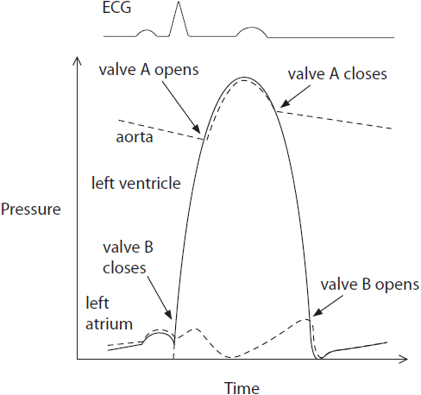
Valve A is the
(1)
A atrioventricular
B mitral
C semi-lunar
D bicuspid

(Total for question = 1 mark)

Q6.
The internal conditions within the body are maintained by homeostatic mechanisms. The regulation of blood glucose involves homeostatic mechanisms.
The diagram shows part of the sequence of events when there is an increase in blood glucose levels.
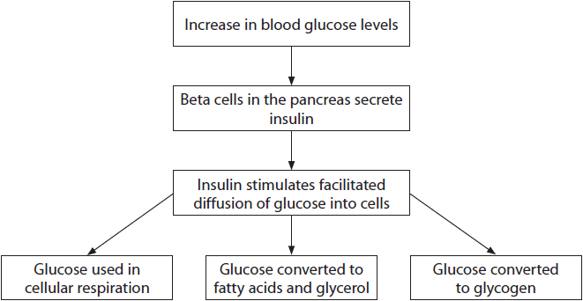
(i) Describe how glucose moves into cells by facilitated diffusion.
(2)
.............................................................................................................................................
.............................................................................................................................................
.............................................................................................................................................
.............................................................................................................................................
.............................................................................................................................................
.............................................................................................................................................
.............................................................................................................................................
.............................................................................................................................................
(ii) Explain how the structure of glycogen allows it to be an energy store.
(3)
.............................................................................................................................................
.............................................................................................................................................
.............................................................................................................................................
.............................................................................................................................................
.............................................................................................................................................
.............................................................................................................................................
.............................................................................................................................................
.............................................................................................................................................
.............................................................................................................................................

(Total for question = 5 marks)

Q7.
Muscle cells contain myofibrils. The diagrams show the arrangement of some of the molecules present in a myofibril when calcium ions are absent and when they are present.
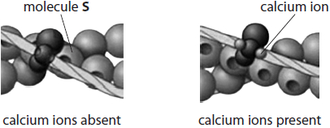
Describe how the concentration of calcium ions around the myofibrils is controlled.
(3)
.............................................................................................................................................
.............................................................................................................................................
.............................................................................................................................................
.............................................................................................................................................
.............................................................................................................................................
.............................................................................................................................................
.............................................................................................................................................
.............................................................................................................................................
.............................................................................................................................................
.............................................................................................................................................

(Total for question = 3 marks)

Q8.
Goblet cells lining the bronchi produce mucus. This mucus is released by exocytosis.
Explain how goblet cells release mucus by exocytosis.
(2)
.............................................................................................................................................
.............................................................................................................................................
.............................................................................................................................................
.............................................................................................................................................
.............................................................................................................................................
.............................................................................................................................................

Q9.
All cells have a cell surface membrane.
Cell surface membranes regulate the movement of substances into and out of cells.
(i) Which of the following describes the movement of water by osmosis?
(1)
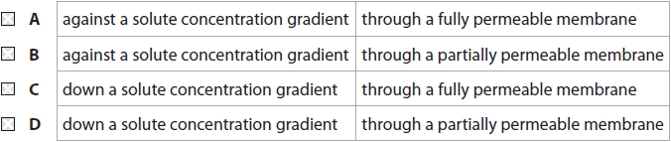
(ii) The concentration of potassium ions inside an animal cell is many times higher than the concentration of potassium ions in the extracellular fluid.
Which mechanism is responsible for the uptake of potassium ions by this animal cell?
(1)
A active transport
B exocytosis
C osmosis
D passive diffusion
(iii) Glucose enters cells by facilitated diffusion.
Which part of the cell surface membrane allows facilitated diffusion of glucose?
(1)
A cholesterol
B glycolipid
C phospholipid
D protein

(Total for question = 3 marks)

Q10.
Mitochondrial disorders may be caused by mutations in the genes coding for mitochondrial components. Some of these genes are found in mitochondrial DNA (mtDNA) and some are found in nuclear DNA.
Leigh syndrome is an example of a mitochondrial disorder. In this syndrome, a number of different proteins involved in respiration are affected.
These mutations may be inherited or may occur when DNA replicates.
Some people with Leigh syndrome have a mutation in the MT-ATP6 gene.
This gene codes for ATP synthase.
This is a point mutation at nucleotide 8993 that changes thymine to guanine.
(i) What type of mutation is this?
(1)
A insertion
B monosomy
C substitution
D translocation
(ii) Explain how this mutation could affect oxidative phosphorylation.
(3)
.............................................................................................................................................
.............................................................................................................................................
.............................................................................................................................................
.............................................................................................................................................
.............................................................................................................................................
.............................................................................................................................................
.............................................................................................................................................
.............................................................................................................................................

(Total for question = 4 marks)

Q11.
A mutation of the F2 gene causes thrombophilia, a condition that results in the production of excess prothrombin.
In this gene mutation, guanine is replaced with adenine.
(i) Name this type of mutation.
(1)
.............................................................................................................................................
(ii) People without this mutation have a 1 in 1000 risk of producing a blood clot in an artery.
The mutation increases this risk by 20 times.
State the probability of producing a blood clot for people with this mutation.
(1)
.............................................................................................................................................
(iii) Explain why thrombophilia increases the risk of producing a blood clot in an artery.
(3)
.............................................................................................................................................
.............................................................................................................................................
.............................................................................................................................................
.............................................................................................................................................
.............................................................................................................................................
.............................................................................................................................................
.............................................................................................................................................
.............................................................................................................................................
.............................................................................................................................................

(Total for question = 5 marks)

Q12.
Leigh syndrome is a disease of the nervous system that affects the brain.
It is caused by a mutation in the DNA present inside mitochondria.
Mitochondrial diseases such as Leigh syndrome are passed on by the mother during fertilisation.
Using IVF, it is possible to produce an embryo that does not have the mitochondrial disease.
The nucleus is removed from a donor egg cell from another individual.
The nucleus from a fertilised egg from a mother with the mutation is then placed in the egg cell from the donor.
(i) Explain why the resulting embryo does not develop mitochondrial disease.
(2)
.............................................................................................................................................
.............................................................................................................................................
.............................................................................................................................................
.............................................................................................................................................
.............................................................................................................................................
.............................................................................................................................................
.............................................................................................................................................
(ii) Comment on the inheritance of parental characteristics in offspring produced in this way.
(3)
.............................................................................................................................................
.............................................................................................................................................
.............................................................................................................................................
.............................................................................................................................................
.............................................................................................................................................
.............................................................................................................................................
.............................................................................................................................................
.............................................................................................................................................
.............................................................................................................................................

(Total for question = 5 marks)

Mark Scheme
Q1.
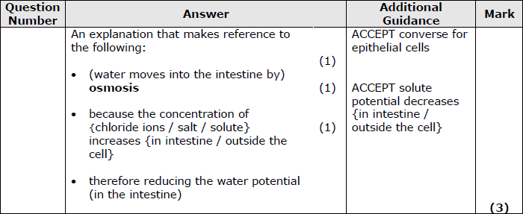

Q2.
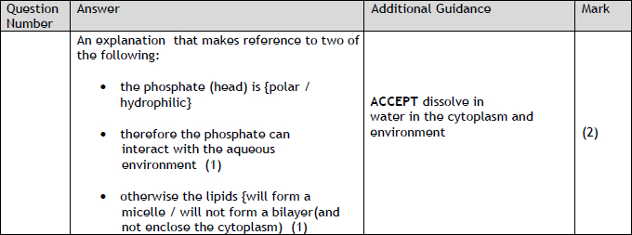

Q3.
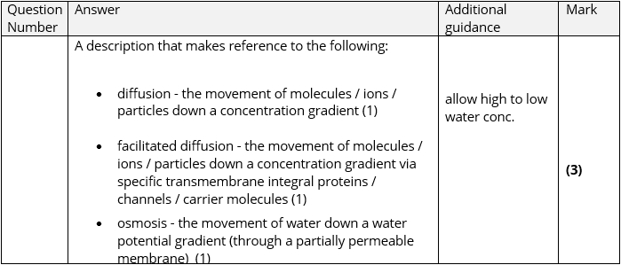

Q4.
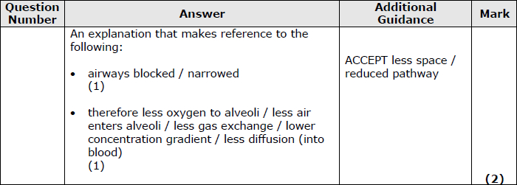

Q5.
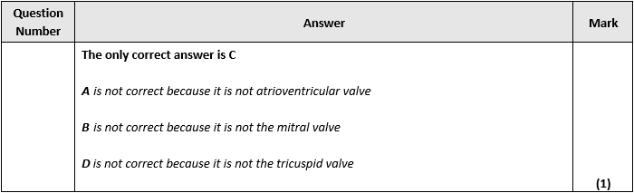

Q6.
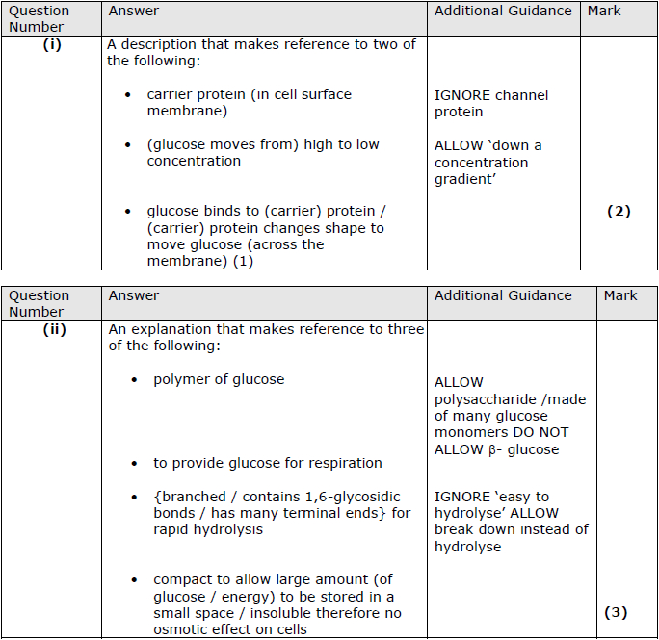

Q7.
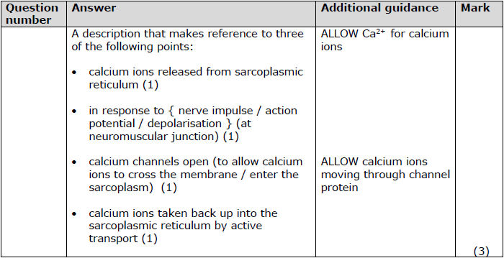

Q8.
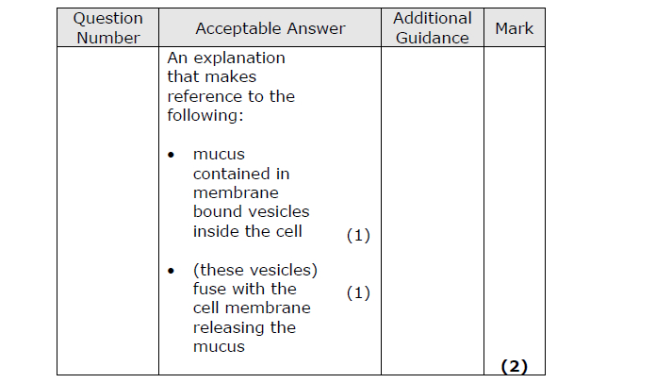

Q9.
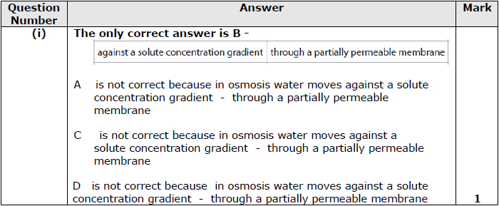
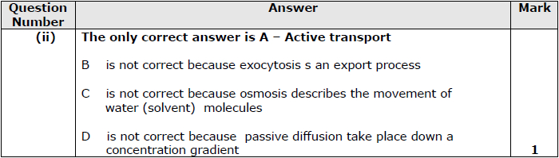
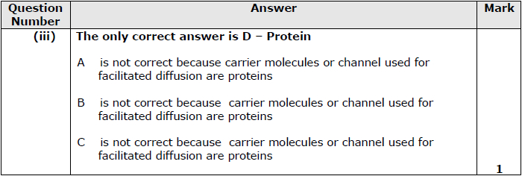

Q10.
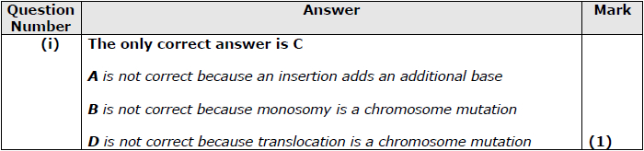
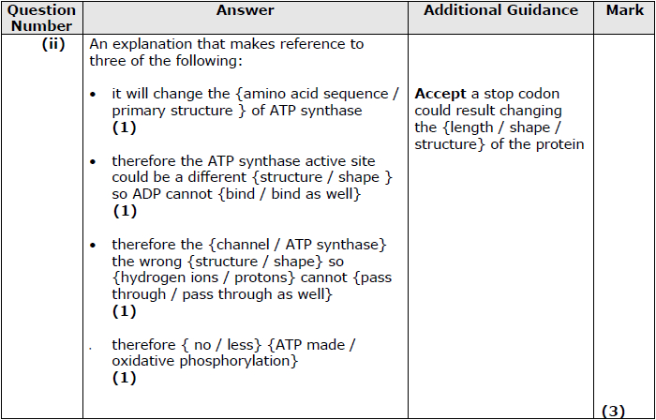

Q11.
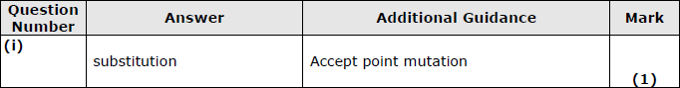
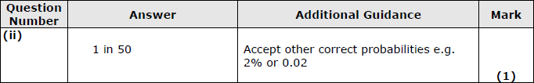
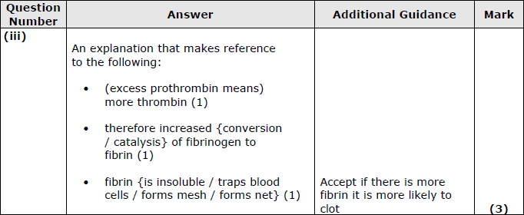

Q12.
