Biology Circulatory System Exam Questions

Q1.
The diameter of the inside of a blood vessel (lumen diameter) affects the speed of blood flow.
The graph shows the relationship between the lumen diameter of blood vessels and the velocity of blood flow.
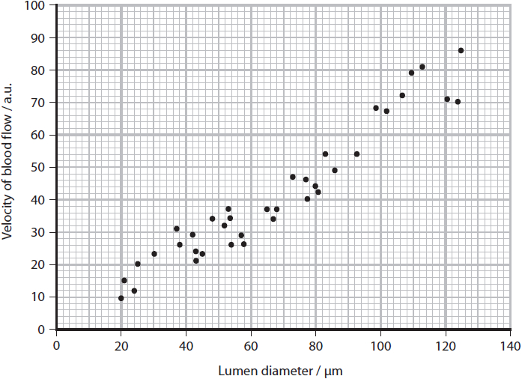
Explain the importance of the relationship, shown in the graph, to capillary function.
(2)
.............................................................................................................................................
.............................................................................................................................................
.............................................................................................................................................
.............................................................................................................................................
.............................................................................................................................................
.............................................................................................................................................

(Total for question = 2 marks)

Q2.
During the development of the mammalian heart, there is a hole between the left ventricle and the right ventricle.
This hole usually becomes sealed before the mammal is born. If it is not sealed, the mammal will become easily tired due to a lack of energy.
Explain why a mammal born with a hole between the two ventricles will have these symptoms.
(3)
.............................................................................................................................................
.............................................................................................................................................
.............................................................................................................................................
.............................................................................................................................................
.............................................................................................................................................
.............................................................................................................................................
.............................................................................................................................................
.............................................................................................................................................

(Total for question = 3 marks)

Q3.
Sepsis is a bacterial infection in the bloodstream. Sepsis can cause tissue death in limbs. This may require parts of a limb to be removed (amputation).
Sepsis can cause blood clots to form and block the supply of blood to tissues in the limbs.
Explain why blood clot formation in capillaries could cause tissues to die.
(2)
.............................................................................................................................................
.............................................................................................................................................
.............................................................................................................................................
.............................................................................................................................................
.............................................................................................................................................
.............................................................................................................................................
.............................................................................................................................................
.............................................................................................................................................

(Total for question = 2 marks)

Q4.
The largest blood vessels in the body are the aorta and the vena cava.
The wall of the aorta is thicker than the wall of the vena cava.
Explain why there is a difference in the thickness of the walls of the aorta and the
vena cava.
(2)
.............................................................................................................................................
.............................................................................................................................................
.............................................................................................................................................
.............................................................................................................................................
.............................................................................................................................................
.............................................................................................................................................

(Total for question = 2 marks)

Q5.
Scientists can use models to explain the need for a circulation system in animals.
The shapes in the diagram represent two different animals that live in water.
The figures represent the height, width and breadth of the animals.
Determine why animal A does not need a circulation system but animal B does.
(4)
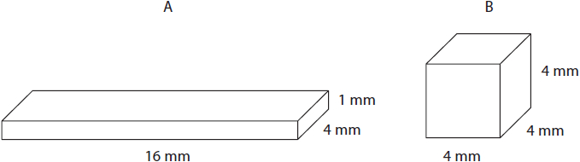
.............................................................................................................................................
.............................................................................................................................................
.............................................................................................................................................
.............................................................................................................................................
.............................................................................................................................................
.............................................................................................................................................
.............................................................................................................................................

(Total for question = 4 marks)

Q6.
The heart pumps blood around the circulation system.
Explain why many animals need a heart and circulation system.
(2)
.............................................................................................................................................
.............................................................................................................................................
.............................................................................................................................................
.............................................................................................................................................
.............................................................................................................................................
.............................................................................................................................................

(Total for question = 2 marks)

Q7.
The heart pumps blood around the circulation system.
If the heart of an animal is removed from its body, the heart will continue to beat for a period of time.
The left atrium stops contracting if it is separated from the rest of the heart.
However, the right atrium and the rest of the heart will continue to beat.
Eventually, the right atrium and the rest of the heart will also stop beating.
(i) Give a reason why the heart will continue to beat after being removed from the body.
(1)
.............................................................................................................................................
(ii) Explain why the left atrium stops beating when it is separated from the right atrium.
(2)
.............................................................................................................................................
.............................................................................................................................................
.............................................................................................................................................
.............................................................................................................................................
.............................................................................................................................................
.............................................................................................................................................
(iii) Explain why the right atrium and the rest of the heart eventually stop beating.
(2)
.............................................................................................................................................
.............................................................................................................................................
.............................................................................................................................................
.............................................................................................................................................
.............................................................................................................................................
.............................................................................................................................................

(Total for question = 5 marks)

Q8.
As levels of activity increase, the heart can respond to the changing demand for oxygen.
During the cardiac cycle there are pressure changes in the chambers of the heart.
Explain how pressure differences in the heart ensure efficient pumping of the blood into the arteries.
(3)
.............................................................................................................................................
.............................................................................................................................................
.............................................................................................................................................
.............................................................................................................................................
.............................................................................................................................................
.............................................................................................................................................
.............................................................................................................................................
.............................................................................................................................................
.............................................................................................................................................
.............................................................................................................................................

(Total for question = 3 marks)

Q9.
Nicotine is a drug found in the smoke of cigarettes.
The effect of inhaling nicotine on the circulatory system of rats was investigated.
In this investigation, three variables were considered:
• the concentration of nicotine in blood plasma
• the diameter of the lumen of one artery
• blood pressure
Two groups of rats were treated as shown in the table.
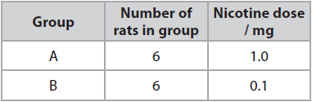
(i) The concentration of nicotine in the blood plasma of the group A rats was recorded at different times and
the means calculated.
The means are shown in the table along with the range of data for each mean.
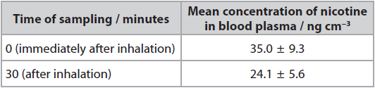
Determine the maximum rate of decrease in the concentration of nicotine in
the blood plasma per minute after being given the nicotine.
(2)
Answer ........................................................... ng cm⁻³ min⁻¹
(ii) The diameter of the lumen of one artery, in each of the 12 rats, was measured
when the rats were resting. The blood pressure of each rat was also measured
and the mean blood pressure calculated.
The diameter of the lumen of the artery and the blood pressure of each rat
were then recorded at intervals, for a total of 30 minutes. The rats inhaled
nicotine for the first minute (0.0 to 1.0).
The table shows the results for the mean diameter of the lumen of the artery.
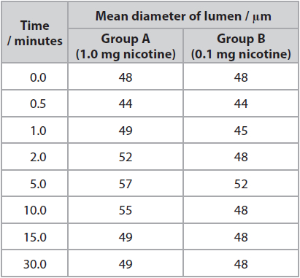
Determine the effect of nicotine concentration on the percentage change in
lumen diameter in the first minute.
(2)
.............................................................................................................................................
.............................................................................................................................................
*(iii) The graph shows the results for the mean blood pressure for the two groups
of rats. Nicotine was inhaled for the first minute.
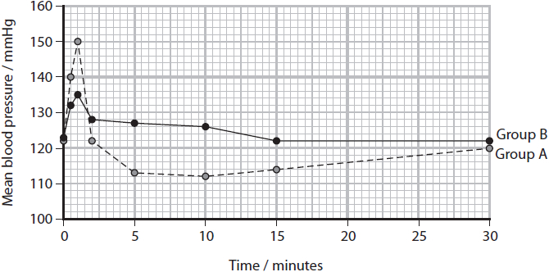
It has been stated that:
'Nicotine gained from smoking cigarettes in humans causes an increase in
blood pressure and a decrease in the lumen of arteries.'
Analyse all the data from this investigation using rats to evaluate the validity
of this statement.
(6)
.............................................................................................................................................
.............................................................................................................................................
.............................................................................................................................................
.............................................................................................................................................
.............................................................................................................................................
.............................................................................................................................................
.............................................................................................................................................
.............................................................................................................................................
.............................................................................................................................................
.............................................................................................................................................
.............................................................................................................................................
.............................................................................................................................................
.............................................................................................................................................
.............................................................................................................................................
.............................................................................................................................................
.............................................................................................................................................
.............................................................................................................................................
.............................................................................................................................................
.............................................................................................................................................
.............................................................................................................................................
.............................................................................................................................................
.............................................................................................................................................
.............................................................................................................................................
.............................................................................................................................................
.............................................................................................................................................

(Total for question = 10 marks)

Examiner's Report
Q1.
A surprising number of students suggested that blood velocity in capillaries was high. Often going on to suggest that this was necessary to allow effective transport and exchange of materials. Students with a better understanding of capillary function found this question straightforward and generally gained both marks. It was sometimes not possible to award marking point two if the response did not clearly make reference to either diffusion or exchange between blood and tissue fluid e.g. '...allowing glucose to leak out of the blood' is not sufficient for MP2.
This response gained both available marks.
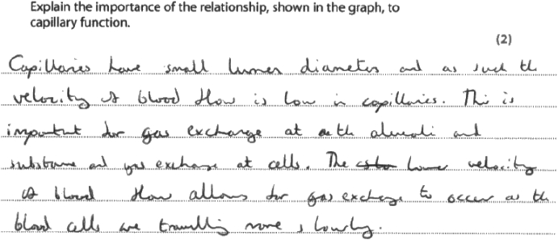
This response gained no marks. Many students described damage to capillaries caused by high pressure, ignoring the question which is about capillary function.
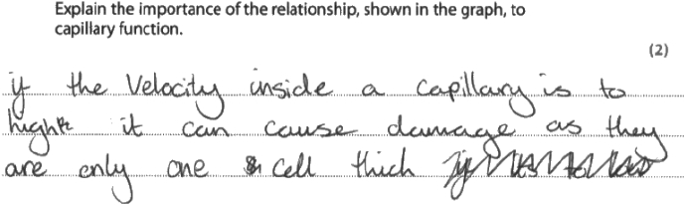

Q2.
Candidates were given some symptoms and then asked to explain how a mammal with a hole in their septum could lead to those symptoms. Almost all candidates appreciated that the oxygenated and deoxygenated blood would mix.
This response not only referred to the mixing but also that there would be less aerobic respiration at respiring tissues due to reduced oxygen levels. Two marks were given for this answer.
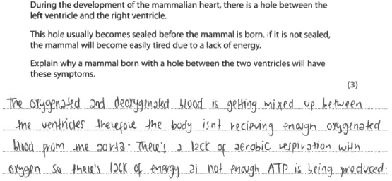

Q3.
This question asked for a link to be made between blood clots in the capillaries and tissue death. Many candidates gained full marks, although few stated that it was the lumen of the capillary that was blocked.
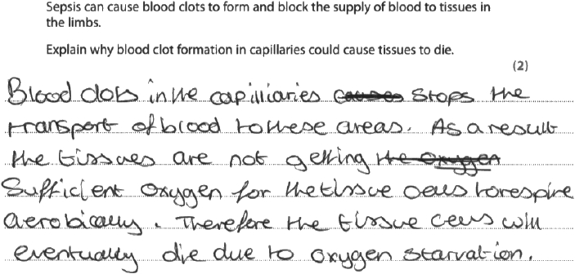
Results Plus: Examiner Comments
A clear answer that gains 2/2 marks.
Although this answer states aerobic respiration, respiration alone is sufficient here as it could also be due to a lack of glucose.

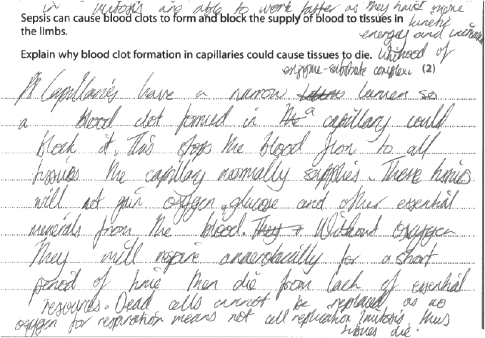
Results Plus: Examiner Comments
This is a detailed answer that covers all 3 marks available.
The mark for lack of respiration would be awarded in the last sentence, it could not be awarded for the reference to anaerobic respiration as there is no mention of lactic acid build up. It gains 2/2.

Q4.
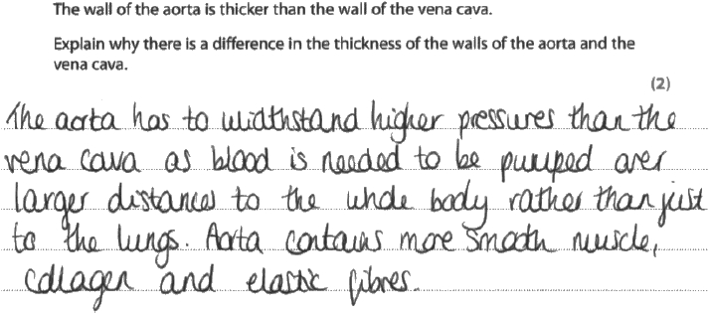
Results Plus: Examiner Comments
This is an example of a typical response. The candidate has been awarded 1 mark; marking point two. Although the candidate makes reference to elastic fibres, smooth muscle, and collagen, these structural features are not linked directly to function. Marking point two was allowed for the general statement that the difference is in thickness, because the aorta needs to withstand a higher pressure, together with 'more collagen' at the end of the response.

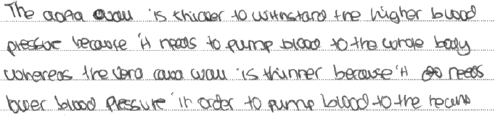
Results Plus: Examiner Comments
Marking point two was allowed for stating that the aorta walls are thicker in order to withstand higher pressure as alternative to marking point two.
This response scored 1 mark.

Q5.
Candidates were presented with two shapes that represented two animals. They had to determine which required a circulation and which did not.
Most candidates made good use of the figures assigned to the two diagrams and were able to calculate the surface area and volume of each. Some then processed this data to make comparable surface area to volume ratios to help justify their choice of animal that did not require a circulatory system.
Those that did not score the higher marks either tended not to use the figures correctly or did not then consider the significance of the data in relation to diffusion being sufficient for the animal or not.
In this response, the first two marking points can be given from the calculations below animal A. The first line of the written text then uses the calculated data to deliver the third marking point. The second sentence then gained the fourth marking point, so all four marks can be awarded here.
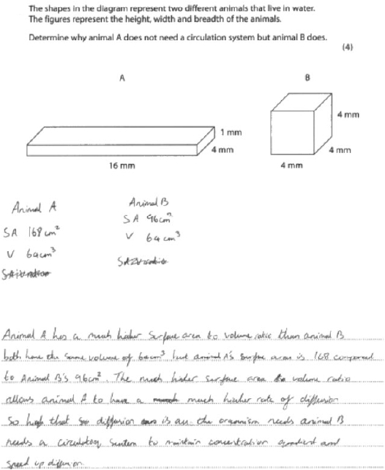

Q6.
Candidates are asked to explain why many animals need a heart and circulation.
While many candidates gained both available marks others produced answers that lacked sufficient detail to gain credit. Mark Point 1 required the idea that the heart pumps blood around blood vessels. Many candidates simply stated, 'animals need a heart to pump blood'. Candidates could gain Mark Point 2 by referring to a requirement for bulk transport or an example of bulk transport. This mark was most frequently awarded for an example. Although lack of detail expected at A level meant the mark was often not awarded. For example, 'to pump oxygen around the body' was not sufficient. Answers needed to indicate where the oxygen was going eg 'to respiring cells' or 'to tissues' and not just to or around the body.
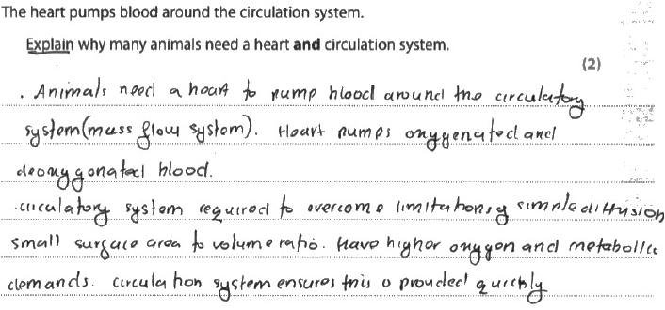
Results Plus: Examiner Comments
This response gained two marks. Mark Point 2 was awarded for 'mass flow system' which was allowed for mass transport (line 2). Mark Point 3 was awarded for the idea of needing to overcome the limitations of diffusion (line 4).

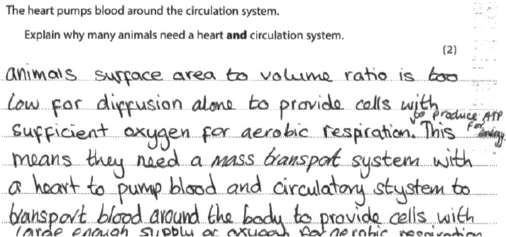
Results Plus: Examiner Comments
This response gained both available marks. Mark Point 3 first three lines, Mark Point 2 line 4 and again the last two lines. This response would not have been awarded Mark Point 1 as 'heart to pump blood around the body' was not sufficient. There needed to be a reference to blood vessels.

Q7.
(i) Most candidates gained the mark by correctly suggesting that cardiac muscle (we allowed the heart) is myogenic.
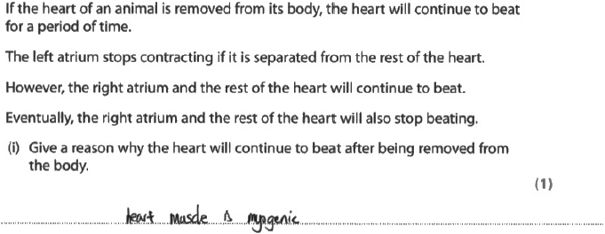
Results Plus: Examiner Comments
A clear response that gained the mark.

(ii) This question was answered well by many candidates. A number of candidates did not gain Mark Point 2 because they used the term signals rather than impulses. Signals is too vague and could mean something other than an electrical impulse.
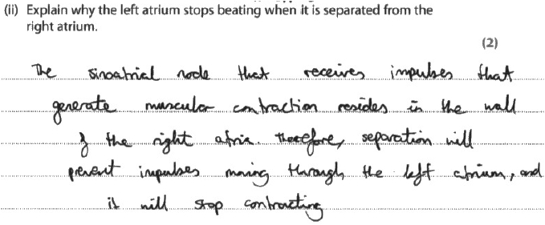
Results Plus: Examiner Comments
A good response that gained Mark Point 1 in the first three lines and Mark Point 2 in the last two lines.

(iii) A majority of candidates provided complete answers that gained both available marks, usually for Mark Point 1 and Mark Point 2. Some candidates described a lack of blood flow through the heart chambers which was not allowed for Mark Point 1. A number of candidates failed to finish the story with the idea of cells no longer being able to produce ATP, Mark Point 3.
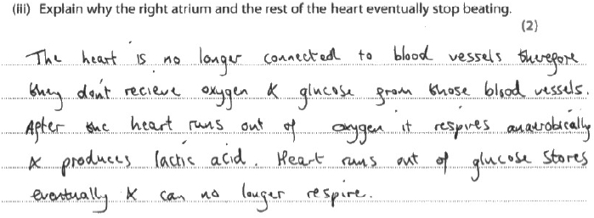
Results Plus: Examiner Comments
This response gained both available marks. Mark Point 1 (line 2) and Mark Point 2 (line 4).

Q8.
It does appear to examiners that there are occasions where candidates read the first few words of a question and then launch straight into their answers, without bothering to read the whole question. As a result, marks are lost unnecessarily. This question was an example of this trend – with many just seeing the words 'pressure differences in the heart' and then describing all the different pressure changes that occur during the whole cardiac cycle, starting with diastole. The actual question asked for an explanation (not a description) of how pressure changes ensure blood is pumped into the arteries – a very different question to the one that the majority of responses would have fit.
A simple statement that 'increased pressure in the ventricles closes the atrioventricular valves and opens the semilunar valves' would have been enough to gain full marks. Indeed, there were some excellent answers that did just that and also referred to the higher pressure in the ventricles than the arteries causing blood to be forced into the arteries as the ventricles contracted.
However, most candidates discussed the pressure changes in the atria at length before moving onto the ventricles, often for more than half of their response. Some referred generically to valves without naming them. Others described reasons for differences between the right and left sides of the heart or just described the pressure in the ventricles as being 'high' rather than 'higher' than in the atria and arteries.
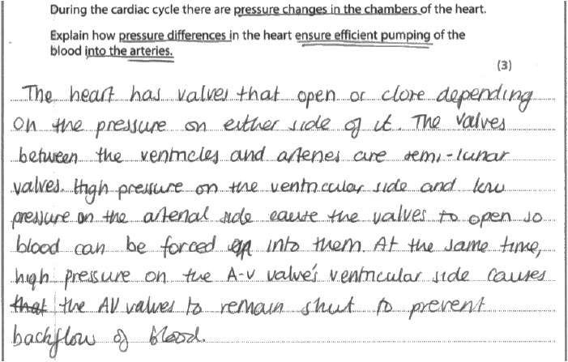
Results Plus: Examiner Comments
This is a good response, that clearly answers the question to gain 3/3. It tackles the pressure differences in the heart that bring about the forcing of blood into the arteries.

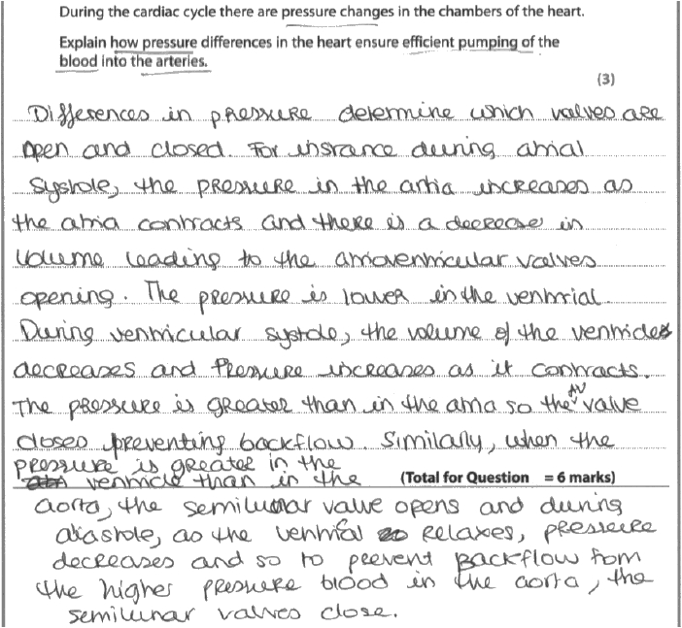
Results Plus: Examiner Comments
This response did gain 3/3. However, this has been as a consequence of writing everything the candidate recalled about pressure changes in the cardiac cycle and not answering the specific question asked. This did result on all 4 possible marking points being covered:
• increased pressure in the ventricles
• pressure greater in ventricles than atria and in the aorta
• causing the AV valves to close
• opening the semi-lunar valve

Results Plus: Examiner Tip
This candidate has run out of space on the lines because they have written much that is irrelevant to the question.

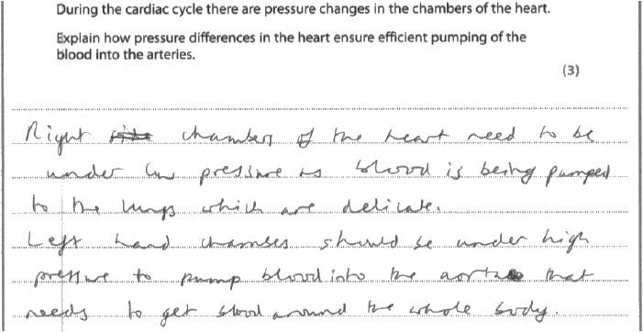
Results Plus: Examiner Comments
This response gained 0 marks. The candidate has misread the question as 'explain the differences in pressure in the heart' and has explained why pressure is lower in the right side than in the left side. This does not explain how blood is efficiently pumped into the arteries.

Results Plus: Examiner Tip
Make sure that questions are read thoroughly, taking into account the context.

Q9.
(i) In this question, candidates had to determine the maximum rate of decrease in nicotine concentration in blood plasma per minute.
Whilst many did take into account the spread of the data provided in the table, a number did not.
Examiner Comments
This answer did not consider the range of data and then calculated a percentage change, so no marks could be awarded.
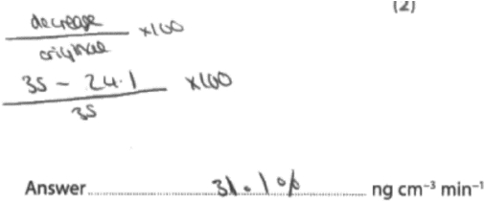
Examiner Comments
This answer sets out the maximum and minumum concentrations and then divides by the time to calculate the correct answer. Both marks given.
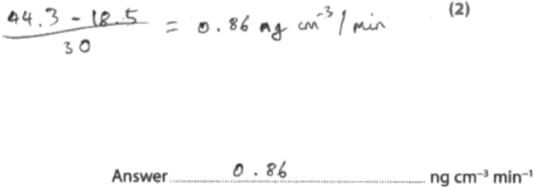
(ii) Data was provided in this item about the size of the lumen of an artery in response to two different nicotine concentrations. Candidates had to use this to determine the effect of the two concentrations on the percentage change in the first minute.
Some candidates gave clear responses that gained full marks. Many, however, did not consider the percentage change component of the question or that it was restricted to the first minute.
Examiner Comments
This example does not take into account the requirement to determine the percentage change. No marks awarded.
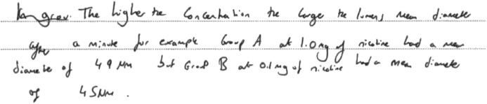
(iii) This item required candidates to analyse all of the investigation data provided relating to rats and nicotine concentration to evaluation a statement. The statement was:
Nicotine gained from smoking cigarettes in humans causes an increase in blood pressure and a decrease in the lumen of arteries.
A wide range of responses were seen, from those that only considered one aspect of the investigation to detailed analyses of all the information given.
Examiner Comments
This response initially considers the effect of nicotine concentration on blood pressure in rats. It then goes onto consider the effect of artery lumen diameter. Whilst these two aspects are discussed, there is no link made between the lumen size due to vasoconstriction and blood pressure. Therefore, three marks were awarded in this instance.
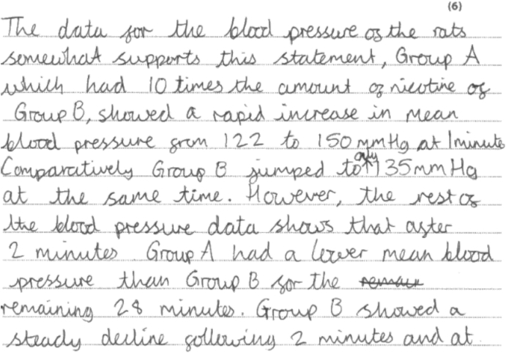
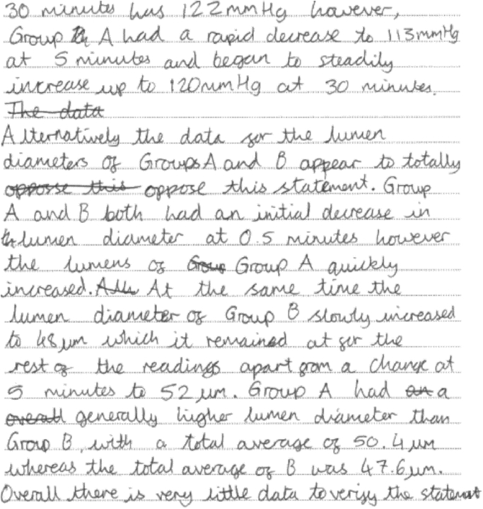

Mark Scheme
Q1.
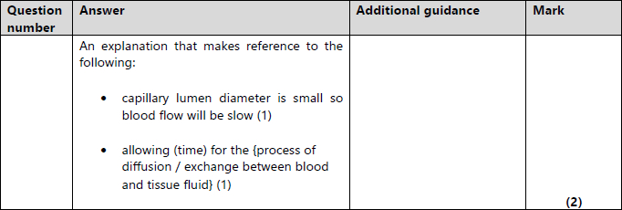

Q2.
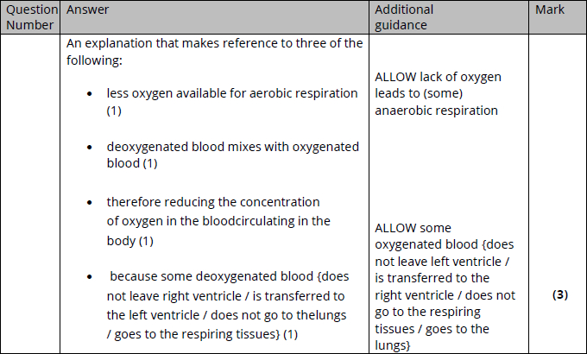

Q3.
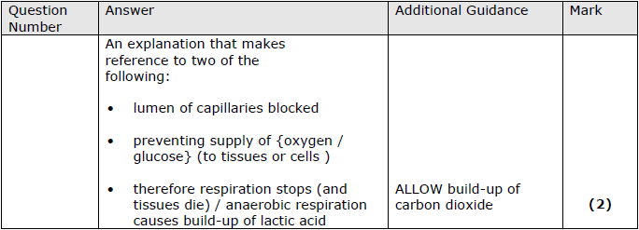

Q4.
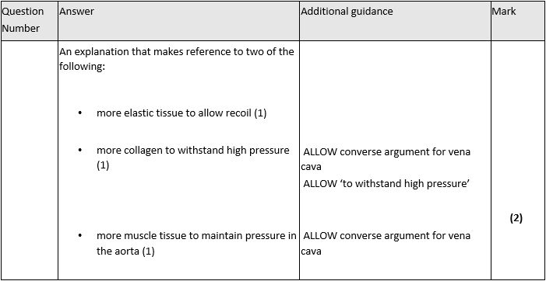

Q5.
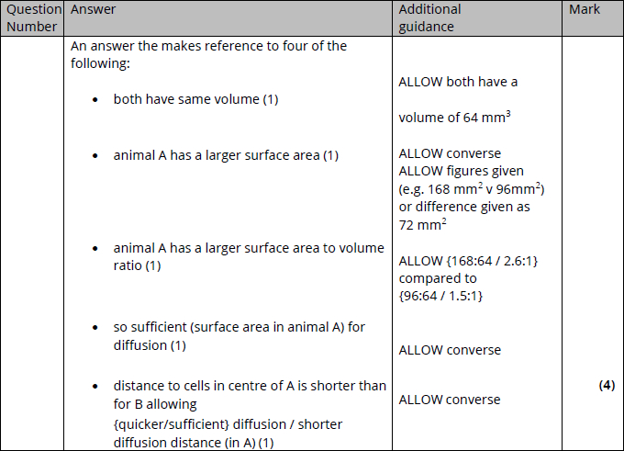

Q6.
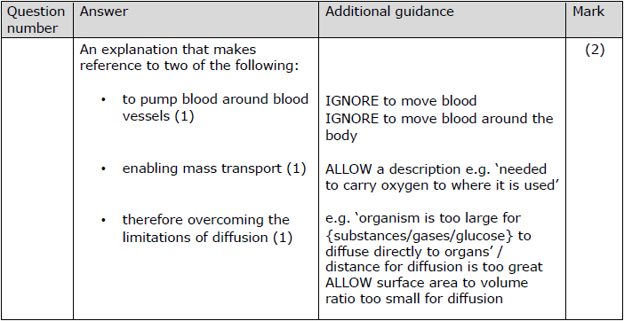

Q7.
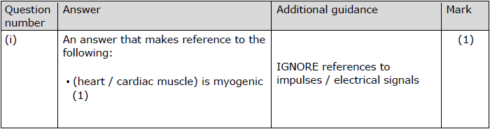
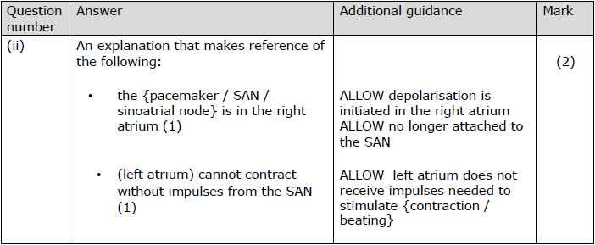
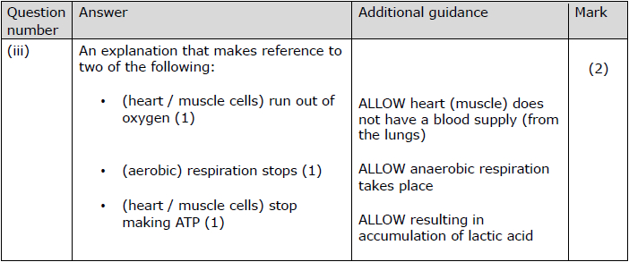

Q8.
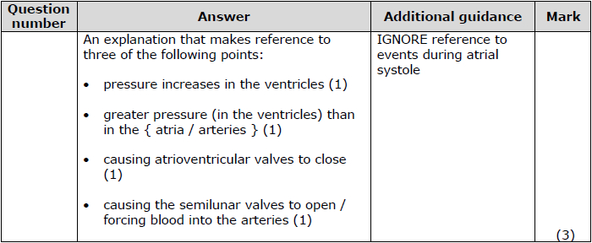

Q9.
