CP12,CP13, 5.20-5.21 temp impact on organisms, carbon cycle questions
Q1.
An experiment was carried out to determine the effect of temperature on the activity
of the enzyme catalase in yeast cells.
The substrate was hydrogen peroxide. A suspension of yeast cells was added to
hydrogen peroxide.
The volume of oxygen produced during the initial two minutes was recorded.
This was repeated at a range of temperatures.
The results are shown in the table.
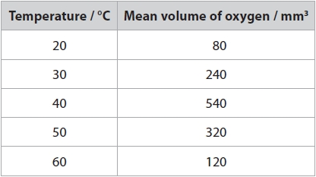
(i) Calculate the temperature coefficient (Q₁₀) for this reaction between 20 °C and 30 °C.
(1)
Answer ...........................................................
(ii) Explain the effects of a temperature increase from 20 °C to 30 °C on the initial
rate of activity of catalase in the yeast cells.
(3)
.............................................................................................................................................
.............................................................................................................................................
.............................................................................................................................................
.............................................................................................................................................
.............................................................................................................................................
.............................................................................................................................................
.............................................................................................................................................
.............................................................................................................................................
.............................................................................................................................................
(iii) Explain what happens to the Q₁₀ value between 40 °C and 50 °C.
(2)
.............................................................................................................................................
.............................................................................................................................................
.............................................................................................................................................
.............................................................................................................................................
.............................................................................................................................................
.............................................................................................................................................

(Total for question = 6 marks)

Q2.
A student investigated the effect of salt concentration on the growth of one species of brine shrimp.
The student placed 100 shrimp eggs in a beaker containing 1dm³ of 3% salt solution. Three days after the eggs hatched, 10 shrimps were collected and their lengths measured. Seven days after hatching, another 10 shrimps were collected and their lengths measured.
The procedure was repeated using a 5% salt solution. All other variables were kept constant.
The results are shown in the table.
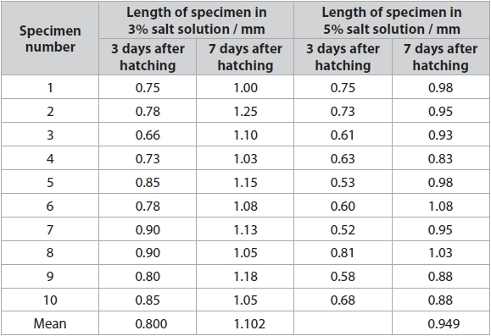
The student carried out a statistical test to see if there was a significant difference between the mean lengths of brine shrimps in these two salt solutions. The student used the 7 days after hatching data.
The student selected the t-test because the data are normally distributed.
(i) Draw a line on the graph to show a normal distribution for a population of brine shrimp.
(1)
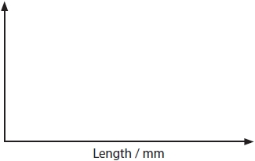
(ii) Complete the table by filling in the missing value for specimen 7 and then calculate the value for .
(1)
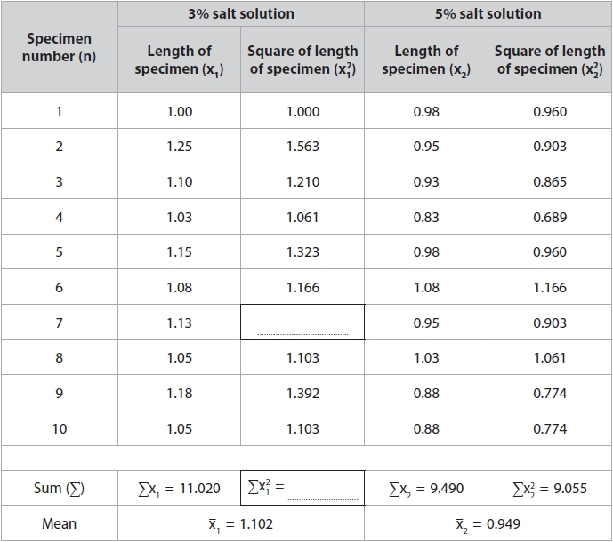
(iii) The variances are used in the calculation of a t-value.
The variance for the 3% salt solution .
Calculate the variance for the 5% salt solution using the formula
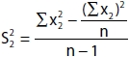
n = the number of specimens
(2)
...........................................................
(iv) Calculate the t-value using the formula.
Give your answer to an appropriate number of significant figures.
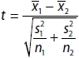
(3)
t = ...........................................................
(v) The calculated t-value is greater than the critical value at p = 0.05.
Describe what this result indicates about the effect of salt concentration on the length of brine shrimp.
(2)
.............................................................................................................................................
.............................................................................................................................................
.............................................................................................................................................
.............................................................................................................................................
.............................................................................................................................................
.............................................................................................................................................
.............................................................................................................................................
.............................................................................................................................................

(Total for question = 9 marks)

Q3.
Climate change has been correlated with changing atmospheric carbon dioxide levels.
Scientists measured the productivity of two types of forest and recorded the mass of carbon taken up per square metre per year (gC m⁻² y⁻¹).
The table shows data on the mean net primary productivity (NPP) and mean gross primary productivity (GPP) of these two types of forest.
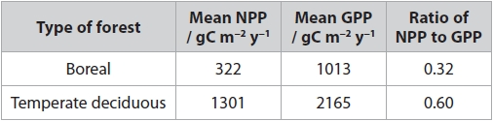
(i) Calculate the percentage increase in mass of carbon released due to respiration by temperate deciduous forests compared with that by boreal forests.
(3)
........................................................... %
(ii) The ratio of net primary productivity to gross primary productivity is a measure of the ability of forests to transfer carbon from the atmosphere into biomass.
Scientists concluded that temperate deciduous forests would reduce levels of carbon dioxide in the atmosphere more than boreal forests.
Justify this conclusion.
(3)
.............................................................................................................................................
.............................................................................................................................................
.............................................................................................................................................
.............................................................................................................................................
.............................................................................................................................................
.............................................................................................................................................
.............................................................................................................................................
.............................................................................................................................................
.............................................................................................................................................
.............................................................................................................................................

(Total for question = 6 marks)

Mark Scheme
Q1.
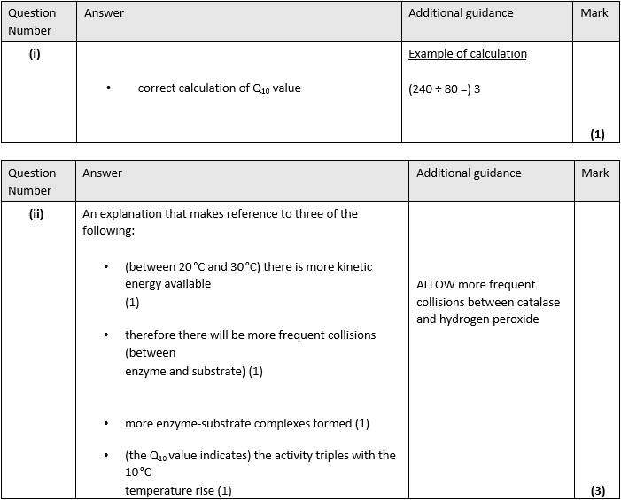
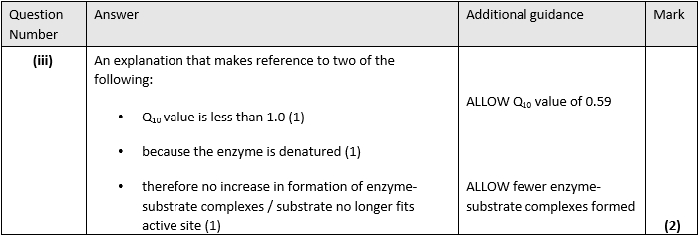

Q2.
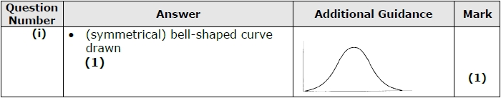
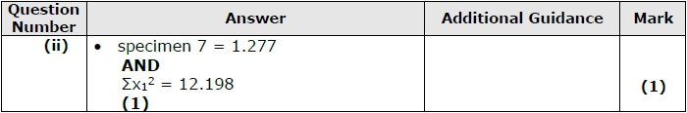
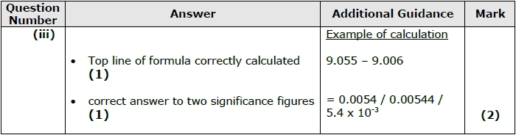
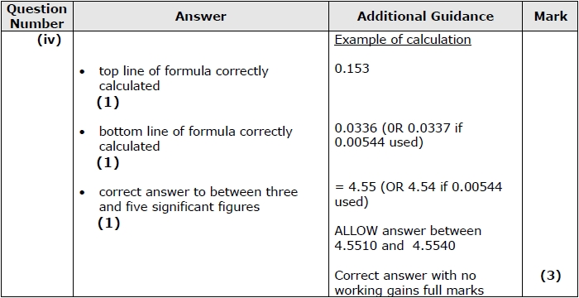
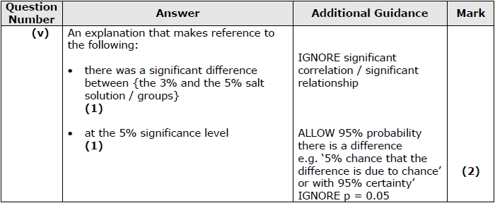

Q3.
