Questions
Q1.
The structure of the cell surface membrane can be explained using the fluid mosaic model.
This model suggests that there are a variety of different proteins and glycoproteins present in a phospholipid bilayer.
* The ratio of lipid to protein in a cell surface membrane is approximately 1:1.
Scientists have studied the proteins present within human cells. Proteins in a cell are found in several locations.
The table shows the percentage of protein found in some locations in a cell.
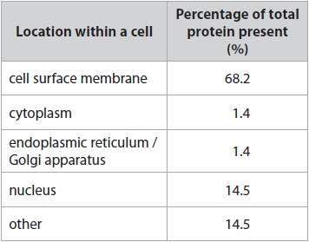
The proteins within the cell surface membrane were further analysed for their function.
The graph shows some of the results of this analysis.
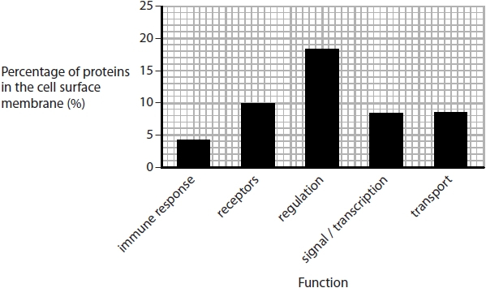
Analyse the data to evaluate the following statement.
'The variety of different proteins present in the cell surface membrane makes them more important than the phospholipid bilayer to the functioning of that cell.'
(9)
.............................................................................................................................................
.............................................................................................................................................
.............................................................................................................................................
.............................................................................................................................................
.............................................................................................................................................
.............................................................................................................................................
.............................................................................................................................................
.............................................................................................................................................
.............................................................................................................................................
.............................................................................................................................................
.............................................................................................................................................
.............................................................................................................................................
.............................................................................................................................................
.............................................................................................................................................
.............................................................................................................................................
.............................................................................................................................................
.............................................................................................................................................
.............................................................................................................................................
.............................................................................................................................................
.............................................................................................................................................
.............................................................................................................................................
.............................................................................................................................................

(Total for question = 9 marks)

Q2.
Opioids are used to treat moderate to severe pain. They are a group of drugs synthesised from morphine.
(a) Opioids and morphine both affect the size of the pupil of the eye.
The graph shows the effects of these drugs on the diameter of the pupil following exposure to a flash of light.
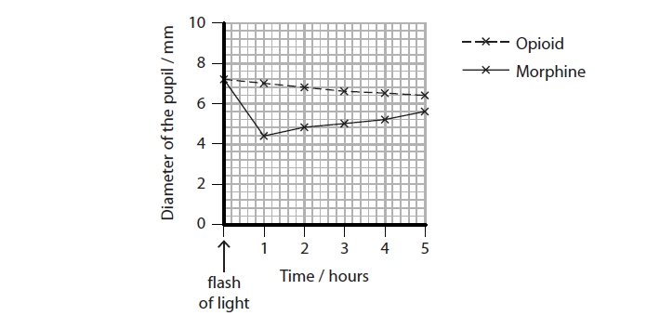
Calculate the rate of change in pupil diameter between one and five hours after exposure to light for those individuals who had taken morphine.
(2)
Answer ........................................................... mm h⁻¹
(ii) Explain the effect of opioids on the diameter of the pupil, between one and five hours after exposure to a flash of light.
(3)
.............................................................................................................................................
.............................................................................................................................................
.............................................................................................................................................
.............................................................................................................................................
.............................................................................................................................................
.............................................................................................................................................
.............................................................................................................................................
.............................................................................................................................................
.............................................................................................................................................
(iii) Comment on reasons why the results of this investigation may not prove that any changes in pupil size were the direct result of either the opioid or morphine.
(4)
.............................................................................................................................................
.............................................................................................................................................
.............................................................................................................................................
.............................................................................................................................................
.............................................................................................................................................
.............................................................................................................................................
.............................................................................................................................................
.............................................................................................................................................
.............................................................................................................................................
.............................................................................................................................................
.............................................................................................................................................
.............................................................................................................................................

(Total for question = 9 marks)

Mark Scheme
Q1.
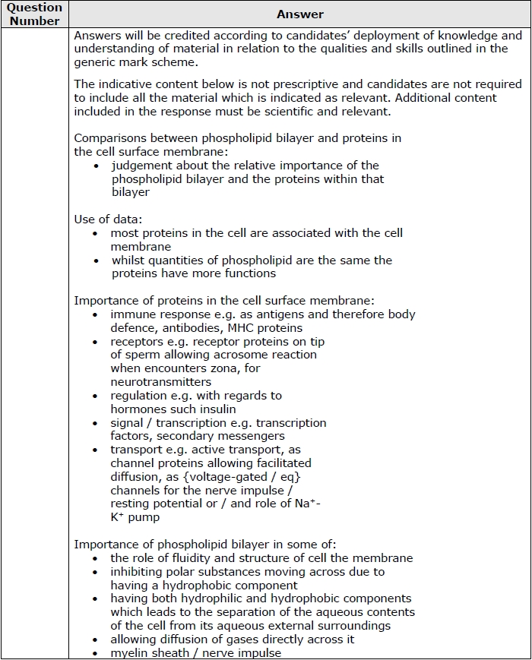
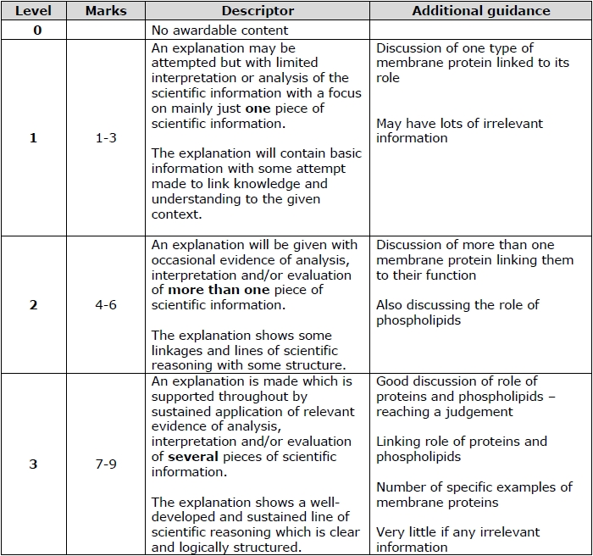

Q2.
