Data Analysis Exam Questions
Q1.
Prostate cancer is one of the most common forms of cancer in adult men.
A number of investigations have been carried out to study prostate cancer in a large
number of men in Denmark, Finland and Sweden.
In a third investigation, prostate cancer in identical and non-identical male twins was studied.
Data were collected on the probability of one male twin developing prostate cancer if his twin brother had prostate cancer.
(i) Explain why identical twins were included in this investigation.
(2)
.............................................................................................................................................
.............................................................................................................................................
.............................................................................................................................................
.............................................................................................................................................
.............................................................................................................................................
.............................................................................................................................................
* (ii) The graph shows the results of this investigation.
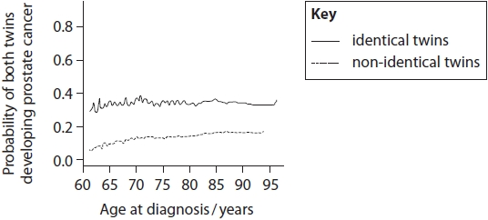
Analyse the data from these three investigations to evaluate the likely causes of prostate cancer.
(6)
.............................................................................................................................................
.............................................................................................................................................
.............................................................................................................................................
.............................................................................................................................................
.............................................................................................................................................
.............................................................................................................................................
.............................................................................................................................................
.............................................................................................................................................
.............................................................................................................................................
.............................................................................................................................................
.............................................................................................................................................
.............................................................................................................................................
.............................................................................................................................................
.............................................................................................................................................
.............................................................................................................................................

(Total for question = 8 marks)

Q2.
Nandrolone is an anabolic steroid, it is a molecule with a similar shape to testosterone.
Nandrolone has been used as a performance-enhancing substance by athletes in the past.
A number of investigations with mice have been carried out to study the effect of
nandrolone on the structure and function of the aorta.
In these investigations, all the mice were of one type and were all supplied with
the same amount of food and water. These mice were placed into four groups.
Each group was treated differently for eight weeks. The treatments are shown in
the table.
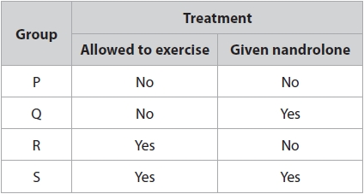
After eight weeks, the aorta of each mouse was studied.
In investigation 1, samples of aorta were put under tension to test elastic recoil.
The tension was removed and the mean maximum percentage recoil for each group
was found.
The results are shown in the table.
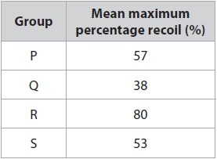
In investigation 2, some of the cells from the middle layer of the aortas of the
mice were removed.
Two protein complexes, A and B, are found in the cells of the middle layer.
These protein complexes are involved in the electron transport chain.
The graphs show the relative percentage of these two protein complexes in
each group of mice.
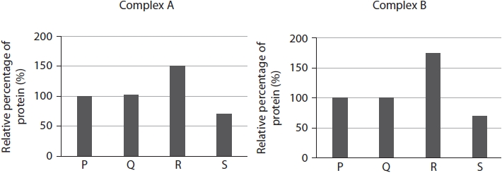
The transcription factor Tfam is involved in the production of mitochondria.
In investigation 3, some of the cells from the middle layer of the aortas of the mice
were removed. The quantity of mRNA per cell coding for Tfam was measured.
The results are shown in the table.
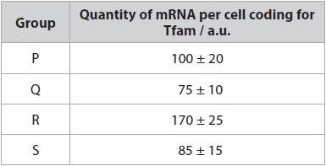
Analyse the data from these three investigations to discuss the advantages of an
exercise programme without nandrolone.
(6)
.............................................................................................................................................
.............................................................................................................................................
.............................................................................................................................................
.............................................................................................................................................
.............................................................................................................................................
.............................................................................................................................................
.............................................................................................................................................
.............................................................................................................................................
.............................................................................................................................................
.............................................................................................................................................
.............................................................................................................................................
.............................................................................................................................................
.............................................................................................................................................
.............................................................................................................................................
.............................................................................................................................................
.............................................................................................................................................
.............................................................................................................................................
.............................................................................................................................................
.............................................................................................................................................
.............................................................................................................................................

(Total for question = 6 marks)

Mark Scheme
Q1.
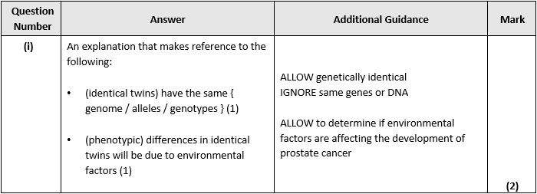
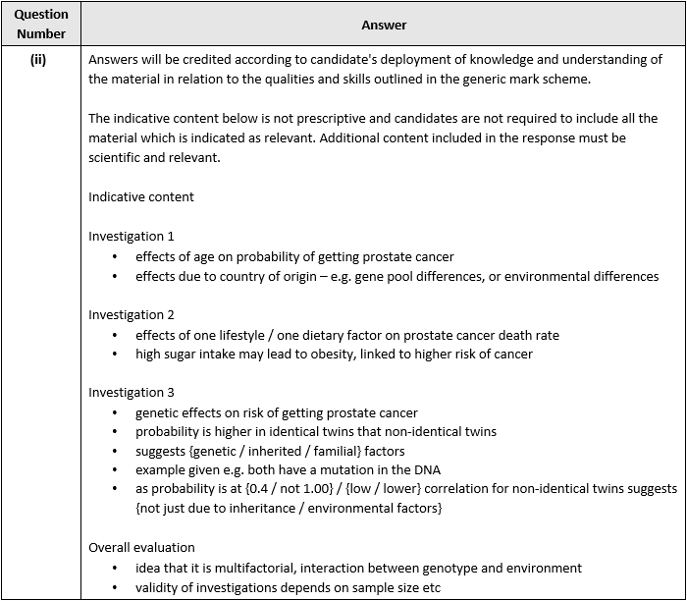
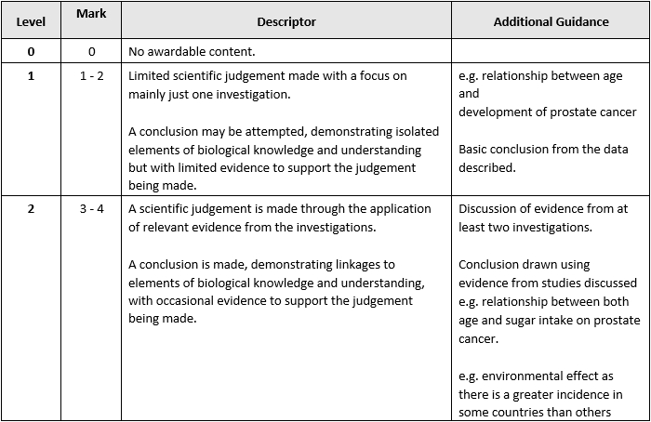
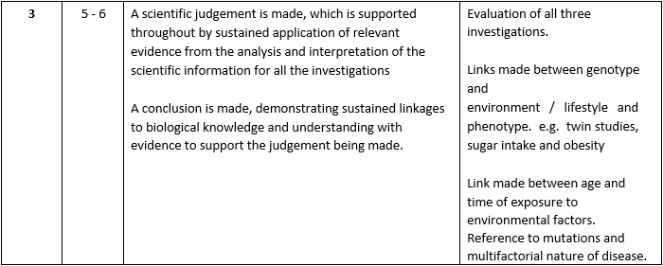

Q2.
