DNA and Protein Synthesis Questions
Q1.
Answer the question with a cross in the boxes you think are correct . If you change your mind about an answer, put a line through the box and then mark your new answer with a cross .
The diagram shows part of a DNA molecule.
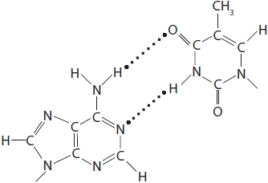
(i) Which part of the DNA molecule is shown?
(1)
A deoxyribose molecule
B one mononucleotide
C two complementary organic bases
D two mononucleotides
(ii) Which type of bond holds the strands of DNA together?
(1)
A disulfide
B glycosidic
C hydrogen
D peptide
(iii) Analysis of a sample of DNA found that 35% of the nucleotides contained thymine.
Determine the percentage of guanine in the same sample of DNA.
(1)
Answer ........................................................... %

(Total for question = 3 marks)

Q2.
DNA is a polymer made from monomers called nucleotides.
Describe how nucleotides join together to form DNA.
(2)
.............................................................................................................................................
.............................................................................................................................................
.............................................................................................................................................
.............................................................................................................................................

(Total for question = 2 marks)

Q3.
DNA is a polymer made from monomers called nucleotides.
The diagram shows the structure of ATP.
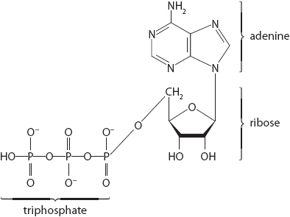
Compare and contrast the structure of ATP and a DNA nucleotide.
(3)
.............................................................................................................................................
.............................................................................................................................................
.............................................................................................................................................
.............................................................................................................................................
.............................................................................................................................................
.............................................................................................................................................
.............................................................................................................................................
.............................................................................................................................................
.............................................................................................................................................
.............................................................................................................................................
.............................................................................................................................................

(Total for question = 3 marks)

Q4.
There are a number of reactions that regularly occur in cells.
∗ Another reaction that regularly occurs in cells is phosphorylation.
Phosphorylation plays a significant role in a wide range of cellular processes. Over a quarter of a million scientific articles have been written on this subject.
Using your knowledge of biology, discuss the roles of phosphorylation in cells.
(9)
.............................................................................................................................................
.............................................................................................................................................
.............................................................................................................................................
.............................................................................................................................................
.............................................................................................................................................
.............................................................................................................................................
.............................................................................................................................................
.............................................................................................................................................
.............................................................................................................................................
.............................................................................................................................................
.............................................................................................................................................
.............................................................................................................................................
.............................................................................................................................................
.............................................................................................................................................
.............................................................................................................................................
.............................................................................................................................................
.............................................................................................................................................
.............................................................................................................................................
.............................................................................................................................................
.............................................................................................................................................

Q5.
Leptin is a protein hormone with a role in the control of appetite in humans.
The leptin gene is located on chromosome 17.
(i) State what is meant by the term gene.
(2)
.............................................................................................................................................
.............................................................................................................................................
.............................................................................................................................................
.............................................................................................................................................
(ii) Describe the role of tRNA in the production of leptin.
(3)
.............................................................................................................................................
.............................................................................................................................................
.............................................................................................................................................
.............................................................................................................................................
.............................................................................................................................................
.............................................................................................................................................
.............................................................................................................................................
.............................................................................................................................................
.............................................................................................................................................
(iii) Describe how the primary structure of leptin enables it to be soluble in water.
(3)
.............................................................................................................................................
.............................................................................................................................................
.............................................................................................................................................
.............................................................................................................................................
.............................................................................................................................................
.............................................................................................................................................
.............................................................................................................................................
.............................................................................................................................................
.............................................................................................................................................
.............................................................................................................................................

(Total for question = 8 marks)

Mark Scheme
Q1.
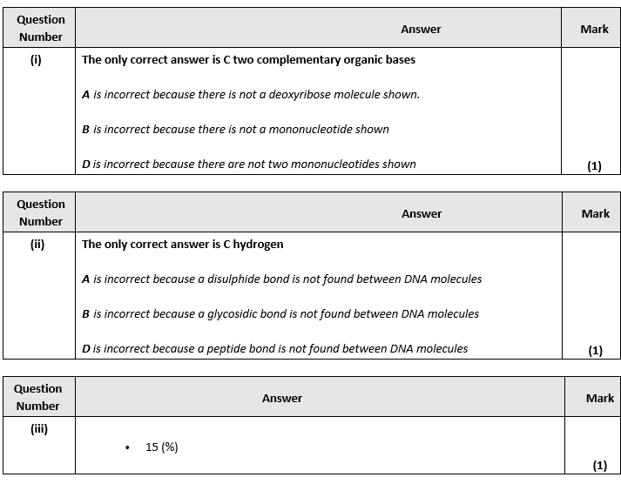

Q2.
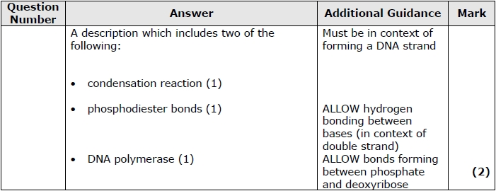

Q3.
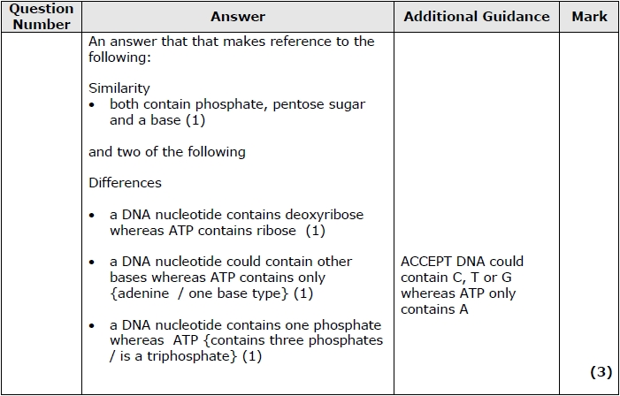

Q4.
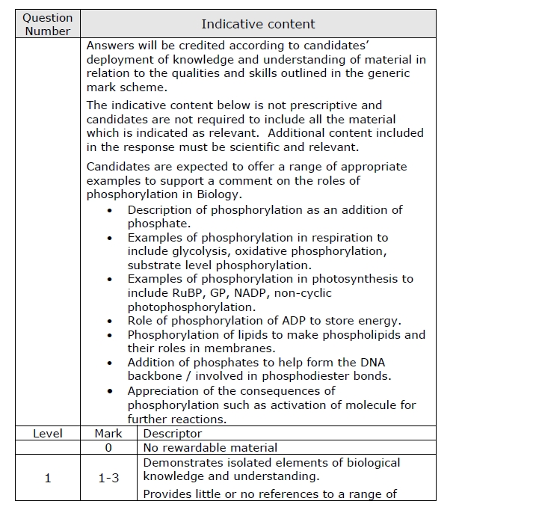
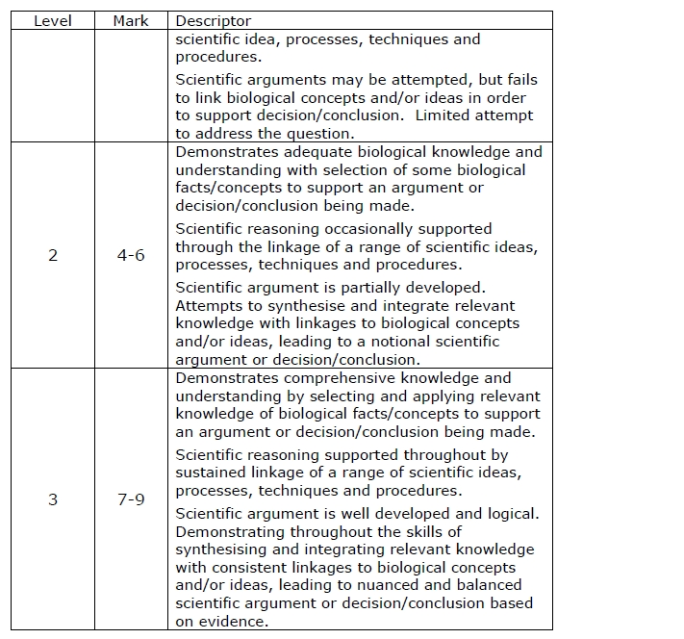

Q5.
